Sound Engineering – Section C
Marcello Bonello 6.3A DGD

Requirement | Implementation in my project
Subtractive EQ across channels | EQ Eight was used on the main Forest, Desert and Combat channels to remove unwanted frequency ranges and reduce masking.
Spectrum/analyser check | Spectrum was placed on the main/master output to inspect the overall frequency balance.
Sidechain compression | Compressor was placed on the Combat Dark Bass track, with the sidechain input coming from the combat drum track.
At least three other audio effects | Reverb, Delay, Auto Filter and Roar were used. Reverb and Delay were routed through return tracks; Auto Filter and Roar were used directly on tracks.
At least four automations | Automation was used for filter frequency, reverb send, volume/mix movement, and Roar drive.
Two return-track effects | Return A was used as Reverb and Return B was used as Delay, with track send knobs routing audio to them.
Master below -0.5 dB | A Limiter was added on the Main/Master track, and the output was checked during playback.
Two devices from given list | Auto Filter and Roar were used and documented.

1. Subtractive Equalisation
What I did: I applied EQ Eight to the main tracks in the backing music projects. The purpose was to remove unnecessary frequency content and reduce clashes between instruments. This was especially important because some of the backing tracks use a lot of different instruments. I used high-pass cuts on pads, plucks and melodic instruments so that they would not compete with bass instruments. I also shaped the bass and percussion, so the low end remained controlled.
Reasoning: Subtractive EQ was used mainly to remove unwanted low-frequency rumble and muddy frequencies. For example, the Forest pad and guitar do not need deep bass frequencies, so cutting those areas leaves more space for the Wood Bass. In the Desert state, the Eastern Harp was shaped so that it sits clearly in the mid/high range without masking the flute and pad. In the Combat state, EQ helped control the bass and drums, so the mix remained powerful but not muddy.

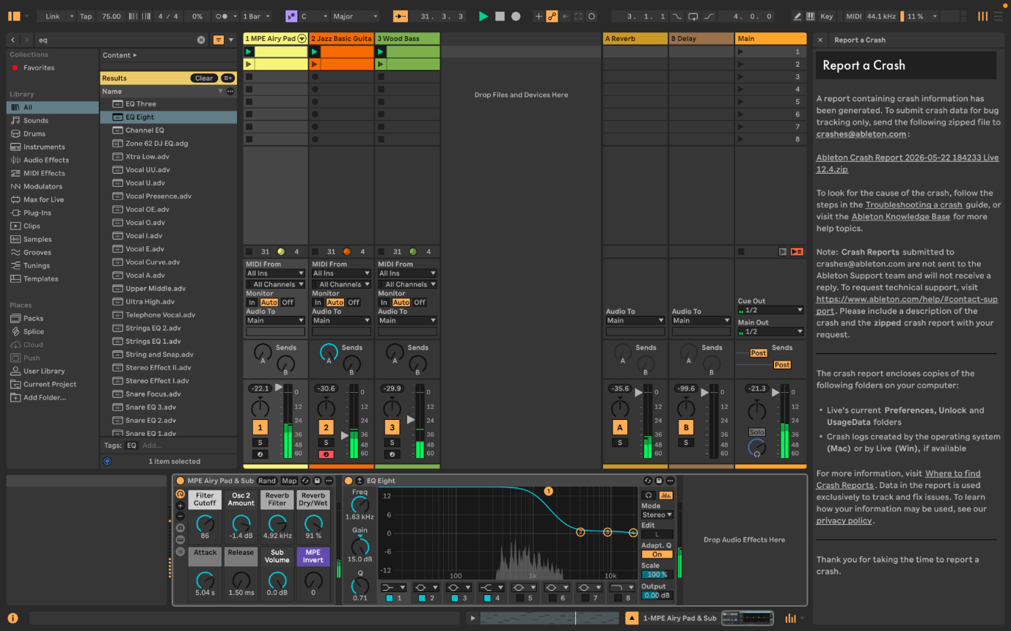
Figure 1: EQ Eight on Forest MPE Airy Pad. The EQ removes unnecessary low-end energy and helps the pad sit behind the rest of the forest mix.
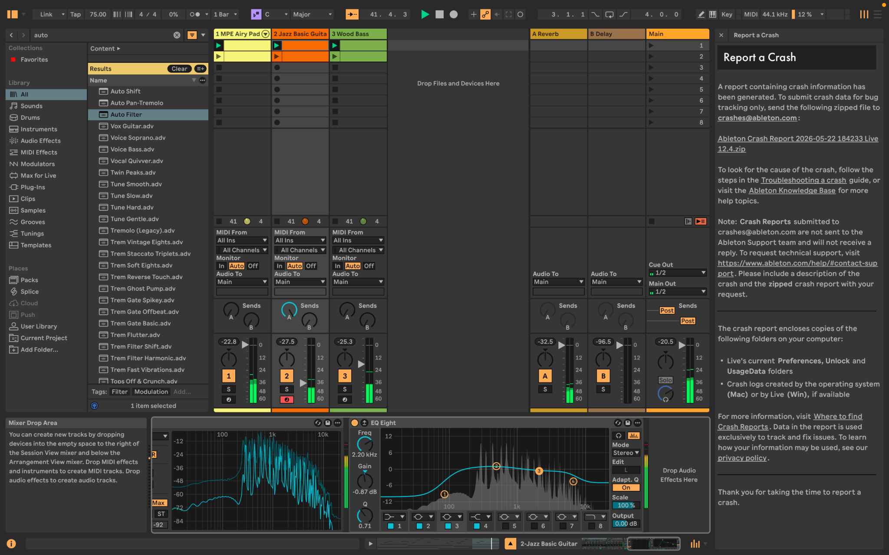
Figure 2: EQ Eight on Forest Jazz Basic Guitar. The guitar was shaped to sit in the mid-range without clashing with the Wood Bass.
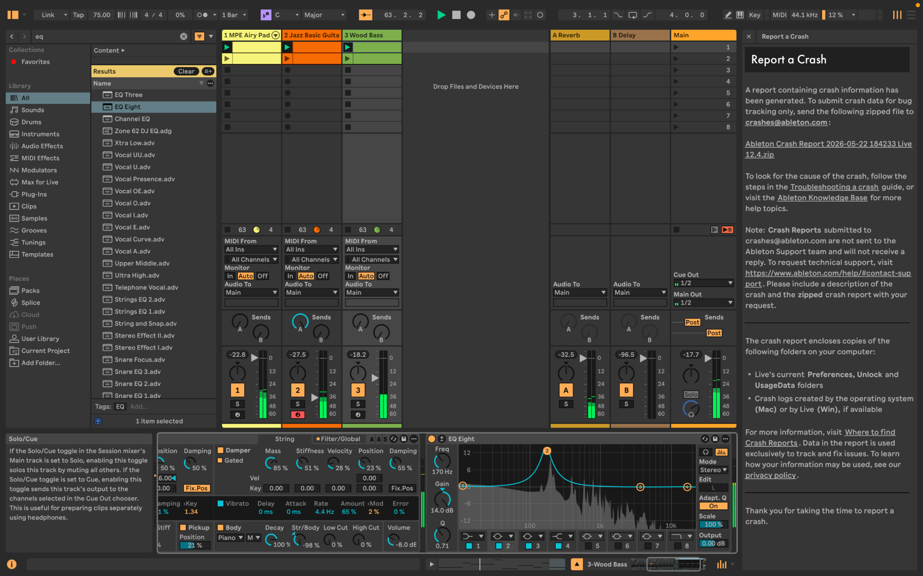
Figure 3: EQ Eight on Forest Wood Bass. The bass was controlled so it provides low-end support without overwhelming the mix.
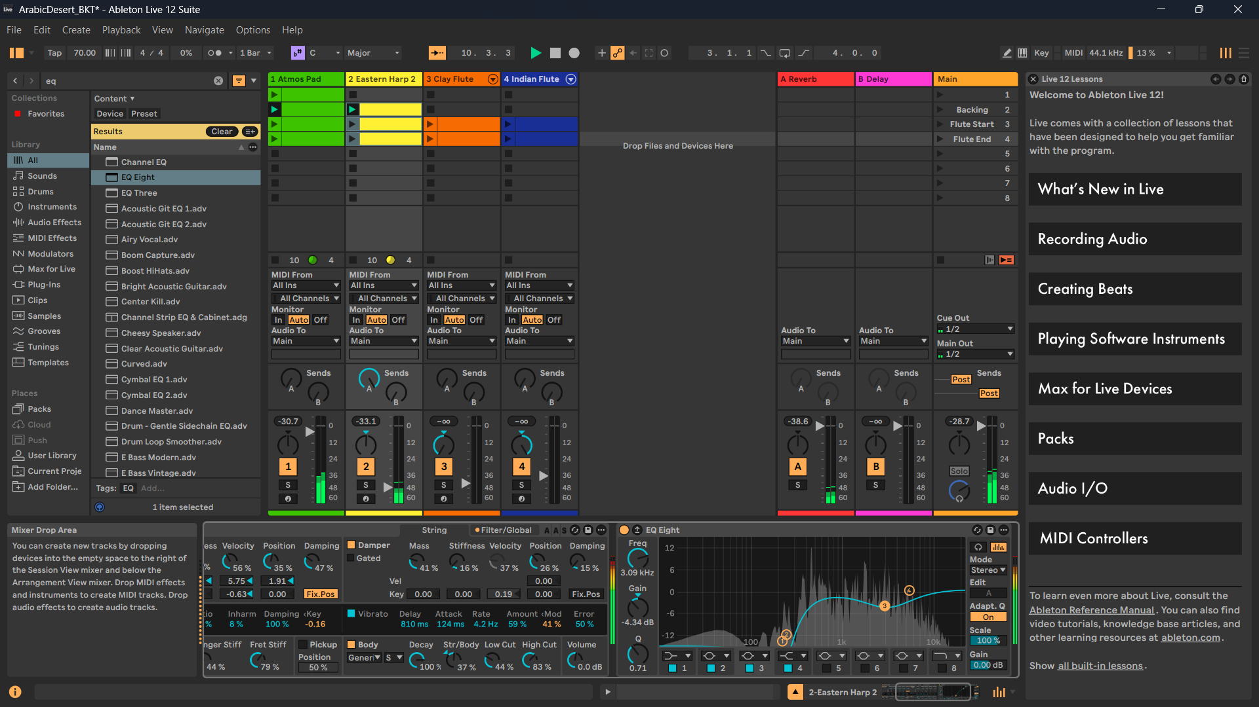
Figure 4: EQ Eight on Desert Eastern Harp. The EQ helps the harp remain clear while leaving space for other melodic and atmospheric layers.

2. Spectrum Analysis
What I did: I used Ableton Spectrum to examine the overall frequency balance of the mix. This helped me see whether bass, drums, pads and melodic instruments were occupying the correct frequency areas. The analyser was used after applying EQ so I could check that the mix was not overly crowded in one frequency range.
Reasoning: Using Spectrum helped confirm that the low end was mainly occupied by bass and percussion, while the pads and melodies were more present in the mid and high ranges. This supports a cleaner mix and makes the backing music easier to integrate into FMOD and the game engine.

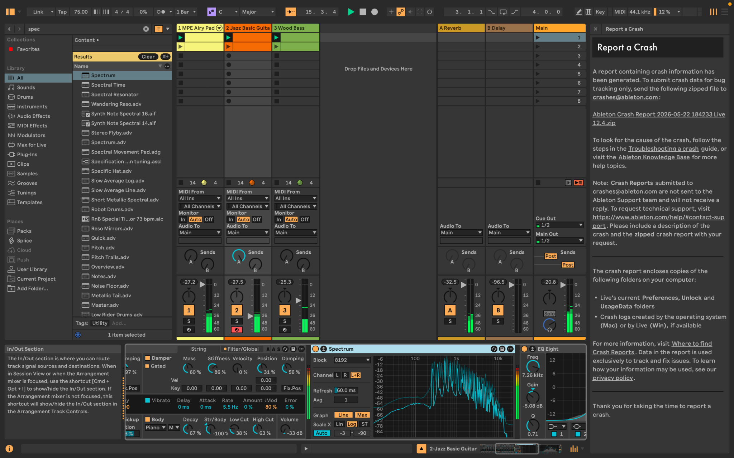
Figure 5: Spectrum analyser showing the frequency content of the Forest backing track.

3. Routing with Return Tracks
What I did: I used return tracks to route several instruments to shared effects. Return A was used for Reverb and Return B was used for Delay. The send knobs on the instrument tracks control how much signal is sent to each return. This method is cleaner than placing separate reverb and delay devices on every track.
Reasoning: The Reverb return creates a shared sense of space across the forest, desert and combat states. The Delay return adds subtle echo and distance to melodic instruments. I kept bass and drum sends low to avoid muddying the mix, while pads, flutes, harp, horns and strings received more ambience where appropriate.

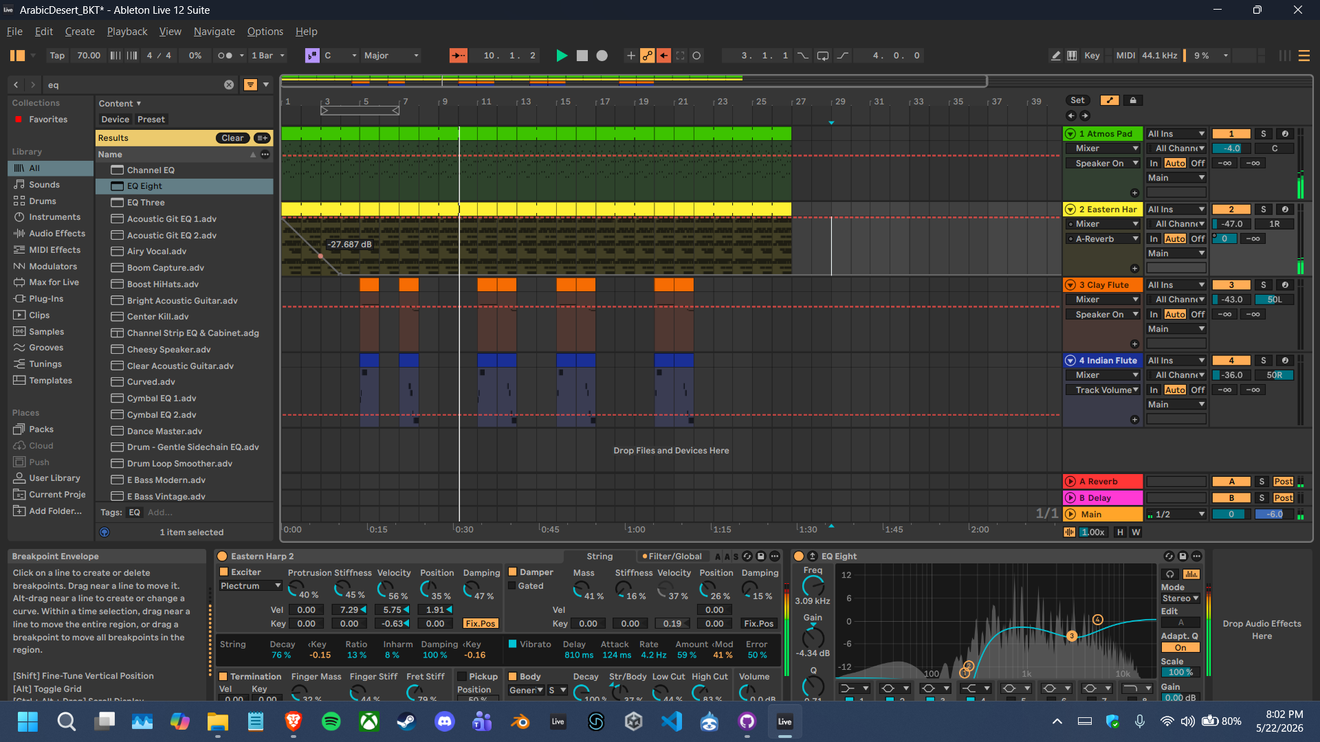
Figure 6: Return A Reverb and Return B Delay visible in the Desert project, with sends used for routing.

4. Sidechain Compression
What I did: I placed Ableton Compressor on the Combat Dark Bass track and enabled sidechain input from the combat drum track. In this setup, the compressor affects the Dark Bass, while the drum track acts as the trigger. The screenshot shows the sidechain source set to the DS Drum Rack, with the threshold around -20 dB and a 4:1 ratio.
Reasoning.: This ducking is appropriate for the combat state because drum and bass music contains strong kick drums and heavy bass. Without sidechain compression, the kick and bass can fight for the same low-frequency space. By ducking the bass slightly when the kick/drum hits, the rhythm becomes clearer and the combat mix feels punchier.

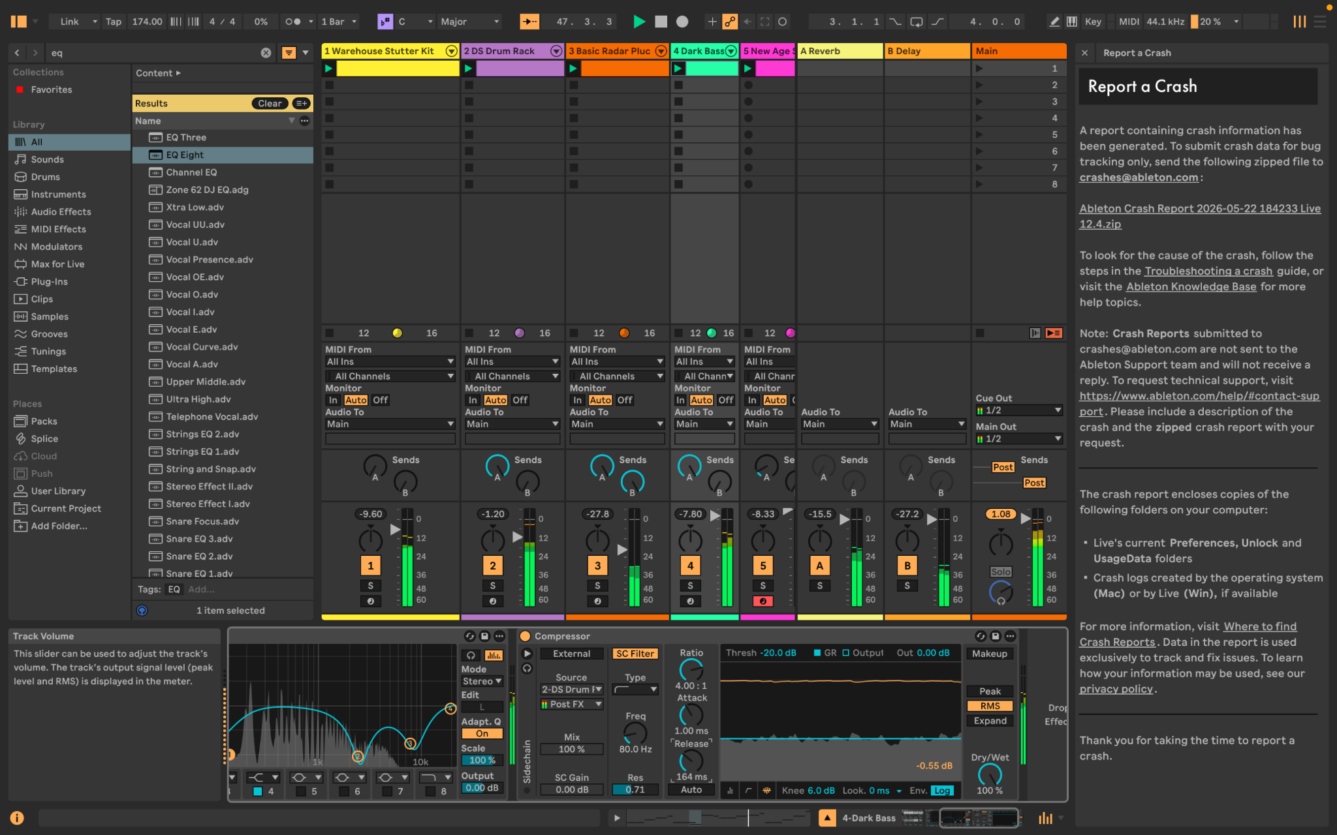
Figure 7: Compressor on Combat Dark Bass with sidechain input from the combat drum track.

5. Additional Audio Effects
Reverb: Reverb was used through Return A to create space and atmosphere, especially for pads, harp, flute, choir, strings and horns.
Delay: Delay was used through Return B to add echo and movement to melodic material, especially in the desert state where a more spacious sound was needed.
Auto Filter: Auto Filter was used on the Forest MPE Airy Pad. This allowed the pad tone to be shaped and later automated so the forest atmosphere could slowly open and become brighter over time.
Roar: Roar was used on the Combat Dark Bass to add harmonic distortion and aggression. This made the combat state feel more intense and threatening compared with the calmer exploration states.

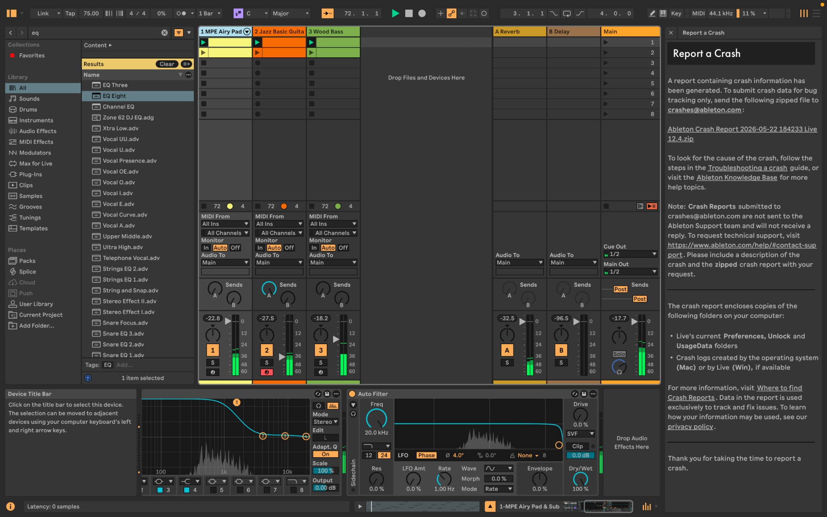
Figure 8: Auto Filter on the Forest MPE Airy Pad.
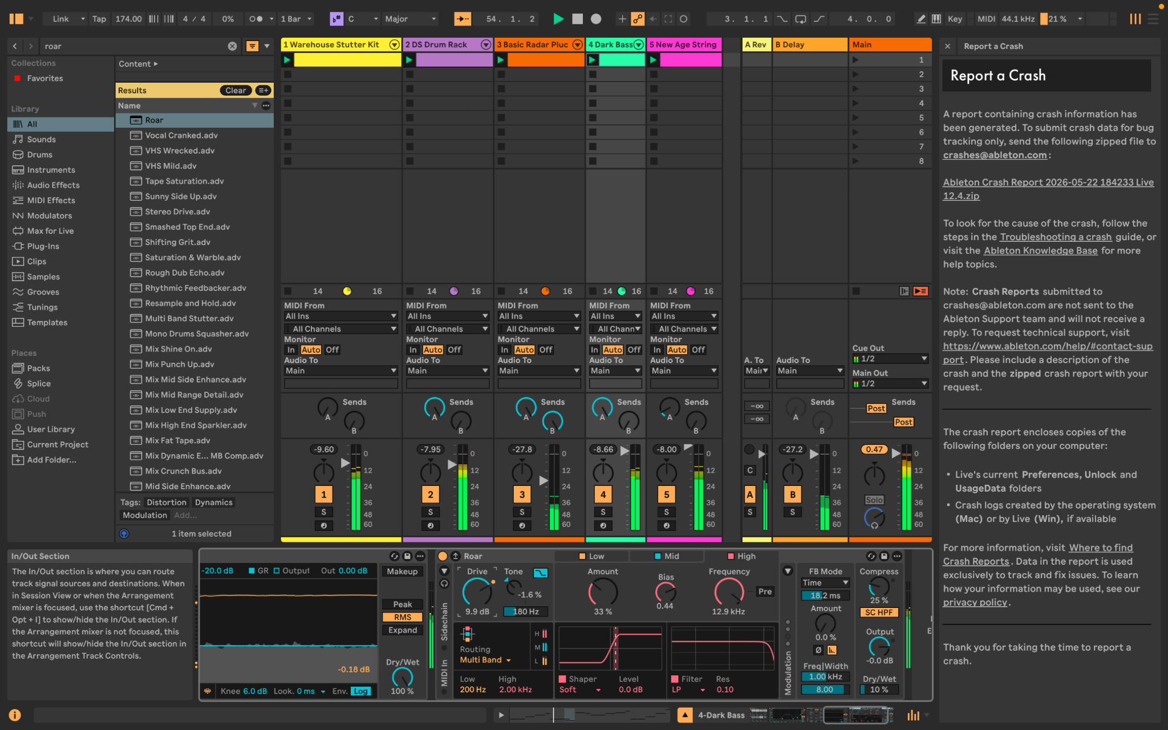
Figure 9: Roar added to Combat Dark Bass to strengthen the aggressive combat tone.

6. Automation
What I did: I created automation in Arrangement View so that the mix changes over time instead of remaining static. These automations support gameplay changes by making exploration feel more open and combat feel more intense.

Automation | Track/Parameter | Purpose | Gameplay meaning
Automation 1 | Forest MPE Airy Pad Auto Filter Frequency | The filter frequency opens across the forest section. | Makes the forest atmosphere feel more alive and less static.
Automation 2 | Desert Eastern Harp Reverb  send | The harp is sent more strongly to the reverb return. | Creates a wider and more spacious desert feeling.
Automation 3 | Desert Eastern Harp Volume/mix movement | The harp level changes over the phrase. | Controls how the desert melody enters and sits in the mix.
Automation 4 | Combat Dark Bass Roar  Drive | The distortion drive increases during combat. | Makes the combat state become more aggressive and energetic.

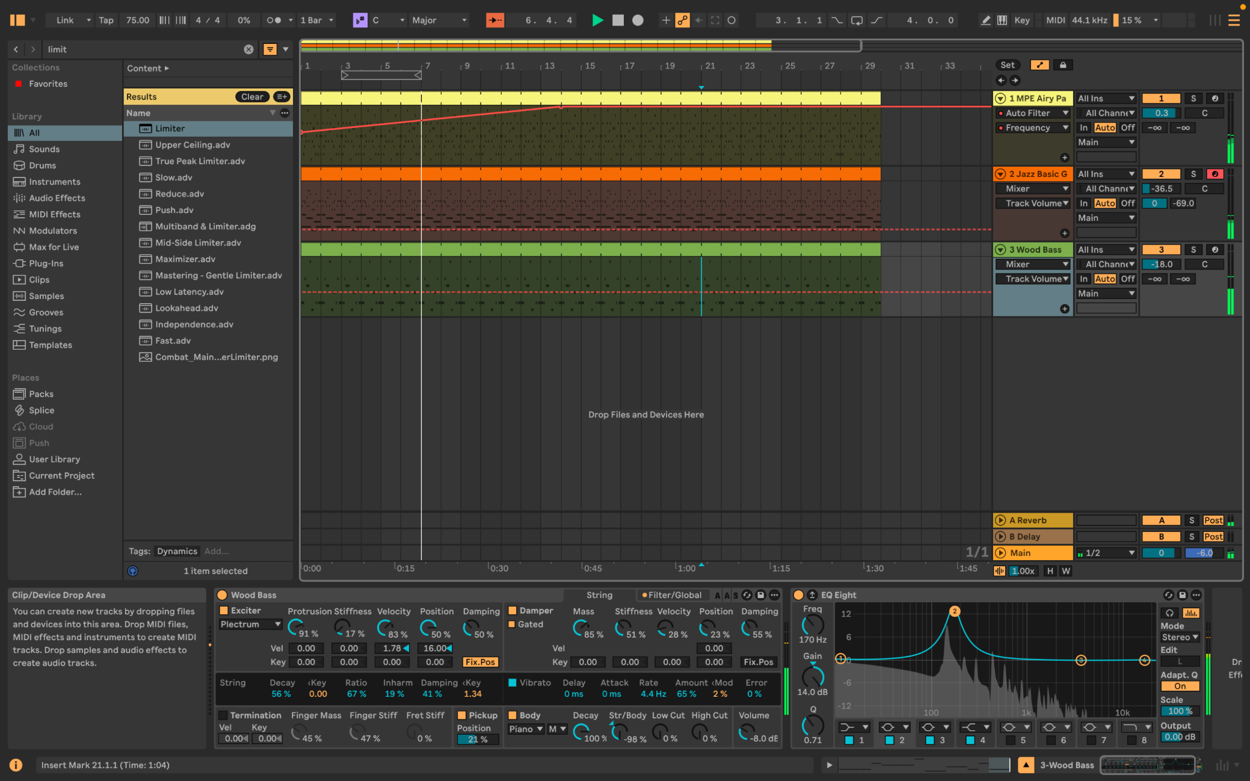
Figure 10: Automation of the Forest MPE Airy Pad Auto Filter frequency.

Figure 11: Automation of the Desert Eastern Harp reverb send/routing.
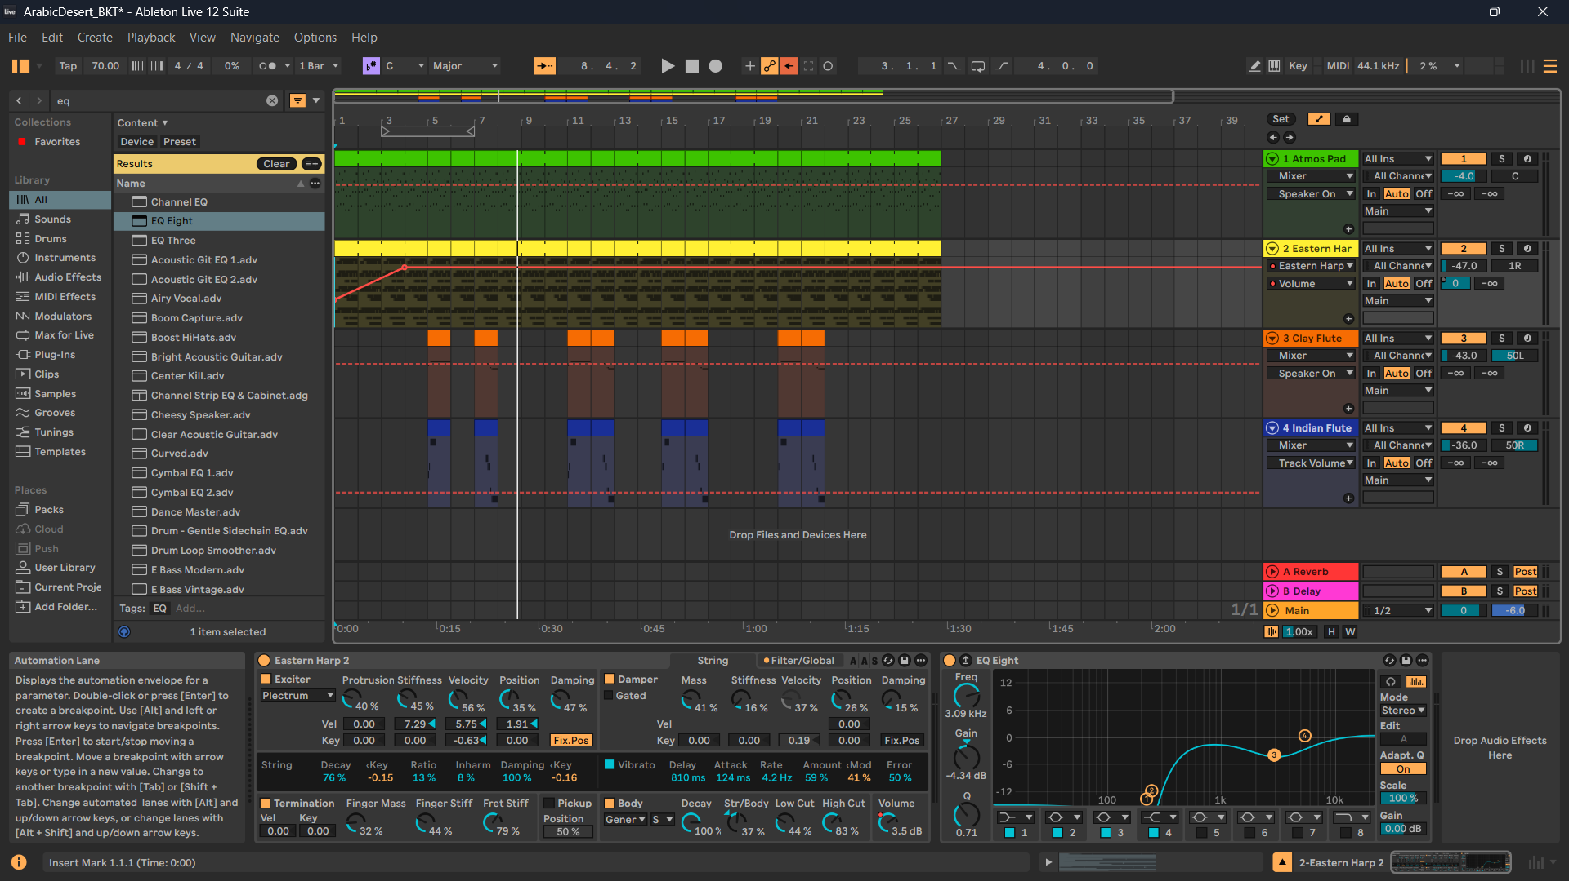
Figure 12: Automation of the Desert Eastern Harp volume/mix movement.
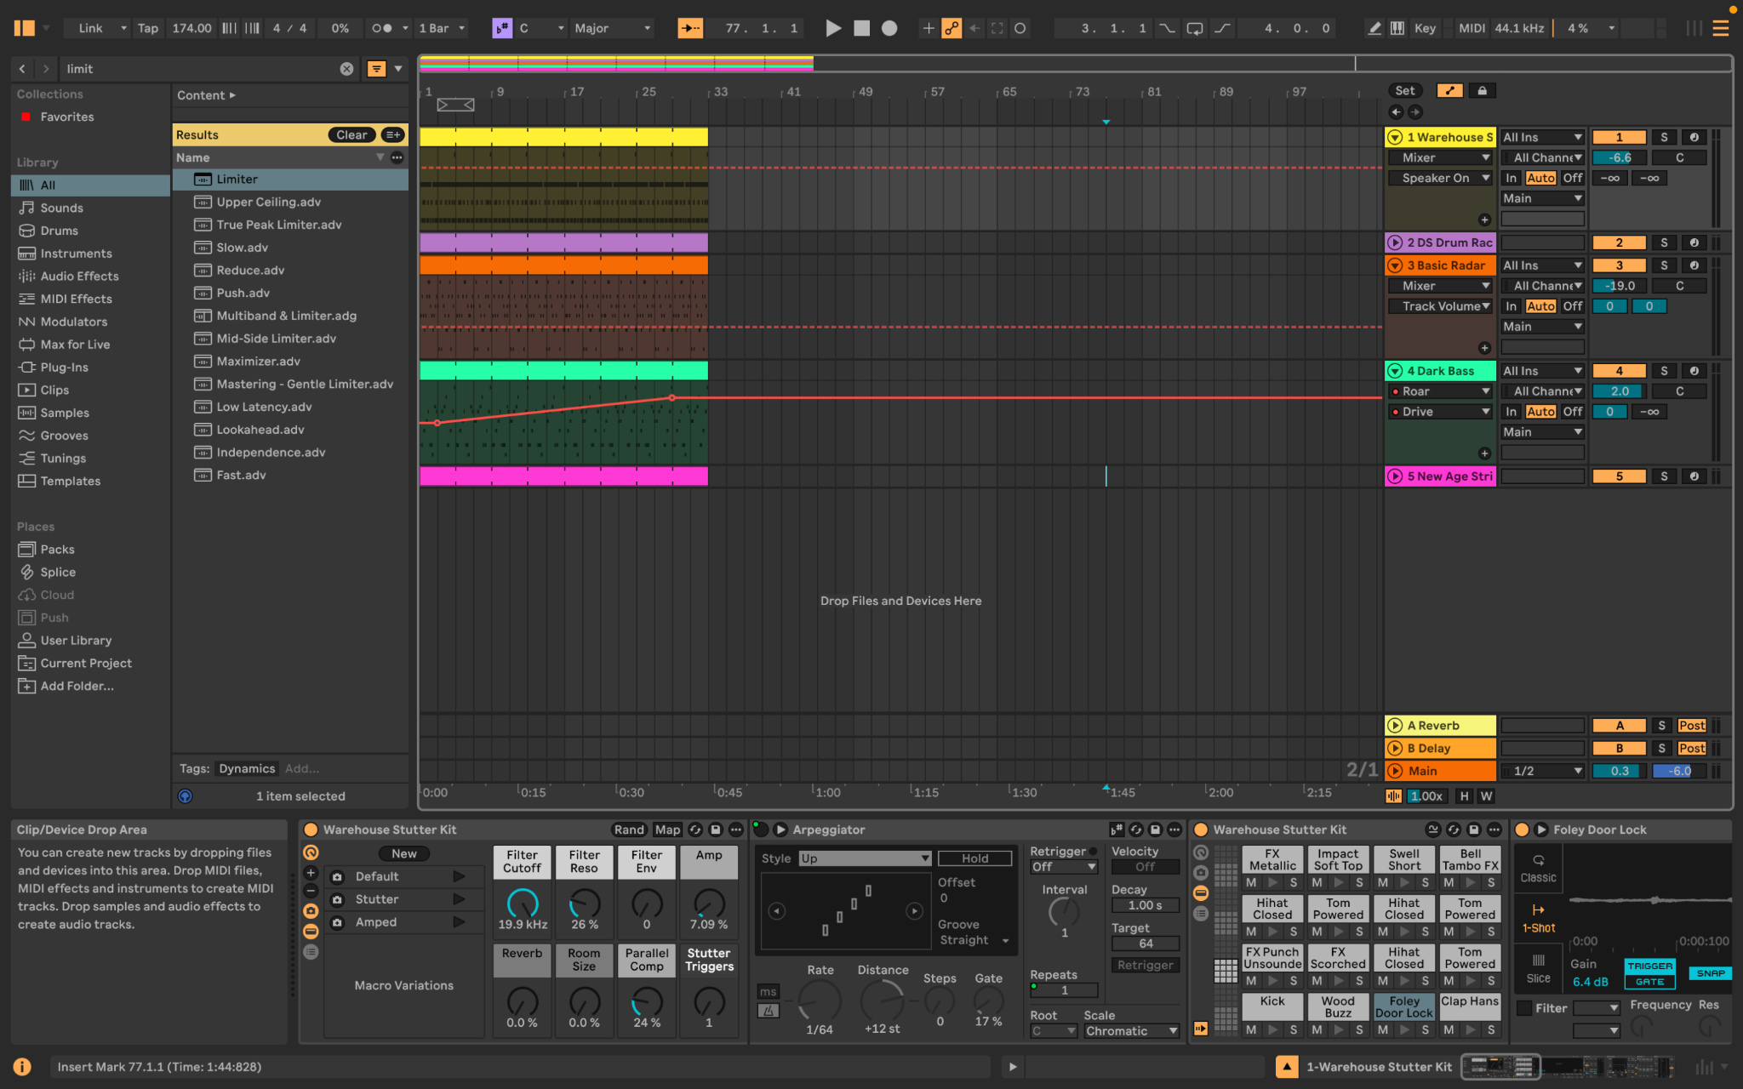
Figure 13: Automation of Combat Dark Bass Roar Drive to increase intensity.

7. Master Limiting and Dynamics
What I did: I added a Limiter to the Main/Master track and checked the output during playback. This was done to prevent clipping and to make sure the overall mix stayed controlled. The master fader was kept at 0 dB while the limiter and track levels were used to prevent the output from exceeding the required level.
Reasoning: The Combat state is the loudest and most dynamic part of the backing music because it includes drums, bass, pluck, horns and strings. The limiter prevents this section from clipping and keeps the final output safe for export and game implementation. The target was to keep the master output below -0.5 dB.
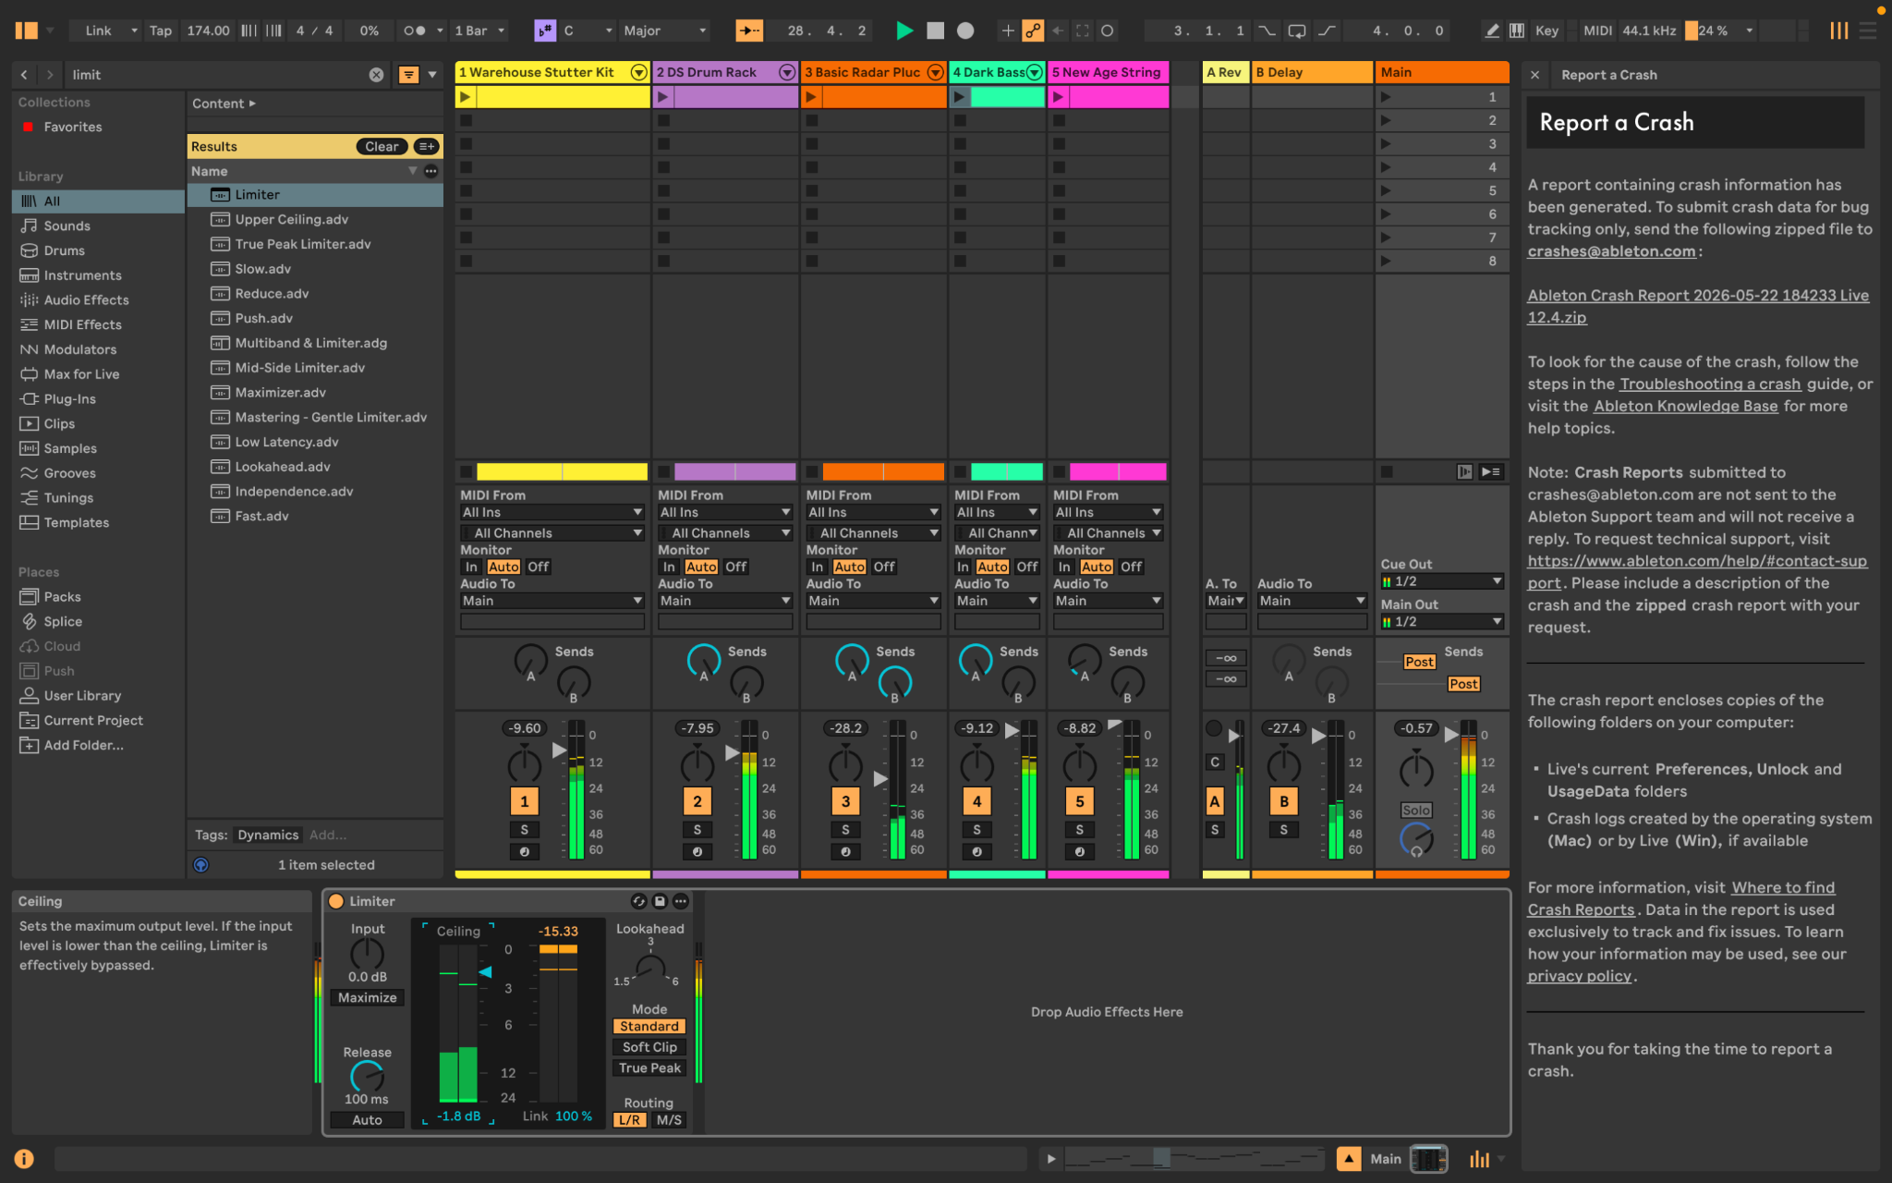
Figure 14: Limiter on the Main/Master track used to prevent clipping and keep the mix below the required peak level.

8. Conclusion
Summary: The Section C mixing work improved the backing music by cleaning frequency ranges with EQ, checking the spectrum, routing shared effects through return tracks, using sidechain compression to separate kick and bass in combat, applying additional effects such as Auto Filter and Roar, adding automation, and controlling the master output with a limiter. These choices support the adaptive music design by making each state sound clearer and by helping the Forest, Desert and Combat sections feel distinct while still being ready for FMOD integration.

