Sound Engineering – Section D
Marcello Bonello 6.3A DGD

1. Section D Requirements Addressed
Two separate Ableton Live SFX project was created, one was used to clean up the SFXs so they are prepared for processing. Each SFX was placed on its own labelled audio channel, at least one SFX sample was warped, audio effects were applied to all SFX, perceived loudness was balanced, and the processed files are prepared for export into FMOD.
Requirement | How it was addressed
Separate SFX Ableton project | Completed in a dedicated SoundEffects Ableton Live project.
Only SFX from the sound brief | The project contains Grass Footsteps, Sand Footsteps, Item Pickup, Enemy Agro Alert, Enemy Die, and Inventory Select.
Original SFX evidence | Untouched files should be kept in the original_sfx directory in the final submission.
Warping technique | Sand Footsteps was warped and stretched to fit the desert biome.
Effects on all SFX | EQ Eight, Utility, Auto Filter, Compressor, and return effects were used where appropriate.
Loudness balancing | Utility and track level adjustments were used to avoid sudden jarring differences between SFX.
Dynamic music write-up | Vertical remixing and horizontal re-sequencing are explained and justified for the game.

2. SFX Project Overview
The SFX work was completed in a separate Ableton Live project dedicated to in-game sound effects. The project contains the six sound effects listed in the sound brief, with one update: Weapon Select was changed to Inventory Select so it can represent selecting any item inside the inventory rather than only changing weapons. Each sound effect is placed on its own clearly labelled audio track, making it easy to process, balance and export each cue individually for FMOD.

# | SFX | Description | In-game trigger
1 | Grass Footsteps | Soft footstep on grass/leaves | Player walks in forest biome
2 | Sand Footsteps | Dry muffled footstep on sand | Player walks in desert biome
3 | Item Pickup | Small magical collect sound | Player collects an item
4 | Enemy Agro Alert | Short tension or alert sound | Enemy detects player or combat starts
5 | Enemy Die | Impact or creature defeat sound | Enemy is hit or defeated
6 | Inventory Select | Short UI / item selection sound | Player selects an item in the inventory

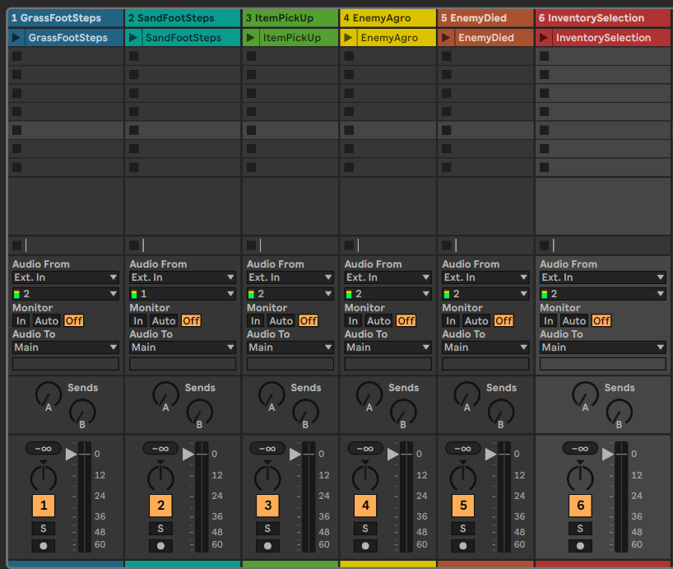

Figure 1 - Six labelled SFX audio channels in the separate Ableton SFX project (before clean)

3. Original SFX Folder
An original_sfx folder should be included in the final submission. This folder contains untouched copies of every source sound before Ableton processing. This is important because it allows the unprocessed source material to be compared with the edited SFX used in the final project.
- Grass_Footsteps_original.wav
- Sand_Footsteps_original.wav
- Item_Pickup_original.wav
- Enemy_Agro_Alert_original.wav
- Enemy_Die_original.wav
- Inventory_Select_original.wav

4. Warping Technique
Warping was applied to the Sand Footsteps SFX. Warp mode was enabled and the timing of the clip was stretched so that the footsteps became slower and softer. This supports the desert biome because movement across sand should sound more muffled and less sharp than movement across grass or hard ground. After warping, additional EQ and filtering were applied to reduce harsh high frequencies and make the sound feel drier.
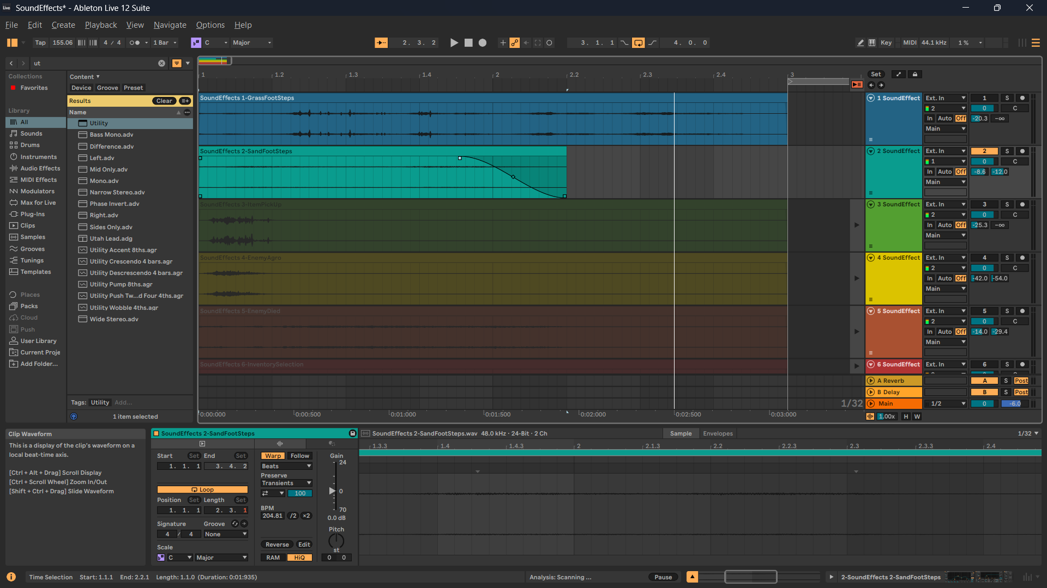
Figure 2 - Sand Footsteps with Warp enabled and the clip stretched for a slower, softer desert footstep feel.

5. SFX Processing and Effects
Each SFX was processed using Ableton audio effects to improve clarity, match the fantasy game setting, and create a more consistent sound package. EQ Eight was used across the SFX to remove unwanted low rumble or harsh frequencies. Utility was used to adjust gain and stereo width, helping the sounds sit at an appropriate level. Additional processing such as Auto Filter and Compressor was used where it suited the sound.
SFX | Processing used | Purpose
Grass Footsteps | EQ Eight, Utility, light reverb send | Low rumble was reduced and the sound was balanced so repeated footsteps stay clear without becoming distracting.
Sand Footsteps | Warp, EQ Eight, Auto Filter, Utility | Warping and filtering made the footsteps slower, softer and more muffled to match movement on sand.
Item Pickup | EQ Eight, Utility, reverb/delay send | The pickup cue was shaped to sound small, clear and slightly magical without overpowering gameplay.
Enemy Agro Alert | EQ Eight, Utility, reverb send | The alert was made more noticeable and tense so the player clearly understands that combat or enemy detection has started.
Enemy Die | EQ Eight, Utility, Compressor, reverb send | Compression controlled the impact and made the death sound more consistent while keeping it powerful.
Inventory Select | EQ Eight, Utility | The selection sound was kept short and clear so it works as a frequent UI / inventory feedback cue.

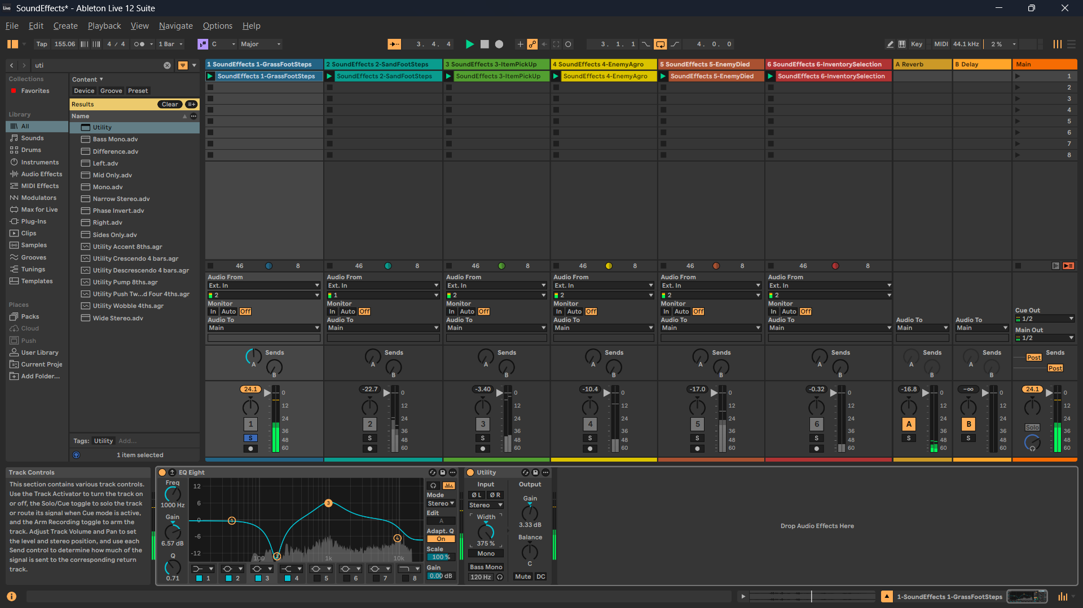
Figure 3 - Grass Footsteps processed with EQ Eight and Utility for low-end cleanup and level control.

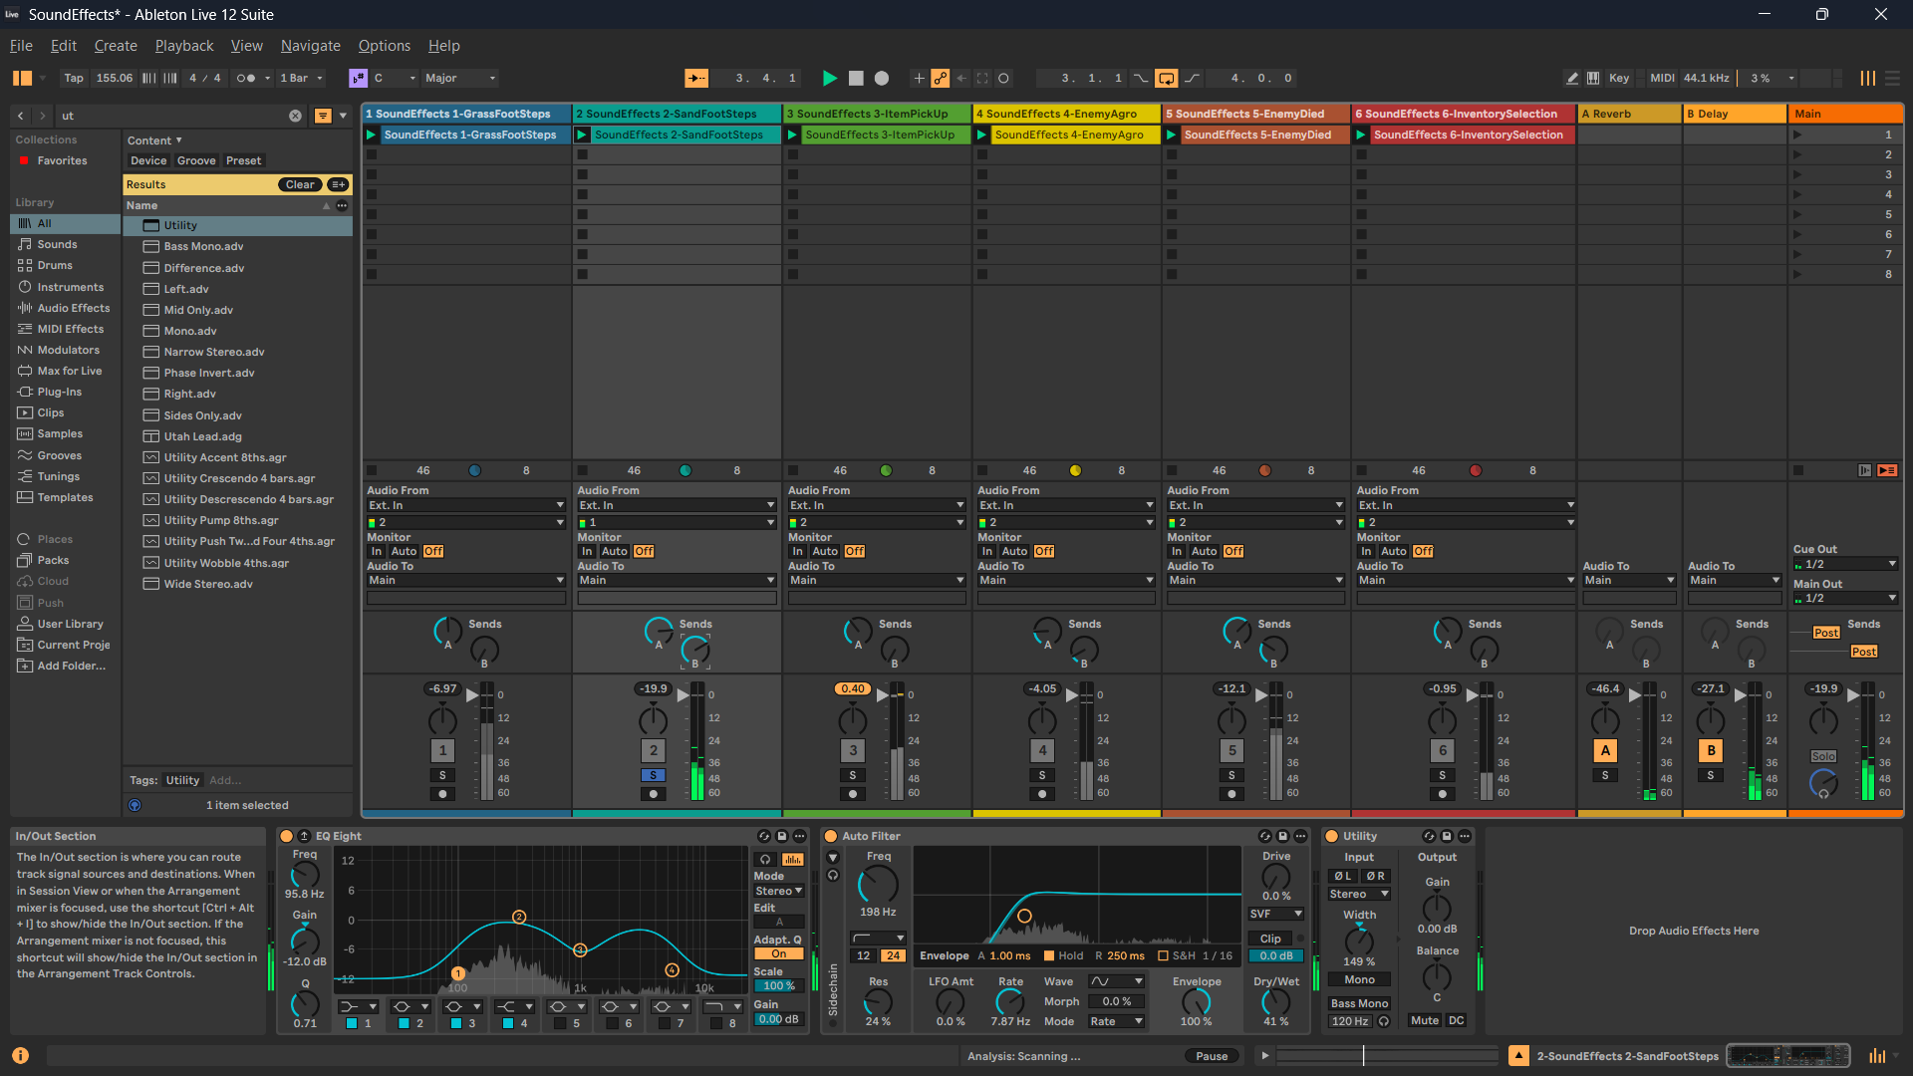
Figure 4 - Sand Footsteps processed with EQ Eight, Auto Filter and Utility after warping.
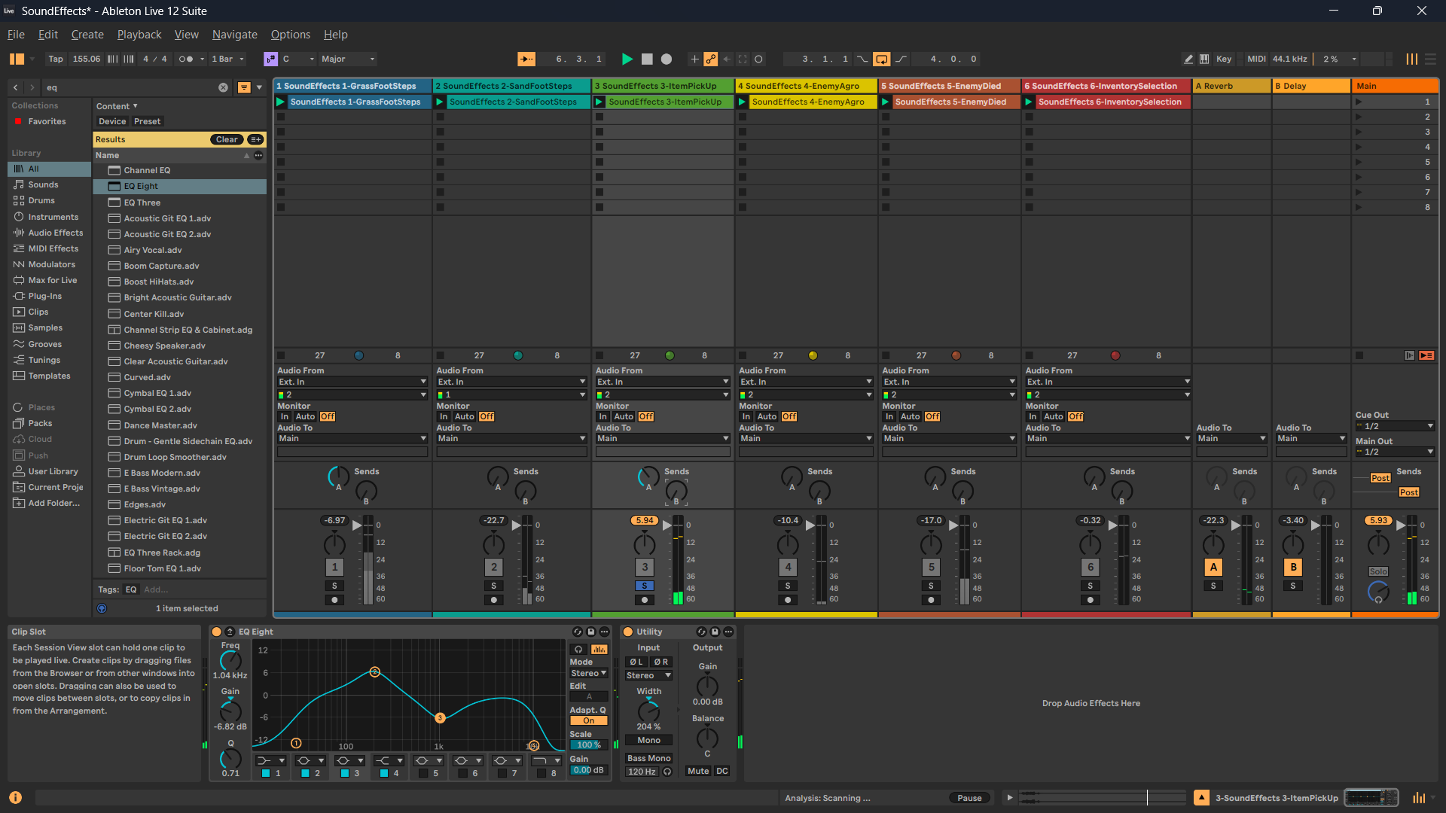
Figure 5 - Item Pickup processed with EQ Eight and Utility for clarity and volume balancing.

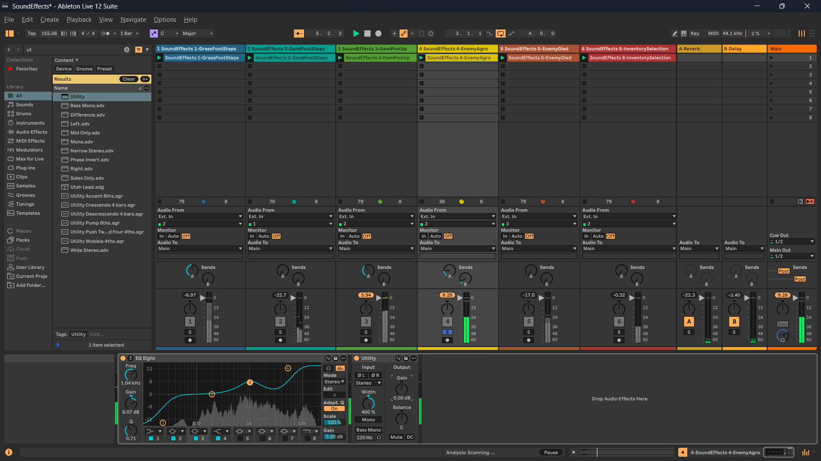
Figure 6 - Enemy Agro Alert processed with EQ Eight and Utility to make the alert clearer.
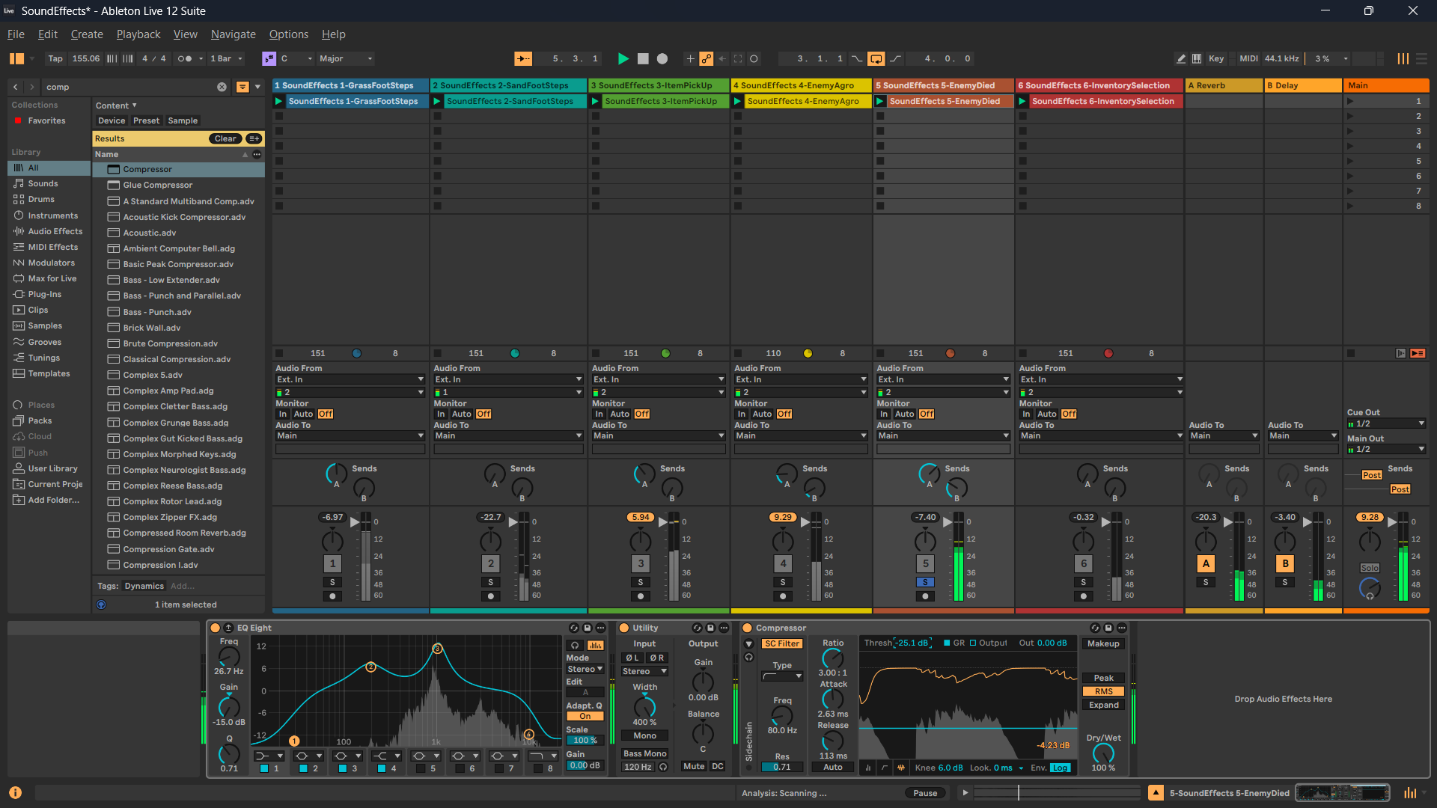
Figure 7 - Enemy Die processed with EQ Eight, Utility and Compressor to control the impact.

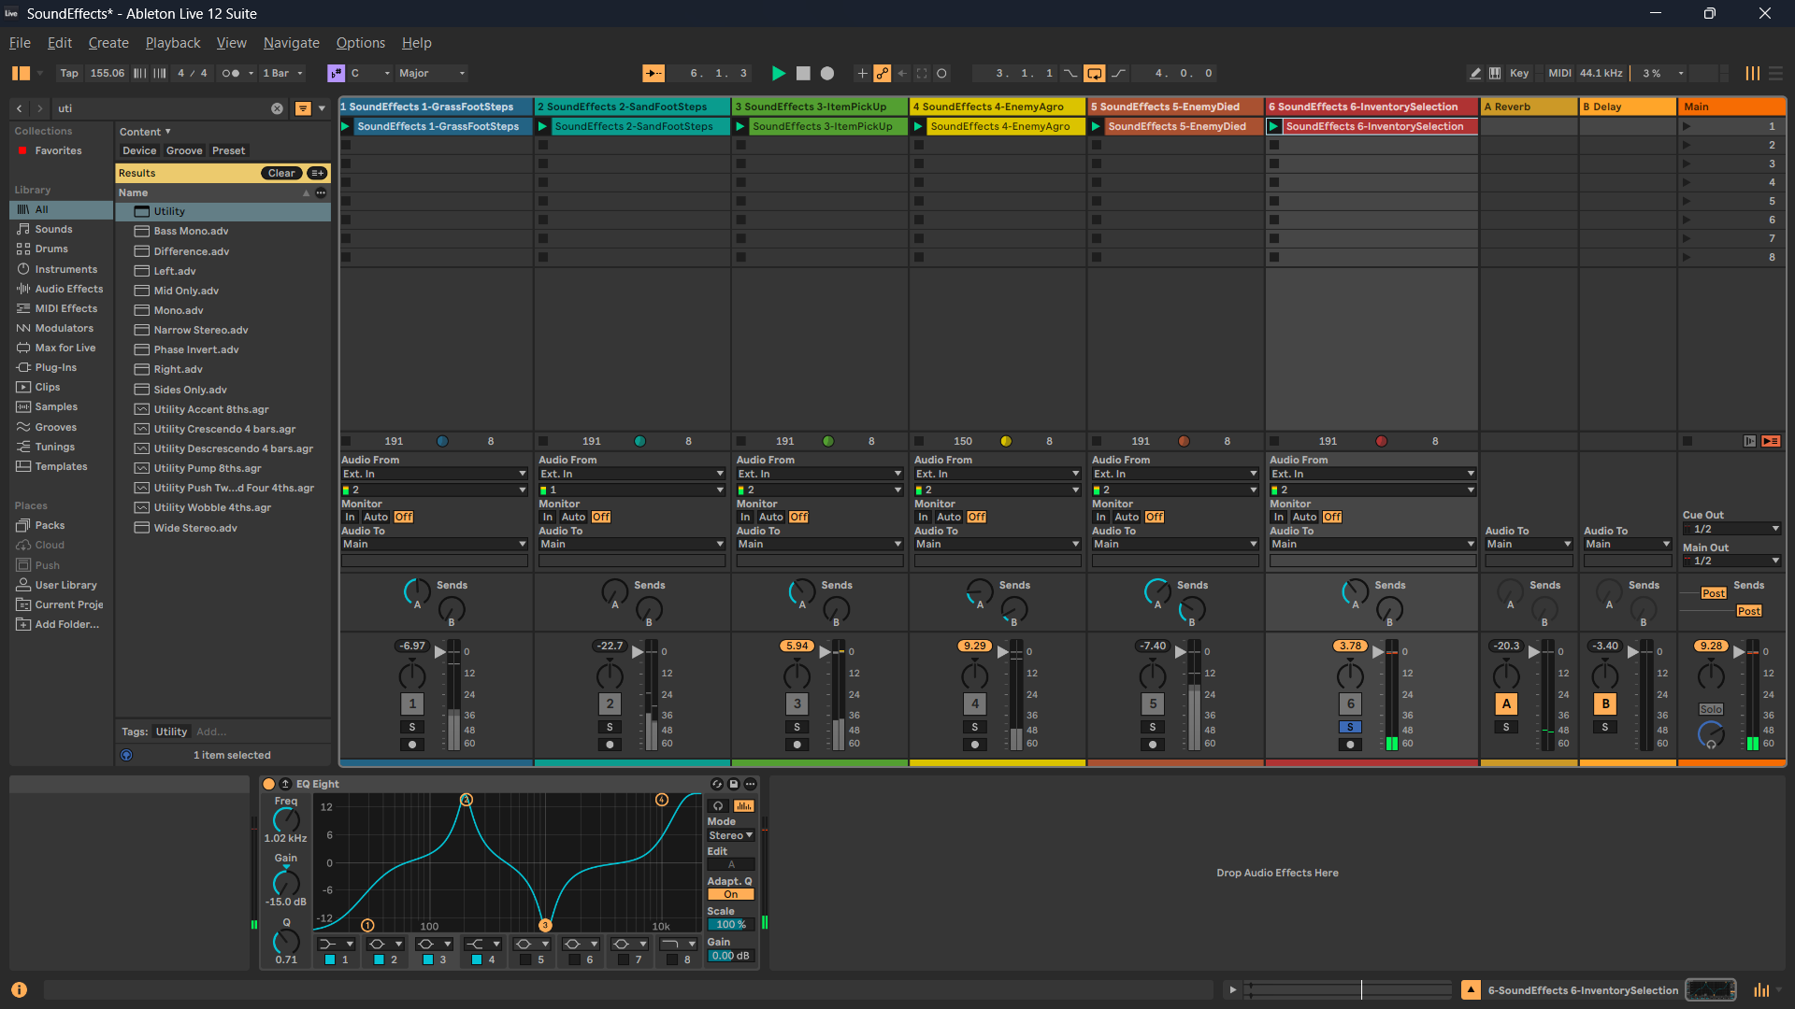
Figure 8 - Inventory Select processed with EQ Eight for a short, clear selection cue.

6. Loudness Balancing
Perceived loudness was balanced using track volume and Utility. The aim was not to make every sound identical in volume, but to make the package feel controlled in context. Repeated sounds such as footsteps and inventory selection were kept quieter so they do not become tiring during gameplay. Important feedback sounds such as Enemy Agro Alert and Enemy Die were allowed to be louder because they communicate more important gameplay events.
SFX type | Relative loudness decision | Reason
Footsteps | Quiet to medium | They occur often during movement and should support gameplay without dominating the mix.
Inventory Select | Quiet to medium | It is a frequent UI-style sound and should remain short and non-intrusive.
Item Pickup | Medium | It should be clearly heard as positive feedback when collecting an item.
Enemy Agro Alert | Medium to loud | It signals a change in danger state and must be noticeable.
Enemy Die | Loudest but controlled | It marks a successful combat result and benefits from stronger impact.

7. Game Setting and Design Decisions
QuestForCastle is a 2D top-down fantasy prototype with two contrasting biomes: forest and desert. The SFX package supports exploration, item collection, inventory interaction and combat feedback. Natural sounds such as footsteps are used for movement feedback, while more exaggerated or processed sounds are used for item pickup, enemy detection and enemy death. This helps the player understand gameplay events clearly while still matching the fantasy adventure setting.
Grass Footsteps are designed to be softer and organic, matching leaves and natural ground in the forest biome. Sand Footsteps are drier and more muffled, matching the desert biome. Item Pickup uses a clearer, brighter sound to communicate reward and collection. Enemy Agro Alert is sharper and more tense so the player understands that danger has started. Enemy Die uses compression and level control to create stronger impact without becoming too harsh. Inventory Select is kept short and clear so it works for repeated item selection.

8. Vertical Remixing and Horizontal Re-sequencing
Horizontal re-sequencing means changing between different musical sections depending on gameplay. In this project, horizontal re-sequencing is used when the player moves between the Forest, Desert and Combat states. For example, entering the forest area triggers the calm forest music, entering the desert area triggers the Middle Eastern ambient desert music, and entering combat triggers the faster medieval fantasy drum and bass combat music.
Vertical remixing means changing music intensity by adding or removing layers while the same section continues playing. Instead of jumping to a completely different piece of music, FMOD can fade in extra layers such as drums, bass, choir, horns or strings when the game becomes more intense. This is useful for combat because the music can become more powerful without restarting or breaking the flow.
This project uses a combination of both methods. Horizontal re-sequencing is suitable because the game has clearly different biomes and gameplay states. Vertical remixing is suitable because combat intensity can increase by layering additional musical elements. Together, these methods allow the soundtrack to respond to both location changes and gameplay intensity.

