Per-tenant observability: the basics
In 30 seconds All four signals (logs, metrics, traces and profiles) land in shared backends: Loki, Mimir, Tempo and Pyroscope. Each backend keeps tenants apart, and each Grafana organization sees exactly the tenants the platform gave it: our Tenant A org sees tenant a and tenant c (tenant a uses tenant c's services), Tenant B sees only tenant b, and the platform team sees everything. The catch: none of the backends checks who is asking, so the platform decides the tenants at every step.
Which gateway? On this page, "the gateway" means obs-gateway: an internal kgateway Gateway that turns an API key into a tenant. It is separate from the ingress Gateways of part 1, but runs on the same kgateway controller. Grafana itself is published through the platform's ingress Gateway.

The picture
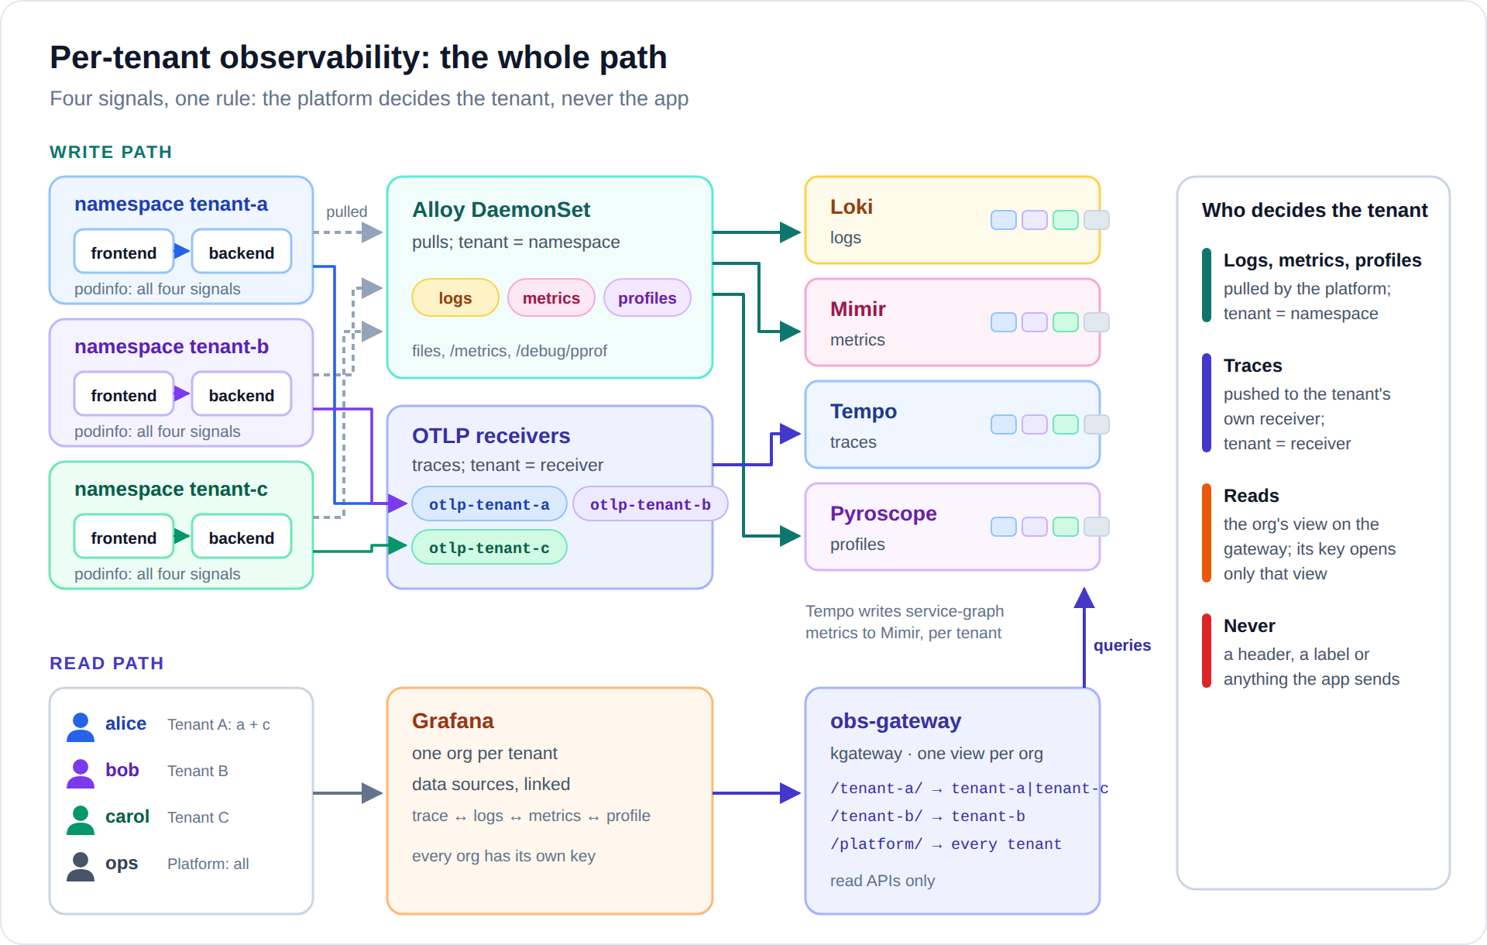
Diagram: images/obs-overview.svg (or .png)
- Write path: the platform collects logs, metrics and profiles itself. Apps push only traces, and only to their tenant's own receiver. Data always lands in the tenant that produced it.
- Read path: a user logs into Grafana, lands in their organization, and every query goes through that org's view on the gateway. The view is a path, opened only by that org's API key, and it decides which tenants the backends are asked for.
- Backends: Loki, Mimir, Tempo and Pyroscope store and search every tenant separately, and the first three can answer for several tenants in one query.

The Grafana stack in one minute
Signal | Backend | Collected by | Tenant decided by
Logs | Loki | Alloy reads container log files on each node | the namespace name
Metrics | Mimir | Alloy scrapes /metrics of pods that opt in | the namespace name
Profiles | Pyroscope | Alloy scrapes /debug/pprof of pods that opt in | the namespace name
Traces | Tempo | the app pushes OTLP to its tenant's receiver | which receiver the pod can reach

All four backends are multi-tenant the same way: every write and every query carries an HTTP header, X-Scope-OrgID, that names the tenant. One switch each turns it on:
loki: auth_enabled: true # logs
mimir: multitenancy_enabled: true # metrics
tempo: multitenancy_enabled: true # traces
pyroscope: -auth.multitenancy-enabled # profiles

The catch: every backend believes the header
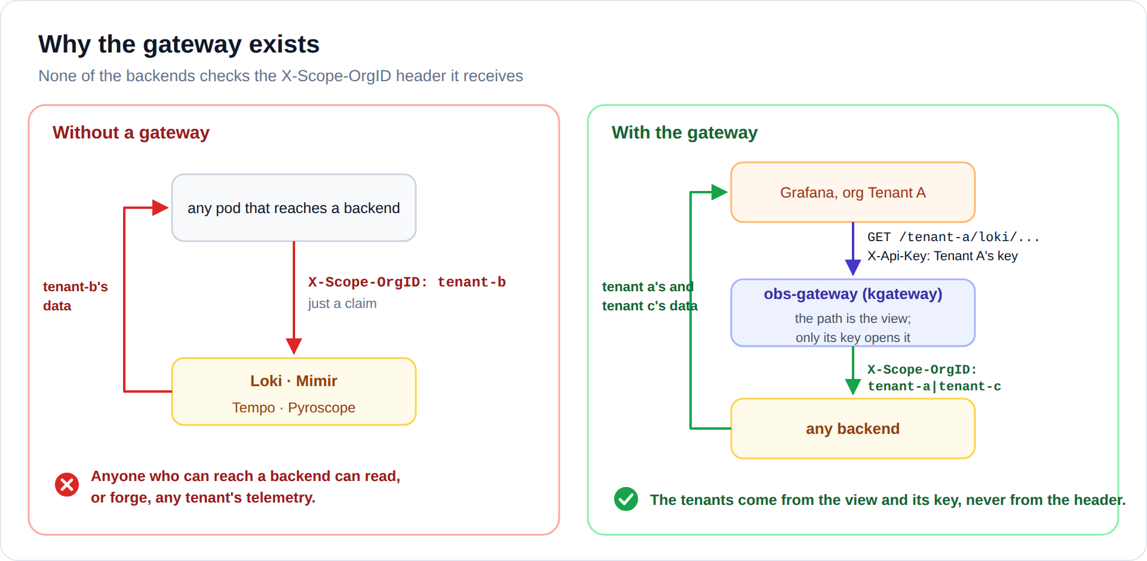
Diagram: images/obs-gateway.svg (or .png)
None of the backends authenticates anyone. X-Scope-OrgID is just a claim, so anything that can reach a backend could claim to be tenant-b and read its data, or write fake data into tenant-a. That is why users never talk to the backends directly. Every query goes through obs-gateway, a kgateway Gateway, on a path that belongs to one Grafana org. The path (the view) sets the header, and only that org's key opens it:
# the route for Tenant A's view: /tenant-a/loki/... -> Loki, as tenant-a|tenant-c
filters:
- type: RequestHeaderModifier # SETS it: whatever the caller sent is replaced
requestHeaderModifier:
set: [{name: X-Scope-OrgID, value: "tenant-a|tenant-c"}]
- type: URLRewrite # strip the view before forwarding
urlRewrite:
path: {type: ReplacePrefixMatch, replacePrefixMatch: /loki/api/v1}

# the policy on that route: only Tenant A's key opens it
apiKeyAuth:
secretRef: {name: obs-key-tenant-a}
keySources: [{header: X-Api-Key}]
forwardCredential: false # the key never reaches the backends
So Tenant B's key on /tenant-a/... gets 401, and a caller that adds its own X-Scope-OrgID gets it overwritten. Envoy normalizes paths first, so /tenant-a/../tenant-b/... is /tenant-b/..., which Tenant A's key does not open. That matters because Grafana Editors can send arbitrary paths through a data source.

Logs, metrics, profiles: pulled by the platform
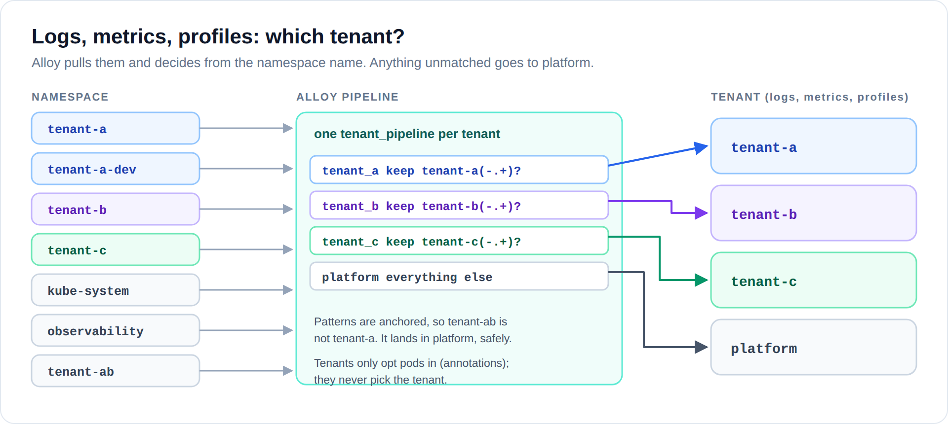
Diagram: images/obs-mapping.svg (or .png)
Tenants never send these signals anywhere. Alloy, one per node, reads the log files from the node's disk and scrapes the pods that opted in. It picks the tenant from the namespace name, which only the platform team controls. Anything that does not match a tenant goes to platform, never to another tenant. Each tenant is one block in Alloy's configuration:
tenant_pipeline "tenant_a" {
id = "tenant-a" // written to Loki, Mimir and Pyroscope
keep = "tenant-a(-.+)?" // the namespaces that are tenant a
...
}

Traces: one receiver per tenant
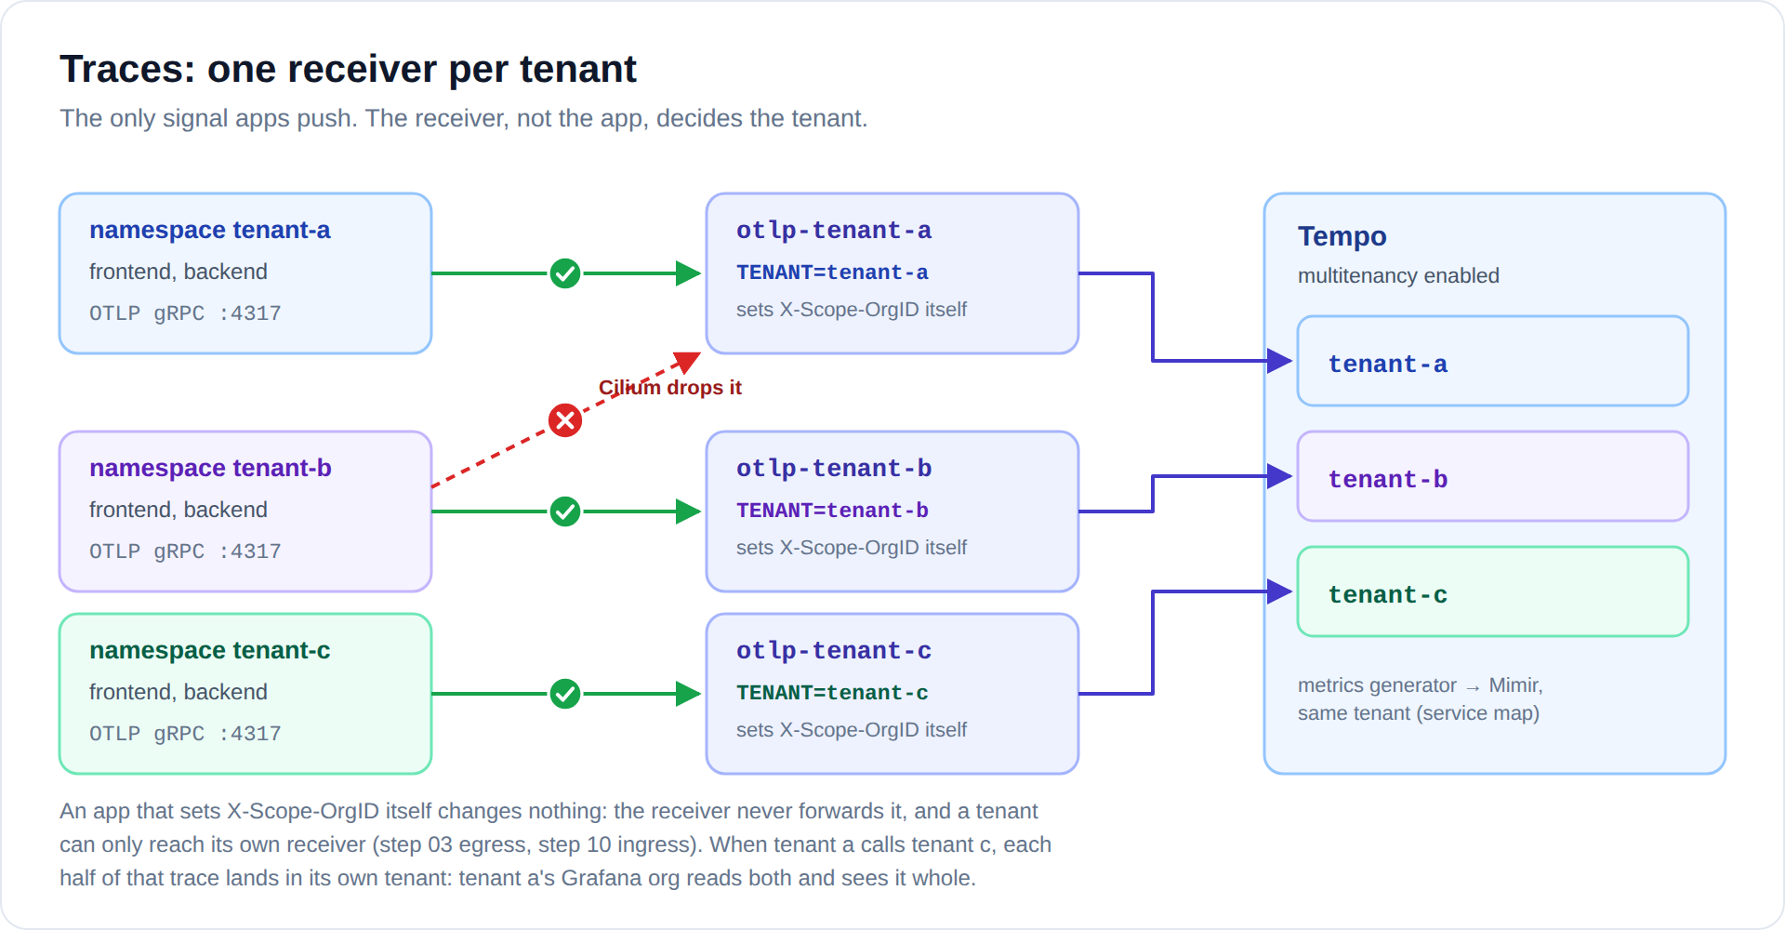
Diagram: images/obs-traces.svg (or .png)
Traces are the one signal apps must push. If apps pushed straight to Tempo, they could put any tenant in the header. Instead, each tenant gets its own small receiver. The receiver sets the tenant from its own configuration and ignores anything the app sends. Cilium lets only tenant a's pods reach otlp-tenant-a:
otelcol.exporter.otlp "tempo" {
client {
endpoint = "tempo.observability.svc.cluster.local:4317"
headers = { "X-Scope-OrgID" = sys.env("TENANT") } // set per receiver, never by the app
}
}

Grafana: one organization per tenant
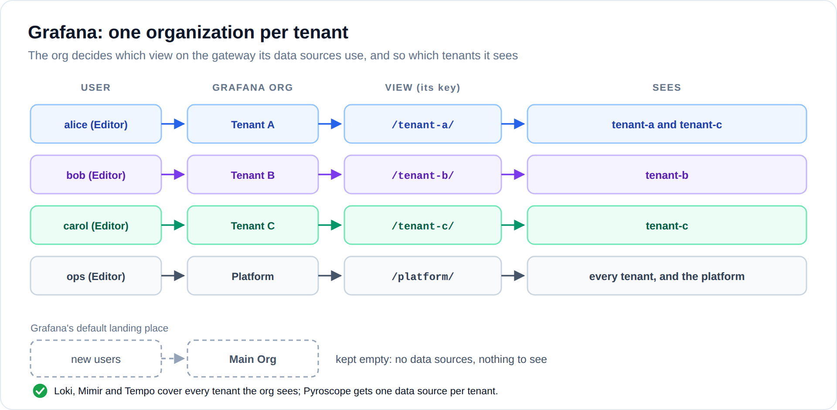
Diagram: images/obs-grafana-orgs.svg (or .png)
Org | User | View | Sees
Tenant A | alice | /tenant-a/ | tenant-a and tenant-c
Tenant B | bob | /tenant-b/ | tenant-b
Tenant C | carol | /tenant-c/ | tenant-c
Platform | ops | /platform/ | every tenant, and the platform's own

Grafana organizations are separate worlds: each has its own data sources and dashboards. Each org's data sources call its own view with its own key, and are linked to each other:
- a span opens that service's logs, its metrics, and its CPU profile;
- a log line with a trace_id opens that trace;
- the service map comes from metrics Tempo generates from the tenant's own spans.
Links only ever point inside the same org. Tenant users are Editors, never org Admins (an Admin could add a data source pointing at another view). The Main Org stays empty, because Grafana puts every new user there by default.
Pyroscope is different Loki, Mimir and Tempo answer one query for several tenants, so Tenant A gets one data source of each. Pyroscope takes one tenant per request, so Tenant A gets two: "Pyroscope" (tenant-a) and "Pyroscope (tenant-c)". For the same reason, Loki's live tail works in Tenant B's and Tenant C's orgs, but not where a view covers several tenants.

Workload example: podinfo
Each tenant runs the same small app, so the team can see all four signals end to end. Tenant a's frontend also calls tenant c's backend, which it is allowed to: that request's trace spans two tenants, and alice sees all of it while carol sees only tenant c's half.
Workload | What it does | Signals
frontend | podinfo; every /echo request calls the backend | logs, metrics, profiles, traces
backend | podinfo; answers the frontend | logs, metrics, profiles, traces
client | calls the frontend every few seconds, sometimes slow (/delay/1), sometimes failing (/status/500) | traffic

Two annotations opt a pod in to metrics and profiles, and two environment variables send its traces to its tenant's receiver:
metadata:
annotations:
prometheus.io/scrape: "true" # metrics (port 9898, /metrics)
profiles.grafana.com/scrape: "true" # profiles (port 9898, /debug/pprof)
env:
- name: OTEL_EXPORTER_OTLP_ENDPOINT # traces
value: http://otlp-tenant-a.observability.svc.cluster.local:4317
What alice sees in Grafana:
- Explore → Tempo → Search: traces of frontend calling backend, including the slow and failing ones.
- Open a span: Logs for this span jumps to the matching Loki lines; Profile opens the backend's CPU flame graph in Pyroscope.
- Explore → Mimir: rate(http_request_duration_seconds_count[5m]) by status code, only for tenant-a's pods.
- Tempo → Service graph: frontend → backend, with request rates and errors.
- Bob sees the same app, but only tenant-b's copy of it.

Locking it down
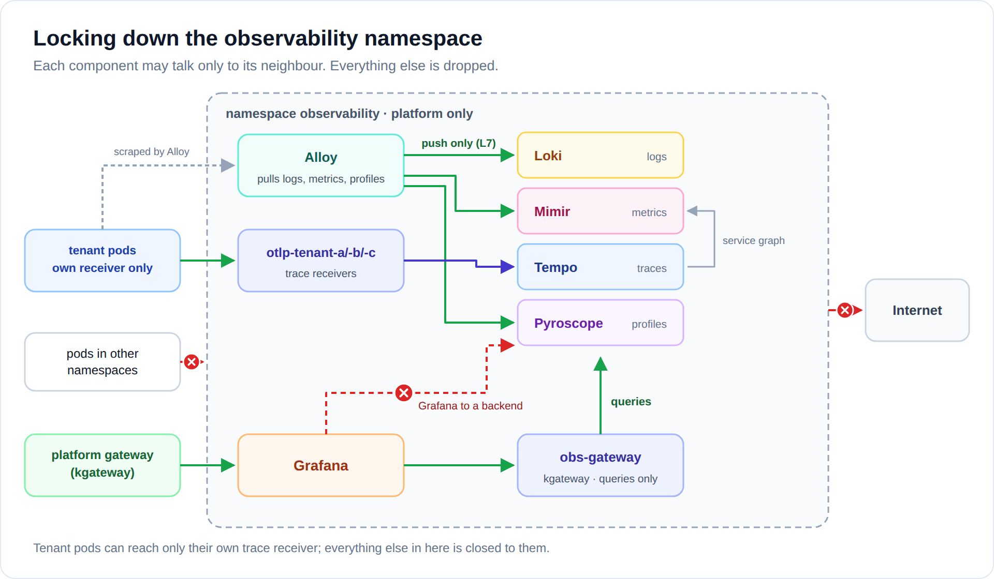
Diagram: images/obs-lockdown.svg (or .png)
The observability namespace gets its own Cilium policies. Only Alloy can write to Loki, Mimir and Pyroscope, and only to their push endpoints. Only the tenant receivers reach Tempo, each accepting only its own tenant. Only the gateway reaches the query APIs, and only Grafana reaches the gateway. Tenant pods can reach nothing here except their own receiver, and nothing in here reaches the internet.

Try it yourself
What we check | How | Expected
alice sees only tenant-a | Grafana → Explore, any data source | only tenant-a data
Header spoofing fails | Tenant A's view plus X-Scope-OrgID: tenant-b | tenant-a and tenant-c only
A key opens one view | Tenant A's key on /tenant-b/..., or on /tenant-a/../tenant-b/... | 401
Trace IDs don't leak | as tenant-b, open a trace ID taken from tenant-a | empty trace
Wrong receiver | from a tenant-a pod, send a span to otlp-tenant-b | connection dropped
Nobody reaches a backend directly | from a test pod, call Mimir or Tempo | timeout

FAQ
Can alice see tenant-b's data by writing a different query? No. Every query runs through her org's data sources, which use her org's view. That view asks the backends for tenant-a and tenant-c, and nothing else.
Why does alice see tenant c at all? Because tenant a uses tenant c's services, so tenant a's team needs tenant c's telemetry to debug its own requests. It is a platform decision, per direction: carol does not see tenant a.
What if alice knows a trace ID from tenant-b? Tempo looks it up only inside tenant-a, and returns an empty trace.
Where do kube-system logs and platform metrics go? To the platform tenant. Only the platform team's org can query it.
What happens when we add a new tenant namespace? Until its tenant_pipeline block and receiver exist, its logs, metrics and profiles land in platform: visible to the platform team, never to another tenant. Its traces go nowhere, because it has no receiver yet.
Can a tenant fake another tenant's telemetry? No. Logs, metrics and profiles are pulled by the platform. Traces can only reach the tenant's own receiver, which stamps its own tenant.
Does Grafana know every org's gateway key? Yes. The keys are stored encrypted in the data sources and never shown to users, but a compromised Grafana could read all tenants. That is a known trade-off of soft tenancy. If that is unacceptable, run one Grafana per tenant.

Glossary
Term | Meaning
Loki, Mimir, Tempo, Pyroscope | Grafana's backends for logs, metrics, traces and profiles.
Alloy | Grafana's collector. Here: one per node (logs, metrics, profiles), plus one small receiver per tenant (traces).
OTLP | OpenTelemetry's protocol for sending traces (and other signals).
X-Scope-OrgID | The HTTP header that tells a backend which tenant a request is for.
Tenant | A separate data space inside a backend: its own storage, its own queries. A query may name several (tenant-a|tenant-c), except in Pyroscope.
obs-gateway | An internal kgateway Gateway in front of the backends. Each Grafana org gets a path on it.
View | One org's path on obs-gateway: only that org's key opens it, and it sets which tenants the backends answer for.
Grafana organization | An isolated space in Grafana with its own users, data sources and dashboards.
Service graph | Metrics Tempo derives from spans: who calls whom, how often, how slowly.
LogQL, PromQL, TraceQL | The query languages of Loki, Mimir (Prometheus) and Tempo.

Related
- Part 1: Soft tenancy with Cilium: the basics (how tenants are kept apart on the network).
- Full walkthrough with every manifest: Soft Multi-Tenancy on Kubernetes, step-by-step guide.

