Soft tenancy on the lab
Three tenants share the cluster: tenant-a, tenant-b and tenant-c.
 | Network (Cilium) | Grafana
tenant a | its own services, and tenant c's | alice sees tenant a and tenant c
tenant b | only its own | bob sees only tenant b
tenant c | only its own: it can't call tenant a | carol sees only tenant c
platform |  | ops sees everything

The goals:
- Tenants only reach what they're allowed to: tenant a may use tenant c's services, nothing else crosses a tenant boundary. Not by service name, pod IP or NodePort, not through the ingress, and not even by DNS lookup.
- Each tenant logs into Grafana and sees exactly the telemetry it's allowed to: logs, metrics, traces and profiles, all linked together.
- The isolation holds when someone makes a mistake: a sloppy allow policy, a spoofed header, an over-privileged Grafana user.
One command: make soft-tenancy in the repo root runs every step below, in order, and verifies each half as it goes (see Quick start). The walkthrough does the same by hand, with the why.
"Soft" tenancy means one cluster, one kernel, shared nodes, with isolation enforced by policy. The limits section covers what that does not give you.
Word versions for the team: soft-tenancy-lab-walkthrough.docx (this walkthrough), soft-multi-tenancy-guide.docx (the same design for any Cilium cluster), and confluence/ (two "basics" pages and one page per backend, with SVG and PNG diagrams, plus paste instructions).
Every gateway is kgateway (Envoy, Gateway API): the read gateway in front of the observability backends (step 07) and the tenant ingress (step 12).

The design
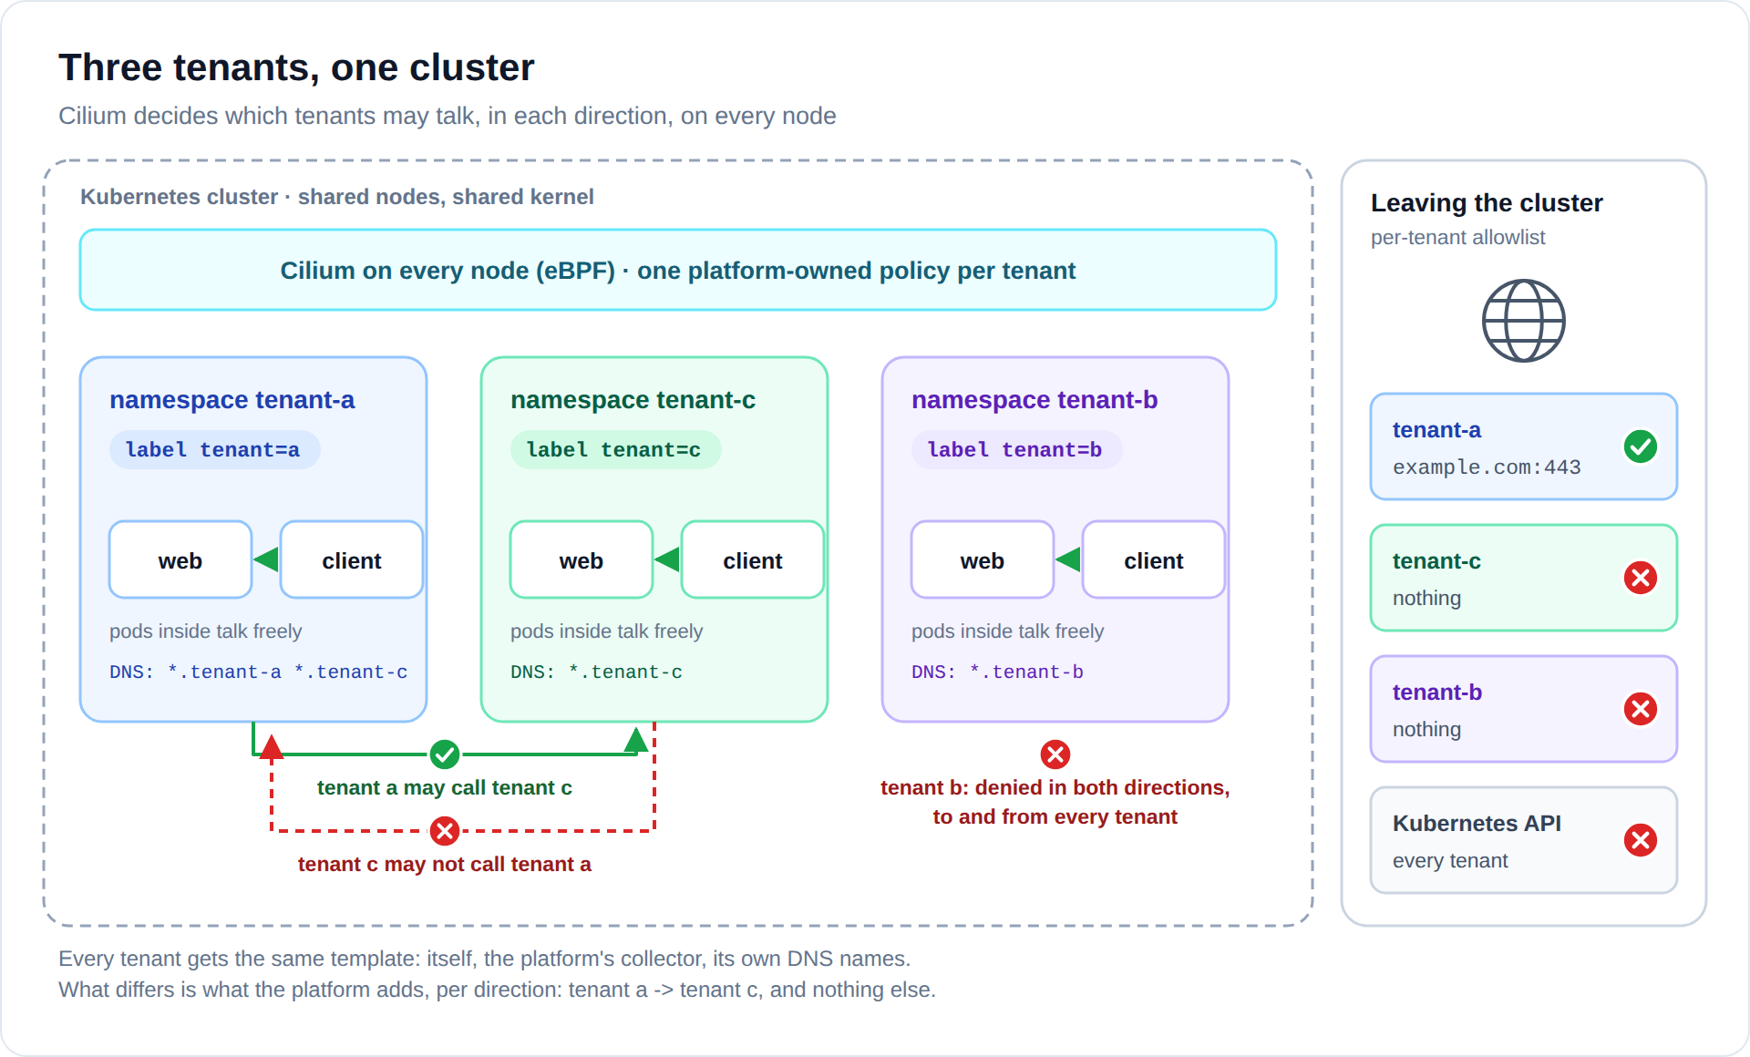
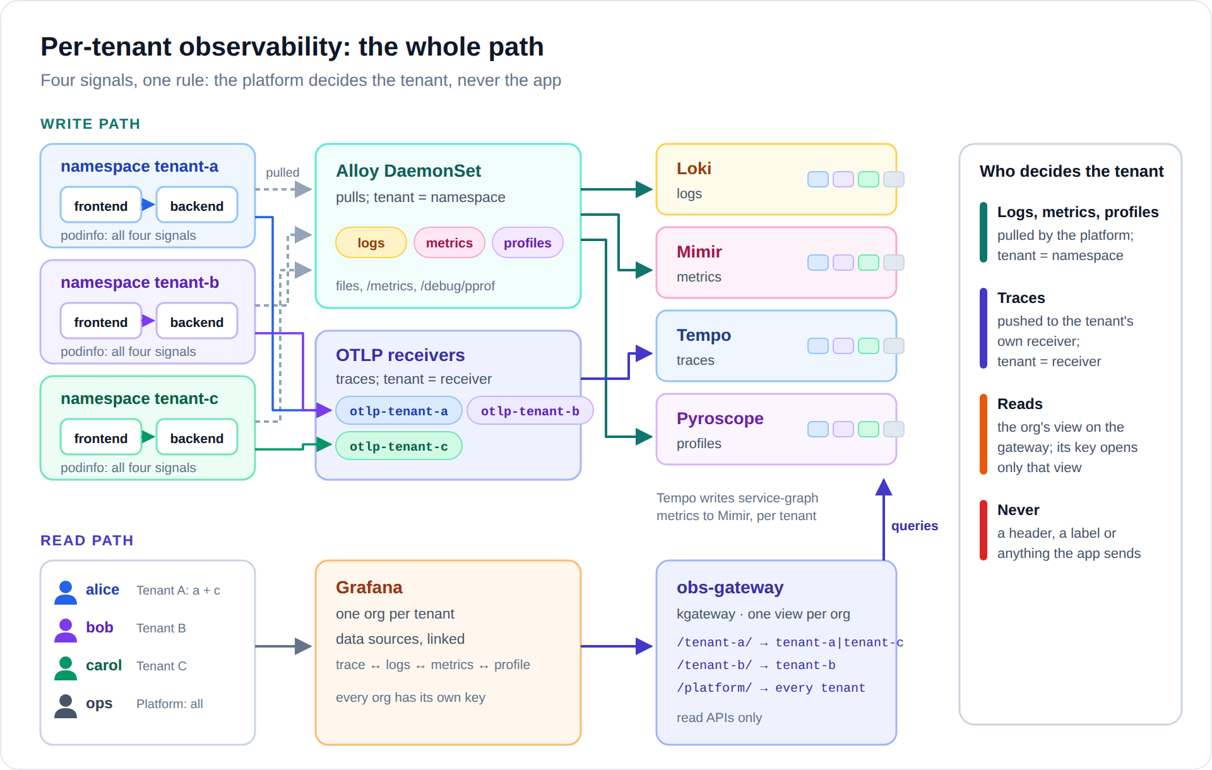
One rule behind every decision: a tenant never controls anything that sets its own identity. Tenants choose their pod labels, the headers they send and the data sources they create, so none of those are trusted. They can't change namespace names or namespace labels (cluster-scoped objects), so those are.
Layer | Trusted identity | Enforced by
Network | namespace label tenant | CiliumClusterwideNetworkPolicy (step 03)
DNS | namespace label tenant | Cilium DNS proxy rules, NXDOMAIN for the rest (steps 00, 03)
Kubernetes API | user → namespaced RoleBinding | RBAC (step 02)
Pods | namespace PSA label | Pod Security restricted: no hostNetwork/hostPath (steps 01, 02)
Namespaces | name and label must match | ValidatingAdmissionPolicy (step 01)
Logs, metrics, profiles (write) | namespace name | Alloy pulls them and maps tenant-X[-*] → tenant tenant-X (step 08)
Traces (write) | which receiver the pod can reach | one OTLP receiver per tenant; Cilium lets only that tenant reach it (steps 03, 08, 10)
All signals (read) | gateway view + API key | each Grafana org has a view on the read gateway that only its key opens; the view sets X-Scope-OrgID to the org's tenant list (step 07)
Grafana | org membership | one org per tenant with linked data sources; users are Editors, never Admins (step 09)
Ingress | Gateway listener, proxy identity | one kgateway Gateway per tenant; its listener only accepts that tenant's routes, and Cilium limits its proxy to that tenant (step 12)

What gets deployed
Component | How | Namespace
Admission guard, RBAC, quotas | plain YAML | cluster / tenants
Tenant network baselines | CiliumClusterwideNetworkPolicy | cluster-wide
Workloads: nginx web, podinfo frontend → backend, netshoot client | plain YAML, applied as the tenant user | tenant-a, tenant-b, tenant-c
Loki 3.6: logs | grafana/loki 7.3.0, single binary | observability
Mimir 3.2: metrics | plain manifest, single binary | observability
Tempo 3.0: traces, with service graphs | grafana-community/tempo 3.0.0 | observability
Pyroscope 2.3: profiles | grafana/pyroscope 2.3.1 | observability
Read gateway (kgateway): one view per Grafana org | Gateway API YAML | observability
Alloy 1.19 DaemonSet: logs, metrics, profiles | grafana/alloy 1.12.1 | observability
Per-tenant OTLP receivers (Alloy): traces | plain YAML | observability
Grafana 13.2 | grafana-community/grafana 13.2.5 | observability
kgateway 2.4 (Gateway API 1.6), installed in step 07 | oci://cr.kgateway.dev/kgateway-dev/charts/kgateway v2.4.5 | kgateway-system
Ingress Gateways: one per tenant, one for the platform | plain YAML | kgateway-system

Chart versions are pinned in lib.sh.

Before you start
- The lab is up: make all in the repo root, and kubectl get nodes shows 3 Ready nodes.
- On the host: helm, jq, openssl, envsubst (all used by the scripts).
- The VMs can reach the internet (images, and the example.com allowlist test).

Quick start
From the repo root:
make soft-tenancy # steps 00-13, with the three verify scripts
make soft-tenancy-verify # re-run the checks any time
make soft-tenancy-clean # remove it all
It ends by printing how to reach Grafana. Every Grafana login uses the password test-tenant: alice (Tenant A), bob (Tenant B), carol (Tenant C), ops (Platform) and admin. Set ST_PASSWORD=... for another one. up.sh is what the target runs: ./up.sh 06 resumes from step 06, and VERIFY=0 ./up.sh skips the checks.
The gateway keys behind the data sources are random, one per Grafana org, in ../.state/soft-tenancy/credentials.env. They must differ: each key opens exactly one org's view.

Walkthrough, by hand
Every command below runs from this folder:
cd soft-tenancy
export KUBECONFIG=$PWD/../.state/kubeconfig

00 · DNS: NXDOMAIN instead of REFUSED
./00-cilium-dns/apply.sh
By default Cilium's DNS proxy answers blocked names with REFUSED, and glibc stops walking the search path on REFUSED. With ndots:5, example.com is first tried as example.com.tenant-a.svc.cluster.local. That query gets refused and the real name is never asked. nameError (NXDOMAIN) fixes this, and gives the semantics we want: to tenant a, tenant b's services don't exist.
The script adds cilium-dns-values.yaml to the lab's HelmChartConfig on cp1 (a kubectl edit would be reverted by RKE2), waits for cilium-config, and restarts the agents.

01 · Namespaces and the admission guard
kubectl apply -f 01-namespaces/namespace-guard.yaml
kubectl apply -f 01-namespaces/namespaces.yaml
Everything later keys off the namespace tenant label. The guard makes that label impossible to get wrong:
- a namespace named tenant-* must have it
- the value is one token, so tenant-a-dev can only belong to tenant a
- tenant=X is only allowed on tenant-X or tenant-X-*, so a namespace called sneaky can't join tenant a
- tenant namespaces must enforce Pod Security restricted. Otherwise a hostNetwork pod gets the node's identity and walks around every pod policy.
Try it:
kubectl create namespace tenant-d # denied, and the message says why

02 · What a tenant user may do
kubectl apply -f 02-tenant-guardrails/
alice works in tenant-a, bob in tenant-b and carol in tenant-c, simulated with impersonation (kubectl --as alice). They get a custom tenant-developer role, not the built-in edit. edit includes NetworkPolicies, and a tenant with that right could write egress: 0.0.0.0/0 and bypass the internet allowlist. Quotas and LimitRanges stop one tenant from eating the workers.
kubectl --as alice auth can-i --list -n tenant-a
kubectl --as alice get pods -n tenant-b # Forbidden

03 · Tenant network baselines
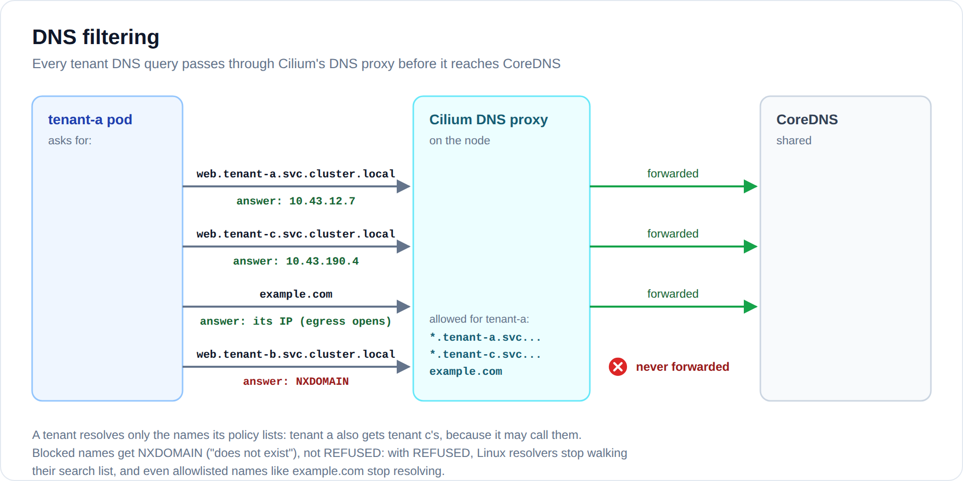
kubectl apply -f 03-tenant-isolation/
One CiliumClusterwideNetworkPolicy per tenant, selected by the namespace label. Once a pod is selected, only what's listed is allowed:
 | tenant-a | tenant-b | tenant-c
ingress | tenant a; the platform's collector (metrics, profiles) | tenant b; the collector | tenant c, tenant a; the collector
egress | tenant a, tenant c, CoreDNS (own names and tenant c's), its own trace receiver, example.com:443 | tenant b, CoreDNS (own names), its own trace receiver | tenant c, CoreDNS (own names), its own trace receiver
explicit deny | every tenant except c, both ways | every other tenant, both ways | every tenant except a (ingress only), both ways

Tenant a → tenant c needs both ends to agree: tenant a's egress allows tenant c, and tenant c's ingress admits tenant a. Tenant c → tenant a stays denied: tenant c's egress deny covers every other tenant, a included. Tenant c can still answer tenant a, because Cilium tracks connections and policy only decides who may open one.
The deny rules are the safety net. In Cilium, deny beats allow, so no allow rule added later can open another path between tenants. Step 05 proves it.

04 · Workloads, deployed by the tenants themselves
kubectl --as alice apply -f 04-demo-apps/tenant-a.yaml
kubectl --as bob apply -f 04-demo-apps/tenant-b.yaml
kubectl --as carol apply -f 04-demo-apps/tenant-c.yaml
Each tenant gets:
Workload | What it is | Used for
web | nginx answering hello from tenant-X | network tests
frontend → backend | podinfo, /echo on the frontend calls the backend | all four signals, one trace across two services
client | netshoot: calls web, then frontend every 5s (some slow, some errors) | traffic, and the verify scripts exec into it

podinfo produces everything the observability half needs: JSON logs with a trace_id, Prometheus metrics and pprof profiles on :9898, and OTLP traces sent to the tenant's own receiver (otlp-tenant-X). Two pod annotations opt it in to the platform's collector:
prometheus.io/scrape: "true" # metrics
profiles.grafana.com/scrape: "true" # profiles
The container name equals the OpenTelemetry service.name, which is how Grafana later jumps from a span to that service's logs and profile. Deploying as alice/bob/carol proves the RBAC and Pod Security setup is usable, not just strict. Tenant b also gets a NodePort (:30082) to test "going around via the node".
Tenant a uses tenant c. Tenant a's client also calls web.tenant-c, and tenant a's frontend calls tenant c's backend on every /echo, next to its own. That request's trace spans two tenants: tenant a's spans land in tenant a, tenant c's in tenant c (each through its own receiver). In Grafana, alice sees the whole trace; carol sees only tenant c's half.

05 · Prove the network isolation
./05-verify-network.sh
43 checks, each stating what must happen, then the flows Cilium dropped (from Hubble). Highlights:
PASS tenant-a -> tenant-c web via DNS name ← allowed
PASS tenant-c -> tenant-a web via pod IP ← blocked
PASS tenant-c gets NXDOMAIN for web.tenant-a
PASS tenant-a -> tenant-b via NodePort 192.168.122.11:30082 ← blocked
PASS tenant-b gets NXDOMAIN for web.tenant-c
PASS tenant-a -> https://example.com (allowlisted)
PASS tenant-c -> https://example.com (no internet)
PASS PSA rejects a hostNetwork pod
PASS 'sneaky' namespace claiming tenant=a
PASS tenant-c -> tenant-a pod IP, rogue allows in place ← deny beats allow
The rogue checks apply "mistake" policies that explicitly allow tenant-a → tenant-b and tenant-c → tenant-a, confirm both are still dropped, then remove them.

06 · The backends: Loki, Mimir, Tempo, Pyroscope
./06-observability-backends/install.sh
All four run as a single binary, and all four are multi-tenant the same way: every push and every query must name its tenant in the X-Scope-OrgID header, and each tenant's data is stored and queried separately.
Backend | Signal | Tenancy switch | Installed from
Loki 3.6 | logs | auth_enabled: true | loki-values.yaml
Mimir 3.2 | metrics | multitenancy_enabled: true | mimir.yaml (plain manifest)
Tempo 3.0 | traces | multitenancyEnabled: true | tempo-values.yaml
Pyroscope 2.3 | profiles | -auth.multitenancy-enabled=true | pyroscope-values.yaml

Chart defaults that don't belong in a multi-tenant cluster are switched off:
- Loki's rules sidecar watches ConfigMaps in every namespace and ships a ClusterRole that can read every Secret.
- Pyroscope's bundled Alloy comes with the same kind of cluster-wide Secret access. Our collector (step 08) does that job.
Several tenants in one query. For alice to see tenant a and tenant c together, a query must name both: X-Scope-OrgID: tenant-a|tenant-c. Loki (multi_tenant_queries_enabled) and Mimir (tenant_federation) are switched to allow it; Tempo allows it by default. Results carry the tenant (Loki and Mimir add a __tenant_id__ label). Only the read gateway can query the backends, and it sets that header itself (steps 07 and 10), so a tenant never picks its own list. Pyroscope can't query several tenants at once: an org that sees several tenants gets one Pyroscope data source per tenant.
Tempo's metrics generator turns each tenant's spans into service-graph and RED metrics, and writes them to Mimir under the same tenant, which powers the service map in Grafana. Mimir has no small chart (only the full microservices setup), so it's a plain StatefulSet. It runs from its data volume so the root filesystem can stay read-only.

07 · The read gateway
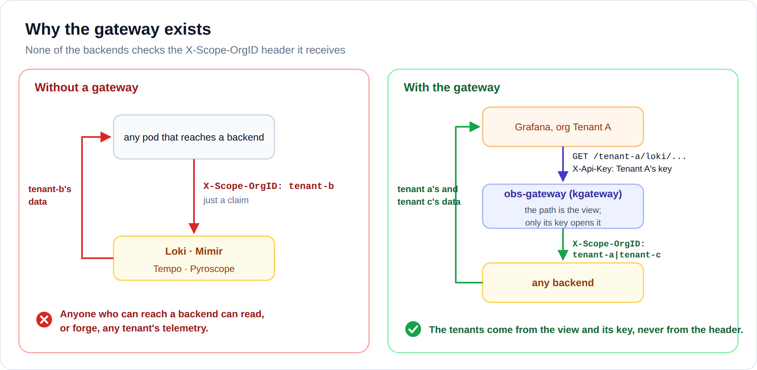
./07-read-gateway/install.sh
None of the four backends authenticates X-Scope-OrgID. It's a claim. The read gateway makes sure it always comes from the platform. It's a kgateway Gateway called obs-gateway in observability (one listener, port 8080), so the script first installs the Gateway API CRDs (unless something already manages them) and kgateway. The ingress in step 12 uses the same controller.
One view per Grafana org (views.yaml): a path prefix, opened only by that org's API key, that asks the backends for a fixed list of tenants.
Grafana org | View | Loki, Mimir and Tempo are asked for
Tenant A | /tenant-a/ | tenant-a|tenant-c
Tenant B | /tenant-b/ | tenant-b
Tenant C | /tenant-c/ | tenant-c
Platform | /platform/ | platform|tenant-a|tenant-b|tenant-c

Pyroscope gets one path per tenant instead: /tenant-a/pyroscope/tenant-a and /tenant-a/pyroscope/tenant-c for Tenant A, one per tenant for Platform.
Each view is one HTTPRoute and one TrafficPolicy:
# HTTPRoute view-tenant-a, one of its rules
- matches:
- path: {type: PathPrefix, value: /tenant-a/loki/api/v1}
filters:
- type: RequestHeaderModifier # SETS the header, replacing what the caller sent
requestHeaderModifier:
set: [{name: X-Scope-OrgID, value: "tenant-a|tenant-c"}]
- type: URLRewrite # /tenant-a/loki/... -> /loki/...
urlRewrite:
path: {type: ReplacePrefixMatch, replacePrefixMatch: /loki/api/v1}
backendRefs:
- {name: loki, port: 3100}

# TrafficPolicy view-tenant-a: only Tenant A's key opens this route
apiKeyAuth:
secretRef: {name: obs-key-tenant-a}
keySources: [{header: X-Api-Key}]
forwardCredential: false # the key never reaches the backends
So Tenant A's key on /tenant-b/... gets 401, and a header claiming another tenant is simply overwritten. Envoy normalizes paths before choosing a route: /tenant-a/../tenant-b/... is /tenant-b/..., and Tenant A's key doesn't open it. That matters because Grafana Editors can send arbitrary paths through a data source.
Each view forwards read APIs only: Loki's query API, Mimir's Prometheus API, Tempo's query API and Pyroscope's querier. Loki push and delete and Tempo's overrides API get 403, anything else 404, a missing or unknown key 401. Queries may run for 300 s (Envoy's default is 15 s), and Loki's live tail stays open. The access log shows who asked for what:
kubectl -n observability logs deploy/obs-gateway | grep tenant=
# tenant=tenant-a|tenant-c "GET /tenant-a/loki/api/v1/labels" 200 675
The keys are generated once into ../.state/soft-tenancy/credentials.env (gitignored, mode 600), one per view, and must stay distinct. Re-running the script is safe; it also removes what older versions of this lab left behind.

08 · The collectors
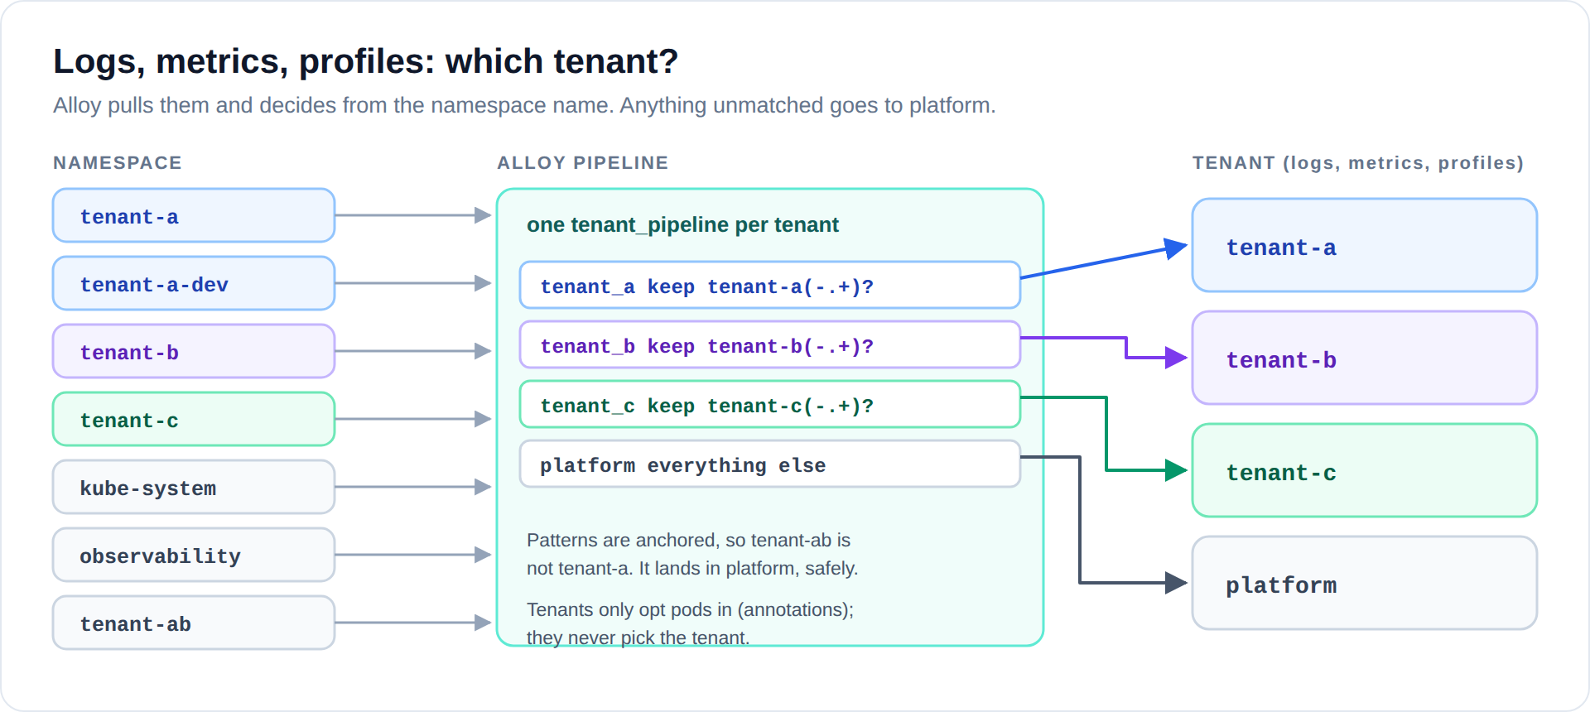
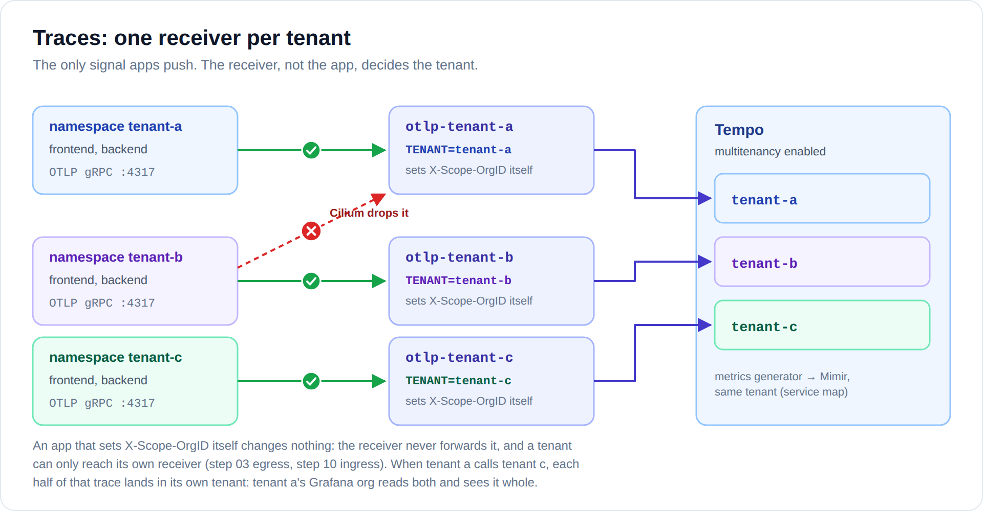
./08-collectors/install.sh
Alloy pulls every signal it can, so tenants never choose their tenant ID. One Alloy per node reads container log files from disk, and scrapes /metrics and /debug/pprof from pods that opted in. The tenant always comes from the namespace name. In alloy-values.yaml each tenant is one block:
tenant_pipeline "tenant_a" {
id = "tenant-a"
keep = "tenant-a(-.+)?" // namespaces that are tenant a
log_targets = discovery.relabel.logs.output
metric_targets = discovery.relabel.metrics.output
profile_targets = discovery.relabel.profiles.output
}
// ...the same for tenant_b and tenant_c, and a "platform" block for
// everything that isn't a tenant
Tenant a reading tenant c's data changes nothing here: tenant c's data is written to tenant c, by tenant c's pipeline. Who may read it is decided in step 07.
Traces are the one signal apps must push. Instead of letting them push straight to Tempo (and pick any tenant), each tenant gets its own small OTLP receiver (otlp-receivers.yaml). The receiver sets X-Scope-OrgID from its own configuration, and Cilium lets only that tenant's pods reach it. Whatever a tenant sends lands in its own tenant. The receiver also stamps a tenant resource attribute on every span, replacing any the app set, so in Tenant A's org { resource.tenant = "tenant-c" } shows which spans are tenant c's.
The Alloy chart's default ClusterRole (every Secret, pods/log, and more) is replaced with pods: get/list/watch, which is all this collector needs.

09 · Grafana, one org per tenant
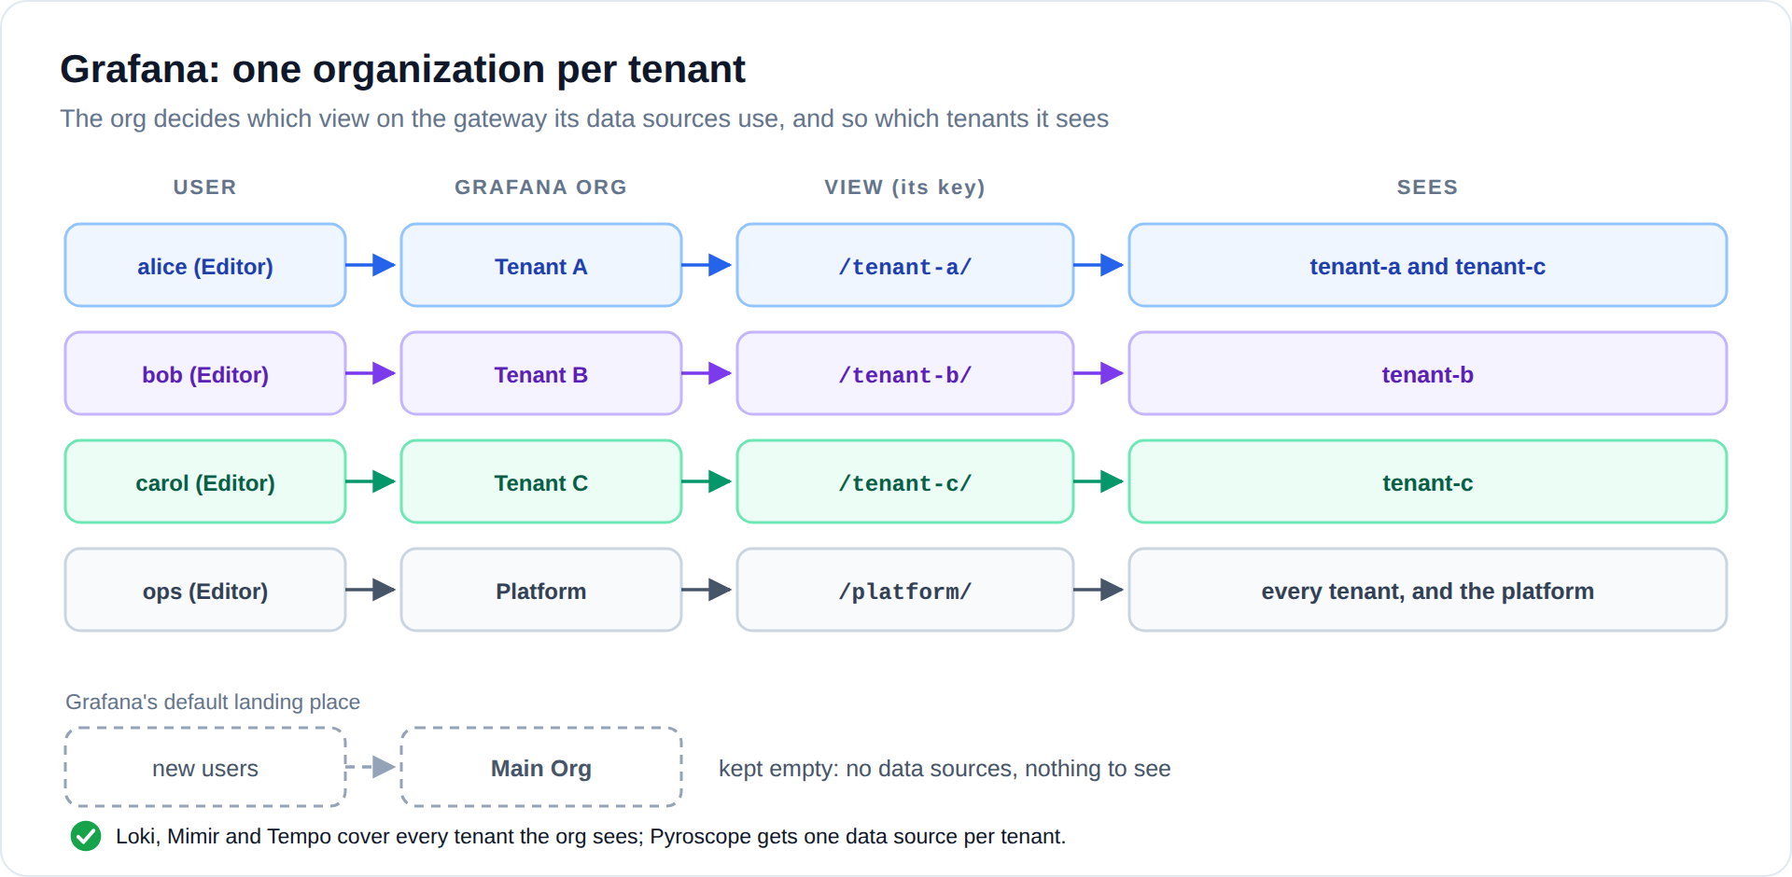
./09-grafana/install.sh
Installs Grafana, then setup-orgs.sh creates the orgs through the API (Grafana can't provision orgs or users from files). Each org's data sources call the read gateway under the org's view, with the org's key (X-Api-Key, stored encrypted in the data source, never shown to the org's users). Every login uses the password test-tenant (ST_PASSWORD), admin included.
Org | User (role) | Sees | Data sources
Tenant A | alice (Editor) | tenant-a, tenant-c | Loki, Mimir, Tempo (both tenants in each); Pyroscope, Pyroscope (tenant-c)
Tenant B | bob (Editor) | tenant-b | Loki, Mimir, Tempo, Pyroscope
Tenant C | carol (Editor) | tenant-c | Loki, Mimir, Tempo, Pyroscope
Platform | ops (Editor) | everything | Loki, Mimir, Tempo (all tenants); Pyroscope (platform) plus one per tenant
Main Org | nobody | nothing | none, because new users land here by default

In Tenant A's org, narrow things down by namespace: {namespace="tenant-c"} (Loki, Mimir). Loki and Mimir also label every result with its tenant, so sum by (__tenant_id__) (...) splits a graph per tenant; Mimir, but not Loki, also filters on it (up{__tenant_id__="tenant-c"}). In Tempo, use { resource.tenant = "tenant-c" }.
The data sources of an org are linked to each other, and only to each other:
- a span opens its logs, its metrics, and its service's CPU profile
- a log line with a trace_id opens that trace
- the service map comes from the metrics Tempo generated
Users are Editors, never org Admins. An org Admin can add data sources, including one pointed at another tenant.
kubectl -n observability port-forward svc/grafana 3000:80
# http://localhost:3000 → alice / test-tenant → Explore → Tempo → Search → open a trace
# a trace from frontend that also calls tenant c's backend shows both tenants' spans

10 · Lock down the observability namespace
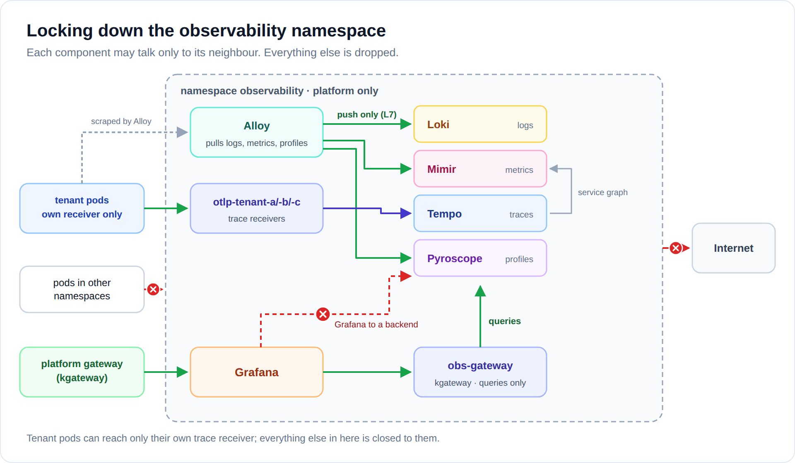
Every backend is multi-tenant now, but not safe yet. Watch why:
./10-observability-lockdown/attack-demo.sh
read tenant-b's logs : {"status":"success","data":["tenant-b"]}
read tenant-b's metrics : {"status":"success","data":["tenant-b"]}
read tenant-b's traces : 5 traces
read tenant-b's profiles : {"names":["tenant-b"]}
forge a log into tenant-a: HTTP 204, accepted
A pod in default (no policy there) claims to be tenant-b and reads all of its telemetry, then claims to be tenant-a and injects a forged log line. Tenant pods can't do this (step 03), but "only tenants are blocked" isn't enough. Lock it down and run it again:
kubectl apply -f 10-observability-lockdown/policies.yaml
./10-observability-lockdown/attack-demo.sh # every line now says BLOCKED
policies.yaml: default deny for the namespace, and each component may talk only to its neighbour:
- Alloy reaches Loki, Mimir and Pyroscope, and an L7 rule lets it only POST to their push endpoints. A compromised collector can't read anyone's data.
- Only the tenant OTLP receivers reach Tempo's OTLP port, and each receiver accepts only its own tenant's pods.
- Only the read gateway's proxy reaches the query APIs, only Grafana reaches the gateway, and Grafana can't reach the backends directly or the internet. The proxy may also reach the kgateway controller, for its configuration.
In Grafana (as alice), the forged line from the first run is still there: {forged="true"}. That's the integrity half of the problem.

11 · Prove the observability isolation
./11-verify-observability.sh
78 checks across all four signals and all four views. Highlights:
PASS logs: /tenant-a/ sees tenant-a tenant-c
PASS metrics: /tenant-c/ sees tenant-c
PASS profiles: /tenant-a/ -> tenant-c's profiles only
PASS traces: /tenant-a/ gets a cross-tenant trace whole ← a's frontend -> c's backend
PASS traces: /tenant-c/ gets only its half of it
PASS tenant-a's key on /tenant-b/ -> 401
PASS path trick /tenant-a/../tenant-b/ -> 401
PASS metrics: tenant-c claiming a|c (header) ← the view beats the header
PASS alice: logs are tenant-a and tenant-c
PASS ops: metrics are everyone's
PASS tenant-a -> tenant-c's trace receiver ← c's services yes, receiver no
PASS Alloy identity: Mimir query -> 403 ← Envoy L7 rule

12 · Ingress with kgateway
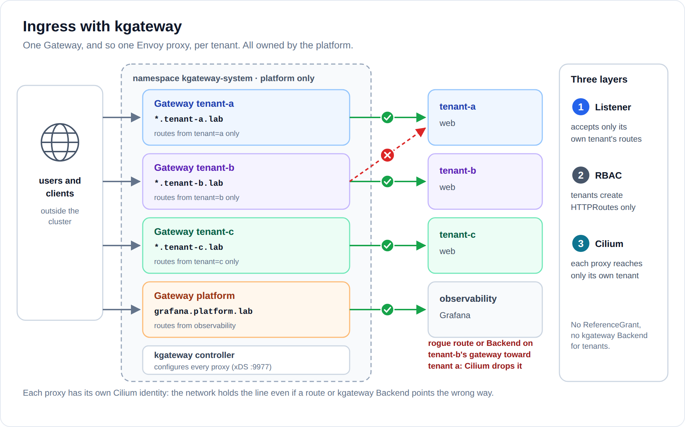
./12-kgateway-ingress/install.sh
kubectl --as alice apply -f 12-kgateway-ingress/route-tenant-a.yaml
kubectl --as bob apply -f 12-kgateway-ingress/route-tenant-b.yaml
kubectl --as carol apply -f 12-kgateway-ingress/route-tenant-c.yaml
kgateway is already installed (step 07; the script re-applies it, so step 12 also works on its own). It creates one Gateway per tenant plus one for the platform, all in kgateway-system:
Gateway | Listener hostname | Accepts routes from | NodePort (lab) | Its proxy may reach
tenant-a | *.tenant-a.lab | namespaces with tenant: a | 30180 | tenant a only
tenant-b | *.tenant-b.lab | namespaces with tenant: b | 30181 | tenant b only
tenant-c | *.tenant-c.lab | namespaces with tenant: c | 30183 | tenant c only
platform | grafana.platform.lab | namespaces with role: platform | 30182 | Grafana only

Why not one shared Gateway? Its Envoy proxy would need a way into every tenant, so Cilium could no longer tell tenant-a's traffic from tenant-b's on that hop. And kgateway's Backend resource (types Static and DynamicForwardProxy) can point a route at any host. On a shared proxy, one RBAC slip turns the ingress into a bridge between tenants. With a proxy per tenant, network-policies.yaml pins each proxy to its own tenant on the network, whatever routes exist.
Three layers, again:
- Listener: allowedRoutes only accepts HTTPRoutes from that tenant's namespaces, so bob can't attach a route that steals web.tenant-a.lab.
- RBAC: tenants may create HTTPRoutes, nothing else. No ReferenceGrant (a data path into your services), no Gateways, and no kgateway Backends or policies (rbac.yaml).
- Cilium: each proxy's egress is its own tenant, the kgateway controller and DNS. Each tenant's ingress now also allows exactly its own proxy.
Tenant a's pods may call tenant c, but tenant a's gateway still serves and reaches tenant a only: publishing tenant c's apps is tenant c's gateway's job.
Grafana moves behind the platform gateway: its policy admits only that proxy. Tenant pods still can't reach any gateway (their baseline has no egress to kgateway-system). Inside the cluster they use service names.
curl -H 'Host: web.tenant-a.lab' http://192.168.122.11:30180/ # hello from tenant-a
curl -H 'Host: grafana.platform.lab' http://192.168.122.11:30182/api/health
In production, drop the GatewayParameters NodePort override and let each Gateway get its own LoadBalancer address.

13 · Prove the ingress isolation
./13-verify-ingress.sh
15 checks. Highlights:
PASS web.tenant-a.lab on tenant-a's gateway
PASS web.tenant-c.lab on tenant-c's gateway
PASS tenant-a's gateway won't serve web.tenant-c.lab ← only tenant a's pods reach c
PASS bob's route on tenant-a's gateway is rejected ← listener allowedRoutes
PASS bob's route can't use tenant-a's service ← no ReferenceGrant
PASS bob can't create kgateway Backends ← RBAC
PASS control: Static Backend via tenant-a's gateway
PASS rogue: tenant-b's proxy -> tenant-a pod IP ← Cilium drops it
The last pair simulates the worst case: an admin (or a slipped RBAC rule) creates a kgateway Backend that points tenant-b's gateway straight at a tenant-a pod. The control proves such a Backend works in general. The rogue one still gets nothing, because tenant-b's proxy has no network path to tenant a.

Exercises: break it on purpose
- See the REFUSED problem. Set dnsRejectResponseCode: refused in 00-cilium-dns/cilium-dns-values.yaml and re-run step 00. From tenant-a, curl https://example.com now fails, although it's allowlisted, while dig example.com still works (dig ignores the search path). Put nameError back.
- Remove the safety net. Delete the ingressDeny block from 03-tenant-isolation/tenant-b.yaml, re-apply it and re-run step 05. The "rogue allows" check now fails, which is exactly why the deny rules exist.
- Give alice the built-in edit role. Bind edit instead of tenant-developer, then as alice create a NetworkPolicy with egress 0.0.0.0/0. Tenant-a can now query 1.1.1.1 for DNS and reach any IP, so the allowlist is gone. Cross-tenant traffic stays blocked (deny beats allow). Revert the binding.
- Make alice a Grafana org Admin, then have her add a Mimir data source pointing at /tenant-b/ on the gateway. She doesn't have Tenant B's key. Pointing it straight at mimir:8080 with a spoofed header gets dropped by Grafana's egress policy. Two layers, each enough on its own.
- Onboard tenant-d. Namespace (the guard tells you what's missing), copy tenant-b's CCNP, add a tenant_pipeline "tenant_d" block to 08-collectors/alloy-values.yaml (and to the platform's drop), an otlp-tenant-d receiver and its policy, a view in 07-read-gateway/views.yaml with its key (OBS_KEY_TENANT_D in lib.sh, a Secret in 07-read-gateway/install.sh), and a line in 09-grafana/setup-orgs.sh.
- Let tenant b see tenant c too. Change /tenant-b/'s header to tenant-b|tenant-c and add a /tenant-b/pyroscope/tenant-c rule in views.yaml, then add tenant-c to bob's line in setup-orgs.sh. Grafana visibility changes; the network doesn't. Which one you change is a separate decision, per direction.
- Watch it live with Hubble:
kubectl -n kube-system exec ds/cilium -c cilium-agent -- hubble observe --namespace tenant-a --protocol dns -f
kubectl -n kube-system exec ds/cilium -c cilium-agent -- hubble observe --verdict DROPPED -f
(ds/cilium picks one agent, so you only see flows on that node.)
- Try to send traces as someone else. From tenant-a's client pod, send a span to otlp-tenant-b (Cilium drops it), then to tenant-a's own receiver with X-Scope-OrgID: tenant-b set (it lands in tenant-a anyway: the receiver stamps its own tenant).

What soft tenancy does NOT protect against
Be honest about the boundary before calling it production-ready:
- Shared kernel. A container escape on a node reaches every tenant's pods on that node. Stronger options: tenant-dedicated nodes (taints plus nodeSelectors), sandboxed runtimes (gVisor, Kata), or separate clusters.
- Shared CoreDNS and Cilium agent. A tenant flooding DNS degrades DNS for everyone. Every tenant DNS query also passes through the cilium-agent's DNS proxy, so an agent restart or upgrade briefly interrupts tenant DNS.
- Grafana holds every tenant's gateway key. A compromised Grafana crosses tenants. If that's unacceptable, run one Grafana per tenant (still in observability, never in the tenant's namespace).
- Node resources. Quotas cap CPU and memory, not disk IO or network bandwidth.
- Data at rest. Each backend keeps tenants in separate directories (or object prefixes), not separately encrypted.
- Shared backends. One tenant's heavy queries or ingest can slow the others. Per-tenant limits help (Loki's runtimeConfig, Mimir's limits), but they cap, they don't isolate.
- Platform access. Cluster admins, kubectl port-forward/exec into observability, and the unauthenticated Hubble UI see everything.
- DNS patterns cover the tenant-X namespace only. A tenant with a second namespace (tenant-a-dev) needs *.tenant-a-dev.svc.cluster.local added.
- One kgateway controller configures every proxy. A bug or compromise in the controller affects every tenant's ingress and the read gateway. The proxies are separate; the control plane is not.
- Profiles don't merge across tenants. Pyroscope can't query several tenants at once, so alice picks "Pyroscope" or "Pyroscope (tenant-c)". A span from tenant c opens tenant a's Pyroscope, which has no profile for it.
- Service graphs stop at the tenant boundary. Tempo builds each tenant's service graph from that tenant's spans only, so tenant a's frontend calling tenant c's backend doesn't show as an edge.

Layout
soft-tenancy/
├── lib.sh # helpers, pinned versions, test harness
├── 00-cilium-dns/ # NXDOMAIN for blocked names (RKE2)
├── up.sh # make soft-tenancy: every step, with checks
├── 01-namespaces/ # tenants a/b/c, observability, guard
├── 02-tenant-guardrails/ # RBAC (alice, bob, carol), quotas
├── 03-tenant-isolation/ # one CCNP per tenant (a -> c allowed)
├── 04-demo-apps/ # web + client per tenant
├── 05-verify-network.sh
├── 06-observability-backends/ # Loki, Mimir, Tempo, Pyroscope + install.sh
├── 07-read-gateway/ # kgateway: gateway.yaml, views.yaml
├── 08-collectors/ # Alloy DaemonSet + per-tenant OTLP receivers
├── 09-grafana/ # install.sh, setup-orgs.sh
├── 10-observability-lockdown/ # policies.yaml + attack-demo.sh
├── 11-verify-observability.sh
├── 12-kgateway-ingress/ # one Gateway per tenant, policies, routes
├── 13-verify-ingress.sh
├── 99-cleanup.sh # --all also deletes the gateway keys
├── soft-tenancy-lab-walkthrough.docx # this README as a Word file
├── soft-multi-tenancy-guide.docx # the design for any cluster (Word)
└── confluence/ # team pages (Word), diagrams, paste how-to

Troubleshooting
Step 05: "tenant-a gets NXDOMAIN" fails, or example.com fails from tenant-a. Step 00 didn't take. Check kubectl -n kube-system get cm cilium-config -o jsonpath='{.data.tofqdns-dns-reject-response-code}' and look for nameError.
Grafana shows "no data" for alice. Give it a minute after step 08: metrics are scraped every 30s, and profiles need about a minute to become queryable. Then check the path piece by piece: kubectl -n observability logs ds/alloy (logs, metrics, profiles), kubectl -n observability logs deploy/otlp-tenant-a (traces), the read gateway's access log (kubectl -n observability logs deploy/obs-gateway | grep tenant=), then ./11-verify-observability.sh.
Grafana's data sources answer 401. The keys in the data sources don't match the obs-key-<view> Secrets, for example after the credentials file was recreated. Re-run ./07-read-gateway/install.sh, then ./09-grafana/setup-orgs.sh.
The read gateway isn't Programmed, or a view answers 404 for everything. kubectl -n observability describe gateway obs-gateway, then check that the views and their policies are attached: kubectl -n observability get httproute,trafficpolicy,listenerpolicy -o wide and kubectl -n observability describe trafficpolicy view-tenant-a.
Can't log in to Grafana with test-tenant. The password is set at install (ST_PASSWORD, default test-tenant). After changing it, re-run ./09-grafana/install.sh: it resets admin's password and every user's.
Live tail in Tenant A's or Platform's org fails. Loki can't tail several tenants at once. Query instead, or tail from the Tenant C org.
The service map is empty. It's built from metrics Tempo generates from spans, a minute or two after traces arrive. Check traces_service_graph_request_total in the tenant's Mimir data source.
After step 10, something in observability stopped working. Find the drop: kubectl -n kube-system exec ds/cilium -c cilium-agent -- hubble observe --namespace observability --verdict DROPPED. Run it against each cilium pod, since each agent only sees its own node.
A Gateway isn't Programmed, or a route isn't accepted. kubectl -n kgateway-system get gateway and kubectl -n tenant-a describe httproute web show the reason. A route on the wrong Gateway reports NotAllowedByListeners.
The gateway answers 503 (upstream connect error). The proxy was dropped on its way to the backend. Check its egress: kubectl -n kube-system exec ds/cilium -c cilium-agent -- hubble observe --verdict DROPPED --from-label gateway.networking.k8s.io/gateway-name=tenant-a.
Start over: ./99-cleanup.sh or make soft-tenancy-clean (add --all to the script to also forget the gateway keys).

