Soft tenancy with Cilium: the basics
In 30 seconds Several teams (tenants) share one Kubernetes cluster, and each tenant gets its own namespace. Cilium, our network plugin, makes sure a tenant's pods cannot reach another tenant's pods, cannot even look up their names, and can only reach the internet destinations we allow. Our ingress, kgateway, gives each tenant its own gateway, so publishing an app never opens a path to another tenant.

Soft or hard tenancy?
 | Soft tenancy (this page) | Hard tenancy
Shared | One cluster, the same nodes, one kernel | Little or nothing: separate nodes or clusters
Isolation by | Policies: network, RBAC, Pod Security | Separate machines and control planes
Good for | Internal teams and environments we trust | Untrusted customers, strict compliance
Cost | Low: one cluster to run | High: many clusters or node pools

The picture
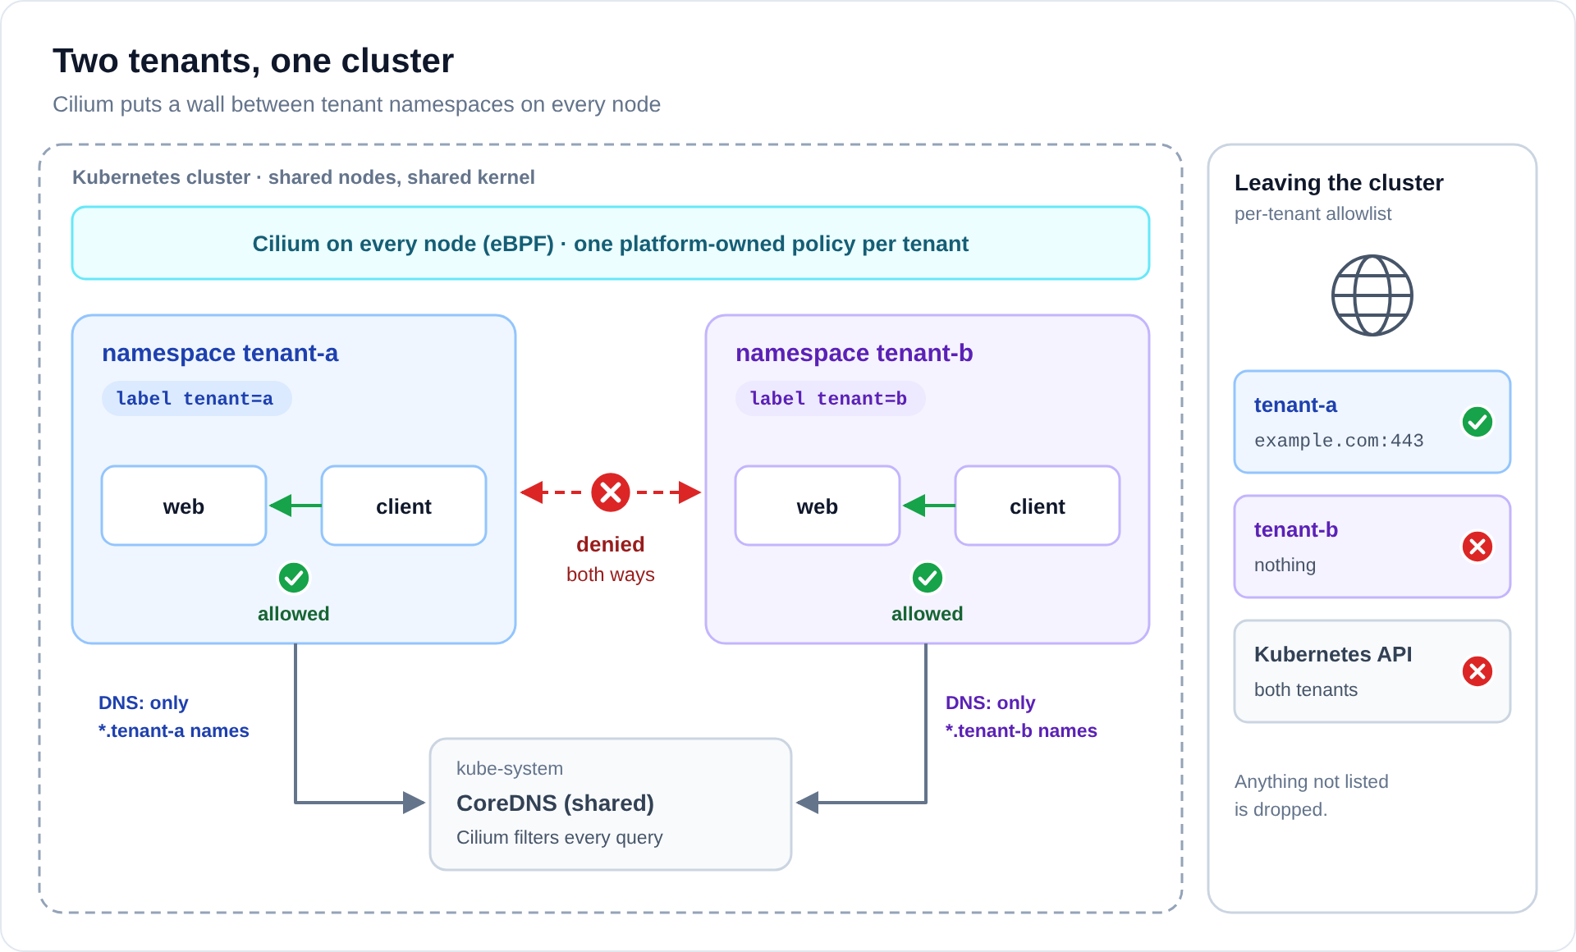
Diagram: images/cilium-overview.svg (or .png)
- Pods inside a tenant talk freely: client can call web.
- Traffic between tenants is denied in both directions, on every node.
- Both tenants use the shared CoreDNS, but each can only resolve its own names.
- Leaving the cluster is an allowlist, per tenant: tenant-a may reach example.com, tenant-b nothing.

How Cilium decides who may talk
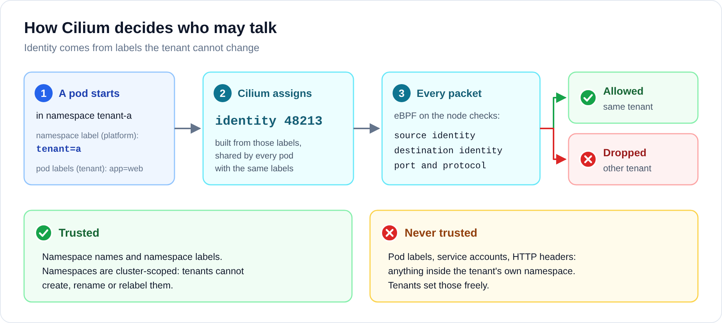
Diagram: images/cilium-identity.svg (or .png)
Cilium does not filter by IP address. When a pod starts, Cilium turns the pod's labels, including its namespace labels, into a numeric identity. On every packet, eBPF code on the node checks the source identity, the destination identity and the port against the policy.
The key point: we base every decision on the namespace label tenant. Only the platform team can set it. Pod labels are chosen by the tenants themselves, so we never trust them.

One policy per tenant
Each tenant gets one CiliumClusterwideNetworkPolicy, owned by the platform team. Tenants cannot see or change it. A simplified version for tenant-a:
apiVersion: cilium.io/v2
kind: CiliumClusterwideNetworkPolicy
metadata:
name: tenant-a-baseline
spec:
endpointSelector: # every pod in tenant a's namespaces
matchLabels:
k8s:io.cilium.k8s.namespace.labels.tenant: a
ingress: # who may call tenant a: only tenant a
- fromEndpoints:
- matchLabels:
k8s:io.cilium.k8s.namespace.labels.tenant: a
egress:
- toEndpoints: # tenant a may call tenant a
- matchLabels:
k8s:io.cilium.k8s.namespace.labels.tenant: a
- toEndpoints: # DNS, but only tenant a's own names
- matchLabels:
k8s:io.kubernetes.pod.namespace: kube-system
k8s:k8s-app: kube-dns
toPorts:
- ports: [{port: "53", protocol: ANY}]
rules:
dns:
- matchPattern: "*.tenant-a.svc.cluster.local"
- matchName: "example.com"
- toFQDNs: # the internet allowlist
- matchName: "example.com"
toPorts:
- ports: [{port: "443", protocol: TCP}]
ingressDeny: # any other tenant: always denied
- fromEndpoints:
- matchExpressions:
- {key: k8s:io.cilium.k8s.namespace.labels.tenant, operator: Exists}
- {key: k8s:io.cilium.k8s.namespace.labels.tenant, operator: NotIn, values: ["a"]}
# egressDeny: the same selector again, for the other direction
Once a policy selects a pod, everything not listed is dropped. The full version, with both deny directions, is in the step-by-step guide.

Deny beats allow
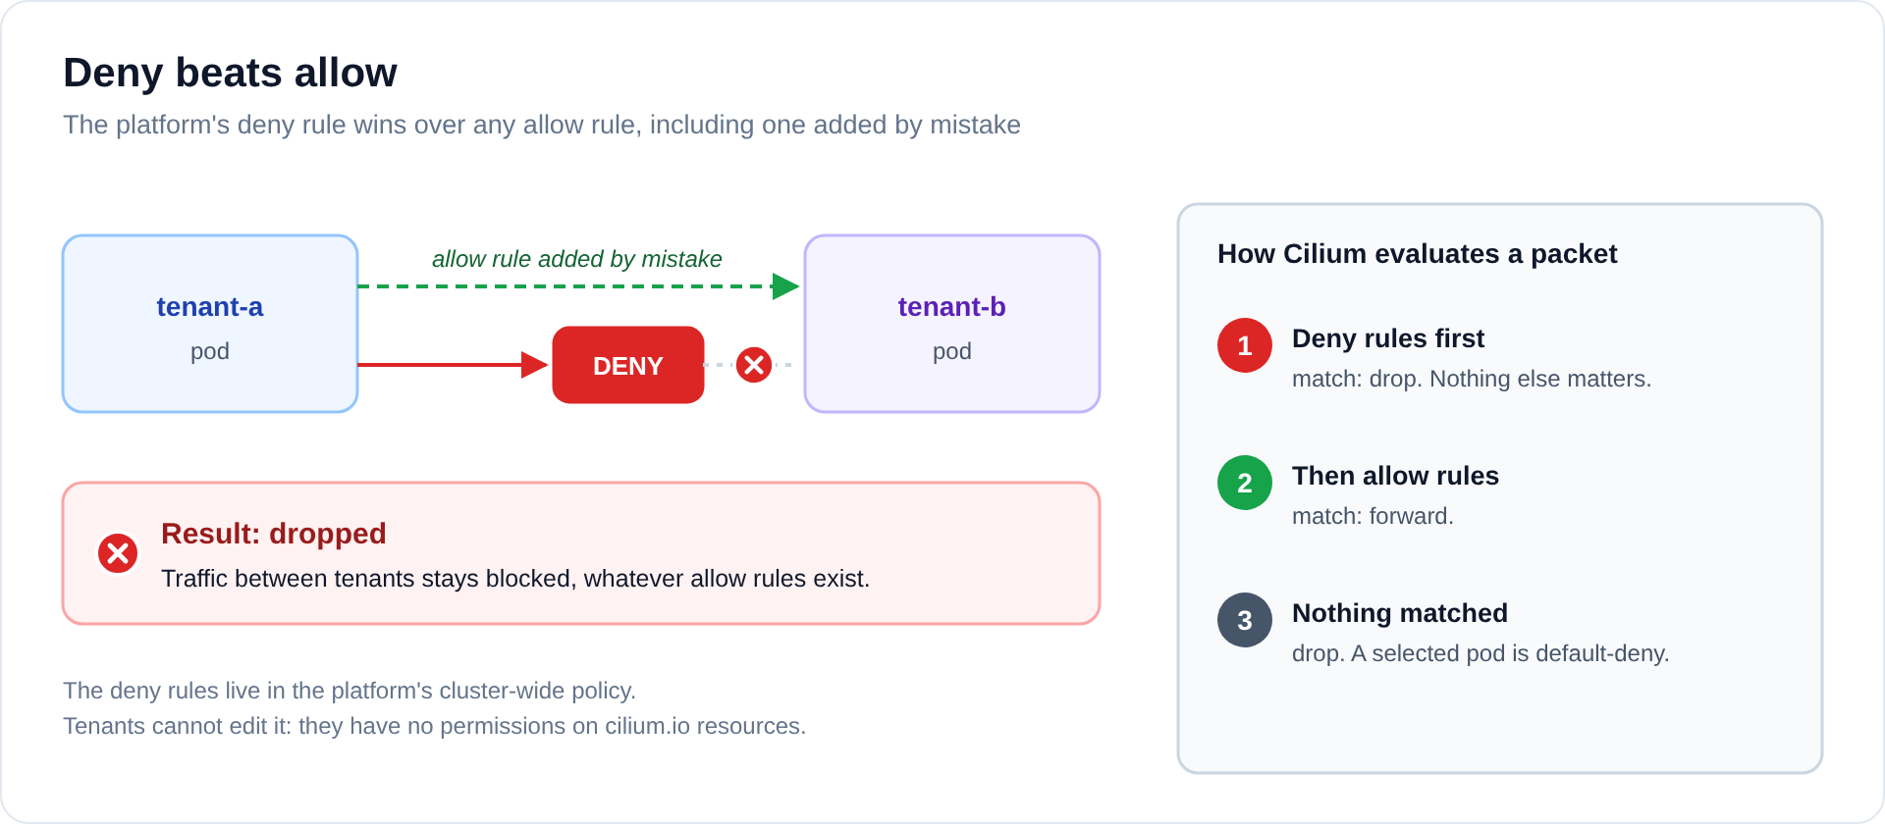
Diagram: images/cilium-deny.svg (or .png)
Mistakes happen: someone might add a NetworkPolicy that allows tenant-a to reach tenant-b. Because the platform policy contains explicit deny rules, and Cilium always checks deny rules first, that traffic is still dropped. The allow rule simply has no effect.

DNS filtering
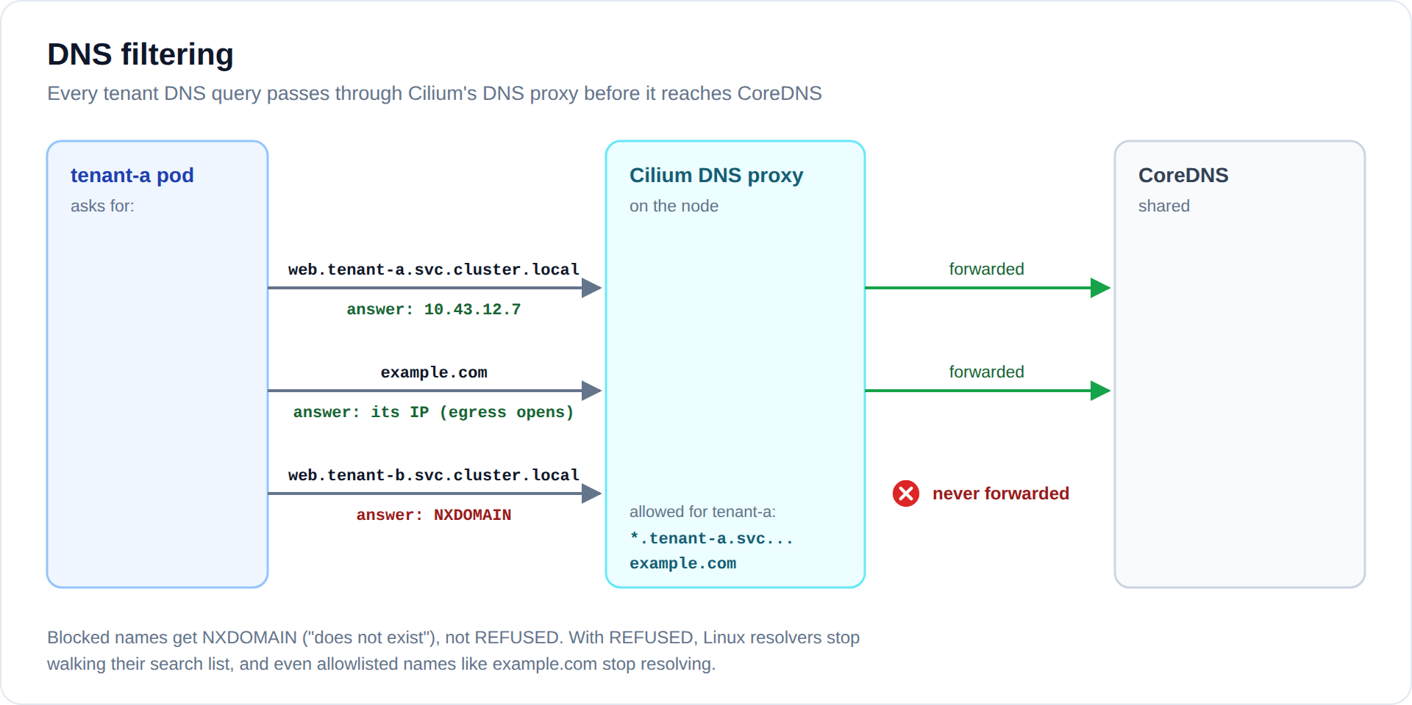
Diagram: images/cilium-dns.svg (or .png)
Because the policy contains DNS rules, every DNS query from a tenant pod goes through Cilium's DNS proxy first. Allowed names are forwarded to CoreDNS. Anything else is answered with NXDOMAIN ("this name does not exist"), so tenant-a cannot even discover which services tenant-b runs. The same lookups tell Cilium which IP addresses example.com uses, which is how the internet allowlist works.
Setting Cilium answers blocked names with REFUSED by default, which breaks normal lookups (Linux resolvers give up on REFUSED). We set dnsProxy.dnsRejectResponseCode: nameError in Cilium's Helm values.

Why Cilium alone is not enough
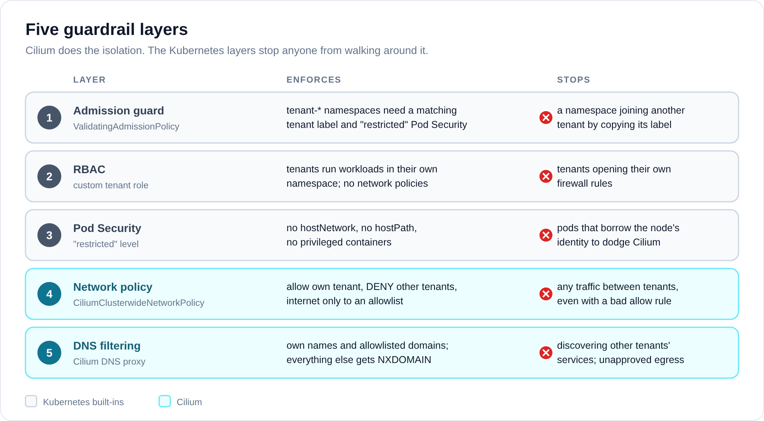
Diagram: images/cilium-layers.svg (or .png)
Cilium does the isolation, but someone could still walk around it. A pod with hostNetwork: true uses the node's network and identity instead of its own, and a tenant allowed to write network policies could open their own firewall. The three Kubernetes layers close those doors, so the two Cilium layers can do their job.

Ingress with kgateway
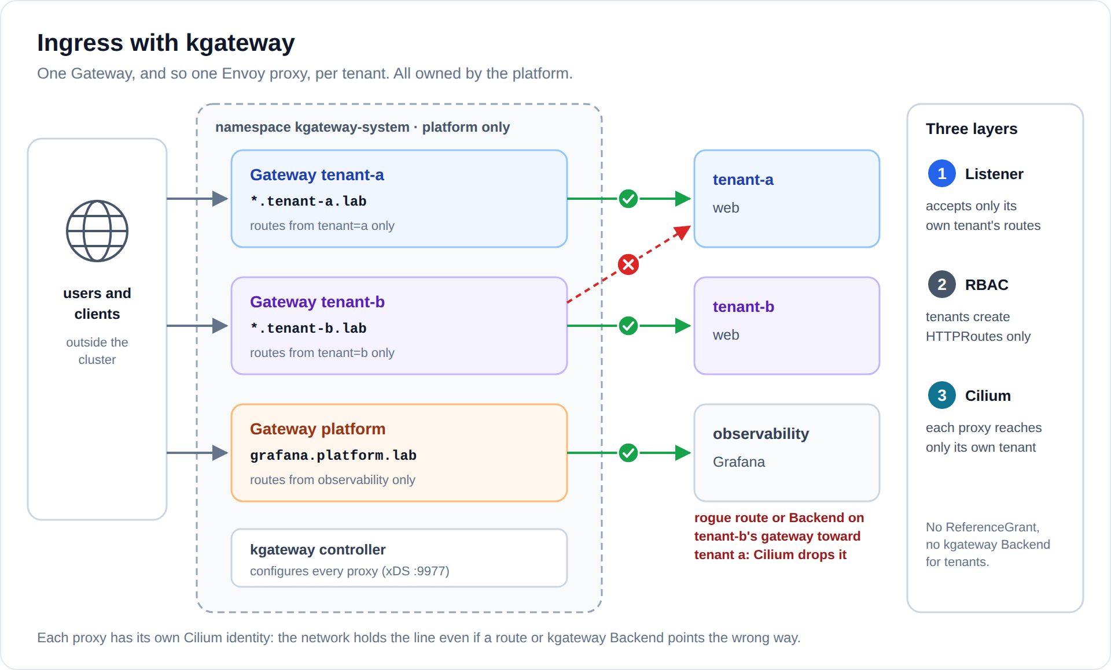
Diagram: images/cilium-kgateway.svg (or .png)
An ingress talks to every backend, which makes it the easiest place to lose isolation. So each tenant gets its own Gateway in kgateway, and with it its own Envoy proxy. The Gateways belong to the platform and live in kgateway-system. Tenants publish their apps by creating an HTTPRoute in their own namespace.
- Listener: tenant-a's Gateway only accepts routes from tenant-a's namespaces, so tenant-b cannot steal web.tenant-a... with a route of its own.
- RBAC: tenants may create HTTPRoutes and nothing else. No ReferenceGrant (which would let another tenant's route use your service), and no kgateway Backend (which can point at any host).
- Cilium: each proxy may only reach its own tenant, and each tenant only accepts its own proxy. Even a rogue route cannot cross over.
Why not one shared Gateway? Its proxy would need a way into every tenant, and on that hop Cilium would see a single identity. One proxy per tenant keeps the network in charge.
Inside the cluster Tenant pods cannot reach any gateway. The ingress is for traffic from outside; inside the cluster, pods use service names.

Try it yourself
What we check | Command (from tenant-a's client pod) | Expected
Same tenant works | curl -s http://web | "hello from tenant-a"
Other tenant is blocked | curl -s -m 3 http://<tenant-b pod IP>:8080 | timeout
Other tenant's names are hidden | dig web.tenant-b.svc.cluster.local | NXDOMAIN
Internet allowlist | curl -sI https://example.com and https://github.com | first works, second fails
See what Cilium dropped | hubble observe --verdict DROPPED --namespace tenant-a | the blocked flows
Gateway serves only its tenant | from outside: curl -H "Host: web.tenant-b..." <tenant-a gateway> | 404

Run the pod commands with kubectl -n tenant-a exec deploy/client -- <command>.

What soft tenancy does not do
- Shared kernel. A container escape on a node reaches every tenant's pods on that node.
- Shared DNS and Cilium agent. One tenant flooding DNS slows it down for everyone.
- Node resources. Quotas cap CPU and memory, not disk or network bandwidth.
- Admins see everything. Cluster admins and the Hubble UI are not tenant-aware.
If any of these is unacceptable for a tenant, that tenant needs hard tenancy: dedicated nodes or its own cluster.

Glossary
Term | Meaning
CNI | The network plugin of a Kubernetes cluster. Ours is Cilium.
eBPF | Small programs running inside the Linux kernel. Cilium uses them to check every packet quickly.
Identity | A number Cilium derives from a pod's labels. Policies are written against identities, not IPs.
CiliumClusterwideNetworkPolicy | A Cilium policy for the whole cluster, owned by the platform team.
toFQDNs | A policy rule that allows traffic to a DNS name (for example example.com) instead of an IP.
NXDOMAIN | The DNS answer "this name does not exist".
Pod Security (restricted) | Built-in Kubernetes check that rejects risky pods, such as ones using hostNetwork.
ValidatingAdmissionPolicy | A built-in Kubernetes rule that rejects objects which break our conventions.
Hubble | Cilium's flow viewer: shows which connections were allowed or dropped.
kgateway | Our gateway controller, an Envoy-based implementation of the Kubernetes Gateway API. It runs the tenant ingress and the internal read gateway of the observability stack.
Gateway / HTTPRoute | Gateway API objects: the platform owns the Gateway (the entry point); tenants attach HTTPRoutes to it.
ReferenceGrant | Lets routes in one namespace use services in another. Tenants cannot create them.

Next
- Part 2: Per-tenant observability: the basics (how each tenant sees only its own logs, metrics, traces and profiles).
- Full walkthrough with every manifest: Soft Multi-Tenancy on Kubernetes, step-by-step guide.

