Loki: per-tenant logs
In 30 seconds Loki stores the logs of every pod in the cluster, and keeps each tenant's logs in a separate space: its own index, storage, limits and queries. Alloy collects the logs on each node and names the tenant from the namespace. Users query through obs-gateway, a kgateway Gateway that names the tenant from an API key. Loki itself trusts whatever tenant a request names, so the network makes sure only those two can reach it.
Series Component page of the soft tenancy series. Read Per-tenant observability: the basics first: it explains the read gateway, the collectors and the Grafana organizations that every backend relies on.
On this page
- What Loki does here
- Where Loki sits
- How tenants are kept apart
- Write path: how logs get in
- Read path: how tenants query
- Our configuration
- Per-tenant limits
- Network lockdown
- Using Loki as a tenant
- How we verify it
- Troubleshooting
- Going to production
- FAQ
- Related

What Loki does here
Loki is our log backend. It indexes a few labels per stream and stores the log lines themselves compressed, in chunks. Queries use LogQL: pick streams by label, then filter or parse the lines.
Every log line gets these labels from Alloy:
Label | Comes from | Example
namespace | the pod's namespace | tenant-a
pod | the pod name | frontend-6d9f7c5b8-x2x4q
container | the container name | frontend
node | the node the pod runs on | worker-1

Key point The tenant is not a label. A label is just a filter that a query can leave out. The tenant is the X-Scope-OrgID header, and a query can never see outside it.

Where Loki sits
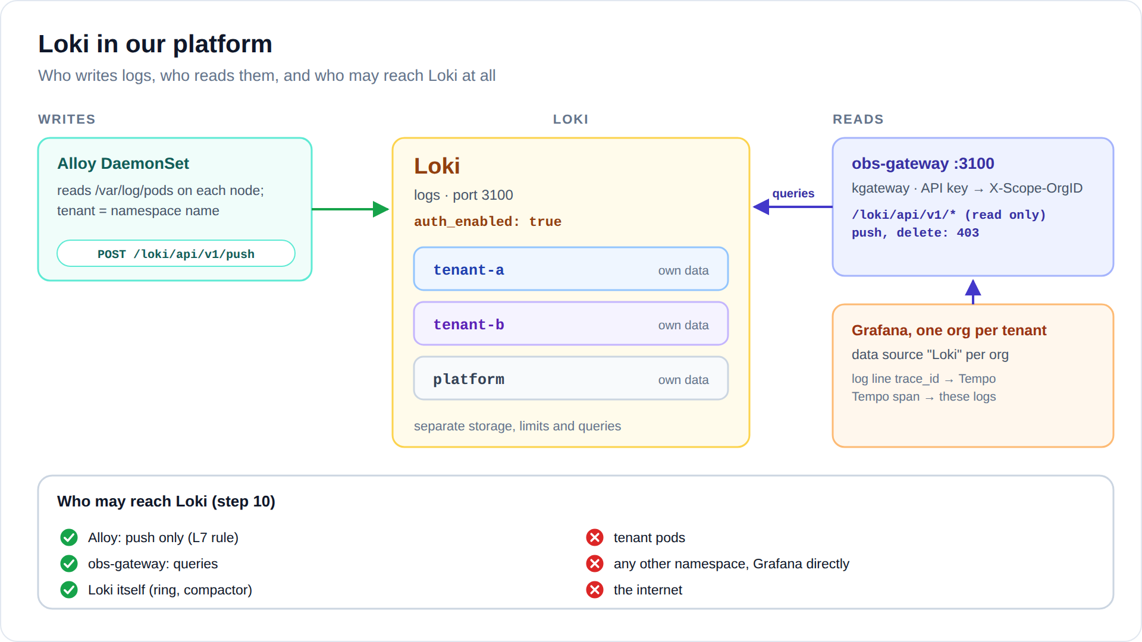
Diagram: images/loki-flow.svg (or .png)
- Writes: only Alloy, one pod per node, and only to the push endpoint.
- Reads: only obs-gateway (kgateway) on port 3100, which forwards Grafana's queries as the tenant whose key they carry.
- Everything else (tenant pods, other namespaces, even Grafana itself) is dropped by Cilium.

How tenants are kept apart
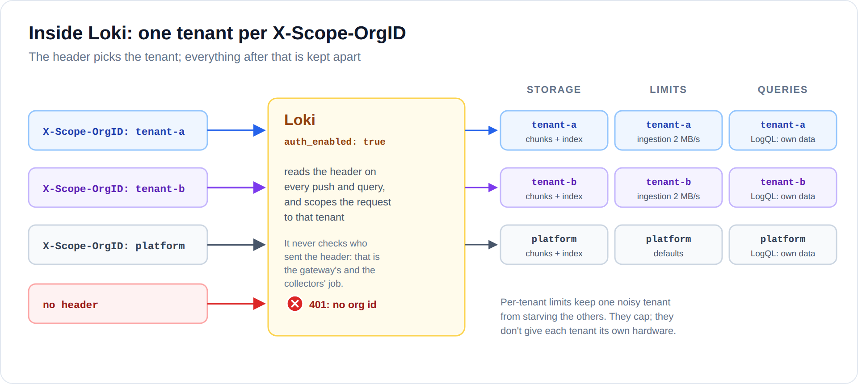
Diagram: images/loki-inside.svg (or .png)
One setting turns this on: auth_enabled: true. From then on, every push and every query must name its tenant in X-Scope-OrgID. A request without it gets 401 no org id.
Loki stores the tenant with every chunk and index entry (in object storage, the tenant ID is part of the path), and a query only ever reads the tenant it names. Loki can also query several tenants at once (X-Scope-OrgID: tenant-a|tenant-b); we keep that switched off.
loki:
auth_enabled: true # every request must name its tenant
querier:
multi_tenant_queries_enabled: false # "tenant-a|tenant-b" stays refused
Remember Loki does not check who sends the header. Anything that can reach Loki can name any tenant. That is why only Alloy and obs-gateway can reach it.

Write path: how logs get in
- Every container writes to stdout and stderr. The container runtime stores that on the node under /var/log/pods/<namespace>_<pod>_<uid>/<container>/.
- Alloy runs on every node. It finds the pods on its own node through the Kubernetes API and reads their log files (read-only hostPath).
- Each tenant_pipeline block keeps the namespaces that match its pattern and pushes them to Loki with its own tenant ID.
- Namespaces that match no tenant go to the platform tenant, never to a customer's.
loki.write "loki" {
endpoint {
url = "http://loki.observability.svc.cluster.local:3100/loki/api/v1/push"
tenant_id = argument.id.value // "tenant-a", "tenant-b" or "platform"
}
}
Tenants configure nothing: anything a container prints is collected. They cannot pick their tenant, because it comes from the namespace name, and the admission policy only lets tenant-a and tenant-a-* namespaces carry tenant a's label.
Why pull, not push If apps pushed their logs to Loki, each app would set X-Scope-OrgID itself, and could set any tenant. Reading the files from the node takes that choice away from them.

Read path: how tenants query
Grafana → the tenant org's Loki data source → obs-gateway port 3100, with the tenant's key → Loki, with X-Scope-OrgID set by the gateway. The gateway only lets read APIs through:
Request | Gateway answer
/loki/api/v1/query, query_range, labels, label/<name>/values, series, tail | forwarded, as the tenant the key belongs to (live tail works too)
/loki/api/v1/push | 403: the gateway is read-only
/loki/api/v1/delete | 403: deleting logs is a platform job
anything else (/config, /metrics, admin pages) | 404
no key, or an unknown one | 401

Queries may run for up to 300 seconds, and a live tail stays open as long as someone watches.
The data source links logs to traces. A log line that contains "trace_id":"..." gets a View trace button, which opens that trace in the same org's Tempo:
"derivedFields": [{
"name": "TraceID",
"matcherRegex": "\"trace_id\":\"(\\w+)\"",
"datasourceUid": "tempo-tenant-a",
"url": "${__value.raw}"
}]
It works the other way too: in Tempo, Logs for this span runs a Loki query for that service's container, filtered by the trace ID.

Our configuration
Loki runs as a single binary from the grafana/loki chart, with its data on a 5 GiB volume. The parts that matter:
deploymentMode: SingleBinary
loki:
auth_enabled: true
storage:
type: filesystem
limits_config: # every tenant
ingestion_rate_mb: 4
ingestion_burst_size_mb: 8
max_global_streams_per_user: 5000
retention_period: 72h
runtimeConfig:
overrides: # per tenant
tenant-a: {ingestion_rate_mb: 2}
tenant-b: {ingestion_rate_mb: 2}
compactor:
retention_enabled: true # really deletes logs older than retention_period

Chart defaults we switch off
Setting | Why it is off
sidecar.rules.enabled: false | The rules sidecar watches loki_rule ConfigMaps in every namespace, tenants included, and comes with a ClusterRole that can read every Secret in the cluster.
serviceAccount.automountServiceAccountToken: false, rbac.namespaced: true | Without the sidecar, Loki never calls the Kubernetes API. No token, and no cluster-wide RBAC.
gateway.enabled: false | The chart's own gateway routes requests but does not tie them to a tenant. obs-gateway (kgateway) does.
chunksCache, resultsCache, lokiCanary, minio | Not needed for a lab. See "Going to production".
analytics.reporting_enabled: false | No usage reports leave the cluster.

Files in the lab
File | What it holds
06-observability-backends/loki-values.yaml | Loki itself: tenancy, limits, retention
08-collectors/alloy-values.yaml | log collection and the tenant_pipeline blocks
07-read-gateway/gateway.yaml | obs-gateway, port 3100
09-grafana/setup-orgs.sh | the Loki data source of each org
10-observability-lockdown/policies.yaml | the loki network policy

Per-tenant limits
All tenants share one Loki, so limits stop one noisy tenant from starving the others. Defaults for everyone live in limits_config. Per-tenant values live in runtimeConfig.overrides, which Loki reloads on its own, without a restart.
Limit | Here | When a tenant goes over it
ingestion_rate_mb | 4 MB/s (tenant-a, tenant-b: 2) | pushes get 429; Alloy retries, and lines can be dropped if it keeps up
ingestion_burst_size_mb | 8 MB | short bursts above the rate are fine up to this size
max_global_streams_per_user | 5000 | new streams (label combinations) are refused
retention_period | 72h | the compactor deletes older logs

Example: give tenant-b 30 days of logs.
runtimeConfig:
overrides:
tenant-b:
ingestion_rate_mb: 2
retention_period: 720h # 30 days, for tenant-b only
Limits cap, they don't reserve A tenant under its limits can still feel a busy Loki. Guaranteed capacity per tenant means separate backends, which is hard tenancy.

Network lockdown
The Cilium policy loki in the observability namespace decides who may reach Loki on port 3100:
From | Allowed | Why
Alloy | POST /loki/api/v1/push only (L7 rule) | writes logs; cannot read any
obs-gateway | port 3100 | the gateway does the filtering
Loki itself | yes | ring and compactor traffic
tenant pods, other namespaces, Grafana, the internet | dropped

- fromEndpoints:
- matchLabels:
app.kubernetes.io/name: alloy
toPorts:
- ports: [{port: "3100", protocol: TCP}]
rules:
http:
- method: POST
path: /loki/api/v1/push
Because of the L7 rule, even a compromised Alloy cannot read anyone's logs: Cilium's proxy answers any other request with 403. Pod labels are safe to use here, because only the platform can create pods in the observability namespace.

Using Loki as a tenant
In Grafana, open Explore and pick the Loki data source. Every query only sees your own tenant; the namespace label just narrows it down further.
What you want | LogQL
All logs of the frontend | {namespace="tenant-a", container="frontend"}
Only request lines that carry a trace | {container="frontend"} |= "trace_id"
Parse the JSON and filter on a field | {container="frontend"} | json | method="POST"
Anything that looks like an error, in all your namespaces | {namespace=~"tenant-a.*"} |~ "(?i)error"
Log lines per container over time (a graph) | sum by (container) (count_over_time({namespace="tenant-a"}[5m]))

Click Live in Explore to tail logs as they arrive. On a line with a trace ID, click View trace.

How we verify it
11-verify-observability.sh runs these checks after every change. The Loki part:
Check | Expected
tenant-a lists the namespaces it has logs for | only tenant-a
tenant-a's key plus the header X-Scope-OrgID: tenant-b | still only tenant-a
no key, or an unknown key | refused (401)
push through the gateway | refused (403)
a tenant-a pod connects to Loki on 3100 | dropped
a pod in default connects to Loki | dropped
a pod with Alloy's identity queries Loki | 403 from the L7 rule
a tenant-a log line's trace_id, opened in Tempo | found for tenant-a, empty for tenant-b
alice in Grafana lists log namespaces | only tenant-a

To try it by hand, from the repository root:
kubectl -n observability port-forward svc/obs-gateway 3100:3100 &
source .state/soft-tenancy/credentials.env
curl -s -H "X-Api-Key: ${OBS_KEY_TENANT_A}" \
http://127.0.0.1:3100/loki/api/v1/label/namespace/values | jq .data
curl -s -H "X-Api-Key: ${OBS_KEY_TENANT_A}" -H 'X-Scope-OrgID: tenant-b' \
http://127.0.0.1:3100/loki/api/v1/label/namespace/values | jq .data # still tenant-a
curl -s -o /dev/null -w '%{http_code}\n' http://127.0.0.1:3100/loki/api/v1/labels # 401

Troubleshooting
Symptom | Likely cause | What to do
no org id (401) | The request reached Loki without X-Scope-OrgID: it skipped the gateway, or a pipeline has no tenant_id. | Query through the gateway. Check tenant_id in loki.write.
Grafana: 401 on the Loki data source | The gateway key in the data source does not match the obs-gateway-keys Secret. | Re-run 07-read-gateway/install.sh, then 09-grafana/setup-orgs.sh.
A new namespace has no logs | It matches no tenant, so its logs are in platform. | Check the name: tenant-a-dev matches tenant a on its own. Otherwise add a tenant_pipeline.
ingestion rate limit exceeded in Alloy's logs | The tenant pushes more than its limit. | Find the noisy container. Raise the tenant's override if that is justified.
Maximum active stream limit exceeded | Too many label combinations. | Never turn IDs, IPs or user names into labels; filter the line instead.
Logs older than 3 days are gone | Retention is 72h. | Set retention_period for that tenant.
No View trace button on a line | The line has no "trace_id":"...". Only requests inside a span log one. | Expected for other lines.
Alloy push timeouts | Cilium drops the push, for example after a label change. | hubble observe --to-namespace observability --verdict DROPPED

Going to production
- Deployment mode: switch to Simple Scalable or Distributed, with a replication factor of 3.
- Object storage: S3, GCS or Azure instead of a volume. Each tenant's data sits under its own prefix in the bucket.
- Caches: turn the chunks and results caches back on.
- Authentication: API keys are simple but static: rotate them, and keep them in a secrets manager. For callers other than Grafana, kgateway also offers JWT and external auth, for example an OIDC login that maps a group to a tenant. Keep the rule: the tenant comes from the credential, never from the client.
- Per-tenant retention and limits: size them from real usage, in the runtime overrides. Deletes stay a platform job.
- Alerting: Grafana-managed alert rules created inside a tenant's org query through that org's data source, so they are tenant-scoped already. Loki's own ruler is multi-tenant too, but is not set up in the lab.

FAQ
Can alice query {namespace="tenant-b"}? She can type it, but it returns nothing. Tenant-b's logs are not in tenant-a's space.
Can a tenant hide logs from Loki? Only by not printing them. Alloy reads the files from the node, not from the app.
Can a tenant add its own labels? No, the pipeline sets them. A tenant can parse its own JSON fields at query time with | json.
Where do kube-system logs go? To the platform tenant. Only the Platform org can query it.
Can the platform team read tenant logs? Through Grafana, no: the Platform org only sees platform. Cluster admins can, with a port-forward straight to Loki. That is the trust model of soft tenancy.

Related
- Per-tenant observability: the basics (the whole stack on one page).
- The other component pages: Mimir, Tempo, Pyroscope.
- Soft tenancy with Cilium: the basics (how tenants are kept apart on the network).
- The lab: soft-tenancy/ in the instant-rke2-lab repository, steps 06 to 11.

