Mimir: per-tenant metrics
In 30 seconds Mimir stores metrics and answers PromQL, just like Prometheus. It keeps each tenant's series in a separate space: its own blocks, limits and queries. Two things write to it: Alloy, which scrapes the pods that opt in, and Tempo, which turns each tenant's spans into service-graph metrics. Users query through obs-gateway. Mimir trusts whatever tenant a request names, so the network makes sure only those three can reach it.
Series Component page of the soft tenancy series. Read Per-tenant observability: the basics first: it explains the read gateway, the collectors and the Grafana organizations that every backend relies on.
On this page
- What Mimir does here
- Where Mimir sits
- How tenants are kept apart
- Write path: how metrics get in
- Read path: how tenants query
- Our configuration
- Per-tenant limits
- Network lockdown
- Using Mimir as a tenant
- How we verify it
- Troubleshooting
- Going to production
- FAQ
- Related

What Mimir does here
Mimir is our metrics backend: Prometheus-compatible, long-term, and multi-tenant. Grafana talks to it with the normal Prometheus data source and PromQL.
Source | Metrics | Tenant from
Alloy, scraping pods that opt in | app metrics such as http_request_duration_seconds_* and http_requests_total, Go runtime (go_*, process_*), and up | the namespace name
Tempo's metrics generator | traces_service_graph_* (who calls whom) and traces_spanmetrics_* (rate, errors, latency per span) | the tenant of the spans

Alloy adds namespace, pod and container labels to every scraped series.

Where Mimir sits
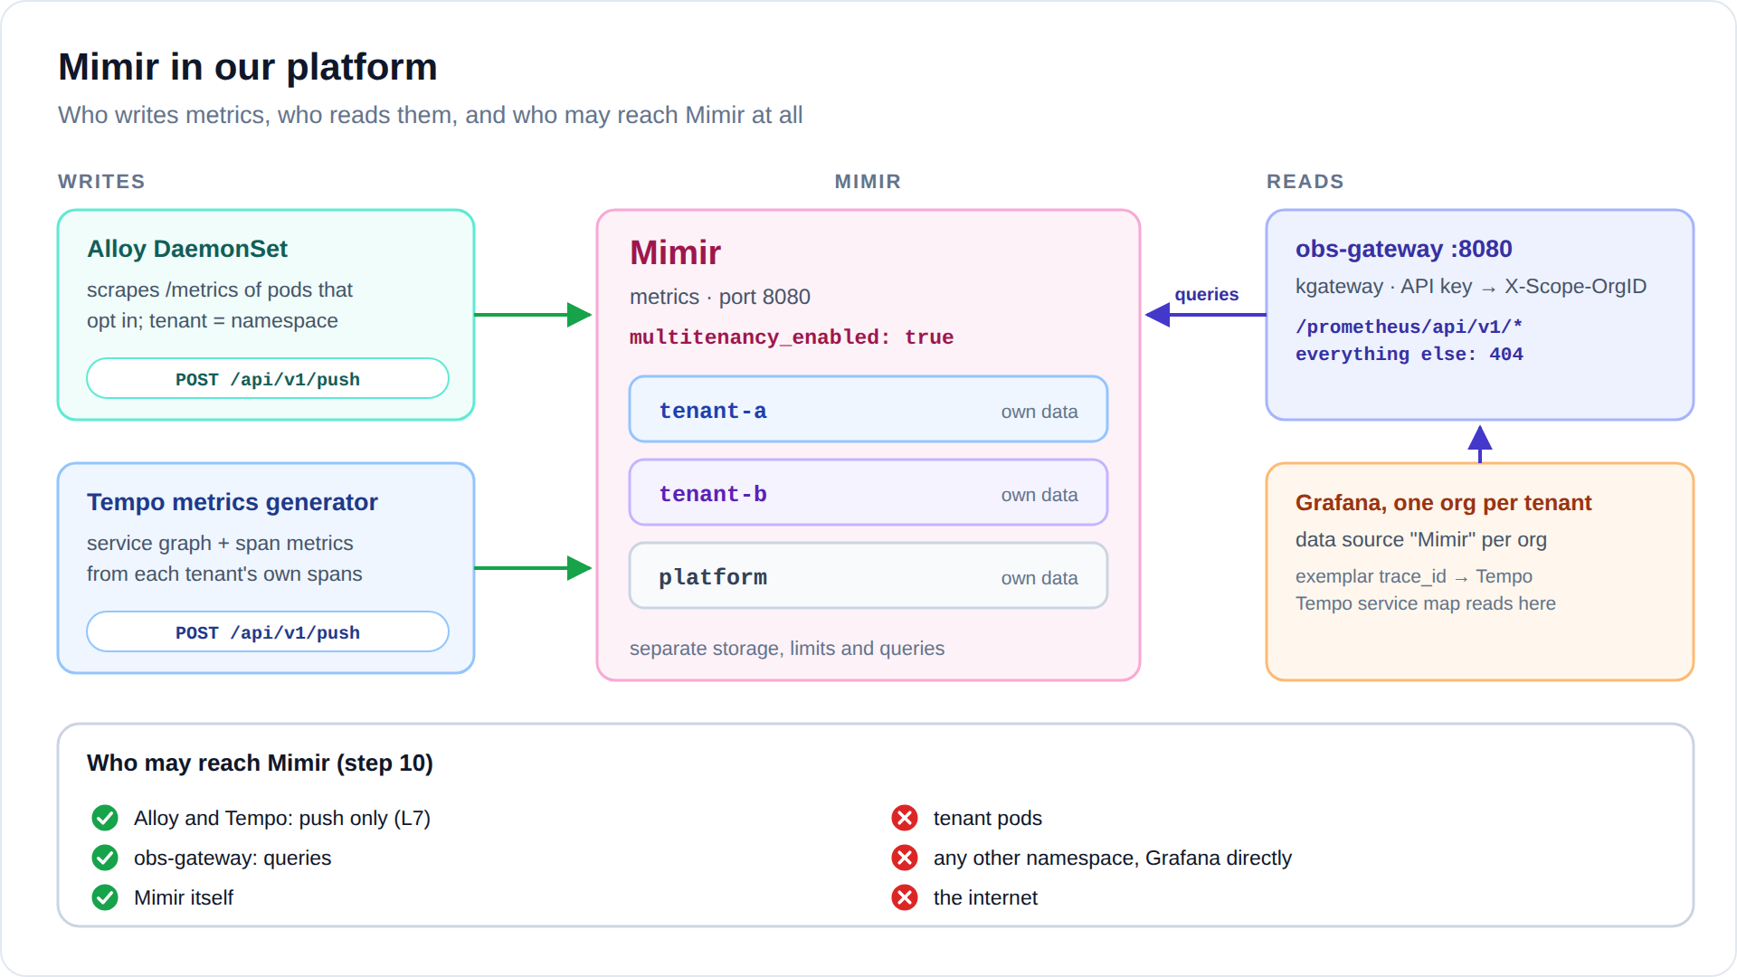
Diagram: images/mimir-flow.svg (or .png)
- Writes: Alloy (scraped metrics) and Tempo (service graph), each only to the push endpoint.
- Reads: only obs-gateway (kgateway) on port 8080, and only the Prometheus query API.
- Everything else is dropped by Cilium, including Grafana talking to Mimir directly.

How tenants are kept apart
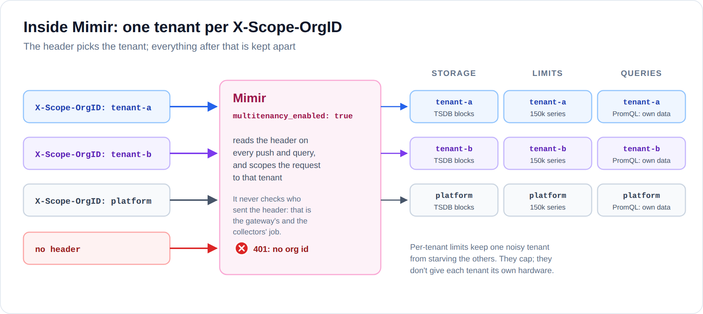
Diagram: images/mimir-inside.svg (or .png)
The switch is multitenancy_enabled: true. Every push and every query must name its tenant in X-Scope-OrgID; without it, Mimir answers 401 no org id.
Each tenant gets its own in-memory series, its own blocks on disk (its own prefix in object storage), and its own limits. A query reads only the tenant it names. Mimir can also run queries across tenants (tenant-a|tenant-b), but only with tenant federation switched on. It is off by default, and we leave it off.
Remember Mimir does not check who sends the header. That is why only Alloy, Tempo and obs-gateway can reach it.

Write path: how metrics get in

From Alloy
A pod opts in with two annotations. Alloy on the pod's node scrapes it every 30 seconds and pushes the samples to Mimir with its tenant pipeline's ID:
metadata:
annotations:
prometheus.io/scrape: "true"
prometheus.io/port: "9898" # must be a declared containerPort
# prometheus.io/path: /metrics # optional; /metrics is the default
prometheus.remote_write "mimir" {
endpoint {
url = "http://mimir.observability.svc.cluster.local:8080/api/v1/push"
headers = { "X-Scope-OrgID" = argument.id.value }
}
}
Pod discovery gives one target per container port. A relabel rule keeps only the port the annotation names, so each pod is scraped once, on the port it chose.

From Tempo
Tempo's metrics generator reads each tenant's spans and writes service-graph and span metrics to Mimir. It adds the tenant of the spans as X-Scope-OrgID (Tempo does that by default), so tenant-a's service map lands in tenant-a's metrics and nowhere else.

Read path: how tenants query
Grafana → the org's Mimir data source → obs-gateway port 8080, with the tenant's key → Mimir. The gateway's Mimir listener forwards the Prometheus query API and nothing else:
Request | Gateway answer
/prometheus/api/v1/query, query_range, labels, label/<name>/values, series, metadata, query_exemplars | forwarded, as the tenant the key belongs to
/api/v1/push | 404: no pushes through the gateway
rules and Alertmanager APIs, admin pages, /metrics | 404
no key, or an unknown one | 401

The data source is a normal Prometheus data source, flagged as Mimir. The URL must end in /prometheus, and the key travels in a custom header, stored encrypted:
{
"name": "Mimir", "uid": "mimir-tenant-a", "type": "prometheus",
"url": "http://obs-gateway.observability.svc.cluster.local:8080/prometheus",
"jsonData": {
"prometheusType": "Mimir", "httpMethod": "POST",
"httpHeaderName1": "X-Api-Key",
"exemplarTraceIdDestinations": [
{"name": "trace_id", "datasourceUid": "tempo-tenant-a"}
]
},
"secureJsonData": {"httpHeaderValue1": "<tenant-a's gateway key>"}
}
When a metric carries exemplars, each exemplar links to its trace in the same org's Tempo. Tempo's service map also reads its data from this data source.

Our configuration
Mimir's only Helm chart deploys the full microservices setup with object storage. For the lab we run a single binary instead (-target=all), from a plain StatefulSet, which keeps the tenancy model easy to see:
multitenancy_enabled: true
limits: # defaults for every tenant
max_global_series_per_user: 150000
ingestion_rate: 20000 # samples per second
compactor_blocks_retention_period: 72h
usage_stats:
enabled: false # no usage reports leave the cluster
- Storage: the local filesystem, on a 5 GiB volume.
- Runs as UID 10001 with a read-only root filesystem. Mimir writes some files relative to its working directory, so workingDir is the data volume.
- No service account token: Mimir never calls the Kubernetes API.

Files in the lab
File | What it holds
06-observability-backends/mimir.yaml | ConfigMap, StatefulSet and Service
08-collectors/alloy-values.yaml | scraping and prometheus.remote_write
06-observability-backends/tempo-values.yaml | the metrics generator that writes to Mimir
07-read-gateway/gateway.yaml | obs-gateway, port 8080
10-observability-lockdown/policies.yaml | the mimir network policy

Per-tenant limits
The lab gives every tenant the same defaults:
Limit | Here | When a tenant goes over it
max_global_series_per_user | 150,000 | new series are refused (error err-mimir-max-series-per-user)
ingestion_rate | 20,000 samples/s | pushes get 429 (error err-mimir-tenant-max-ingestion-rate)
compactor_blocks_retention_period | 72h | older blocks are deleted

To give one tenant different values, add a runtime config file with an overrides section. Mimir reloads it on its own, without a restart:
# mimir.yaml ConfigMap: a second file next to mimir.yaml
runtime.yaml: |
overrides:
tenant-a:
max_global_series_per_user: 300000
ingestion_rate: 40000
tenant-b:
compactor_blocks_retention_period: 720h # 30 days

# StatefulSet: one more argument
args: ["-config.file=/etc/mimir/mimir.yaml", "-target=all",
"-runtime-config.file=/etc/mimir/runtime.yaml"]
The usual culprit Hitting the series limit almost always means a label with too many values: request IDs, user IDs, full URLs. Fix the label in the app before raising the limit.

Network lockdown
The Cilium policy mimir decides who may reach Mimir on port 8080:
From | Allowed | Why
Alloy | POST /api/v1/push only (L7 rule) | writes scraped metrics; cannot read
Tempo | POST /api/v1/push only (L7 rule) | writes service-graph metrics
obs-gateway | port 8080 | the gateway does the filtering
Mimir itself | yes | its internal ring
tenant pods, other namespaces, Grafana, the internet | dropped

10-observability-lockdown/attack-demo.sh shows why this matters: before step 10, a pod in default reads tenant-b's metrics just by sending X-Scope-OrgID: tenant-b. After step 10, the same request times out.

Using Mimir as a tenant
In Grafana, open Explore and pick Mimir. You never need namespace= to stay inside your tenant; use it to narrow things down.
What you want | PromQL
Request rate by status code | sum by (status) (rate(http_request_duration_seconds_count{namespace="tenant-a"}[5m]))
95th percentile latency per service | histogram_quantile(0.95, sum by (le, container) (rate(http_request_duration_seconds_bucket[5m])))
Share of failing requests | sum(rate(http_requests_total{status=~"5.."}[5m])) / sum(rate(http_requests_total[5m]))
Is every target scraped? | up (0 means the scrape fails)
Who calls whom (service graph) | sum by (client, server) (rate(traces_service_graph_request_total[5m]))
Calls per span, from traces | sum by (service, span_name) (rate(traces_spanmetrics_calls_total[5m]))
Your biggest metrics (series count) | topk(10, count by (__name__) ({__name__=~".+"}))

Alert rules created in your org (Grafana-managed alerts) query through the same data source, so they only ever see your tenant.

How we verify it
11-verify-observability.sh runs these checks after every change. The Mimir part:
Check | Expected
tenant-a lists the namespaces it has metrics for | only tenant-a
tenant-a's key plus X-Scope-OrgID: tenant-b | still only tenant-a
no key, or an unknown key | refused (401)
push through the gateway | refused
a pod with Alloy's identity pushes / queries | push passes the L7 rule; query gets 403
a tenant-a pod connects to Mimir on 8080 | dropped
a pod in default connects to Mimir (the attack) | dropped
service graph frontend → backend, as tenant-a | present
podinfo request metrics, as tenant-a | present
ops (Platform org) lists namespaces | no tenant namespaces
alice and bob in Grafana list metric namespaces | only their own tenant

By hand, from the repository root:
kubectl -n observability port-forward svc/obs-gateway 8080:8080 &
source .state/soft-tenancy/credentials.env
curl -s -H "X-Api-Key: ${OBS_KEY_TENANT_A}" \
http://127.0.0.1:8080/prometheus/api/v1/label/namespace/values | jq .data
curl -s -H "X-Api-Key: ${OBS_KEY_TENANT_A}" --data-urlencode 'query=up' \
http://127.0.0.1:8080/prometheus/api/v1/query | jq '.data.result[].metric.namespace'

Troubleshooting
Symptom | Likely cause | What to do
A pod's metrics are missing | Annotations missing, or prometheus.io/port is not a declared containerPort. | Declare the port in the container spec. Check the targets in the UI of the Alloy pod on that node (port 12345).
err-mimir-max-series-per-user | Too many active series, usually one label with too many values. | Fix the label at the source; raise the tenant's limit only if justified.
err-mimir-tenant-max-ingestion-rate (429) | The tenant pushes faster than ingestion_rate. | Same as above.
Grafana data source test fails with 404 | The URL does not end in /prometheus. | Re-run 09-grafana/setup-orgs.sh.
Grafana data source test fails with 401 | The key in the data source does not match the gateway's Secret. | Re-run 07-read-gateway/install.sh, then 09-grafana/setup-orgs.sh.
Service graph is empty | It needs both sides of a call in one trace, a few minutes of traffic, and Tempo allowed to write to Mimir. | Check Tempo's logs for remote-write errors.
Mimir crash-loops with "read-only file system" | It writes files relative to its working directory. | Keep workingDir: /data.
no org id (401) | The request reached Mimir without the header. | Go through the gateway.

Going to production
- The mimir-distributed chart: separate distributors, ingesters, queriers, store-gateways and compactor, with a replication factor of 3.
- Object storage: each tenant's blocks sit under its own prefix in the bucket.
- Per-tenant limits: set through the chart's runtime config, sized from real usage. Add max_global_series_per_metric to catch one exploding metric.
- Shuffle sharding: limits how many ingesters one tenant uses, so a noisy tenant cannot slow down all of them.
- Alerting: Grafana-managed alerts per org work as they are. Mimir's own ruler and Alertmanager are multi-tenant too, but their APIs would have to be exposed per tenant through the gateway.

FAQ
What if tenant-a's app exports a metric labelled namespace="tenant-b"? It still lands in tenant-a's space. Alloy also renames the app's label to exported_namespace, because the target's own namespace label wins.
Can tenants see node or cluster metrics? Not in the lab. Cluster-wide metrics (nodes, kube-state-metrics) belong to platform. Giving tenants their own pods' resource usage means copying those series into each tenant, filtered by namespace: a platform job.
Why may Tempo write to Mimir? For the service map. It writes each tenant's service-graph metrics into that same tenant.
Why does the data source use POST? Long PromQL queries fit in a POST body. The gateway allows any method on the query API.

Related
- Per-tenant observability: the basics (the whole stack on one page).
- The other component pages: Loki, Tempo, Pyroscope.
- Soft tenancy with Cilium: the basics (how tenants are kept apart on the network).
- The lab: soft-tenancy/ in the instant-rke2-lab repository, steps 06 to 11.

