Tempo: per-tenant traces
In 30 seconds Tempo stores traces: the path of one request through frontend and backend. Each tenant's traces live in a separate space, and a trace ID from another tenant finds nothing. Traces are the one signal apps push themselves, so each tenant pushes to its own small OTLP receiver, and the receiver stamps the tenant. Tempo also turns each tenant's spans into service-graph metrics in Mimir, under the same tenant.
Series Component page of the soft tenancy series. Read Per-tenant observability: the basics first: it explains the read gateway, the collectors and the Grafana organizations that every backend relies on.
On this page
- What Tempo does here
- Where Tempo sits
- How tenants are kept apart
- Write path: how traces get in
- Read path: how tenants query
- Our configuration
- Per-tenant limits
- Network lockdown
- Using Tempo as a tenant
- How we verify it
- Troubleshooting
- Going to production
- FAQ
- Related

What Tempo does here
A trace is one request's journey; each step in it is a span. In our workload, the client calls the frontend, and the frontend's /echo calls the backend, so a typical trace has spans from both services. Some calls are slow (/delay/1) and some fail (/status/500), which gives the team something to look for.
Apps send spans with OTLP, OpenTelemetry's protocol. Tempo stores them, finds them by trace ID, and searches them with TraceQL. Tempo runs as a single binary from the grafana-community/tempo chart.

Where Tempo sits
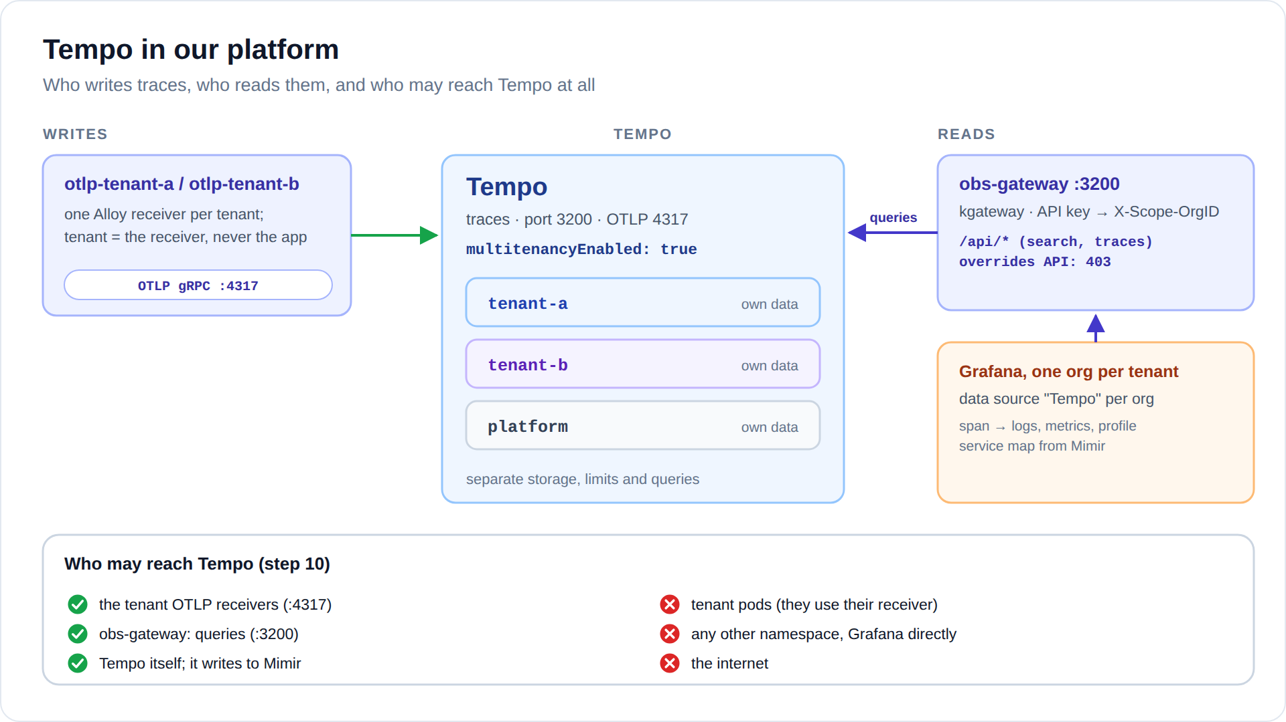
Diagram: images/tempo-flow.svg (or .png)
- Writes: only the tenant OTLP receivers (otlp-tenant-a, otlp-tenant-b), on OTLP gRPC port 4317.
- Reads: only obs-gateway (kgateway) on port 3200, and only the query API.
- Tempo writes too: its metrics generator pushes service-graph metrics to Mimir.
- Tenant pods cannot reach Tempo at all. They reach their own receiver, and nothing else in the observability namespace.

How tenants are kept apart
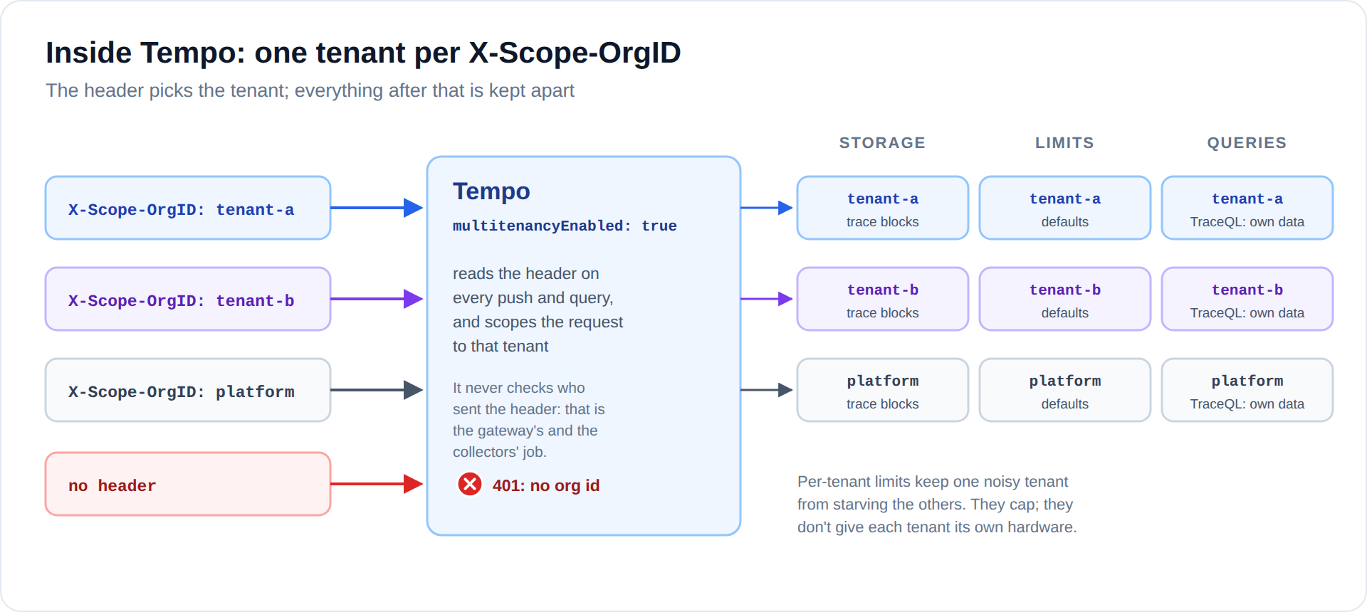
Diagram: images/tempo-inside.svg (or .png)
The chart value multitenancyEnabled: true sets multitenancy_enabled in Tempo's configuration. Every push and every query must then name its tenant in X-Scope-OrgID; without it, Tempo answers 401.
Everything happens per tenant: storage, search, trace ID lookups, and the metrics generator. A trace ID is only looked up inside the requesting tenant, so tenant-b asking for one of tenant-a's trace IDs gets an empty trace. Trace IDs are not secrets, and they don't need to be.

Write path: how traces get in
- The app sends its spans over OTLP gRPC to its tenant's receiver, otlp-tenant-a.observability.svc.cluster.local:4317.
- Tenant a's DNS rule allows exactly that name, and Cilium lets tenant a's pods reach only that receiver, on port 4317.
- The receiver, a small Alloy, batches the spans and forwards them to Tempo with X-Scope-OrgID taken from its own TENANT variable. Nothing the app sends in its headers is forwarded.
- Tempo accepts spans only from the receivers.
In the app, two environment variables are enough:
env:
- name: OTEL_EXPORTER_OTLP_ENDPOINT
value: http://otlp-tenant-a.observability.svc.cluster.local:4317
- name: OTEL_EXPORTER_OTLP_INSECURE
value: "true"
And in the receiver, the tenant is fixed per Deployment:
otelcol.exporter.otlp "tempo" {
client {
endpoint = "tempo.observability.svc.cluster.local:4317"
headers = { "X-Scope-OrgID" = sys.env("TENANT") } // tenant-a or tenant-b
}
}
Why one receiver per tenant A shared receiver could only learn the tenant from the request, which means trusting the app. With one receiver per tenant, the network is the proof: only tenant a's pods can reach otlp-tenant-a, so whatever arrives there is tenant a's.
A new tenant needs one more receiver (a Deployment and a Service with its own TENANT), its own Cilium policy, and the receiver's DNS name and port in the tenant's baseline policy.

Service graphs, from spans
Tempo's metrics generator runs two processors for every tenant: service-graphs (who calls whom, how often, how slowly) and span-metrics (rate, errors and duration per span). It writes the results to Mimir under the same tenant.

Read path: how tenants query
Grafana → the org's Tempo data source → obs-gateway port 3200, with the tenant's key → Tempo.
Request | Gateway answer
/api/search, /api/v2/traces/<id>, /api/search/tags, tag values, and the rest of /api/* | forwarded, as the tenant the key belongs to
/api/overrides | 403: tenants must not change their own limits
anything outside /api/ (for example /flush, /shutdown, /metrics) | 404
OTLP pushes | not on the gateway at all
no key, or an unknown one | 401

The Tempo data source ties the four signals together, always inside the same org:
Link | Set up as | What alice gets
Trace → logs | tracesToLogsV2: Loki, tag service.name → label container, ±5 minutes, filtered by trace ID | Logs for this span: that container's lines for this trace
Trace → metrics | tracesToMetrics: Mimir | a jump to that service's metrics
Trace → profile | tracesToProfiles: Pyroscope, service.name → service_name, CPU | the service's CPU flame graph for the span's time
Service map | serviceMap: Mimir | frontend → backend, with rates and errors
Node graph | on | one trace drawn as a graph
Streaming | off | search uses the plain HTTP API, the only part the gateway forwards

Naming rule These links only work because names line up: the container name is the OpenTelemetry service.name (--otel-service-name=frontend) and the Pyroscope service_name. Keep them equal in every app.

Our configuration
tempo:
multitenancyEnabled: true
reportingEnabled: false
metricsGenerator:
enabled: true
remoteWriteUrl: "http://mimir.observability.svc.cluster.local:8080/api/v1/push"
overrides:
defaults: # every tenant
metrics_generator:
processors: [service-graphs, span-metrics]
retention: 72h
persistence:
enabled: true
size: 5Gi
The receivers stay at the chart defaults (OTLP and Jaeger); the chart expects that block. Only OTLP gRPC on 4317 is reachable, and only from the tenant receivers.

Files in the lab
File | What it holds
06-observability-backends/tempo-values.yaml | Tempo: tenancy, metrics generator, retention
08-collectors/otlp-receivers.yaml | the per-tenant OTLP receivers
03-tenant-isolation/tenant-a.yaml, tenant-b.yaml | each tenant's DNS and egress rule for its receiver
04-demo-apps/ | podinfo with its OTLP settings
07-read-gateway/gateway.yaml | obs-gateway, port 3200
10-observability-lockdown/policies.yaml | the tempo, otlp-tenant-a and otlp-tenant-b policies

Per-tenant limits
overrides.defaults applies to every tenant; the lab uses it only to switch on the metrics generator. Per-tenant values go in per_tenant_overrides:
tempo:
per_tenant_overrides:
tenant-b:
ingestion:
rate_limit_bytes: 5000000 # 5 MB/s of spans
burst_size_bytes: 10000000
global:
max_bytes_per_trace: 2000000 # one huge trace can't use up the budget
compaction:
block_retention: 168h # tenant-b keeps 7 days
The per-tenant receivers are a limit of their own: each has its own CPU and memory limits, so a flood of spans from tenant-a fills tenant-a's receiver, not tenant-b's.

Network lockdown
From → to | Allowed | Policy
tenant-a pods → otlp-tenant-a:4317 | yes | tenant-a baseline, otlp-tenant-a
tenant-a pods → otlp-tenant-b | dropped (and the name does not resolve) | otlp-tenant-b accepts only tenant b
tenant receivers → Tempo:4317 | yes | tempo
obs-gateway → Tempo:3200 | yes | tempo
Tempo → Mimir:8080 | yes, push only | tempo egress, mimir L7 rule
tenant pods → Tempo directly | dropped | tempo
anything else, the internet | dropped | default deny

# otlp-tenant-a: accepts only tenant a, forwards only to Tempo
ingress:
- fromEndpoints:
- matchLabels:
k8s:io.cilium.k8s.namespace.labels.tenant: a
toPorts:
- ports: [{port: "4317", protocol: TCP}]
egress:
- toEndpoints:
- matchLabels:
k8s:io.kubernetes.pod.namespace: observability
app.kubernetes.io/name: tempo
toPorts:
- ports: [{port: "4317", protocol: TCP}]
This policy selects the namespace label tenant, so a new namespace like tenant-a-dev can use tenant a's receiver right away.

Using Tempo as a tenant
In Grafana, open Explore, pick Tempo, and use Search or type TraceQL:
What you want | TraceQL
All frontend traces | { resource.service.name = "frontend" }
Failed requests | { status = error }
Slow requests (the /delay/1 calls) | { duration > 900ms }
Frontend requests that reached the backend | { resource.service.name = "frontend" } >> { resource.service.name = "backend" }
Slow backend spans | { resource.service.name = "backend" && duration > 100ms }

Open a trace and click a span: Logs for this span opens Loki, Profiles opens the service's CPU flame graph. The Service graph tab shows frontend → backend with request rates and errors. A trace ID from a log line opens directly.

How we verify it
11-verify-observability.sh runs these checks after every change. The Tempo part:
Check | Expected
tenant-a opens one of its own traces | spans returned
tenant-b opens that same trace ID | empty
tenant-a opens one of tenant-b's trace IDs | empty
tenant-a's key plus X-Scope-OrgID: tenant-b | still tenant-a only
no key, or an unknown key | refused (401)
the overrides API through the gateway | refused (403)
a tenant-a log line's trace_id | opens for tenant-a, empty for tenant-b
service graph frontend → backend, as tenant-a | present in Mimir
tenant-a pod → its own receiver / tenant-b's receiver | connects / dropped
tenant-a pod → Tempo directly | dropped
pod in default → Tempo, or → a receiver | dropped

By hand, from the repository root:
kubectl -n observability port-forward svc/obs-gateway 3200:3200 &
source .state/soft-tenancy/credentials.env
KA="X-Api-Key: ${OBS_KEY_TENANT_A}"; KB="X-Api-Key: ${OBS_KEY_TENANT_B}"
ID=$(curl -s -H "$KA" 'http://127.0.0.1:3200/api/search?limit=1' | jq -r '.traces[0].traceID')
curl -s -H "$KA" "http://127.0.0.1:3200/api/v2/traces/${ID}" \
| jq '[.trace.resourceSpans[]?] | length' # more than 0
curl -s -H "$KB" "http://127.0.0.1:3200/api/v2/traces/${ID}" \
| jq '[.trace.resourceSpans[]?] | length' # 0: not in tenant-b

Troubleshooting
Symptom | Likely cause | What to do
No traces from an app | The OTLP endpoint is not set, or the app is not instrumented. | Check the env variables. Read the receiver's logs: kubectl -n observability logs deploy/otlp-tenant-a.
The app cannot connect to the receiver | Wrong tenant's receiver, or its name is not in the tenant's DNS rule. | Use otlp-<own tenant>. hubble observe --from-namespace tenant-a --verdict DROPPED
A trace ID from a log shows nothing | It is not flushed yet, or you are in another tenant's org. | Wait a few seconds; check the org.
Service graph is empty | Needs both sides of a call in one trace, a few minutes, and Tempo → Mimir allowed. | Check Tempo's logs for remote-write errors.
Logs for this span is empty | service.name differs from the container name, or the lines carry no trace ID. | Follow the naming rule.
Profiles link is empty | Pyroscope's service_name differs from service.name, or the span is too short to have CPU samples. | Follow the naming rule; widen the time range.
RATE_LIMITED in the receiver's logs | The tenant is over its ingestion limit. | Raise it in per_tenant_overrides if justified.

Going to production
- The distributed chart, with object storage. Each tenant's blocks sit under its own prefix in the bucket.
- Receivers: scale each tenant's receiver on its own (HPA), and use TLS from app to receiver to Tempo.
- Sampling per tenant: the per-tenant receiver is the natural place for a tenant's own tail-sampling rules.
- Retention and limits per tenant, in per_tenant_overrides, sized from real usage.
- The overrides API stays closed to tenants.

FAQ
Can tenant-a send spans as tenant-b by setting X-Scope-OrgID? No. The receiver does not forward the app's headers; it sets its own.
Can tenant-a send to tenant-b's receiver? No. The name does not resolve for tenant-a, and Cilium drops the connection anyway.
What about a call from tenant-a to tenant-b? The network forbids it. If a shared service is ever allowed, each tenant would see only its own half of such a trace.
Can apps use Jaeger or Zipkin? Not as set up: the receivers only accept OTLP gRPC. Adding another protocol means a change to the receiver configuration, done by the platform.
Why can't tenant pods reach the gateway? The read path is for Grafana. Tenants query through their org.

Related
- Per-tenant observability: the basics (the whole stack on one page).
- The other component pages: Loki, Mimir, Pyroscope.
- Soft tenancy with Cilium: the basics (how tenants are kept apart on the network).
- The lab: soft-tenancy/ in the instant-rke2-lab repository, steps 06 to 11.

