Pyroscope: per-tenant profiles
In 30 seconds Pyroscope stores continuous profiles: where each service spends CPU and memory, down to the function, shown as flame graphs. It keeps each tenant's profiles in a separate space. Alloy pulls profiles from the pods that opt in and names the tenant from the namespace; users query through obs-gateway. From a span in Tempo, a tenant jumps straight to that service's CPU profile.
Series Component page of the soft tenancy series. Read Per-tenant observability: the basics first: it explains the read gateway, the collectors and the Grafana organizations that every backend relies on.
On this page
- What Pyroscope does here
- Where Pyroscope sits
- How tenants are kept apart
- Write path: how profiles get in
- Read path: how tenants query
- Our configuration
- Per-tenant limits
- Network lockdown
- Using Pyroscope as a tenant
- How we verify it
- Troubleshooting
- Going to production
- FAQ
- Related

What Pyroscope does here
Go programs can expose built-in profiling endpoints under /debug/pprof. podinfo serves them on port 9898. Alloy collects them continuously, and Pyroscope stores and merges them, so you can ask "where did the backend spend its CPU between 10:00 and 10:05?"
Profile type | Answers
CPU (process_cpu) | Which functions use the CPU?
Memory (allocations, in use) | Which functions allocate, and what stays in memory?
Goroutines | How many goroutines, started where?
Mutex, block | Where do goroutines wait on locks or channels?

Alloy labels every profile with namespace, pod and service_name. service_name is the container name, the same as the app's OpenTelemetry service.name. Pyroscope 2 runs as a single binary from the grafana/pyroscope chart.

Where Pyroscope sits
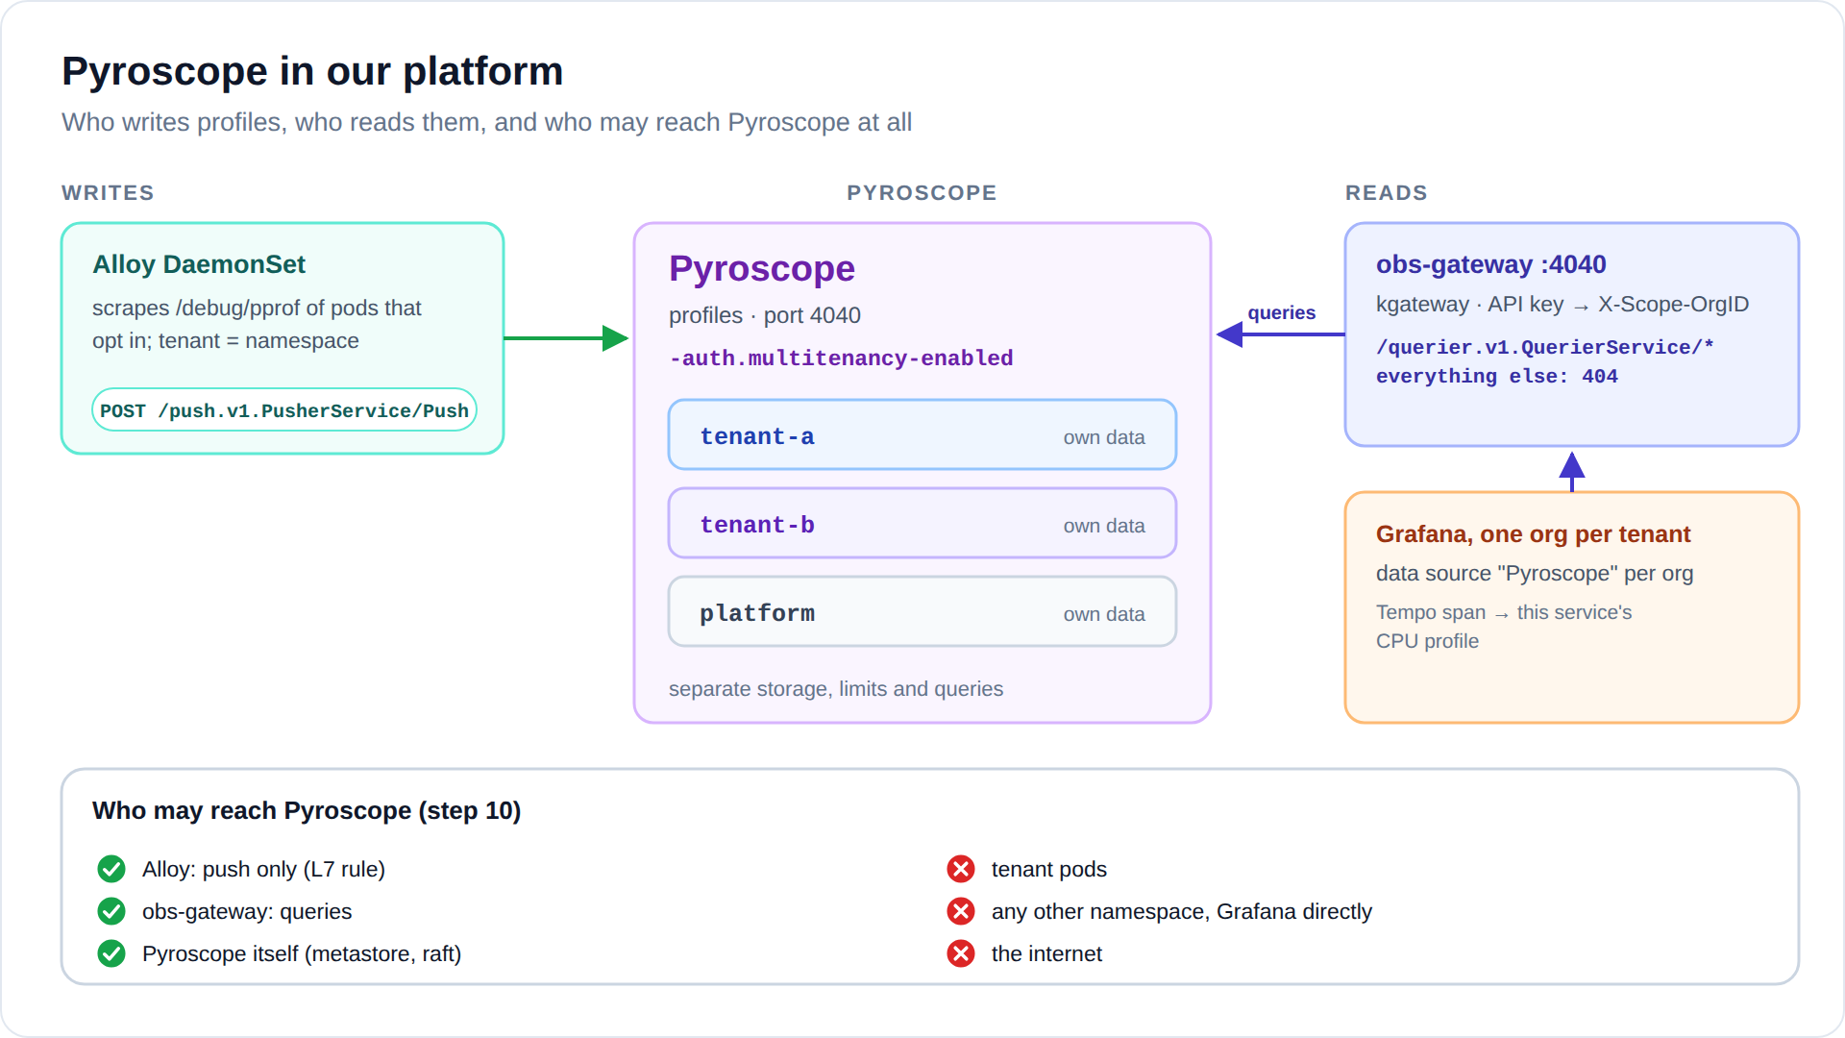
Diagram: images/pyroscope-flow.svg (or .png)
- Writes: only Alloy, and only to the push endpoint.
- Reads: only obs-gateway (kgateway) on port 4040, and only the querier API.
- Everything else is dropped by Cilium. Pyroscope may also reach the Kubernetes API, which its metastore uses to find its peers.

How tenants are kept apart
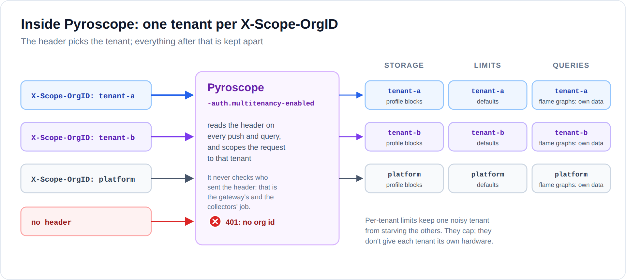
Diagram: images/pyroscope-inside.svg (or .png)
The switch is the flag -auth.multitenancy-enabled=true. Without it, Pyroscope puts everything into one tenant called anonymous. With it, every push and query must name its tenant in X-Scope-OrgID, and a request without it gets 401.
Each tenant's profiles are stored, limited and queried separately; a query only reads the tenant it names.
Remember Pyroscope does not check who sends the header. That is why only Alloy and obs-gateway can reach it.

Write path: how profiles get in
A pod opts in with two annotations. The port must be a declared containerPort that serves /debug/pprof:
metadata:
annotations:
profiles.grafana.com/scrape: "true"
profiles.grafana.com/port: "9898"
Alloy on the pod's node scrapes the profiles and pushes them with its tenant pipeline's ID:
pyroscope.write "pyroscope" {
endpoint {
url = "http://pyroscope.observability.svc.cluster.local:4040"
headers = { "X-Scope-OrgID" = argument.id.value }
}
}
The push goes to POST /push.v1.PusherService/Push, the only path Cilium lets Alloy use. As with logs and metrics, the tenant comes from the namespace name, never from the app.
Apps that are not written in Go Other languages need a profiling SDK that pushes, or Alloy's eBPF profiler. Pushing SDKs would need a per-tenant receiver, like traces. The eBPF profiler needs privileged access to every process on the node. Both are platform decisions.

Read path: how tenants query
Grafana → the org's Pyroscope data source → obs-gateway port 4040, with the tenant's key → Pyroscope.
Request | Gateway answer
/querier.v1.QuerierService/* (profile types, label names and values, flame graphs, series, diffs) | forwarded, as the tenant the key belongs to
the push API | 404
Pyroscope's own web UI (/), admin pages, /metrics | 404: tenants use Grafana
no key, or an unknown one | 401

The data source type is grafana-pyroscope-datasource, and its URL is the gateway on port 4040. The link from traces lives in the Tempo data source: tracesToProfiles maps service.name to service_name and opens the CPU profile.
Our apps do not attach span IDs to their profiles, so the link opens the service's CPU profile for the span's time range, not a profile of that one span. For span-level profiles, an app needs the Pyroscope SDK with OpenTelemetry integration.

Our configuration
pyroscope:
replicaCount: 1
extraArgs:
auth.multitenancy-enabled: "true"
persistence:
enabled: true
size: 5Gi
alloy:
enabled: false # the chart's own Alloy; ours does the job

Chart defaults we change, and one we keep
Setting | Why
alloy.enabled: false | By default the chart also deploys its own Alloy, with a ClusterRole that can read every Secret in the cluster. Our Alloy already collects profiles.
chart RBAC: kept | Pyroscope 2's metastore finds its peers through the Kubernetes API. The Role is namespaced and read-only (endpoints, pods and services in observability).

Files in the lab
File | What it holds
06-observability-backends/pyroscope-values.yaml | Pyroscope: tenancy, storage
08-collectors/alloy-values.yaml | profile scraping and pyroscope.write
04-demo-apps/ | the profile annotations on podinfo
07-read-gateway/gateway.yaml | obs-gateway, port 4040
10-observability-lockdown/policies.yaml | the pyroscope network policy

Per-tenant limits
The lab uses Pyroscope's default limits for every tenant. The chart's tenantOverrides value sets per-tenant limits, which Pyroscope reloads without a restart:
pyroscope:
tenantOverrides:
tenant-b:
ingestion_rate_mb: 2
ingestion_burst_size_mb: 4
Other per-tenant limits cover series, labels and query length; see Pyroscope's configuration reference.

Network lockdown
From → to | Allowed | Why
Alloy → Pyroscope:4040 | POST /push.v1.PusherService/Push only (L7 rule) | writes profiles; cannot read
obs-gateway → Pyroscope:4040 | yes | the gateway does the filtering
Pyroscope → Pyroscope (its own pods) | yes | metastore (raft), ring, query backend
Pyroscope → Kubernetes API | yes | the metastore finds its peers
tenant pods, other namespaces, Grafana, the internet | dropped

Using Pyroscope as a tenant
In Grafana, open Explore and pick Pyroscope. Choose a profile type, add a label selector, and read the flame graph: the wider a bar, the more of the resource that function used.
What you want | Profile type | Label selector
Backend CPU | process_cpu, cpu | {service_name="backend"}
Frontend memory allocations | memory, alloc_space | {service_name="frontend"}
One pod only | any | {namespace="tenant-a", pod=~"frontend-.*"}
Goroutines of the backend | goroutine | {service_name="backend"}

To compare two time ranges, for example before and after a deploy, use the diff view. From a trace, click a span and choose Profiles.

How we verify it
11-verify-observability.sh runs these checks after every change. The Pyroscope part:
Check | Expected
tenant-a lists the namespaces it has profiles for | only tenant-a
tenant-a's key plus X-Scope-OrgID: tenant-b | still only tenant-a
no key, or an unknown key | refused (401)
push through the gateway | refused
a pod with Alloy's identity queries Pyroscope | 403 from the L7 rule
a tenant-a pod connects to Pyroscope on 4040 | dropped
a pod in default connects to Pyroscope | dropped
alice in Grafana lists profile namespaces | only tenant-a

By hand, from the repository root:
kubectl -n observability port-forward svc/obs-gateway 4040:4040 &
source .state/soft-tenancy/credentials.env
NOW=$(date +%s)
curl -s -H "X-Api-Key: ${OBS_KEY_TENANT_A}" -X POST -H 'Content-Type: application/json' \
-d "{\"name\":\"namespace\",\"start\":$(( (NOW-3600)*1000 )),\"end\":$(( NOW*1000 ))}" \
http://127.0.0.1:4040/querier.v1.QuerierService/LabelValues | jq .names

Troubleshooting
Symptom | Likely cause | What to do
No profiles for a pod | Annotations missing, the port is not a declared containerPort, or the app does not serve /debug/pprof. | Fix the annotations or the port. Check the targets in the UI of the Alloy pod on that node (port 12345).
Some profile types are missing | The app does not expose them; mutex and block profiles must be switched on in Go code. | Expected.
Pyroscope not ready, metastore errors | The metastore cannot reach the Kubernetes API or its peers. | Check its logs; the pyroscope policy must allow both.
Profiles link from a span is empty | service_name differs from service.name, or the span is too short for CPU samples. | Follow the naming rule; widen the time range.
Data source test fails with 401 | The key in the data source does not match the gateway's Secret. | Re-run 07-read-gateway/install.sh, then 09-grafana/setup-orgs.sh.
no org id (401) | The request reached Pyroscope without the header. | Go through the gateway.
429 in Alloy's logs | The tenant is over its ingestion limit. | Raise it in tenantOverrides if justified.

Going to production
- Scale out with the chart's microservices mode and object storage. Each tenant's data stays separate in the bucket.
- Other languages: a per-tenant Alloy receiving pushed profiles (pyroscope.receive_http), the same pattern as the trace receivers.
- eBPF profiling covers every process without code changes, but needs privileged access on each node. If you add it, keep deriving the tenant from the namespace.
- Keep Pyroscope's own UI closed to tenants; it is not tenant-aware the way the gateway and Grafana are.

FAQ
Do profiles contain our data? They contain function names, file names and line numbers, not the values the program handled. Either way, they stay inside the tenant.
Does profiling slow the app down? Go's built-in profiler is designed to run in production; the overhead is small.
Can a tenant switch profiling off? Yes: remove the two annotations.
Can alice see platform profiles? No. Platform pods go to the platform tenant, which only the Platform org can query.

Related
- Per-tenant observability: the basics (the whole stack on one page).
- The other component pages: Loki, Mimir, Tempo.
- Soft tenancy with Cilium: the basics (how tenants are kept apart on the network).
- The lab: soft-tenancy/ in the instant-rke2-lab repository, steps 06 to 11.

