Final Mini Project

CODE & OUTPUT
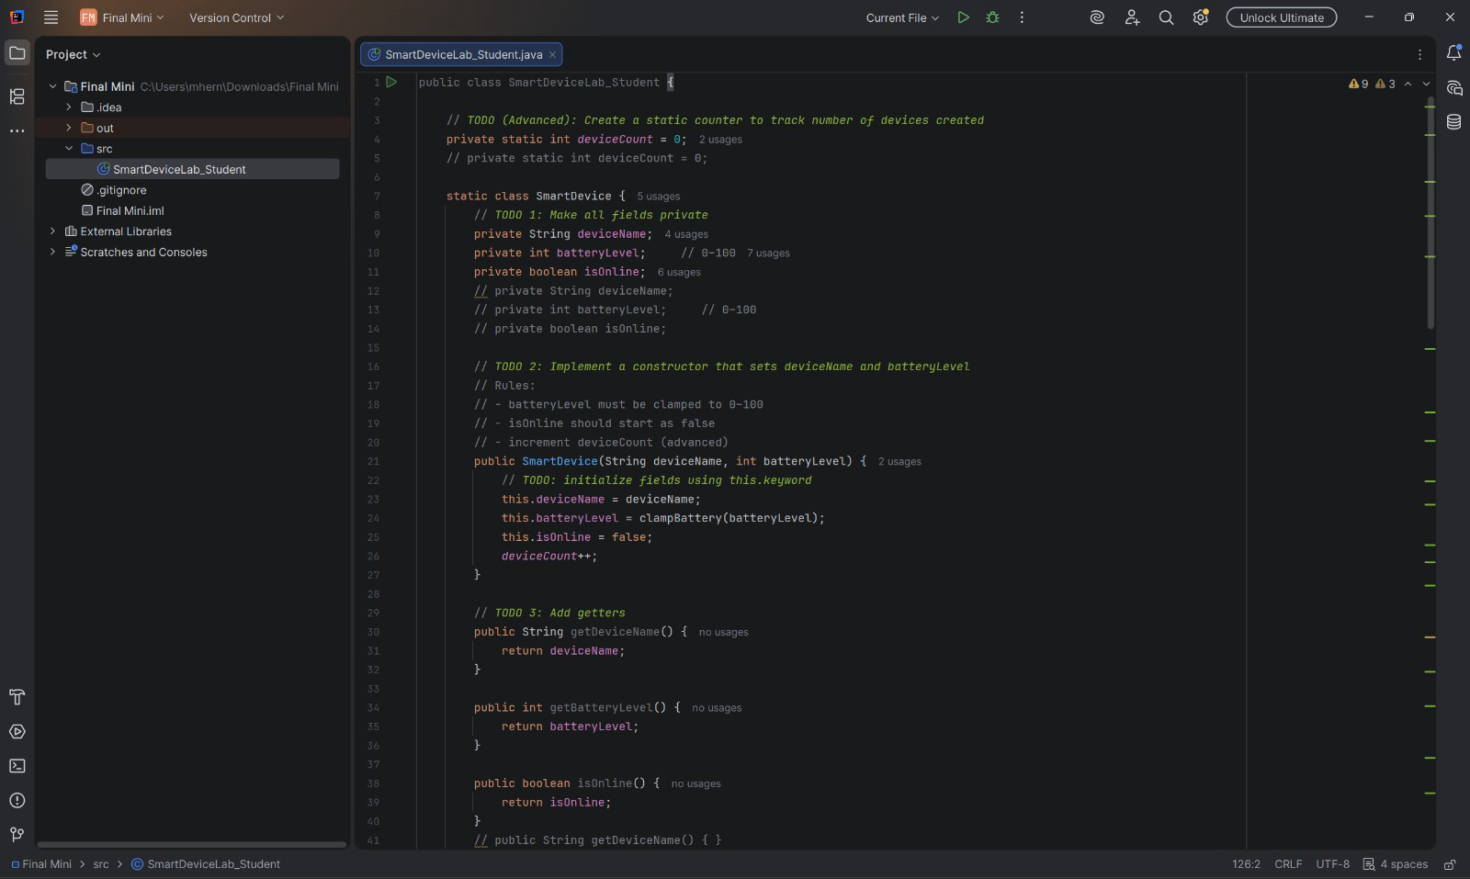
For this project, a smart device class is designed with a private static int device count. Because device count is static, it belongs to the whole class rather than an individual smart device instance. A static class is also defined with the private fields deviceName, batteryLevel, and isOnline. A constructor is defined that initializes the private fields and increments deviceCount by one when called, and the appropriate getters and setters are defined. ClampBattery is used to ensure the battery level does not exceed 100.
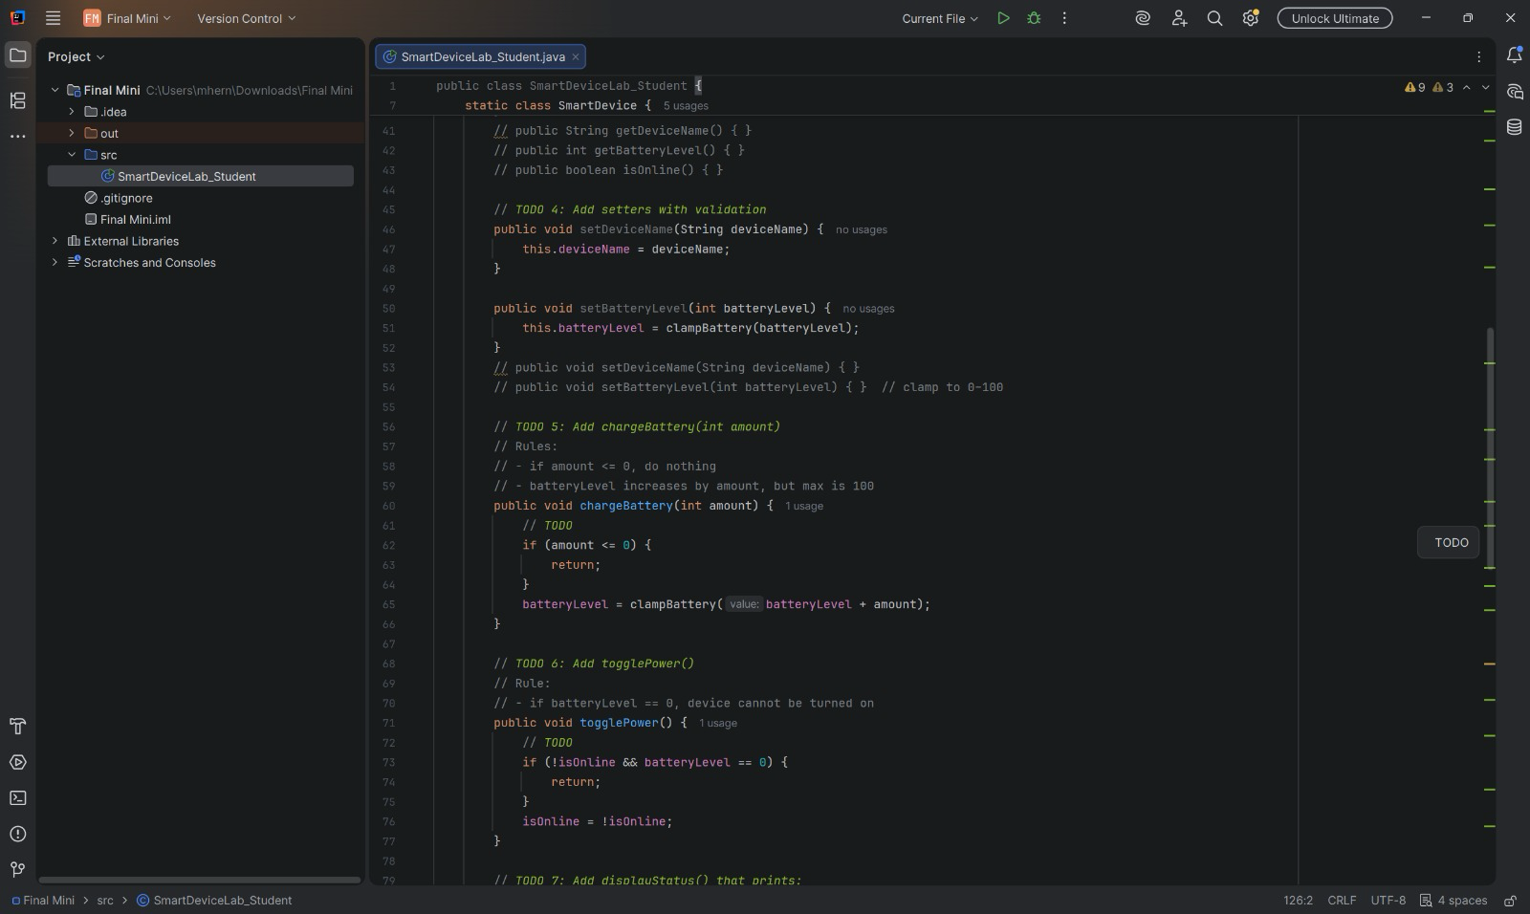
The chargeBattery method takes an integer amount and and returns the clamped battery amount, if there is any charge when chargeBattery is called, then it will not return anything. TogglePower is used to turn a battery on or off by switching between true or false, if the device is OFF and the battery level is 0, then a device cannot be toggled on and the method returns nothing.
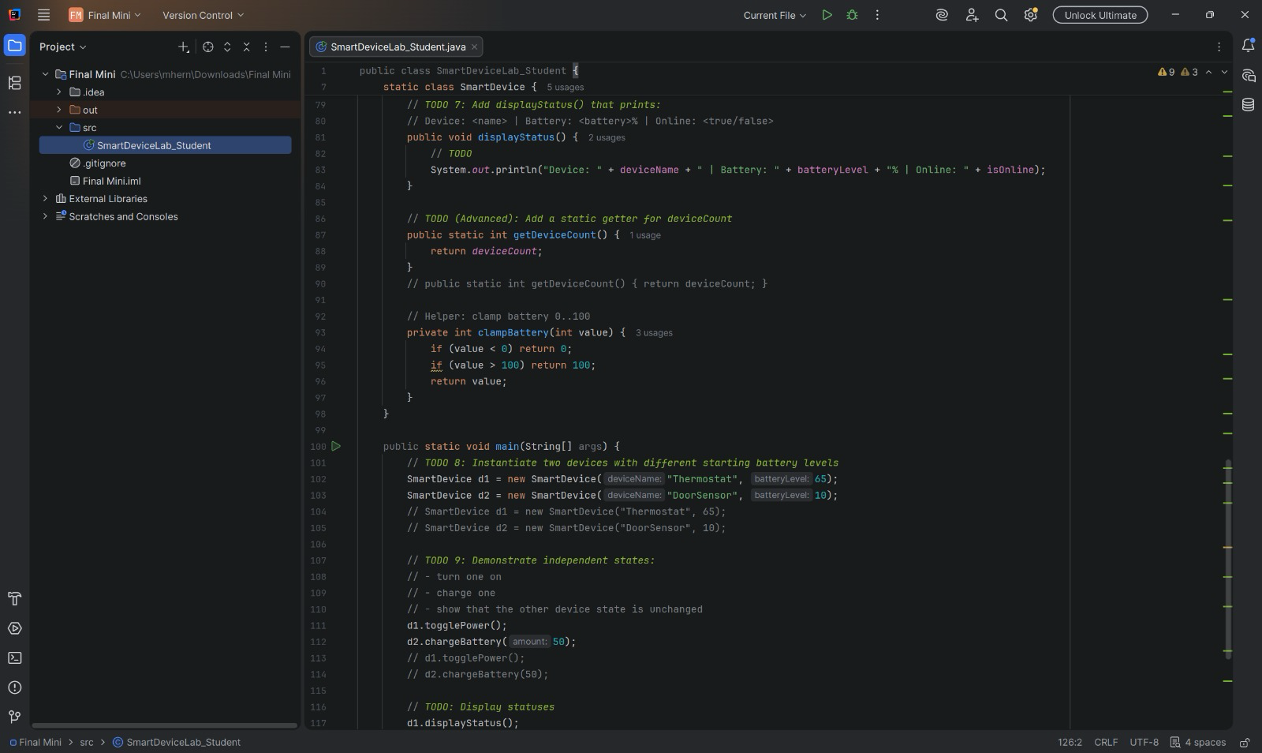
The method displayStatus prints out the device’s name, battery %, and online status. GetDevice count is a static method, that returns the device count. Finally, clamp battery ensures a battery’s level does not exceed 100 nor fall below 0.
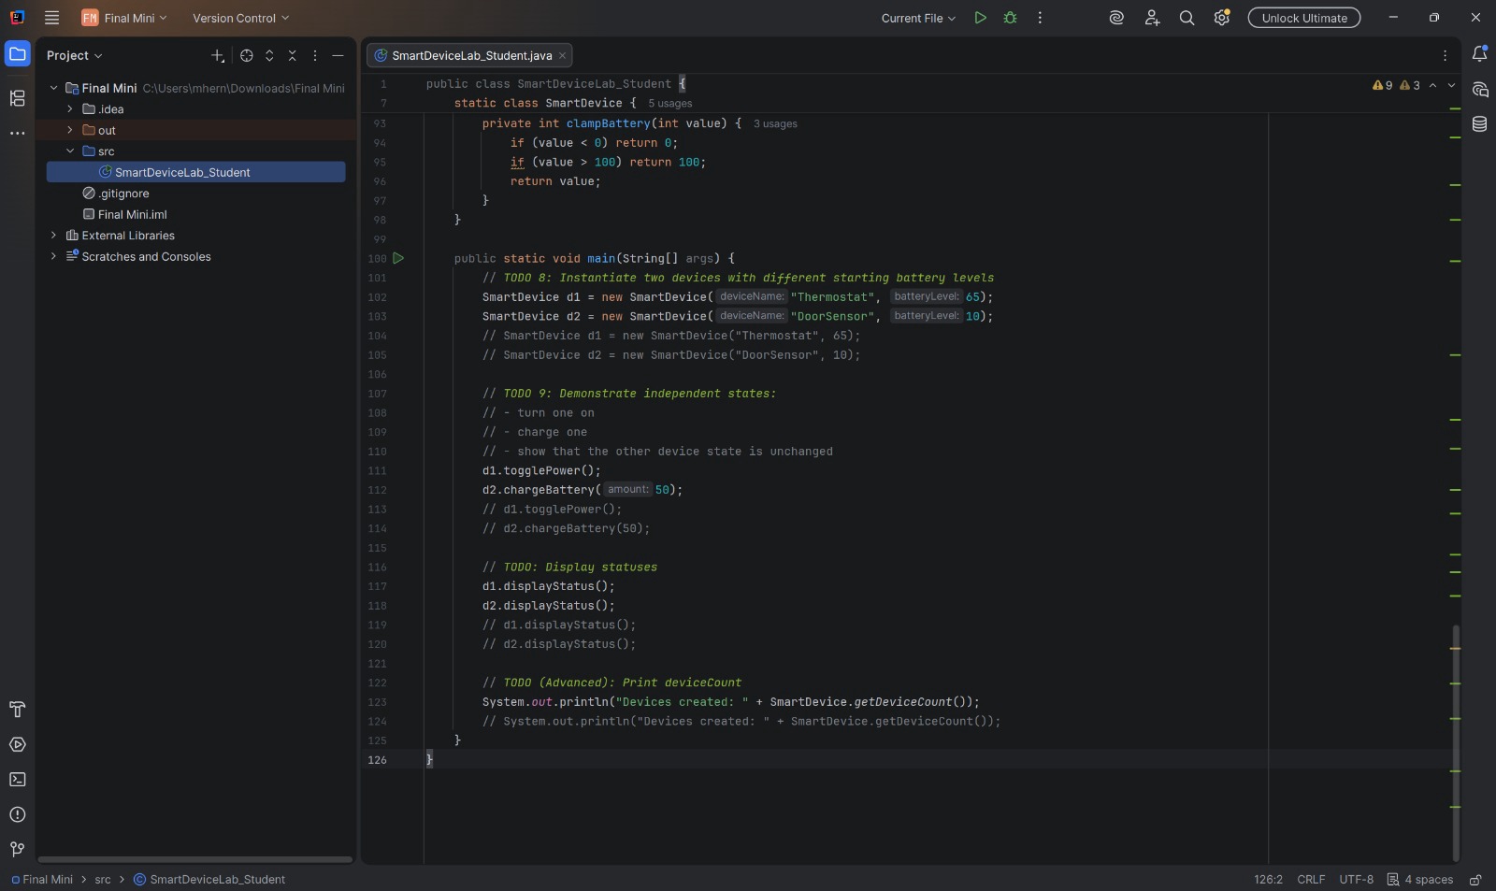
Main creates two Smart device objects d1 and d2. D1 is assigned a name of thermostat and a battery level of 65%, while D2 is named DoorSensor and has a battery level of 10%. The thermostat’s power is toggled, while DoorSensor charges its battery by 50%. Then both of the statuses for the smart devices are displayed, as well as the total device count.
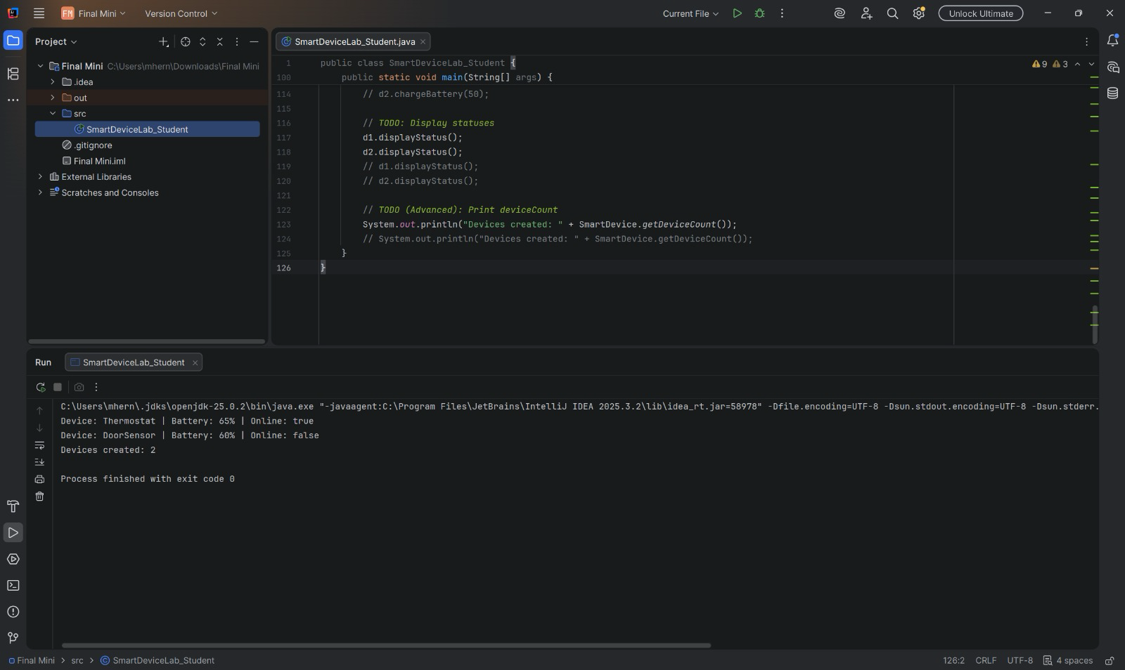

Reflection
The concept of encapsulation in this project helped reduce accidental misuse since it removed the possibility an object’s methods interfering with other objects’ attributes. Were batteryLevel public, then there would be unforeseen errors caused by outside code that managed to change the batteryLevel. This provided us with a key insight of how important encapsulation is when creating objects and classes, without them the program would likely be buggy or inoperable. We felt the most error prone was the chargeBattery method because of the required conditions, which checking them was our most effective debugging strategy. The output demonstrates independent object state by displaying different online statuses and battery levels. We also learned the importance of the static modifier, and how they differ from instance variables: the static methods belong to an entire object class as opposed to instance methods which only affect individual objects of that class. The static variable deviceCount was defined outside the instance class and in a way is shared among every instance, whereas the batteryLevel variable is instantiated to a single smart device, and each smart devices battery level can be different.

