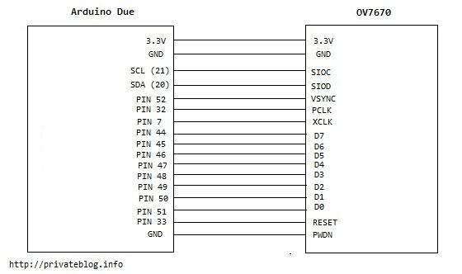
Pin | Pino | Type | Description
VDD** |  | Supply | Power supply
GND |  | Supply | Ground level
SDIOC |  | Input | SCCB clock
SDIOD |  | Input/Output | SCCB data
VSYNC | 52 (B.21) | Output | Vertical synchronization
HREF |  | Output | Horizontal synchronization
PCLK | 32 (D.10) | Output | Pixel clock
XCLK | 7 (C.23) | Input | System clock
D0-D7 |  | Output | Video parallel output
RESET |  | Input | Reset (Active low)
PWDN |  | Input | Power down (Active high)

