Article
Development and Internal Validation of a Tooth-Level Early-Childhood Caries Prediction Model with a Prespecified External Validation Protocol
[AUTHOR NAMES REQUIRED BEFORE SUBMISSION]
[AFFILIATIONS AND AUTHOR E-MAILS REQUIRED BEFORE SUBMISSION]
[CORRESPONDING AUTHOR, E-MAIL, AND OPTIONAL TELEPHONE REQUIRED BEFORE SUBMISSION]
Abstract
Background/Objectives: Early-childhood caries (ECC) is tooth-specific, yet transportable tooth-level risk prediction remains insufficiently validated. We aimed to develop and internally validate transparent clinical prediction models using a public longitudinal cohort and to define a version-locked candidate with a prespecified framework for independent external validation. Methods: Healthy teeth were linked to the next consecutive recorded visit, 2–5 months later, and the outcome was healthy-to-carious transition. Penalised logistic models used either minimal clinical predictors or clinical-plus-spatial predictors. Five outer and three inner child-grouped folds separated tuning from evaluation; recalibration was fitted only in outer-training children. Uncertainty was estimated with 1,000 paired child-cluster bootstrap samples of out-of-fold predictions. Results: The analysis included 996 tooth transitions, 83 events (8.33%), and 81 children. Average precision was 0.166 (95% interval 0.120–0.246) for the minimal model and 0.178 (0.138–0.239) for the spatial model; AUROCs were 0.686 (0.618–0.754) and 0.737 (0.660–0.804), respectively. Paired model differences included zero. Intercept-and-slope recalibration reduced the minimal model Brier score from 0.0806 to 0.0745 (paired difference −0.00610; 95% interval −0.01173 to −0.00067), whereas the spatial-model change included zero. The development dataset contained 83 events for 24 effective model degrees of freedom, indicating substantial sample-size constraint. Conclusions: The models show exploratory internal predictive signal, but incremental spatial benefit, transportability, and clinical utility are unestablished. The locked artifact is a research instrument only; independent external validation with a precision-based sample-size calculation is required before any patient-level use.
Keywords: early-childhood caries; clinical prediction; internal validation; calibration; tooth-level risk; external validation

1. Introduction
Early-childhood caries develops across individual teeth, changing oral environments, and repeated visits. The source study by Yang and colleagues assembled a tooth-resolved longitudinal plaque dataset and reported its own microbiome-based prediction results [1]. Clinical and behavioural information also predicts subsequent caries [2]. Other longitudinal studies associate oral microbial community development with future disease [3,4], and salivary microbiome prediction in very young children has been investigated [5]. These findings motivate tooth-level prediction research but do not validate a different model, implementation, or deployment setting.
Biofilm simulation offers a mechanistic rationale for examining local interactions: in-silico studies have explored the roles of sugar exposure and bacterial interactions [6,7]. OdontoCA extends that idea to a probabilistic cellular-automaton rule and clinical, spatial, microbiome, and image branches. Its saved v1.3.2 CI_SMOKE notebook executed the synthetic branch; its v1.9.1 architecture diagram described a broader protocol. Neither artifact alone established performance in real children.
Prediction studies require particular care when records from the same child recur across teeth and visits. Nested cross-validation can reduce model-selection bias [8], while data leakage can inflate apparent performance [9]. TRIPOD+AI provides reporting guidance [10], and PROBAST+AI separates reporting from risk-of-bias and applicability assessment [11]. We therefore treat an executable pipeline, internal validation, and independent clinical validation as distinct evidence states.
Earlier work on spatial and temporal oral microbiota [12] and oral community composition [13] reinforces the biological motivation. At the same time, a review found limited prospective validation of early-childhood caries risk tools [14], and a systematic review identified modifiable risk factors that are not represented fully by a tooth-level spreadsheet [15]. The objective here was to reproduce the public clinical cohort underlying OdontoCA, develop two transparent baseline risk models, quantify internal predictive performance and calibration with child-level uncertainty, and identify the evidence required to progress toward clinical evaluation. We therefore framed the study as model development with internal validation, not as evidence of clinical readiness. The primary objective was to quantify internally validated discrimination and probability accuracy for transparent clinical models; the secondary objective was to define a reproducible, version-locked candidate and a methodologically defensible external-validation protocol.

2. Materials and Methods

2.1. Study Design, Source Data, and Provenance
This was a secondary analysis of the public all_metadata worksheet in the source study’s Table_S1.xlsx, obtained from the authors’ Single-tooth-ECC repository at commit e5868fe5. The exact file used in this analysis had SHA-256 b7819fee81efbe2e227b7700c3cd86ce8bc6f7fe6f49da6214f4107d099184fa; the analysis script recomputes this digest and aborts on mismatch. The complete analysis was re-executed against that verified file, and every aggregate statistic reported below was reproduced exactly. We did not redistribute the source records. The OdontoCA notebook’s reconstruction functions were executed independently against that file. Its expected counts were compared with observed counts before model fitting. All clinical results in this paper come from this public table, not from the notebook’s synthetic CI_SMOKE output.
The source study also makes sequencing data available via Qiita [1]. We did not complete an exact clinical SampleID-to-BIOM match, analyse real microbial counts, or use dental images. The planned microbiome analysis would need to address the compositional nature of sequencing counts and fit all selection and log-ratio transformations inside training folds [16,17]. Figure 1 distinguishes the executed clinical analysis from these unrun branches.
Sampling provenance, and what we could not verify. The released worksheet contains no recruitment, eligibility, or sampling-procedure documentation, and no sampling frame, sampling method, or response rate for the 89 source children is recoverable from it. We therefore cannot describe the source cohort as a probability sample, a convenience sample, or a consecutive clinical series, and we do not assert any of them. This is a material limitation rather than a reporting formality: without sampling provenance, selection bias in the source cohort cannot be appraised, which is one reason the PROBAST+AI Participants domain is rated High. We report the analysable cohort exactly as released (2,504 records, 89 children) and treat recruitment provenance as an unresolved author-verification item.
Comparator structure. This was a prognostic prediction-model development study rather than an intervention study; therefore, an intervention control group was neither applicable nor constructed. The clinical-minimal model was the reference prediction model for assessing incremental information from the clinical-spatial feature set, and a fold-specific training-prevalence model was used as a benchmark for probability scores. These are analytical comparators and should not be interpreted as clinical control groups. No randomisation or masking was involved.
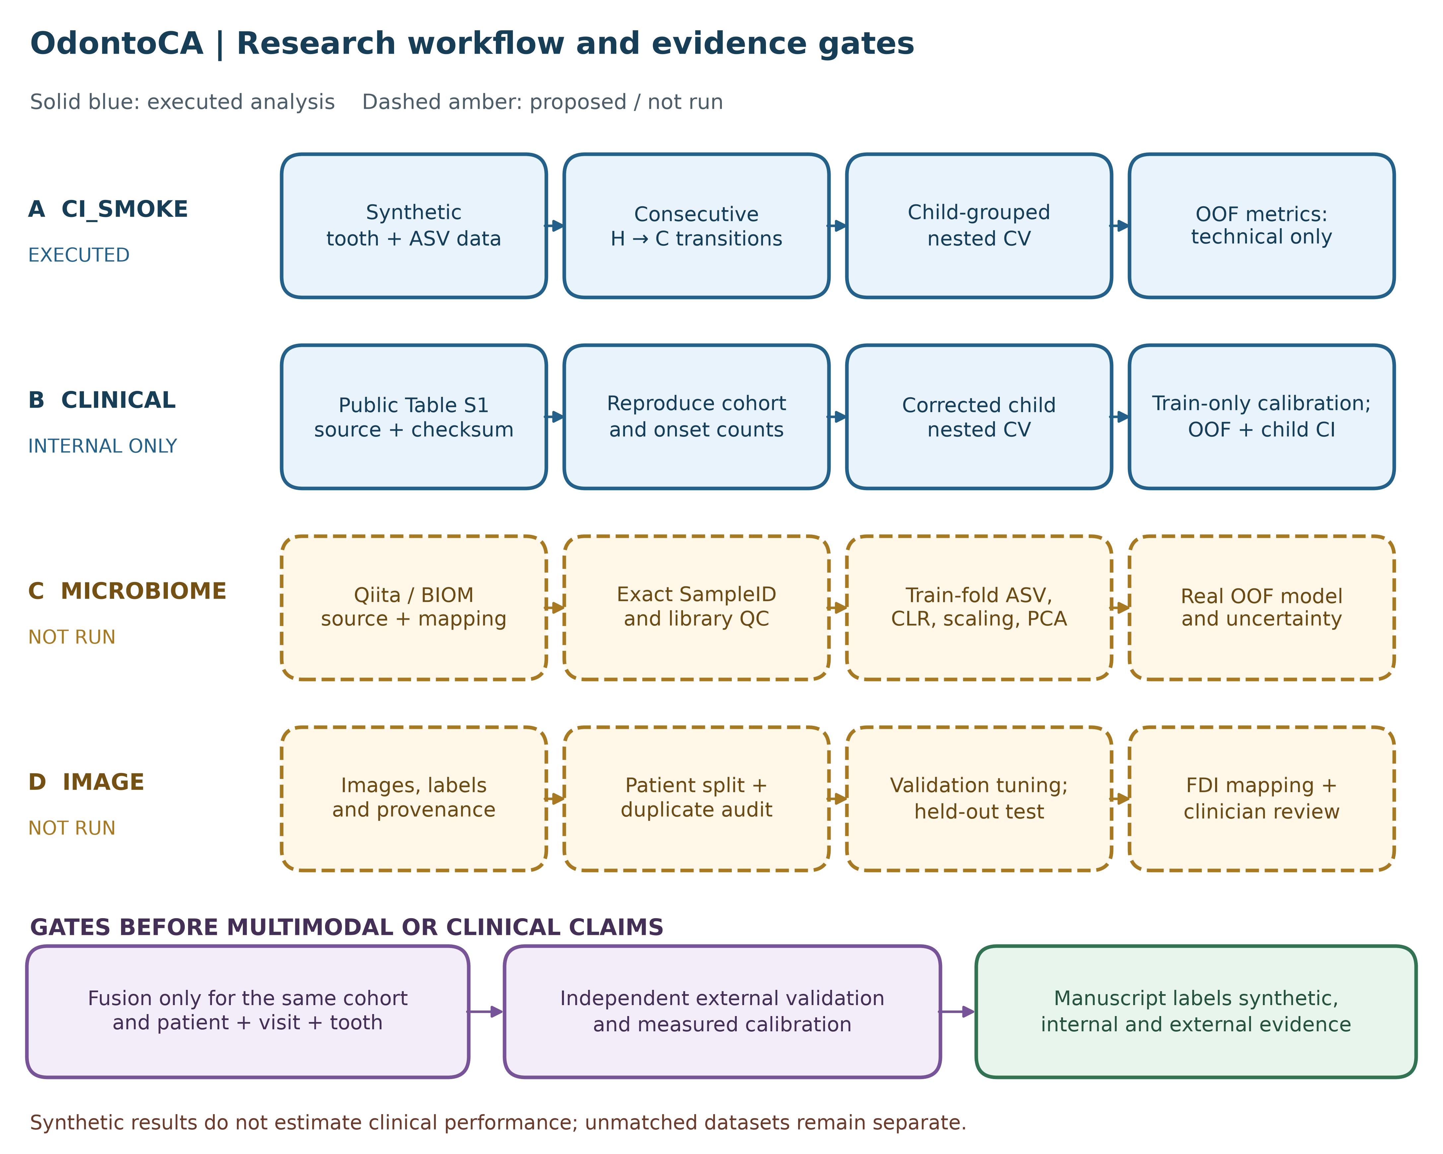
Figure 1. Evidence workflow for the present study. The executed branches comprise the prior synthetic technical demonstration and the public-cohort clinical reconstruction/internal prediction analysis. Microbiome, image, patient-linked multimodal fusion, and independent external validation branches were not executed for the present manuscript. The distinction between executed and proposed branches is maintained throughout the text.

2.2. Tooth Transitions and Analysis Cohort
The published spreadsheet contains patient, tooth-position, visit, and current tooth-status fields. We mapped the 20 primary-tooth positions to FDI identifiers, removed composite position T5161 from individual-tooth modelling, and linked each child’s same tooth to its next recorded visit. Only consecutive visit indices were retained. The binary outcome was H→C versus H→H, where H means clinically healthy at visit t and C means carious at the next visit. Teeth already carious at t were excluded from onset prediction. Current-visit neighbour status and host caries experience were derived or taken from the visit-t record. Source-defined HostGroup, future tooth status, time to decay, next-visit status, and follow-up interval were barred from predictors.
Reporting was mapped to TRIPOD+AI [10], and methodological quality, risk of bias, and applicability were assessed using PROBAST+AI [11]. Supplementary Files S3 and S4 record item-level responses, evidence locations, and unresolved information. These AI-assisted internal assessments are not independent external reviews.
The notebook’s original transition rule yielded 997 eligible H transitions and 84 events. We excluded one transition with a recorded follow-up interval of zero months from the primary predictive analysis; that transition was an event. The final set contained 996 transitions from 81 children. Follow-up time was not a fixed horizon; observed positive intervals ranged from two to five months. Consequently, the estimated risk refers to the next recorded visit within this range, not to a universal two-month endpoint.

2.3. Candidate Prediction Models
Two penalised logistic-regression feature sets were defined in the analysis code before fitting. No prospectively registered analysis protocol was available. The minimal clinical model used tooth position, age in months at t, host dmfs at t, and the number of adjacent carious teeth at t. The clinical-spatial model added the source table’s current-visit host status, niche categories, spatially weighted dmfs, and three spatial summary fields. This comparison asks whether recorded spatial context adds predictive information to a simple clinical baseline. Source-derived spatial fields were used as provided; their construction and availability at a prospective clinical visit require further independent verification.
Categorical fields were imputed by the most frequent training value and one-hot encoded; numeric fields were median-imputed and standardised. All operations were fitted on training rows within each fold. The regularisation parameter C was chosen from 0.01, 0.1, 1, and 10 using average precision in the inner folds. The positive probability was explicitly selected for outcome class 1. No feature was selected after examining outer-fold results, and the test rows were not used for imputation, encoding, scaling, or tuning.

2.4. Internal Validation, Calibration, and Uncertainty
We used five outer stratified group folds and three inner stratified group folds, with the child as the group, fixed seed 20260930, and no child shared between outer training and test sets. The primary analysis used a deterministic permutation of child-group labels before stratified allocation, yielding the corrected group-split policy documented in the executable script. The original shuffled splitter in scikit-learn 1.6.1 had a confirmed group-remapping defect; the output of an earlier non-public exploratory run under that policy is retained in Supplementary File S2 as a historical reproduction, not combined with the primary analysis. The corrected split assignments were reproduced under scikit-learn 1.6.1 and 1.9.0. The reported probabilities are pooled out-of-fold predictions. The event fraction was the reference for average precision. A fold-specific training-prevalence model supplied a reference Brier score and log loss. Because positive outcomes were uncommon, we reported precision–recall results alongside ROC area: precision–recall changes with event prevalence [18], whereas ROC area continues to describe ranking discrimination under imbalance [19]. Neither measure by itself establishes clinical utility.
For each outer fold and each model, we generated inner cross-fitted probabilities on the outer training children at the selected regularisation value. We fitted two monotone mappings to those training-only probabilities: an intercept adjustment with slope fixed at one and logistic intercept-and-slope recalibration with a positive slope constraint. The full outer-training model’s probabilities for held-out children were then transformed without using their outcomes for fitting. This evaluates the entire recalibration procedure on held-out children; pooled out-of-fold outcomes were never used to fit a calibrator. Both calibration methods were evaluated as an exploratory extension after the initial model audit. We describe calibration using mean predicted risk, observed event fraction, calibration-in-the-large, a fitted slope, and eight quantile risk bins. Brier score and log loss are overall probability scores, not standalone proof of calibration [20]. Performance and calibration were considered together [21]. For uncertainty, we resampled children 1,000 times with replacement, retaining their tooth observations, and calculated percentile intervals for each uncalibrated model, the paired spatial-minus-minimal difference, and paired within-model recalibration changes in Brier score and log loss. These intervals condition on the fitted out-of-fold probabilities; they omit the full variability of repeating development. Independent external or temporal validation, using the locked model and a prospectively justified sample size, remains necessary [22].
The development sample size was fixed by the available public cohort; no prospective sample-size calculation was possible. The 83 observed events relative to 24 effective model degrees of freedom (3.46 events per parameter) are reported descriptively as a warning of potential overfitting, not as a formal adequacy criterion. Contemporary sample-size methods for prediction-model development depend on the outcome proportion, the number of candidate parameters, anticipated model fit, and target shrinkage rather than on a universal events-per-variable rule [23].

2.5. Version-Locked Model and Prespecified External Validation Framework
A final research artifact was version-locked before any external dataset was available so that subsequent external evaluation can apply the same preprocessing, coefficients, and probability transformation without post hoc modification. Locking an artifact does not constitute validation and does not justify clinical deployment.
Primary model. The locked primary model is the clinical-minimal set. The choice is not a default and was not made from validation performance: every clinical-minimal predictor (tooth position, age in months, host dmfs, number of adjacent carious teeth) is plausibly available at a routine caries visit, whereas the clinical-spatial predictors were derived in the source dataset, were not reconstructed from raw records, and their prospective availability requires independent verification. Selecting the spatial model on its higher point estimate would be data-driven selection and would raise the PROBAST+AI risk in the Analysis domain. The clinical-spatial model was therefore locked as a secondary exploratory candidate and must not be deployed until its derived predictors are reconstructed and verified.
Locking procedure. The regularisation value was selected once by grouped cross-validation on the full cohort, cross-fitted training-only probabilities were generated, the intercept-and-slope recalibration map was fitted on those probabilities, and the base pipeline was refitted on all rows. The cohort was asserted fail-closed before locking: 996 transitions, 83 events, and 81 children, with a hard abort on any divergence. The published bundle records the source SHA-256, the seed, Python and library versions, the lock timestamp, and its own SHA-256, so that an external centre scores exactly this artifact.
Honest reporting of the locked artifact. Because the regularisation value was chosen once on the full cohort, the artifact’s cross-fitted metrics are optimistic relative to the fold-wise estimates reported in Section 3.2. The artifact’s apparent resubstitution metrics are optimistic still. Performance reporting must cite the fold-wise out-of-fold estimates in Section 3.2, not the artifact’s own metric fields. The model card states this explicitly so that the artifact cannot be misread as validation evidence.
External-validation sample size. No definitive external-validation sample size is claimed in this manuscript. Before recruitment, the validation study should use a precision-based calculation tailored to the anticipated outcome proportion, distribution of predicted risks, expected discrimination/calibration, and desired confidence-interval widths for key performance measures. Rules of thumb such as 100 events and 100 non-events may provide only an initial floor; tailored calculations can require substantially larger samples, particularly for calibration assessment [24]. The calculation and all assumptions should be registered before outcome data are inspected.
Prespecified external-validation analysis. The locked model should be applied without refitting to a genuinely independent centre or time period. Primary reporting should include AUROC with child-level uncertainty, calibration-in-the-large, calibration slope, a smoothed calibration curve with uncertainty, and overall prediction error. AUPRC, Brier score, log loss, and clinically justified decision-curve analyses may be reported as secondary measures. Subgroup performance should be evaluated where sample size permits. Thresholds of 0.05, 0.10, and 0.20 may be retained only as sensitivity analyses unless clinical stakeholders justify them as actionable thresholds before registration. External performance should be reported as estimates with uncertainty rather than reduced to a single dichotomous “transportable/non-transportable” decision.

2.6. Technical Audit, Reproducibility, and Analysis Boundary
The supplied v1.3.2 notebook was inspected for outcome timing, grouped partitioning, and test quality. Its saved CI_SMOKE run used synthetic records, and a separate rerun of its current source code reproduced identical transition and event counts but different predictive metrics. A duplicated-key self-test, a tautological patient-overlap test, and two hard-coded acceptance gates were found on inspection. None of this constitutes clinical evidence: the synthetic and rerun outputs were not pooled, and neither was used as a clinical result. The clinical analysis reported here instead used explicit child-disjoint and future-feature assertions. The full audit, the rerun discrepancy, and the effect of the corrected split policy on internal estimates are documented in Supplementary File S2. The broader v1.9.1 flowchart was treated as a design source only; the revised detailed workflow is Supplementary File S1.
Reproducibility boundary. All clinical results reported in this manuscript derive from the verified public worksheet and the corrected child-grouped analysis policy. Synthetic CI_SMOKE outputs, historical exploratory runs, microbiome analyses, image analyses, and patient-linked multimodal fusion are not pooled with or used to support the reported clinical performance. Versioned scripts, source-file digest, software versions, split assignments, and aggregate outputs should accompany the submission or be deposited in a permanent repository before publication.

2.7. Use of Generative AI and Computational Assistance
OpenAI Codex assisted with analysis-code review, execution support, editorial revision, reference checking, and deterministic figure scripting. Generative AI was not used to create, alter, or fabricate primary observations, patient data, clinical images, or outcome labels. The named authors are responsible for verifying the data provenance, code, statistical outputs, citations, and final manuscript. Tool names and versions should be updated to the exact systems used at the time of final submission, in accordance with MDPI disclosure requirements.

3. Results

3.1. Source-Cohort Reconstruction
All 11 prespecified count checks matched the public source: 2,504 metadata rows from 89 children included 220 composite-position rows and 2,284 single-tooth rows. Same-child, same-tooth linking generated 1,388 observed transitions, of which 1,160 connected consecutive visit indices. The latter comprised 913 H→H, 84 H→C, 163 C→C, and no C→H transitions. Thus the original onset cohort contained 997 healthy-at-t transitions. Removing one nonpositive follow-up interval left 996 transitions, 83 events (8.33%), 81 children, and 44 children with an event (Table 1). Positive follow-up intervals had a median of two months, interquartile range two to three months, and range two to five months.
Table 1. Reconstruction of the published-source cohort and definition of the predictive analysis set.
Stage | Records | Children or events | Interpretation
Public all_metadata worksheet | 2,504 | 89 children | Source records before tooth filtering
Composite position T5161 | 220 | — | Excluded from individual-tooth modelling
Single-tooth rows | 2,284 | — | Tooth-level records
Same-tooth observed transitions | 1,388 | — | Any successive recorded visits
Consecutive-index transitions | 1,160 | 913 H→H; 84 H→C; 163 C→C; 0 C→H | Exact transition rule
Healthy-at-t onset cohort | 997 | 84 events | Reproduced target counts
Primary predictive analysis | 996 | 83 events; 81 children | One zero-month interval excluded
H = clinically healthy; C = carious at the next recorded visit.
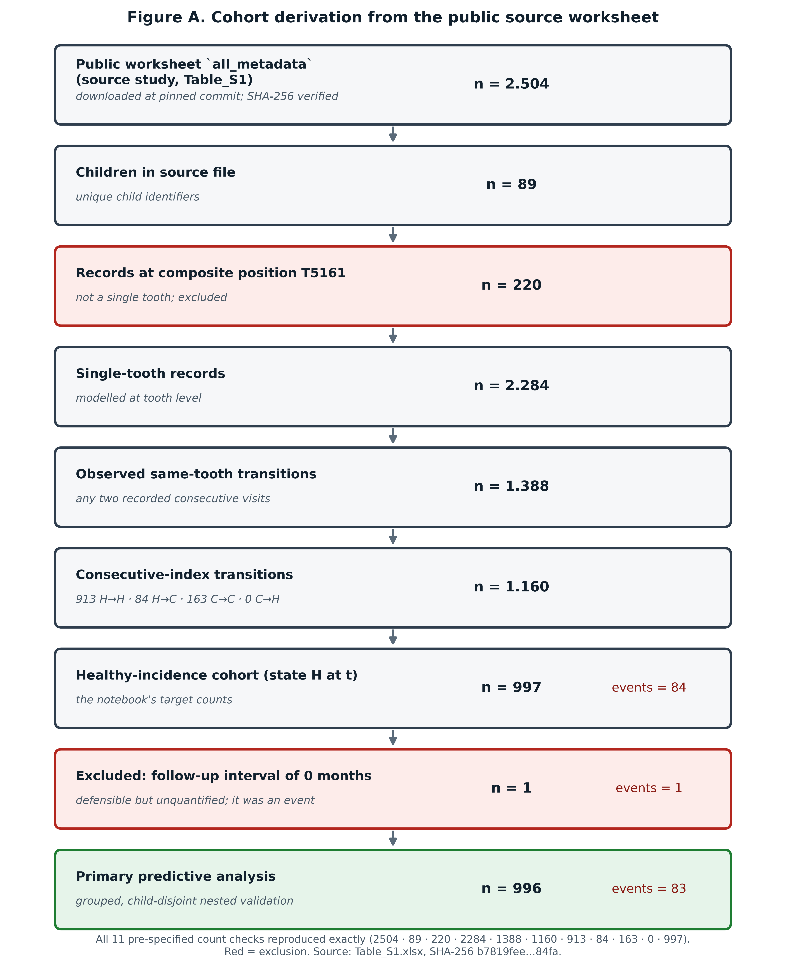
Figure 2. Reconstruction of the analysis cohort from the public source worksheet. The flow diagram reproduces the prespecified count checks and distinguishes the primary predictive cohort from records excluded before modelling. Microbiome and imaging branches were not executed for this analysis.

3.2. Internal Predictive Performance
Across the child-grouped out-of-fold predictions, the minimal clinical model achieved average precision 0.166 (95% child-bootstrap interval 0.120–0.246) and ROC area 0.686 (0.618–0.754). The clinical-spatial model achieved average precision 0.178 (0.138–0.239) and ROC area 0.737 (0.660–0.804), above the event fraction of 0.083 for average precision (Table 2; Figure 2). The spatial-minus-minimal difference was 0.012 (−0.046 to 0.058) for average precision and 0.051 (−0.009 to 0.112) for ROC area. Both intervals included zero; superiority of the spatial model was not established.
Table 2. Child-grouped pooled out-of-fold predictive performance in the public clinical cohort (996 transitions; 83 events).
Model | Average precision (95% interval) | AUROC (95% interval) | Brier score (95% interval) | Log loss
Minimal clinical | 0.166 (0.120–0.246) | 0.686 (0.618–0.754) | 0.0806 (0.0624–0.0996) | 0.2884
Clinical plus spatial | 0.178 (0.138–0.239) | 0.737 (0.660–0.804) | 0.0754 (0.0574–0.0949) | 0.2690
Fold-specific training prevalence | — | — | 0.0764 | 0.2869
Intervals are child-cluster bootstrap percentile intervals where reported. These are internal-validation estimates, not external validation.
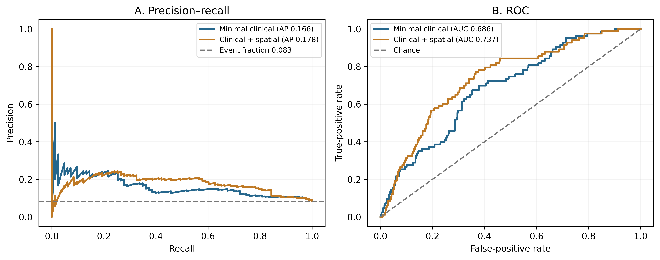
Figure 3. Precision–recall and receiver-operating-characteristic curves for the uncalibrated models under the corrected child-grouped split policy. Predictions were generated only for each child’s held-out outer fold. The horizontal precision reference is the event fraction (0.083), and the ROC diagonal denotes chance ranking.

3.3. Calibration and Model Comparison
The uncalibrated minimal model had mean predicted risk 0.1182 against an observed event fraction of 0.0833, calibration-in-the-large −0.446, and slope 0.516. The spatial model’s corresponding values were 0.0878, −0.066, and 0.605. Slopes below one indicate predictions that were too extreme in this internal sample. The eight-bin plot shows the uncalibrated and two training-only recalibrated versions of each model (Figure 3). The spatial model’s uncalibrated Brier score, 0.0754, was close to the training-prevalence reference, 0.0764; the minimal model’s score, 0.0806, was worse. The paired spatial-minus-minimal Brier difference was −0.0052 (95% bootstrap interval −0.0104 to 0.0004), including zero.
Intercept-and-slope recalibration reduced the minimal model’s Brier score to 0.0745: paired difference −0.00610 (95% child-cluster interval −0.01173 to −0.00067). Its log loss changed from 0.2884 to 0.2680, but that paired interval included zero (−0.04058 to 0.00020). The spatial model’s Brier score changed from 0.0754 to 0.0740: paired difference −0.00141 (−0.00308 to 0.00037), also including zero. Intercept-only updating did not provide a clear paired Brier improvement for either model. These comparisons are exploratory, conditional on the cross-fitted predictions, and do not establish clinical benefit. The recalibrated slopes remained below one (Table 3). We did not derive a treatment threshold or clinical decision rule.
Table 3. Held-out probability assessment before and after recalibration fitted only on outer-training children.
Model and probability version | Mean risk | Calibration slope | Brier score | Log loss
Minimal, uncalibrated | 0.1182 | 0.516 | 0.0806 | 0.2884
Minimal, intercept only | 0.0819 | 0.613 | 0.0762 | 0.2730
Minimal, intercept and slope | 0.0802 | 0.808 | 0.0745 | 0.2680
Spatial, uncalibrated | 0.0878 | 0.605 | 0.0754 | 0.2690
Spatial, intercept only | 0.0810 | 0.603 | 0.0753 | 0.2690
Spatial, intercept and slope | 0.0827 | 0.811 | 0.0740 | 0.2638
Observed event fraction = 0.0833. Calibration slopes were estimated from held-out predictions; paired uncertainty for Brier changes is reported in the text.
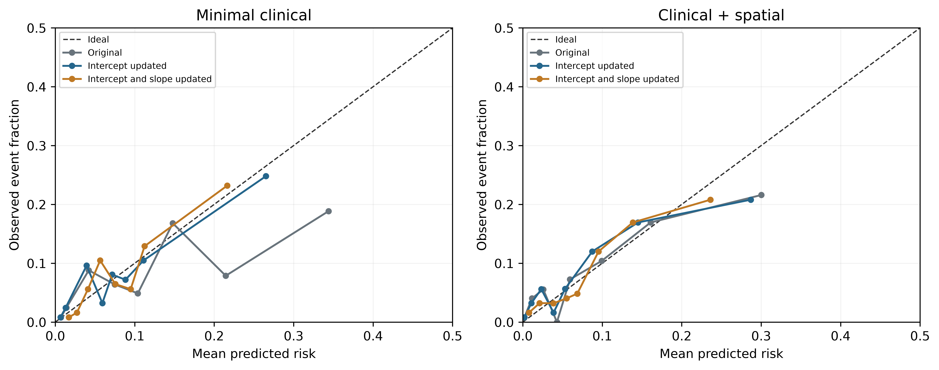
Figure 4. Descriptive eight-bin calibration plots for uncalibrated, intercept-updated, and intercept-and-slope-updated held-out predictions. The 45° diagonal denotes perfect calibration. Because grouped points can obscure local miscalibration, this figure is descriptive and does not substitute for a smoothed calibration curve in the planned external validation.

3.4. Outcome Events by Tooth Position
Outcome events were not distributed evenly across the dentition. All 83 events in the analysis cohort occurred in the eight primary molar positions (T54, T55, T64, T65, T74, T75, T84, T85); the 181 anterior-tooth transitions contributed no events (Table 4, Figure 4). Position-specific event fractions ranged from 0.028 to 0.165, with the highest values in second primary molars and first molars. Because anterior teeth have an event fraction of exactly zero in this cohort, tooth_position separates a structurally risk-free subpopulation from the remainder rather than merely adjusting for nuisance variation. This is a property of the source data, not a modelling artefact, and it has three consequences for interpretation.
First, the reported predictive performance is conditional on a cohort in which the minority-group event rate is zero, so the models cannot be assumed to generalise to settings with anterior-tooth caries onset. Second, predicted probabilities for anterior teeth are low by construction of the data, not because the model has demonstrated accuracy in that subgroup; no subgroup performance estimate is reported because no outcome was available. Third, the comparison between the minimal and clinical-spatial models is partly driven by this position structure, which both feature sets encode.
Third, the zero-event anterior subgroup makes tooth position a strong structural discriminator in this cohort. Consequently, any apparent performance that depends on this distribution may deteriorate in populations with anterior-tooth caries. This feature should therefore be examined explicitly during external validation and should not be interpreted as evidence that anterior teeth are intrinsically risk-free.
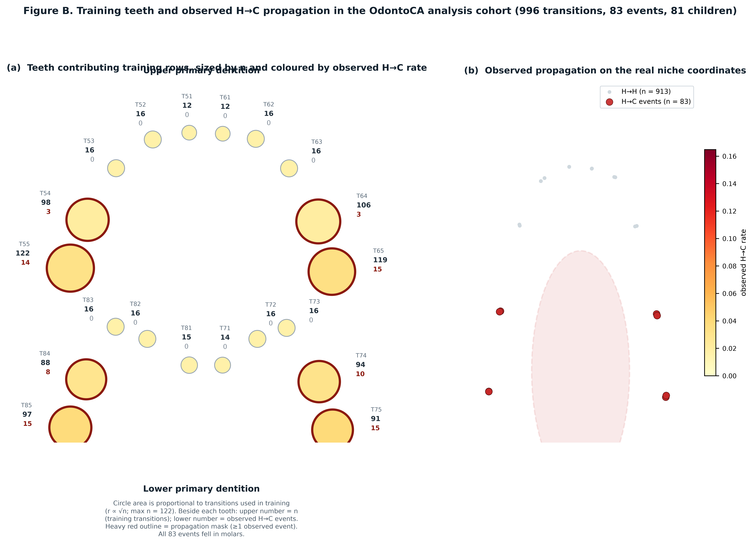
Figure 5. Distribution of training transitions and observed healthy-to-carious events by tooth position in the 996-transition analysis cohort. Panel (a) displays anatomically arranged primary-tooth positions, with marker size proportional to the number of transitions and fill representing the observed event fraction; positions with at least one event are outlined. Panel (b) shows the same positions in the source coordinate system. The figure represents tabular tooth-position data and not radiographic anatomy.
Table 4. Transition counts and observed event fractions by tooth position in the primary analysis cohort.
Tooth position | Transitions | Events | Event fraction
T51 | 12 | 0 | 0.000
T52 | 16 | 0 | 0.000
T53 | 16 | 0 | 0.000
T54 | 98 | 3 | 0.031
T55 | 122 | 14 | 0.115
T61 | 12 | 0 | 0.000
T62 | 16 | 0 | 0.000
T63 | 16 | 0 | 0.000
T64 | 106 | 3 | 0.028
T65 | 119 | 15 | 0.126
T71 | 14 | 0 | 0.000
T72 | 16 | 0 | 0.000
T73 | 16 | 0 | 0.000
T74 | 94 | 10 | 0.106
T75 | 91 | 15 | 0.165
T81 | 15 | 0 | 0.000
T82 | 16 | 0 | 0.000
T83 | 16 | 0 | 0.000
T84 | 88 | 8 | 0.091
T85 | 97 | 15 | 0.155
All 83 events occurred in the eight primary molar positions. Event fractions are descriptive cohort frequencies, not model-estimated risks.

3.5. Status of Non-Clinical OdontoCA Branches
No real microbiome model, image model, patient-linked multimodal fusion, or external clinical validation was executed for this manuscript. Two earlier internal runs of the synthetic branch and an earlier non-public exploratory run on the real cohort returned different estimates under different group-split policies despite identical cohort counts. These discrepancies, the software versions under which each result was produced, and the resulting limits on cross-run comparability are documented in Supplementary File S2. They are reported because they bound what can be claimed, not because they bear on the clinical estimates in Tables 2 and 3, which were produced under a single locked policy with a fixed seed.

4. Discussion

4.1. Principal Findings
This analysis advances OdontoCA from a synthetic integration demonstration to a reproducible public-cohort reconstruction and an exploratory real clinical prediction study. The 11 count checks establish that the tooth-level target was reconstructed as expected. Patient-grouped internal validation produced discrimination above chance and average precision above event prevalence for both clinical models. The stronger point estimate for the spatial model is consistent with a potential role for local oral context, but the paired uncertainty intervals include zero. Training-only intercept-and-slope recalibration reduced the minimal model’s held-out Brier score; the spatial model’s Brier change remained uncertain. These results warrant prospective methodological work; they do not show that spatial features or recalibration improve patient care.

4.2. Interpretation of Discrimination and Calibration
The event fraction was 8.33%, making the prevalence reference for average precision low and emphasizing the need to interpret AUPRC alongside AUROC. A ROC area of 0.737 describes ranking in this one cohort. The uncalibrated spatial Brier score was close to that of a simple prevalence predictor, while the recalibrated minimal Brier score was lower in this internal analysis. Its residual calibration slope of 0.808 and the limited number of children show that probability estimates still need development before individual interpretation. Fold-specific monotone updates can alter pooled rankings across folds; any resulting change in pooled discrimination should not be interpreted as new feature information. Internal out-of-fold evaluation limits some optimism but cannot replace transportability testing; PROBAST highlights concerns about participants, predictors, outcomes, and analysis [25]. Decision-curve analysis can quantify net benefit when clinically justified thresholds are available [26], but thresholds should not be presented as treatment recommendations without a defined decision context.
A further concern is the descriptive calibration graphic. Contemporary validation guidance favors calibration assessment across the full prediction range with a smoothed calibration curve rather than grouped points alone. The eight-bin display in Figure 4 is therefore retained only as a compact internal description; the planned independent validation should include a smoothed curve with confidence intervals and the distribution of predicted risks.

4.3. Relation to Spatial and Microbiome Literature
The clinical-only design avoids attributing another group’s microbiome results to OdontoCA. Recent microbiome risk modelling in a small nested case-control study [27] adds context, not a direct comparator, because case mix, follow-up, and validation differ. The source paper’s tooth-resolved microbiome findings [1] and the observed structure of oral plaque communities [28] motivate an exact SampleID-linked extension. That extension should audit sequencing library quality, compositional preprocessing, patient grouping, and incremental performance against the clinical baseline. It must use matched patient, visit, and tooth records; data from unrelated image or microbiome cohorts cannot be fused to create a fictitious multimodal patient.

4.4. Reporting and the Next Validation Phase
The original TRIPOD statement [29], the updated TRIPOD+AI guidance [10], and practical model-development guidance [30] support full disclosure of cohort flow, candidate predictors, tuning, uncertainty, and deviations. The next phase should lock the clinical-spatial algorithm, independently reconstruct or document each derived spatial feature from measurements available at the prediction visit, and validate it in a genuinely separate clinic or later time period. A fixed prediction horizon, prespecified thresholds, subgroup checks, calibration updating, and clinical utility analysis should be planned before testing. The same evidence gate applies to proposed image and microbiome branches.
For the next phase, the strongest design would be a prospectively registered, independent cohort with predictor measurements available at the intended prediction time, a fixed and clinically meaningful prediction horizon, blinded or otherwise independent outcome assessment where feasible, and sufficient sample size for precise calibration and discrimination estimates. The locked artifact should be applied unchanged first; any recalibration or model updating should be reported as a separate post-validation analysis.

4.5. Limitations
The analysis uses one public cohort and a modest number of children and events, with multiple teeth per child. The model was developed from only 83 outcome events for 24 effective degrees of freedom (3.46 events per parameter), indicating substantial sample-size constraint and potential overfitting; this ratio is descriptive rather than a formal sample-size criterion. Follow-up varies from two to five months, and the target is the next visit rather than a fixed-time risk. Sampling provenance for the 89 source children is not recoverable from the released worksheet, so selection bias in the source cohort cannot be appraised. Source-derived spatial fields were not reconstructed from raw examinations, and information about acquisition, missingness, and prospective availability needs author verification. The child bootstrap resampled existing out-of-fold predictions rather than refitting every nested model, so its intervals omit model-development variability. Two calibration forms were examined without an independent external dataset, and selecting one after seeing these results may overstate its future benefit. No independent outcome adjudication, external population, prospective workflow test, or net-benefit analysis was available. Locking the final model regularisation value once on the full cohort, as required for a deployable artifact, makes the artifact’s own cross-fitted metrics optimistic relative to the fold-wise estimates in Section 3.2; performance reporting must cite the fold-wise values. The saved synthetic notebook and its current-code rerun yielded different metrics, and the legacy and corrected split policies gave different internal estimates; executable outputs and software versions therefore must be pinned. The original work’s reported diagnostic or predictive accuracy [1] is not an OdontoCA result.
Additional limitations relevant to peer review include variable follow-up (2–5 months), absence of a fixed prediction horizon, lack of an independent external cohort, reliance on source-derived spatial fields whose prospective availability is unverified, and the fact that the fitted logistic model does not explicitly model within-child correlation even though validation and bootstrap uncertainty were grouped by child. Item-level missingness mechanisms and predictor acquisition procedures should be documented in the supplement to the extent recoverable from the source data.

5. Conclusions
This secondary analysis reproduced the public tooth-level cohort and identified modest exploratory predictive signal under child-grouped internal validation. The clinical-spatial model had an AUROC of 0.737 and average precision of 0.178, but its advantage over the minimal clinical model was uncertain. Training-only intercept-and-slope recalibration improved the minimal model Brier score within this cohort, while calibration remained imperfect. A version-locked primary model and a prespecified external-validation framework now support a falsifiable next step; they do not establish transportability or clinical utility. Given the limited number of children and events, variable follow-up, unverified source-derived spatial predictors, and absence of external validation, the artifact should be treated strictly as a research model. Independent validation with a prospectively justified, precision-based sample size is required before any patient-level decision support is considered.
Supplementary Materials: Supplementary File S1 contains the detailed evidence-aware architecture; Supplementary File S2 documents the synthetic-notebook audit, rerun discrepancy, and validation limits; Supplementary File S3 maps reporting to TRIPOD+AI; Supplementary File S4 provides the internal PROBAST+AI appraisal. Reproducibility materials should include the verified analysis script, split assignments, aggregate outputs, source-file digest, and version-locked inference artifact.
Author Contributions: [REQUIRED: insert CRediT roles for the confirmed authors. Authorship and contributions must reflect actual work performed.]
Funding: [REQUIRED: state “This research received no external funding” or provide the verified funder, grant number, and APC funding statement.]
Institutional Review Board Statement: [REQUIRED BEFORE SUBMISSION: this secondary analysis used de-identified records released publicly by the source investigators and recruited no new participants. Confirm with the authors’ institution whether ethical review was not required, exempted, or waived for this secondary analysis, and insert the formal determination/protocol number if applicable. Do not submit with this placeholder.]
Informed Consent Statement: [REQUIRED BEFORE SUBMISSION: confirm the appropriate statement for secondary analysis of the public source data, and, if relevant, cite the consent procedures of the original study. Do not infer consent status from public availability alone.]
Data Availability Statement: The analysis used the public all_metadata worksheet released with Yang et al. [1]. The exact source file analysed was pinned by commit identifier e5868fe5 and SHA-256 b7819fee81efbe2e227b7700c3cd86ce8bc6f7fe6f49da6214f4107d099184fa. The clinical reconstruction and analysis code, aggregate outputs, figure scripts, and version-locked inference artifact should be deposited in a permanent public repository before publication. Third-party source records should be redistributed only if their original reuse terms permit it.
Acknowledgments: During preparation of this manuscript, the authors used OpenAI Codex for code-review assistance, execution support, editorial revision, reference checking, and deterministic diagram/figure scripting. The authors reviewed and edited all outputs and retain full responsibility for the accuracy and integrity of the publication. Exact tool/version information should be confirmed before submission.
Conflicts of Interest: [REQUIRED: each author must complete and verify the MDPI conflict-of-interest disclosure. If none exist, replace this text with “The authors declare no conflicts of interest.”]

Abbreviations
The following abbreviations are used in this manuscript:
Table 5. Abbreviations used in the manuscript.
Abbreviation | Definition
AUPRC | Area under the precision–recall curve
AUROC | Area under the receiver-operating-characteristic curve
ECC | Early-childhood caries
FDI | Fédération Dentaire Internationale tooth notation
OOF | Out-of-fold
PROBAST+AI | Prediction model Risk Of Bias ASsessment Tool + AI
TRIPOD+AI | Transparent Reporting of a multivariable prediction model for Individual Prognosis Or Diagnosis + AI

References
- Yang F, Teng F, Zhang Y, et al. Single-tooth resolved, whole-mouth prediction of early childhood caries via spatiotemporal variations of plaque microbiota. Cell Host & Microbe. 2025;33(6):1019-1032.e6. https://doi.org/10.1016/j.chom.2025.05.006.
- Toledo Reyes L, Knorst J, Ortiz F, et al. Early Childhood Predictors for Dental Caries: A Machine Learning Approach. Journal of Dental Research. 2023;102(9):999-1006. https://doi.org/10.1177/00220345231170535.
- Dashper SG, Mitchell HL, Lê Cao KA, et al. Temporal development of the oral microbiome and prediction of early childhood caries. Scientific Reports. 2019;9(1):19732. https://doi.org/10.1038/s41598-019-56233-0.
- Blostein F, Bhaumik D, Davis E, et al. Evaluating the ecological hypothesis: early life salivary microbiome assembly predicts dental caries in a longitudinal case-control study. Microbiome. 2022;10(1):240. https://doi.org/10.1186/s40168-022-01442-5.
- Raksakmanut R, Thanyasrisung P, Sritangsirikul S, et al. Prediction of Future Caries in 1-Year-Old Children via the Salivary Microbiome. Journal of Dental Research. 2023;102(6):626-635. https://doi.org/10.1177/00220345231152802.
- Head D, Devine DA, Marsh PD. In silico modelling to differentiate the contribution of sugar frequency versus total amount in driving biofilm dysbiosis in dental caries. Scientific Reports. 2017;7(1):17413. https://doi.org/10.1038/s41598-017-17660-z.
- Martin B, Tamanai-Shacoori Z, Bronsard J, et al. A new mathematical model of bacterial interactions in two-species oral biofilms. PLOS ONE. 2017;12(3):e0173153. https://doi.org/10.1371/journal.pone.0173153.
- Varma S, Simon R. Bias in error estimation when using cross-validation for model selection. BMC Bioinformatics. 2006;7(1):91. https://doi.org/10.1186/1471-2105-7-91.
- Rosenblatt M, Tejavibulya L, Jiang R, et al. Data leakage inflates prediction performance in connectome-based machine learning models. Nature Communications. 2024;15(1):1829. https://doi.org/10.1038/s41467-024-46150-w.
- Collins GS, Moons KGM, Dhiman P, et al. TRIPOD+AI statement: updated guidance for reporting clinical prediction models that use regression or machine learning methods. BMJ. 2024;385:e078378. https://doi.org/10.1136/bmj-2023-078378.
- Moons KGM, Damen JAA, Kaul T, et al. PROBAST+AI: an updated quality, risk of bias, and applicability assessment tool for prediction models using regression or artificial intelligence methods. BMJ. 2025;388:e082505. https://doi.org/10.1136/bmj-2024-082505.
- Teng F, Yang F, Huang S, et al. Prediction of Early Childhood Caries via Spatial-Temporal Variations of Oral Microbiota. Cell Host & Microbe. 2015;18(3):296-306. https://doi.org/10.1016/j.chom.2015.08.005.
- Grier A, Myers J, O’Connor T, et al. Oral Microbiota Composition Predicts Early Childhood Caries Onset. Journal of Dental Research. 2021;100(6):599-607. https://doi.org/10.1177/0022034520979926.
- Jørgensen MR, Twetman S. A systematic review of risk assessment tools for early childhood caries: is there evidence? European Archives of Paediatric Dentistry. 2020;21(2):179-184. https://doi.org/10.1007/s40368-019-00480-2.
- Moynihan P, Tanner L, Holmes R, et al. Systematic Review of Evidence Pertaining to Factors That Modify Risk of Early Childhood Caries. JDR Clinical & Translational Research. 2019;4(3):202-216. https://doi.org/10.1177/2380084418824262.
- Gloor GB, Macklaim JM, Pawlowsky-Glahn V, et al. Microbiome Datasets Are Compositional: And This Is Not Optional. Frontiers in Microbiology. 2017;8:2224. https://doi.org/10.3389/fmicb.2017.02224.
- Quinn TP, Erb I, Gloor G, et al. A field guide for the compositional analysis of any-omics data. GigaScience. 2019;8(9):giz107. https://doi.org/10.1093/gigascience/giz107.
- Saito T, Rehmsmeier M. The Precision-Recall Plot Is More Informative than the ROC Plot When Evaluating Binary Classifiers on Imbalanced Datasets. PLOS ONE. 2015;10(3):e0118432. https://doi.org/10.1371/journal.pone.0118432.
- Richardson E, Trevizani R, Greenbaum JA, et al. The receiver operating characteristic curve accurately assesses imbalanced datasets. Patterns. 2024;5(6):100994. https://doi.org/10.1016/j.patter.2024.100994.
- Van Calster B, McLernon DJ, van Smeden M, et al. Calibration: the Achilles heel of predictive analytics. BMC Medicine. 2019;17(1):230. https://doi.org/10.1186/s12916-019-1466-7.
- Collins GS, Dhiman P, Ma J, et al. Evaluation of clinical prediction models (part 1): from development to external validation. BMJ. 2024;384:e074819. https://doi.org/10.1136/bmj-2023-074819.
- Riley RD, Archer L, Snell KIE, et al. Evaluation of clinical prediction models (part 2): how to undertake an external validation study. BMJ. 2024;384:e074820. https://doi.org/10.1136/bmj-2023-074820.
- Riley RD, Ensor J, Snell KIE, Harrell FE Jr, Martin GP, Reitsma JB, Moons KGM, Collins GS, van Smeden M. Calculating the sample size required for developing a clinical prediction model. BMJ. 2020;368:m441. https://doi.org/10.1136/bmj.m441.
- Riley RD, Snell KIE, Archer L, Ensor J, Debray TPA, Van Calster B, van Smeden M, Collins GS. Evaluation of clinical prediction models (part 3): calculating the sample size required for an external validation study. BMJ. 2024;384:e074821. https://doi.org/10.1136/bmj-2023-074821.
- Wolff RF, Moons KG, Riley RD, et al. PROBAST: A Tool to Assess the Risk of Bias and Applicability of Prediction Model Studies. Annals of Internal Medicine. 2019;170(1):51-58. https://doi.org/10.7326/M18-1376.
- Vickers AJ, Elkin EB. Decision Curve Analysis: A Novel Method for Evaluating Prediction Models. Medical Decision Making. 2006;26(6):565-574. https://doi.org/10.1177/0272989X06295361.
- Ho TE, Yang YM, Gu WJ, et al. Construction of an early childhood caries risk prediction model based on the oral microbiome: a nested case‒control study. BMC Oral Health. 2025;25(1):923. https://doi.org/10.1186/s12903-025-06147-3.
- Valm AM. The Structure of Dental Plaque Microbial Communities in the Transition from Health to Dental Caries and Periodontal Disease. Journal of Molecular Biology. 2019;431(16):2957-2969. https://doi.org/10.1016/j.jmb.2019.05.016.
- Collins GS, Reitsma JB, Altman DG, et al. Transparent Reporting of a multivariable prediction model for Individual Prognosis Or Diagnosis (TRIPOD): The TRIPOD Statement. Annals of Internal Medicine. 2015;162(1):55-63. https://doi.org/10.7326/M14-0697.
- Efthimiou O, Seo M, Chalkou K, et al. Developing clinical prediction models: a step-by-step guide. BMJ. 2024;386:e078276. https://doi.org/10.1136/bmj-2023-078276.

