

|  |
| --- |
| Team Horse  Chestnut |
| Project Ideation |
|  |
| Northumbria University | SOftware Eng. Practice | 2nd Semester |

Table of Contents

Problem statement 1

Problem Motivation 2

Literature Review 3

Project Statement 6

Reference list 6

# Problem statement

Alzheimer's is a progressive neurodegenerative disorder that impairs memory, thinking, and behaviour. An estimated 50 million people worldwide suffer from Alzheimer's, being most prevalent in old age, but its link with the brain is largely unknown and can strike at any age (Liu et al., 2024). It kills more than breast cancer and prostate cancer combined and every 1 in 3 seniors dies with Alzheimer's or another dementia. However, the disease not only impacts the diagnosed but also causes significant emotional and financial challenges for their families and caregivers (Alzheimer's Association, 2023). Detecting Alzheimer's is a complex process that presents many challenges.

One of these issues is the labour shortage in the healthcare sector. With an ageing population, the demand for healthcare professionals, particularly those specialising in neurology, is increasing (Alzeihmer's Research UK, 2021). However, the supply of such professionals is not keeping pace, causing a significant gap in service provision (Care Quality Commission, 2023).  Currently, over 35% of Long-Term Care providers have reported being unable to hire or maintain staff numbers reliably to be effective (Care Quality Commission, 2022). Furthermore, as populations across the globe are living longer, this trend is expected to worsen, putting additional strain on limited healthcare resources.

Human error is another significant challenge. Alzheimer's symptoms can be subtle and easily mistaken for normal ageing, leading to delayed diagnosis and treatment. A study in 2011 found that 12% to 23% of Alzheimer’s cases were incorrect at autopsy, and out of those correctly diagnosed, 63% had been given an incorrect type of Alzheimer’s (Gaugler et al., 2013). Additionally, the disease's progression varies among individuals, making it difficult to predict its course accurately, and the lack of a definitive diagnosis adds difficulty. Furthermore, societal stigma also prevents individuals from seeking help when symptoms first appear.

The cost of services is the last major obstacle. Diagnostic procedures such as PET scans and MRI scans (NHS, 2019), are expensive and often not covered by insurance. Since doctors need an extremely broad yet specialised understanding of the brain to diagnose Alzheimer’s, the high expense of labour pushes away patients (Michalowsky et al., 2017). This makes it difficult for many patients to access these services, with costs in Denmark alone being an extra €4996 in the year of diagnosis compared to an average patient, showing the financial barrier in diagnosis. Overall, dementia-related costs in the UK alone are predicted to rise from £34.7 billion in 2019 to £94.1 billion in 2040 (Alzheimer's Society, 2019).

In conclusion, while strides have been made in understanding and diagnosing Alzheimer's, significant challenges remain. There needs to be improved efficiency in cost reduction in detection, so Alzeihmer's can be treated earlier, to reduce the growing cost to both society and individuals. Addressing these will require concerted efforts from healthcare professionals, researchers, policymakers, and society at large.

# Problem Motivation

The impact of identifying Alzheimer's disease early on cannot be overstated, as the human toll of not doing so is immense. Alzheimer's not only affects the individuals diagnosed with it, but also has a significant impact on their families and caregivers. The mental health of these individuals is heavily impacted, with increased rates of stress, anxiety, and depression, with spouses fairing the worst with 63% of senior spouses having a higher mortality rate, and 18% of healthy spouses dying before their partner did (Samuels, 2020). This means that there is a large motivation to increase the efficiency of Alzheimer's screenings because it will not only be felt by the patients, but also by whole other sectors like mental health services, as well as increase the general happiness of millions of individuals globally.

Identifying Alzheimer's disease early is crucial as it impacts not only the diagnosed individuals but also their families and caregivers. It heavily affects their mental health, leading to increased rates of stress, anxiety, and depression, with spouses fairing the worst. Samuels, 2020 showed that 63% of senior spouses had a higher mortality rate, and 18% of healthy spouses died before their partner did, indicating there is a large hidden cost to Alziehmer's. There is a need to improve Alzheimer's screenings, which will benefit not only the patients and the Alzheimer’s community but also mental health services and millions of individuals worldwide.

The labour shortage in the healthcare sector, as mentioned in the previous section, exacerbates these mental health issues. Global population ageing will make Alzheimer's more lethal in the poorest healthcare systems. The current system of diagnosis for Alzheimer's is costly and is risking creating a large divide between populations that can afford treatment and those that cannot (Alzeihmer's Research UK, 2021). It is imperative to find ways of decreasing the cost while maintaining accuracy to prevent long-term inequality and a physical divide in life expectancy and quality of life.

Given these challenges, there is a strong motivation to develop better screening processes for Alzheimer's (Alzeihmer's Research UK, 2021), particularly using Machine Vision and Machine Learning. These technologies have the potential to revolutionise the diagnosis of Alzheimer's. Machine Vision and Machine Learning can be used to analyse imaging data as accurately but incredibly more efficiently than humans. It is especially useful in reducing the likelihood of error and increasing the accuracy of early diagnosis, another major problem mentioned in the previous section.

In conclusion, addressing the challenges in detecting Alzheimer's disease is of utmost importance. It has the potential to reduce the human cost associated with the disease, improve mental health outcomes for patients and their families, and ensure that the increasing number of Alzheimer's cases due to the ageing global population can be managed effectively.

In conclusion, there is a crucial need to use existing technology to reduce both the time and financial cost of Alzheimer's detection systems. Its ability to reduce the human cost associated with the disease, improve mental health outcomes for patients and their families, and manage global ageing's increased number of Alzheimer's cases, is untenable and is an opportunity that cannot be missed.

# Literature Review

Over the past 10 years, the number of AI-related papers on the study of dementia and its specific types has increased, with several techniques and data sources used. The research has mainly been a redeployment of proven techniques in other medical fields, such as for Parkinson’s disease (Ali et al., 2019), hepatitis (Akbar et al., 2020), carcinoma (Ali et al., 2020), and heart failure (Javeed et al., 2020) among others. Overall, the most common investigations were into using historical health records, MRI scans with machine vision, voice identification, and EEG pattern recognition.

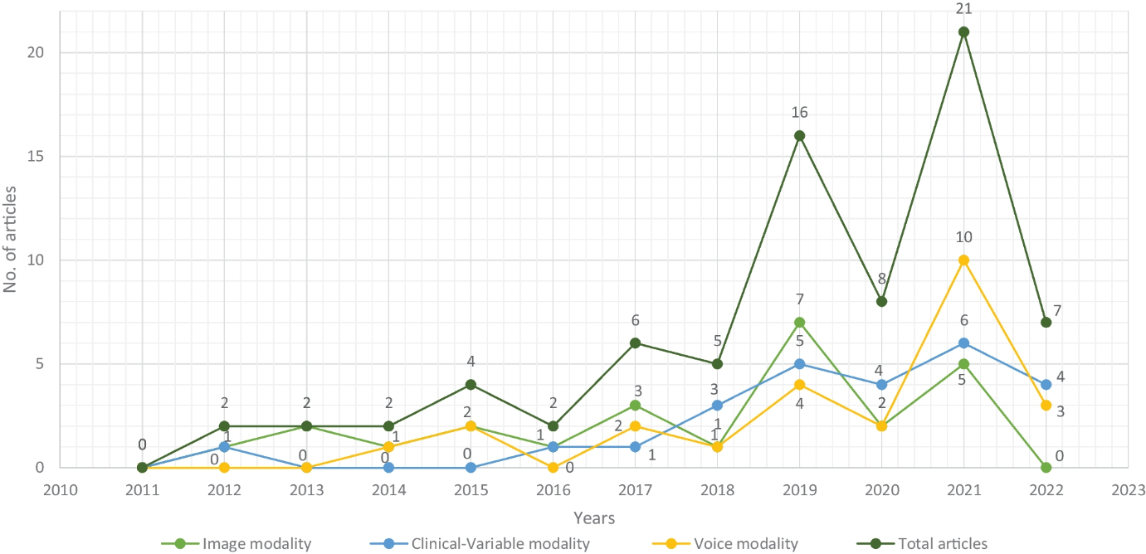

Figure 1 [Selected research articles which are published from 2011 to 2022 regarding data modality, Figure 4 from Javeed et al. (2023)]

In a peer-reviewed study by Javeed et al. (2023), they conducted a systematic analysis of some of the efficiencies of AI for four categories of dementia-related datasets, as seen in Figure 1. Their finds were that Image Modality was most efficient, with 6 separate models being studied, all of them achieving over 65% accuracy, with one achieving 99.9% and another 100% accuracy. Clinical-Variable modality (dataset of patient history), the models were again over 65% accurate but were on average less likely to be as accurate as image modality. ‘Voice’ modality was worst, but still averaging above 55%.

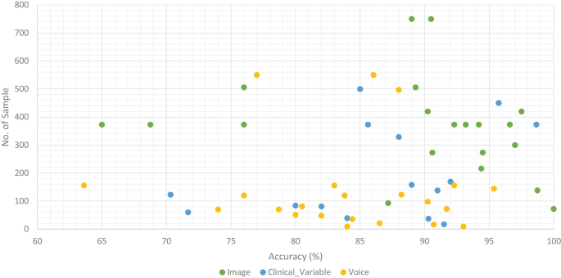

Figure 2 [Accuracy comparison of ML models along with number of samples in the dataset based on data modality, Figure 10 from Javeed et al. (2023)]

For EEG modality analysis, there are limited research articles about the subject. For three of the articles found on the topic, all of them were limited in their datasets, because of the limited publicly available sources that contain both EEG data and accurate labelling. In Xavier Stephen Mootoo et al. (2023) and Kim et al. (2023), both of their models only reached 84% and 88% accuracy, and both used their own procured datasets for their studies, both of which were less than 100 people. Bairagi (2018) was much more promising, reaching a 94% accuracy with its best testing phase. However, again the model was trained on only 50 cases and procurement of a unique dataset for the study was needed, something outside of the scope of our project. There is also a note that none of these studies attempted to detect the specific types of Alzheimer’s, and were only effective on those with strong/progressed Alzheimer’s. There is also the fact that EEG data alone currently does not accurately detect dementia, and other data sources like facial scans were needed as a supplement (Klepl et al., 2023). This is in stark contrast to the other data types in Alzheimer research, shown in Figure 2, with image modality having between 100 to 750 samples, and some studies in voice and patient history being around 500 samples.

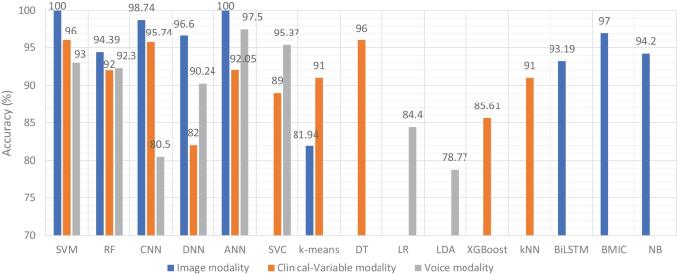

Figure 3 [Accuracy comparison of ML models based on data modality, Figure 8 from Javeed et al. (2023)]

In terms of specific models that were the best, Javeed et al. (2023) broke down each model's accuracy and performance, as seen in Figure 3. In their findings, there were no ‘wrong’ or terrible performances from any of the models, but SVM and ANN models performed well on all three types of modality, with SVM, CNN, and ANN models working particularly well for the Image modality. For the EEG models, they used only SVM models.

Overall, there are some major upsides as well as negatives to each of the techniques and the use of AI generally in current literature. The main positive is that the current models are reaching high accuracy with Image modality particularly being consistent and reliable. Patient history, Voice, and EEG techniques have brought mixed success, with EEG particularly being held back by its lack of available research.

In terms of solving the cost problems of diagnosis systems, image modality is worse due to the fact it still needs highly expensive MRI or PET scans, while EEG and Voice are both extremely cheap for equipment and require little training to operate. Patient history is most useful due to the fact it requires no direct interaction with the patient or any specific equipment or even any personnel.

However, for the creation of models, both EEG and voice have numerous problems. The two modalities' datasets do not have adequate size and labelling for Alzheimer’s, and there is little protection against bias for ethnicity, age or gender that comes with small datasets., which Vien Ngoc Dang et al. (2023) showed heavily affects current Alzheimer’s detection models. Bias is still a possibility with the other modal forms, but is less pronounced since all have much larger datasets.

There are also problems with patient history as current data protection laws in the UK, US, and EU mean that large-scale access and usage of this data is extremely hard, and in some cases illegal (UK Government, 2023). This also affects image modality, as some key steps such as ensuring geographic, ethnic, age and gender diversity may be hindered due to data protection.

# Project Statement

The project will aim to develop a CNN model that is trained on a large dataset of Alzheimer’s cases, and be able to not only diagnose Alzheimer's but also give the specific type. This is due to the research by Javeed et al. (2023) showing that CNN models are the most accurate for Alzheimer's detection by a large margin. We believe the most useful dataset should be MRI images because while it does not solve the issues with cost, it is by far the most reliable data source, and the sample size should be at least 1000 individuals. Reliability is an incredibly important variable for medical applications such as ours, and if we want to solve the issue of misdiagnosis in the industry shown in the problem statement (Gaugler et al., 2013), we cannot have our model trained on sketchy data, and by having a larger dataset, we should also avoid the ethical problems shown by Vien Ngoc Dang et al. (2023) seen with small sample sizes of Alzheimer’s. Furthermore, Javeed et al. (2023) again showed that image modality is the best datatype to diagnose Alzheimer’s, and we are also aiming to try and detect the specific types of Alzheimer’s, a task that is currently impossible using other datatypes (Klepl et al., 2023).

Overall, we believe we can develop an AI that is at the forefront of current research in Alzheimer’s detection, and help aid in the crucial current and future problem that is dementia diagnosis. While our approach is not fully novel, we believe that adding the aspect of detecting each type of Alzheimer’s in addition to just the disease itself, lends our task to being highly useful in the under-researched field that is Machine Vision for Alzheimer’s detection. Furthermore, as research from Javeed et al. (2023) shows, the sample sizes in current models are highly problematic (seen in Figure 2), and by having a larger dataset size than others, we believe we can help negate the bias issues seen by Vien Ngoc Dang et al. (2023).

# Reference list

Akbar, W., Wu, W., Saleem, S., Farhan, M., Saleem, M.A., Javeed, A. and Ali, L. (2020). Development of Hepatitis Disease Detection System by Exploiting Sparsity in Linear Support Vector Machine to Improve Strength of AdaBoost Ensemble Model. *Mobile Information Systems*, 2020, pp.1–9. doi:https://doi.org/10.1155/2020/8870240.

Ali, L., Wajahat, I., Amiri Golilarz, N., Keshtkar, F. and Bukhari, S.A.C. (2020). LDA–GA–SVM: improved hepatocellular carcinoma prediction through dimensionality reduction and genetically optimized support vector machine. *Neural Computing and Applications*, 33(7), pp.2783–2792. doi:https://doi.org/10.1007/s00521-020-05157-2.

Ali, L., Zhu, C., Golilarz, N.A., Javeed, A., Zhou, M. and Liu, Y. (2019). Reliable Parkinson’s Disease Detection by Analyzing Handwritten Drawings: Construction of an Unbiased Cascaded Learning System Based on Feature Selection and Adaptive Boosting Model. *IEEE Access*, 7, pp.116480–116489. doi:https://doi.org/10.1109/access.2019.2932037.

Alzeihmer's Research UK (2021). *The Right to Know: Accurate and Earlier Diagnosis of Dementia*. [online] *alzheimersresearchuk.org*, Alzeihmer’s Research UK , pp.3–4. Available at: https://www.alzheimersresearchuk.org/wp-content/uploads/2021/05/ARUK-The-Right-to-Know_Accurate-and-Earlier-Diagnosis-of-Dementia_25May21.pdf [Accessed 4 Mar. 2024].

Alzheimer's Association (2023). *Alzheimer’s disease facts and figures*. [online] Alzheimer’s Disease and Dementia. Available at: https://www.alz.org/alzheimers-dementia/facts-figures [Accessed 4 Mar. 2024].

Alzheimer's Society (2019). *How many people have dementia and what is the cost of dementia care?* [online] Alzheimer’s Society. Available at: https://www.alzheimers.org.uk/about-us/policy-and-influencing/dementia-scale-impact-numbers [Accessed 4 Mar. 2024].

Bairagi, V. (2018). EEG signal analysis for early diagnosis of Alzheimer disease using spectral and wavelet based features. *International Journal of Information Technology*, 10(3), pp.403–412. doi:https://doi.org/10.1007/s41870-018-0165-5.

Care Quality Commission (2022). *Staff shortages and the impact on patients - Care Quality Commission*. [online] www.cqc.org.uk. Available at: https://www.cqc.org.uk/publications/monitoring-mental-health-act/2021-2022/staff-shortages [Accessed 4 Mar. 2024].

Care Quality Commission (2023). *The health and care workforce*. [online] www.cqc.org.uk. Available at: https://www.cqc.org.uk/publications/major-report/state-care/2022-2023/workforce [Accessed 4 Mar. 2024].

Gaugler, J.E., Ascher-Svanum, H., Roth, D.L., Fafowora, T., Siderowf, A. and Beach, T.G. (2013). Characteristics of patients misdiagnosed with Alzheimer’s disease and their medication use: an analysis of the NACC-UDS database. *BMC Geriatrics*, 13(1). doi:https://doi.org/10.1186/1471-2318-13-137.

Javeed, A., Dallora, A.L., Berglund, J.S., Ali, A., Ali, L. and Anderberg, P. (2023). Machine Learning for Dementia Prediction: A Systematic Review and Future Research Directions. *Journal of Medical Systems*, 47(1). doi:https://doi.org/10.1007/s10916-023-01906-7.

Javeed, A., Rizvi, S.S., Zhou, S., Riaz, R., Khan, S.U. and Kwon, S.J. (2020). Heart Risk Failure Prediction Using a Novel Feature Selection Method for Feature Refinement and Neural Network for Classification. *Mobile Information Systems*, 2020, pp.1–11. doi:https://doi.org/10.1155/2020/8843115.

Kim, M., Jang, S., Lee, D., Lee, S., Jeonghwan Gwak, Sung Chan Jun and Jae Gwan Kim (2023). A comprehensive research setup for monitoring Alzheimer’s disease using EEG, fNIRS, and Gait analysis. *Biomedical Engineering Letters*, 14(1), pp.13–21. doi:https://doi.org/10.1007/s13534-023-00306-7.

Klepl, D., He, F., Wu, M., Blackburn, D.J. and Sarrigiannis, P. (2023). Adaptive Gated Graph Convolutional Network for Explainable Diagnosis of Alzheimer’s Disease Using EEG Data. *IEEE Transactions on Neural Systems and Rehabilitation Engineering*, [online] 31, pp.3978–3987. doi:https://doi.org/10.1109/tnsre.2023.3321634.

Liu, Y., Tan, Y., Zhang, Z., Yi, M., Zhu, L. and Peng, W. (2024). The interaction between ageing and Alzheimer’s disease: insights from the hallmarks of ageing. *Translational Neurodegeneration*, 13(1). doi:https://doi.org/10.1186/s40035-024-00397-x.

Michalowsky, B., Flessa, S., Hertel, J., Goetz, O., Hoffmann, W., Teipel, S. and Kilimann, I. (2017). Cost of diagnosing dementia in a German memory clinic. *Alzheimer’s Research & Therapy*, 9(1). doi:https://doi.org/10.1186/s13195-017-0290-6.

NHS (2019). *Diagnosis - Alzheimer’s Disease*. [online] www.NHS.uk. Available at: https://www.nhs.uk/conditions/alzheimers-disease/diagnosis/ [Accessed 4 Mar. 2024].

Samuels, C. (2020). *6 Dementia Caregiver Health Risks*. [online] www.aplaceformom.com. Available at: https://www.aplaceformom.com/caregiver-resources/articles/health-risks-for-dementia-caregivers [Accessed 4 Mar. 2024].

Sopina, E., Spackman, E., Martikainen, J., Waldemar, G. and Sørensen, J. (2018). Long-term medical costs of Alzheimer’s disease: matched cohort analysis. *The European Journal of Health Economics*, 20(3), pp.333–342. doi:https://doi.org/10.1007/s10198-018-1004-0.

UK Government (2023). *NHS England’s protection of patient data*. [online] GOV.UK. Available at: https://www.gov.uk/government/publications/nhs-englands-protection-of-patient-data/nhs-englands-protection-of-patient-data.

Vien Ngoc Dang, Adrià Casamitjana, Martijn P. A. Starmans, Martín-Isla, C., Jerónimo Hernández-González, Karim Lekadir and for (2023). Auditing Unfair Biases in CNN-Based Diagnosis of Alzheimer’s Disease. *Lecture Notes in Computer Science*, pp.172–182. doi:https://doi.org/10.1007/978-3-031-45249-9_17.

Xavier Stephen Mootoo, Fours, A., Chinthaka Dinesh, Ashkani, M., Kiss, A. and Mateusz Faltyn (2023). Detecting Alzheimer’s Disease in EEG Data with Machine Learning and the Graph Discrete Fourier Transform. *medRxiv (Cold Spring Harbor Laboratory)*. doi:https://doi.org/10.1101/2023.11.01.23297940.