|  |  |
| --- | --- |
| **Project Case** |  |
| COMP7116  Computer Vision |
| **Computer Science** | **O212-COMP7116-AC01-00** |
| ***Valid on*** *Odd Semester 2020/2021* | **Revision 00** |

1. Seluruh kelompok tidak diperkenankan untuk:

*The whole group is not allowed to:*

* + 1. Melihat sebagian atau seluruh proyek kelompok lain,

*Seeing a part or the whole project from other groups*

* + 1. Menyadur sebagian maupun seluruh proyek dari buku,

*Adapted a part or the whole project from the book*

* + 1. Mendownload sebagian maupun seluruh proyek dari internet,

*Downloading a part or the whole project from the internet,*

* + 1. Mengerjakan soal yang tidak sesuai dengan tema yang ada di soal proyek,

*Working with another theme which is not in accordance with the existing theme in the matter of the project,*

* + 1. Melakukan tindakan kecurangan lainnya,

*Committing other dishonest actions,*

* + 1. Secara sengaja maupun tidak sengaja melakukan segala tindakan kelalaian yang menyebabkan hasil karyanya berhasil dicontek oleh orang lain / kelompok lain.

*Accidentally or intentionally conduct any failure action that cause the results of the project was copied by someone else / other groups.*

1. Jika kelompok terbukti melakukan tindakan seperti yang dijelaskan butir 1 di atas, maka **nilai kelompok** yang melakukan kecurangan (menyontek maupun dicontek) akan di – **NOL** – kan.

*If the group is proved to the actions described in point 1 above, the score of the group which committed dishonest acts (cheating or being cheated) will be “Zero”*

1. Perhatikan jadwal pengumpulan proyek, segala jenis pengumpulan proyek di luar jadwal tidak dilayani.

*Pay attention to the submission schedule for the project, all kinds of submission outside the project schedule will not be accepted*

1. Persentase penilaiaan untuk matakuliah ini adalah sebagai berikut:

*Marking percentage for this subject is described as follows:*

|  |  |  |
| --- | --- | --- |
| **Tugas Mandiri**  *Assignment* | **Proyek**  *Project* | **UAP**  *Final Exam* |
| 40% | 60% | - |

1. Software yang digunakan pada matakuliah ini adalah sebagai berikut:

*Software will be used in this subject are described as follows:*

|  |
| --- |
| **Software**  *Software* |
| Visual Studio Code  Python 3.7  SciPy 1.5.0  OpenCV 3.4.2.16 |

## Ekstensi file yang harus disertakan dalam pengumpulan tugas mandiri, proyek dan uap untuk matakuliah ini adalah sebagai berikut:

*File extensions should be included in assignment, project, and final exam collection for this subject are described as follows:*

|  |  |  |
| --- | --- | --- |
| **Tugas Mandiri**  *Assignment* | **Proyek**  *Project* | **UAP**  *Final Exam* |
| PY | PY | - |

## Soal

*Case*

**AiCrez**

**AiCrez** is an application to differentiate the member of a famous girl band in korea, Twice. This application is currently being develop by **AcrezCompany**. This company focus on developing application with **Artificial** **Intelligence** concept, especially **Computer** **Vision**. **AiCrez** will recognize every Twice member based on **profile** **image** with **single** **face** and **name** **the** **member**. You, as a programmer of **AcrezCompany**, are asked to create that application using **Python** **programming** **language** and **OpenCv** **Library**.

* **Dataset** **Description**

The given dataset contains **training** **dataset** consists of **6 – 21 profile images of each user** that already uploaded from the applications and **testing images** consisting of **6 random user’s profile images**.

* **Get Path List**

The directories of the **given training dataset** will be stored into a **list** containing the **names of directories**. This list will also be used as the **labels** of the training images.

* **Get Class Id**

The image from the **train dataset** will be **stored** into a **list** and every class will have a generated **image** **class** **id**.

* **Detect Train Face and Filter**

**Faces** inside the **training** **images** will be **detected** and **stored** into **a list of images**. You need to **filter** the training images if there are **no face detected**.

* **Detect Test Face and Filter**

**Faces** inside the **test** **images** will be **detected** and **stored** into **a list of images**. You need to **filter** the test images if there are **no** **face** **detected**. You also need to **store** the **position** and **size** of **detected** **face** into **a list of rectangles**.

* **Train**

The **list** of **face** **images** from **train dataset** which already **detected** will be used to **train** the **face recognizer**.

* **Get Test Image Data**

The **image** from **test dataset** will be **loaded** and **stored** into a **list of images**.

* **Predict**

The **list** of **testing images** will be **predicted** to **produce** the **prediction** **result** based on **trained** **recognizer**.

* **Draw Prediction Result**

The **prediction** **results** which consist of the **predicted** **names** and **face** **location** of the user will be **drawn** to every single test image. You also need to **resize** all the image to **200 x 200** since the images are **not in the same size**.

* **Combine and Show Result**

**List** of **testing** **images** that has been drawn and resized will be **combined** into a single image. After being combined, **show** the **final** **image** **result**.

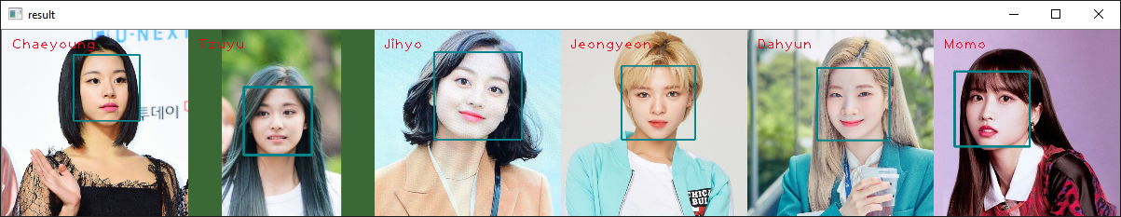

**Figure 1. Final Result**

**Guidelines:**

1. **All** the **steps mentioned in the case** should be **put** in the **corresponding function** in the **template**. **All codes written** **outside** the **corresponding function** will **not be marked**.
2. Do not **modify** or **erase** **any** **codes** in the **template**.

**Reference:**

* + - The dataset is obtained from Google Image