REPORT
Zajęcia: Analog and digital electronic circuits
Teacher: prof. dr hab. Vasyl Martsenyuk
Lab 1
15.01.2026
Topic: Spectral Analysis of Deterministic Signals
Variant 9

Marcin Chowaniec
Informatyka II stopień,
nie stacjonarne,
1 semestr,
Gr.B

1. Problem statement:
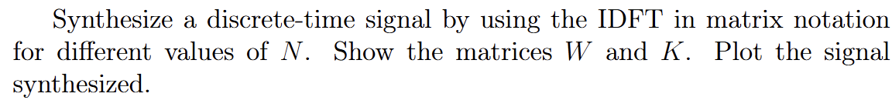

2. Input data:
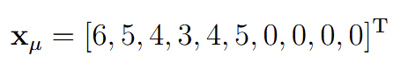

3. Commands used (or GUI):
IDFT
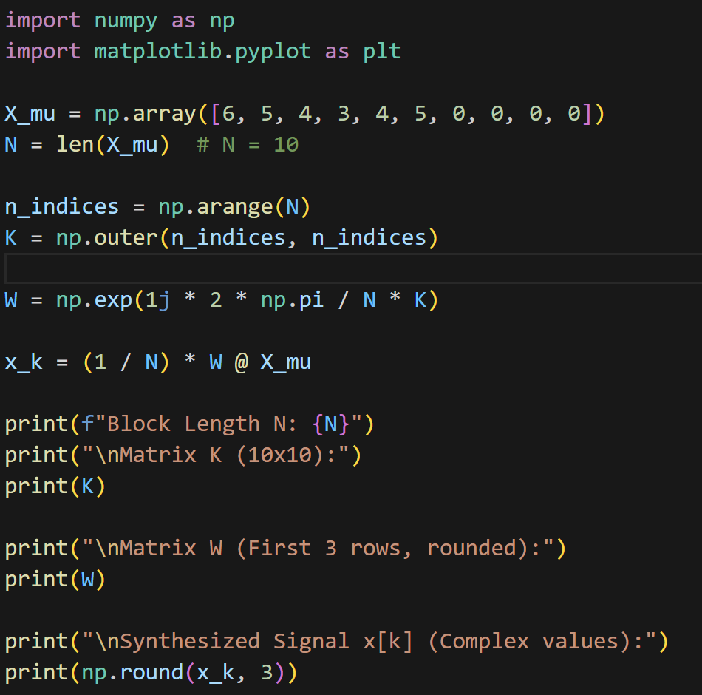

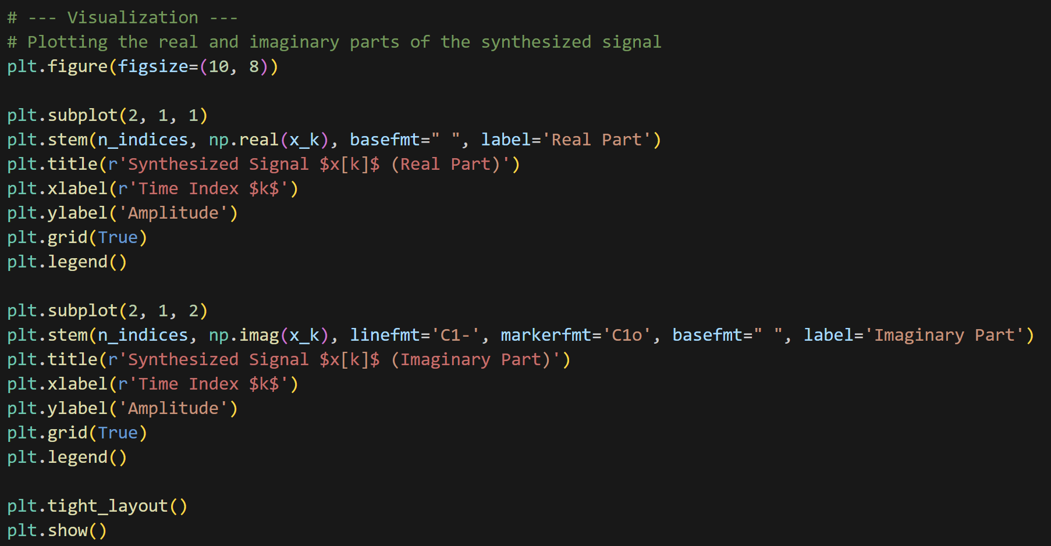

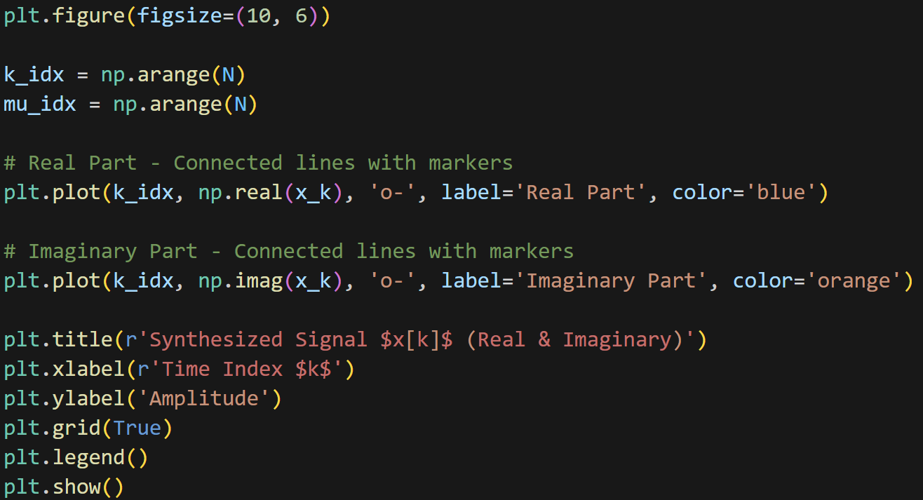
Link to repo https://github.com/MarcinCho/DSP_UBB_1/blob/main/1SA/lab1_mchowaniec.ipynb

4. Outcomes:
Matrices K and W (W was truncated for visibility reasons) were printed out and after synthesized signal.
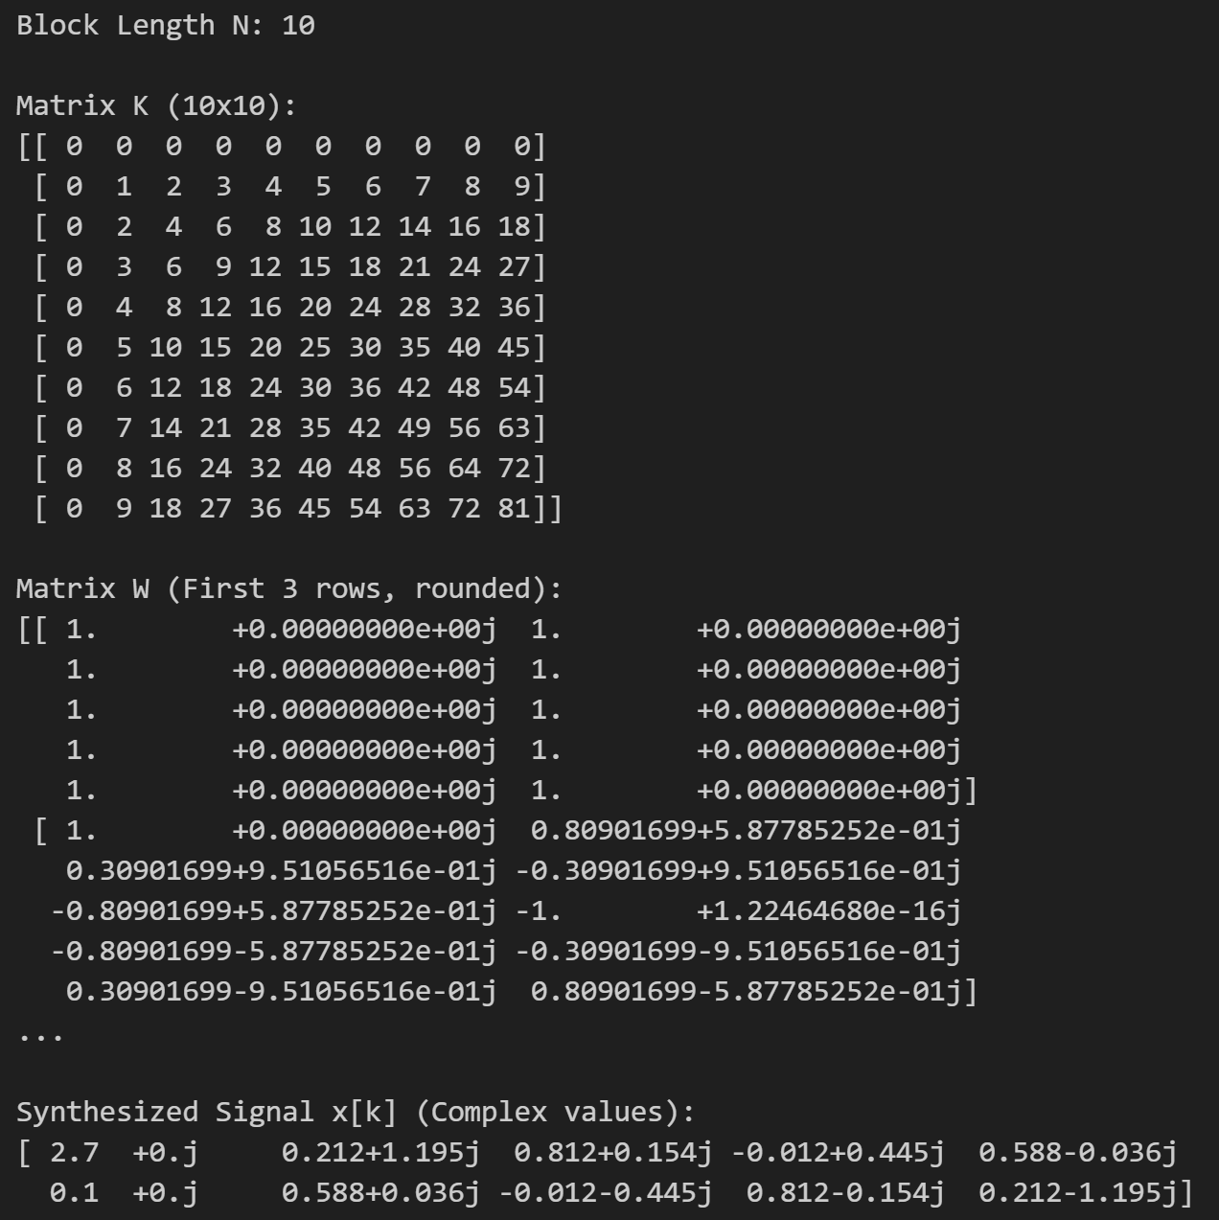

3 plots were created showing imaginary and real parts as well as both on one plot.
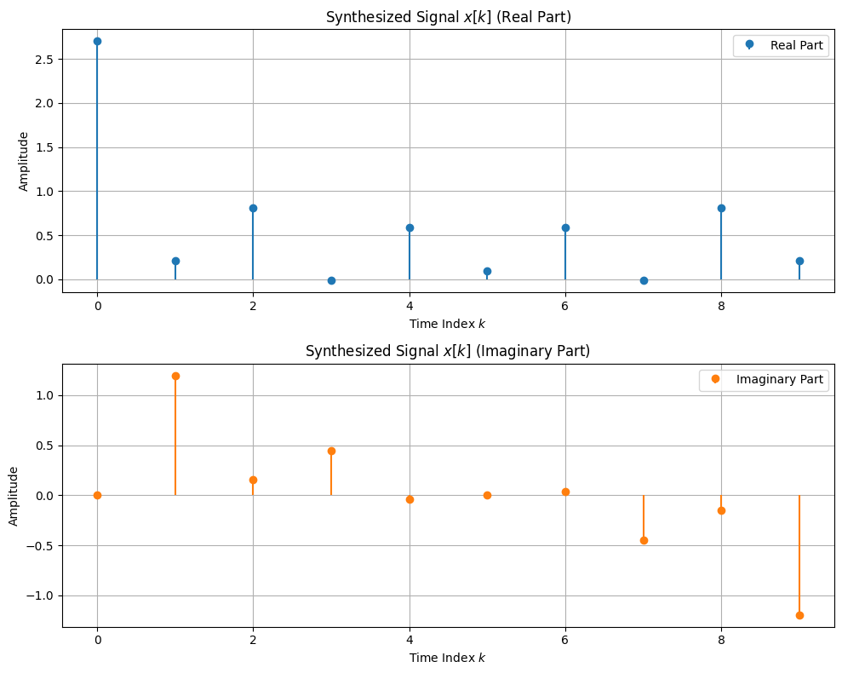
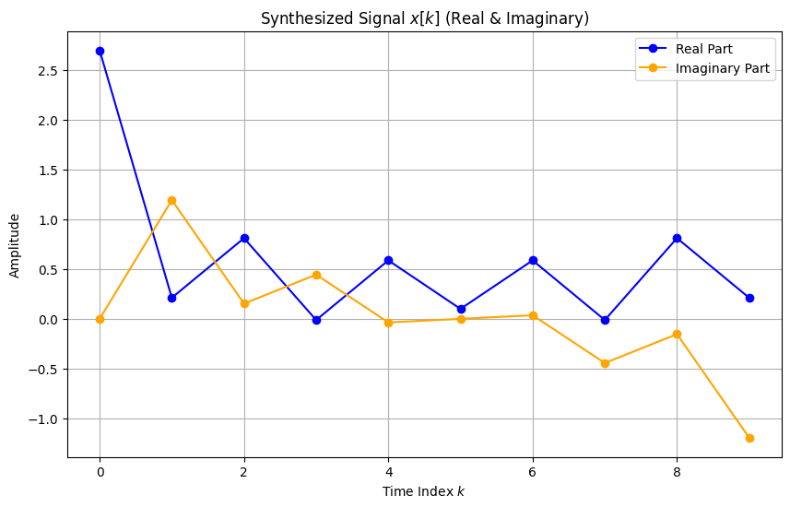

5. Conclusions: Exercise successfully demonstrated that a discrete-time signal x[k] can be synthesized from its frequency spectrum vectors X[u] using the Inverse Discrete Fourier Transform (IDFT) in matrix notation. The implementation confirmed the validity of the synthesis equation:
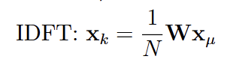
where W is the Fourier matrix containing complex exponentials.
A key observation from the results (specifically the plot and the numerical output) is that the synthesized time-domain signal x[k] is complex-valued, possessing both non-zero real and imaginary parts.
The plot visualizes the signal components effectively. The Real Part (blue) and Imaginary Part (orange) behave as expected for the given non-symmetric input. This verifies that the Python implementation of the matrix dot product (@ operator) correctly handles complex arithmetic required for DSP operations.

