REPORT
Zajęcia: Analog and digital electronic circuits
Teacher: prof. dr hab. Vasyl Martsenyuk
Lab 2
15.01.2026
Topic: Spectral Analysis of Deterministic Signals
Variant 9

Marcin Chowaniec
Informatyka II stopień,
stacjonarne,
1 semestr,
Gr.B

1. Problem statement:
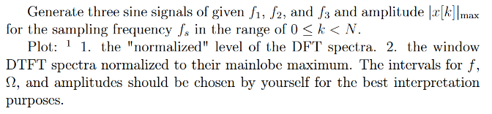
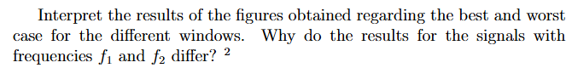
2. Input data:
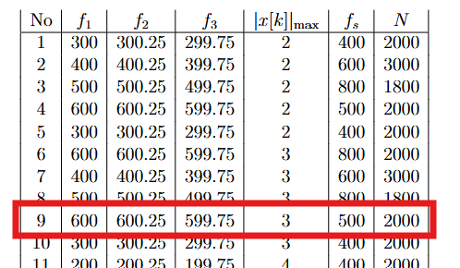

3. Commands used (or GUI):
Setting the variables
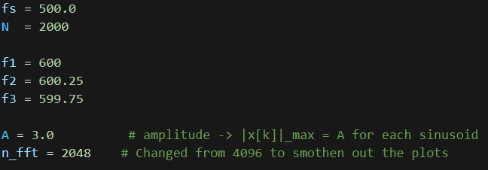
Generating signals
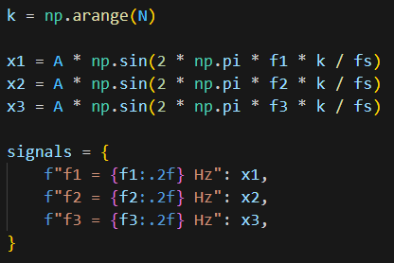
Normalized DFT spectra of each signal
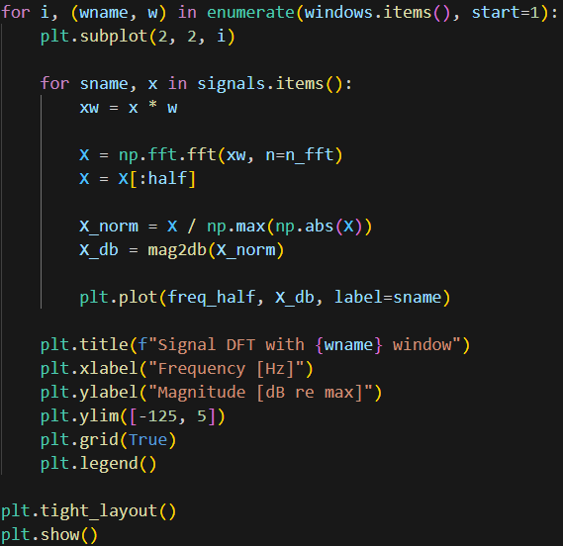
Window DTFT spectra
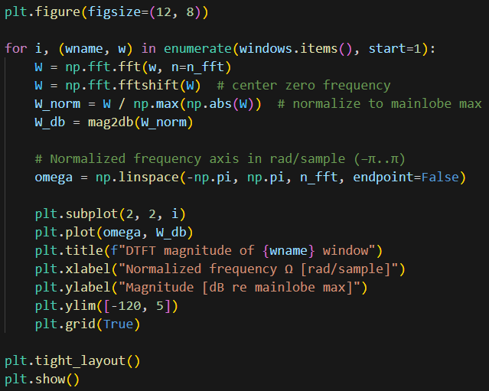

Link to repo
https://github.com/MarcinCho/DSP_UBB_1/blob/main/2.Windowing/MCH_lab2.ipynb

4. Outcomes:
DFT plots:
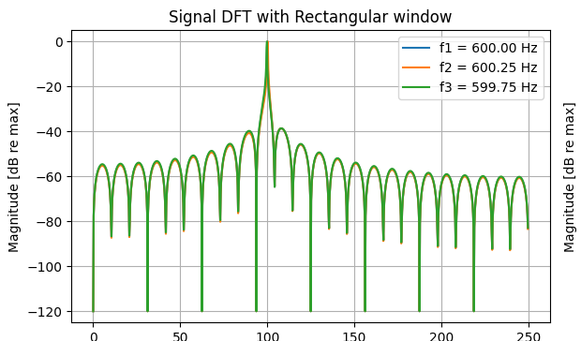
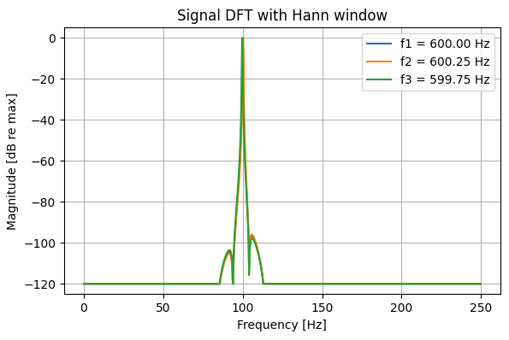
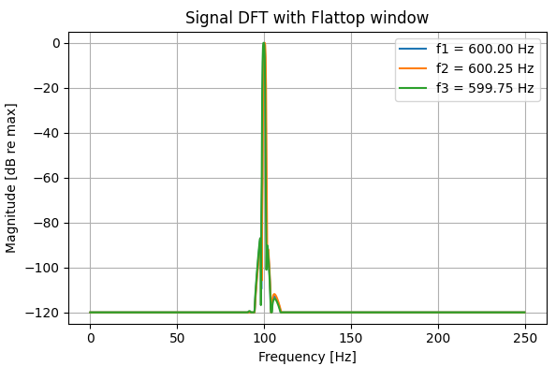
DTFT Plots:
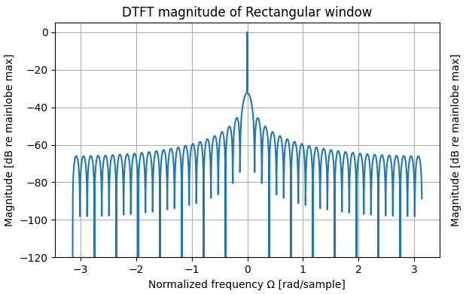
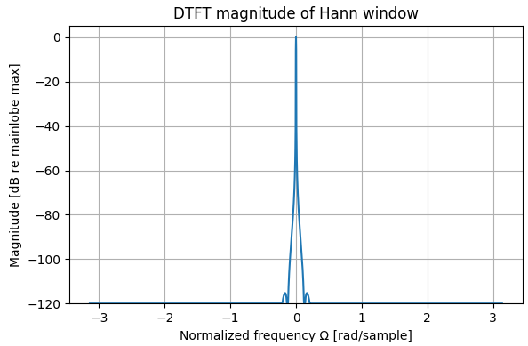
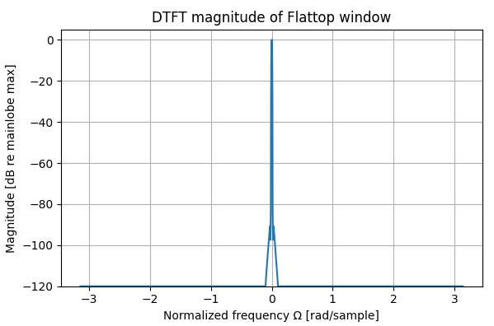

5. Conclusions:
Generated plots were quite different from the ones in laboratory notebook
- Rectangular Window - The analysis demonstrates that the Rectangular window provides the best frequency resolution, characterized by the narrowest main lobe width among the tested windows. The distinctively high side lobes observed in the magnitude plot indicate that energy from strong signals bleeds significantly into adjacent frequencies, making this window unsuitable for detecting weak signals in the presence of strong interference.
- Hann Window - window results demonstrate a compromise between resolution and leakage suppression. While the main lobe is observed to be wider than that of the Rectangular window indicating a slight reduction in frequency resolution the side lobes decay much more rapidly.
- Flattop Window - the characteristic broad, flat plateau at the peak of the main lobe validates its primary design purpose: amplitude accuracy. This "flat top" ensures that even if a signal's frequency does not align perfectly with a frequency bin (minimizing scalloping loss), the measured amplitude remains accurate.

f1 and f2 comparison:
- Signal f1 (Coherent Sampling): This signal frequency aligns perfectly with the DFT bins (integer number of cycles), resulting in a single, sharp spectral peak. The Rectangular window provides an accurate amplitude measurement with zero spectral leakage for this specific case.
- Signal f2 (Incoherent Sampling): This signal falls between DFT bins (non-integer cycles), causing significant spectral leakage (visible side lobes) and scalloping loss (inaccurate, lower amplitude). This represents the typical real-world scenario where signal frequencies are unknown or not aligned with the sampling grid.
The contrast between f1 and f2 confirms that while the Rectangular window is optimal for perfectly coherent signals, non-rectangular windows (like Hann or Flattop) are essential for general applications to suppress leakage and improve amplitude accuracy for incoherent signals like f2.

