REPORT
Zajęcia: Analog and digital electronic circuits
Teacher: prof. dr hab. Vasyl Martsenyuk

Lab 5
13.12.2025
Topic: Projektowanie i analiza filtrów cyfrowych: implementacja filtrów FIR i IIR w Matlabu/Pythonie. 6. Filtracja adaptacyjna: zastosowanie algorytmów filtracji adaptacyjnej w redukcji szumów.

Variant 9

Marcin Chowaniec
Informatyka II stopień,
niestacjonarne,
1 semestr,
Gr.B

1. Problem statement: Implement all three types of filters: FIR, IIR, and Adaptive LMS, using different parameters and observe the performance for noise reduction.

2. Input data:
Design an FIR filter with the following coefficients and implement it in Python to reduce noise in a noisy sinusoidal signal.
FIR Filter Coefficients: b = {0, 1, 0} -
Design an IIR filter with the following coefficients and implement it in Python to reduce noise in the same noisy sinusoidal signal.
IIR Filter Coefficients: b = {0.2, 0.8}, a = {1, 0.5} -
Implement an adaptive LMS filter in Python with a step size µ = 0.05 and filter length M = 3 to reduce noise in the same noisy sinusoidal signal.

3. Commands used (or GUI):
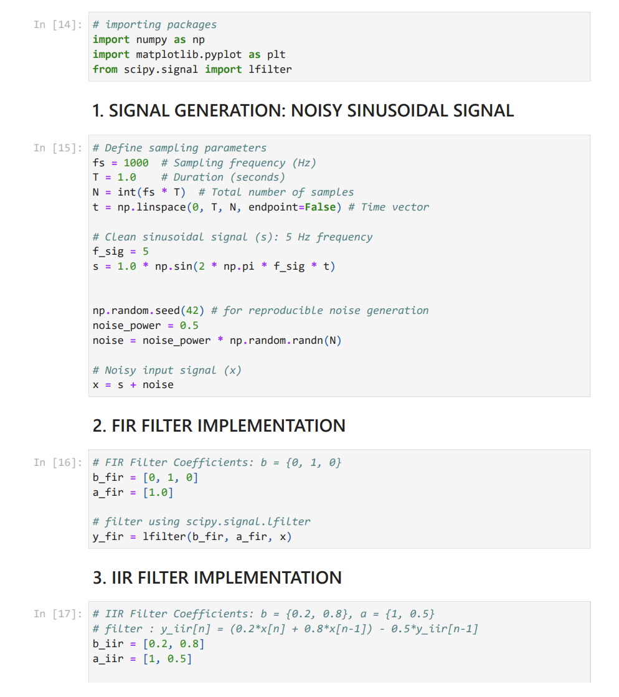
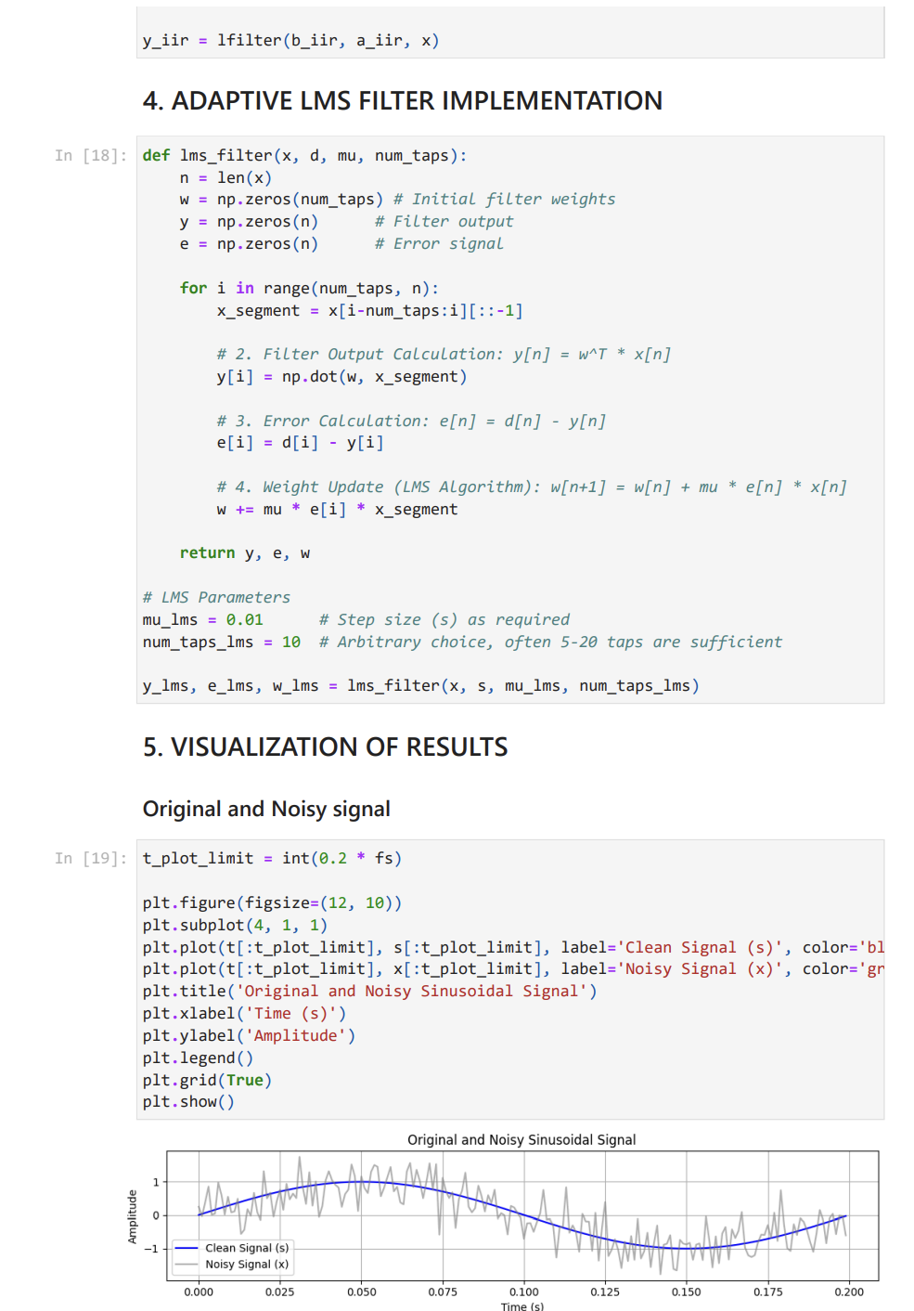
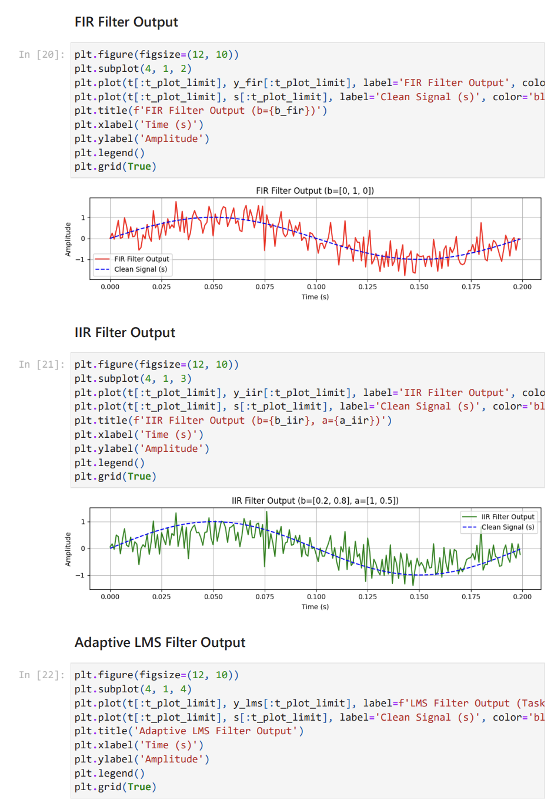

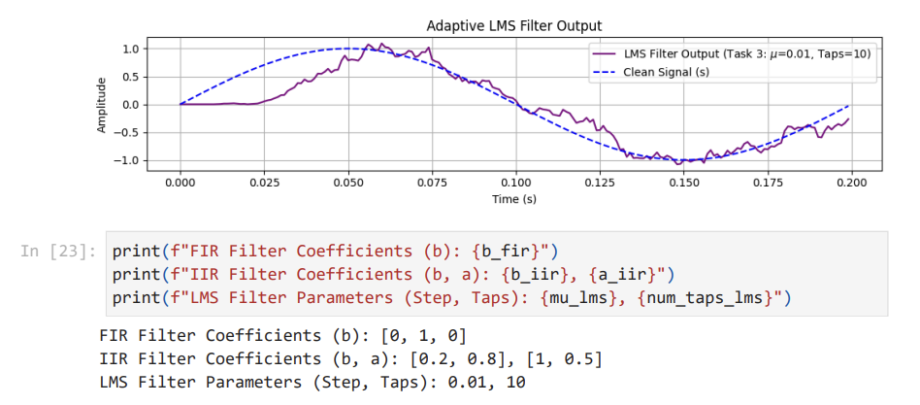
https://github.com/MarcinCho/DSP_UBB_1/blob/main/LAB5-6_Filtering/lab_MCh.ipynb
4. Outcomes:

Outcomes and results are shown in previous point.

5. Conclusions: For the reasons given, we conclude that.

- FIR Filter Performance (Task 1): The FIR filter, implemented with simple coefficients $b=\{0, 1, 0\}$ 1111, essentially acted as a one-sample delay2. Consequently, it provided no effective noise reduction and the output signal remained highly corrupted, closely following the noisy input3.
- IIR Filter Performance (Task 2): The IIR filter, designed with coefficients $b=\{0.2, 0.8\}$ and $a=\{1, 0.5\}$ 4444, visibly smoothed the noisy signal5. This non-adaptive, first-order recursive structure functioned as a low-pass filter, successfully attenuating some of the high-frequency noise components present in the signal6.
- Adaptive LMS Filter Performance (Task 3): The Adaptive LMS filter, implemented with a step size $\mu=0.01$ and 10 taps 7, demonstrated the most effective noise reduction88. After a brief initial convergence period, the filter output closely tracked the clean sinusoidal signal, minimizing the error signal9999. This highlights the superiority of adaptive algorithms in learning and removing unknown noise when a reference (desired) signal is available.
Overall Summary: The experiment successfully demonstrated the principle differences between fixed-coefficient and adaptive filters. While the IIR filter offered reasonable passive noise smoothing, the Adaptive LMS filter proved to be the most appropriate and effective solution for this noise reduction task due to its ability to dynamically adjust its weights to minimize the mean square error, resulting in a cleaner output signal.

