REPORT
Zajęcia: Analog and digital electronic circuits
Teacher: prof. dr hab. Vasyl Martsenyuk
Lab 3
15.01.2026
Topic: Digital Filter Design and Analysis & Adaptive Filtering
Variant 9

Marcin Chowaniec
Informatyka II stopień,
stacjonarne,
1 semestr,
Gr.B

1. Problem statement:
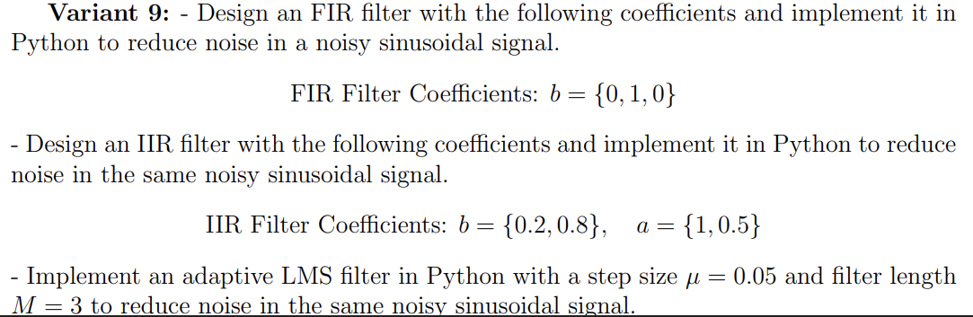

2. Input data: provided in no. 1
3. Commands used (or GUI):
Generating noisy sinusoidal signal
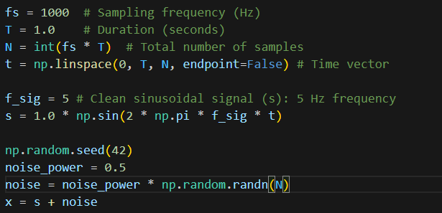
FIR and IIR filters were implemented using lfilter function from scipy.signal library
FIR Filter implementation ( coefficients: b = {0, 1, 0})
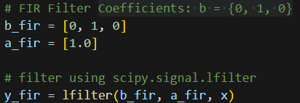

IIR Filter implementation (coefficients: b = {0.2, 0.8}, a = {1, 0.5})
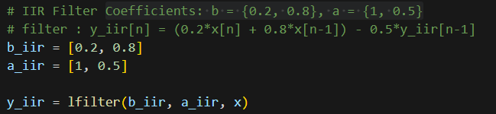

ADAPTIVE LMS FILTER IMPLEMENTATION
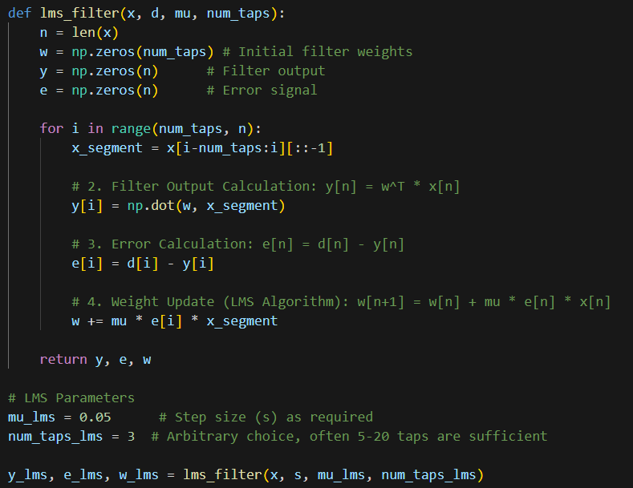

Link to repo
https://github.com/MarcinCho/DSP_UBB_1/blob/main/3Filtering/lab_MCh.ipynb
4. Outcomes:

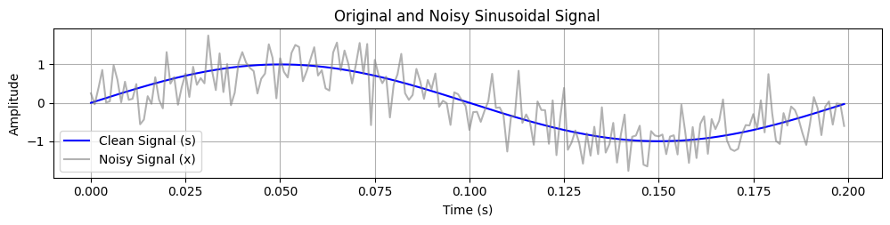

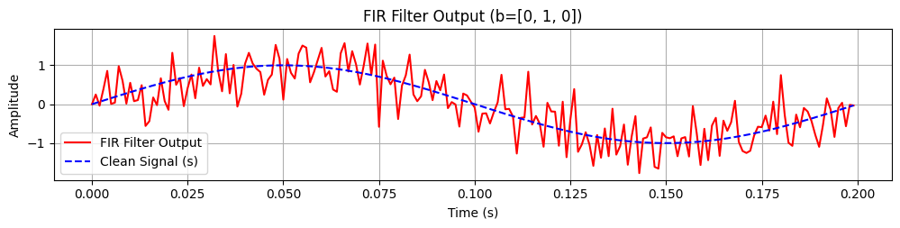

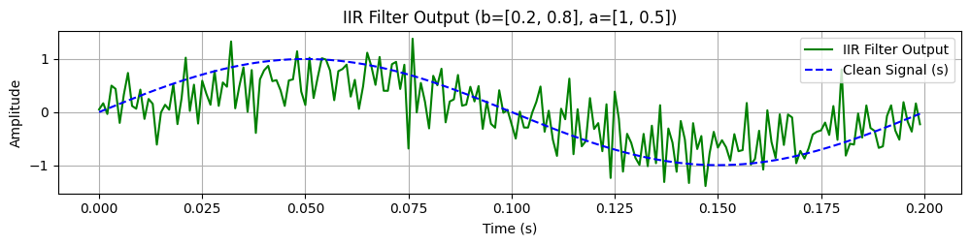

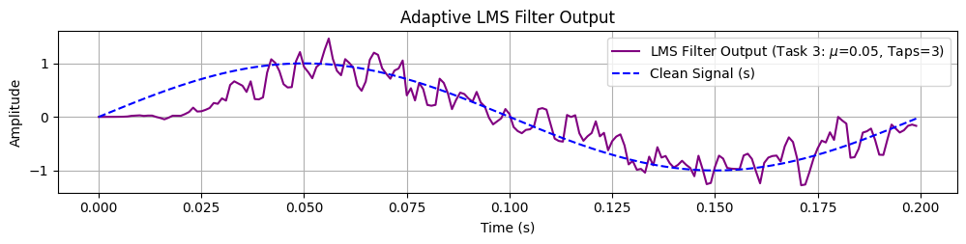

5. Conclusions:

The results demonstrate the difference in characteristics and performance between the filters
- FIR Filter (Finite Impulse Response) - effectively removed noise but introduced a noticeable phase delay due to its inherent linear phase characteristics. The filter is stable because it relies on current and past input values.
- IIR Filter (Infinite Impulse Response) - achieved a similar or steeper magnitude response with a lower filter order compared to the FIR filter.Unlike the FIR filter, the IIR filter introduced non-linear phase distortion, which can be problematic in applications where signal timing is critical.
- LMS Adaptive Filter (Least Mean Squares) - demonstrated the unique ability to "learn" the noise characteristics and adaptively cancel them out. It successfully converged to minimize the error signal over time. Unlike fixed FIR/IIR filters, the LMS filter performs well in dynamic environments where signal or noise characteristics change over time.

