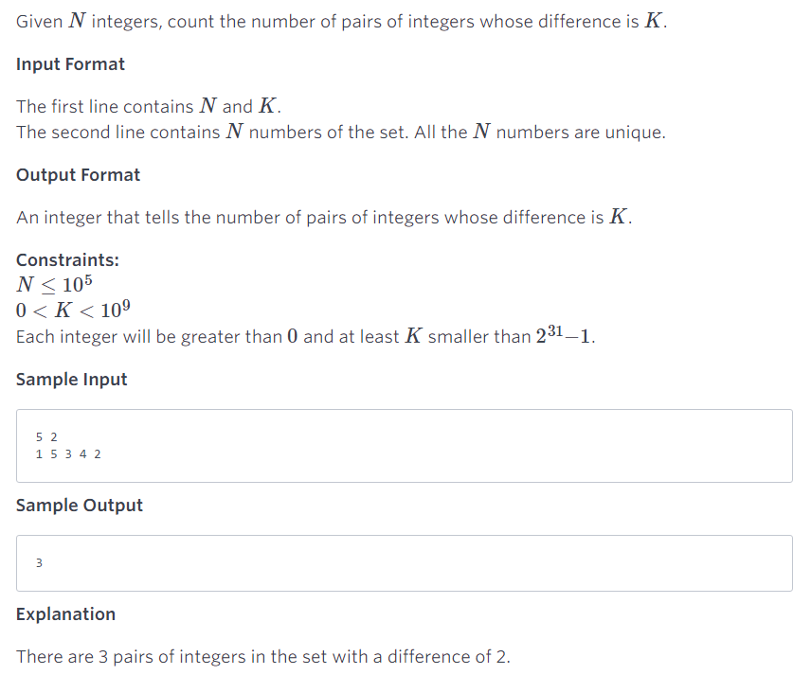

Pairs

Given NN integers, count the number of pairs of integers whose difference is KK.
Input Format
The first line contains NN and KK.
The second line contains NN numbers of the set. All the NN numbers are unique.
Output Format
An integer that tells the number of pairs of integers whose difference is KK.
Constraints:
N≤10N≤1055
0<K<100<K<1099
Each integer will be greater than 00 and at least KK smaller than 223131−1−1.
Sample Input
5 2
1 5 3 4 2
Sample Output
3
Explanation
There are 3 pairs of integers in the set with a difference of 2.

