MTS INSTALLATION WITH DOCKER

**1] TARGET**

Network Equipment (Window)

VM-Host

CentoS

Docker

PC Desktop (Window)

Docker Container

**2] PREREQUIS**

PC Desktop :

Acces to Internet

Window 7

Acces to VM-Host by ssh and X11 forwarding

VM-Host :

Acces to Internet

centos7

Java ??

Xorg for X 11Forwarding

Firefox

**3] DOCKER INSTALLATION AND CONFIGURATION**

On VM-Host

1. Install Docker

[root@RedHat_03 ~]# /usr/bin/curl -sSL https://get.docker.com/ | /bin/sh

1. Run Docker

[root@RedHat_03 ~]# service docker start

Redirecting to /bin/systemctl start docker.service

1. Check Url Web Repository

<https://hub.docker.com/r/mtsericsson/mts-master/>

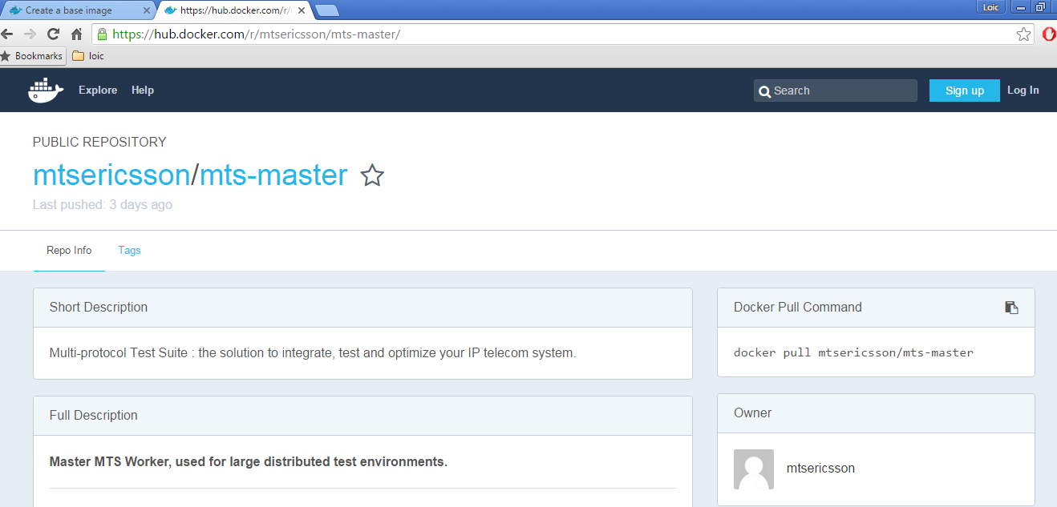

1. Pull the image on VM host

[root@RedHat_03 ~]# docker pull mtsericsson/mts-master

Using default tag: latest

latest: Pulling from mtsericsson/mts-master

fa5be2806d4c: Pull complete

2bf4902415e3: Pull complete

86bcb57631bd: Pull complete

c8a648134623: Pull complete

385bb6b9704e: Pull complete

111858be9989: Pull complete

6a9a03328d8b: Pull complete

58d2b93cb1f3: Pull complete

9594dd65cd4a: Pull complete

9b6ceecfe6a8: Pull complete

152760b3df50: Pull complete

280108310292: Pull complete

e29a87ea944a: Pull complete

1b29957b2afd: Pull complete

941dcf7e1b0e: Pull complete

6ee470d68fc3: Pull complete

0e2ff04cefd2: Pull complete

334d4c6c783e: Pull complete

3c6a17a5f92b: Pull complete

da007235e83b: Pull complete

56c1db327ff1: Pull complete

30b075fa55d0: Pull complete

a61cf2cbb0db: Pull complete

6a54aaebd34e: Pull complete

Digest: sha256:ced7a0e1b28dec00025b1fb6a74cb1ce64b731091875408411bfe96fe07e9116

Status: Downloaded newer image for mtsericsson/mts-master:latest

1. Run the image on VM host

[root@RedHat_03 ~]# docker run mtsericsson/mts-master

change vnc password!

Password:Verify:Warning: could not find self.pem

Using local websockify at /root/noVNC/utils/websockify/run

Starting webserver and WebSockets proxy on port 6901

Can't find file /root/.vnc/509c55292372:1.pid

You'll have to kill the Xvnc process manually

remove old vnc locks to be a reattachable container

xauth: file /root/.Xauthority does not exist

WebSocket server settings:

- Listen on :6901

- Flash security policy server

- Web server. Web root: /root/noVNC

- No SSL/TLS support (no cert file)

- proxying from :6901 to 172.17.0.2:5901

Navigate to this URL:

http://509c55292372:6901/vnc.html?host=509c55292372&port=6901

Press Ctrl-C to exit

New '509c55292372:1 ()' desktop is 509c55292372:1

Starting applications specified in /root/.vnc/xstartup

Log file is /root/.vnc/509c55292372:1.log

gpg-agent[81]: directory `/root/.gnupg' created

gpg-agent[81]: directory `/root/.gnupg/private-keys-v1.d' created

gpg-agent[82]: gpg-agent (GnuPG) 2.0.22 started

(polkit-gnome-authentication-agent-1:93): polkit-gnome-1-WARNING **: Error getting authority: Error initializing authority: Could not connect: No such file or directory

(xfsettingsd:97): xfsettingsd-WARNING **: Failed to get the _NET_NUMBER_OF_DESKTOPS property.

(xfce4-session:55): GLib-WARNING **: GError set over the top of a previous GError or uninitialized memory.

This indicates a bug in someone's code. You must ensure an error is NULL before it's set.

The overwriting error message was: Got unexpected reply from sudo shutdown helper

(xfce4-session:55): GLib-WARNING **: GError set over the top of a previous GError or uninitialized memory.

This indicates a bug in someone's code. You must ensure an error is NULL before it's set.

The overwriting error message was: Got unexpected reply from sudo shutdown helper

------------------ VNC environment started ------------------

VNCSERVER started on DISPLAY= :1

=> connect via VNC viewer with 172.17.0.2:5901

noVNC HTML client started:

=> connect via http://172.17.0.2:6901/vnc_auto.html?password=...

------------------ /root/.vnc/*:1.log ------------------

Xvnc TigerVNC 1.3.1 - built Nov 20 2015 20:53:05

Copyright (C) 1999-2011 TigerVNC Team and many others (see README.txt)

See http://www.tigervnc.org for information on TigerVNC.

Underlying X server release 11702000, The X.Org Foundation

Mon Feb 1 14:27:59 2016

vncext: VNC extension running!

vncext: Listening for VNC connections on all interface(s), port 5901

vncext: created VNC server for screen 0

1. Connect to the docker image via Firefox ( launched from VM-Host)

<http://172.17.0.2:6901/vnc_auto.html>

PWD : mts-ericsson

We have now access to MTS on our Docker Container

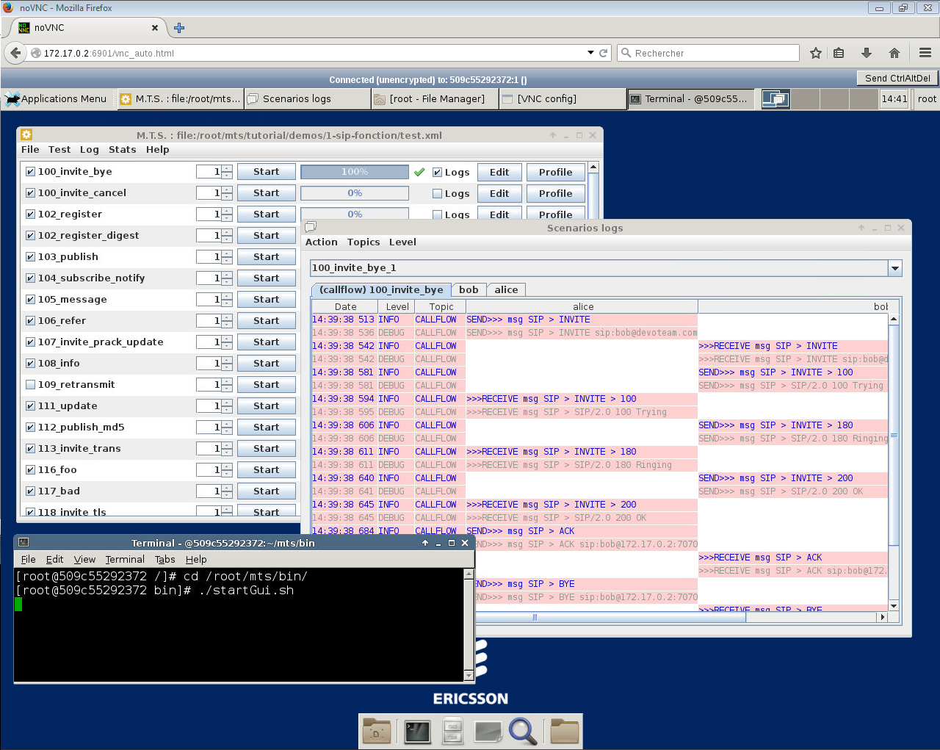

At this step we have the following configuration

**PC Desktop : IP@ = 164.48.219.71**

**VM-Host : IP@ = 192.168.56.106**

**Docker Container : IP@ = 172.17.0.2**

Due to SSH access on Docker Container

We can transfer files from VM-Host to Docker Container

Exemple : scp root@192.168.56.106:/usr/local/mts-6.2.1_beta/tutorial root@172.17.0.2:/root/mts/tutorial

REM

With Putty: We can create SSH tunnel from PC Windows to Docker Container to simplify acces

(using X11 forwarding instead of Web Interface)

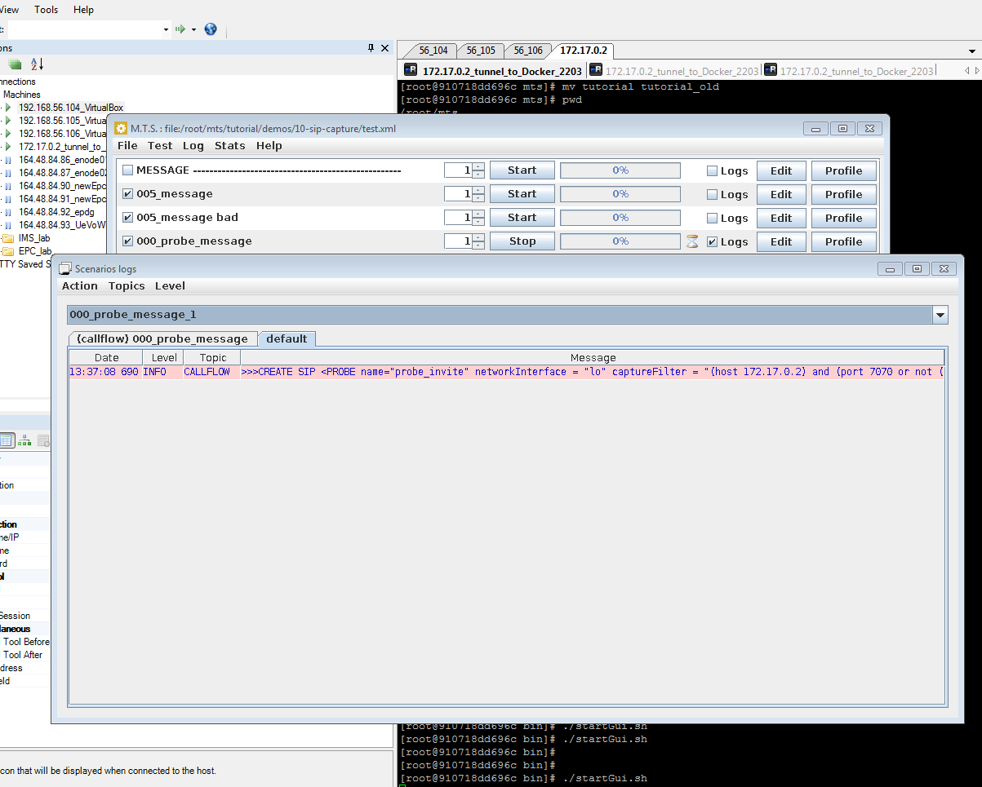

1. Exchange Messages between MTS Docker and Network Equipment

.

.  
.