Coursera Math Course:

1. **Linear Algebra**
   1. Vectors, Matrices
   2. Linear Transformation
   3. System of Equations
   4. Determinants
   5. (NN) Deep Learning Operations ( Matrix with Functions of Activations)
2. **Calculus**
   1. Maximazing and Minimizing Fuctions
   2. Cost Function
   3. Gradient Decent
   4. ADAM
   5. Optimazers
3. **Probability and Statistics**
   1. P-value
   2. Probability
   3. Maximum Likehood

**First Course** **– Linear Algebra**

Linear Algebra and Machine Learning

1. Linear Regression ( y=Wx+b)

* System of Linear Equations

System of Equations

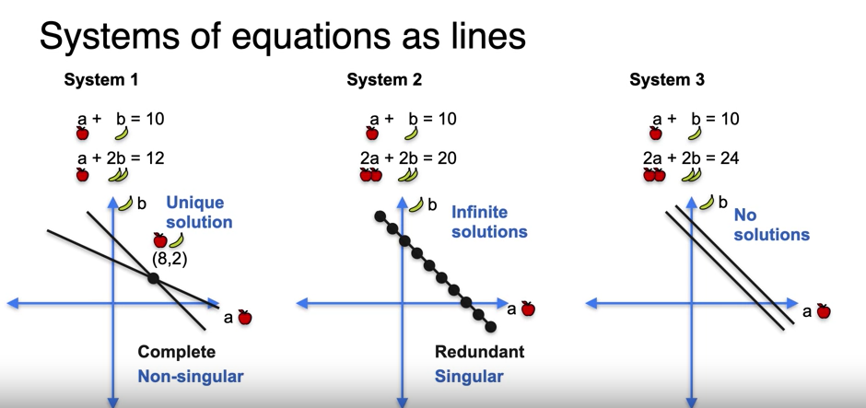

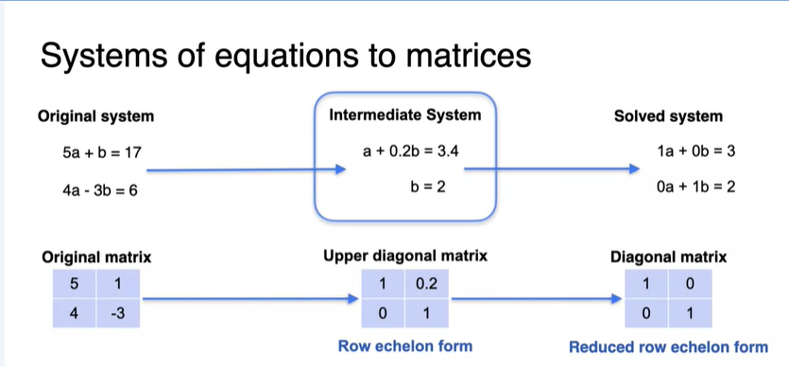

Linear Algebra and Machine Learning

1. Derivative
   1. Functions
   2. Sum rule, chain rule, product rule
   3. Maximazer or minimizer

