**Time Series – Forecasting**

**Common Patterns**

**Trend (Tendência)**

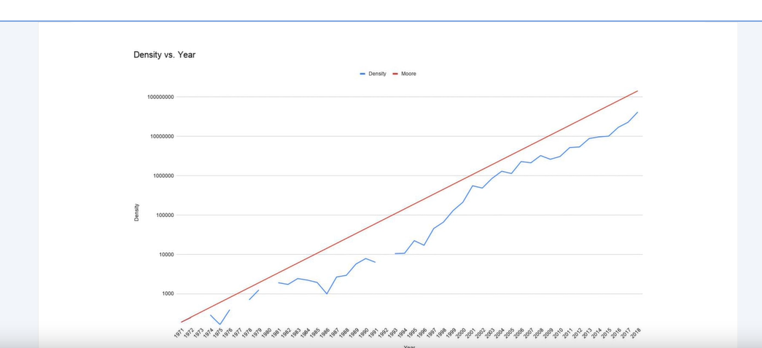

**Sazonality (sazonalidade)**

**White Noise**

**Autocorrelation**

With machine Learning we can predict patterns but not the noise. Of course we need to becarful with big example.

**Prediction – How can we build our baseline?**

**Naïve Forecasting = The next value is gonna be the same as the actual value.**

**Performance – How can we measure?**

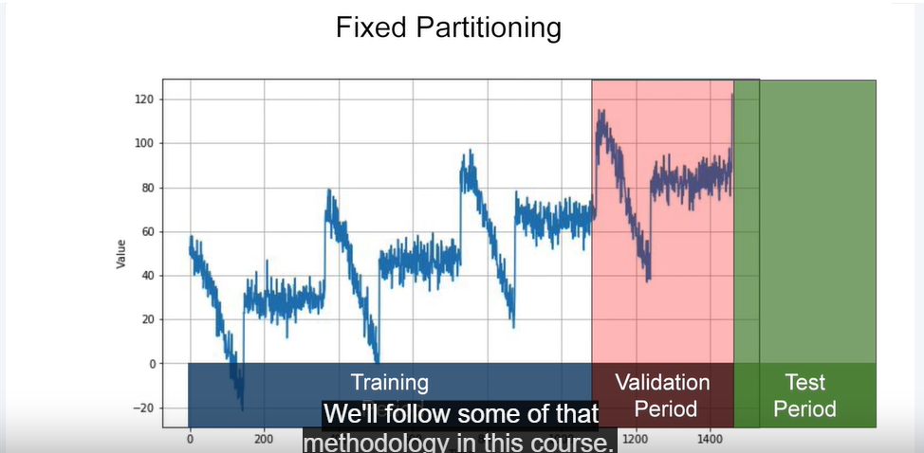

**Metrics –**

**Preparing fetures and labels**

**Feature X – Window size**

**Target Y – Value to predict**

**Trailing Window (Média Móvel Simples)**

**Centered Moving Average (Média Móvel Centralizada) – better for trends**

**Statistical Models – Forecasting**