Aldon Lifecycle Manager(e) Client Usage Instructions

How Do I……..

Page 7 how to prepare working folder (path environment) to get latest for the first time.

Mutual of America

Author: Rina Thakore

This page intentionally left blank.

TABLE OF CONTENTS
HOW DO I…: 5
1. Make an Initial connection to ALDON LM(e) Server from the LM(e) Client on my workstation: 5
2. Add A Path Designator To A Release: 5
3. Set Up The Client Path For An IDE Project: (Working Folders) 7
4. Get Code currently in Aldon down to my Workstation: 10
5. Add new code to an Aldon LM(e) Release: 10
6. Check-in Files: 12
7. Add a JAVA IDE Project: 12
8. Delete Files from Aldon LM(e): 14
9. Delete Folders from Aldon LM(e): 15
10. Restore the Minus-One Version of code to the Production / Test / Dev Server: 16
11. Resolve a Conflict Condition on a File: 17
12. Promote a Task Assembly from DEV environment to TEST environment: 18
13. Verify that the changes were successfully placed on the deployment target server: 22
14. Move code from Test to PAT (or PAT to Production): 25
15. Perform an AdHoc Deployment: 31
16. Promote a File or Task Assembly Without Deployment: 33
17. Promote A Child / Branch Release to Production: OR Promote to Parent: 34
18. Do An Emergency Check-out and Check-in from Production: (Change Management ONLY): 35
19. Emergency Restore of -1 version of code on Production servers: (Network Enginners ONLY): 35
20. Create a new Task Assembly: 36
21. Add files to a Task Assembly: 37
Method 1: Check out: 37
Method 2: Associate Collection Assembly: 38
22. Remove files from a Task Assembly: 39
23. Move files from one Task Assembly to Another: 40
24. Associate a Task Assembly to Multiple Releases: 41
GLOSSARY: 44

This page intentionally left blank.

HOW DO I…:

Make an Initial connection to ALDON LM(e) Server from the LM(e) Client on my workstation:
  - On your workstation, go to the following folder
“C:\Program Files\Aldon\Aldon LM 5.4”
  - Look for the file “AldonLMClient.conf”
  - Edit this file with Notepad
  - Add the following 2 lines to the bottom of the file
brpallm=10.7.150.100/7890
brdtallm=10.7.150.101/7890
- Save the file
- Go to “Start – Programs – Aldon LM 5.1 – Aldon LM 5.1”
- Sign on with your network USERID. Password would be same as USERID.
- Host / Computer: brpallm (lowercase please)

Add A Path Designator To A Release:

A “Path Designator” is also called and “IDE Project” in Aldon LM(e). To add files to Aldon LM(e) source control system, an IDE Project needs to be created. There are 3 ways in which Path Designator’s or IDE Projects can be created.

NOTE: Always create the NEW Path Designator on the BASE Release first.
- Then set up the Path Designator for the Branch/Child release “C” or “A” with the same name followed by “_C” or “_A”.
- When setting up the Branch/Child path designator identify the BRANCH path designator with the BASE / PRIMARY path designator as follows:
  - Select “Attach to existing path designator assembly.” In the “Path designator assembly” section.
  - Click on the dropdown Arrow and select the BASE assembly name. Click OK.
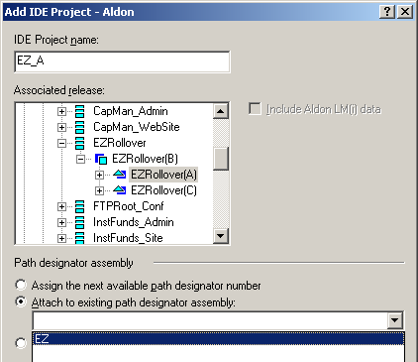

- Microsoft IDE’s:
- Create a Task Assembly for adding the new project to Aldon.
- Open up a project or solution in a Microsoft IDE.
- Connect the IDE to Aldon via the TOOLS menu option.
- Right click the solution or project file and select “Add Solution to Source Control”.
- Go to the Aldon LM(e) Parts window – Locations tab.
- Hit the F5 (Refresh) the Aldon LM(e) client from the Aldon Server.
- Find the Application – Release – Path Designator created for the project.
- Right Click on the Path designator – “New” –“Parts”.

- Eclipse IDE’s:
- Create a Task Assembly for adding the new project to the Eclipse Java Release.
- Right Click on the Project in the “Package Explorer”. Select “Team” – “Share Project”. Select Aldon LM, Select a Release where the project is to be added. Click on “Finish”.
- Right Click on the Project in the “Package Explorer”. Select “Team” – “Add”.
- Right Click on the Project in the “Package Explorer”. Select “Team” – “Check-in”

- Via ALDON LM(e) Thick Client:
- In the Parts Window, Select Menu option “SETUP – EXTERNAL SETUP…”.
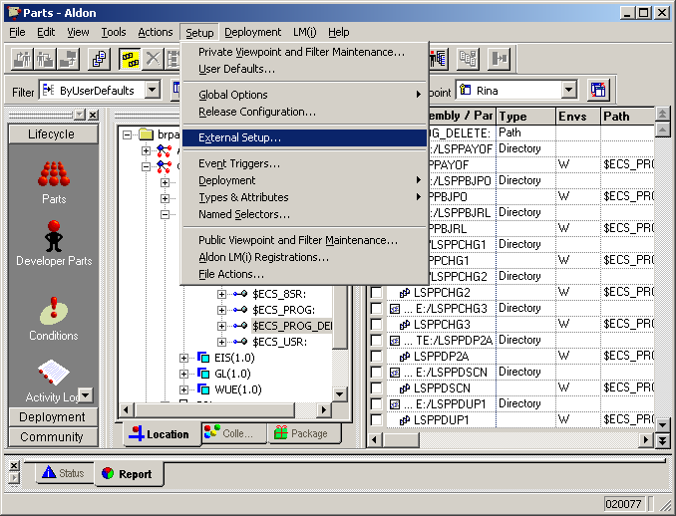

- In the External Setup Window that opens up, Select IDE Projects in the left Pane.
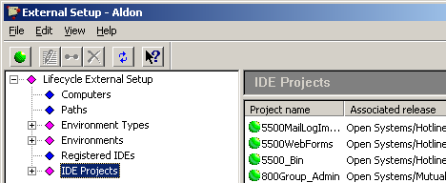
- Click on the Green button in the top left corner of the window above (under File menu option). The Add IDE Project window below pops up.
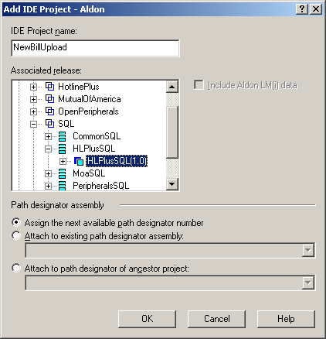

- Type in the IDE Project Name: in the edit box,
- Select the Associated Release:
- Click the OK Button. The next window pops up.

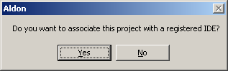

- Click No in this pop-up window.

Set Up The Client Path For An IDE Project: (Working Folders)
- In the Parts window select the “Setup” Menu option, and select External Setup.

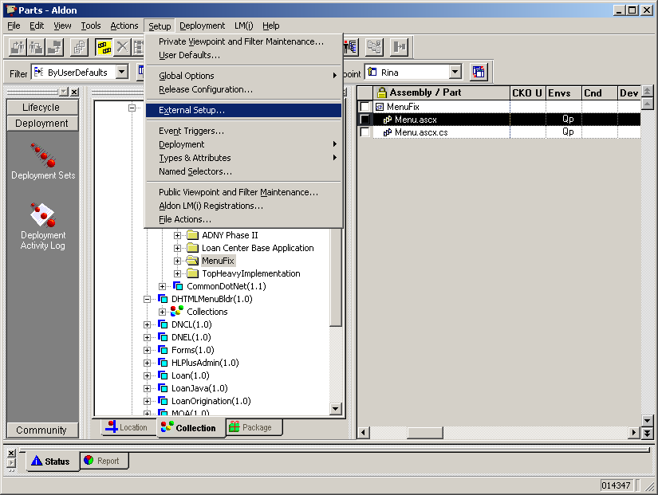

- Expand the “Environments” in the left pane of External Setup window. Select the “Development” environment.
- Go to the Environments – Development – <Your development ENV>
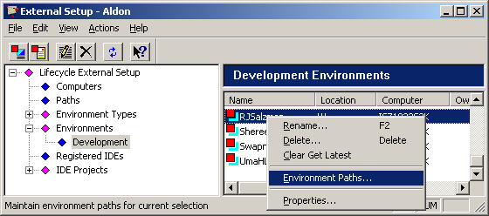
- Right Click on <Your development ENV> - Environment Paths…
- In the Edit Development Environment window that opens up,
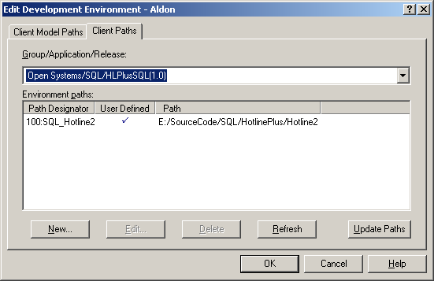

- Select Client Paths tab,
- Select your Group/Application/Release in the drop-down box
- Add the new Environment Paths: by clicking on the NEW… button
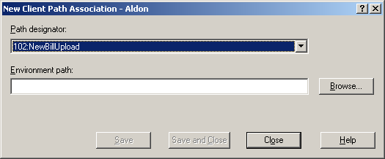

- In the New Client Path association window, select your Path Designator: and Browse to your Environment path:. Click Save and Close.
- Click OK in the Edit Development Environment window.
- Close the External Setup… window.
- F5 refresh in the Parts… window.

Get Code currently in Aldon down to my Workstation:
- Make a backup copy of your development environment.
- Open up your IDE
- Connect to Aldon LM(e) as your source control via your IDE.
- Add the project from Source Control to your workstation
- Go to the Aldon LM(e) “Parts” window.
- Do a Get Latest of the project from Aldon LM(e)
- Refresh your IDE, and
- Try to rebuild your code in your IDE as usual, to verify that you are successfully connected to Aldon LM(e)

Add new code to an Aldon LM(e) Release:
If You Need to ADD new parts to the Release:
- Refresh the Parts window (Function key F5)
- Select/drill down to the Release
- Select the Project / Path designator where you want to add the new files to.
- Right Click Project
- Highlight New
- Highlight Parts… and Select.
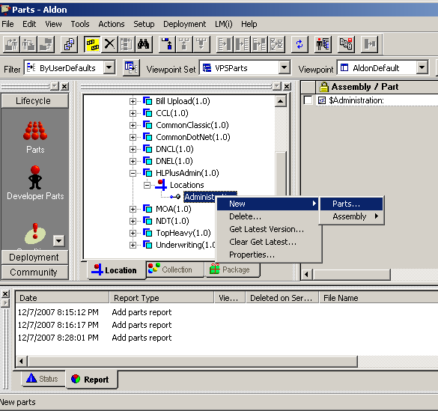

- In the “Add Parts” window that opens up, select the Path of the Working Folder.
- Associate the new parts with the correct Task Assembly
- Select the files to be added from the right pane
- Add a comment on the Comment tab and click on OK

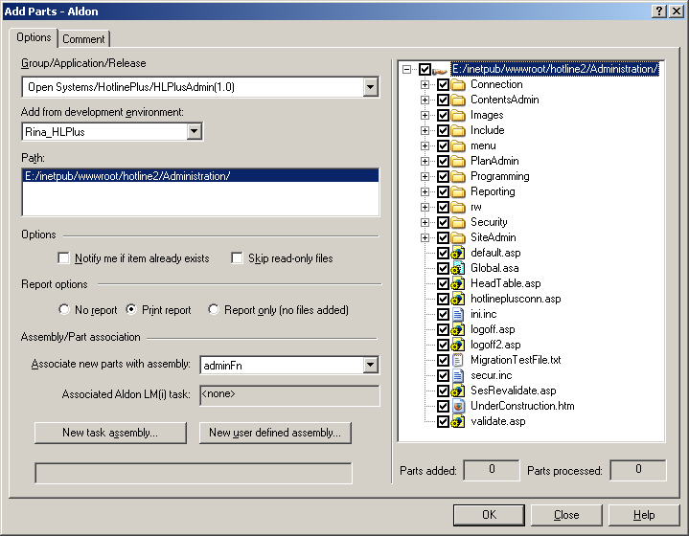

- Then go to the Collections tab and check in all the files currently added to the Task Assembly for this Release

Check-in Files:
To Move the files to the Dev server for Integration Testing:
- All that is required to move the code from Workstation to Development Server is to Check in the code to Aldon LM(e). This will move the files to Dev environment as well as deploy the code to the Development server BRHLDEV or BRWEBDEV2 as required..

Add a JAVA IDE Project:

- Open up the Java IDE (MyEclipse) and select the Project to be loaded.
- Select the root of the project in the Project window
- Right Click – Open Project if the project is not yet open. Then
- Right Click – Team – Share Project.
- Select “AldonLM“
- Select “Next” - Connect to ALDON LM(e).
- Click “Next” – Expand “OpenSystems” – HotlinePlus.
- Select the correct “Release” from the list. – Click Finish.
- Select the webroot folder of the project in the Project window – Right Click – Team - Add
- .In the left pane select the files that need to be added. De-select all the “*.class” files in the “webroot\web-inf\classes\moa\....” folders.
- Place a comment in the center window and then select the Task Assembly in the right pane and click OK.
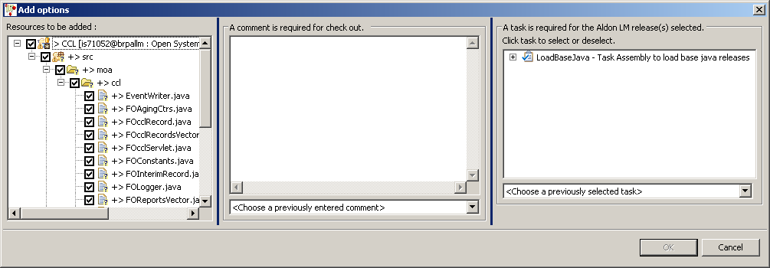

- Check-in the files into the project

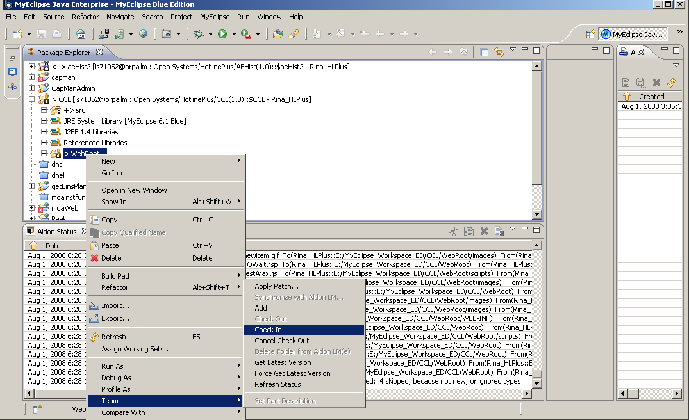

- For JAVA source, before Adding the source do the following;
- Go to the ALDON LM(e) Parts window,
- Open up “Webroot” folder under the java release. Go to the web-inf folder
- Right Click on web-inf folder and select NEW – Assembly – Directory Assembly
- Create a directory called “classes”
- Right Click “classes” folder and select NEW – Assembly – Directory Assembly
- Create a directory called “moa”
- Right Click “moa” folder and select NEW – Assembly – Java Package
- Create a Java Package called “moa”
- Now go back to the IDE and ADD the Java source code to ALDON and
- Check-in the Java Source Code to ALDON
- The Java Files will be compiled and checked in with their associated Class files.

Delete Files from Aldon LM(e):
- Press the F5 refresh button to clear the Aldon LM(e) client and refresh it from the Aldon LM(e) Server
- In the parts window highlight the file and right click – Actions – Delete

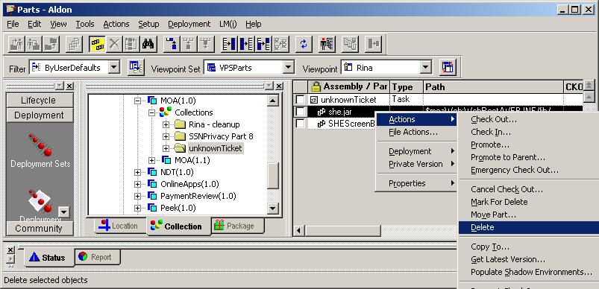

- In the Select Assembly Part Instance window select the file (ENV Type) you want to delete from.
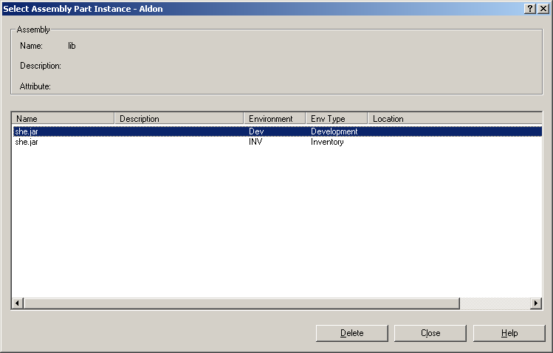
- Click Delete.

NOTE: Dev environment : Developers and Project leads can delete files.
Tst environment: Project Leads and Change Management can delete files.
PAT and PROD/INV environments: No one has rights for file delete.

Delete Folders from Aldon LM(e):
- In the Locations tab drill down to the Release – Path Designator – Folder – Sub-Folder you want to delete

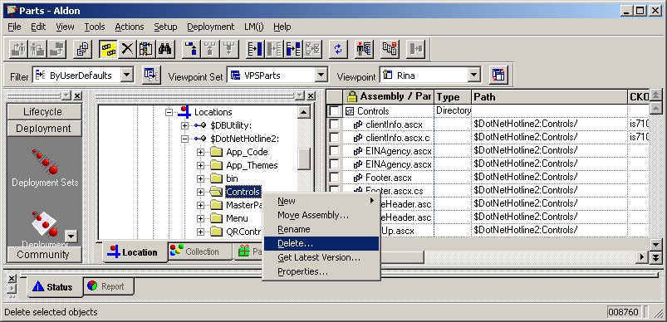

- Select “Delete” for Child assemblies and parts disposition section and click on Delete button.

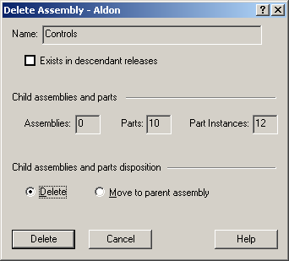

Restore the Minus-One Version of code to the Production / Test / Dev Server:
- For DEV & TEST servers: connect to the Test / Dev server via PCAnywhere.
- Change Directory to the “Drive” where Aldon Deployment Client is installed (D: drive for website servers or E: drive for HotlinePlus, Aldon share on General Ledger servers)
- Change Directory to the “\program files\aldon\aldon 5.4\distribution\Deployment Packages” folder.
- For the date when the files were deployed, Locate the XXXXXmanifest.txt file that lists the files installed by the Deployment set that needs to be removed.
- Locate the zip file corresponding to the XXXXXmanifest.txt file
- Open the zip file
- Extract all the files to the root of the drive where the programs are installed. (D: drive for website servers or E: drive for HotlinePlus, D: drive on the General Ledger servers).
- For PRODUCTION: In Aldon LM(e) Developer/Change Management will identify the Deployment set for the production migration.
- Note the time the Deployment set was created. Notify Network Engineer of the back out and the exact time of the Deployment Set.
- Network Engineer: connect to the Production server via PCAnywhere and follow steps 2 through 7 to complete the back out.

Resolve a Conflict Condition on a File:
NOTE: When a file is checked out in Parent and Child Branches of a Release, It is required that all conflict conditions on the file be resolved before it can be promoted from TEST to PAT
- First right click on the file in the parts window and select Actions – View Related Data – Conditions.

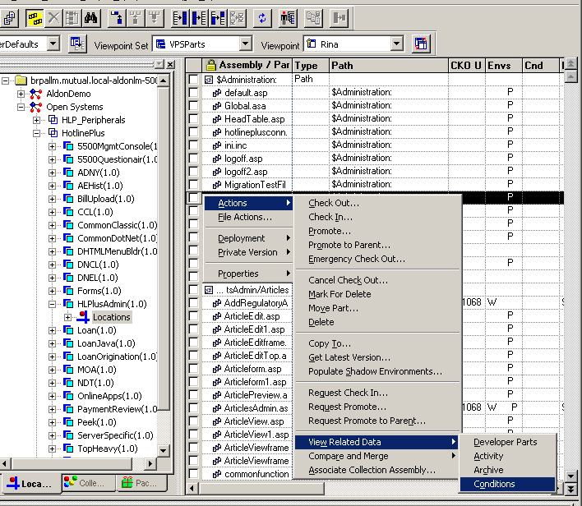

- When the Conditions window opens look for the file with a condition code of “C” in the Cnd column. This is a conflict condition.
- Right Click – Compare and Merge – Resolve Conflict on the file to find the differences between the file in Production and the file in your environment.
- Then use any compare and merge software that you are familiar with and create the merged file and save it.
- Check in this merged file to Aldon. Move it to the Test environment in your Task Assembly and then do the following to resolve the conflict.
- Right Click – Remove Condition.

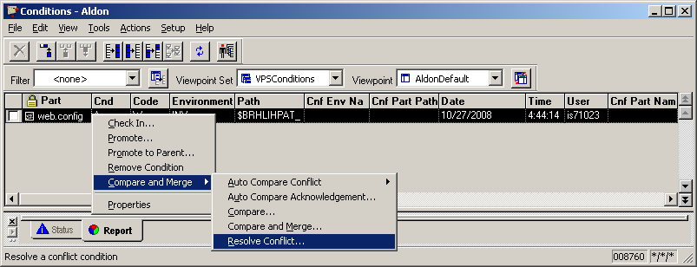

Promote a Task Assembly from DEV environment to TEST environment:
To migrate a Task Assembly (migration package) to the Test Environment (within the repository and to the physical locations on the Test server)
- Sign on to Aldon LM(e) Client.
- Click on the “Collections” Tab in the center pane of the Parts window..
- Drill down into the Release (sub-application) of the code being migrated
- Find the Task assembly and highlight it.
- In the Right pane select the Assembly name and
- Right click – Select Promote . This will promote the files to the “TEST” level in the Aldon Repository and deploy the files onto the BRHLTSTS server.

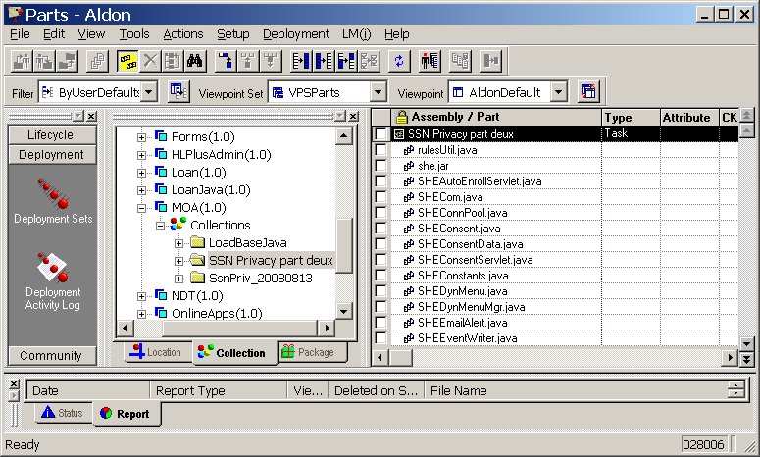
RELEASE
COLLECTIONS TAB
TASK ASSEMBLY

NOTE:
- Project Lead and Tech Lead only have authority to Promote code from “DEV” to “TEST” environment.
- If the file (s) being migrated are in multiple environments (check the Envs column). Then you will be asked to select the environment you would like to Promote from. In the case of Project Leads the only Environment they can promote from is DEV. Make this selection. See Below.

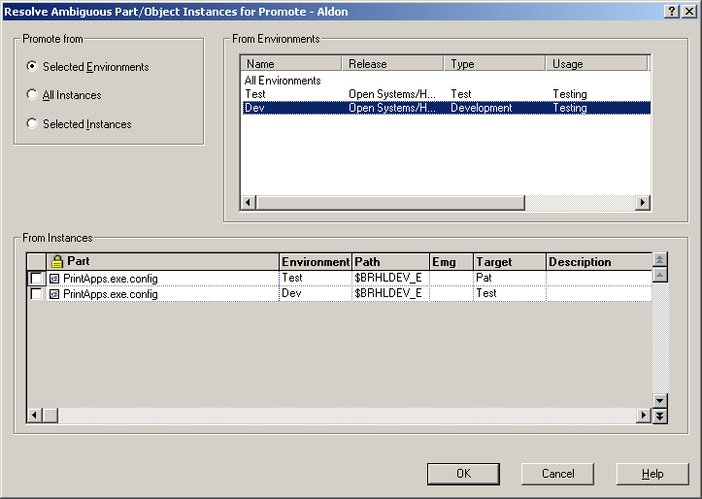

- Click OK
- When the “Promote Options” window opens, drag it down to view the files in the “Confirm Promote” window behind it.
- If you see more than one “From Env” in the column – cancel out of the Promote Options window.
- Individually select the file in the lowest environment ( in this case Dev).
- Promote these files first.
- Then perform the promote action on the entire task assembly.

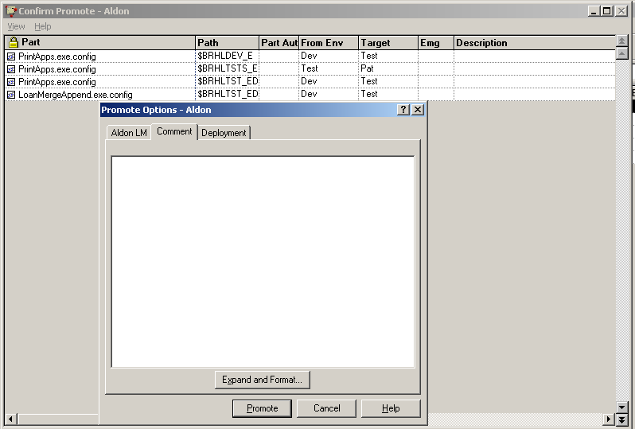

Verify that the changes were successfully placed on the deployment target server:

- In the Aldon LM(e) client “PARTS” window, click on the Deployment Tab in the Left Pane.
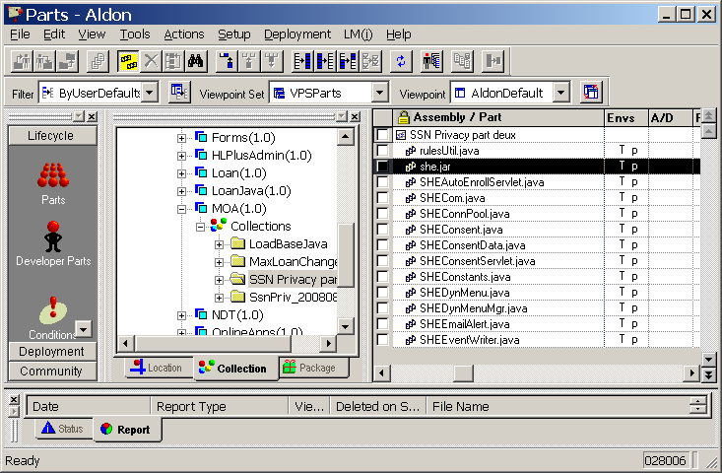
DEPLOYMENT TAB

- Then click on the “Deployment Sets” Icon in the Left Pane
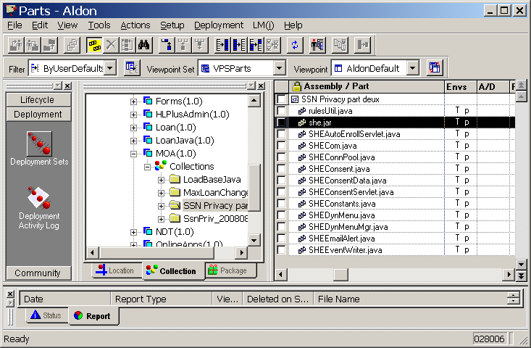
DEPLOYMENT SETS

- In the window that opens up, select the Deployment set associated with your userID and the timestamp when you had completed Check-in or Promote.
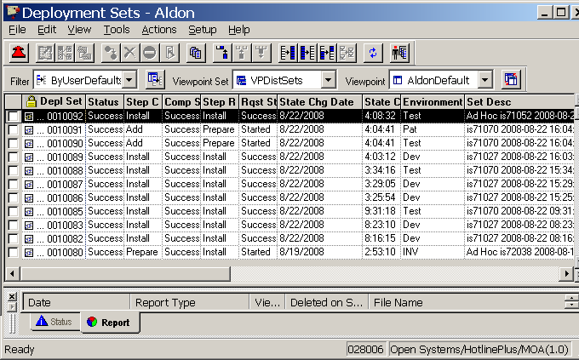

- Right click on the set, select Properties - Target Computers.
- The following window will open
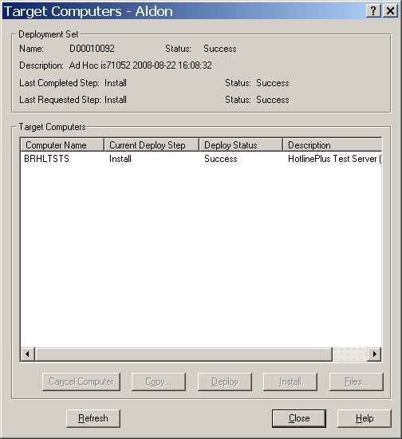

- Select the computer on the window. Highlight the Computer name and the buttons at the bottom will become enabled.
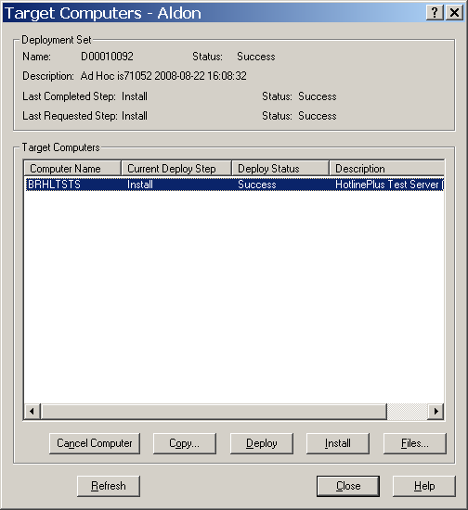
FILES BUTTON

- Click on Button Files and you can see the files that are being copied to the server and the location they are being copied to.
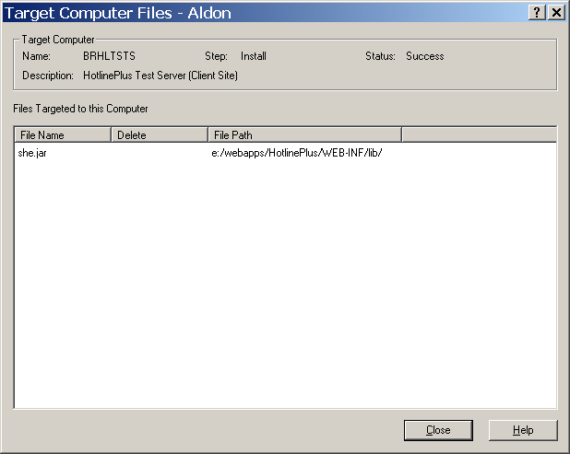

- If all the above looks good and your file still is not being placed on the Production server – Go to the drive on the server where the code is installed (D drive for Website servers and E drive for HotlinePlus servers)
- CD to the “\Program Files\Aldon\Aldon LM 5.4\Distribution\wrapper_win32_2.2.7\logs” folder.
- Open up the wrapper.log file and check for errors in deployment of your file. If no errors show up verify that the path where the file is deployed is correct.

Move code from Test to PAT (or PAT to Production):

- Based on the Migration Email sent to you, identify the “RELEASE” for the migration.
- Identify the “TASK ASSEMBLY” for the migration.
- To perform the migration do the following.
- Logon to the Aldon LM(e) Client
- In the “PARTS” window that opens
PARTS WINDOW
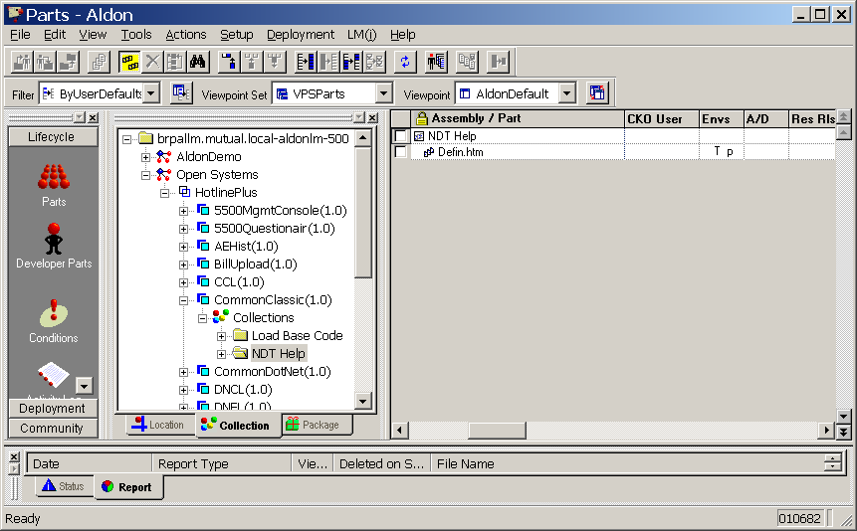

- Tab over to the “COLLECTIONS” tab in the center pane.
- Drill down the OpenSystems – HotlinePlus route to the identified “RELEASE”, and its identified “TASK ASSEMBLY” for the migration.
- Highlight the Task Assembly in the center pane.
- This will bring up the assembly in the Right Pane.
- Click on the top level of this assembly in the Right Pane
- Right Click here and select “Actions – Promote”

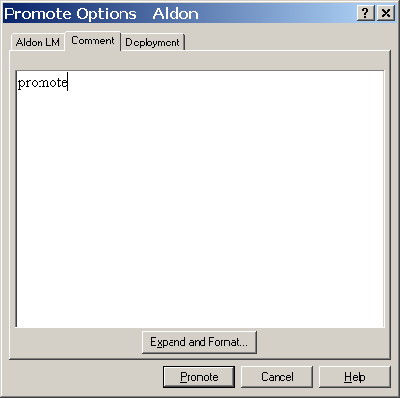

- The window above will open up.
- Put in a Comment to explain the migration
- Check that the Promote is associated with a Deployment set. It should NOT say “No Deployment” (as it does below)

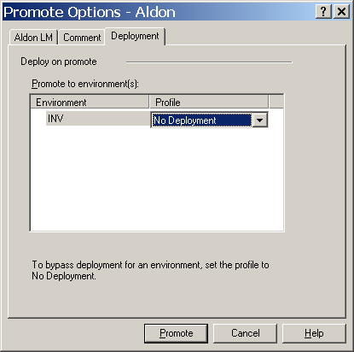

- Click the Promote button.
- This will start the deployment to the PAT server
- Use the instructions in the section above to identify the Deployment set for the promotion.
- Select the Deployment set associated with your userID and the timestamp when you had completed Check-in or Promote.

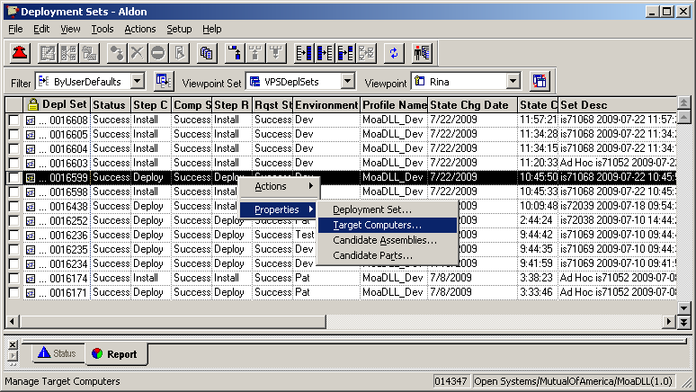

- Right click on the set, select Properties - Target Computers.
- The following window will open

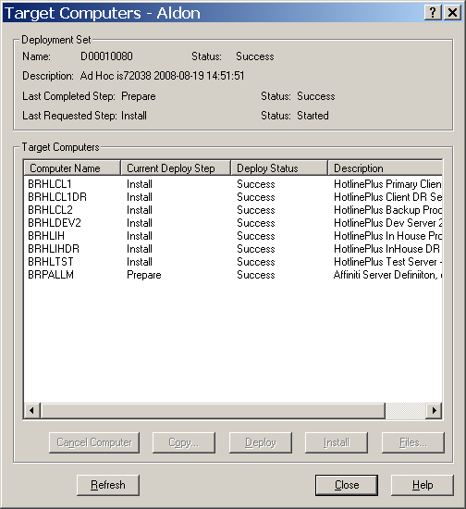

- Select the computer name where you need to deploy to in the window. The buttons at the bottom will become enabled.
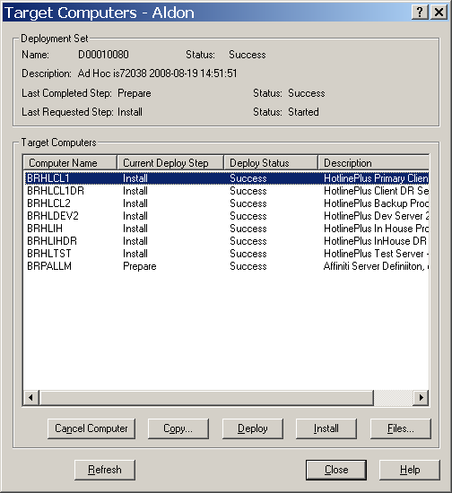
FILES BUTTON

- Click on Button Files and you can see the files that are being copied to the server and the location they are being copied to.
- The following window will open.

- Verify that the files listed in the migration form are listed here and they are being moved to the correct folders on the production server.
- Close this window.

- Go back to the Target Computers window.
- If the computer name selected has a Current Deploy step listed as “DEPLOY” then you will need to complete the “INSTALL” step.
- If there are any special instructions for the NETWORK ENGINEER in the Migration form, for performing tasks on the servers before the files get copied to the servers. Then let Network Engineer know that they will need to complete their task and communicate back to you.
- With the Computer name selected, click on the “INSTALL” button in the bottom of the window.

INSTALL BUTTON

- Keep clicking on the “Refresh” button until the “Deploy Status” column shows “Success” against this computer.
- Send out the notification of Deployment to this computer.
- Continue to install one computer / a set of computers at a time as required.
- Please install on the DEV2 and TST servers after the last DR server has been completed.

Perform an AdHoc Deployment:

- On the Collections tab select the Release – and then select the Task Assembly

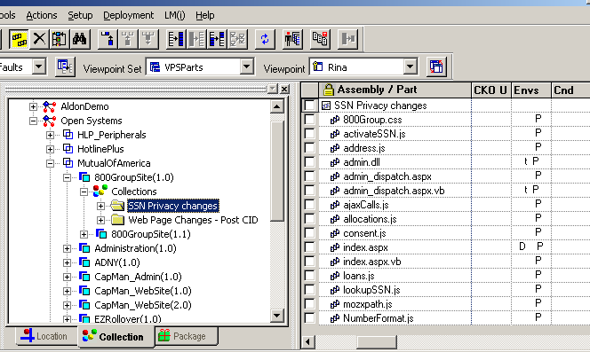

- In the Right Pane highlight the Task assembly and right click
- Select “Deployment” - "Deploy"

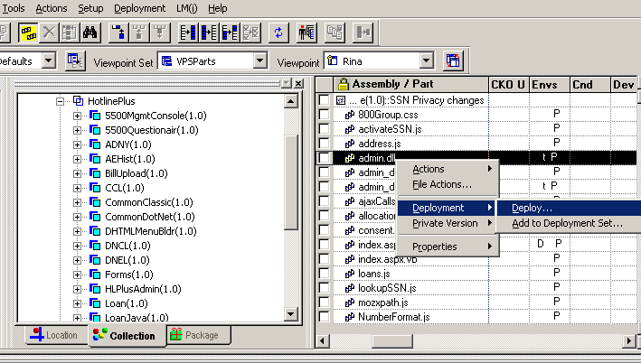

- In the window that opens up select "From environment" INV (since all the files in the window above are in “P” Env.

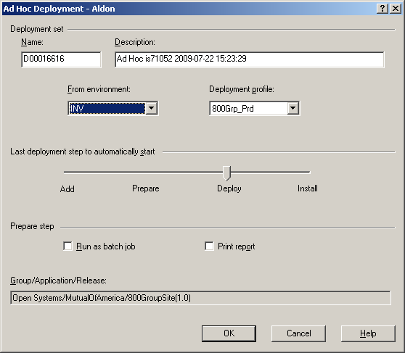

- Accept the default profile unless you are moving files to a different set of servers (from Production to Test).
- Select OK.
- Then Install the deployed package only on servers specified.

Promote a File or Task Assembly Without Deployment:
- In the Parts window, go to the Collections Tab and select the Release and Task Assembly to be deployed.

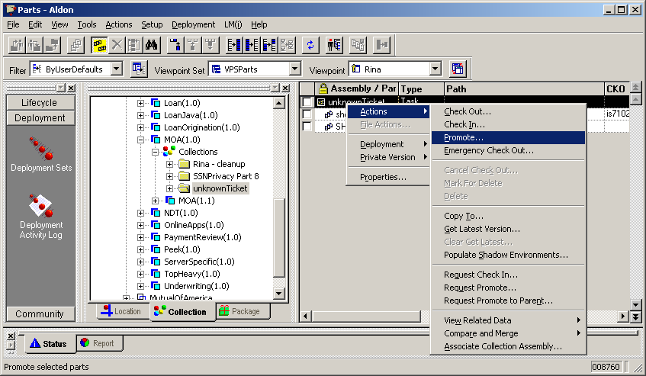

- In the rightmost window, highlight the Task Assembly name
- Right Click and select “Actions – Promote”
- In the new window that opens up, go to the Deployment Tab

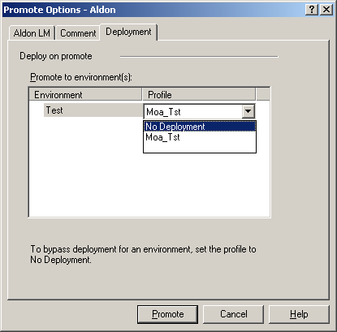

- Select No Deployment in the drop down box.
- Click on Promote.

Promote A Child / Branch Release to Production: OR Promote to Parent:
- Verify that there are no conflict conditions on any files in the Task Assembly.

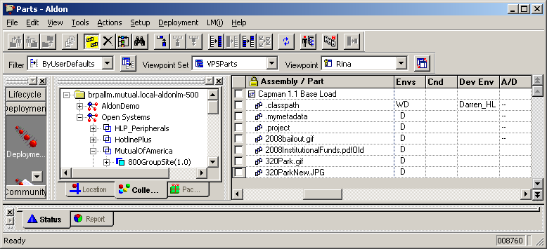

- Select and highlight task assembly in the Collections Tab.

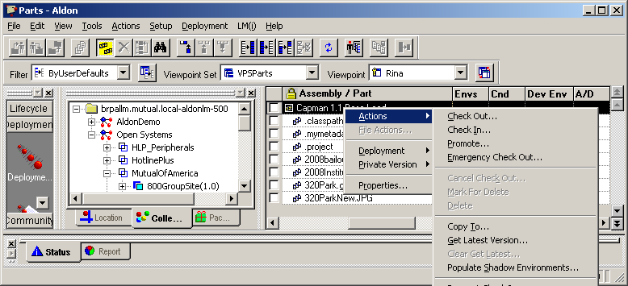

- Do a normal promote to PAT and Install the deployment set on the PAT server
- Do a normal promote to Production. There will be no deployment set available for this environment in the Branch Release.
- Now start the Promotion to Parent.
- Select and highlight task assembly
- Under actions or right click on mouse select Promote to Parent
- Deployment set will be from prod to prod
- Install as usual

Do An Emergency Check-out and Check-in from Production: (Change Management ONLY):
NOTE: This is only used in two scenarios (i) To back out a production Migration when an problem is introduced. (ii) To place a debug version of a production file to troubleshoot a production issue in the internal production environment (website only).
- Go to the Parts Window and do an Emergency Check-out of the file. Use the original task assembly or one specifically created for this change.
- Take check out the file from Aldon LM(e) production archive OR the debug version of the file from Project Lead. Copy to mapped working folder.
- Emergency Check-In the file to production servers requested.

Emergency Restore of -1 version of code on Production servers: (Network Enginners ONLY):
- Get the Aldon Deployment Package ID from Change Management OR the Migration Verifier (Developer)
- Unzip the Deployment Package identified on the production folder.

Create a new Task Assembly:
- In the collections tab, Right Click on the Release where you want to create a new Task Assembly.
- Select “New – Assembly – Task…”

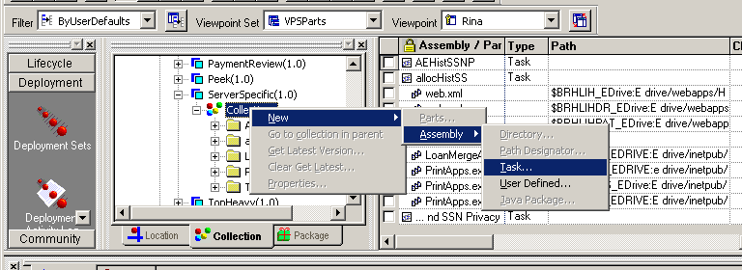

- In the new window type in the new task assembly name and click OK
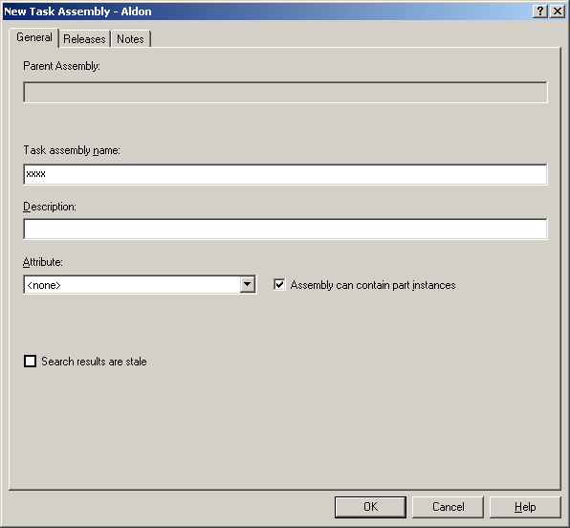

Add files to a Task Assembly:

Method 1: Check out:
- When you check a file out of Aldon, you will need to associate the file with a Task Assembly.

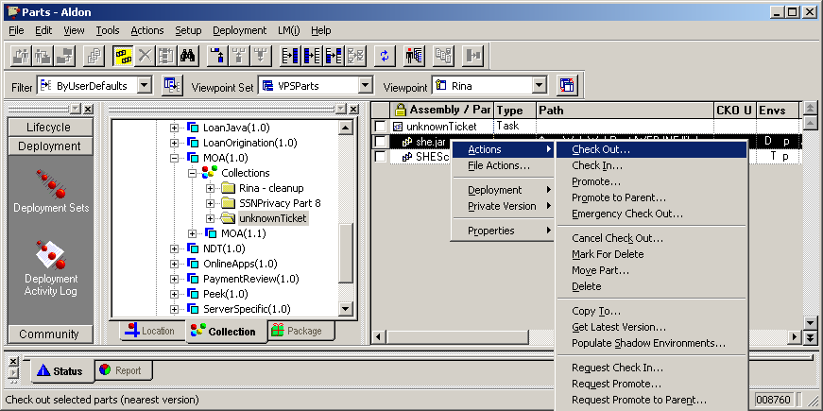

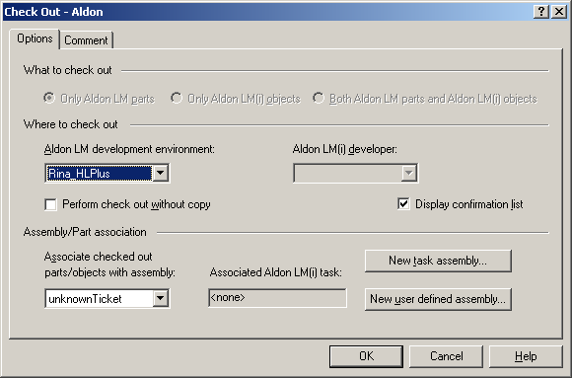

Method 2: Associate Collection Assembly:
- In the Parts window, select the file
- Right click – Actions – Associate Collection Assembly

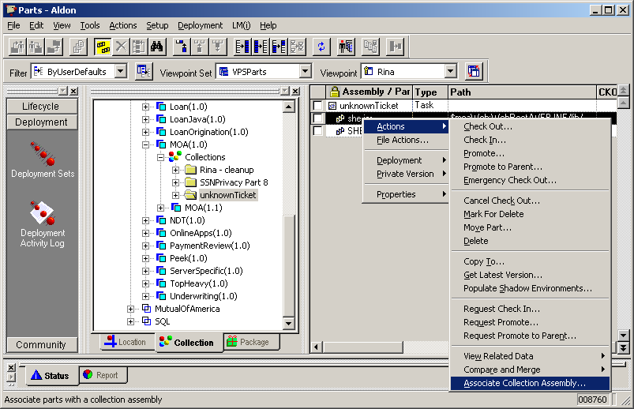

- In the window that opens up, find the Task Assembly name in the “Choose Collection Assembly” drop down box
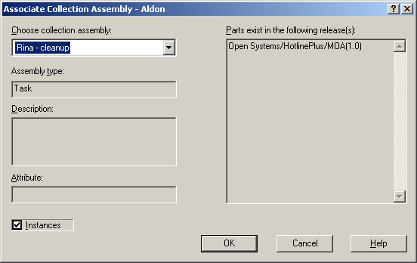

Remove files from a Task Assembly:
- In the Collections Tab, Right Click on the Task Assembly and choose Remove Associations.

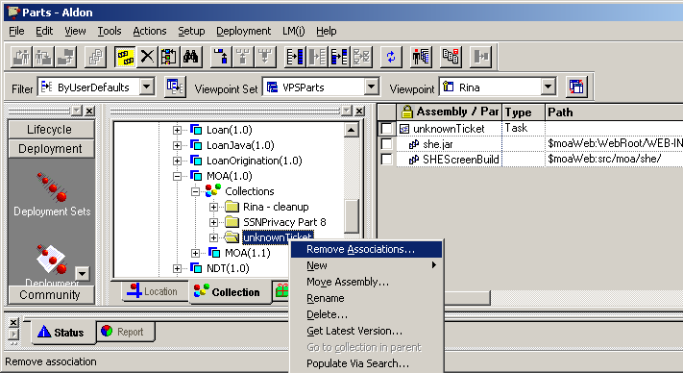

- In the window that opens up select the file you want to remove.

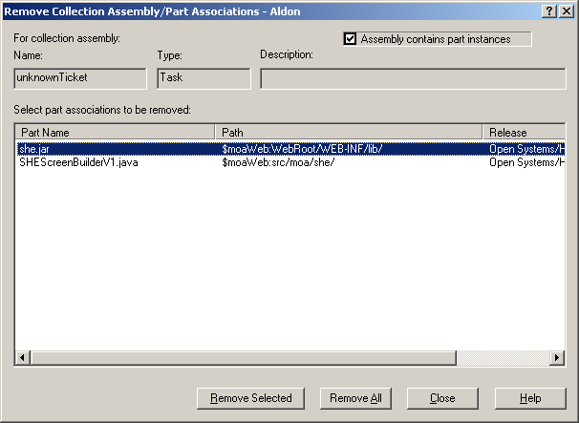

- Click Remove Selected.

Move files from one Task Assembly to Another:
- Follow steps outlined in Section 21, Method 2 to associate the file to the second task assembly.
- Follow steps outlined in Section 22 to remove the file from the first task assembly.

Associate a Task Assembly to Multiple Releases:
- In the Collections Tab, Right Click – Properties on the Task Assembly.

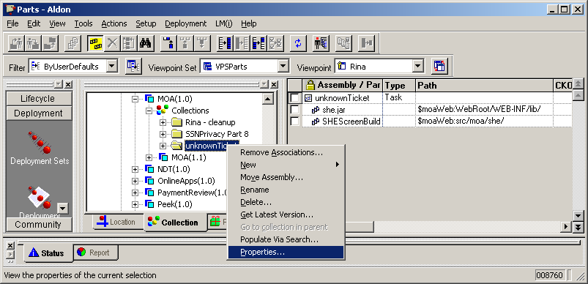

- In the window that opens up select the Releases tab

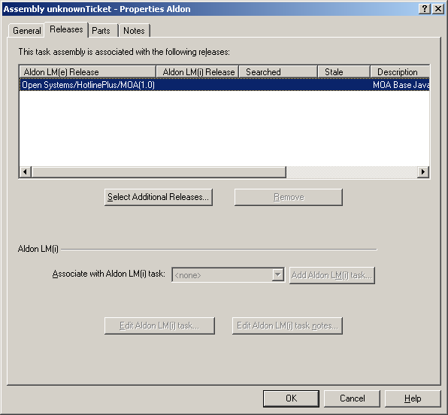

- Click on Select Additional Releases

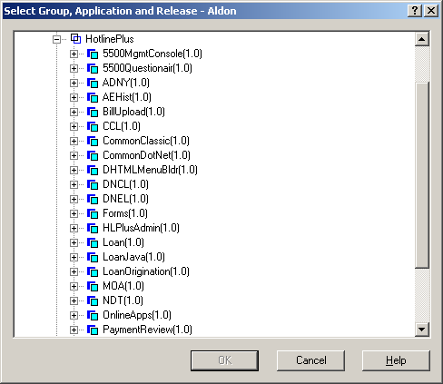

- Drill down to the release you want to add and click OK.
- Repeat the process to add more releases to the task assembly.
- Click OK again on the Properties window.

GLOSSARY:

Our Terminology | Aldon Terminology | Description
Web site | Application | HotlinePlus, Moaweb, Capman,,,etc
Application | Release | Major functions within a site  BillUpload, TopHeavy… or MoawebSite, EZRolloverSite…
Project or Solution within IDE  OR a Folder in the website where ASP code is stored on the web server. | Path Designator : eg  $Hotline2Folder  $MoaDLL | Working Folder on the developers workstation.
Migration Package | Task Assembly | A task assembly should be created for each migration request. All files that need to be changed & migrated for this request should be associated with one Task Assembly
Production Environment | INV

