|  |
| --- |
|  |
| SR-TAFE Ticketing System |
| Manual | Version 1.3 |

|  |
| --- |
| Author: Marck Munoz  9/14/2016 |

Contents

Introduction 2

System Requirements 2

Ticketing system features 2

Users (Admins and Technicians) 3

User levels: 3

Administrator 3

Technician 3

Default Admin username/password 3

Creating new admins/technicians 4

User manager 5

Register user form 6

Editing user info /privilege 7

User information page 8

Creating a ticket 9

Creating the ticket 10

Selecting technicians 10

Viewing tickets 12

Viewing assigned tickets 12

Viewing all active /closed tickets (Admins only) 12

Viewing a ticket 13

Updating ticket category, priority and status 13

Commenting on a ticket 13

Editing the ticket (Admins only) 14

Editing 15

Reports 16

Security 17

Security features overview 17

Login/Register 17

Hashed/salted passwords 17

Privilege checking on every page 17

Minimum of 9-character password 17

Backing up with Comodo back up 18

Creating back up script 18

Running the back up 22

Restoring a backup 23

# Introduction

This is the manual for the SR-TAFE ticketing system. This documentation will cover how to navigate and use the ticketing system.

# System Requirements

Modern web browser.

Confirmed working on:

* Google chrome – (Tested on version 53.0.2785.116 m)
* Mozilla Firefox – (Tested on version 48.0.2)

# Ticketing system features

* Multi user functionality with user hierarchy
* View assigned tickets
* View All Active/Closed tickets
* Update ticket status (Technician access)
* Select a client for a ticket
* Add new client
* Create tickets
* Ticket Comments (With attachment functionality)
* Ticket attachments capability
* Assign multiple agents to a ticket
* Edit tickets (Admin only)
* View ticket Reports

# Users (Admins and Technicians)

The SR-TAFE Ticketing System supports multi and concurrent users.

## User levels:

### Administrator

Administrator privileges:

* Add users (admin and technician)
* Edit user information
* Create a ticket (And assign agents to ticket)
* Add new client
* View assigned ticket
* View all open/closed tickets in the system
* Edit ticket information
* View reports
* Comment on any ticket

### Technician

Technician privileges:

* View assigned ticket
* Update assigned tickets category, status and priority.
* Comment on assigned ticket

## Default Admin username/password

Default email:

[**Admin@srtafe.wa.edu.au**](mailto:Admin@srtafe.wa.edu.au)

Default password:

**Password1**

## Creating new admins/technicians

To add a new user (admin or technician) log in as admin and on the homepage, click ‘User Manager ’ on the admin toolbar above.

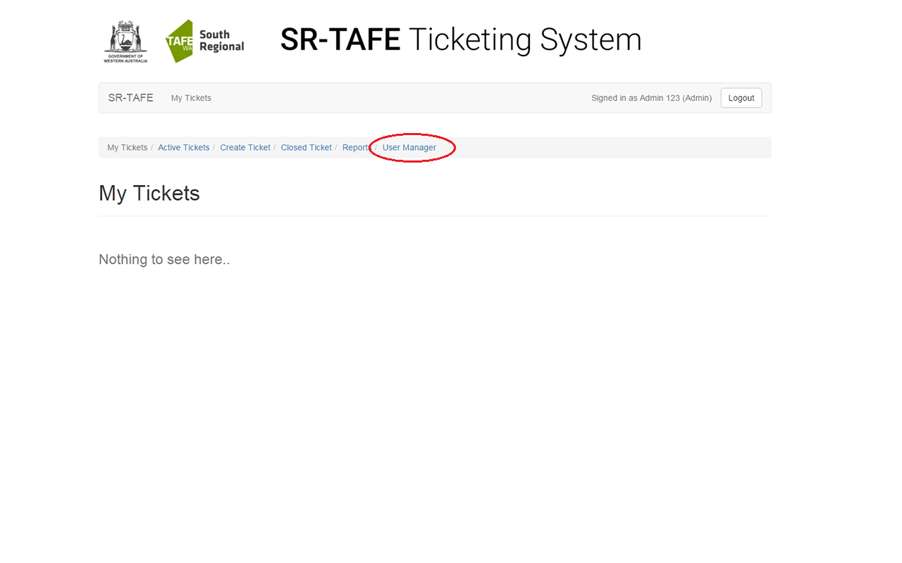

### User manager

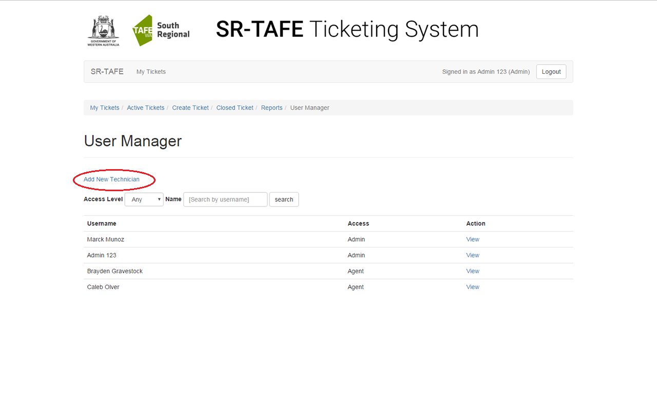Once in the user manager screen, click the ‘Add New Technician’ link as shown in the image to bring up the register user form.

### F:\Manual pics\add new user.pngRegister user form

The register user screen allows admins to add users (admins or technicians). Once all the fields have been filled and the privilege for the user selected, click the register button to register the user.

## Editing user info /privilege

To edit a user’s information or privilege, navigate into the user manager page and click ‘View / Edit’ on the person’s details you want to edit.

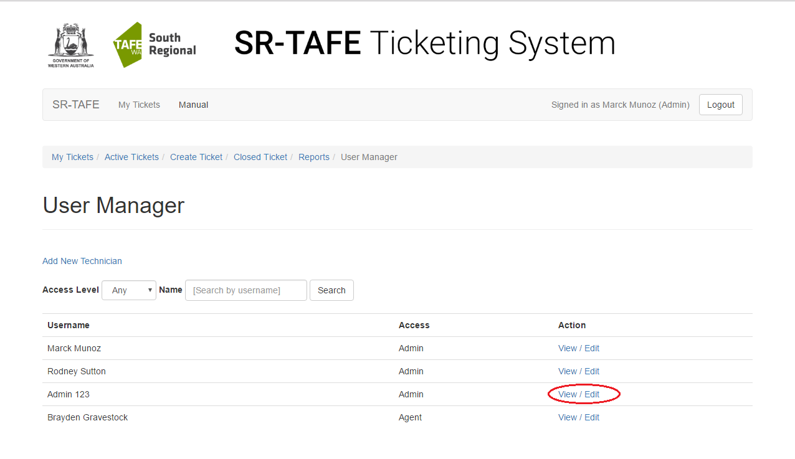

### User information page

After the ‘View / Edit’ link has been clicked for a particular person, the page with their information will load; where their information can be edited.

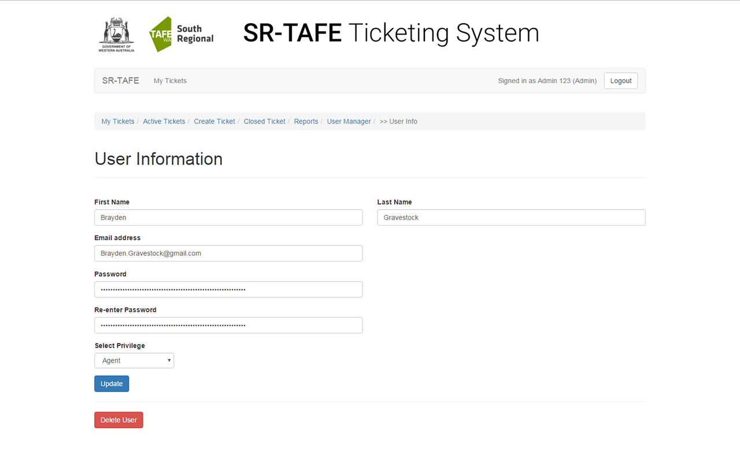Click the ‘Update’ button to finalize any changes made to the user’s information.

Warning: The password must be re-entered again every time a change is created.

# Creating a ticket

Only admins have the power to create tickets. Admins will assign a client and technician(s) to a ticket.

To create a new ticket, click ‘Create Ticket’ on the homepage of the admin toolbar.

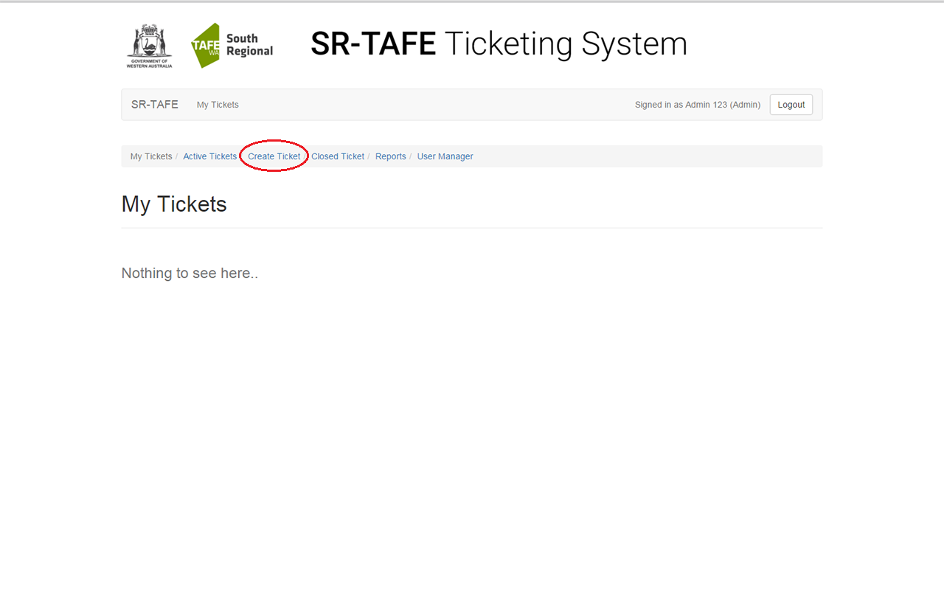

## Creating the ticket

On the create ticket screen, choose the client on the dropdown if the client already exists or add a new client by filling out the client’s name and email on the right and then clicking ‘Add Client’.

Populate the rest of the ticket information and then assign the technician(s) you would like to assign the ticket to.

If you would like to add an attachment to the ticket, click the ‘Choose Files’ button and choose the attachment(s) to add to the ticket.

Supported comment attachment file extensions:

* .txt
* .jpg
* .png
* .docx
* .pdf
* .zip
* .rar

### Selecting technicians

To select technicians for the ticket, navigate to the bottom of the create ticket page where the ‘Assign technician’ selector is.

Choose technicians by clicking each technician on the left box. Chosen technicians will be viewable on the right box.

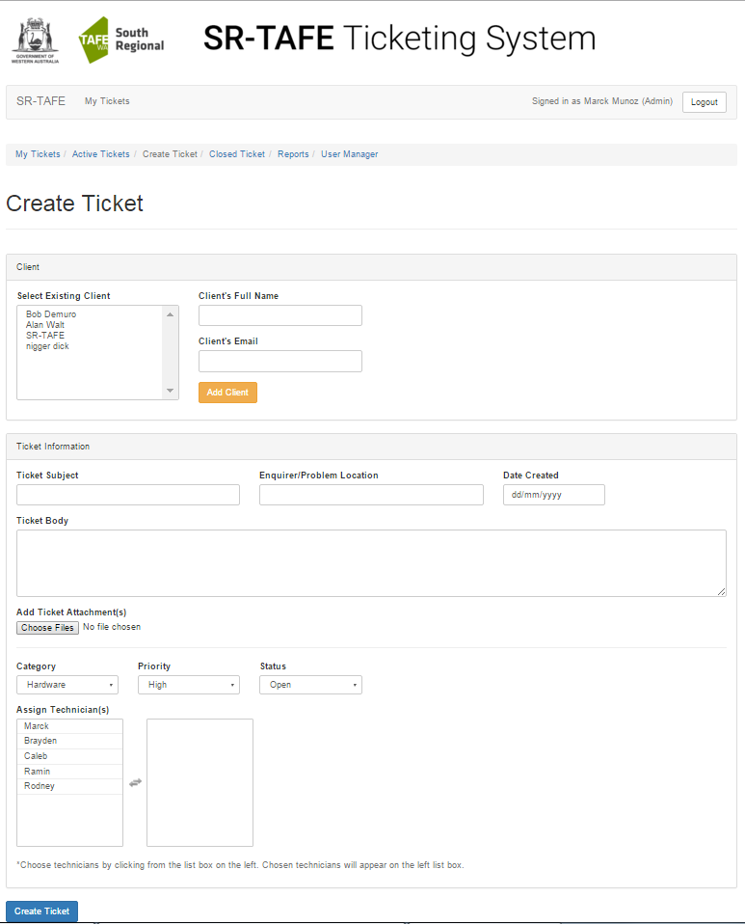

# Viewing tickets

## Viewing assigned tickets

To view the currently signed in user’s assigned tickets, navigate to the homepage (whilst logged in) and under ‘My Tickets’ are all the assigned tickets to currently logged in user.

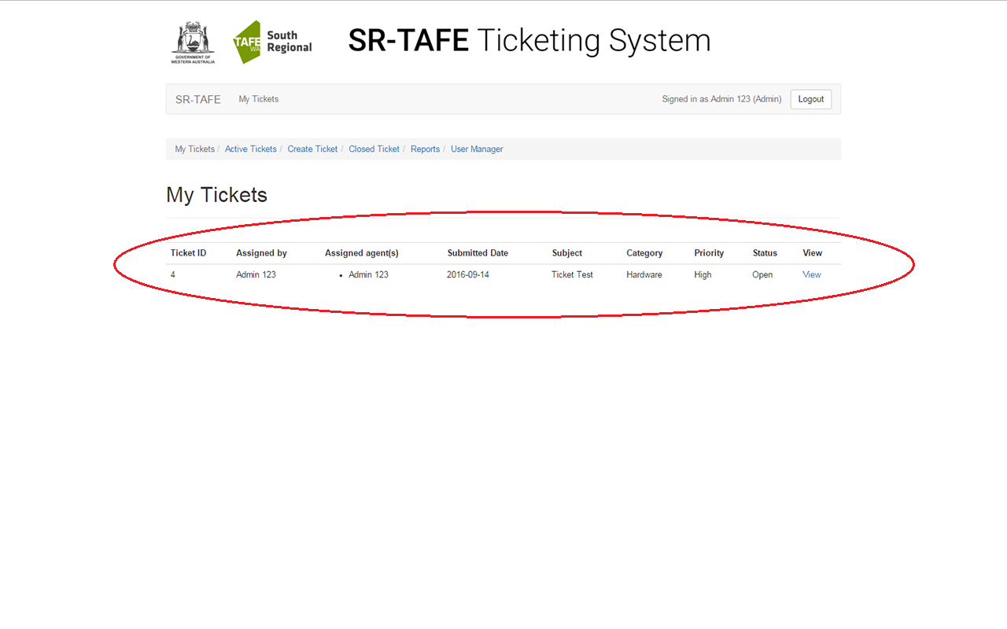

The summary of the ticket will be displayed in each row including the ticket id, the creator of the ticket (Assigned by) the assigned technician(s), the submitted date, subject of the ticket, category, priority, status as well as the link to view the ticket.

## Viewing all active /closed tickets (Admins only)

To view all the current active tickets, click on the ‘Active Tickets’ link on the admin toolbar.

To view all the closed tickets, click on the ‘Closed Tickets’ link on the admin toolbar.

## Viewing a ticket

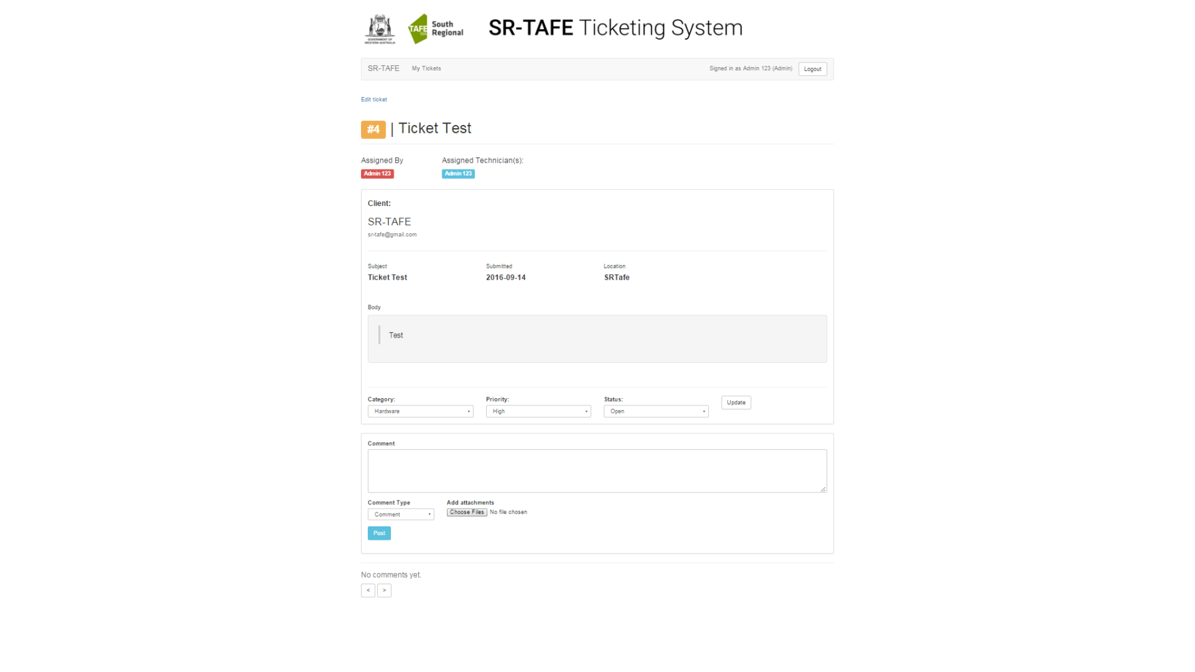To view a particular ticket, click on the ‘View’ link of the ticket you would like to view.

### Updating ticket category, priority and status

From this view ticket page, the category, priority and status of the ticket can be quickly changed by any admin and any technician assigned to the ticket. Click the ‘Update’ Button to confirm any changes.

### Commenting on a ticket

To comment on a ticket, view the ticket and under the ticket information is the comment box.

Write your comment in the comment box, choose the comment type (Comment or Solution, default is comment) and click ‘Post’ to post the comment.

You may also attach attachments by clicking on the ‘Choose Files’ button and choosing the attachments you would like to attach on your comment.

Supported comment attachment file extensions:

* .txt
* .jpg
* .png
* .docx
* .pdf
* .zip
* .rar

### Editing the ticket (Admins only)

To edit a ticket, view the ticket you would like to edit and on the top left of the page, click the ‘Edit ticket’ link.

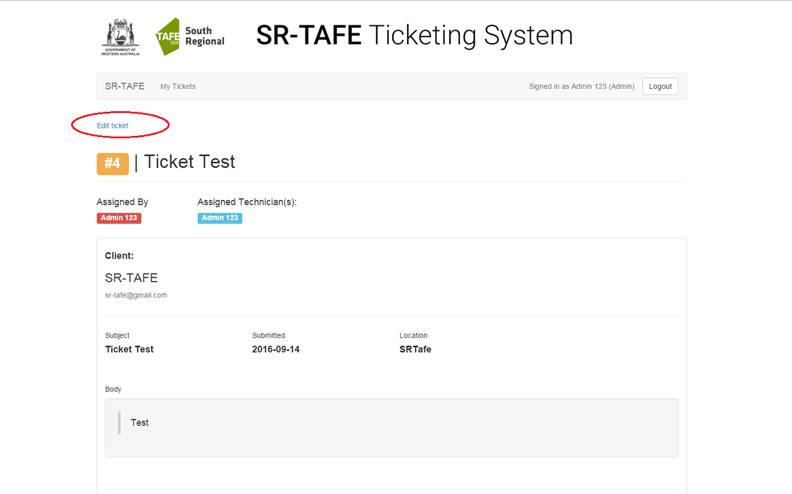

### EditingC:\Users\Student\Desktop\newcreateticket.PNG

Once on the edit ticket page, the ticket can be altered and updated. A new client can be selected or added and then selected.

The ticket subject, Location, date, body, attachments (add, remove) etc. can also be edited.

##### Removing/Adding attachments

To remove an existing ticket attachment, tick the ‘Remove’ checkbox next to the attachment you would like to remove and click update.

To add new attachment(s), click the ‘Choose Files’ button, choose the desired attachments and click the ‘Update’ button.

**Note: Every time a ticket is edited, technicians must be re-assigned.**

# Reports

Admins can also access the report page. To access the report page, navigate to the homepage and click the ‘Reports’ link on the admin toolbar.

The report page will show the number of open/closed tickets in the last seven days and a pie chart based on the number of active tickets in the last 30 days by category (hardware, software etc.)

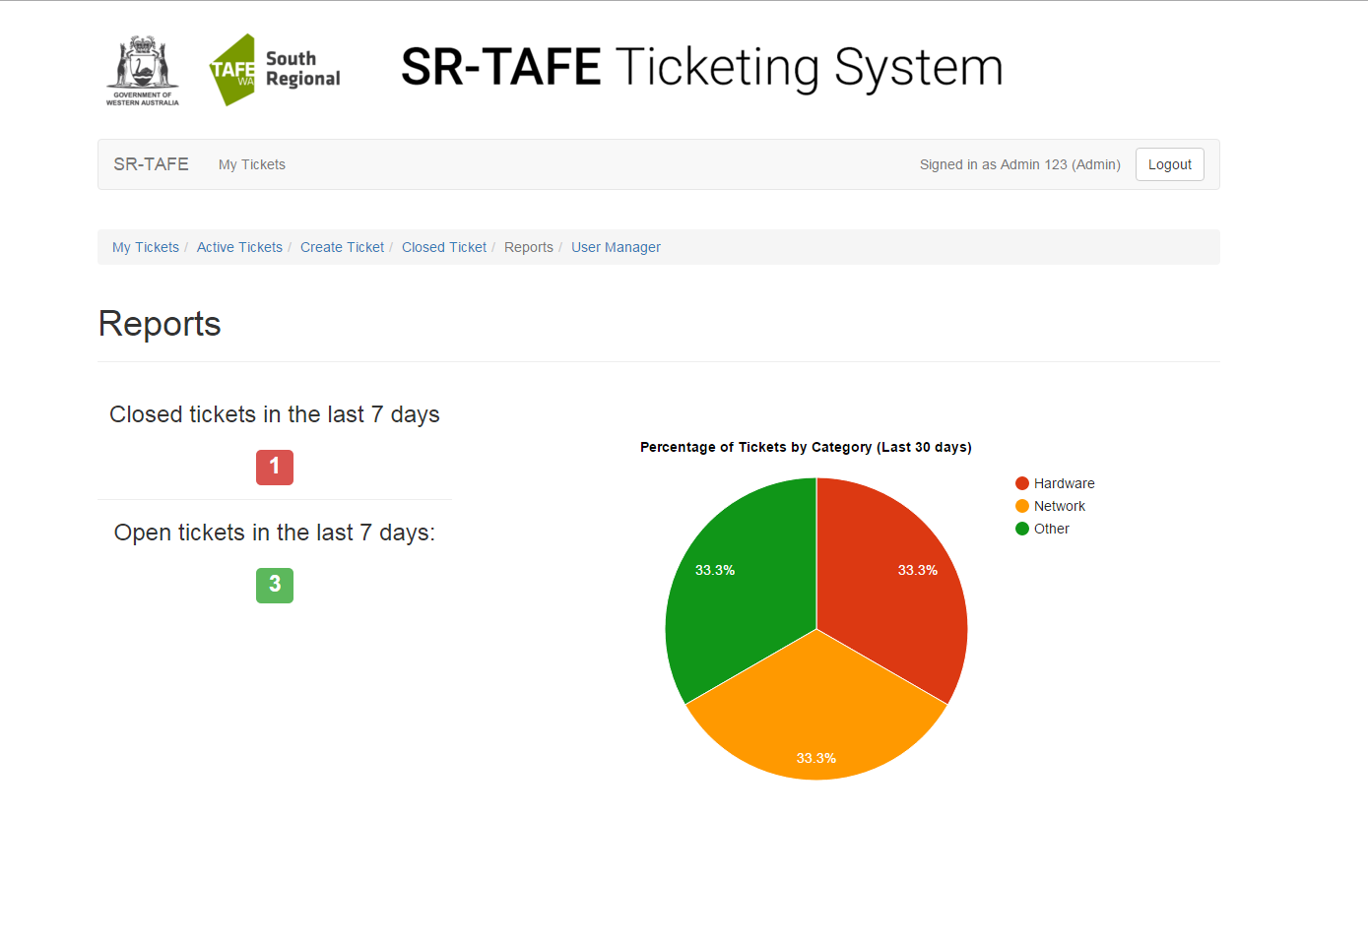

# Security

## Security features overview

* Login system
* Hashed/salted passwords
* Privilege checking on each page
* Minimum of 9-character password

## Login/Register

Only admins can create other technicians. For a technician (or admin) to access the ticketing system, they must first log in with a valid credential.

## Hashed/salted passwords

When a user is registered in the database, their password is hashed and salted, making it extremely difficult to know their password even if the database is compromised.

## Privilege checking on every page

Each page will check the if a user is logged in and the currently signed in user’s privilege (if a user is logged in). This prevents any unauthorized access to a page if no user is logged in or they don’t have the right privilege.

## Minimum of 9-character password

When registering a user, their password must be more than eight characters long in order for them to be registered in the database.

# Backing up with Comodo back up

## Creating back up script

Creating a backup script enables the user to quickly run a script which will back up the necessary files to a safe location.

To create a backup script with Comodo, open up the Comodo backup software and click on ‘Backup’ on the left hand side.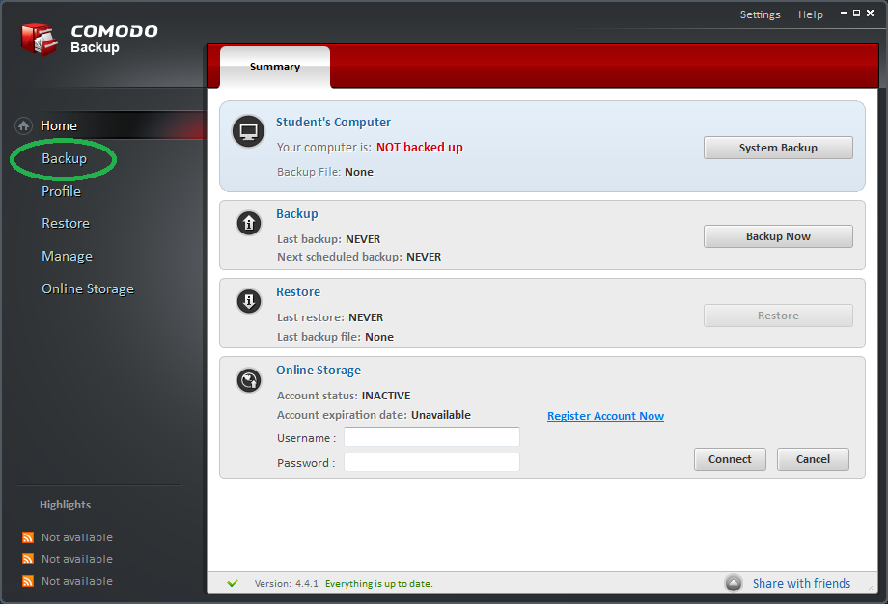

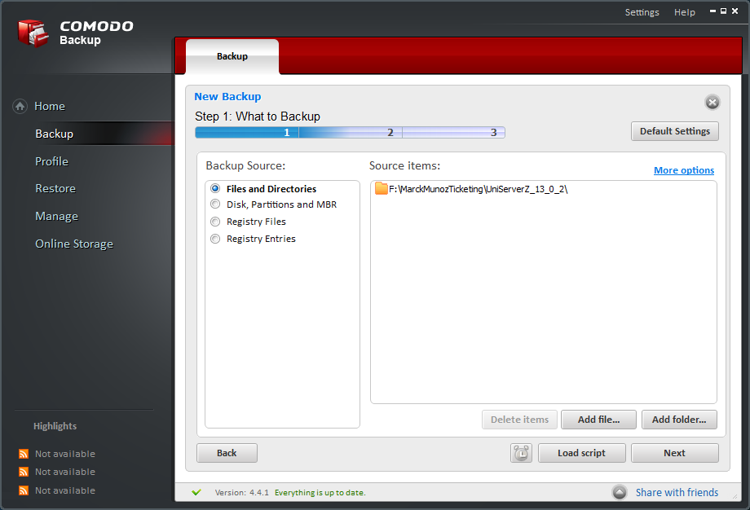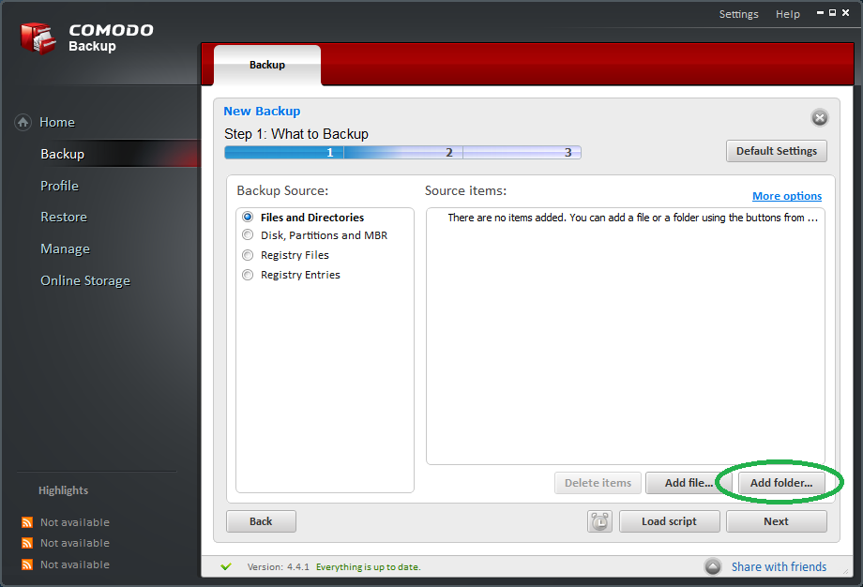Click ‘Add folder’ and navigate to the UniserverZ folder and then click next to add it to the Source items window.

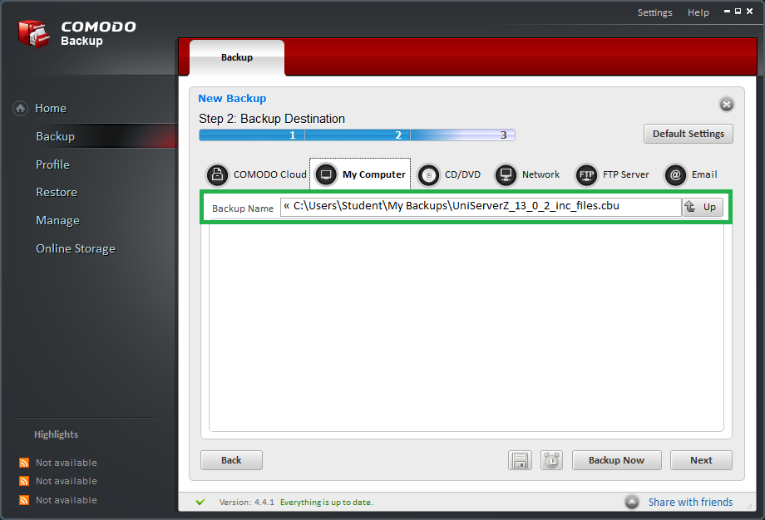

Click ‘My Computer’ on the backup destination screen, choose the destination of the backup and click next to continue.

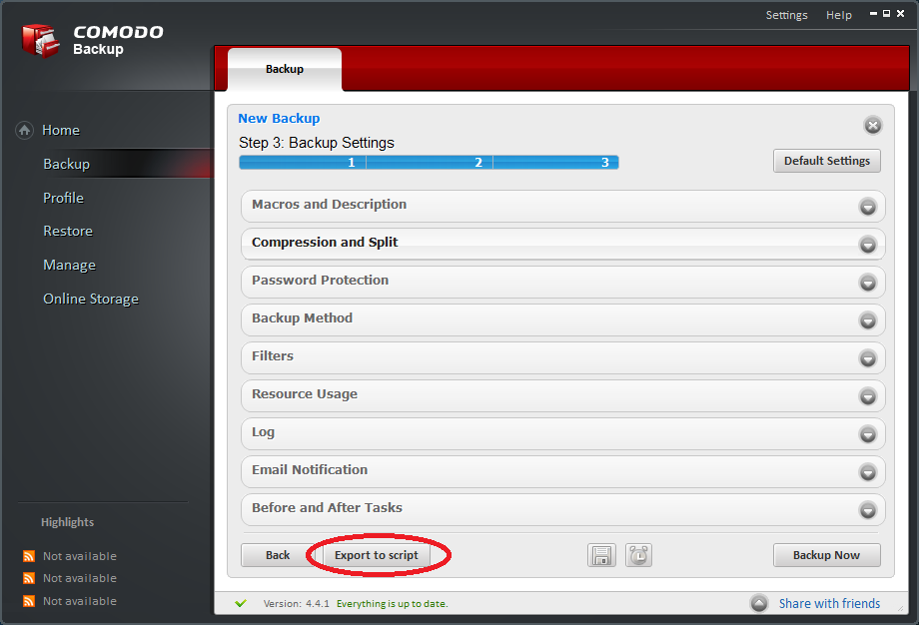

Click the ‘Export to script’ button to create the script and save it to your desired location.

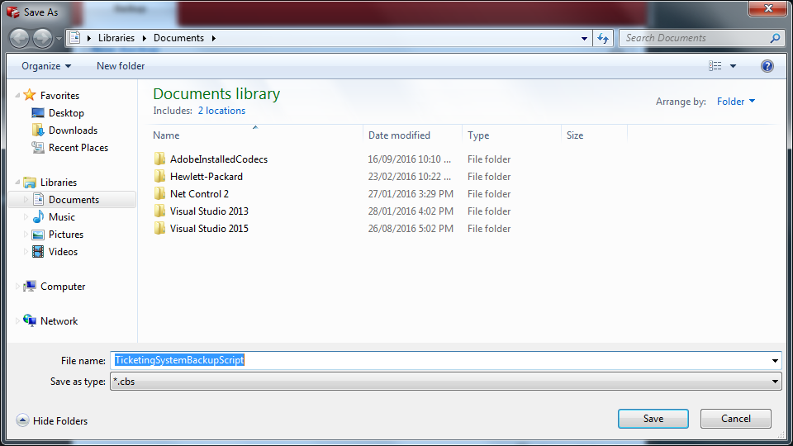

## Running the back up

To run the backup, simply run the script generated by Comdo.

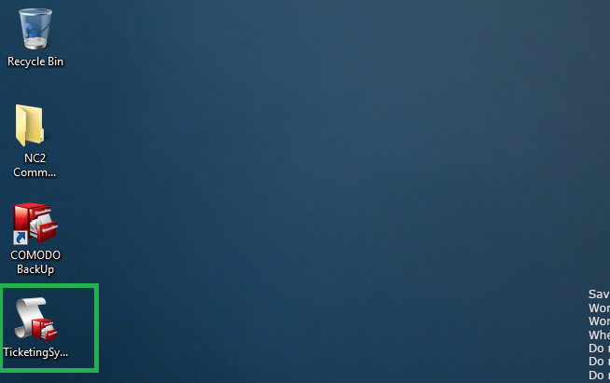

# Restoring a backup

To restore a backup with Comodo backup, open Comodo and click on ‘Restore’ on the left hand side and then click on the ‘Recent Backups’ tab.

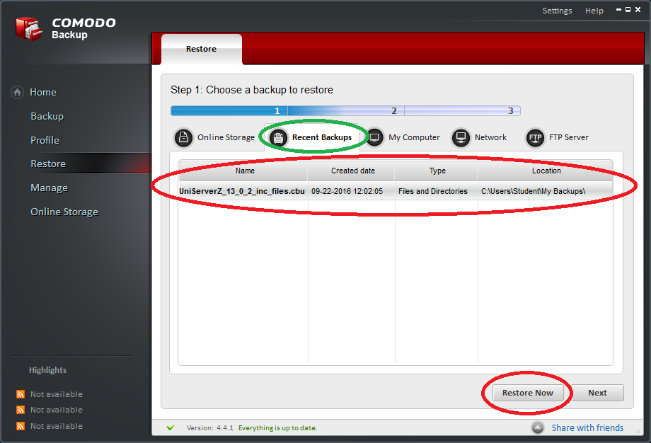

Select the backup you would like to restore and then click ‘Restore Now’ to restore the files.