**Inventory Management System**

____________________

A Project Proposal

Presented to the **Department of College of Computer Studies**

**Cebu Institute of Technology University**

**Cebu City, Philippines**

____________________

In Partial Fulfillment

of the Requirements for the Subject

**Information Management 2**

____________________

**Prepared by:**

**Paraiso, Marck Ramon G.**

**Gabison, Andrei Mighel A.**

**Bustamante, William.**

August 2024

**Inventory Management System**

This document features the functional Requirements for the Inventory Management System **(IMS).** This outlines the important features and capabilities the System itself must have to meet the needs/requirements of the inventory managers, warehouse staff, and business administrators effectively.

**Functional Requirements Table Illustration**:

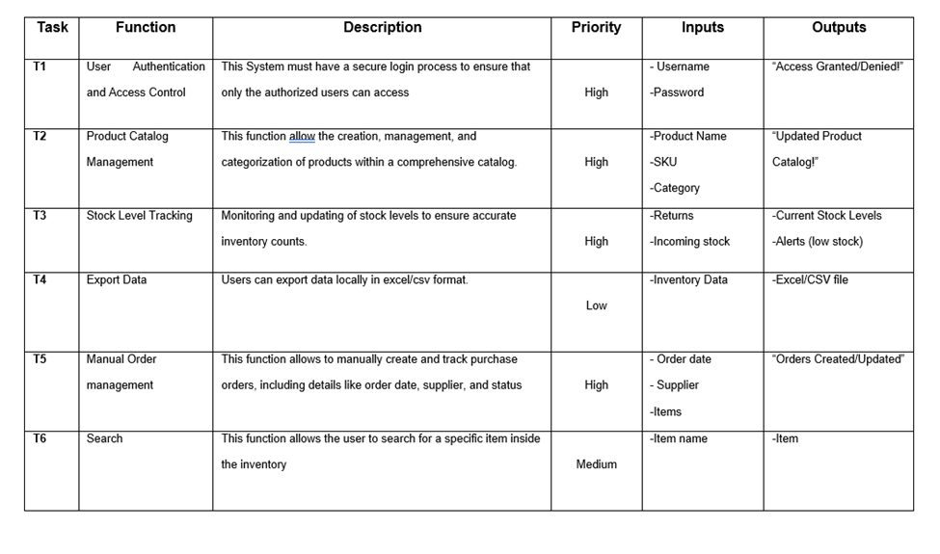

These functional requirements outline the important and essential features needed for the *Inventory Management System* (IMS). The System focuses on delivering a Minimum Viable Product that serves as a foundation for further development. As the project progresses, these requirements may be refined, changed or expanded based on the system’s needs and any new requirements that may need to be added.

**System ERD Draft:**  
  
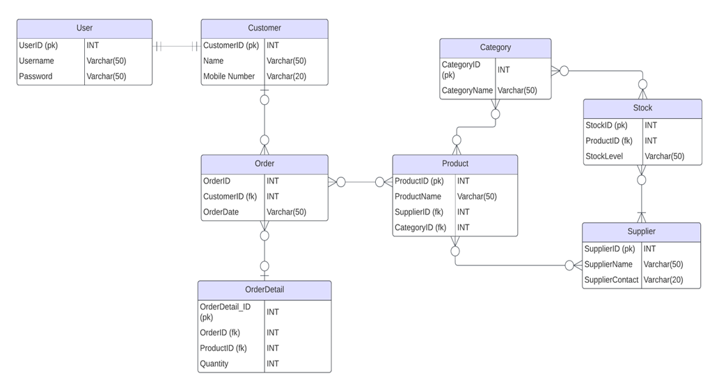

**Functional Requirements Table:**

|  |  |  |  |  |  |
| --- | --- | --- | --- | --- | --- |
| **Task** | **Function** | **Description** | **Priority** | **Inputs** | **Outputs** |
| **T1** | User Authentication and Access Control | This System must have a secure login process to ensure that only the authorized users can access | High | - Username  -Password | “Access Granted/Denied!” |
| **T2** | Product Catalog  Management | This function allow the creation, management, and categorization of products within a comprehensive catalog. | High | -Product Name  -SKU  -Category | “Updated Product Catalog!” |
| **T3** | Stock Level Tracking | Monitoring and updating of stock levels to ensure accurate inventory counts. | High | -Returns  -Incoming stock | -Current Stock Levels  -Alerts (low stock) |
| **T4** | Export Data | Users can export data locally in excel/csv format. | Low | -Inventory Data | -Excel/CSV file |
| **T5** | Manual Order management | This function allows to manually create and track purchase orders, including details like order date, supplier, and status | High | - Order date  - Supplier  -Items | “Orders Created/Updated” |
| **T6** | Search | This function allows the user to search for a specific item inside the inventory | Medium | -Item name | -Item |