COS226: Practical 7

Marco Geral | u23584565

# Introduction

This project focuses on implementing and evaluating the performance of three types of concurrent stacks: a **Sequential Blocking Stack**, a **Lock-Free Stack**, and an **Elimination Backoff Stack**. The goal is to compare their performance under varying levels of thread contention. The Sequential Blocking Stack uses locks for thread safety but may suffer from contention. The Lock-Free Stack uses atomic operations to improve concurrency. The Elimination Backoff Stack enhances this further by allowing threads to exchange values directly, reducing contention. By running experiments, we aim to observe the scalability and efficiency of each approach under different thread loads.

# Findings

|  |  |  |  |
| --- | --- | --- | --- |
| Thread Count | Sequential_Blocking_avg | Lock_Free_avg | Elimination_Backoff_avg |
| 1 | 52 | 8.2 | 7.2 |
| 2 | 2.6 | 4.0 | 3.2 |
| 4 | 4.8 | 3.6 | 3.6 |
| 8 | 13.4 | 7.0 | 4.6 |
| 16 | 9.6 | 10.6 | 9.4 |

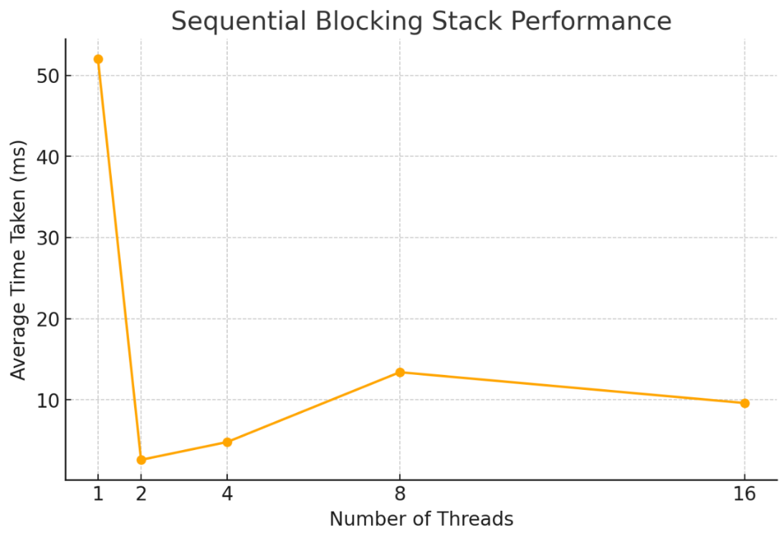

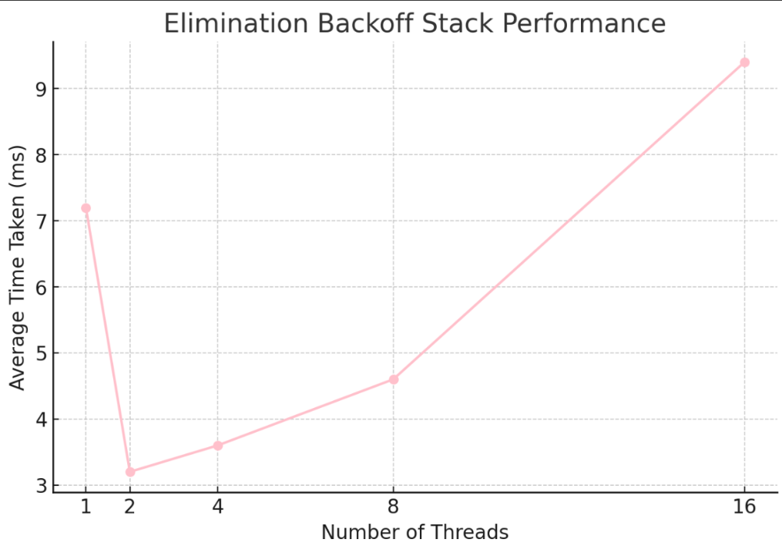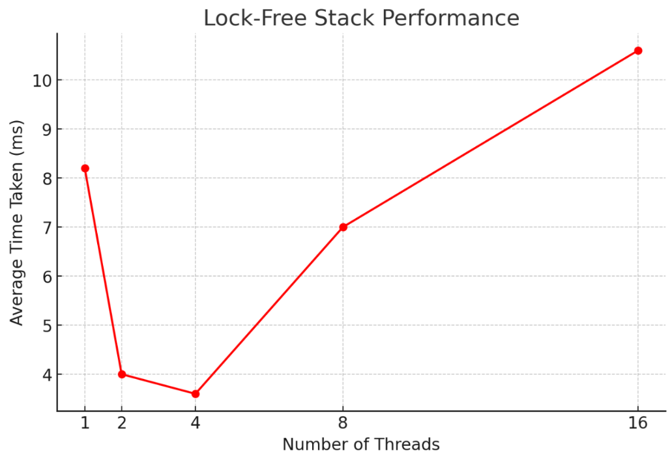

# Observed Trends:

1. **Sequential Blocking Stack**:
   * Initially, with 1 thread, the Sequential Blocking Stack takes significantly longer, due to the overhead of locks.
   * As the number of threads increases, the performance improves slightly up to 8 threads but then begins to degrade due to contention. At higher thread counts (16), performance becomes more variable due to lock contention.
2. **Lock-Free Stack**:
   * The Lock-Free Stack consistently performs well with low thread counts. It shows minimal increase in time as the thread count rises, but slight degradation occurs at 16 threads due to contention at the stack’s top, even with lock-free mechanisms.
3. **Elimination Backoff Stack**:
   * The Elimination Backoff Stack outperforms the other two implementations at higher thread counts. Its performance remains stable and improves slightly as more threads are introduced. This is because it can offload contention by using the elimination array, allowing threads to exchange values directly rather than contending for the stack's top.

# Reasons for the Trends:

* **Sequential Blocking Stack** suffers due to the locking mechanism, which introduces overhead and contention, especially as thread counts rise.
* **Lock-Free Stack** improves concurrency by avoiding locks, but still faces contention at the top of the stack due to the sequential nature of push and pop operations.
* **Elimination Backoff Stack** reduces contention by allowing threads to cancel each other out via elimination, improving performance under high contention.

# Conclusion:

The **Elimination Backoff Stack** demonstrates better scalability under high thread counts, supporting the statement that elimination techniques improve performance as contention increases. While the Lock-Free Stack performs similarly at low contention levels, the Elimination Backoff Stack scales much better at higher thread counts due to its ability to offload operations via elimination.