# Results

## Using single PCA axes as conservation features

### Conservation cost

In prioritizr, total conservation cost increases with the number of PCA axes included in the prioritization (Figure 2A and B). The number of discrete classes has no consistent effects on conservation cost across the four tested methods to subdivide the single-axis PCA scores into discrete classes (Figure 2C and D): only for the quantile method, increasing number of discrete classes leads to increasing conservation costs. Similarly, the subdivision method has no consistent effect on conservation cost across the three tested number of discrete classes.

In raptr, conservation cost does not change with the number of PCA axes included in the prioritization and is always lower than that of prioritizr (Figure 2A and B). There is no increase in total conservation cost with either the class method or the number of classes (Figure 2C and D).

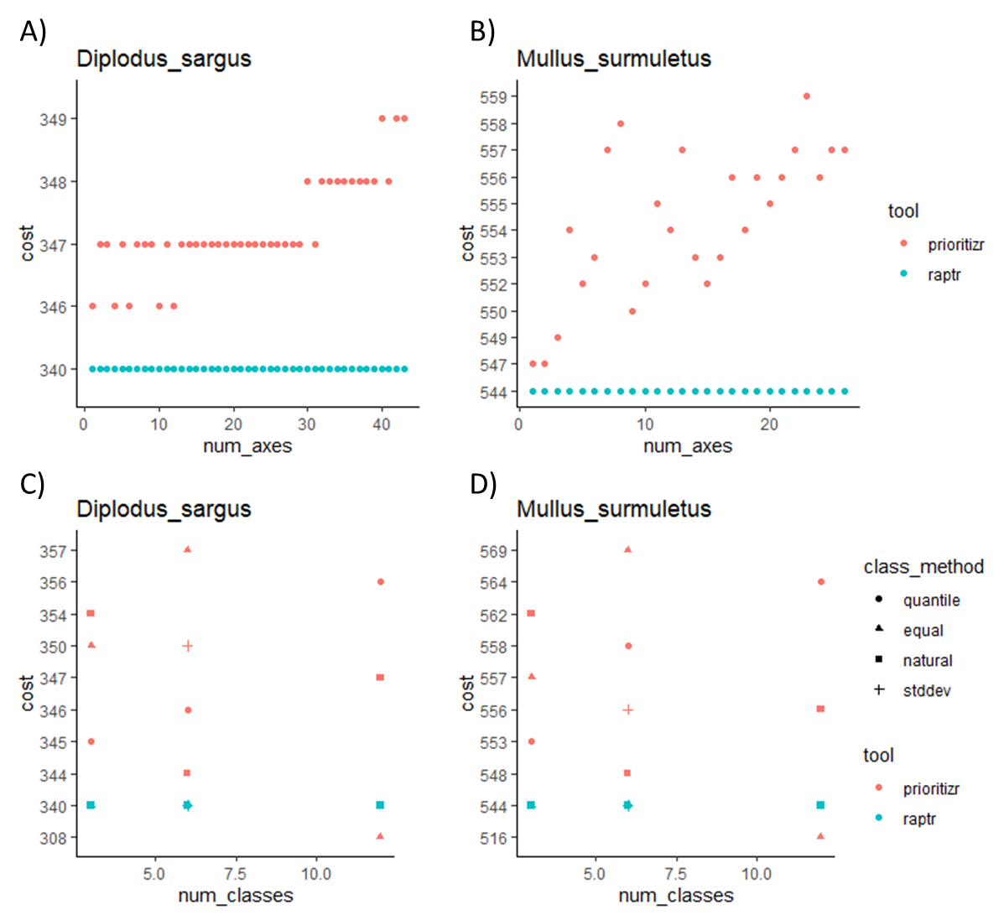

**Figure 2.** Total conservation cost for different prioritization settings. Panels A and B show total conservation cost as a function of the number of PCA axes included in the prioritization. Panels C and D show total conservation cost for different subdivision methods and number of classes. Results in panels (A) and (B) where obtained using a quantile subdivision method with six discrete classes. Results in panels (C) and (D) were obtained using a number of PCA axes representing 80% of genetic diversity (i.e. 17 PCA axes for D. sargus and 26 PCA axes for M. surmuletus).

### Selection of PUs

In prioritizr, solutions found using different number of PCA axes are very different. The median Jaccard distance between solutions is 0.94 (interquartile range: 0.80 to 0.95) for *D. sargus*, and 0.92 (interquartile range: 0.89 to 0.95) for *M. surmuletus*. In raptr, solutions found using different number of PCA axes are increasingly different as the number of PCA axes included changes. Differences between solutions appear larger in prioritzr than in raptr.

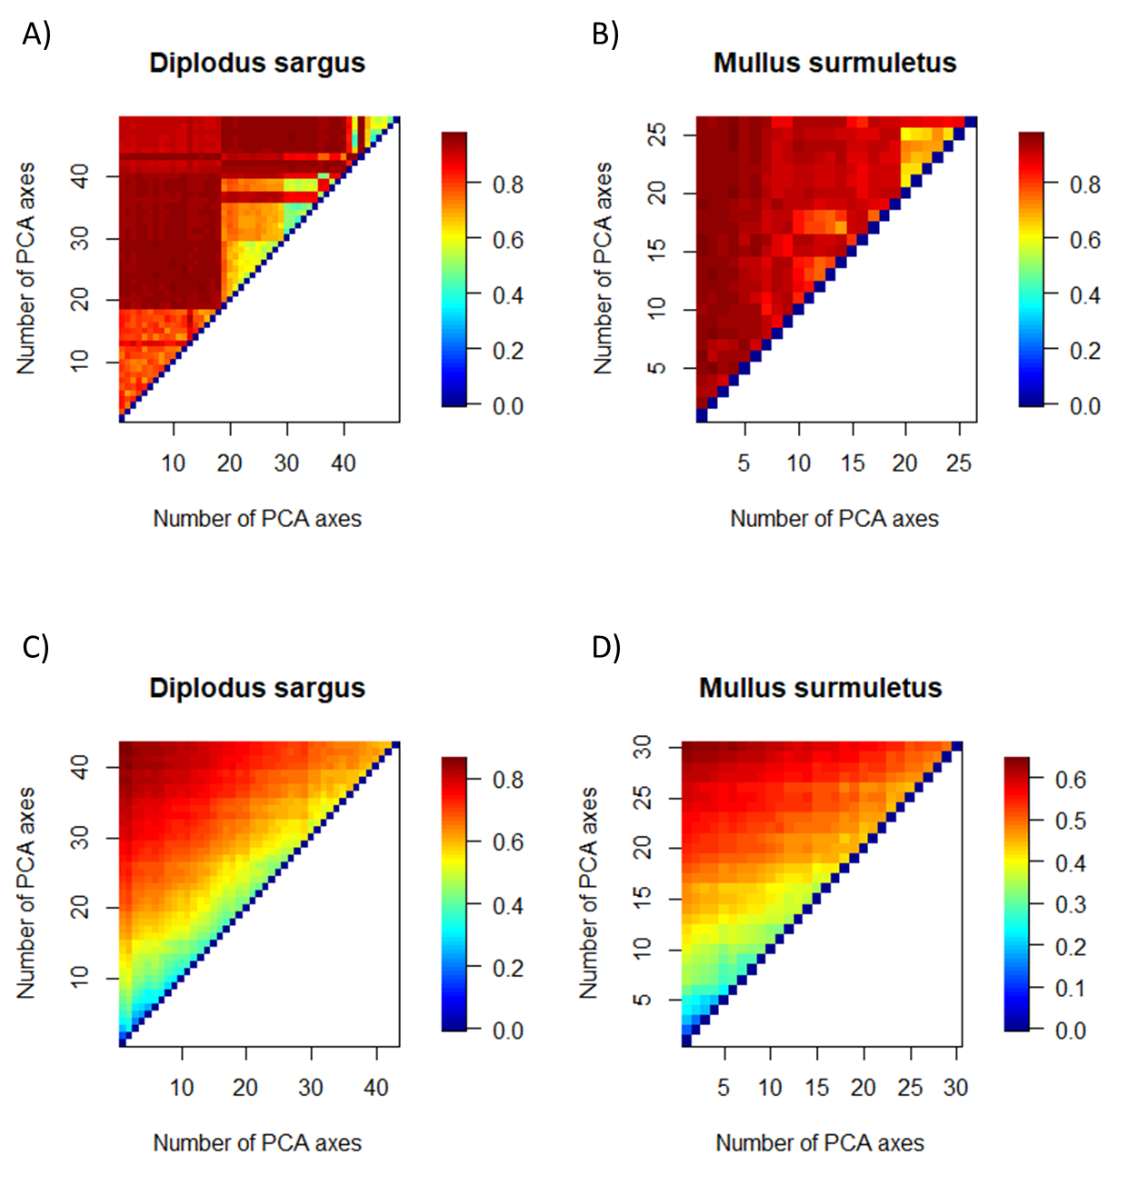

**Figure 3.1.** Distance matrices between solutions using different number of PCA axes, for prioritizr (A and B) and raptr (C and D).

In prioritizr, solutions found using different subdivision methods and different number of discrete classes are very different. In raptr, the differences increase with the number of demand points, but do not change with subdivision method.

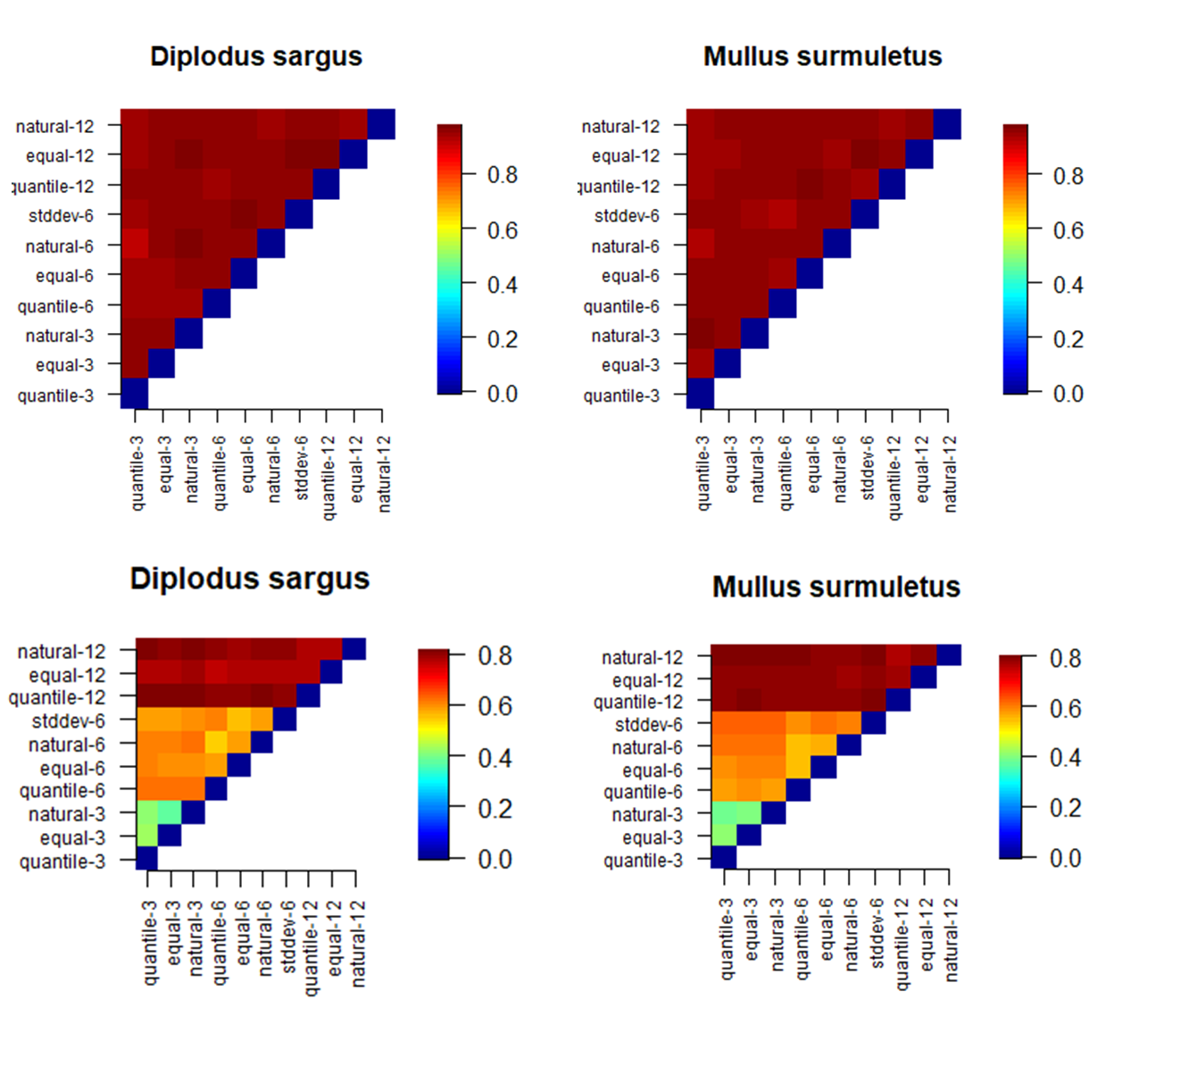

**Figure 3.2.** Distance matrices between solutions using different subdivision methods and different number of number of discrete classes for prioritizr (A and B) and different number of demand points for raptr (C and D).

How much different are multiple solutions for the same dataset? replicates within scenarios.

## Combining PCA axes to define conservation features

We then used a k-means clustering algorithm to split species distribution into discrete classes using the scores on multiple, rather than single, PCA axes. Contrarily to using single PCA axes as conservation features, in prioritizr the number of axes used to split the species distribution did not affect total conservation costs (Figure 4), while increasing the number of discrete classes led to slightly higher conservation costs (not shown).

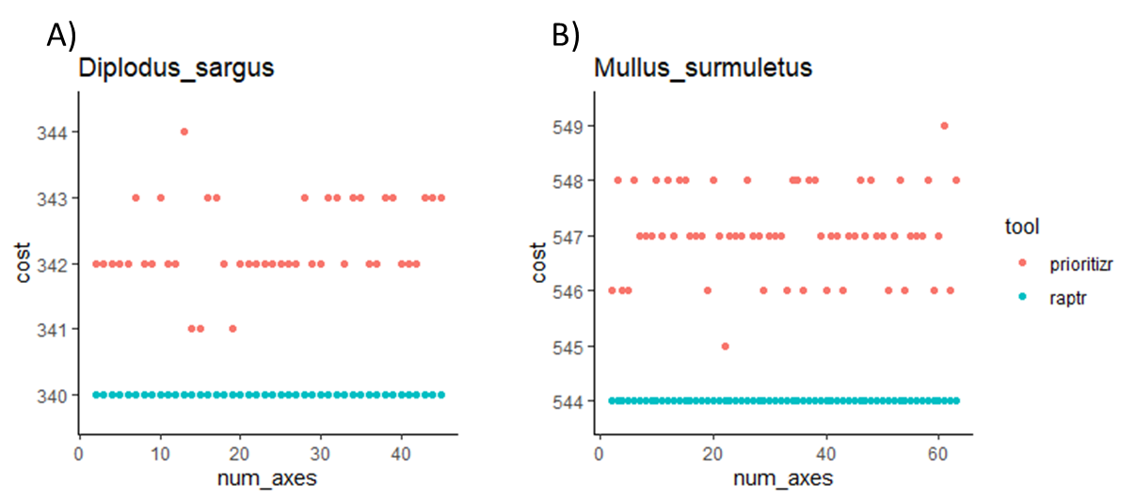

**Figure 4.** Total conservation cost for different prioritization settings when PCA axes are combined to define conservation features. Panels A and B show total conservation cost as a function of the number of PCA axes included in the prioritization when the number of classes is 6.

In raptr, conservation costs were not affected by the number of PCA axes (Figure 4), nor by the number of demand points used, because satisfying amount targets required more PUs than satisfying genetic targets with so few demand points. However, using few demand points lowered the maximum achievable target. (Figure 5).

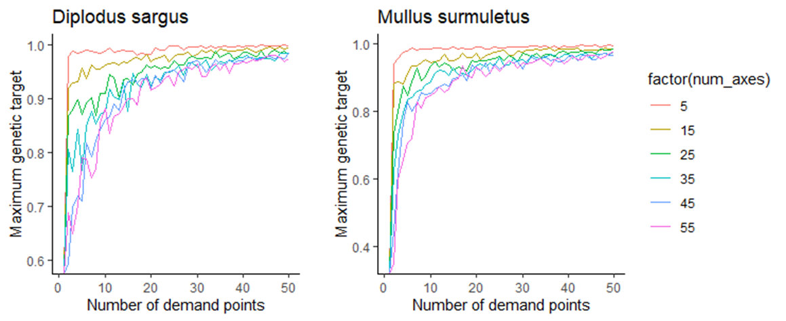

**Figure 5.** Maximum genetic targets as a function of number of demand points, for different number of PCA axes combined to define conservation features in raptr.

# Discussion

We explored the behaviour of the SCP tools applied to continuous genetic metrics (PCA axis scores) under different parameter settings. Our analyses revealed xxx significant results. When single PCA axes are used as conservation features:

First, total conservation costs are susceptible to increase as the number of PCA axes increased, but only in prioritizr

Second, the method used to split the continuous values into discrete classes and the number of classes used did not lead to systematic changes in total conservation costs.

Third, splitting PCA axis scores into discrete classes could lead to several problems when applied blindly. These problems can be corrected quite easily if they are recognized.

Fourth, solutions are very different: because of inherent variability/low irreplaceability?

When combining PCA axes to define conservation features:

First, conservation costs do not increase with the number of PCA axes

Second, in raptr, using few classes led to lower maximum achievable targets. So a rule of thumb to determine the sufficient number of demand points could be to look at whether the maximum achievable target is high enough.