* Abstract
* Introduction
* Methods
* Results and discussion

# Abstract

*Lorem ipsum dolor sit amet, est ad doctus eligendi scriptorem. Mel erat falli ut. Feugiat legendos adipisci vix at, usu at laoreet argumentum suscipiantur. An eos adhuc aliquip scriptorem, te adhuc dolor liberavisse sea. Ponderum vivendum te nec, id agam brute disputando mei.*

# Introduction

Lorem ipsum dolor sit amet, est ad doctus eligendi scriptorem. Mel erat falli ut. Feugiat legendos adipisci vix at, usu at laoreet argumentum suscipiantur. An eos adhuc aliquip scriptorem, te adhuc dolor liberavisse sea. Ponderum vivendum te nec, id agam brute disputando mei.

# Methods

Lorem ipsum dolor sit amet, est ad doctus eligendi scriptorem. Mel erat falli ut. Feugiat legendos adipisci vix at, usu at laoreet argumentum suscipiantur. An eos adhuc aliquip scriptorem, te adhuc dolor liberavisse sea. Ponderum vivendum te nec, id agam brute disputando mei.

math should be included and should work as *μi* = *β*0 + *β*1*x*, and this equation show:

$$ \\frac{1}{\\sqrt{2\\pi}\\sigma}e^{-(x-\\mu\_i)^2/(2\\sigma^2)} $$

Tables show also work without problems:

Estimate

Std. Error

t value

Pr(>|t|)

(Intercept)

-0.02

0.10

-0.17

0.87

x

2.01

0.09

21.51

0.00

As should any graphics:

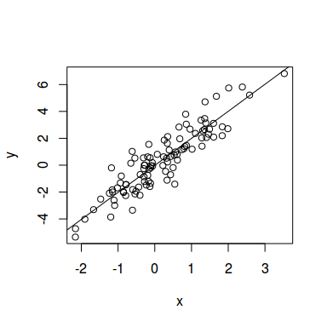

Relationship between x and y. The solid line is least-squares linear regression.

# Results and discussion

When we cite anyone it should work too like R for instance (R Core Team 2014), and we used package knitcitations` (Boettiger 2014).

# References

Boettiger, Carl. 2014. *Knitcitations: Citations for Knitr Markdown Files*. <http://CRAN.R-project.org/package=knitcitations>.

R Core Team. 2014. *R: A Language and Environment for Statistical Computing*. Vienna, Austria: R Foundation for Statistical Computing. <http://www.R-project.org/>.