How to Use this Software
The software is divided into 2 areas. The upper portion "Search Files" helps you select the files to rename. The lower portion "Random Rename Options" determines the way in which your files are renamed. To familiarize yourself with the function, it is recommended that a "test order" with to create "test files". Thus, they reduce the risk of errors.

6.1 Select files to rename
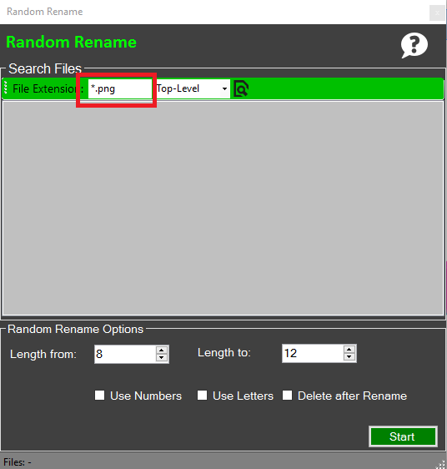
In the upper part of the software allows you to search your computer for files. There are in the green bar Toolbox 2 settings. You can search for files after a certain file extension. For example, according to PNG files.
Figure 1: File Extension filter
To use a file extension filter, type in the File Extension text box the file extensions (See Figure 1).

Do you want to consider all file extensions, simply use the preconfigured Setting (*. *). In the drop down box you can set whether only the folder you want to consider selecting want to search (top-level) or all subdirectories (recursive).
By default, only the files are included in the specified folder.
In order to select files, then click the Browse icon . Thereupon a dialog open, you must select a folder. All files in this folder will now be added to the list.
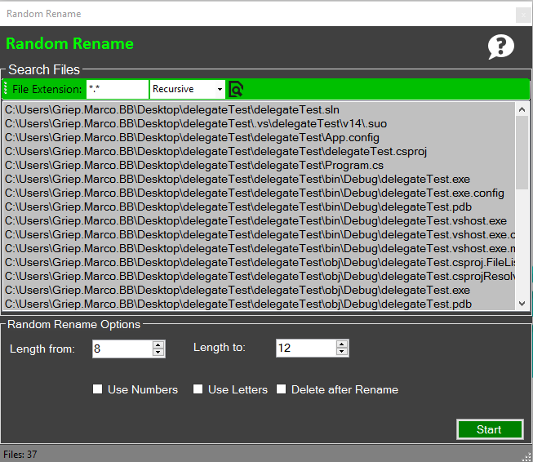
Figure 2: Selected files

6.2 Make renaming settings
Once the files are selected, you can determine the scheme for your files to be renamed. The two number fields "Length from" and "Length to" determine the number of characters of the filename. By default, the random file name is therefore 8-12 characters long. If you want, for example, have a file name of the still 5 is Stellig, set both values. 5
The 3 checkboxes at the bottom of the settings define whether characters and / or letters may occur in random names. For example, to the have the filename only display numeric values. Select only "Use Numbers".
You can mix numbers and letters also with each other.
The checkbox "Delete after Rename" determines whether the Original files should be retained or deleted before renaming. By default, no and help prevent accidental data loss deletes this application the original files. This has that after renaming you have to follow each file 2 times in the folder. Put the check mark for "after Delete Rename" the original files will be deleted and you have only the renamed files.

6.3 Start processing
The renaming of files, you can just start clicking the green button "Start" in the. Depending on the number of files can take quite a while, especially if they also rename files in the subfolders of this process. Just wait for the final report.

