Data Mining & Machine Learning
M.Sc. in Artificial Intelligence and Data Engineering
University of Pisa
Project Report
Academic Year 2025–2026
Project Title: ASL Alphabet Recognition from MediaPipe Hand Landmarks
Authors
Elia Valeriano — Student ID: 585114
Marco Guglielmi — Student ID: 720166
Submission date: 14/06/2026

Abstract
This project addresses ASL alphabet recognition from static hand images using MediaPipe hand landmarks and engineered geometric features instead of raw pixels. Five traditional classifiers were compared with 5 x 4 group-aware nested cross-validation using macro F1. HistGradientBoosting achieved the best performance, with 97.49% mean outer accuracy and 97.31% mean macro F1. The results show that a landmark-based representation can support accurate, interpretable real-time inference, with remaining limitations related to MediaPipe detection quality, static signs, and visually similar letters.

1. Introduction
Automatic sign language recognition can support more accessible interaction between sign-language users and systems that do not understand signed communication. This project focuses on static ASL alphabet recognition, a constrained but useful setting for studying hand-pose classification.

The project uses a two-stage approach: MediaPipe Hands [2], [3] extracts a 21-landmark skeleton from each image, then normalized landmarks are expanded with fingertip distances, joint angles, and wrist-to-fingertip vectors. This converts the image task into an interpretable tabular learning problem.

The project uses the ASL Alphabet Dataset from Kaggle [1]. The available local setup contains the 26 alphabet folders A-Z, so the experiments are framed as 26-class static alphabet classification.

This project aims to:
- Build a complete pipeline that extracts normalized hand landmarks from ASL alphabet images and converts them into a structured tabular dataset.
- Apply data quality checks and geometric consistency filters to remove failed detections and implausible hand skeletons.
- Engineer compact and interpretable geometric features that describe the hand pose.
- Compare multiple traditional machine learning classifiers under a leakage-aware nested cross-validation protocol.
- Train a final model for real-time inference through a webcam demo application.
References
- [1] Debashish Sau. ASL(American Sign Language) Alphabet Dataset. Kaggle. https://www.kaggle.com/datasets/debashishsau/aslamerican-sign-language-aplhabet-dataset
- [2] Lugaresi, C., Tang, J., Nash, H., et al. (2019). MediaPipe: A Framework for Building Perception Pipelines. arXiv:1906.08172. https://arxiv.org/abs/1906.08172
- [3] Zhang, F., Bazarevsky, V., Vakunov, A., et al. (2020). MediaPipe Hands: On-device Real-time Hand Tracking. arXiv:2006.10214. https://arxiv.org/abs/2006.10214

2. Problem
The problem is a supervised multi-class classification task. Each input sample corresponds to one image of a hand sign. The target variable is the ASL alphabet label, with 26 possible values from A to Z. The final model receives a tabular representation of the hand pose rather than the raw image.

Each valid image is converted into normalized MediaPipe hand landmarks and geometric descriptors. Wrist-centered normalization reduces the effect of hand position and image scale, while distance, angle, and vector features preserve the pose information required for classification. Metadata columns are retained for traceability but removed before training.

Table 1. Problem and dataset at a glance.
Attribute | Summary
Task type | Supervised multi-class classification
Dataset | ASL(American Sign Language) Alphabet Dataset, Kaggle — 203,575 samples
Target variable | ‘label’, one of the 26 alphabet letters
Features | 95 numerical features after dropping metadata — see Section 2.1
Missing values | 0
Class distribution | Mostly 5k-7.7k samples per class, with smaller classes such as T (2,308) and N (4,177) approximately balanced
Evaluation metric(s) | Accuracy, macro precision, macro recall and macro F1-score
Train / Val / Test | 5 outer folds and 4 inner folds nested cross-validation — group stratified

2.1 Exploratory Data Analysis
The local dataset contains 203,575 images from the A-Z folders. MediaPipe extracted exactly one hand in 155,012 images, while 48,563 images were discarded due to failed detection. After structural consistency checks removed 88 additional implausible samples, the final dataset contained 154,924 valid instances; class imbalance was addressed through stratified folds and macro F1 rather than resampling.
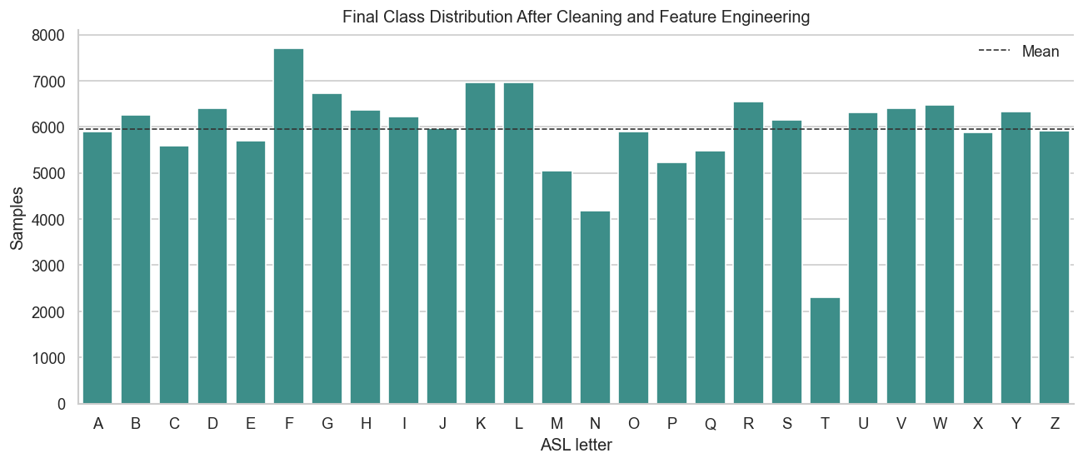
Figure 1. Final Class Distribution after Cleaning and Feature Engineering
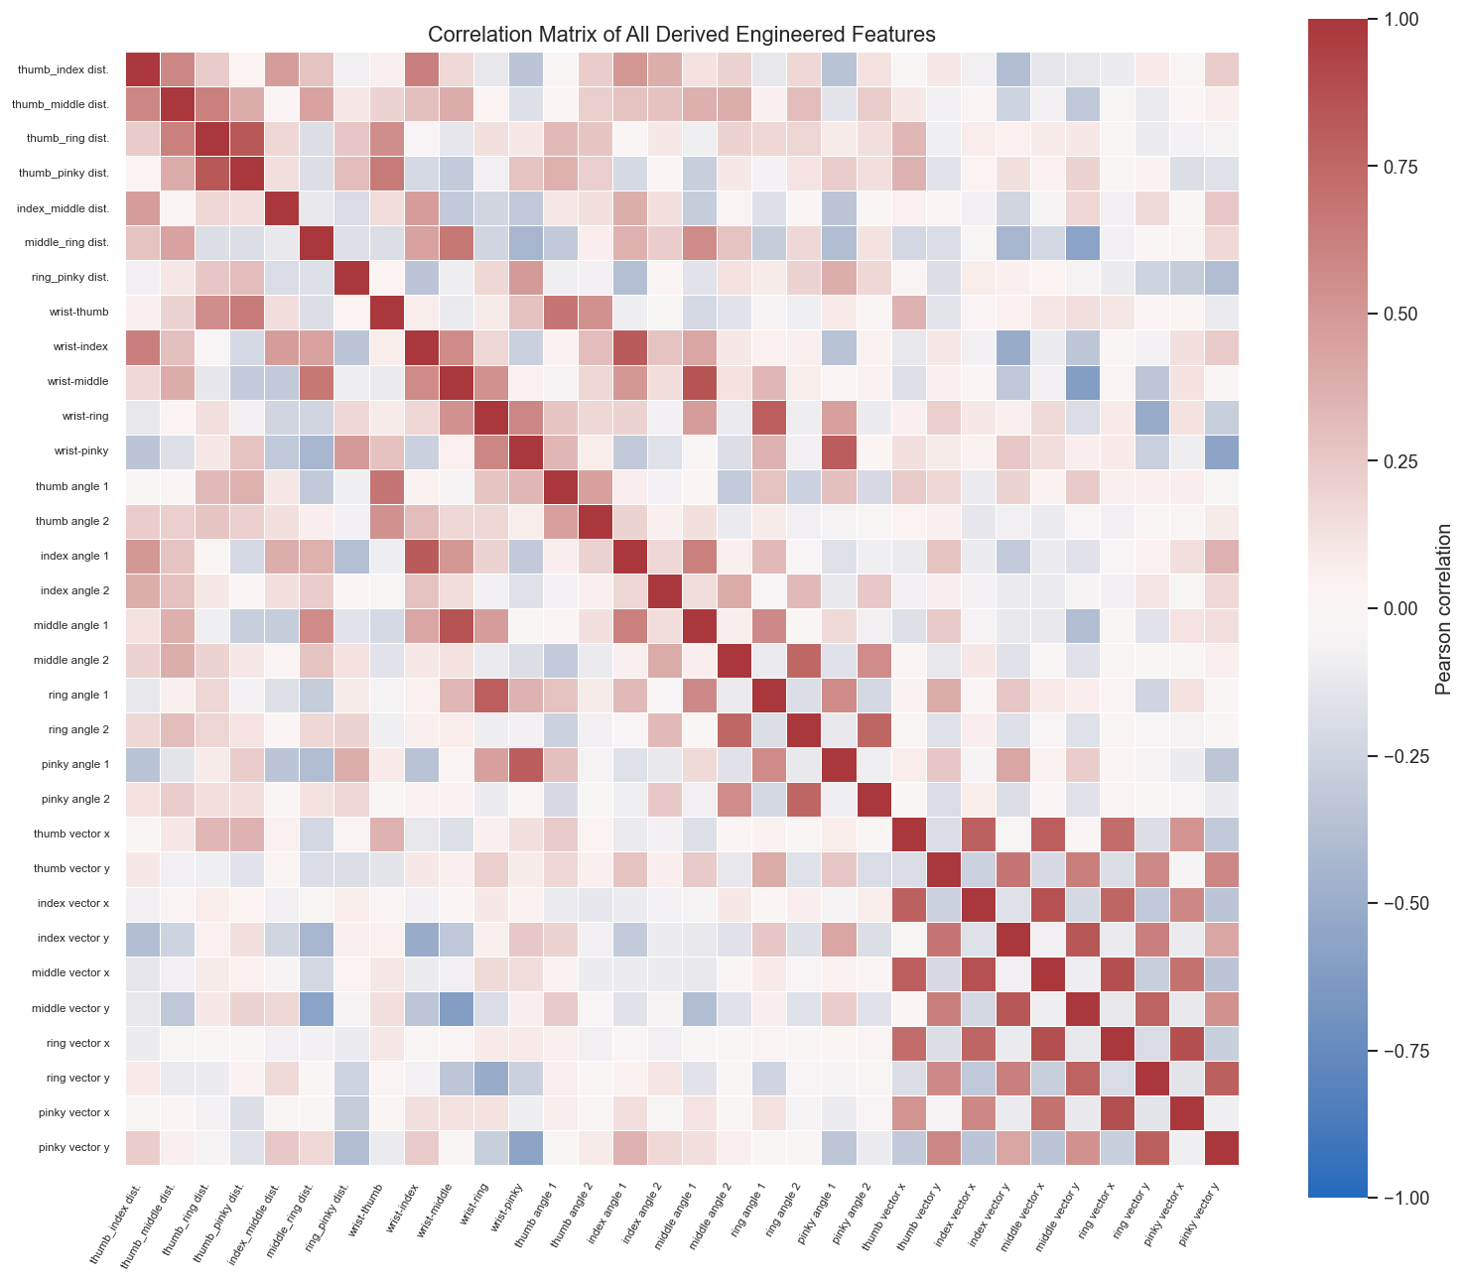
Figure 2. Correlation matrix of engineered features.

2.2 Feature Description

The feature set combines normalized landmark coordinates with geometric descriptors: fingertip and wrist distances, joint angles, and wrist-to-fingertip vectors. These features describe hand shape, finger flexion, and finger direction while keeping the representation interpretable and suitable for tabular machine learning models.
The feature engineering step uses 2D geometry for the derived distance, angle, and vector features (`USE_Z = False`), while the raw normalized z coordinates are still retained as part of the original landmark feature set. This design keeps the engineered representation simple and robust, while preserving the depth information estimated by MediaPipe.

3. Pipeline and Experiments

Overview
The machine learning pipeline consisted of five stages: landmark extraction, data cleaning, feature engineering, nested cross-validation for model and hyperparameter selection, and final model training.
To avoid data leakage, model selection was performed with nested cross-validation and all fitted preprocessing steps were placed inside Scikit-Learn pipelines.

3.1 Preprocessing
Images were converted into geometric hand representations using MediaPipe Hand Landmarker. A labeling inconsistency in the letter T was corrected before feature extraction by removing the non-standard variant and replacing it with canonical T samples.
For each image, MediaPipe produced 21 hand landmarks. Failed detections were retried using horizontal flipping and CLAHE enhancement, and coordinates were normalized relative to the wrist and wrist-to-middle-MCP distance so that the model learned hand shape rather than image scale or position.
After extraction, a three-stage cleaning procedure removed invalid landmark rows, collapsed detections, and anatomically implausible hand structures. No missing values remained after cleaning, so invalid detections were removed rather than imputed because they generally correspond to failed hand detection rather than random missingness.

3.2 Feature Selection and Engineering
No explicit feature selection procedure was performed. The final representation retained the normalized landmarks and added distance, angle, and wrist-to-fingertip vector descriptors, as summarized in Figure 3. Given the moderate dimensionality, preserving all features allowed the selected tree-based model to exploit useful interactions without relying on manual pruning. The later permutation-importance analysis was therefore used for interpretation rather than as a feature-removal step.
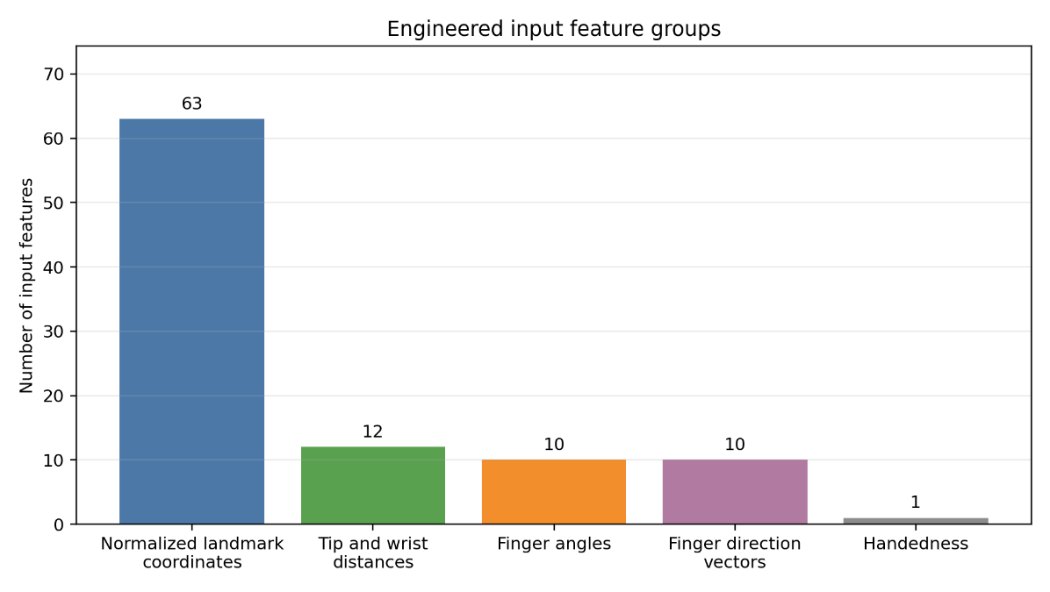
Figure 3. Engineered input feature groups used by the classifiers.

3.3 Model Selection and Cross-Validation
Candidate models were KNN, Decision Tree, Random Forest, HistGradientBoosting, and Approximate RBF SVM, covering distance-based, tree-based, ensemble, boosting, and kernel-approximation approaches.
Model comparison used 5 x 4 nested cross-validation with stratified group folds. The outer loop estimated generalization, while the inner loop optimized hyperparameters. Groups were built from feature hashes to reduce leakage from identical or near-identical samples, and all fitted preprocessing steps were executed inside Scikit-Learn pipelines. HistGradientBoosting obtained the highest average outer-fold Macro F1 score (97.31%).
Table 2. Comparison of candidate models.
Model | Hyperparameter tuning | CV Strategy | Val. Metric | Test Metric
KNN | Grid Search | 5 outer folds, 4 inner folds nested CV | Inner macro F1: 96.53% | Outer macro F1: 96.81%
Decision Tree | Grid Search | 5 outer folds, 4 inner folds nested CV | Inner macro F1: 92.95% | Outer macro F1: 93.28%
Random Forest | Grid Search | 5 outer folds, 4 inner folds nested CV | Inner macro F1: 96.60% | Outer macro F1: 96.83%
HistGradientBoosting | Grid Search | 5 outer folds, 4 inner folds nested CV | Inner macro F1: 97.04% | Outer macro F1: 97.31%
Approx RBF SVM | Grid Search | 5 outer folds, 4 inner folds nested CV | Inner macro F1: 95.83% | Outer macro F1: 96.02%

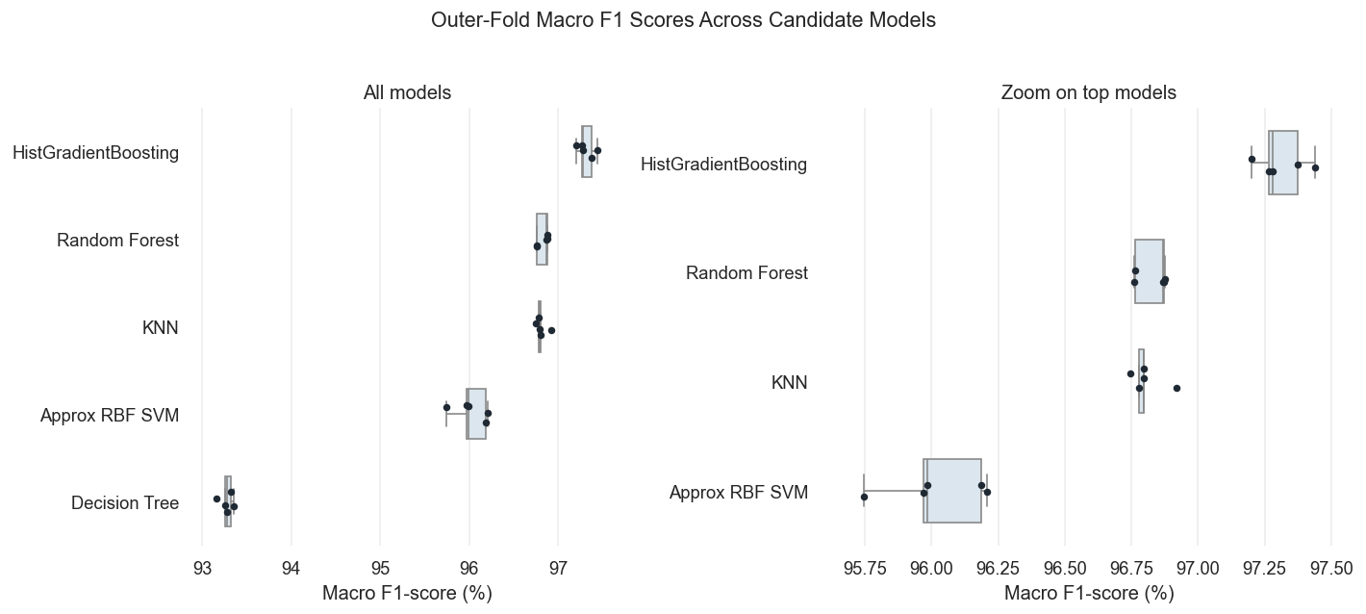
Figure 4. Outer-fold macro F1 distribution across candidate models.

3.4 Hyperparameter Optimization
Hyperparameter optimization used exhaustive Grid Search inside the inner cross-validation loop, with Macro F1 as the selection metric.
The grids covered neighborhood and distance choices for KNN, split constraints for tree models, ensemble size for Random Forests, learning-rate and regularization parameters for HistGradientBoosting, and kernel approximation plus regularization for Approximate RBF SVM.
The best-performing configuration corresponded to HistGradientBoosting with learning_rate=0.05, max_iter=800, max_leaf_nodes=31, min_samples_leaf=40, l2_regularization=0.0, and early_stopping=False, achieving an average inner-fold Macro F1 score of 97.04%.
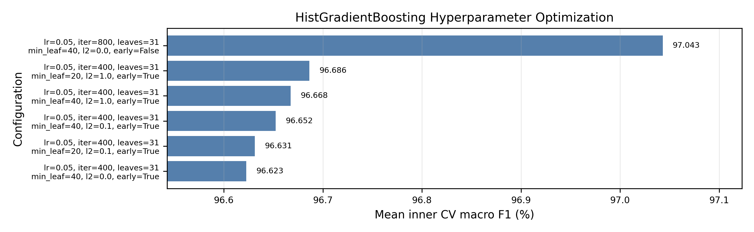
Figure 5. HistGradientBoosting hyperparameter optimization across inner cross-validation configurations.

3.5 Statistical Tests
Non-parametric tests were applied to the outer-fold Macro F1 scores to assess whether model differences were statistically meaningful. With only five outer folds, Wilcoxon results were interpreted cautiously because the minimum achievable p-value is 0.03125; each HistGradientBoosting pairwise comparison had Wilcoxon statistic = 15.0 and p = 0.03125. The Friedman test also indicated an overall difference among classifiers (statistic = 19.36, p = 0.000668). Nemenyi post-hoc ranks placed HistGradientBoosting first (1.0), followed by Random Forest (2.2), KNN (2.8), Approx RBF SVM (4.0), and Decision Tree (5.0), with significant differences against Approx RBF SVM (p = 0.0227) and Decision Tree (p = 0.0006). Overall, the tests support the model-selection result while still acknowledging the limited resolution imposed by the small number of outer folds.
Comparison | Wilcoxon statistic | p-value | Significant (α = 0.05)
HistGradientBoosting vs Approx RBF SVM | 15.0 | 0.03125 | Yes
HistGradientBoosting vs Decision Tree | 15.0 | 0.03125 | Yes
HistGradientBoosting vs KNN | 15.0 | 0.03125 | Yes
HistGradientBoosting vs Random Forest | 15.0 | 0.03125 | Yes

3.6 Final Model Training
After model selection, the final HistGradientBoosting pipeline was instantiated with the most frequently selected hyperparameter configuration and fitted on the full cleaned engineered dataset. The trained pipeline was serialized for deployment, while the outer-fold Macro F1 score of 97.31% remained the unbiased estimate of expected generalization performance.

4. Results and Discussion

4.1 Performance Evaluation
Performance was evaluated using the outer test folds of the nested cross-validation protocol. HistGradientBoosting achieved 97.49% mean accuracy and 97.31% mean macro F1, outperforming the other candidate models.
The normalized confusion matrix in Figure 6 shows a strong diagonal structure, confirming high precision and recall across most classes. The remaining visible errors concentrate around a small number of similar letter pairs, especially M/N and, to a lesser extent, G/H and W-related confusions. This pattern is preferable to diffuse errors across unrelated signs, because it indicates that the classifier fails mainly near plausible geometric boundaries.
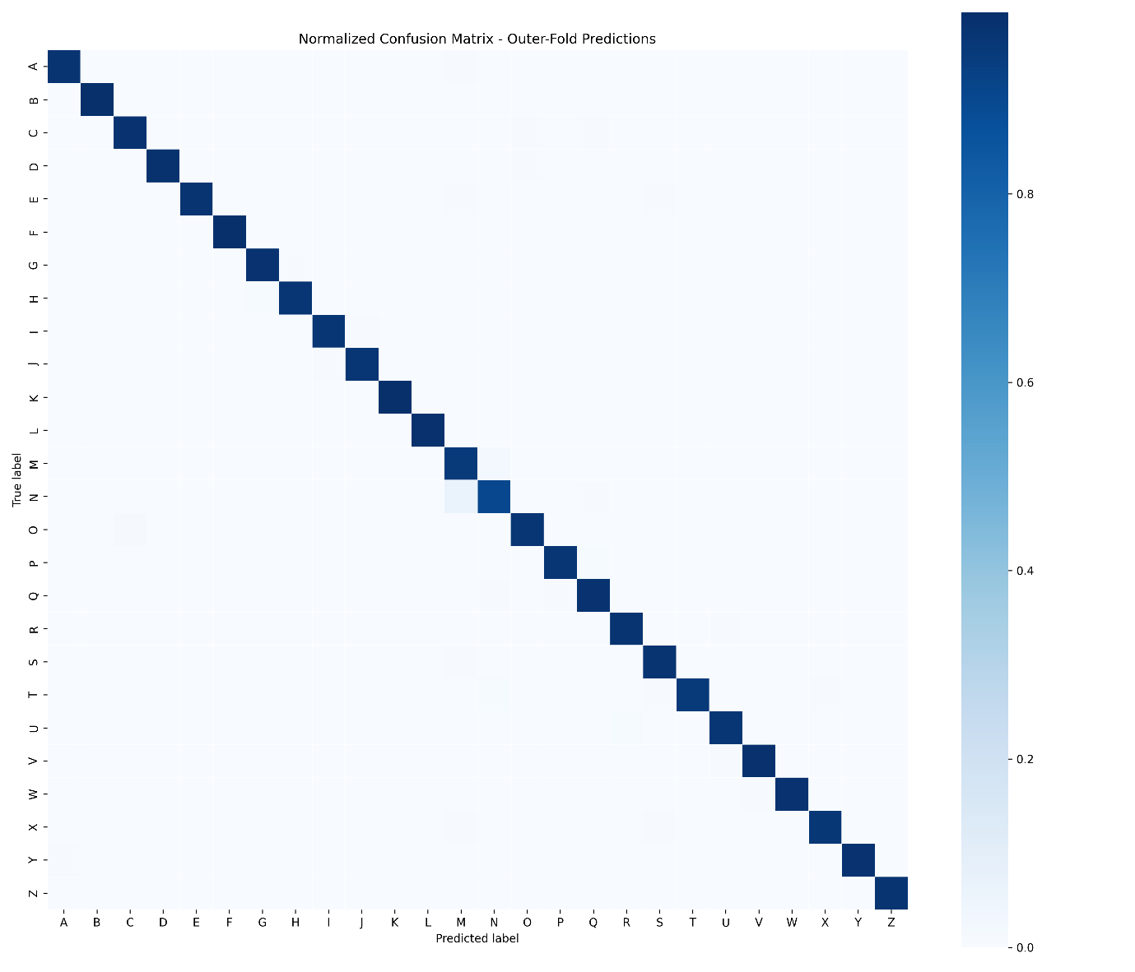
Figure 6. Normalized confusion matrix for HistGradientBoosting outer-fold predictions.
In this application, silent substitutions are more problematic than simple recognition failures because they may corrupt the intended message without being noticed.
Figure 7 isolates the most frequent misclassification pairs. The dominant error is N -> M, followed by M -> N; both signs differ by subtle finger-folding details, explaining why these mistakes are more common than errors between geometrically distinct letters.
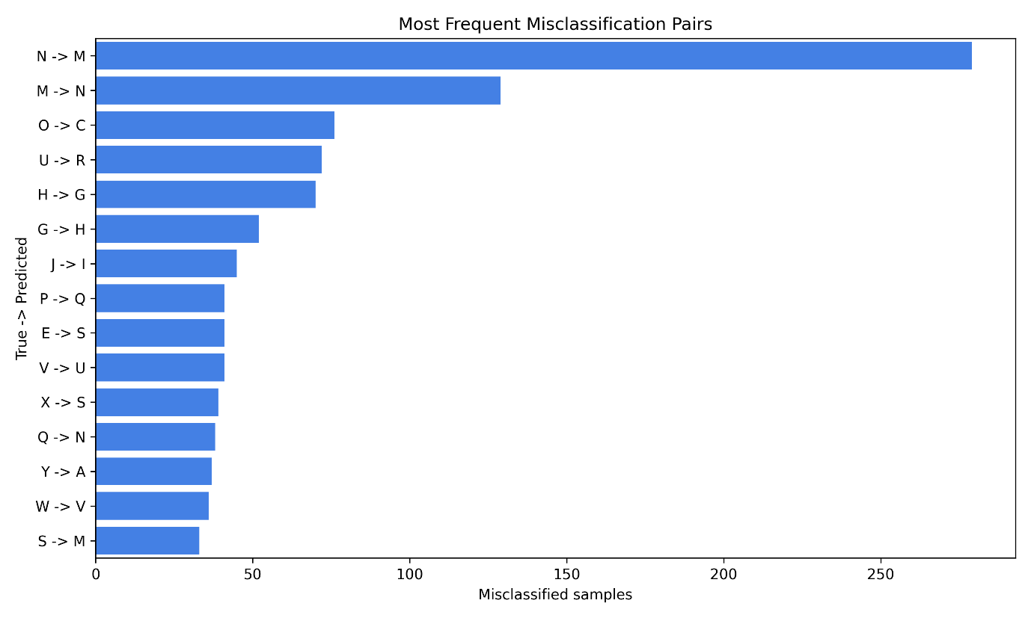
Figure 7. Most frequent misclassification pairs for HistGradientBoosting outer-fold predictions.

4.2 Model Explainability
Permutation importance was computed by shuffling each feature and measuring the macro F1 decrease (Figure 8). The result is highly asymmetric: index_middle_tip_distance dominates the ranking, causing an approximately 0.071 macro F1 decrease when permuted, while the remaining features have much smaller global effects.
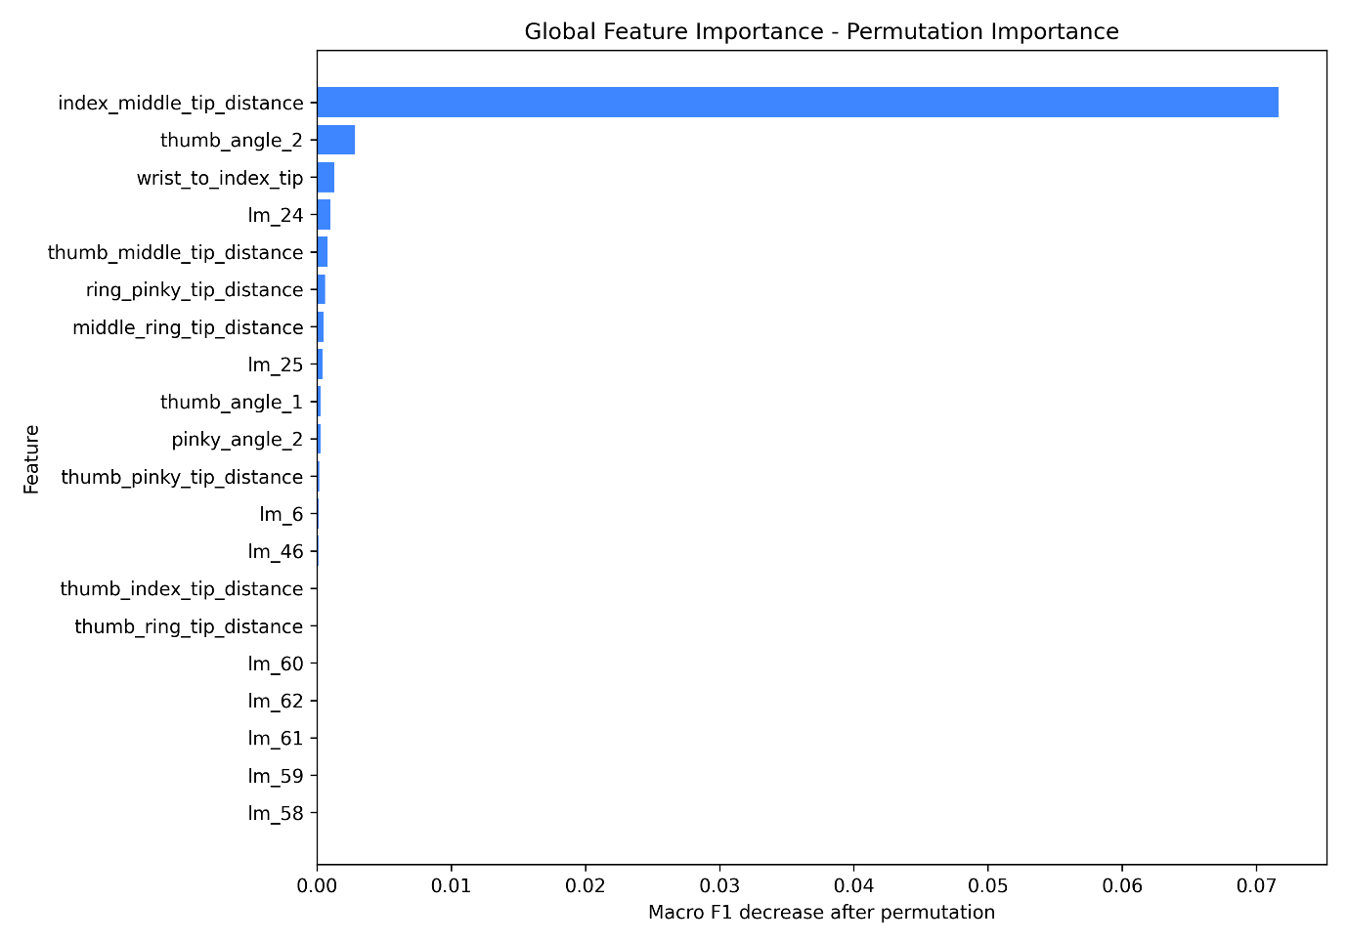
Figure 8. Global permutation importance measured as macro F1 decrease after feature permutation.
Figure 9 shows a local SHAP explanation for a high-confidence U -> W misclassification. The relevant point is that the incorrect prediction is mainly driven by ring- and pinky-related features, which is anatomically coherent because U and W differ in the involvement of the ring finger.
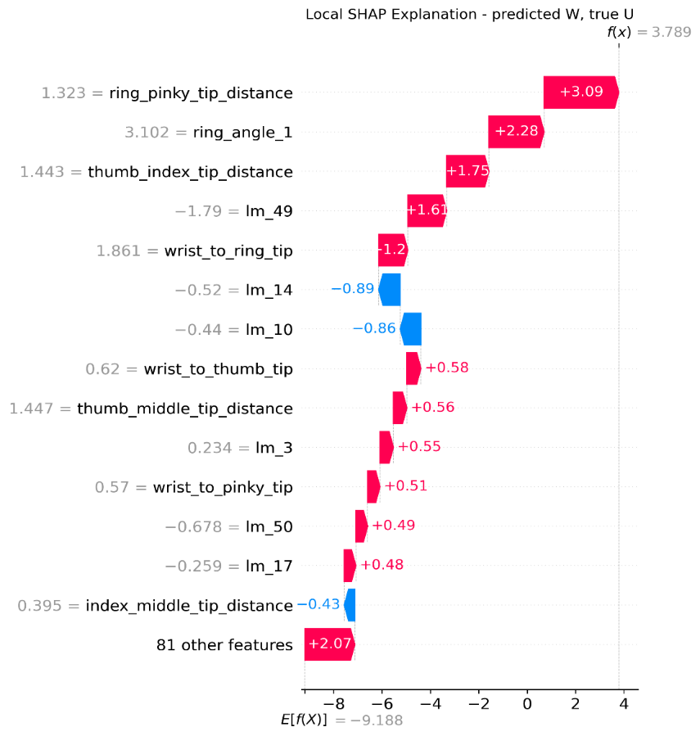
Figure 9. Local SHAP waterfall explanation for a high-confidence U -> W misclassification.

4.3 Error Analysis
The error patterns in Figure 7, together with the explanations in Section 4.2, indicate that most residual mistakes are caused by genuine geometric ambiguity rather than random model failures.
The dominant N/M confusion reflects the ring finger as the main discriminator between two otherwise similar gestures. Other frequent confusions, such as O/C and G/H, are linked to hand aperture and viewpoint-dependent geometry, which are difficult to resolve from a single 2D projection.
This interpretation is consistent with the local SHAP example: the U -> W mistake is driven by ring- and pinky-related evidence, exactly the hand region that distinguishes the two signs. The remaining errors are therefore not arbitrary model failures, but cases where small variations in finger extension, hand rotation, or depth projection can make two valid ASL configurations look similar in a single frame.

5. Conclusions
This project met its main objectives: it produced a complete landmark extraction and cleaning pipeline, engineered interpretable geometric features, compared five candidate classifiers under leakage-aware nested cross-validation, selected HistGradientBoosting with statistical support, and deployed the final model in a webcam inference demo. The final model achieved 97.49% mean outer accuracy and 97.31% mean macro F1.

The main limitations are MediaPipe detection failures, the restriction to static signs, and residual errors on geometrically similar pairs such as M/N and O/C. These limitations are important because the system depends on reliable landmark extraction and cannot model temporal information for dynamic signs such as J and Z.
Future work could add targeted descriptors for hard pairs, extend the pipeline to dynamic signs through temporal landmark modelling, and use character-level post-processing to reduce structured substitution errors in context.

