Conclusion

today

# Introduction

The significance of this topic stems from the accelerating evolution of data science, business analytics, and machine learning in today’s digital economy. According to According to @pwc2024barometer, AI-related job skills are evolving 66% faster than those in non-AI sectors, signaling a profound transformation in the job market. , AI-related job skills are evolving 66% faster than those in non-AI sectors, signaling a profound transformation in the job market. As organizations generate unprecedented volumes of data, the ability to interpret, manage, and extract actionable insights from this data has become an indispensable capability. AI technologies are no longer confined to research labs—they are now deeply embedded in daily business operations, creating new opportunities across a wide range of industries. In this context, understanding the emerging skills and trends is not only essential for current job readiness but also for influencing the future of work and business innovation.

## Current Trends Driving the Importance of AI and Data Skills

In 2024, the integration of artificial intelligence and machine learning into core business strategies has intensified the demand for professionals proficient in developing, deploying, and optimizing AI systems. Key competencies now include mastery of machine learning algorithms, data engineering, and the implementation of scalable AI models. For instance, companies like Meta are increasingly investing in professionals who can support large-scale AI initiatives through advanced model development and data pipeline automation [@time2024meta]. Moreover, as automation becomes more pervasive, skills in predictive analytics, process automation, and data-informed decision-making are becoming crucial across sectors. The convergence of big data technologies, AI solutions, and industry-specific expertise marks a pivotal shift in workforce requirements, with these capabilities emerging as critical assets in a rapidly transforming job market.

## Expected Findings and Analytical Focus

Through our analysis, we aim to identify the essential technical and strategic skills shaping the future of data science, business analytics, and machine learning. We anticipate a pronounced focus on machine learning expertise, particularly regarding algorithm design and model deployment. As the demand for data-literate professionals continues to surge, familiarity with big data ecosystems and decision-support platforms will be increasingly vital. Furthermore, we expect industry verticals such as retail, finance, and healthcare to demonstrate a growing reliance on domain-specific analytics to enhance operational efficiency and guide strategic planning. These findings will provide valuable insights into the evolving skill sets necessary for success in a data-driven, AI-augmented business environment.

# Literature

Recent studies show that the demand for AI and machine learning (ML) skills has expanded significantly across industries in the United States. Gulati et al. (2025) found that job postings requiring generative AI capabilities now emphasize 36.7% more cognitive and 5.2% more social skills, highlighting a shift from purely technical hiring to profiles combining AI fluency with reasoning and communication. This evolution aligns with Cobloom (2025), which reports that 69% of data scientist roles now require ML, and Python appears in 78% of job ads—suggesting that AI/ML literacy has become foundational for data-centric roles.

In parallel, Bone et al. (2023) observe a move toward skills-based hiring, where practical competencies now yield a 23% wage premium, compared to a 15% premium for formal degrees. This shift indicates that certifications and project experience may outweigh traditional academic credentials in AI-related careers.

Employment projections reinforce this trend. The U.S. Bureau of Labor Statistics (2024) estimates a 36% growth in data scientist roles through 2033, with nearly 21,000 new openings per year, while operations research roles—common in business analytics—are expected to grow 23%. Similarly, the firm Forwrd.ai (2025) projects that the U.S. data science labor force will grow at a 26.5% annual rate between 2023 and 2025.

Industry-specific analyses by PwC (2025) show that companies leveraging AI report three times higher revenue growth per worker and twice the wage growth in AI-driven roles. Sectors such as finance, healthcare, and consulting are particularly active in hiring AI and analytics professionals, reinforcing the strategic importance of these roles.

In summary, the integration of AI across sectors is reshaping workforce expectations. Today’s job market favors professionals who combine technical skills (e.g., ML, Python) with cognitive flexibility, business insight, and communication ability. To remain competitive, job seekers should pursue practical AI/analytics projects, update skills through certifications, and develop soft skills that align with emerging job designs.

# Geographic distribution of salary and job demand state_map

(Marco’s content)

# Select (LOT_NAME_SPECIFIC) Mean Salary & Job Demand

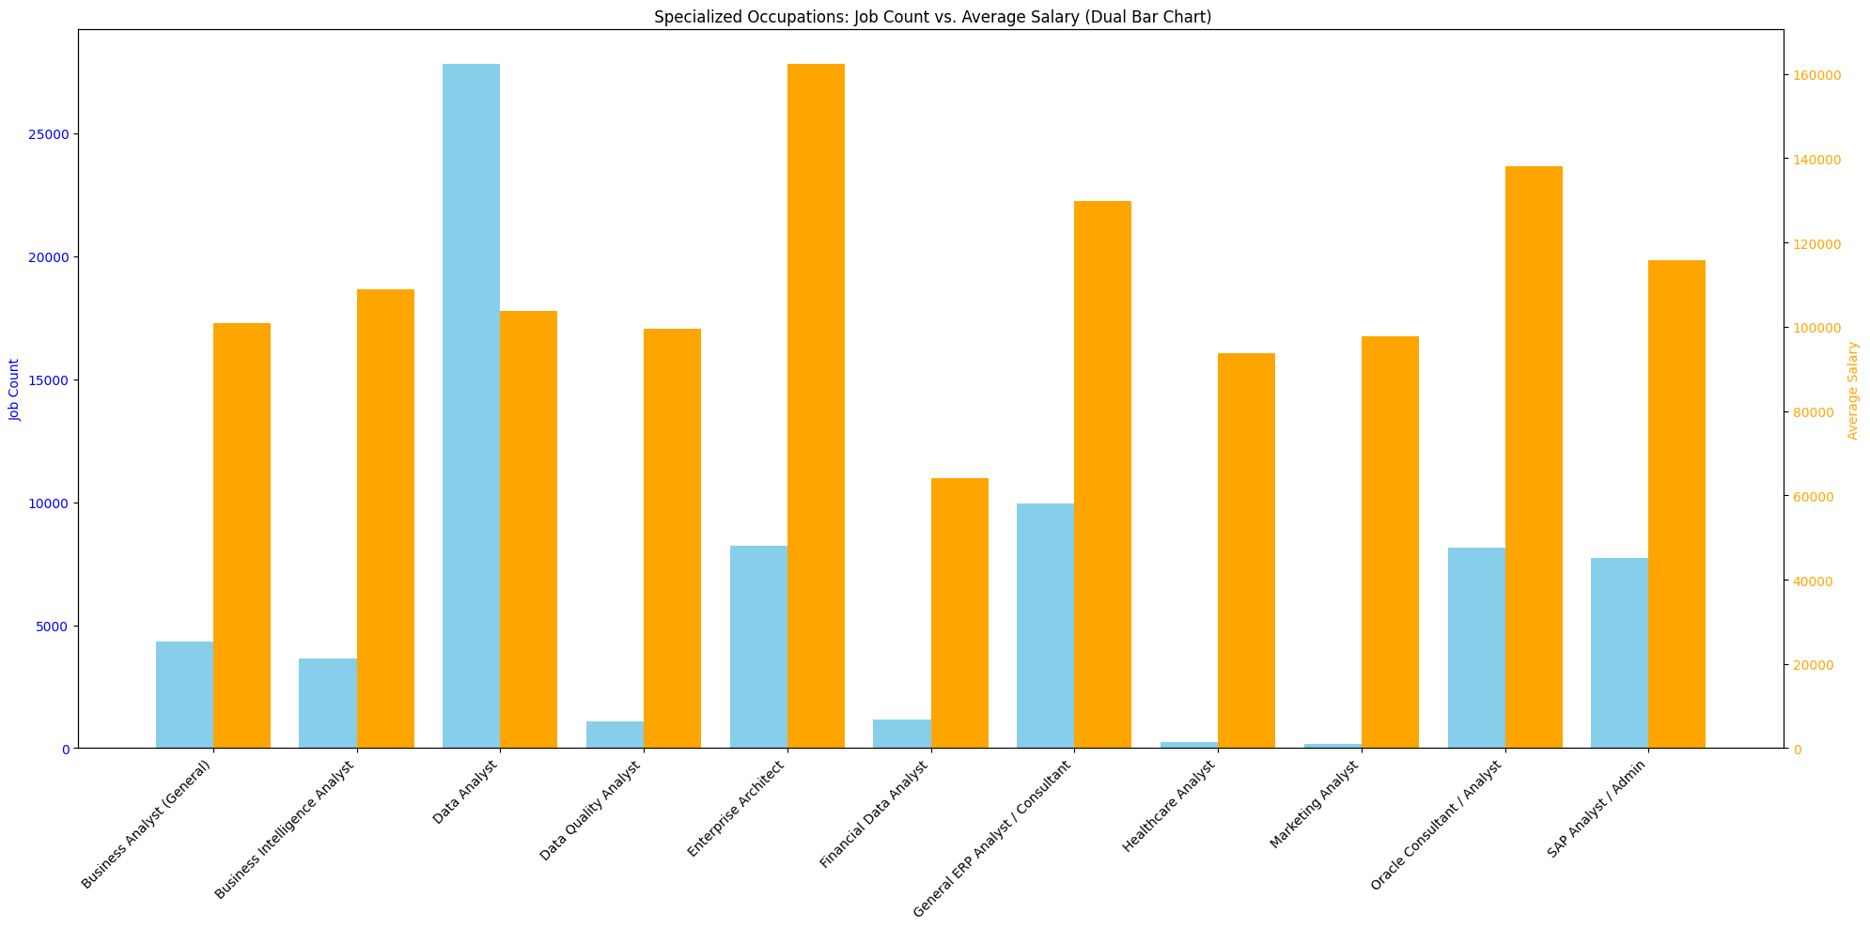

Select (LOT_NAME_SPECIFIC) Mean Salary & Job Demand

This chart shows the number of job openings and average salaries for different professional positions. The dual-axis coordinates allow us to observe the relationship between supply, demand and strategic career path.

Among various analyst roles, Data Analyst positions show **the highest number of job openings, reflecting strong market demand and suggesting a relatively low barrier to entry**. In contrast, Enterprise Architects and Oracle Consultants/Analysts command **the highest average salaries despite limited openings, indicating that these roles require highly specialized and scarce skill sets**. Healthcare Analysts and Marketing Analysts are associated with **both lower salaries and fewer opportunities, suggesting more limited market demand.** Meanwhile, General ERP Analysts/Consultants strike a balance—offering relatively high salaries along with a moderate number of job openings—making them attractive for professionals seeking both compensation and career opportunity.

# Skills radar chart

# Skill Evaluation

## Marco’s Skills Evaluation

(Marco’s content)

### Millie’s Skills Evaluation

This radar chart illustrates Millie’s self-assessed proficiency across a range of analyst-related skills. Overall, she demonstrates strong capabilities in **communication, management, and Microsoft Excel, each rated at 4**, indicating solid workplace readiness and strong collaboration skills.

Millie also shows competence in areas like data management, data visualization, problem solving, and leadership, with scores generally around 3, suggesting she has a solid foundation in analytical thinking and business-related soft skills.

On the technical side, her proficiency in tools such as **SQL, Python, Tableau, Power BI, and statistics ranges between 2 and 3**, reflecting basic familiarity with room for growth. These skills can be strengthened through hands-on project work or further technical training.

In summary, Millie is a promising early-career analyst with strong soft skills and business tool proficiency, and she is actively developing her technical analytics skillset. She would thrive in roles that bridge communication and data, with clear potential to grow into a well-rounded data analyst.

#### Summary

Based on the skill assessment results, Marco and Millie are able to clearly identify their strengths and areas for improvement. This evaluation provides a valuable foundation for them to take targeted actions—whether by enhancing technical skills through training or leveraging existing strengths in communication and management to further optimize their capabilities and better align with their career goals.

# Kmeans clustering for NAICS2_NAME skills (for Analyst position)

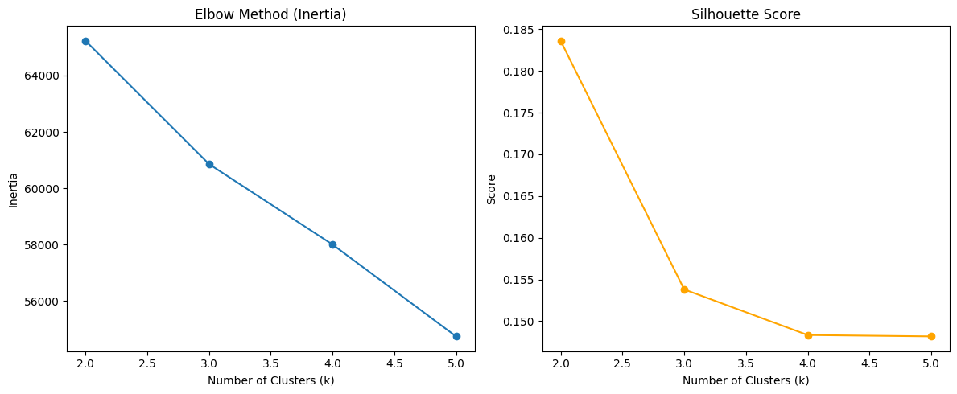

Select Two Way Find Best K

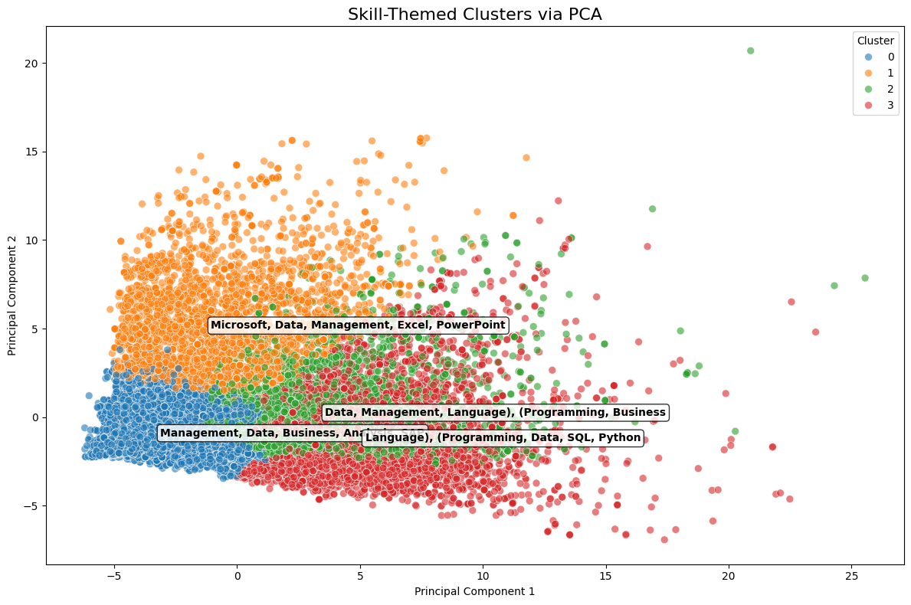

Select (LOT_NAME_SPECIFIC) Mean Salary & Job Demand

This figure reveals how different skill groups correspond to analyst positions. This insight helps align training, hiring, and upskilling strategies with industry-specific needs.

Cluter 0 - Management, Data, Business, Analytics Positions in this group tend to **emphasize management and business logic skills**. Positions may focus on data-driven decision making, project coordination, and report analysis. People with **logical thinking and business sensitivity** have a competitive advantage in this group.

Cluster 1 — Administrative and Office Support Skills (Microsoft, Data, Management, Excel, PowerPoint) This group clearly prefers office **practical skills and tool operation capabilities**. This type of position has lower technical requirements and places more **emphasis on detail processing and internal communication skills**.

Cluster 2 — Hybrid Skill Group (Data, Management, Language, Programming, Business) This is a group with **obvious cross-skills, integrating data analysis, management, language communication and basic programming skills**. Language skills and diverse backgrounds are particularly important in this group, suitable for people with communication skills + elementary programming + business perception.

Cluster 3 — Technology-oriented group This group is obviously **highly technical, covering core skills (such as Programming, Python, and SQL.)** These positions usually require strong programming and logic skills and suitable for computer, statistics, engineering backgrounds or those who have completed technical transformation training.

# Random Forest

(Marco’s content)

---This is Diagnostic check, No need to print it in the final doc---  
root  
 |-- ID: string (nullable = true)  
 |-- LAST_UPDATED_DATE: string (nullable = true)  
 |-- LAST_UPDATED_TIMESTAMP: timestamp (nullable = true)  
 |-- DUPLICATES: integer (nullable = true)  
 |-- POSTED: string (nullable = true)  
 |-- EXPIRED: string (nullable = true)  
 |-- DURATION: integer (nullable = true)  
 |-- SOURCE_TYPES: string (nullable = true)  
 |-- SOURCES: string (nullable = true)  
 |-- URL: string (nullable = true)  
 |-- ACTIVE_URLS: string (nullable = true)  
 |-- ACTIVE_SOURCES_INFO: string (nullable = true)  
 |-- TITLE_RAW: string (nullable = true)  
 |-- BODY: string (nullable = true)  
 |-- MODELED_EXPIRED: string (nullable = true)  
 |-- MODELED_DURATION: integer (nullable = true)  
 |-- COMPANY: integer (nullable = true)  
 |-- COMPANY_NAME: string (nullable = true)  
 |-- COMPANY_RAW: string (nullable = true)  
 |-- COMPANY_IS_STAFFING: boolean (nullable = true)  
 |-- EDUCATION_LEVELS: string (nullable = true)  
 |-- EDUCATION_LEVELS_NAME: string (nullable = true)  
 |-- MIN_EDULEVELS: integer (nullable = true)  
 |-- MIN_EDULEVELS_NAME: string (nullable = true)  
 |-- MAX_EDULEVELS: integer (nullable = true)  
 |-- MAX_EDULEVELS_NAME: string (nullable = true)  
 |-- EMPLOYMENT_TYPE: integer (nullable = true)  
 |-- EMPLOYMENT_TYPE_NAME: string (nullable = true)  
 |-- MIN_YEARS_EXPERIENCE: integer (nullable = true)  
 |-- MAX_YEARS_EXPERIENCE: integer (nullable = true)  
 |-- IS_INTERNSHIP: boolean (nullable = true)  
 |-- SALARY: integer (nullable = true)  
 |-- REMOTE_TYPE: integer (nullable = true)  
 |-- REMOTE_TYPE_NAME: string (nullable = true)  
 |-- ORIGINAL_PAY_PERIOD: string (nullable = true)  
 |-- SALARY_TO: integer (nullable = true)  
 |-- SALARY_FROM: integer (nullable = true)  
 |-- LOCATION: string (nullable = true)  
 |-- CITY: string (nullable = true)  
 |-- CITY_NAME: string (nullable = true)  
 |-- COUNTY: integer (nullable = true)  
 |-- COUNTY_NAME: string (nullable = true)  
 |-- MSA: integer (nullable = true)  
 |-- MSA_NAME: string (nullable = true)  
 |-- STATE: integer (nullable = true)  
 |-- STATE_NAME: string (nullable = true)  
 |-- COUNTY_OUTGOING: integer (nullable = true)  
 |-- COUNTY_NAME_OUTGOING: string (nullable = true)  
 |-- COUNTY_INCOMING: integer (nullable = true)  
 |-- COUNTY_NAME_INCOMING: string (nullable = true)  
 |-- MSA_OUTGOING: integer (nullable = true)  
 |-- MSA_NAME_OUTGOING: string (nullable = true)  
 |-- MSA_INCOMING: integer (nullable = true)  
 |-- MSA_NAME_INCOMING: string (nullable = true)  
 |-- NAICS2: integer (nullable = true)  
 |-- NAICS2_NAME: string (nullable = true)  
 |-- NAICS3: integer (nullable = true)  
 |-- NAICS3_NAME: string (nullable = true)  
 |-- NAICS4: integer (nullable = true)  
 |-- NAICS4_NAME: string (nullable = true)  
 |-- NAICS5: integer (nullable = true)  
 |-- NAICS5_NAME: string (nullable = true)  
 |-- NAICS6: integer (nullable = true)  
 |-- NAICS6_NAME: string (nullable = true)  
 |-- TITLE: string (nullable = true)  
 |-- TITLE_NAME: string (nullable = true)  
 |-- TITLE_CLEAN: string (nullable = true)  
 |-- SKILLS: string (nullable = true)  
 |-- SKILLS_NAME: string (nullable = true)  
 |-- SPECIALIZED_SKILLS: string (nullable = true)  
 |-- SPECIALIZED_SKILLS_NAME: string (nullable = true)  
 |-- CERTIFICATIONS: string (nullable = true)  
 |-- CERTIFICATIONS_NAME: string (nullable = true)  
 |-- COMMON_SKILLS: string (nullable = true)  
 |-- COMMON_SKILLS_NAME: string (nullable = true)  
 |-- SOFTWARE_SKILLS: string (nullable = true)  
 |-- SOFTWARE_SKILLS_NAME: string (nullable = true)  
 |-- ONET: string (nullable = true)  
 |-- ONET_NAME: string (nullable = true)  
 |-- ONET_2019: string (nullable = true)  
 |-- ONET_2019_NAME: string (nullable = true)  
 |-- CIP6: string (nullable = true)  
 |-- CIP6_NAME: string (nullable = true)  
 |-- CIP4: string (nullable = true)  
 |-- CIP4_NAME: string (nullable = true)  
 |-- CIP2: string (nullable = true)  
 |-- CIP2_NAME: string (nullable = true)  
 |-- SOC_2021_2: string (nullable = true)  
 |-- SOC_2021_2_NAME: string (nullable = true)  
 |-- SOC_2021_3: string (nullable = true)  
 |-- SOC_2021_3_NAME: string (nullable = true)  
 |-- SOC_2021_4: string (nullable = true)  
 |-- SOC_2021_4_NAME: string (nullable = true)  
 |-- SOC_2021_5: string (nullable = true)  
 |-- SOC_2021_5_NAME: string (nullable = true)  
 |-- LOT_CAREER_AREA: integer (nullable = true)  
 |-- LOT_CAREER_AREA_NAME: string (nullable = true)  
 |-- LOT_OCCUPATION: integer (nullable = true)  
 |-- LOT_OCCUPATION_NAME: string (nullable = true)  
 |-- LOT_SPECIALIZED_OCCUPATION: integer (nullable = true)  
 |-- LOT_SPECIALIZED_OCCUPATION_NAME: string (nullable = true)  
 |-- LOT_OCCUPATION_GROUP: integer (nullable = true)  
 |-- LOT_OCCUPATION_GROUP_NAME: string (nullable = true)  
 |-- LOT_V6_SPECIALIZED_OCCUPATION: integer (nullable = true)  
 |-- LOT_V6_SPECIALIZED_OCCUPATION_NAME: string (nullable = true)  
 |-- LOT_V6_OCCUPATION: integer (nullable = true)  
 |-- LOT_V6_OCCUPATION_NAME: string (nullable = true)  
 |-- LOT_V6_OCCUPATION_GROUP: integer (nullable = true)  
 |-- LOT_V6_OCCUPATION_GROUP_NAME: string (nullable = true)  
 |-- LOT_V6_CAREER_AREA: integer (nullable = true)  
 |-- LOT_V6_CAREER_AREA_NAME: string (nullable = true)  
 |-- SOC_2: string (nullable = true)  
 |-- SOC_2_NAME: string (nullable = true)  
 |-- SOC_3: string (nullable = true)  
 |-- SOC_3_NAME: string (nullable = true)  
 |-- SOC_4: string (nullable = true)  
 |-- SOC_4_NAME: string (nullable = true)  
 |-- SOC_5: string (nullable = true)  
 |-- SOC_5_NAME: string (nullable = true)  
 |-- LIGHTCAST_SECTORS: string (nullable = true)  
 |-- LIGHTCAST_SECTORS_NAME: string (nullable = true)  
 |-- NAICS_2022_2: integer (nullable = true)  
 |-- NAICS_2022_2_NAME: string (nullable = true)  
 |-- NAICS_2022_3: integer (nullable = true)  
 |-- NAICS_2022_3_NAME: string (nullable = true)  
 |-- NAICS_2022_4: integer (nullable = true)  
 |-- NAICS_2022_4_NAME: string (nullable = true)  
 |-- NAICS_2022_5: integer (nullable = true)  
 |-- NAICS_2022_5_NAME: string (nullable = true)  
 |-- NAICS_2022_6: integer (nullable = true)  
 |-- NAICS_2022_6_NAME: string (nullable = true)

+--------------------+-----------------+----------------------+----------+--------+---------+--------+--------------------+--------------------+--------------------+-----------+-------------------+--------------------+--------------------+---------------+----------------+--------+--------------------+-----------+-------------------+----------------+---------------------+-------------+-------------------+-------------+------------------+---------------+--------------------+--------------------+--------------------+-------------+------+-----------+----------------+-------------------+---------+-----------+--------------------+--------------------+-------------+------+--------------+-----+--------------------+-----+----------+---------------+--------------------+---------------+--------------------+------------+--------------------+------------+--------------------+------+--------------------+------+--------------------+------+--------------------+------+--------------------+------+--------------------+------------------+-------------------+--------------------+--------------------+--------------------+--------------------+-----------------------+--------------------+--------------------+--------------------+--------------------+--------------------+--------------------+----------+--------------------+----------+--------------------+--------------------+--------------------+--------------------+--------------------+--------------------+--------------------+----------+--------------------+----------+--------------------+----------+---------------+----------+---------------+---------------+--------------------+--------------+--------------------+--------------------------+-------------------------------+--------------------+-------------------------+-----------------------------+----------------------------------+-----------------+----------------------+-----------------------+----------------------------+------------------+-----------------------+-------+--------------------+-------+--------------------+-------+---------------+-------+---------------+-----------------+----------------------+------------+--------------------+------------+--------------------+------------+--------------------+------------+--------------------+------------+--------------------+  
| ID|LAST_UPDATED_DATE|LAST_UPDATED_TIMESTAMP|DUPLICATES| POSTED| EXPIRED|DURATION| SOURCE_TYPES| SOURCES| URL|ACTIVE_URLS|ACTIVE_SOURCES_INFO| TITLE_RAW| BODY|MODELED_EXPIRED|MODELED_DURATION| COMPANY| COMPANY_NAME|COMPANY_RAW|COMPANY_IS_STAFFING|EDUCATION_LEVELS|EDUCATION_LEVELS_NAME|MIN_EDULEVELS| MIN_EDULEVELS_NAME|MAX_EDULEVELS|MAX_EDULEVELS_NAME|EMPLOYMENT_TYPE|EMPLOYMENT_TYPE_NAME|MIN_YEARS_EXPERIENCE|MAX_YEARS_EXPERIENCE|IS_INTERNSHIP|SALARY|REMOTE_TYPE|REMOTE_TYPE_NAME|ORIGINAL_PAY_PERIOD|SALARY_TO|SALARY_FROM| LOCATION| CITY| CITY_NAME|COUNTY| COUNTY_NAME| MSA| MSA_NAME|STATE|STATE_NAME|COUNTY_OUTGOING|COUNTY_NAME_OUTGOING|COUNTY_INCOMING|COUNTY_NAME_INCOMING|MSA_OUTGOING| MSA_NAME_OUTGOING|MSA_INCOMING| MSA_NAME_INCOMING|NAICS2| NAICS2_NAME|NAICS3| NAICS3_NAME|NAICS4| NAICS4_NAME|NAICS5| NAICS5_NAME|NAICS6| NAICS6_NAME| TITLE| TITLE_NAME| TITLE_CLEAN| SKILLS| SKILLS_NAME| SPECIALIZED_SKILLS|SPECIALIZED_SKILLS_NAME| CERTIFICATIONS| CERTIFICATIONS_NAME| COMMON_SKILLS| COMMON_SKILLS_NAME| SOFTWARE_SKILLS|SOFTWARE_SKILLS_NAME| ONET| ONET_NAME| ONET_2019| ONET_2019_NAME| CIP6| CIP6_NAME| CIP4| CIP4_NAME| CIP2| CIP2_NAME|SOC_2021_2| SOC_2021_2_NAME|SOC_2021_3| SOC_2021_3_NAME|SOC_2021_4|SOC_2021_4_NAME|SOC_2021_5|SOC_2021_5_NAME|LOT_CAREER_AREA|LOT_CAREER_AREA_NAME|LOT_OCCUPATION| LOT_OCCUPATION_NAME|LOT_SPECIALIZED_OCCUPATION|LOT_SPECIALIZED_OCCUPATION_NAME|LOT_OCCUPATION_GROUP|LOT_OCCUPATION_GROUP_NAME|LOT_V6_SPECIALIZED_OCCUPATION|LOT_V6_SPECIALIZED_OCCUPATION_NAME|LOT_V6_OCCUPATION|LOT_V6_OCCUPATION_NAME|LOT_V6_OCCUPATION_GROUP|LOT_V6_OCCUPATION_GROUP_NAME|LOT_V6_CAREER_AREA|LOT_V6_CAREER_AREA_NAME| SOC_2| SOC_2_NAME| SOC_3| SOC_3_NAME| SOC_4| SOC_4_NAME| SOC_5| SOC_5_NAME|LIGHTCAST_SECTORS|LIGHTCAST_SECTORS_NAME|NAICS_2022_2| NAICS_2022_2_NAME|NAICS_2022_3| NAICS_2022_3_NAME|NAICS_2022_4| NAICS_2022_4_NAME|NAICS_2022_5| NAICS_2022_5_NAME|NAICS_2022_6| NAICS_2022_6_NAME|  
+--------------------+-----------------+----------------------+----------+--------+---------+--------+--------------------+--------------------+--------------------+-----------+-------------------+--------------------+--------------------+---------------+----------------+--------+--------------------+-----------+-------------------+----------------+---------------------+-------------+-------------------+-------------+------------------+---------------+--------------------+--------------------+--------------------+-------------+------+-----------+----------------+-------------------+---------+-----------+--------------------+--------------------+-------------+------+--------------+-----+--------------------+-----+----------+---------------+--------------------+---------------+--------------------+------------+--------------------+------------+--------------------+------+--------------------+------+--------------------+------+--------------------+------+--------------------+------+--------------------+------------------+-------------------+--------------------+--------------------+--------------------+--------------------+-----------------------+--------------------+--------------------+--------------------+--------------------+--------------------+--------------------+----------+--------------------+----------+--------------------+--------------------+--------------------+--------------------+--------------------+--------------------+--------------------+----------+--------------------+----------+--------------------+----------+---------------+----------+---------------+---------------+--------------------+--------------+--------------------+--------------------------+-------------------------------+--------------------+-------------------------+-----------------------------+----------------------------------+-----------------+----------------------+-----------------------+----------------------------+------------------+-----------------------+-------+--------------------+-------+--------------------+-------+---------------+-------+---------------+-----------------+----------------------+------------+--------------------+------------+--------------------+------------+--------------------+------------+--------------------+------------+--------------------+  
|1f57d95acf4dc67ed...| 9/6/2024| 2024-09-06 20:32:...| 0|6/2/2024| 6/8/2024| 6| [\n "Company"\n]|[\n "brassring.c...|[\n "https://sjo...| []| NULL|Enterprise Analys...|31-May-2024\n\nEn...| 6/8/2024| 6| 894731| Murphy USA| Murphy USA| false| [\n 2\n]| [\n "Bachelor's ...| 2| Bachelor's degree| NULL| NULL| 1|Full-time (> 32 h...| 2| 2| false| NULL| 0| [None]| NULL| NULL| NULL|{\n "lat": 33.20...|RWwgRG9yYWRvLCBBUg==|El Dorado, AR| 5139| Union, AR|20980| El Dorado, AR| 5| Arkansas| 5139| Union, AR| 5139| Union, AR| 20980| El Dorado, AR| 20980| El Dorado, AR| 44| Retail Trade| 441|Motor Vehicle and...| 4413|Automotive Parts,...| 44133|Automotive Parts ...|441330|Automotive Parts ...|ET29C073C03D1F86B4|Enterprise Analysts|enterprise analys...|[\n "KS126DB6T06...|[\n "Merchandisi...|[\n "KS126DB6T06...| [\n "Merchandisi...| []| []|[\n "KS126706DPF...|[\n "Mathematics...|[\n "KS440W865GC...|[\n "SQL (Progra...|15-2051.01|Business Intellig...|15-2051.01|Business Intellig...|[\n "45.0601",\n...|[\n "Economics, ...|[\n "45.06",\n ...|[\n "Economics",...|[\n "45",\n "27...|[\n "Social Scie...| 15-0000|Computer and Math...| 15-2000|Mathematical Scie...| 15-2050|Data Scientists| 15-2051|Data Scientists| 23|Information Techn...| 231010|Business Intellig...| 23101011| General ERP Analy...| 2310| Business Intellig...| 23101011| General ERP Analy...| 231010| Business Intellig...| 2310| Business Intellig...| 23| Information Techn...|15-0000|Computer and Math...|15-2000|Mathematical Scie...|15-2050|Data Scientists|15-2051|Data Scientists| [\n 7\n]| [\n "Artificial ...| 44| Retail Trade| 441|Motor Vehicle and...| 4413|Automotive Parts,...| 44133|Automotive Parts ...| 441330|Automotive Parts ...|  
|0cb072af26757b6c4...| 8/2/2024| 2024-08-02 17:08:...| 0|6/2/2024| 8/1/2024| NULL| [\n "Job Board"\n]| [\n "maine.gov"\n]|[\n "https://job...| []| NULL|Oracle Consultant...|Oracle Consultant...| 8/1/2024| NULL| 133098|Smx Corporation L...| SMX| true| [\n 99\n]| [\n "No Educatio...| 99|No Education Listed| NULL| NULL| 1|Full-time (> 32 h...| 3| 3| false| NULL| 1| Remote| NULL| NULL| NULL|{\n "lat": 44.31...| QXVndXN0YSwgTUU=| Augusta, ME| 23011| Kennebec, ME|12300|Augusta-Watervill...| 23| Maine| 23011| Kennebec, ME| 23011| Kennebec, ME| 12300|Augusta-Watervill...| 12300|Augusta-Watervill...| 56|Administrative an...| 561|Administrative an...| 5613| Employment Services| 56132|Temporary Help Se...|561320|Temporary Help Se...|ET21DDA63780A7DC09| Oracle Consultants|oracle consultant...|[\n "KS122626T55...|[\n "Procurement...|[\n "KS122626T55...| [\n "Procurement...| []| []| []| []|[\n "BGSBF3F508F...|[\n "Oracle Busi...|15-2051.01|Business Intellig...|15-2051.01|Business Intellig...| []| []| []| []| []| []| 15-0000|Computer and Math...| 15-2000|Mathematical Scie...| 15-2050|Data Scientists| 15-2051|Data Scientists| 23|Information Techn...| 231010|Business Intellig...| 23101012| Oracle Consultant...| 2310| Business Intellig...| 23101012| Oracle Consultant...| 231010| Business Intellig...| 2310| Business Intellig...| 23| Information Techn...|15-0000|Computer and Math...|15-2000|Mathematical Scie...|15-2050|Data Scientists|15-2051|Data Scientists| NULL| NULL| 56|Administrative an...| 561|Administrative an...| 5613| Employment Services| 56132|Temporary Help Se...| 561320|Temporary Help Se...|  
|85318b12b3331fa49...| 9/6/2024| 2024-09-06 20:32:...| 1|6/2/2024| 7/7/2024| 35| [\n "Job Board"\n]|[\n "dejobs.org"\n]|[\n "https://dej...| []| NULL| Data Analyst|Taking care of pe...| 6/10/2024| 8|39063746| Sedgwick| Sedgwick| false| [\n 2\n]| [\n "Bachelor's ...| 2| Bachelor's degree| NULL| NULL| 1|Full-time (> 32 h...| 5| NULL| false| NULL| 0| [None]| NULL| NULL| NULL|{\n "lat": 32.77...| RGFsbGFzLCBUWA==| Dallas, TX| 48113| Dallas, TX|19100|Dallas-Fort Worth...| 48| Texas| 48113| Dallas, TX| 48113| Dallas, TX| 19100|Dallas-Fort Worth...| 19100|Dallas-Fort Worth...| 52|Finance and Insur...| 524|Insurance Carrier...| 5242|Agencies, Brokera...| 52429|Other Insurance R...|524291| Claims Adjusting|ET3037E0C947A02404| Data Analysts| data analyst|[\n "KS1218W78FG...|[\n "Management"...|[\n "ESF3939CE1F...| [\n "Exception R...|[\n "KS683TN76T7...|[\n "Security Cl...|[\n "KS1218W78FG...|[\n "Management"...|[\n "KS126HY6YLT...|[\n "Microsoft O...|15-2051.01|Business Intellig...|15-2051.01|Business Intellig...| []| []| []| []| []| []| 15-0000|Computer and Math...| 15-2000|Mathematical Scie...| 15-2050|Data Scientists| 15-2051|Data Scientists| 23|Information Techn...| 231113|Data / Data Minin...| 23111310| Data Analyst| 2311| Data Analysis and...| 23111310| Data Analyst| 231113| Data / Data Minin...| 2311| Data Analysis and...| 23| Information Techn...|15-0000|Computer and Math...|15-2000|Mathematical Scie...|15-2050|Data Scientists|15-2051|Data Scientists| NULL| NULL| 52|Finance and Insur...| 524|Insurance Carrier...| 5242|Agencies, Brokera...| 52429|Other Insurance R...| 524291| Claims Adjusting|  
|1b5c3941e54a1889e...| 9/6/2024| 2024-09-06 20:32:...| 1|6/2/2024|7/20/2024| 48| [\n "Job Board"\n]|[\n "disabledper...|[\n "https://www...| []| NULL|Sr. Lead Data Mgm...|About this role:\...| 6/12/2024| 10|37615159| Wells Fargo|Wells Fargo| false| [\n 99\n]| [\n "No Educatio...| 99|No Education Listed| NULL| NULL| 1|Full-time (> 32 h...| 3| NULL| false| NULL| 0| [None]| NULL| NULL| NULL|{\n "lat": 33.44...| UGhvZW5peCwgQVo=| Phoenix, AZ| 4013| Maricopa, AZ|38060|Phoenix-Mesa-Chan...| 4| Arizona| 4013| Maricopa, AZ| 4013| Maricopa, AZ| 38060|Phoenix-Mesa-Chan...| 38060|Phoenix-Mesa-Chan...| 52|Finance and Insur...| 522|Credit Intermedia...| 5221|Depository Credit...| 52211| Commercial Banking|522110| Commercial Banking|ET2114E0404BA30075|Management Analysts|sr lead data mgmt...|[\n "KS123QX62QY...|[\n "Exit Strate...|[\n "KS123QX62QY...| [\n "Exit Strate...| []| []|[\n "KS7G6NP6R6L...|[\n "Reliability...|[\n "KS4409D76NW...|[\n "SAS (Softwa...|15-2051.01|Business Intellig...|15-2051.01|Business Intellig...| []| []| []| []| []| []| 15-0000|Computer and Math...| 15-2000|Mathematical Scie...| 15-2050|Data Scientists| 15-2051|Data Scientists| 23|Information Techn...| 231113|Data / Data Minin...| 23111310| Data Analyst| 2311| Data Analysis and...| 23111310| Data Analyst| 231113| Data / Data Minin...| 2311| Data Analysis and...| 23| Information Techn...|15-0000|Computer and Math...|15-2000|Mathematical Scie...|15-2050|Data Scientists|15-2051|Data Scientists| [\n 6\n]| [\n "Data Privac...| 52|Finance and Insur...| 522|Credit Intermedia...| 5221|Depository Credit...| 52211| Commercial Banking| 522110| Commercial Banking|  
|cb5ca25f02bdf25c1...| 6/19/2024| 2024-06-19 07:00:00| 0|6/2/2024|6/17/2024| 15|[\n "FreeJobBoar...|[\n "craigslist....|[\n "https://mod...| []| NULL|Comisiones de $10...|Comisiones de $10...| 6/17/2024| 15| 0| Unclassified| LH/GM| false| [\n 99\n]| [\n "No Educatio...| 99|No Education Listed| NULL| NULL| 3|Part-time / full-...| NULL| NULL| false| 92500| 0| [None]| year| 150000| 35000|{\n "lat": 37.63...| TW9kZXN0bywgQ0E=| Modesto, CA| 6099|Stanislaus, CA|33700| Modesto, CA| 6|California| 6099| Stanislaus, CA| 6099| Stanislaus, CA| 33700| Modesto, CA| 33700| Modesto, CA| 99|Unclassified Indu...| 999|Unclassified Indu...| 9999|Unclassified Indu...| 99999|Unclassified Indu...|999999|Unclassified Indu...|ET0000000000000000| Unclassified|comisiones de por...| []| []| []| []| []| []| []| []| []| []|15-2051.01|Business Intellig...|15-2051.01|Business Intellig...| []| []| []| []| []| []| 15-0000|Computer and Math...| 15-2000|Mathematical Scie...| 15-2050|Data Scientists| 15-2051|Data Scientists| 23|Information Techn...| 231010|Business Intellig...| 23101012| Oracle Consultant...| 2310| Business Intellig...| 23101012| Oracle Consultant...| 231010| Business Intellig...| 2310| Business Intellig...| 23| Information Techn...|15-0000|Computer and Math...|15-2000|Mathematical Scie...|15-2050|Data Scientists|15-2051|Data Scientists| NULL| NULL| 99|Unclassified Indu...| 999|Unclassified Indu...| 9999|Unclassified Indu...| 99999|Unclassified Indu...| 999999|Unclassified Indu...|  
+--------------------+-----------------+----------------------+----------+--------+---------+--------+--------------------+--------------------+--------------------+-----------+-------------------+--------------------+--------------------+---------------+----------------+--------+--------------------+-----------+-------------------+----------------+---------------------+-------------+-------------------+-------------+------------------+---------------+--------------------+--------------------+--------------------+-------------+------+-----------+----------------+-------------------+---------+-----------+--------------------+--------------------+-------------+------+--------------+-----+--------------------+-----+----------+---------------+--------------------+---------------+--------------------+------------+--------------------+------------+--------------------+------+--------------------+------+--------------------+------+--------------------+------+--------------------+------+--------------------+------------------+-------------------+--------------------+--------------------+--------------------+--------------------+-----------------------+--------------------+--------------------+--------------------+--------------------+--------------------+--------------------+----------+--------------------+----------+--------------------+--------------------+--------------------+--------------------+--------------------+--------------------+--------------------+----------+--------------------+----------+--------------------+----------+---------------+----------+---------------+---------------+--------------------+--------------+--------------------+--------------------------+-------------------------------+--------------------+-------------------------+-----------------------------+----------------------------------+-----------------+----------------------+-----------------------+----------------------------+------------------+-----------------------+-------+--------------------+-------+--------------------+-------+---------------+-------+---------------+-----------------+----------------------+------------+--------------------+------------+--------------------+------------+--------------------+------------+--------------------+------------+--------------------+  
only showing top 5 rows

+-----------------+--------+---------+--------+--------------------+--------------------+-------------------+--------------------+--------------------+---------------+----------------+--------+--------------------+-----------+-------------------+----------------+---------------------+-------------+-------------------+-------------+------------------+---------------+--------------------+--------------------+--------------------+-------------+------+-----------+----------------+-------------------+---------+-----------+--------------------+--------------------+-------------+------+--------------+-----+--------------------+-----+----------+---------------+--------------------+---------------+--------------------+------------+--------------------+------------+--------------------+--------------------+--------------------+--------------------+--------------------+--------------------+------------------+-------------------+--------------------+--------------------+--------------------+--------------------+-----------------------+--------------------+--------------------+--------------------+--------------------+--------------------+--------------------+----------+--------------------+----------+--------------------+--------------------+--------------------+--------------------+--------------------+--------------------+--------------------+----------+--------------------+----------+--------------------+----------+---------------+----------+---------------+---------------+--------------------+--------------+--------------------+--------------------------+-------------------------------+--------------------+-------------------------+-----------------------------+----------------------------------+-----------------+----------------------+-----------------------+----------------------------+------------------+-----------------------+--------------------+--------------------+-------+---------------+-------+---------------+-----------------+----------------------+------------+--------------------+------------+--------------------+------------+--------------------+------------+--------------------+------------+--------------------+  
|LAST_UPDATED_DATE| POSTED| EXPIRED|DURATION| SOURCE_TYPES| SOURCES|ACTIVE_SOURCES_INFO| TITLE_RAW| BODY|MODELED_EXPIRED|MODELED_DURATION| COMPANY| COMPANY_NAME|COMPANY_RAW|COMPANY_IS_STAFFING|EDUCATION_LEVELS|EDUCATION_LEVELS_NAME|MIN_EDULEVELS| MIN_EDULEVELS_NAME|MAX_EDULEVELS|MAX_EDULEVELS_NAME|EMPLOYMENT_TYPE|EMPLOYMENT_TYPE_NAME|MIN_YEARS_EXPERIENCE|MAX_YEARS_EXPERIENCE|IS_INTERNSHIP|SALARY|REMOTE_TYPE|REMOTE_TYPE_NAME|ORIGINAL_PAY_PERIOD|SALARY_TO|SALARY_FROM| LOCATION| CITY| CITY_NAME|COUNTY| COUNTY_NAME| MSA| MSA_NAME|STATE|STATE_NAME|COUNTY_OUTGOING|COUNTY_NAME_OUTGOING|COUNTY_INCOMING|COUNTY_NAME_INCOMING|MSA_OUTGOING| MSA_NAME_OUTGOING|MSA_INCOMING| MSA_NAME_INCOMING| NAICS2_NAME| NAICS3_NAME| NAICS4_NAME| NAICS5_NAME| NAICS6_NAME| TITLE| TITLE_NAME| TITLE_CLEAN| SKILLS| SKILLS_NAME| SPECIALIZED_SKILLS|SPECIALIZED_SKILLS_NAME| CERTIFICATIONS| CERTIFICATIONS_NAME| COMMON_SKILLS| COMMON_SKILLS_NAME| SOFTWARE_SKILLS|SOFTWARE_SKILLS_NAME| ONET| ONET_NAME| ONET_2019| ONET_2019_NAME| CIP6| CIP6_NAME| CIP4| CIP4_NAME| CIP2| CIP2_NAME|SOC_2021_2| SOC_2021_2_NAME|SOC_2021_3| SOC_2021_3_NAME|SOC_2021_4|SOC_2021_4_NAME|SOC_2021_5|SOC_2021_5_NAME|LOT_CAREER_AREA|LOT_CAREER_AREA_NAME|LOT_OCCUPATION| LOT_OCCUPATION_NAME|LOT_SPECIALIZED_OCCUPATION|LOT_SPECIALIZED_OCCUPATION_NAME|LOT_OCCUPATION_GROUP|LOT_OCCUPATION_GROUP_NAME|LOT_V6_SPECIALIZED_OCCUPATION|LOT_V6_SPECIALIZED_OCCUPATION_NAME|LOT_V6_OCCUPATION|LOT_V6_OCCUPATION_NAME|LOT_V6_OCCUPATION_GROUP|LOT_V6_OCCUPATION_GROUP_NAME|LOT_V6_CAREER_AREA|LOT_V6_CAREER_AREA_NAME| SOC_2_NAME| SOC_3_NAME| SOC_4| SOC_4_NAME| SOC_5| SOC_5_NAME|LIGHTCAST_SECTORS|LIGHTCAST_SECTORS_NAME|NAICS_2022_2| NAICS_2022_2_NAME|NAICS_2022_3| NAICS_2022_3_NAME|NAICS_2022_4| NAICS_2022_4_NAME|NAICS_2022_5| NAICS_2022_5_NAME|NAICS_2022_6| NAICS_2022_6_NAME|  
+-----------------+--------+---------+--------+--------------------+--------------------+-------------------+--------------------+--------------------+---------------+----------------+--------+--------------------+-----------+-------------------+----------------+---------------------+-------------+-------------------+-------------+------------------+---------------+--------------------+--------------------+--------------------+-------------+------+-----------+----------------+-------------------+---------+-----------+--------------------+--------------------+-------------+------+--------------+-----+--------------------+-----+----------+---------------+--------------------+---------------+--------------------+------------+--------------------+------------+--------------------+--------------------+--------------------+--------------------+--------------------+--------------------+------------------+-------------------+--------------------+--------------------+--------------------+--------------------+-----------------------+--------------------+--------------------+--------------------+--------------------+--------------------+--------------------+----------+--------------------+----------+--------------------+--------------------+--------------------+--------------------+--------------------+--------------------+--------------------+----------+--------------------+----------+--------------------+----------+---------------+----------+---------------+---------------+--------------------+--------------+--------------------+--------------------------+-------------------------------+--------------------+-------------------------+-----------------------------+----------------------------------+-----------------+----------------------+-----------------------+----------------------------+------------------+-----------------------+--------------------+--------------------+-------+---------------+-------+---------------+-----------------+----------------------+------------+--------------------+------------+--------------------+------------+--------------------+------------+--------------------+------------+--------------------+  
| 9/6/2024|6/2/2024| 6/8/2024| 6| [\n "Company"\n]|[\n "brassring.c...| NULL|Enterprise Analys...|31-May-2024\n\nEn...| 6/8/2024| 6| 894731| Murphy USA| Murphy USA| false| [\n 2\n]| [\n "Bachelor's ...| 2| Bachelor's degree| NULL| NULL| 1|Full-time (> 32 h...| 2| 2| false| NULL| 0| [None]| NULL| NULL| NULL|{\n "lat": 33.20...|RWwgRG9yYWRvLCBBUg==|El Dorado, AR| 5139| Union, AR|20980| El Dorado, AR| 5| Arkansas| 5139| Union, AR| 5139| Union, AR| 20980| El Dorado, AR| 20980| El Dorado, AR| Retail Trade|Motor Vehicle and...|Automotive Parts,...|Automotive Parts ...|Automotive Parts ...|ET29C073C03D1F86B4|Enterprise Analysts|enterprise analys...|[\n "KS126DB6T06...|[\n "Merchandisi...|[\n "KS126DB6T06...| [\n "Merchandisi...| []| []|[\n "KS126706DPF...|[\n "Mathematics...|[\n "KS440W865GC...|[\n "SQL (Progra...|15-2051.01|Business Intellig...|15-2051.01|Business Intellig...|[\n "45.0601",\n...|[\n "Economics, ...|[\n "45.06",\n ...|[\n "Economics",...|[\n "45",\n "27...|[\n "Social Scie...| 15-0000|Computer and Math...| 15-2000|Mathematical Scie...| 15-2050|Data Scientists| 15-2051|Data Scientists| 23|Information Techn...| 231010|Business Intellig...| 23101011| General ERP Analy...| 2310| Business Intellig...| 23101011| General ERP Analy...| 231010| Business Intellig...| 2310| Business Intellig...| 23| Information Techn...|Computer and Math...|Mathematical Scie...|15-2050|Data Scientists|15-2051|Data Scientists| [\n 7\n]| [\n "Artificial ...| 44| Retail Trade| 441|Motor Vehicle and...| 4413|Automotive Parts,...| 44133|Automotive Parts ...| 441330|Automotive Parts ...|  
| 8/2/2024|6/2/2024| 8/1/2024| NULL| [\n "Job Board"\n]| [\n "maine.gov"\n]| NULL|Oracle Consultant...|Oracle Consultant...| 8/1/2024| NULL| 133098|Smx Corporation L...| SMX| true| [\n 99\n]| [\n "No Educatio...| 99|No Education Listed| NULL| NULL| 1|Full-time (> 32 h...| 3| 3| false| NULL| 1| Remote| NULL| NULL| NULL|{\n "lat": 44.31...| QXVndXN0YSwgTUU=| Augusta, ME| 23011| Kennebec, ME|12300|Augusta-Watervill...| 23| Maine| 23011| Kennebec, ME| 23011| Kennebec, ME| 12300|Augusta-Watervill...| 12300|Augusta-Watervill...|Administrative an...|Administrative an...| Employment Services|Temporary Help Se...|Temporary Help Se...|ET21DDA63780A7DC09| Oracle Consultants|oracle consultant...|[\n "KS122626T55...|[\n "Procurement...|[\n "KS122626T55...| [\n "Procurement...| []| []| []| []|[\n "BGSBF3F508F...|[\n "Oracle Busi...|15-2051.01|Business Intellig...|15-2051.01|Business Intellig...| []| []| []| []| []| []| 15-0000|Computer and Math...| 15-2000|Mathematical Scie...| 15-2050|Data Scientists| 15-2051|Data Scientists| 23|Information Techn...| 231010|Business Intellig...| 23101012| Oracle Consultant...| 2310| Business Intellig...| 23101012| Oracle Consultant...| 231010| Business Intellig...| 2310| Business Intellig...| 23| Information Techn...|Computer and Math...|Mathematical Scie...|15-2050|Data Scientists|15-2051|Data Scientists| NULL| NULL| 56|Administrative an...| 561|Administrative an...| 5613| Employment Services| 56132|Temporary Help Se...| 561320|Temporary Help Se...|  
| 9/6/2024|6/2/2024| 7/7/2024| 35| [\n "Job Board"\n]|[\n "dejobs.org"\n]| NULL| Data Analyst|Taking care of pe...| 6/10/2024| 8|39063746| Sedgwick| Sedgwick| false| [\n 2\n]| [\n "Bachelor's ...| 2| Bachelor's degree| NULL| NULL| 1|Full-time (> 32 h...| 5| NULL| false| NULL| 0| [None]| NULL| NULL| NULL|{\n "lat": 32.77...| RGFsbGFzLCBUWA==| Dallas, TX| 48113| Dallas, TX|19100|Dallas-Fort Worth...| 48| Texas| 48113| Dallas, TX| 48113| Dallas, TX| 19100|Dallas-Fort Worth...| 19100|Dallas-Fort Worth...|Finance and Insur...|Insurance Carrier...|Agencies, Brokera...|Other Insurance R...| Claims Adjusting|ET3037E0C947A02404| Data Analysts| data analyst|[\n "KS1218W78FG...|[\n "Management"...|[\n "ESF3939CE1F...| [\n "Exception R...|[\n "KS683TN76T7...|[\n "Security Cl...|[\n "KS1218W78FG...|[\n "Management"...|[\n "KS126HY6YLT...|[\n "Microsoft O...|15-2051.01|Business Intellig...|15-2051.01|Business Intellig...| []| []| []| []| []| []| 15-0000|Computer and Math...| 15-2000|Mathematical Scie...| 15-2050|Data Scientists| 15-2051|Data Scientists| 23|Information Techn...| 231113|Data / Data Minin...| 23111310| Data Analyst| 2311| Data Analysis and...| 23111310| Data Analyst| 231113| Data / Data Minin...| 2311| Data Analysis and...| 23| Information Techn...|Computer and Math...|Mathematical Scie...|15-2050|Data Scientists|15-2051|Data Scientists| NULL| NULL| 52|Finance and Insur...| 524|Insurance Carrier...| 5242|Agencies, Brokera...| 52429|Other Insurance R...| 524291| Claims Adjusting|  
| 9/6/2024|6/2/2024|7/20/2024| 48| [\n "Job Board"\n]|[\n "disabledper...| NULL|Sr. Lead Data Mgm...|About this role:\...| 6/12/2024| 10|37615159| Wells Fargo|Wells Fargo| false| [\n 99\n]| [\n "No Educatio...| 99|No Education Listed| NULL| NULL| 1|Full-time (> 32 h...| 3| NULL| false| NULL| 0| [None]| NULL| NULL| NULL|{\n "lat": 33.44...| UGhvZW5peCwgQVo=| Phoenix, AZ| 4013| Maricopa, AZ|38060|Phoenix-Mesa-Chan...| 4| Arizona| 4013| Maricopa, AZ| 4013| Maricopa, AZ| 38060|Phoenix-Mesa-Chan...| 38060|Phoenix-Mesa-Chan...|Finance and Insur...|Credit Intermedia...|Depository Credit...| Commercial Banking| Commercial Banking|ET2114E0404BA30075|Management Analysts|sr lead data mgmt...|[\n "KS123QX62QY...|[\n "Exit Strate...|[\n "KS123QX62QY...| [\n "Exit Strate...| []| []|[\n "KS7G6NP6R6L...|[\n "Reliability...|[\n "KS4409D76NW...|[\n "SAS (Softwa...|15-2051.01|Business Intellig...|15-2051.01|Business Intellig...| []| []| []| []| []| []| 15-0000|Computer and Math...| 15-2000|Mathematical Scie...| 15-2050|Data Scientists| 15-2051|Data Scientists| 23|Information Techn...| 231113|Data / Data Minin...| 23111310| Data Analyst| 2311| Data Analysis and...| 23111310| Data Analyst| 231113| Data / Data Minin...| 2311| Data Analysis and...| 23| Information Techn...|Computer and Math...|Mathematical Scie...|15-2050|Data Scientists|15-2051|Data Scientists| [\n 6\n]| [\n "Data Privac...| 52|Finance and Insur...| 522|Credit Intermedia...| 5221|Depository Credit...| 52211| Commercial Banking| 522110| Commercial Banking|  
| 6/19/2024|6/2/2024|6/17/2024| 15|[\n "FreeJobBoar...|[\n "craigslist....| NULL|Comisiones de $10...|Comisiones de $10...| 6/17/2024| 15| 0| Unclassified| LH/GM| false| [\n 99\n]| [\n "No Educatio...| 99|No Education Listed| NULL| NULL| 3|Part-time / full-...| NULL| NULL| false| 92500| 0| [None]| year| 150000| 35000|{\n "lat": 37.63...| TW9kZXN0bywgQ0E=| Modesto, CA| 6099|Stanislaus, CA|33700| Modesto, CA| 6|California| 6099| Stanislaus, CA| 6099| Stanislaus, CA| 33700| Modesto, CA| 33700| Modesto, CA|Unclassified Indu...|Unclassified Indu...|Unclassified Indu...|Unclassified Indu...|Unclassified Indu...|ET0000000000000000| Unclassified|comisiones de por...| []| []| []| []| []| []| []| []| []| []|15-2051.01|Business Intellig...|15-2051.01|Business Intellig...| []| []| []| []| []| []| 15-0000|Computer and Math...| 15-2000|Mathematical Scie...| 15-2050|Data Scientists| 15-2051|Data Scientists| 23|Information Techn...| 231010|Business Intellig...| 23101012| Oracle Consultant...| 2310| Business Intellig...| 23101012| Oracle Consultant...| 231010| Business Intellig...| 2310| Business Intellig...| 23| Information Techn...|Computer and Math...|Mathematical Scie...|15-2050|Data Scientists|15-2051|Data Scientists| NULL| NULL| 99|Unclassified Indu...| 999|Unclassified Indu...| 9999|Unclassified Indu...| 99999|Unclassified Indu...| 999999|Unclassified Indu...|  
+-----------------+--------+---------+--------+--------------------+--------------------+-------------------+--------------------+--------------------+---------------+----------------+--------+--------------------+-----------+-------------------+----------------+---------------------+-------------+-------------------+-------------+------------------+---------------+--------------------+--------------------+--------------------+-------------+------+-----------+----------------+-------------------+---------+-----------+--------------------+--------------------+-------------+------+--------------+-----+--------------------+-----+----------+---------------+--------------------+---------------+--------------------+------------+--------------------+------------+--------------------+--------------------+--------------------+--------------------+--------------------+--------------------+------------------+-------------------+--------------------+--------------------+--------------------+--------------------+-----------------------+--------------------+--------------------+--------------------+--------------------+--------------------+--------------------+----------+--------------------+----------+--------------------+--------------------+--------------------+--------------------+--------------------+--------------------+--------------------+----------+--------------------+----------+--------------------+----------+---------------+----------+---------------+---------------+--------------------+--------------+--------------------+--------------------------+-------------------------------+--------------------+-------------------------+-----------------------------+----------------------------------+-----------------+----------------------+-----------------------+----------------------------+------------------+-----------------------+--------------------+--------------------+-------+---------------+-------+---------------+-----------------+----------------------+------------+--------------------+------------+--------------------+------------+--------------------+------------+--------------------+------------+--------------------+  
only showing top 5 rows

TITLE_RAW 104  
TITLE_NAME 44  
TITLE_CLEAN 140  
EMPLOYMENT_TYPE_NAME 44  
REMOTE_TYPE_NAME 44  
COMMON_SKILLS_NAME 44  
SPECIALIZED_SKILLS_NAME 44  
SOFTWARE_SKILLS_NAME 44  
MIN_EDULEVELS_NAME 44  
MAX_EDULEVELS_NAME 56183  
EDUCATION_LEVELS_NAME 44  
MIN_YEARS_EXPERIENCE 23146  
MAX_YEARS_EXPERIENCE 64068  
LOCATION 44  
STATE 44  
STATE_NAME 44  
CITY_NAME 44  
COUNTY_NAME 44  
SALARY 41690  
SALARY_FROM 40100  
SALARY_TO 40100  
LOT_V6_OCCUPATION_NAME 44  
LOT_V6_OCCUPATION_GROUP_NAME 44  
LOT_V6_SPECIALIZED_OCCUPATION_NAME 44  
COMPANY_RAW 541  
dtype: int64

(72498, 25)

array(['General ERP Analyst / Consultant', 'Oracle Consultant / Analyst',  
 'Data Analyst', 'Enterprise Architect',  
 'Business Analyst (General)', 'SAP Analyst / Admin',  
 'Business Intelligence Analyst', 'Financial Data Analyst',  
 'Data Quality Analyst', 'Healthcare Analyst', None,  
 'Marketing Analyst'], dtype=object)

TITLE_RAW 26  
TITLE_NAME 0  
TITLE_CLEAN 56  
EMPLOYMENT_TYPE_NAME 0  
REMOTE_TYPE_NAME 0  
COMMON_SKILLS_NAME 0  
SPECIALIZED_SKILLS_NAME 0  
SOFTWARE_SKILLS_NAME 0  
MIN_EDULEVELS_NAME 0  
MAX_EDULEVELS_NAME 22098  
EDUCATION_LEVELS_NAME 0  
MIN_YEARS_EXPERIENCE 7111  
MAX_YEARS_EXPERIENCE 27052  
LOCATION 0  
STATE 0  
STATE_NAME 0  
CITY_NAME 0  
COUNTY_NAME 0  
SALARY 0  
SALARY_FROM 0  
SALARY_TO 0  
LOT_V6_OCCUPATION_NAME 0  
LOT_V6_OCCUPATION_GROUP_NAME 0  
LOT_V6_SPECIALIZED_OCCUPATION_NAME 0  
COMPANY_RAW 227  
dtype: int64

(30808, 25)

LOT_V6_SPECIALIZED_OCCUPATION_NAME  
Data Analyst 27832  
General ERP Analyst / Consultant 9931  
Enterprise Architect 8212  
Oracle Consultant / Analyst 8141  
SAP Analyst / Admin 7734  
Business Analyst (General) 4326  
Business Intelligence Analyst 3639  
Financial Data Analyst 1155  
Data Quality Analyst 1070  
Healthcare Analyst 261  
Marketing Analyst 153  
Name: count, dtype: int64

# PLOT 2 Select (LOT_NAME_SPECIFIC) Mean Salary & Job Demand

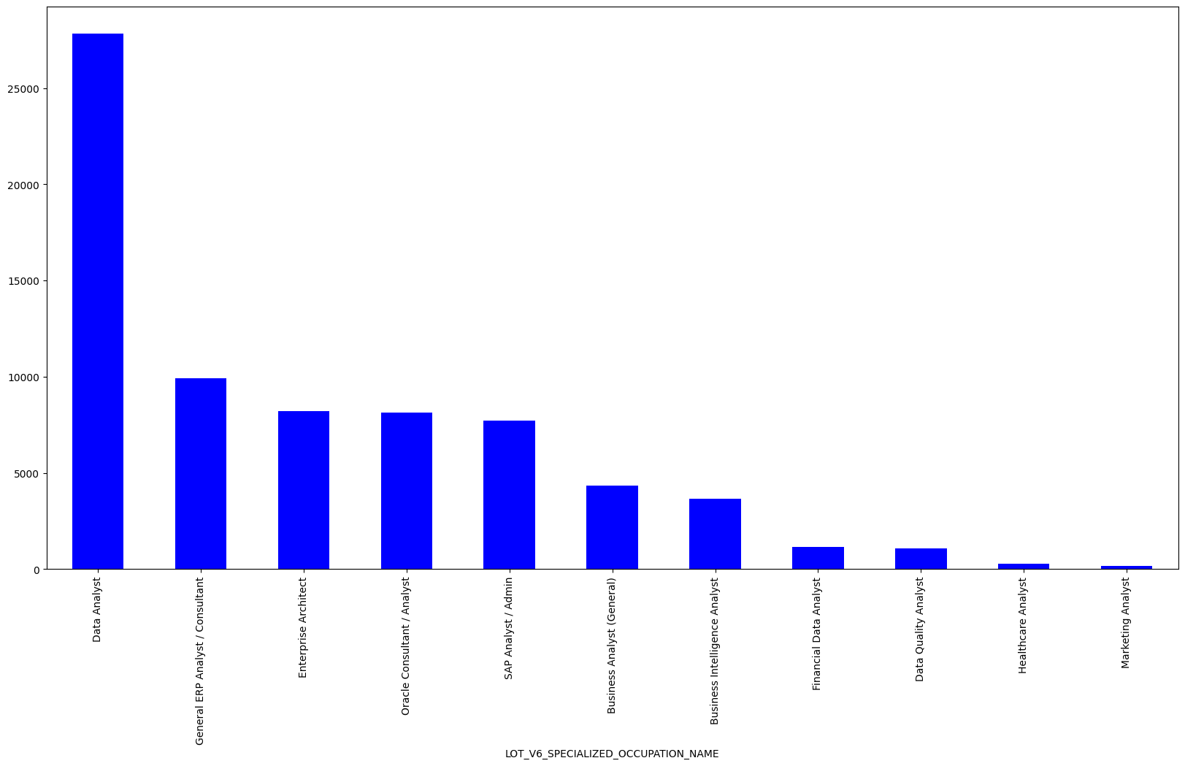

LOT_V6_SPECIALIZED_OCCUPATION_NAME  
Business Analyst (General) 100888.607317  
Business Intelligence Analyst 108886.397778  
Data Analyst 103796.067383  
Data Quality Analyst 99441.350000  
Enterprise Architect 162408.228546  
Financial Data Analyst 64161.114219  
General ERP Analyst / Consultant 129766.138806  
Healthcare Analyst 93609.968085  
Marketing Analyst 97650.153846  
Oracle Consultant / Analyst 138141.414918  
SAP Analyst / Admin 115745.803736  
Name: SALARY, dtype: float64



# Plot 1 Geographic distribution of salary and job demand

# Plot 3 Extract the top 10 skills by category

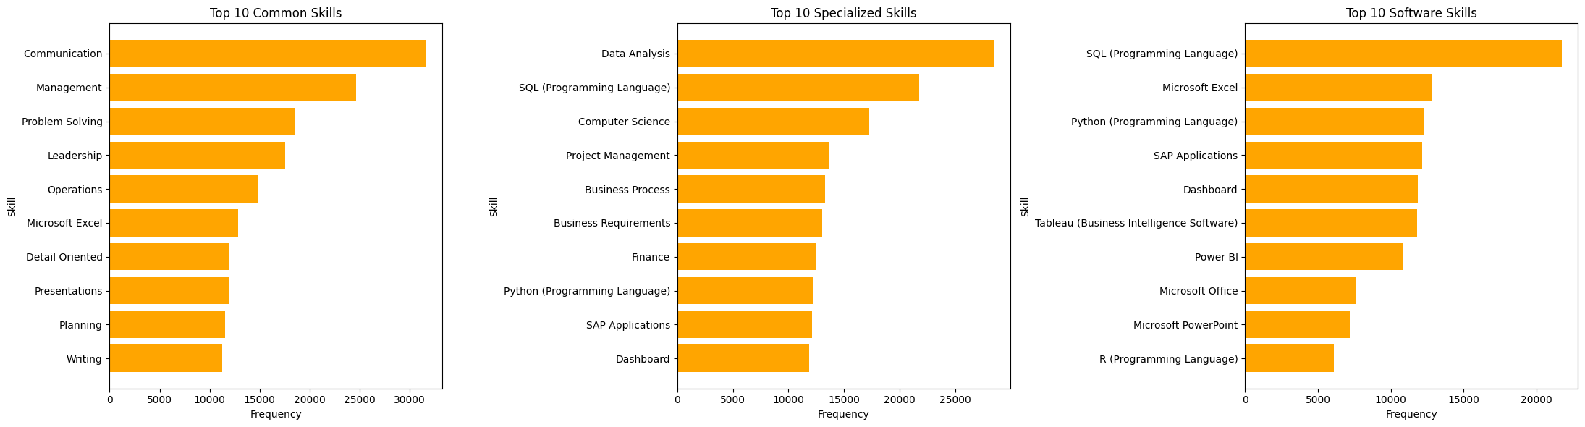

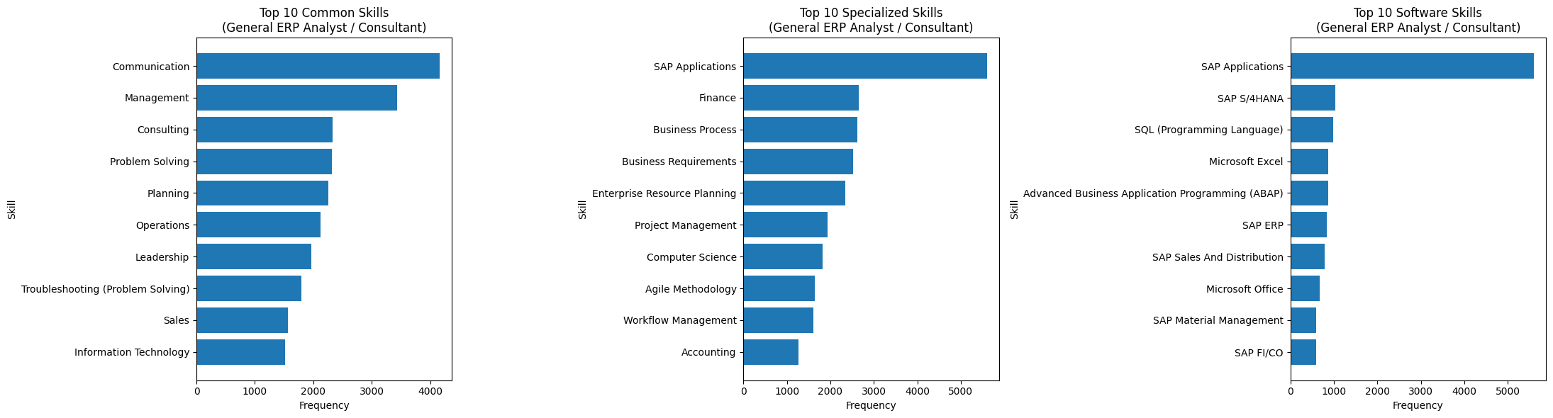

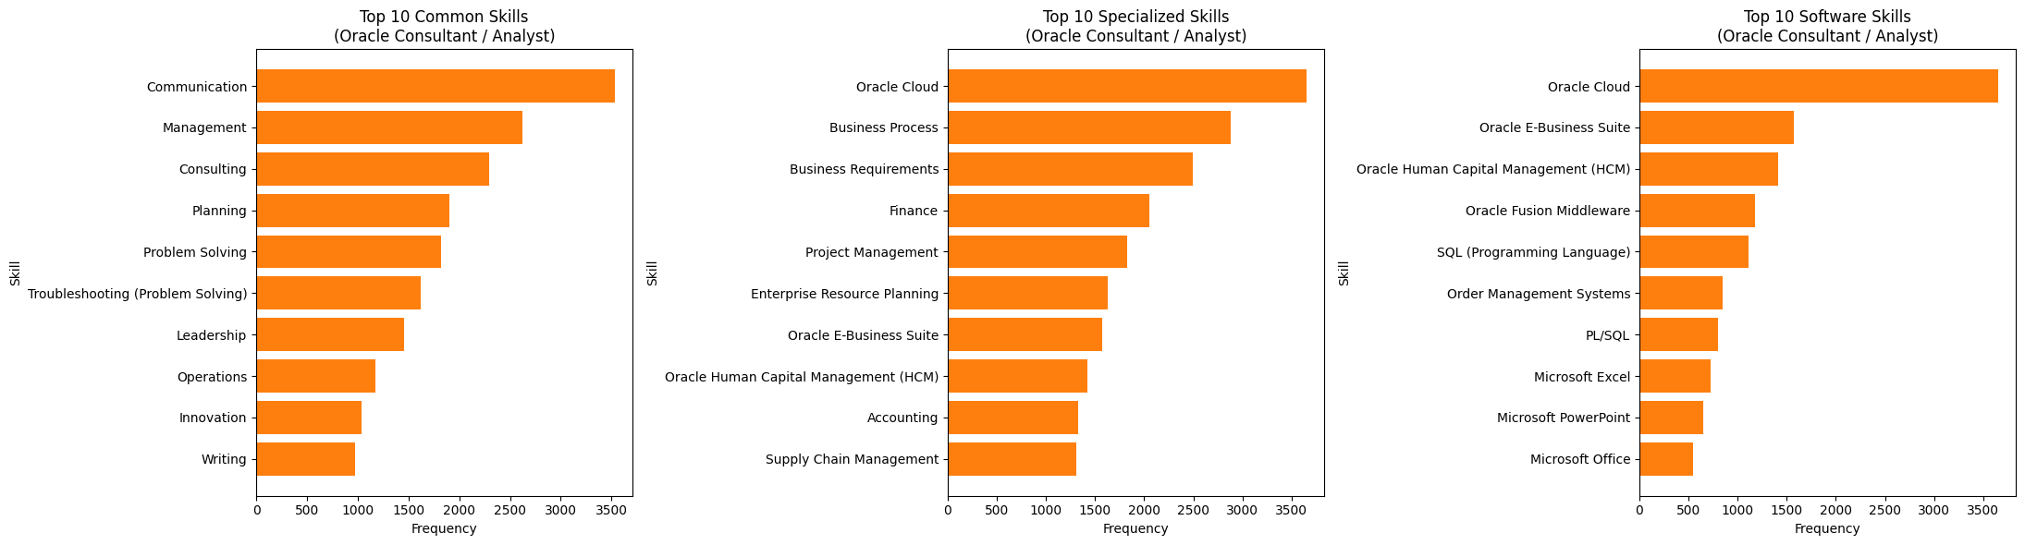

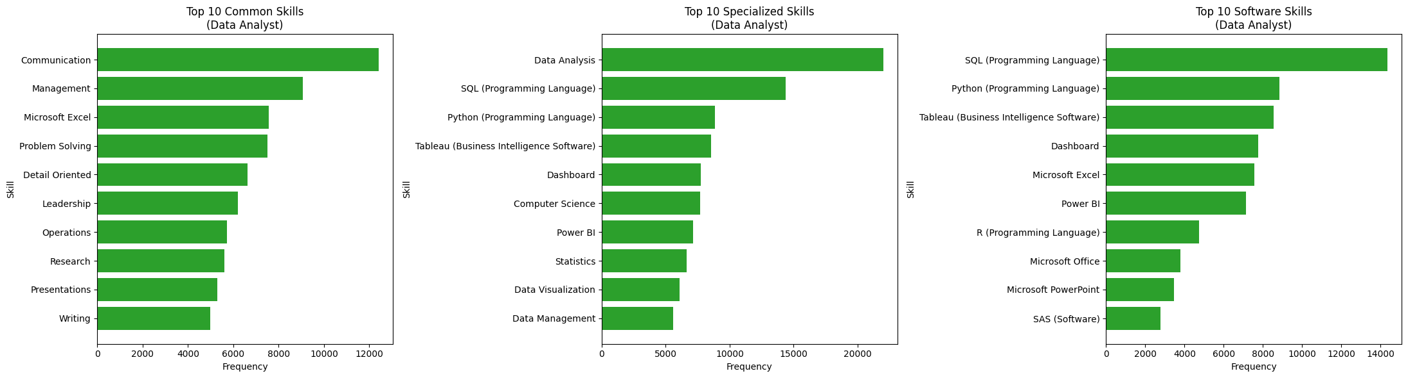

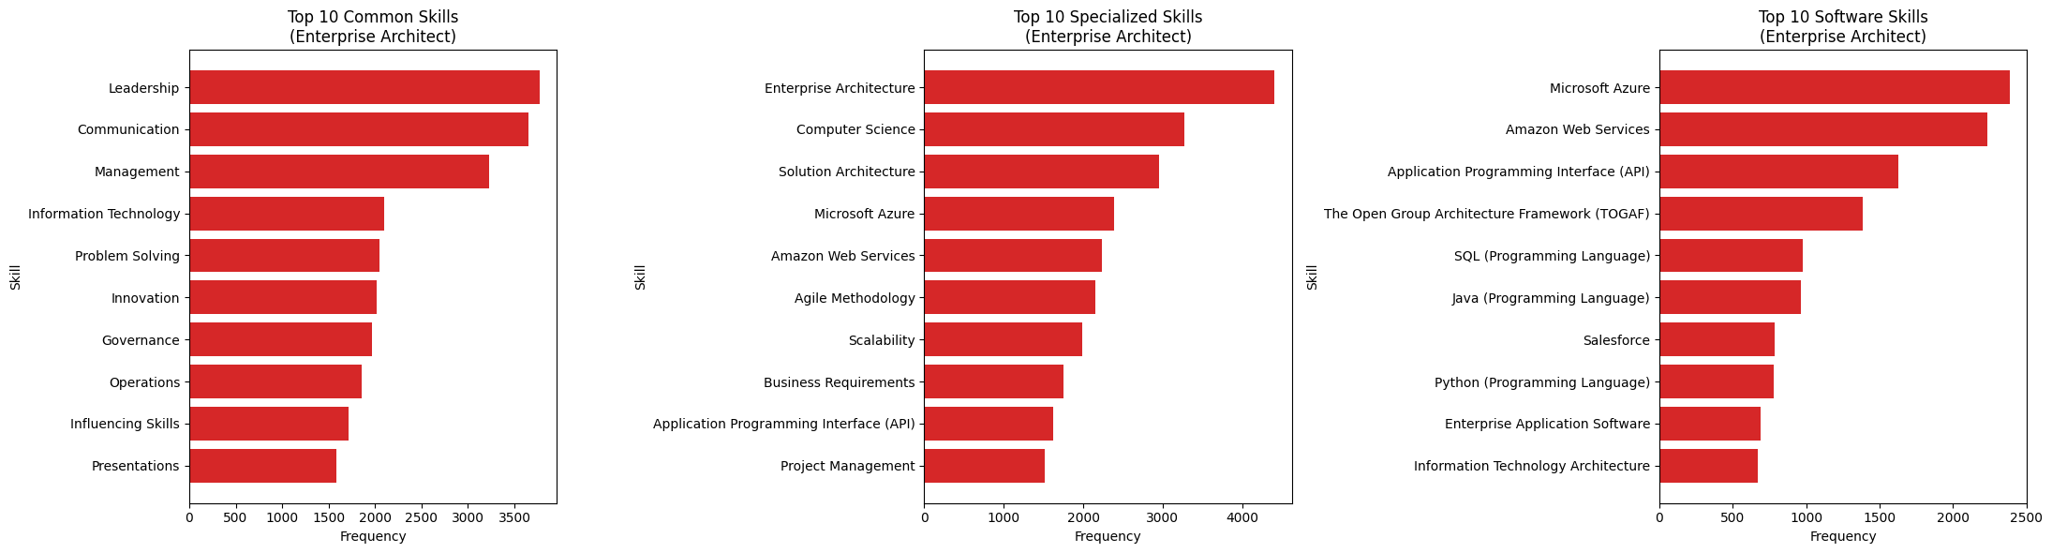

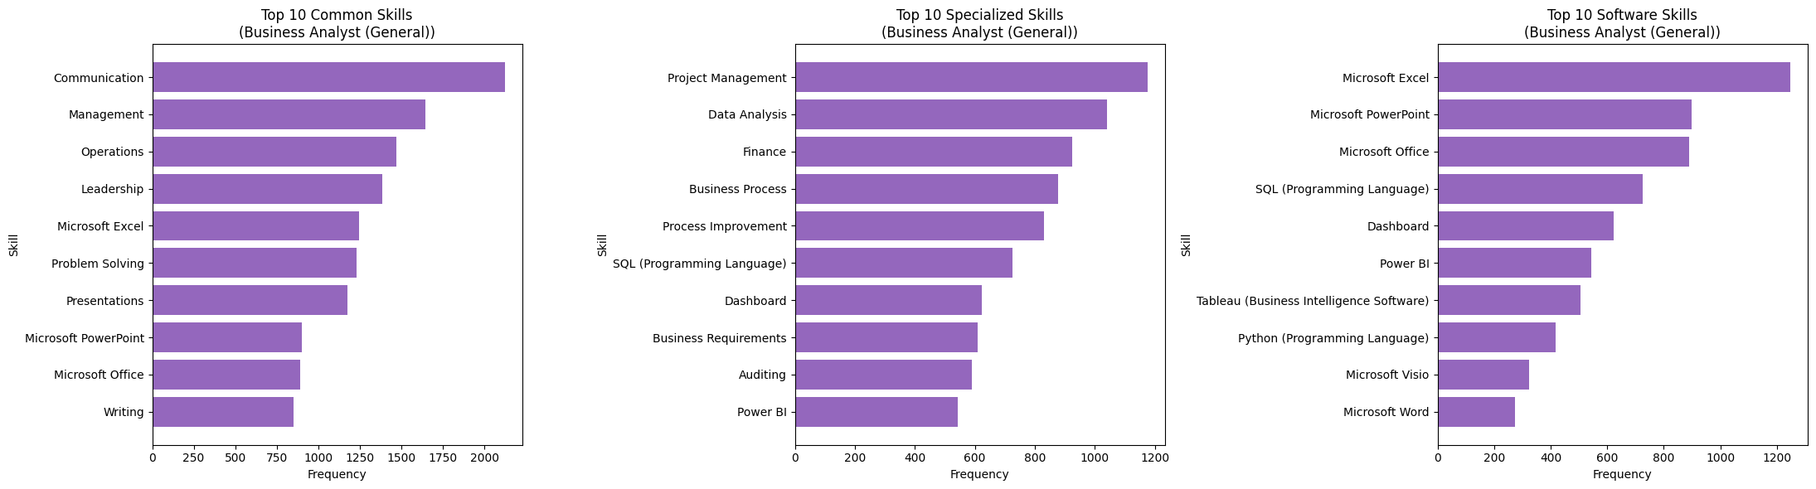

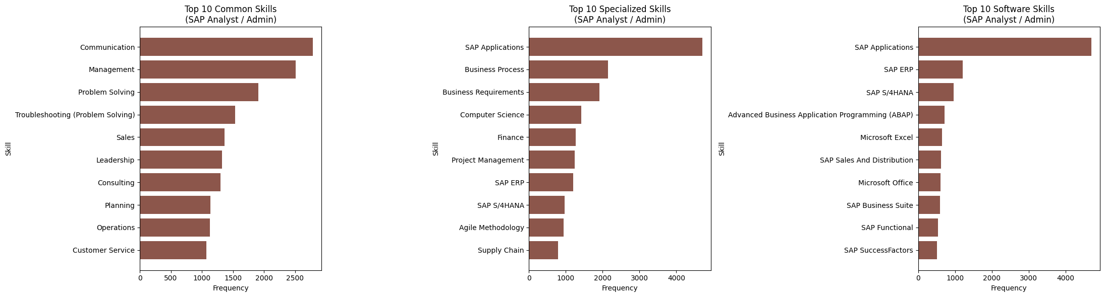

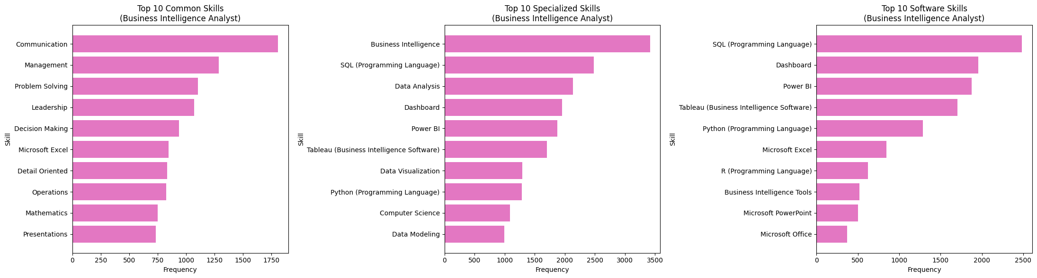

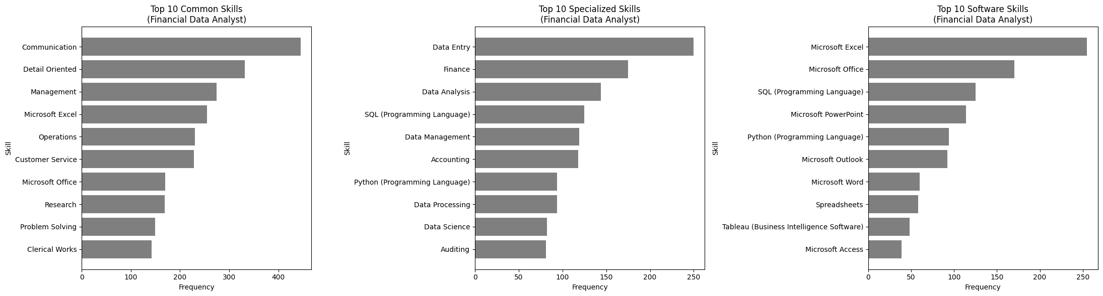

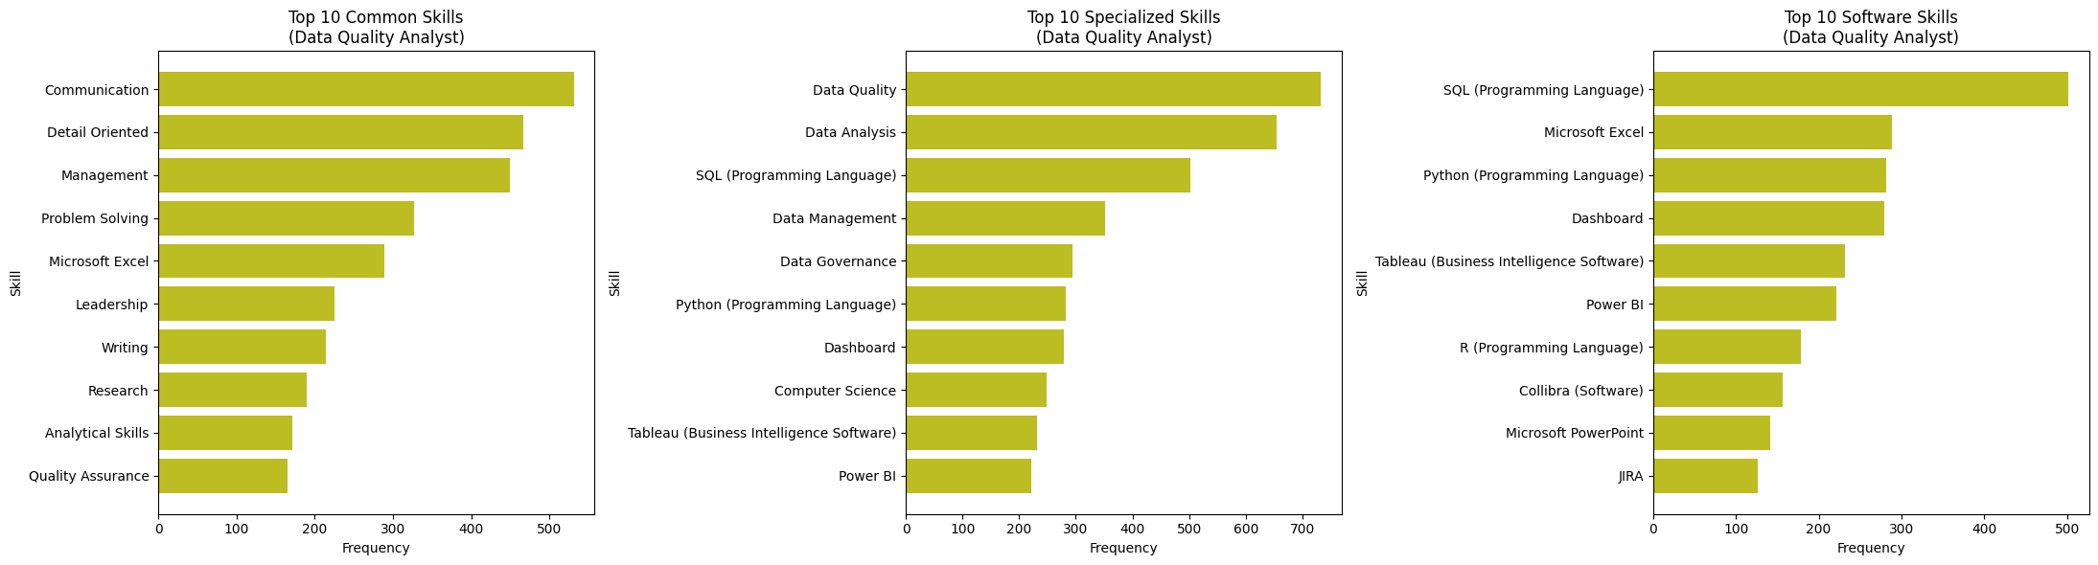

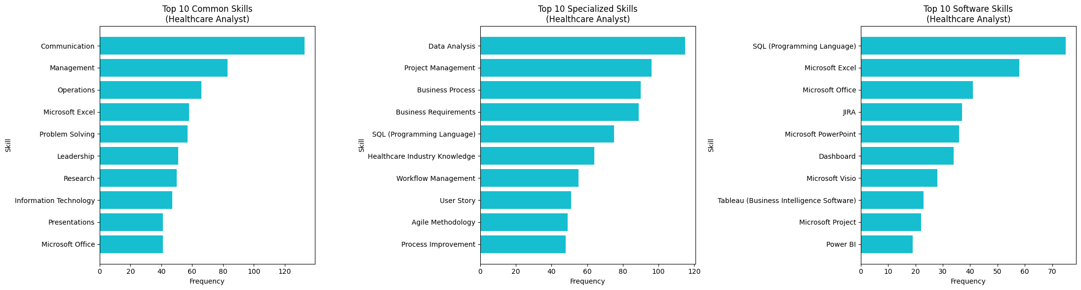

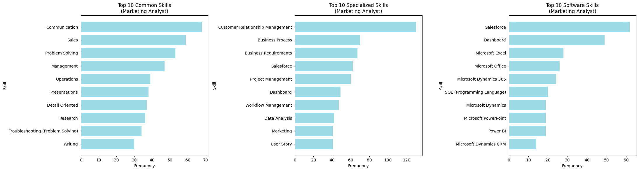

# Skill Gap Analysis

Required Skills for Data Analyst Role:  
- Communication  
- Management  
- Microsoft Excel  
- Problem Solving  
- Detail Oriented  
- Leadership  
- Operations  
- Research  
- Presentations  
- Writing  
- Data Analysis  
- SQL (Programming Language)  
- Python (Programming Language)  
- Tableau (Business Intelligence Software)  
- Dashboard  
- Computer Science  
- Power BI  
- Statistics  
- Data Visualization  
- Data Management  
- R (Programming Language)  
- Microsoft Office  
- Microsoft PowerPoint  
- SAS (Software)

Skill Marco Millie  
0 Communication 4 4  
1 Management 2 3  
2 Microsoft Excel 3 4  
3 Problem Solving 4 4  
4 Detail Oriented 4 3  
5 Leadership 4 4  
6 Operations 2 2  
7 Research 4 3  
8 Presentations 4 3  
9 Writing 3 2  
10 Data Analysis 4 3  
11 SQL (Programming Language) 2 2  
12 Python (Programming Language) 3 3  
13 Tableau (Business Intelligence Software) 2 1  
14 Dashboard 2 2  
15 Computer Science 1 1  
16 Power BI 2 2  
17 Statistics 3 2  
18 Data Visualization 4 3  
19 Data Management 2 3  
20 R (Programming Language) 2 2  
21 Microsoft Office 4 4  
22 Microsoft PowerPoint 3 4  
23 SAS (Software) 1 1

Marco's average rating: 2.88 / 5.00  
Millie's average rating: 2.71 / 5.00

# PLOT 4 Kmeans clustering for NAICS2_NAME skills (for Analyst position)

['Enterprise Analysts' 'Data Analysts' 'Management Analysts' ...  
 'Oracle Solution Architects' 'Donor Relations Managers'  
 'Philanthropy Interns']

['access' 'accounting' 'analysis' 'analytical' 'analytics' 'and' 'apache'  
 'application' 'applications' 'azure']





PC1 PC2  
access 0.017736 0.076920  
accounting -0.011342 0.004536  
amazon 0.030360 -0.012343  
analysis 0.077540 0.031537  
analytical 0.014053 0.013053  
... ... ...  
user -0.000095 0.006242  
visualization 0.039281 -0.001602  
warehousing 0.025778 0.009641  
workflow 0.002306 0.004493  
writing 0.006385 0.023276  
  
[100 rows x 2 columns]

# PLOT 5 Random Forest Classification

|  | SALARY | STATE | COMMON_SKILLS_NAME | SPECIALIZED_SKILLS_NAME | SOFTWARE_SKILLS_NAME | skills_text |
| --- | --- | --- | --- | --- | --- | --- |
| 5 | 110155.0 | AR | [\n "Presentations",\n "Data Reporting",\n ... | [\n "Power BI",\n "Qlik Sense (Data Analytic... | [\n "Power BI",\n "Qlik Sense (Data Analytic... | presentations data_reporting operations power_... |
| 9 | 92962.0 | NY | [\n "Prioritization",\n "Google Sheets",\n ... | [\n "Salesforce",\n "Google Docs",\n "Produ... | [\n "Salesforce",\n "Google Docs",\n "Produ... | prioritization google_sheets microsoft_powerpo... |
| 10 | 107645.0 | CA | [\n "Research",\n "Information Technology",\... | [\n "Regression Testing",\n "Flight Testing"... | [\n "Python (Programming Language)",\n "Visu... | research information_technology communication ... |
| 19 | 170000.0 | CA | [\n "Curiosity",\n "Interpersonal Communicat... | [\n "Business Continuity Planning",\n "Growt... | [\n "C (Programming Language)",\n "Python (P... | curiosity interpersonal_communications influen... |
| 20 | 110155.0 | TN | [\n "Presentations",\n "Data Reporting",\n ... | [\n "Power BI",\n "Qlik Sense (Data Analytic... | [\n "Power BI",\n "Qlik Sense (Data Analytic... | presentations data_reporting operations power_... |
| ... | ... | ... | ... | ... | ... | ... |
| 72482 | 117500.0 | CA | [\n "Analytical Skills",\n "Microsoft PowerP... | [\n "Healthcare Industry Knowledge",\n "Life... | [\n "Microsoft PowerPoint",\n "Microsoft Off... | analytical_skills microsoft_powerpoint communi... |
| 72483 | 80750.0 | IL | [\n "Research",\n "Presentations",\n "Forec... | [\n "Marketing Strategies",\n "Power BI",\n ... | [\n "Power BI",\n "Shiny (R Package)",\n "A... | research presentations forecasting communicati... |
| 72485 | 91520.0 | GA | [\n "Customer Service",\n "Management",\n "... | [\n "Organizational Communications",\n "Fina... | [\n "Business Intelligence Tools",\n "Report... | customer_service management analytical_skills ... |
| 72492 | 158855.0 | NC | [\n "Data Reporting",\n "Microsoft PowerPoin... | [\n "Data Extraction",\n "Data Manipulation"... | [\n "Microsoft PowerPoint",\n "Python (Progr... | data_reporting microsoft_powerpoint influencin... |
| 72495 | 72800.0 | MI | [\n "Detail Oriented",\n "Microsoft Excel",\... | [\n "Workflow Management",\n "Acceptance Tes... | [\n "Microsoft Excel",\n "Dashboard",\n "Ta... | detail_oriented microsoft_excel customer_servi... |

CountVectorizer(binary=True,  
 vocabulary=['mapreduce', 'microsoft_excel', 'data_engineering',  
 'influencing_skills', 'governance', 'data_entry',  
 'detail_oriented', 'leadership',  
 'data_architecture', 'team_building',  
 'decision_science', 'hematology', 'react',  
 'programming_language', 'data_modeling',  
 'organizational_skills', 'taxonomy', 'triage',  
 'apache_kafka', 'data_quality', 'business_analysis',  
 'continuing_care', 'time_management',  
 'policy_development', 'data_strategy', 'research',  
 'pyspark', 'consulting', 'data_infrastructure',  
 'python_', ...])

Fitting 3 folds for each of 15 candidates, totalling 45 fits  
Best Hyperparameters: {'max_depth': 24, 'max_features': 44, 'min_samples_leaf': 1, 'min_samples_split': 5, 'n_estimators': 149}  
RMSE: 24094.44  
R² Score: 0.635

['advanced_analytics', 'advocacy', 'agile_methodology', 'alation_data_catalog', 'analytical_skills', 'apache_hadoop', 'apache_kafka', 'apache_spark', 'balancing_', 'banking', 'big_data', 'billing', 'biotechnology', 'business_acumen', 'business_analysis', 'business_analytics', 'business_intelligence_software', 'business_requirements', 'business_statistics', 'business_strategies', 'communication', 'consulting', 'continuing_care', 'curiosity', 'cyber_threat_intelligence', 'dashboard', 'data_acquisition', 'data_analysis', 'data_architecture', 'data_collection', 'data_engineering', 'data_entry', 'data_governance', 'data_infrastructure', 'data_lineage', 'data_modeling', 'data_quality', 'data_science', 'data_strategy', 'data_synthesis', 'data_warehousing', 'decision_science', 'deep_learning', 'detail_oriented', 'diplomacy', 'emotional_intelligence', 'ethernet_physical_layer', 'etl', 'extract_transform_load_', 'finance', 'financial_services', 'generally_accepted_accounting_principles', 'governance', 'hematology', 'hospital_medicine', 'influencing_skills', 'innovation', 'leadership', 'machine_learning', 'management', 'mapreduce', 'market_trend', 'marketing_strategies', 'mentorship', 'microsoft_azure', 'microsoft_excel', 'microsoft_outlook', 'natural_language_processing_', 'nlp', 'node', 'ontologies', 'operations', 'organizational_skills', 'organizational_strategy', 'policy_development', 'power_bi', 'prioritization', 'problem_solving', 'programming_language', 'project_management', 'pyspark', 'python_', 'r_', 'react', 'regulatory_affairs', 'research', 'resilience', 'rockwell_factorytalk', 'scalability', 'software_engineering', 'sql_', 'stakeholder_management', 'taxonomy', 'team_building', 'team_leadership', 'thought_leadership', 'time_management', 'tooling', 'triage', 'visionary']

Predicted Salary: $91,979.83

## Educational Development

**Marco’s Educational Recommand**:

SQL for Data Science – Coursera（UC Davis）

Data Engineering with Python – Coursera（IBM）

Power BI Essential Training – LinkedIn Learning

**Millie’s Educational Recommand**:

Intro to SQL – Mode Analytics

Statistics for Data Science – Coursera

Tableau for Analytics – Coursera

**Supplement skills and knowledge through courses and build a solid theoretical foundation and choose tool courses that have the most obvious gap with current skills, and combine them with practical exercises to enhance the absorption effect.**

## Project-Based Application

**Marco’s Project Exercises**:

Netflix Movies & TV Shows (model development and dashboard implementation) – Kaggle

NASA Bearing Dataset (R&D application scenario) – Kaggle

**Millie’s Project Exercises**:

Used-Car Data (SQL and dashboard operations) – Kaggle

Hotel Booking Demand (simulated consultant scenario analysis) – Kaggle

**Apply skills to real data sets through actual project operations, accumulate works and experience (such as business analysis, consulting, data science) and organize them into a portfolio.**

## Skills to Improve

**Marco’s Key Skills**:

Python、SQL、Dashboarding、Machine Learning

**Millie’s Key Skills**:

SQL、Problem Solving、Dashboarding、Data Analysis、Statistics

**Clearly list the technologies and capabilities that need to be strengthened, make strategic plans. Prioritize strengthening core data skills (such as SQL, Dashboarding), and simultaneously improve logical reasoning and problem-solving abilities.**

Our analysis of Business Analytics, Data Science, and Machine Learning trends reveals a clear alignment between high-demand roles and specialized skill sets. By mapping job postings and average salaries, we observed that roles in data-related fields offer both abundant opportunities and competitive compensation. The dual bar chart comparing job counts and salaries for specialized occupations further confirms the premium placed on data-driven expertise.

Through skill-based PCA clustering, we identified distinct groups of in-demand competencies, ranging from technical programming skills to business-oriented and communication strengths. This skill landscape highlights the importance of both technical fluency and strategic thinking in the analytics workforce.

In our own team, we conducted a skills assessment and used a random forest model to understand the key features driving role readiness. This was followed by a personalized career strategy map, where each member outlined their skills to improve and aligned courses and projects to build targeted capabilities. This individualized approach not only bridges current skill gaps but also ensures continuous alignment with evolving industry expectations.

In conclusion, the future of analytics careers lies in a balanced development of technical, analytical, and soft skills. By staying informed of labor market trends and proactively upskilling through structured strategies, professionals can position themselves to thrive in this dynamic, data-driven economy.