IKEA × SANRIO
Home of Happiness
Press Kit
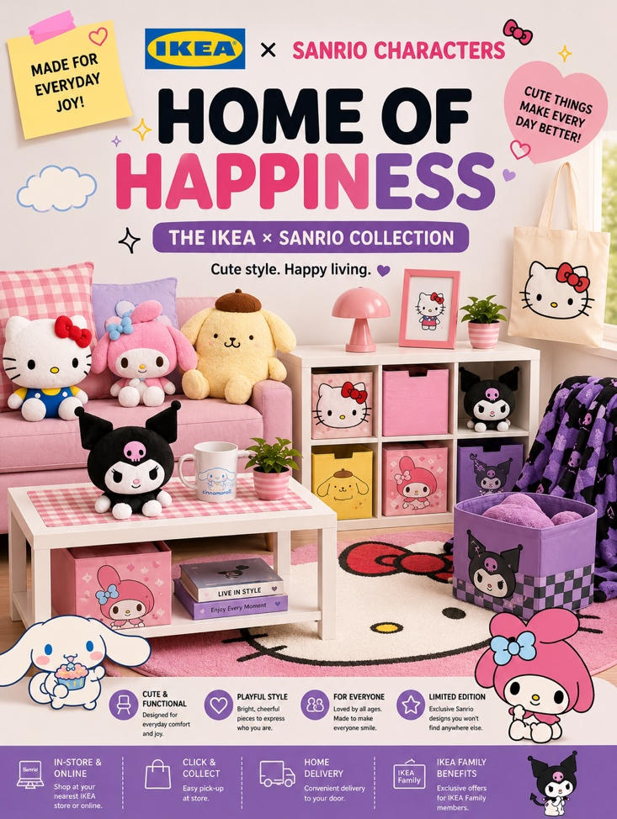

A collaborative lifestyle campaign designed for Gen Z consumers
Transforming everyday living spaces into places of comfort, creativity and self-expression through immersive design, character culture and social media engagement.

Campaign Platforms:

Website Experience:

TikTok Campaign

Instagram Promotion
About the Campaign
Home of Happiness is a cross-media collaboration campaign between IKEA and Sanrio designed to connect with younger audiences through emotional branding, immersive room aesthetics and social media culture.
The campaign introduces themed IKEA room displays inspired by popular Sanrio characters including Kuromi, Cinnamoroll and Pompompurin.
By combining IKEA’s functional home solutions with Sanrio’s emotionally engaging character culture, the collaboration transforms living spaces into expressive and personalised environments.
The campaign aims to reposition IKEA as more than a furniture retailer. Instead, it presents IKEA as a lifestyle and identity-driven brand that resonates with Gen Z consumers.

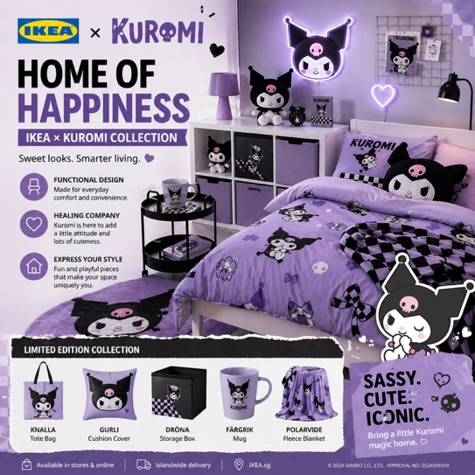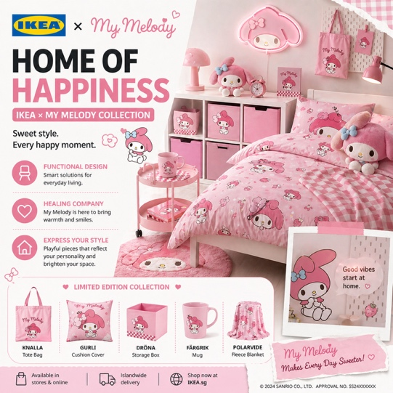

Campaign Objectives
Reach new Gen Z audiences
Increase social media engagement
Strengthen emotional brand connection
Encourage user participation and content sharing
Refresh IKEA’s brand image through experiential marketing

Designed for Gen Z Living
The campaign primarily targets Gen Z consumers aged 18–27 who value aesthetics, identity expression and digital culture.
These audiences are highly active on platforms such as TikTok and Instagram and are strongly influenced by visually engaging and emotionally relatable content.

Audience Interests | Audience Behaviour
Room décor and lifestyle aesthetics | Frequently shares visual content online
Character and kawaii culture | Engages with interactive campaigns
Social media trends | Values emotional and aesthetic branding
Collectibles and personalised spaces | Uses personal spaces as identity expression

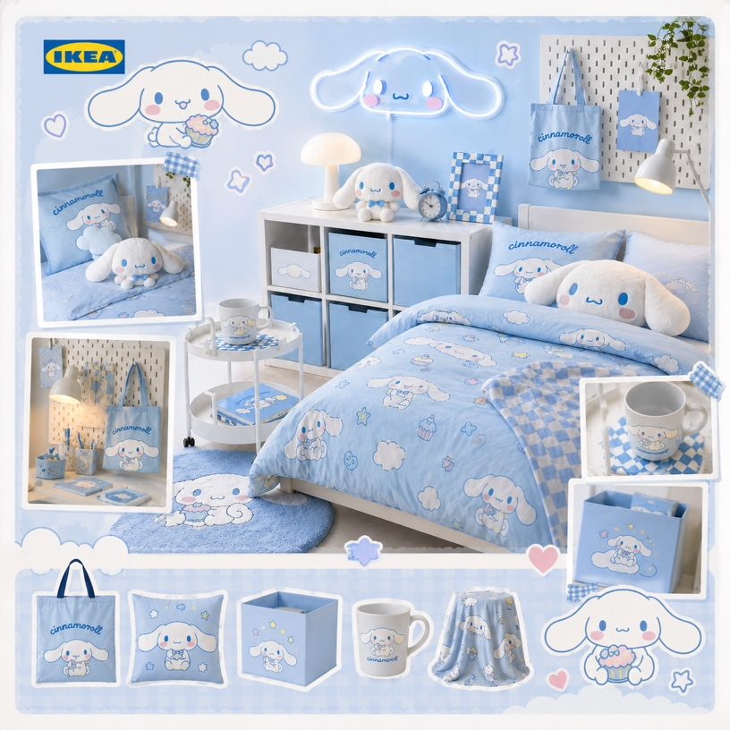
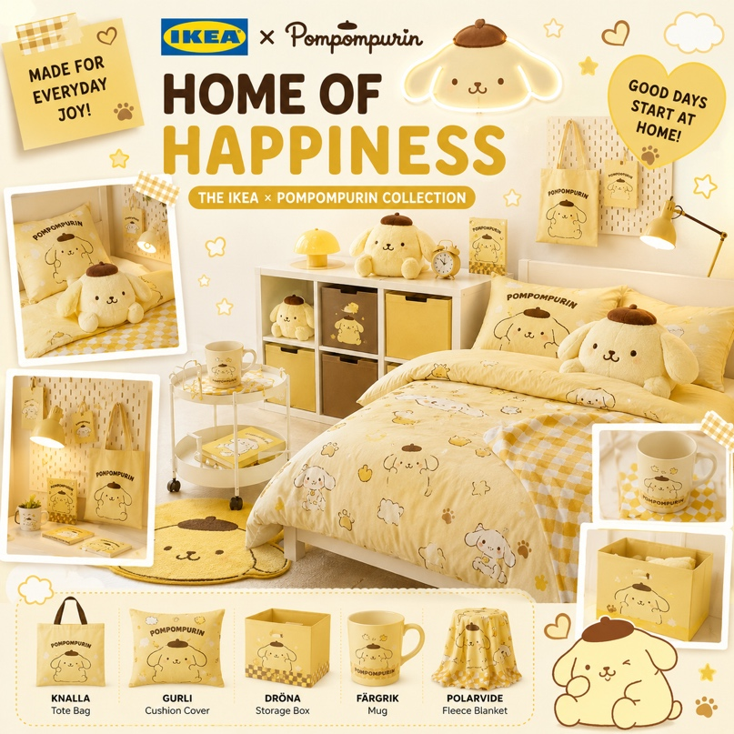
Character-Based Aesthetic Segments

Cinnamoroll → soft and calming aesthetics
Pompompurin → cozy and comforting aesthetics

Immersive Lifestyle Experience
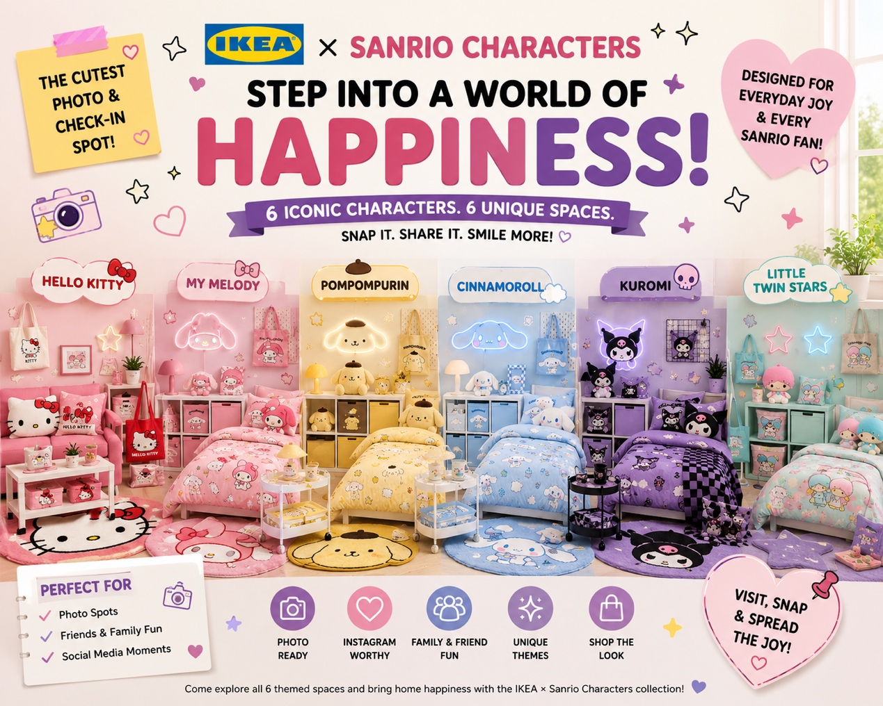

The campaign combines retail, entertainment and digital participation to create a highly shareable brand experience.
Customers can explore themed room environments, interact with limited-edition collections and participate in online engagement activities across multiple platforms.
Campaign Highlights. Key Campaign Hashtags
IKEA × Sanrio themed rooms. #HomeOfHappiness
Limited-edition homeware collection. #IKEAxSanrio
Interactive photo spots
TikTok and Instagram campaigns
User-generated content participation
Social hashtag engagement

IKEA × Sanrio Collection
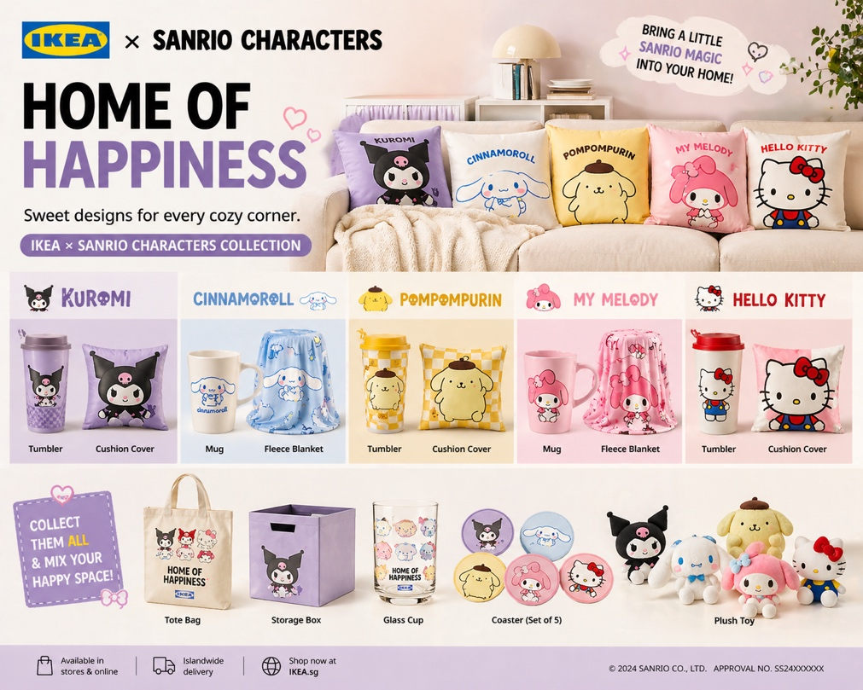
Product Line
- Cushion Covers
- Tote Bags
- Storage Boxes
- Tumblers & Mugs
- Glass Cups
- Coasters
- Plush Toys
- Fleece Blankets
- Decorative Storage

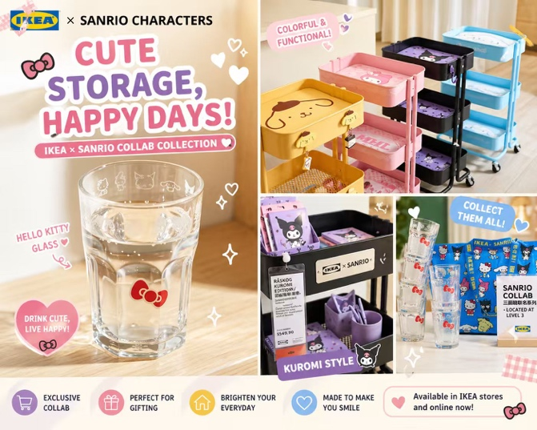
Available
- IKEA stores
- IKEA online platform
- Limited campaign release

Social Media Campaign
Social media serves as the campaign’s primary engagement platform, encouraging audiences to participate, share and create content around the collaboration.
Through cross-platform promotion on TikTok and Instagram, the campaign transforms “Home of Happiness” into an interactive and highly shareable digital lifestyle experience for Gen Z audiences.
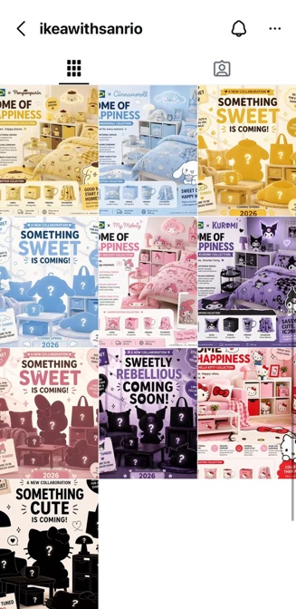
Instagram focuses on creating a visually consistent and aesthetically engaging campaign identity through themed character content and curated feed layouts.
Content Types:
- Character room reveals
- Product showcase posts
- Teaser visuals
- Aesthetic carousel posts
Key Objective: Increase brand visibility and audience interaction
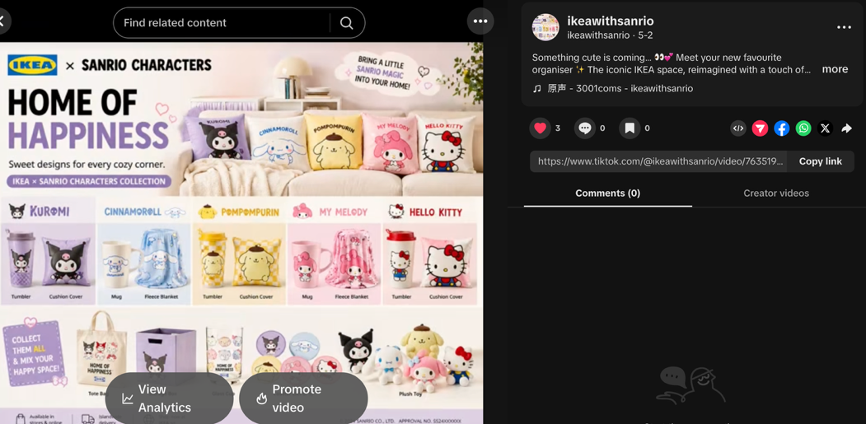
TikTok content emphasises short-form engagement and immersive room experiences through teaser campaigns and character-themed videos.
Content Types
Room makeover videos
Product reveal videos
Aesthetic edits
Interactive hashtag campaigns
Key Objective: Boost campaign exposure among Gen Z audiences.
IKEA Launches “Home of Happiness” Collaboration with Sanrio
Singapore — IKEA officially announces the launch of Home of Happiness, a collaborative campaign with Sanrio designed to bring immersive lifestyle experiences to Gen Z consumers.
The campaign combines IKEA’s practical and affordable home solutions with Sanrio’s globally recognised character culture, creating themed living spaces that encourage creativity, comfort and self-expression.
The collaboration introduces limited-edition products inspired by popular Sanrio characters including Kuromi, Cinnamoroll and Pompompurin, alongside a cross-platform social media campaign and interactive digital experiences.

“Home of Happiness reflects how younger audiences use personal spaces as a form of identity and emotional expression,” said the campaign team. “This collaboration transforms everyday living into an engaging and shareable experience.”

The campaign will be available through selected IKEA stores, digital platforms and social media channels.

Contact Information
📧: coms3001group@gmail.com
🌐: https://marcolin0004.github.io/COMS3001-IKEA/
📱 Instagram: https://www.instagram.com/ikeawithsanrio/
🎵 TikTok: https://www.tiktok.com/@ikeawithsanrio

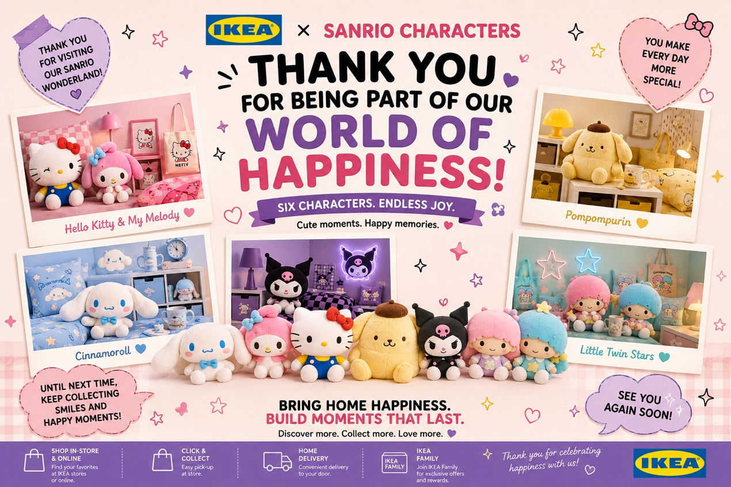

Available In Stores & Online

HOME OF HAPPISNESS

