- **Diversity and network coherence as indicators of interdisciplinarity: Case studies in bionanoscience** (vale la pena leggerlo per intero con calma, molto più rudimentale rispetto alla nostra idea ma con alcuni spunti e somiglianze)
  - Ismael Ràfols and Martin Meyer (2009) introduced a conceptual framework using diversity (the heterogeneity across disciplinary categories) and network coherence (structural integrity within a citation network) to characterize interdisciplinarity at the article level—especially illustrated in bionanoscience case studies.
- **Interdisciplinarity metric based on the co-citation network** (usa grafi di co-citazione, bibliometria pura)
  - Juan M. Hernández and Pablo Dorta-González (2020) proposed an interdisciplinarity metric derived directly from the co-citation network. This approach avoids relying on predefined classification schemes: instead, it defines a publication's field via network structure and uses that to quantify interdisciplinarity.
- **From indicators to indicating interdisciplinarity: A participatory mapping methodology for research communities in-the-making** and also Indicators of the interdisciplinarity of journals: Diversity, centrality, and citations
  - Betweenness centrality—a network-theoretic measure of how often a node lies on shortest paths between others—has long been used to gauge interdisciplinary intermediation. For example, Leydesdorff (2007) used betweenness in journal-journal citation networks as an indicator of interdisciplinarity, although normalization is important to avoid bias toward large, generalist journals.
- **Interdisciplinarity of scientific fields and its evolution based on graph of project collaboration and co-authoring** (tentativo molto più semplice che deriva dagli ACN)
  - Karlovčec & Mladenić (2015) proposed a graph-based interdisciplinarity measure derived from collaboration networks—measuring interdisciplinarity of fields based on co-authorship and project collaborations, including structural and content similarity aspects. This was applied in analyzing Slovenian research fields.
- **Author multidisciplinarity and disciplinary roles in field of study networks** (attenzione: questo è particolarmente simile nella parte hierarchical, da guardare con molta attenzione, seppur non si preoccupi di fornire una misura sul singolo paper in quanto, mi sembra di capire, catturi perlopiù la multidisciplinarietà degli autori nei vari fields (nell’immagine, f2 ed f3 sono collegati in quanto a5 si è occupato in due paper distinti di ambo i fields)).
  - A more recent formalisation (2022) uses Field-of-Study networks—graph structures where nodes represent fields (or topics) and edges link fields that share authorship connections (i.e., an author publishing in both fields). This can be built at multiple hierarchical levels, and even temporally.
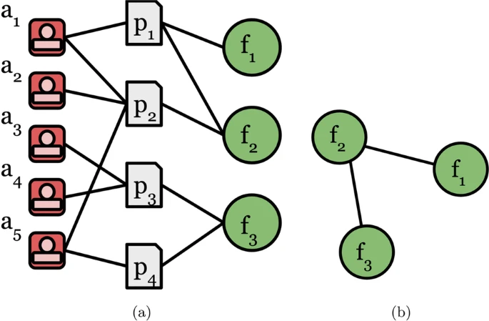
The formation of a static Field of Study (FoS) network involving two steps: a creation of a heterogenous network of papers, authors and fields; b projection to an undirected network of fields, preserving field-paper-author-paper-field meta-paths
The formation of a static Field of Study (FoS) network involving two steps: a creation of a heterogenous network of papers, authors and fields; b projection to an undirected network of fields, preserving field-paper-author-paper-field meta-paths

