Due to bootstrap classes, it's necessary a document to remember the classes affiliated to each object.

That document will be deleted at the end of the project.

\*\*\*\*\*\*\*\*\*\*\*\*\*\*\*\*\*\*\*\*\*\*\*\*\*\*\*\*\*\*\*\*\*\*\*\*\*\*\*\*\*\*\*\*\*\*\*\*\*\*\*\*\*\*\*\*\*\*\*\*\*\*\*\*\*\*\*\*\*\*\*\*\*\*\*\*\*\*\*\*\*\*\*\*\*\*\*

Logo





Toggle Button



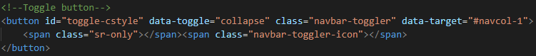

Header Button



