

PUBLIC

How to Configure Postman Collection

SAP Logistics Business Network, Freight Collaboration Option

Document Version: LBN 2.0 – 2021-09-18

Table of ContentS

History of Changes 3

Prerequisites 4

Configuring Postman Collection 4

Adding Postman Collection and Environment 4

Setting Variables in Postman Environment 5

Activate and Configure Certificate-Based Connection 8

Activate the Connection Using IAS Certificate in SAP LBN 8

Configure Certificate-Based Authentication in Postman 11

# History of Changes

The following table provides an overview of the most important changes that have been made in the latest versions.

| **Document Version** | **Release Date** | **Important Changes** |
| --- | --- | --- |
| 1.0 | September 2021 | Initial version |

# Prerequisites

1. You must download the postman collection with environment from the below link:
2. You must have setup a connection to the test shipper tenant in SAP Logistics Business Network.

For more details on how to set up the connection, see the chapter Activate and Configure Certificate-Based Connection.

1. You must have an OAuth client for event posting in the test carrier/visibility-provider tenant.

For more details on how to get the OAuth client, follow steps 2.2 to 6 in [How to Integrate with SAP LBN APIs](https://github.com/SAP-samples/logistics-business-network-integration#22-request-test-technical-user).

# Configuring Postman Collection

To execute the postman collection for testing by partners, you must configure the postman environment.

## Adding Postman Collection and Environment

Once you download the postman collection and environment from the <link>, perform the following:

1. Import the postman collection and environment.

The import dialog box appears.

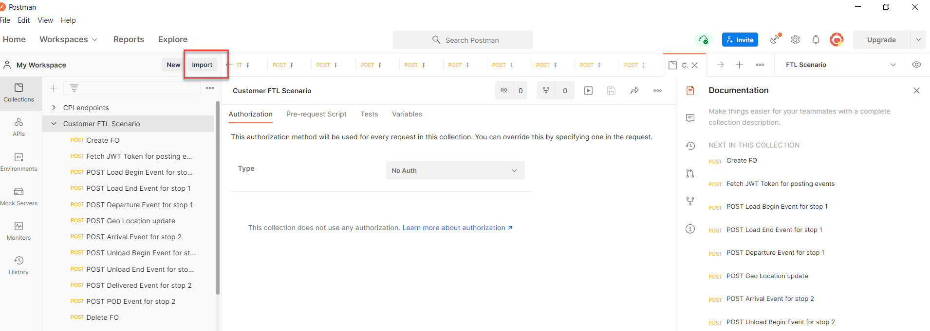

1. Choose **Upload Files** and select the files that you want to upload.

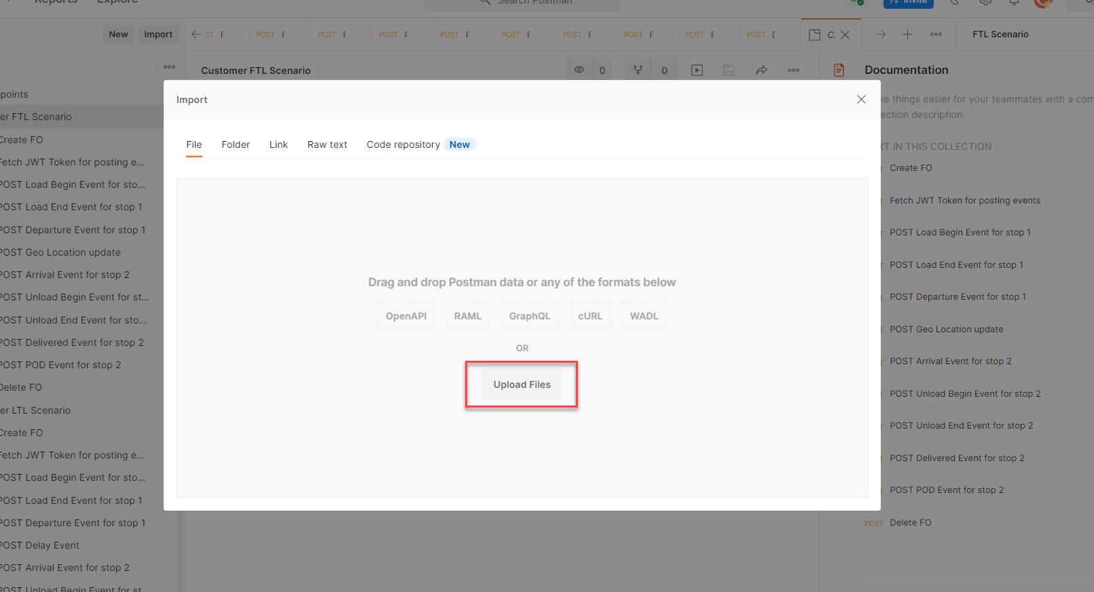

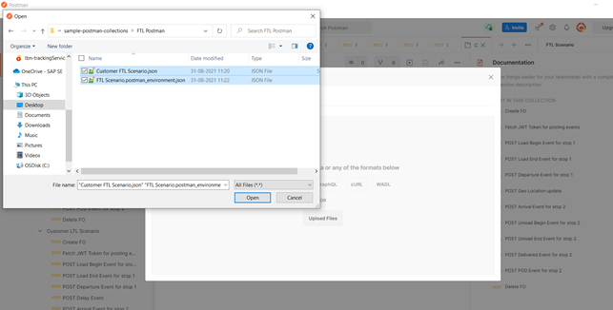

1. Choose **Import**.

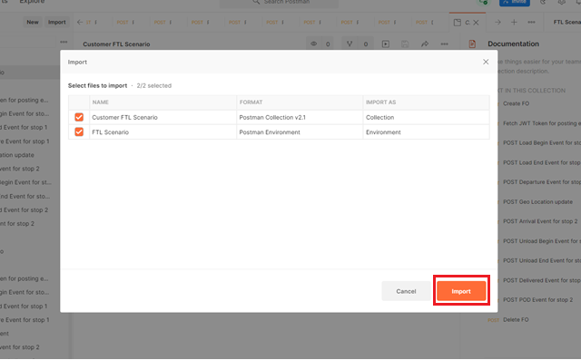

1. Save your settings.

## Setting Variables in Postman Environment

You can assign one or more variables to the postman environment that you have created. To assign variables, proceed as follows:

1. In the postman environment that you imported, choose **Edit**.

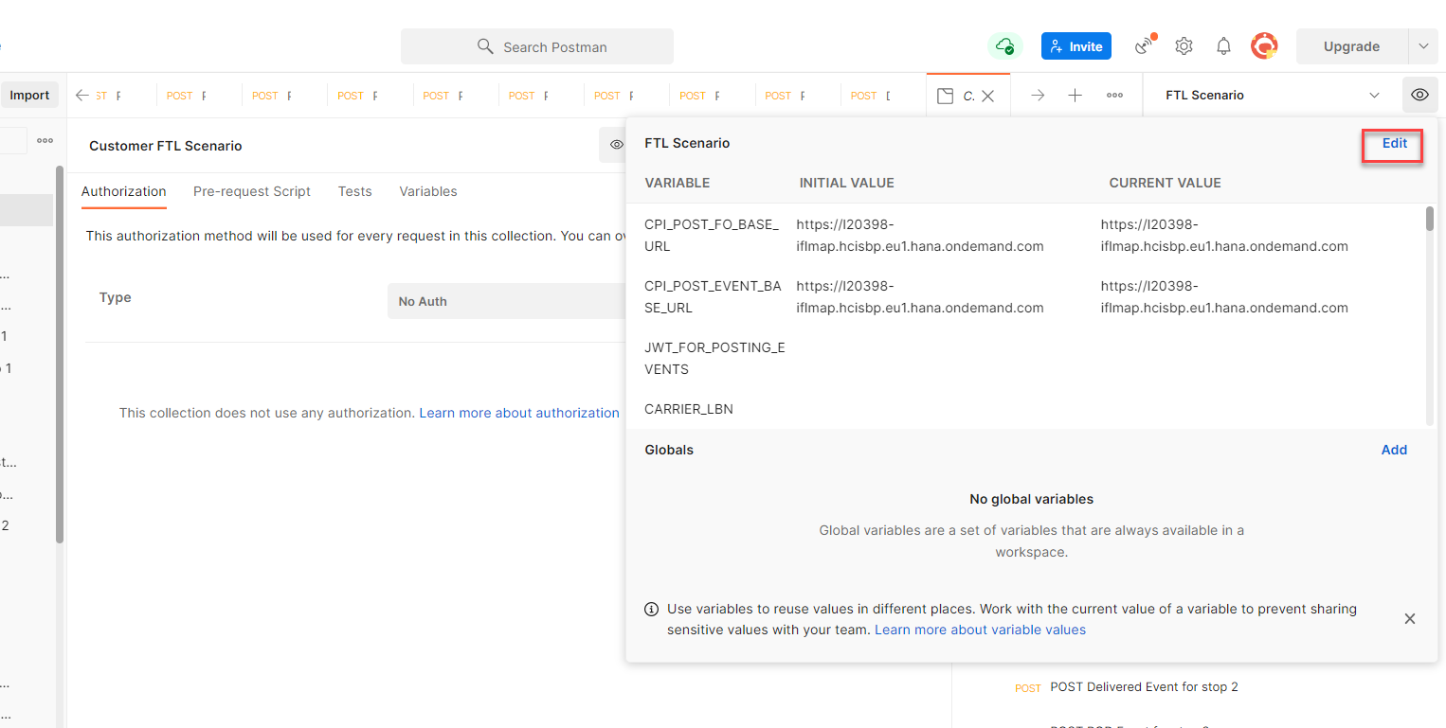

1. Assign the following variables:

* CARRIER_LBN

Denotes the SAP LBN ID of the carrier

* SHIPPER_LBN_ID

Denotes the SAP LBN ID of the shipper

* networkPartnerLBNID

Denotes the SAP LBN ID of the network partner

* username

Denotes the client ID of the oAuth client

* password

Denotes the client Secret of the oAuth client

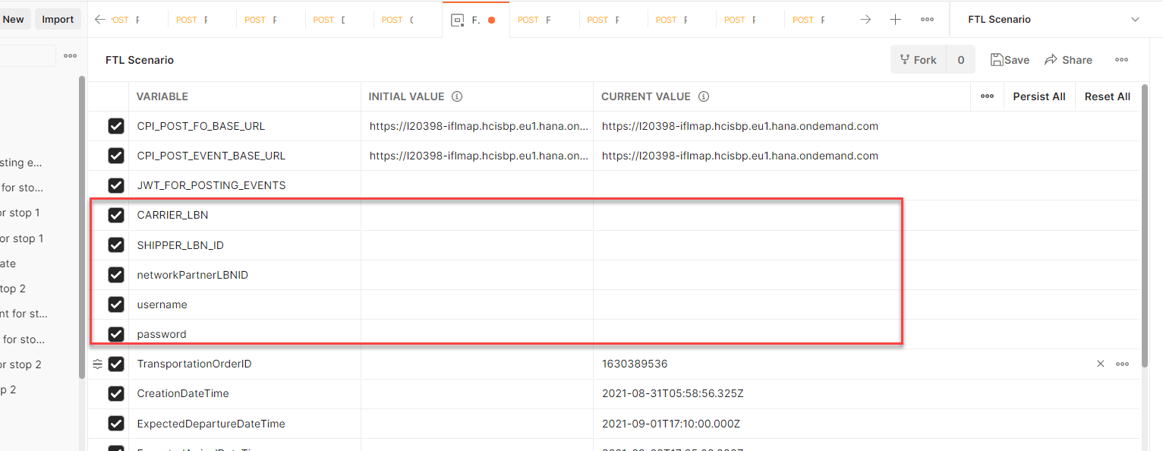

1. Save the environment.
2. Execute the first request to create a freight order.
3. Execute the second request to fetch the token for posting events on the freight order.
4. Execute the next requests in the collection to post events on the freight order.

**Result**

You have configured the postman collection and environment to create a freight order with a unique freight order ID each time a request is sent.

To check the freight order ID of the latest request sent, you can check the environment and look for the variable TransportationOrderID.

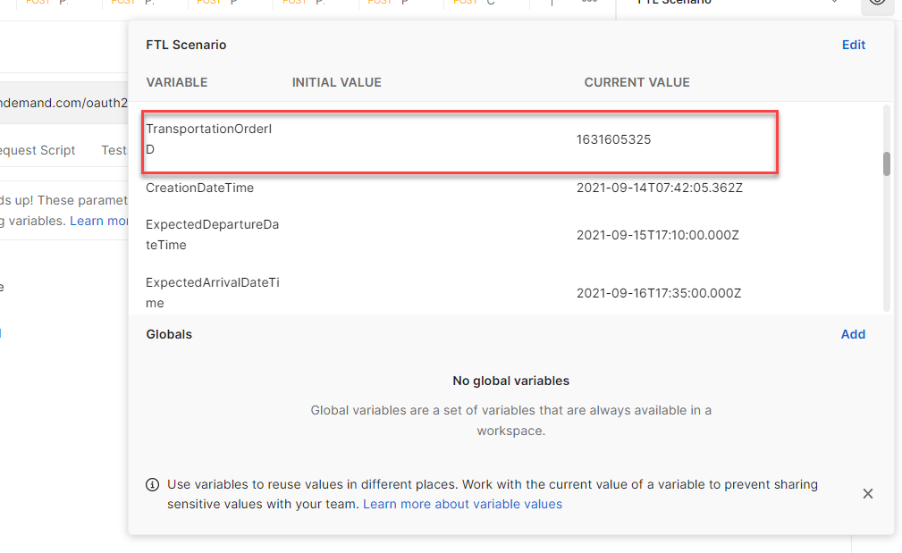

**Note**

Though we recommend you to use the default value assigned to the variables, you can change the postman environment for custom values such as SOURCE_LOC_EXT_ID**,** the location ID of the source location of the freight order. Note that when you introduce custom values, you may notice a difference in the map or events in the **Track Freight Movement** app for the freight order.

# Activate and Configure Certificate-Based Connection

## Activate the Connection Using IAS Certificate in SAP LBN

1. Login to the shipper tenant.
2. Go to **System Connections** app.

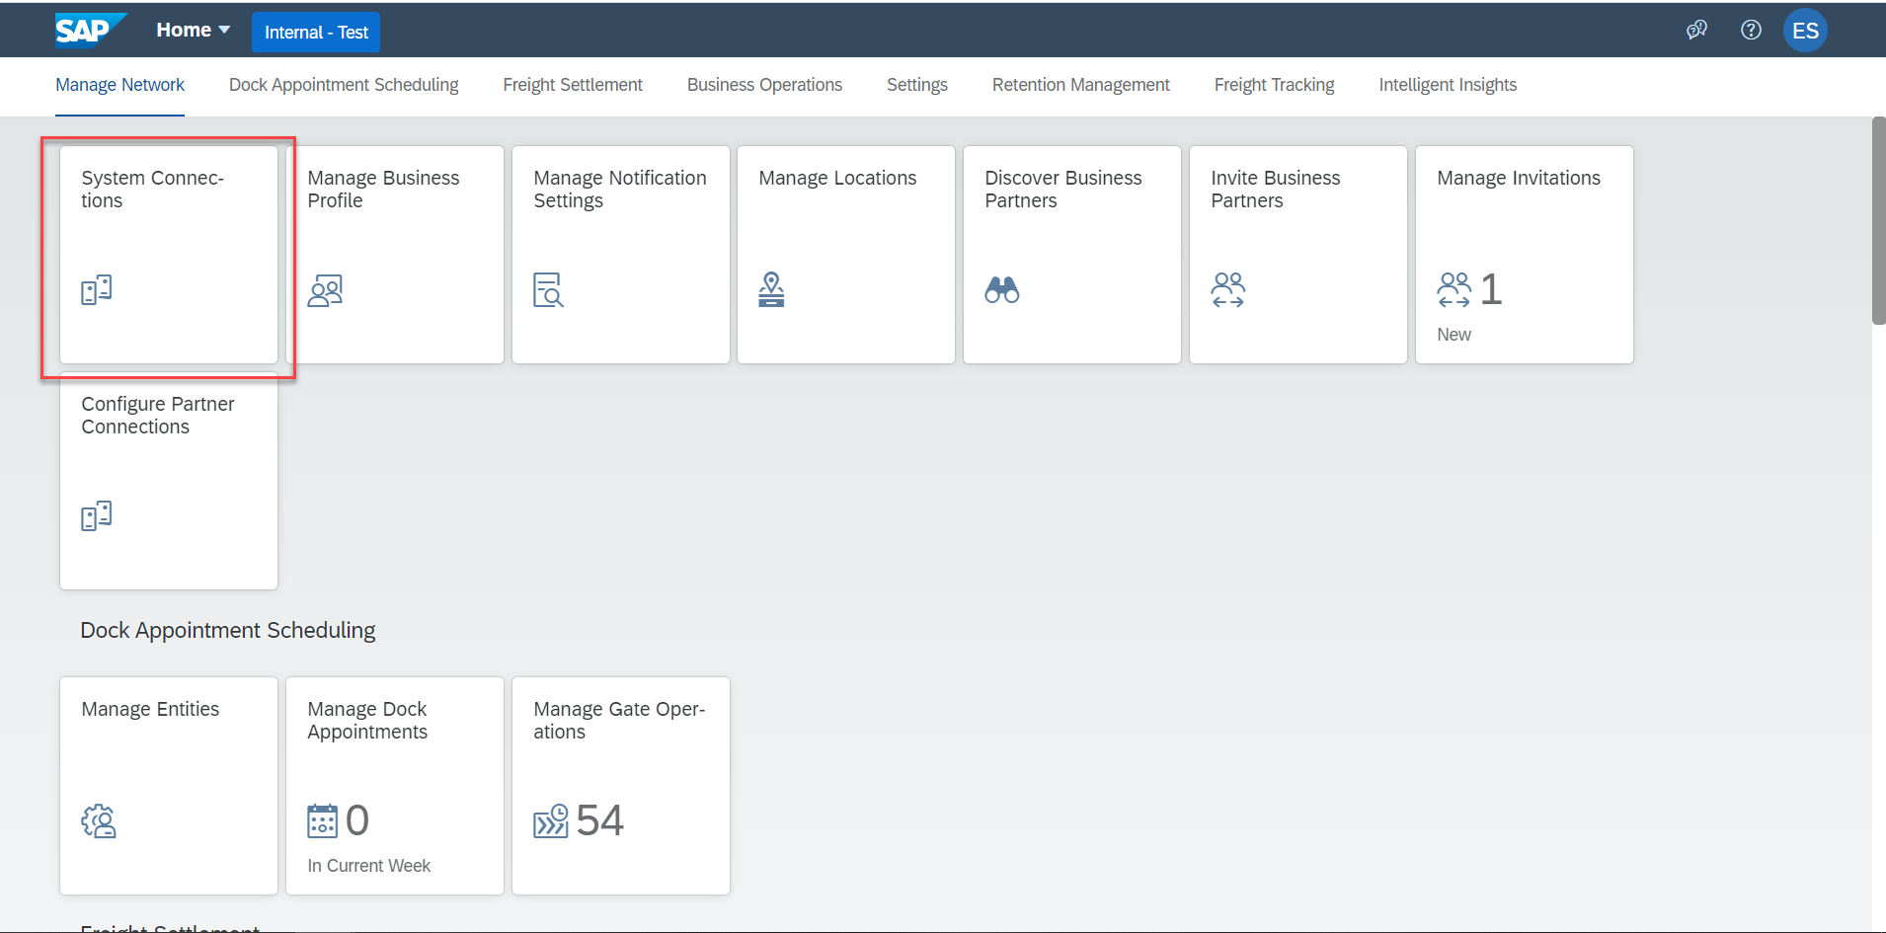

1. Choose **Add**.

A new connection dialog box appears.

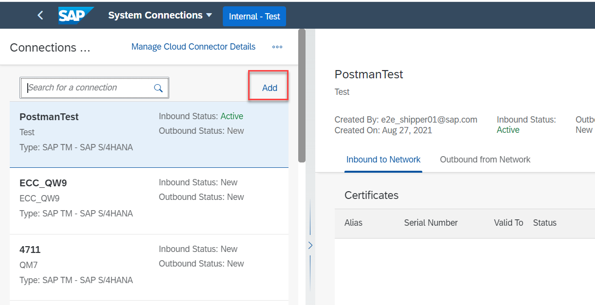

1. In the **Connection Type** dropdown menu, choose **SAP TM – SAP S/4 HANA.**

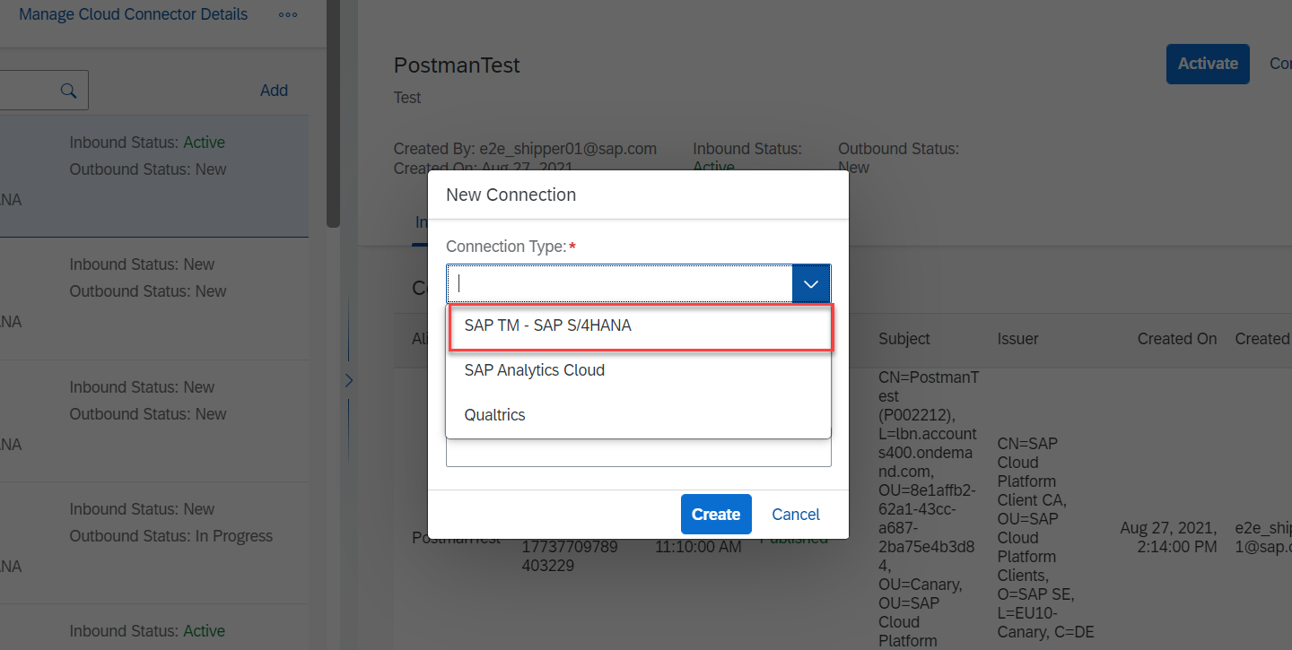

1. Enter the Connection ID and System ID.

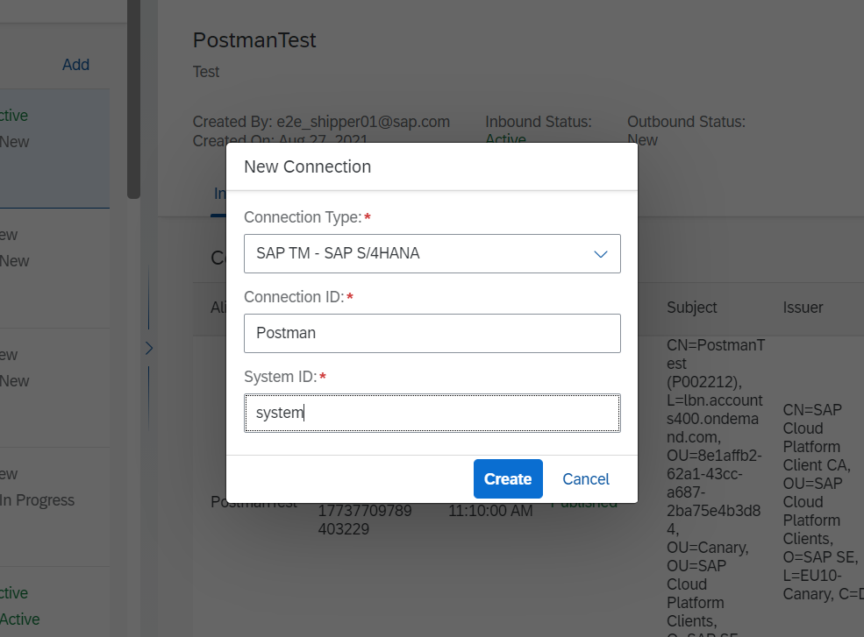

1. Choose **Create**.

The system creates a connection.

1. On the connection details page, choose **Add**.

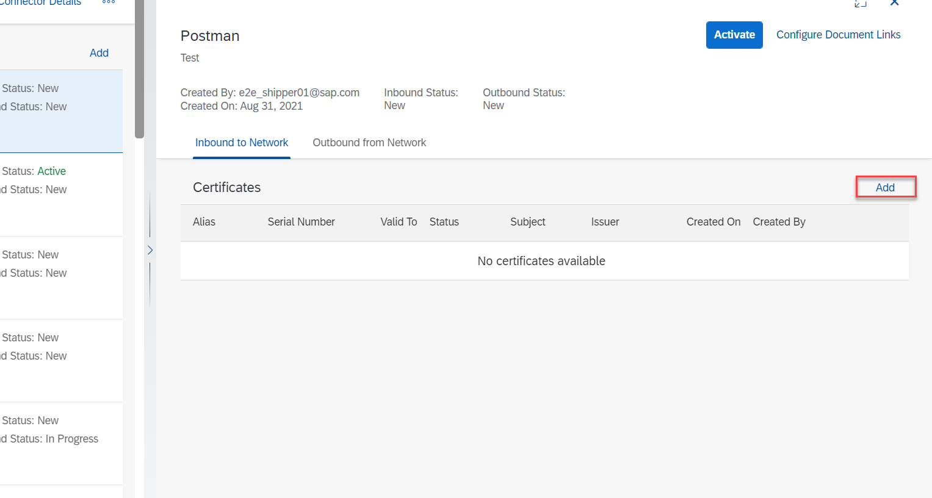

1. Enter an **Alias**.

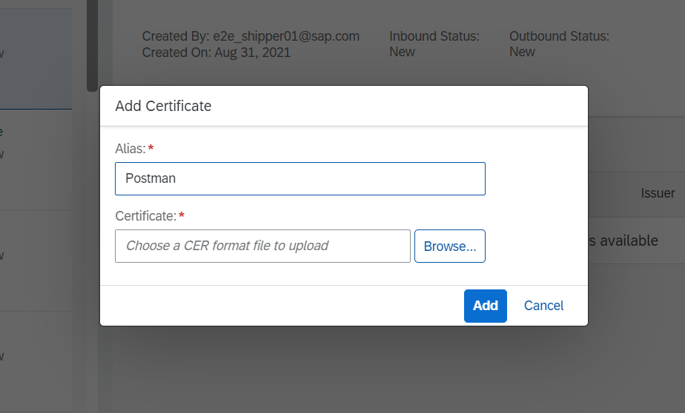

1. Browse for a certificate and choose **Add**.

Note that the certificate you upload must be in .cerformat. To convert the certificate file in .cer format, you can use tools such as KeyStoreExplorer.

1. Choose **Activate**.

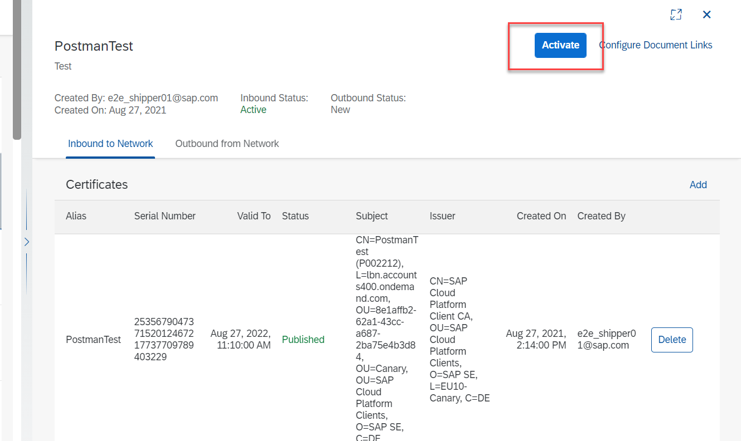

## Configure Certificate-Based Authentication in Postman

1. Choose the settings icon and choose **Settings**.

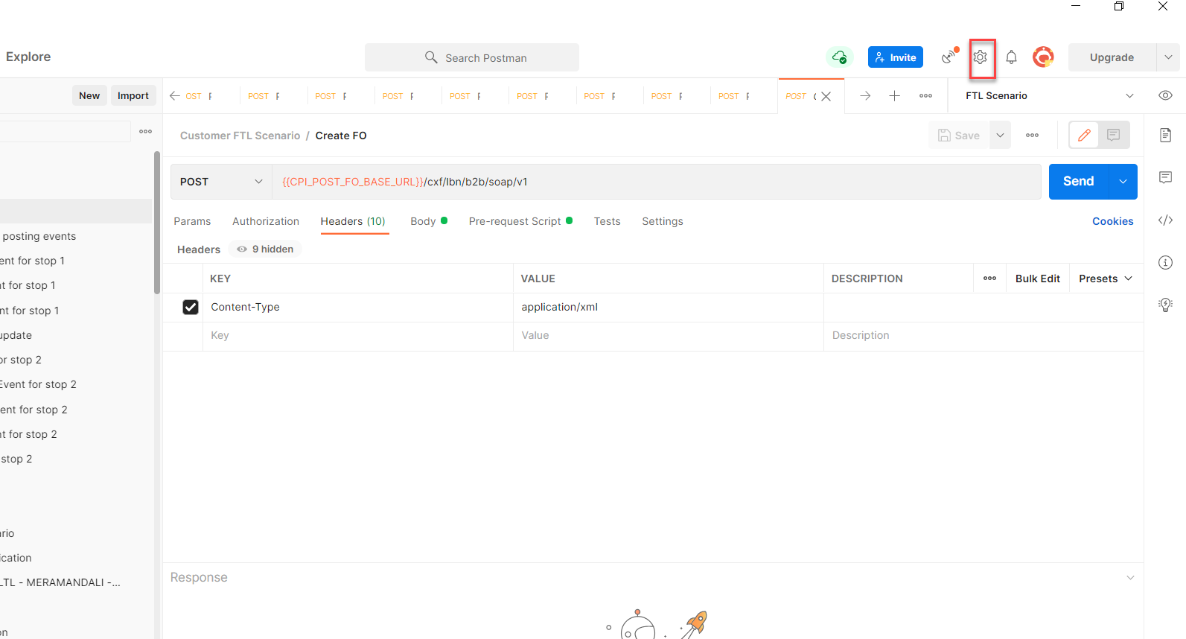

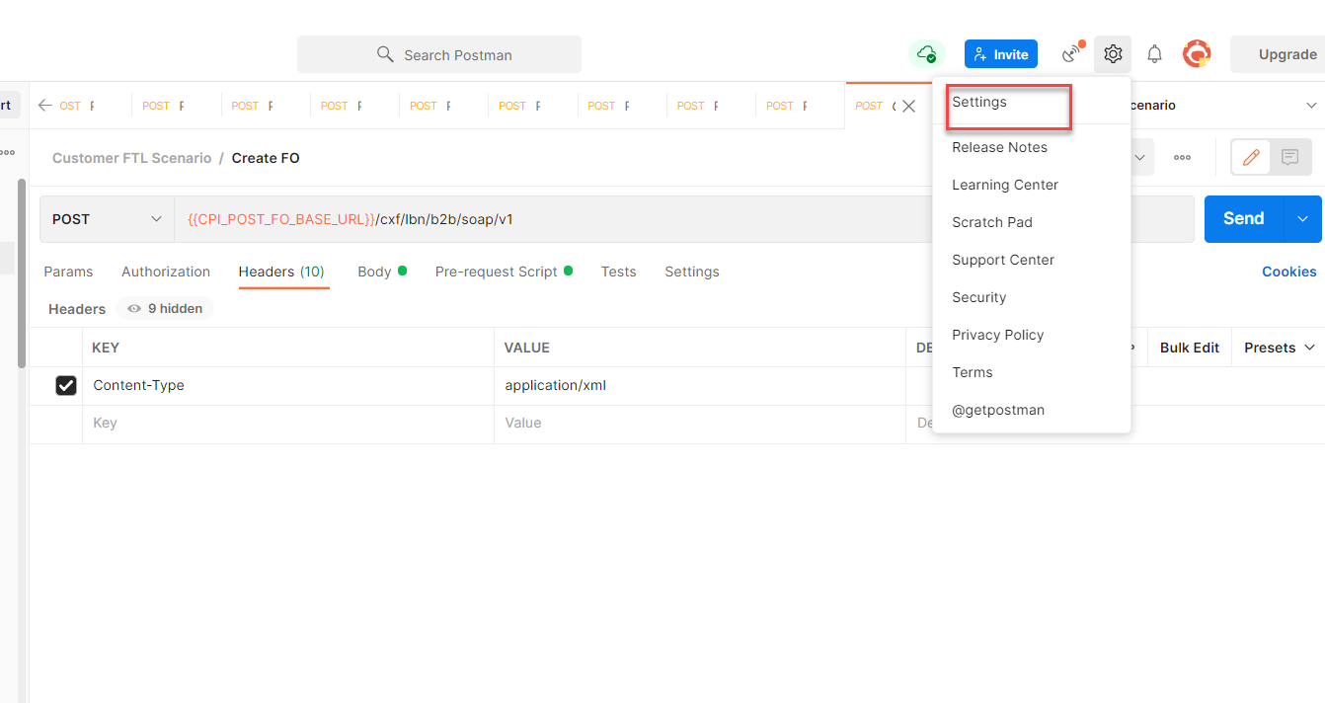

1. On the settings dialog box, navigate to the **Certificates** tab, and choose **Add Certificate**.

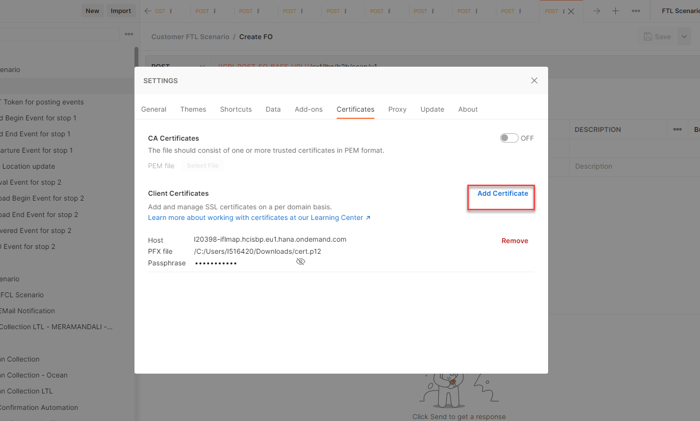

1. Enter the host name as l20398-iflmap.hcisbp.eu1.hana.ondemand.com. Upload the .p12 file in the PFX file along with the passphrase used while creating the certificate.

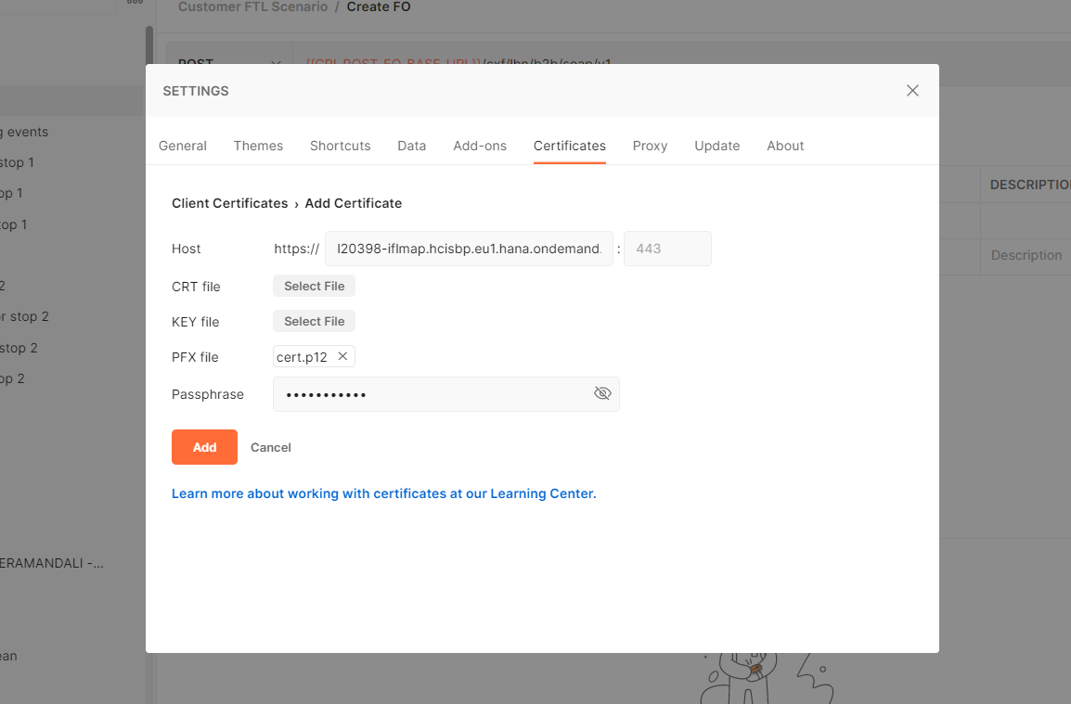

1. Choose **Add**.