Increased top-down controls on terrestrial productivity across the Pleistocene-Holocene transition
Vidal-Cordasco, M.^{1,2}, Rodrigo-Gámiz, M. ³, García-Alix, Antonio³, Jiménez-Moreno, Gonzalo³, Camuera, Jon⁴, Manica, A.¹.
¹ Department of Zoology, University of Cambridge, Cambridge, United Kingdom
²EvoAdapta I+D+I Group, Dpto. Ciencias Históricas, Universidad de Cantabria. Av. Los Castros 44, 39005, Santander, Spain
³ Department of Stratigraphy and Paleontology, University of Granada, Spain
⁴Andalusian Earth Sciences Institute (IACT), Spanish National Research Council (CSIC), Armilla, Granada, Spain
Corresponding author: 1) Vidal-Cordasco, M. (mav54@cam.ac.uk)
Abstract
The capacity of terrestrial ecosystems to support biodiversity and human populations depends on Net Primary Productivity (NPP), yet robust reconstructions of past NPP remain challenging. Using a global dataset of branched glycerol dialkyl glycerol tetraethers (brGDGTs)—bacterial membrane lipids sensitive to climate, soil properties, and vegetation structure—we show that the relative abundance of individual brGDGTs provides a reliable molecular proxy for reconstructing NPP across terrestrial ecosystems, achieving accuracy comparable to satellite-derived estimates. This enables reconstruction of past terrestrial ecosystem productivity and its deviation from climate-potential NPP. Applied to a paleolake record from southern Iberia, the method reveals a deficit between climate-potential and actual NPP that progressively increased from the Gravettian to the Neolithic, coinciding with regional human population growth and rising charcoal concentrations. These results indicate a strengthening of top-down controls on primary productivity across the Pleistocene–Holocene transition, with implications for mammalian biomass distribution and human carrying capacity.

The capacity of vegetation to capture solar energy and fix carbon governs energy flow through terrestrial ecosystems. Net Primary Productivity (NPP), which quantifies the rate at which plants accumulate biomass per unit area and time, underpins biodiversity ^{1–3}, resource availability ⁴, carrying capacity⁵ and carbon cycling ⁶. Consequently, reconstructing fluctuations in NPP is essential for assessing how bottom-up changes propagate through food webs and influence ecosystem stability. However, robust quantification remains challenging, particularly for past ecosystems.
The difference between potential and actual NPP (i.e., ΔNPP), also called Human Appropriation of NPP, is a widely used metric to quantify human impacts on terrestrial ecosystems nowadays⁷. Potential NPP is commonly estimated using climate-based models that use temperature and precipitation as primary predictors^{8–10}. While these models often overestimate productivity⁹, they provide useful approximations of the potential NPP a region can sustain. In contrast, actual NPP is challenging to quantify because it cannot be measured directly at large spatial scales⁶. Remote sensing approaches have become the standard, combining satellite-derived vegetation properties with meteorological data¹¹ to reconstruct actual NPP. However, this solution is not possible for archaeological timescales and, as a result, despite increasing interest in reconstructing how fluctuations in NPP affected human societies^{12–16}, all existing reconstructions still rely on potential NPP estimates.
Branched glycerol dialkyl glycerol tetraethers (brGDGTs) are bacterial membrane lipids abundant in soils, lakes, rivers, peat deposits, and marine sediments^{17–19}. The fifteen most abundant brGDGTs consist of two alkyl chains attached to glycerol molecules through ether bonds²⁰. These compounds differ in the number (4–6) and position (5, 5′, 6, 6′) of methyl groups, as well as in the presence and number (0–2) of cyclopentane rings along the alkyl chains (Supplementary Figure 1)²⁰. The degree of cyclization (CBT’) and methylation (MBT and MBT’5_{ME}) correlate with mean annual temperature and soil pH, making brGDGTs valuable proxies for paleoclimate reconstruction^{19–23}. Recent studies, however, show that brGDGT distributions are also influenced by a broad range of factors closely linked to NPP, including soil temperature and moisture during the growing season^{24,25}, precipitation²⁶, vegetation structure²⁷, soil chemistry and nutrient availability^{21,28}. If brGDGTs prove to be reliable proxies for reconstructing actual NPP, they could offer a novel approach to overcoming key limitations in existing NPP reconstruction methods.
This study has two objectives: (1) to assess the reliability of brGDGTs as a proxy for reconstructing actual NPP, and (2) to apply this proxy to a continental sedimentary sequence, the Padul paleolake record, to reconstruct past NPP fluctuations and evaluate their impacts during the Pleistocene-Holocene transition. To achieve these goals, we first quantified the relationship between NPP and brGDGT distributions using a global dataset of 2,234 modern samples and analysed the environmental, climatic, and edaphic factors driving this relationship. We then trained a Random Forest model to predict NPP from brGDGTs across multiple terrestrial settings, including soils, peat, and lacustrine sediments. Model performance was evaluated through 1) random five-fold cross-validation, 2) nested spatial cross-validation, and 3) against 107 independent in-field NPP measurements from 22 sites worldwide. Predictions were also compared with estimates from the MOD17A3 remote sensing product²⁹. To reconstruct past ecosystem productivity, we applied the brGDGTs-NPP model to the Padul paleolake sediment record, spanning 27–5 kyr BP. Palynology-derived annual temperature and precipitation were used to estimate potential NPP, while actual NPP was inferred from brGDGT distributions. The difference between climate-derived and brGDGT-derived NPP was then compared with charcoal concentrations in the paleolake’s sediments and with the regional archaeological record. To evaluate the extent to which reconstructed NPP fluctuations could propagate through the food chain and influence human carrying capacity, we quantified biomass fluxes across the terrestrial mammalian trophic network, incorporating both bottom-up and top-down dynamics (see Methods for details). This enabled us to determine whether, and to what extent, NPP fluctuations and the restructuring of mammalian communities at the end of the Late Pleistocene can account for observed changes in human demography and subsistence strategies.

RESULTS
brGDGT patterns along NPP gradients

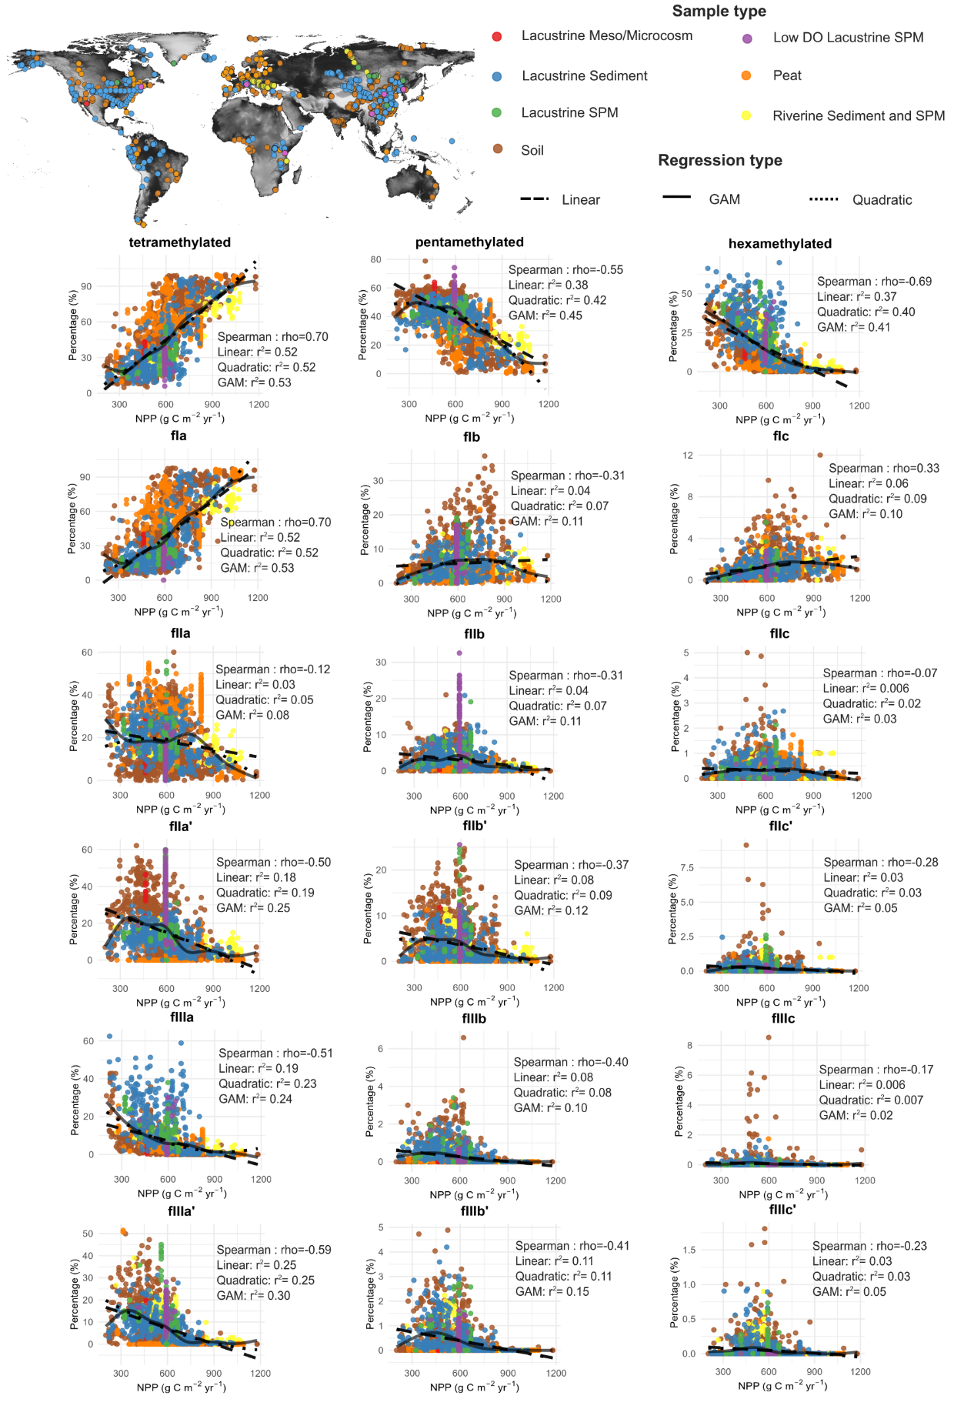
Figure 1. Relationship between Net Primary Productivity (NPP) and relative abundances of individual branched glycerol dialkyl glycerol tetraether (brGDGT) fractions. (a) Geographic distribution of brGDGTs measurements. (b) Scatterplots showing the relative abundances of tetra-, penta-, and hexamethylated brGDGTs, including individual isomers, plotted against NPP. Points are coloured by sample type. Spearman correlation coefficient (rho) and coefficients of determination (r²) for linear, quadratic, and Generalised Additive Models (GAMs) are reported. Complete information, including associated p-values for all correlations, is provided in Supplementary Table 1.
To evaluate the relationships between relative abundance of individual brGDGT and NPP, we used Spearman correlation tests, linear and quadratic regressions, and Generalized Additive Models (GAM), corresponding to monotonic, linear, U-shaped, and flexible nonlinear response patterns, respectively. All brGDGT compounds show significant, nonlinear relationships with NPP (Fig. 1 and Supplementary Table 1). BrGDGTs containing at least one cyclopentane moiety (b- and c-type compounds) and the 6-methyl isomers generally display a unimodal, hump-shaped distribution along the NPP gradient, whereas the non-cyclized 5-methyl isomers (Ia, IIa, IIIa) show monotonic responses, with Ia increasing and IIa and IIIa decreasing with NPP. At the group level, the fractional abundance of tetramethylated brGDGTs rises exponentially with NPP, while penta- and hexamethylated brGDGTs decline.
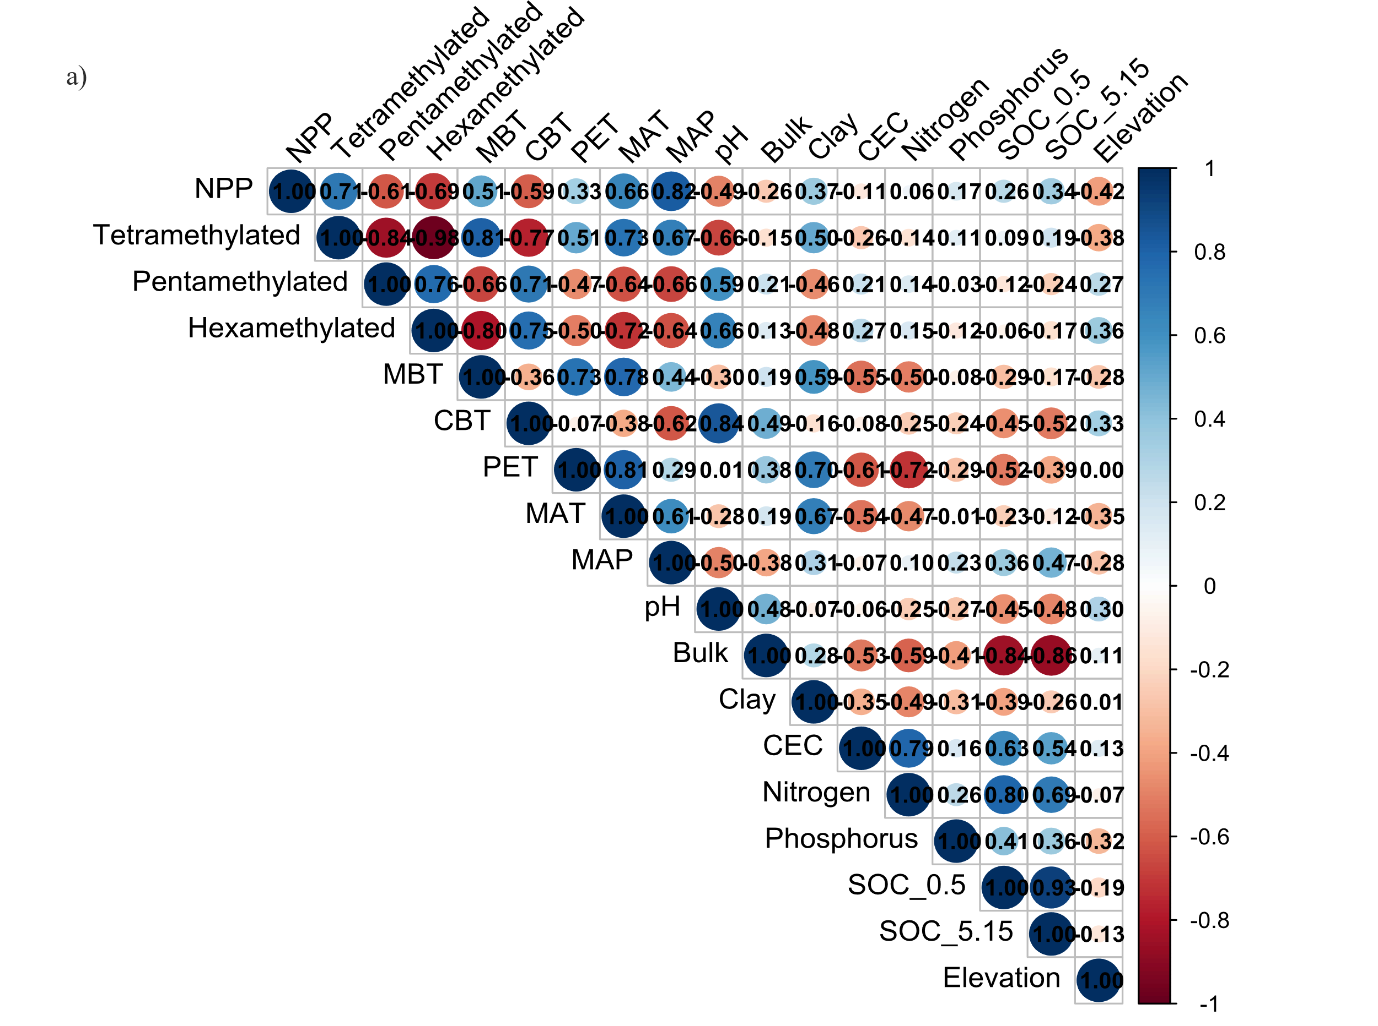
Fig 2. Relationships between environmental, climatic, and edaphic factors and Net Primary Productivity (NPP). Spearman correlation matrix showing associations between NPP, brGDGT, climatic variables and soil properties.
Tetramethylated brGDGTs are more abundant in acidic, clay-rich soils and in regions with higher mean annual temperature, precipitation, and potential evapotranspiration, whereas penta- and hexamethylated brGDGTs are more prevalent in cooler, drier environments with soils characterised by higher pH, lower cation exchange capacity (CEC), and reduced organic content (SOC) (Fig. 2). Spearman correlation coefficients between brGDGT groups and mean annual temperature (MAT) and precipitation (MAP) (rho = 0.64–0.73) are similar to those observed with NPP (rho = 0.61–0.71), indicating that brGDGT distributions capture a similar fraction of NPP variability as they do of climate.
The methylation index (MBT’5_{ME}) is positively correlated with mean annual temperature (MAT; rho= 0.77), precipitation (MAP; rho= 0.44), evapotranspiration (PET; rho= 0.73), and soil clay content (Clay; rho= 0.59), all of which are positively associated with NPP (Fig. 2). MBT’5_{ME} is negatively correlated with soil pH (rho= -0.30), cation exchange capacity (CEC; rho= -0.55), and elevation (rho= -0.28), factors that are also negatively correlated with NPP. These correlations suggest that higher MBT’5_{ME} values reflect the accumulation of less methylated brGDGTs in soils experiencing warmer, wetter conditions and higher clay content, which promote greater productivity. In contrast, the cyclization index (CBT’) is higher under conditions that constrain NPP. CBT’ increases with soil pH (rho= 0.84) and bulk density (rho= 0.49) and decreases with precipitation (rho= -0.62), temperature (rho= -0.38), clay content (rho= -0.16), phosphorus (rho= -0.24), and organic content (SOC; rho= -0.52). As pH and bulk density are negatively correlated with NPP while the other factors show positive associations, the overall negative correlation between CBT’ and NPP (rho= -0.59) reflects lower CBT’ values in soils that support higher productivity (Fig. 2).
These results indicate that tetramethylated brGDGTs and MBT’5_{ME} are positively associated with climatic and edaphic factors that promote higher NPP, including mean annual temperature, precipitation, evapotranspiration, bulk density, and soil clay, phosphorus, and organic content. In contrast, penta- and hexamethylated brGDGTs and CBT’ are negatively correlated with these same factors (Supplementary Figure 2). These patterns suggest that brGDGT distributions capture the combined influence of key soil and climate variables on Net Primary Productivity.

NPP prediction based on brGDGTs
A Random Forest model was trained to predict NPP from compositional, centered log-ratio (CLR)-transformed brGDGT fractions (see Methods for details). Model performance was evaluated in three steps. First, the model was assessed using conventional random five-fold cross-validation. Second, geographic transferability was tested using nested spatial cross-validation, in which the data were partitioned into spatial blocks at scales of 50, 100, 500, and 1000 km. During each of the five folds, entire geographic blocks were sequentially excluded from the training dataset and reserved for testing, providing an assessment of model performance when applied to unsampled regions. Finally, model predictions were evaluated against an independent set of in-field NPP measurements that were not included in model training (see Methods for details).
Validation | Block size | Summary | S  (n=1045) | LS  (n=388) | P  (n=383) | SPM  (n=418) | All  (n=2234)
Random cross-validation | - | r | 0.81 | 0.81 | 0.87 | 0.92 | 0.86
Random cross-validation | - | r² | 0.65 | 0.66 | 0.76 | 0.85 | 0.74
Random cross-validation | - | RMSE | 93.3 | 91.4 | 99.5 | 64.8 | 89.48
Nested spatial cross-validation | 50 | r | 0.75 | 0.78 | 0.73 | 0.82 | 0.78
Nested spatial cross-validation | 50 | r² | 0.56 | 0.61 | 0.53 | 0.68 | 0.61
Nested spatial cross-validation | 50 | RMSE | 104 | 98.1 | 139 | 96.9 | 109
Nested spatial cross-validation | 100 | r | 0.75 | 0.77 | 0.75 | 0.78 | 0.78
Nested spatial cross-validation | 100 | r² | 0.56 | 0.60 | 0.57 | 0.64 | 0.61
Nested spatial cross-validation | 100 | RMSE | 103 | 100 | 134 | 102 | 109
Nested spatial cross-validation | 500 | r | 0.72 | 0.71 | 0.70 | 0.74 | 0.71
Nested spatial cross-validation | 500 | r² | 0.51 | 0.56 | 0.49 | 0.54 | 0.51
Nested spatial cross-validation | 500 | RMSE | 109 | 113 | 148 | 119 | 118
Nested spatial cross-validation | 1000 | r | 0.70 | 0.77 | 0.66 | 0.80 | 0.71
Nested spatial cross-validation | 1000 | r² | 0.50 | 0.59 | 0.44 | 0.64 | 0.51
Nested spatial cross-validation | 1000 | RMSE | 112 | 101 | 159 | 101 | 116
Table 1. Random Forest model performance by sample type after random and nested spatial cross-validation. n = number of samples; r = correlation coefficient between predicted and observed NPP; r² = coefficient of determination; RMSE = root mean square error (g C m⁻² yr⁻¹). S = soil; LS = lacustrine sediment; P = peat; SPM = riverine or lacustrine suspended particulate matter.
The Random Forest model showed consistent predictive performance across sample types under random cross-validation, with correlation coefficients (r) ranging from 0.81 to 0.92 and coefficients of determination (r²) between 0.65 and 0.85 (Table 1). When evaluated across the entire dataset, the model achieved an r² of 0.74 with an RMSE of 89.5 g C m⁻² yr⁻¹. In contrast, nested spatial cross-validation revealed a progressive decline in model performance with increasing block size: correlation coefficients fell from 0.78 to 0.71, and coefficients of determination declined from 0.61 to 0.50 as block sizes increased from 50 km to 1000 km. This trend was consistent across individual sample types, suggesting that the brGTGT-NPP relationship primarily reflects a local signal and, therefore, accurate NPP predictions require regional calibration in areas beyond the model’s training data (Fig. 3).

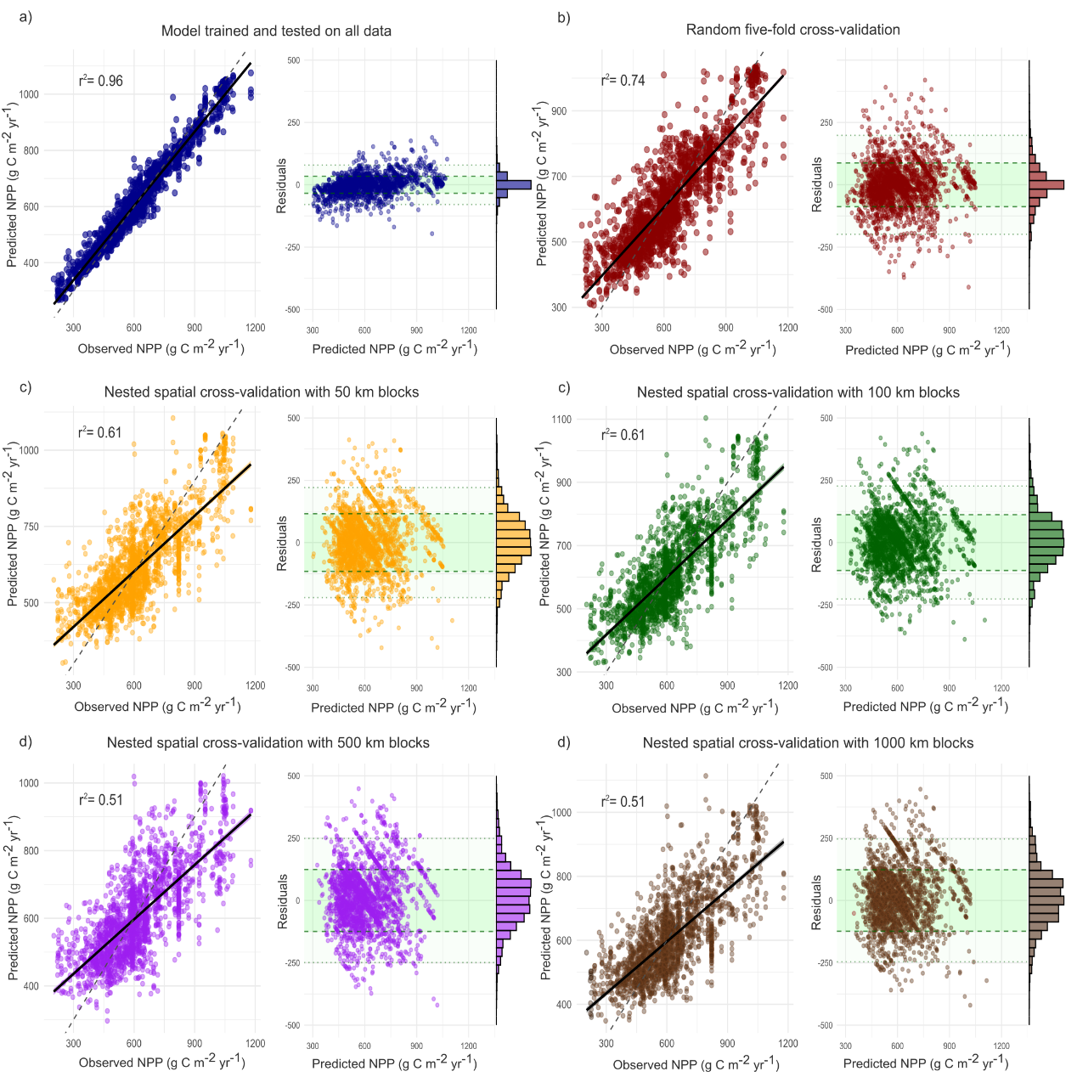
Fig. 3. Observed vs. predicted NPP. (a) Relationship between observed and predicted NPP for the entire dataset according to the Random Forest model trained and tested on all data. (b) Five-fold random cross-validation. Nested spatial cross-validation results are shown for block sizes of 50 km (c), 100 km (d), 500 km (e), and 1000 km (f). To the right of each plot, residuals are plotted against predicted NPP. The green band represents 95% of predictions, and the adjacent histogram shows the frequency distribution of residuals.
Predictions from the brGDGTs-NPP models were evaluated against independent in-field NPP measurements and compared with the MOD17A3 (remote sensing) model (Fig. 4). BrGDGT-based models, whether trained on the full dataset, with random cross-validation, or nested spatial cross-validation in blocks of 50–1000 km, consistently showed good agreement with observations (Fig. 4). Performance metrics included correlation coefficients (r) ranging from 0.88 to 0.89, coefficients of determination (r²) between 0.77 and 0.79, and RMSE values between 210 and 221 g C m⁻² yr⁻¹ (Fig. 4). MOD17A3 performed similarly (r = 0.89, r² = 0.79) but its RMSE (291.7 g C m⁻² yr⁻¹), was between 32% and a 39% higher than that of the brGDGTs models. Excluding sample type from the brGDGT-NPP model’s predictors had minor impact on both performance and predictions (Supplementary Figure 3). These results indicate that, regardless of the depositional environment, brGDGTs provide a reliable proxy for predicting actual NPP in terrestrial ecosystems, with an accuracy comparable to that of conventional satellite-based models.
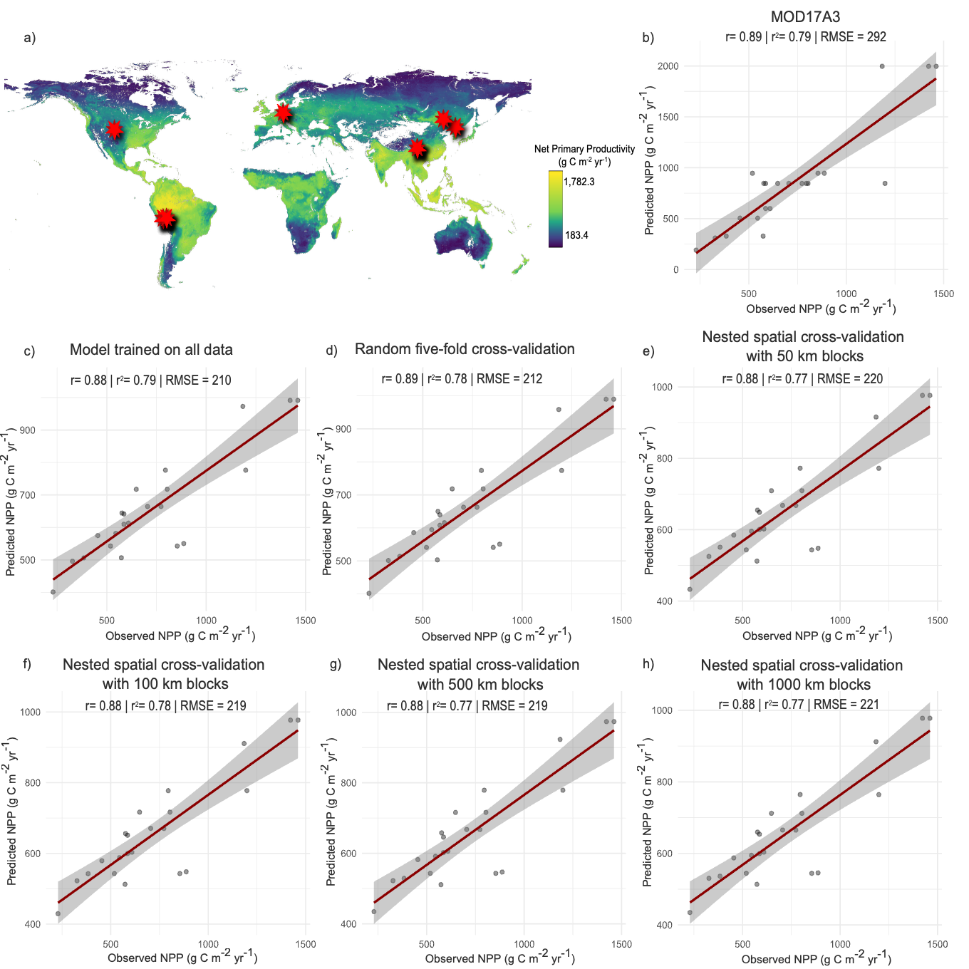
Fig. 4. Observed versus predicted NPP based on independent in-field measurements. (a) Map of Net Primary Productivity (NPP) used as the dependent variable in the Random Forest models³⁰. Red stars indicate sites where both brGDGTs and in-field NPP measurements were collected to evaluate model performance. Correlations between independently measured NPP and predicted NPP are shown for: (b) the remote sensing NPP model (MOD17A3)²⁹, (c) the brGDGT Random Forest model trained on all data, (d) trained and tested with five-fold random cross-validation, and nested spatial cross-validation with block sizes of (e) 50 km, (f) 100 km, (g) 500 km, and (h) 1000 km.

NPP at Padul lake.

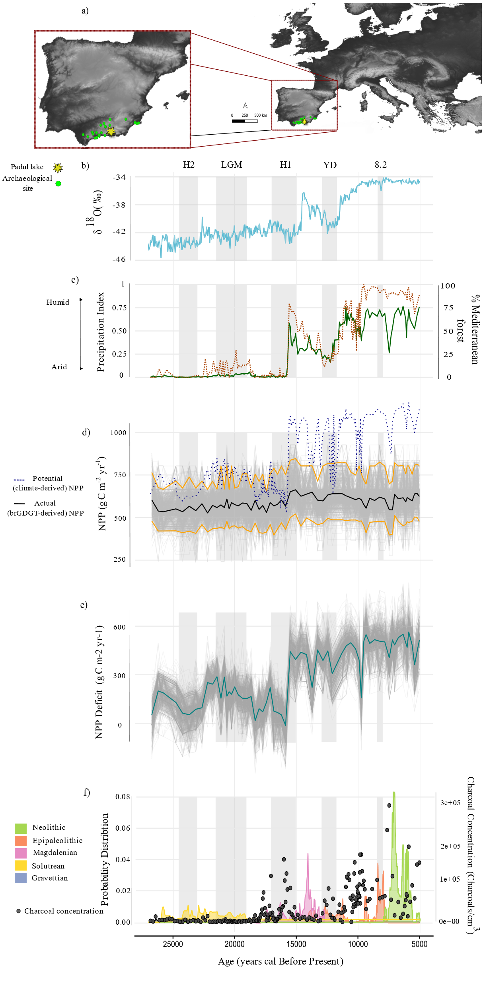
Fig. 5. Ecosystem productivity during the Late Pleistocene–Holocene transition, 27-5 kyr cal BP. a) Location of Padul lake and regional archaeological sites used to construct Summed Probability Distributions (SPDs). b) δ¹⁸O record from the NGRIP ice core^{31,32}. c) Percentage of Mediterranean forest reconstructed and Precipitation index reconstructed from the Padul palynological record (15-05³³). d) Random Forest predictions of NPP based on brGDGTs from Padul sediment record. Gray lines show individual tree predictions (n = 1000), the black line shows the mean prediction, yellow lines indicate the 95% confidence interval, and the dashed blue line marks climate-derived NPP. e) Deficit of NPP, calculated as the difference between climate-derived and brGDGT-derived NPP. Gray lines represent differences from individual tree predictions; the green line shows the mean across all trees. f) Summed Probability Distribution (SPD) or archaeological levels in the region, reflecting population density changes by cultural period. Black dots in the second axis reflects the charcoal concentrations in the paleolake sediments.

The brGDGT-NPP model was applied to Padul lake sediment record to estimate past NPP between 27 and 5 kyr cal BP. These estimates were compared with potential NPP (NPP_{POT}) reconstructed from paleotemperature and paleoprecipitation data derived from the lake’s palynological record (see Methods for details). These pollen-based paleoclimate reconstructions were validated against other local and regional paleoclimate reconstructions^{34–37}, showing good agreement (Supplementary Figure 4). To quantify the influence of paleoclimate reconstruction uncertainties on estimates of NPP_{POT}, we performed a Monte Carlo sensitivity analysis in which temperature and precipitation were resampled 1,000 times within their 95% CI. For each iteration, NPP_{POT} was computed to assess the extent to which uncertainties in pollen-based climate reconstructions propagate into NPP_{POT} estimates. The difference between potential (climate-derived) and actual (brGDGT-derived) NPP—i.e., Deficit of NPP—was evaluated against the regional archaeological record through Summed Probability Distribution (SPD) of archaeological levels (see Methods for details).
To evaluate whether changes in the origin of brGDGTs affect NPP_{ACT} estimates, actual NPP was recalculated assuming different source contributions (e.g., lacustrine, riverine, soil). This sensitivity analysis accounts for source shifts —i.e., temporal or sample-to-sample changes in the relative contribution of each source to the brGDGT pool. The results showed small differences in NPP_{ACT} predictions, indicating that such variation in brGDGT source is expected to have a minimal impact on reconstructed NPP_{ACT} (Supplementary Fig 5). When uncertainty propagation was accounted for in computing potential NPP, the 95% CI for NPP_{POT} was twice as large as that for the Random Forest–derived NPP, indicating that brGDGT-based reconstructions substantially reduced uncertainty in NPP estimates (Supplementary Fig 6). In addition, NPP_{ACT} exhibited a significant positive correlation with total pollen concentration (grains/cm³) (r =0.59, p-vale =<0.001) and pollen accumulation rates (grains/cm/yr) (r = 0.55, p-value = <0.001) (Supplementary Fig 7), suggesting that brGDGTs effectively captured fluctuations in past primary productivity. These results indicate that, although brGDGTs may be influenced by factors such as source mixing, diagenesis, or in-lake production, they provide a reliable proxy of past ecosystem productivity.
Between the Gravettian and the Solutrean, the difference between potential and actual NPP was low, with a difference of 114.2 g C m⁻² yr⁻¹ on average (SD = 48.6) (Figure 5). During this cold and dry phase, the small gap between potential and actual NPP indicates that climate was the primary constraint on productivity. Both potential and actual NPP remained relatively stable across these cultural phases (Supplementary Table 2). Nevertheless, in the Magdalenian, increases in temperature and precipitation triggered a substantial expansion of Mediterranean forests around Padul lake and a 17.3% rise in potential NPP. Conversely, actual NPP increased by only 7.9%. This divergence became increasingly pronounced into the Holocene (Figure 6), coinciding with a marked increase in human population size and elevated charcoal concentrations in paleolake sediments during the Epipaleolithic and Neolithic.
Episodes of human population growth and elevated charcoal concentrations are associated with increases in the Deficit of NPP (ΔNPP), while demographic contractions and decreases in charcoal abundance correspond to reductions in ΔNPP (Figure 5). Accordingly, there is a significant positive correlation between ΔNPP and human population size (p-value = 0.003, r = 0.84) and between ΔNPP and charcoal concentration (p-vale <0.001, r = 0.53) (Supplementary Fig. 8). During the Gravettian and Solutrean, NPP_{ACT} fluctuations are not associated with changes in charcoal concentrations; yet, from the Magdalenian onwards, charcoal concentrations show a significant negative correlation with NPP_{ACT} (p-value = 0.01; r = -0.41) (Supplementary Fig. 9). These results indicate that, during the Late Pleistocene-Holocene transition, ecosystem productivity was increasingly influenced by top-down controls that constrained actual NPP.
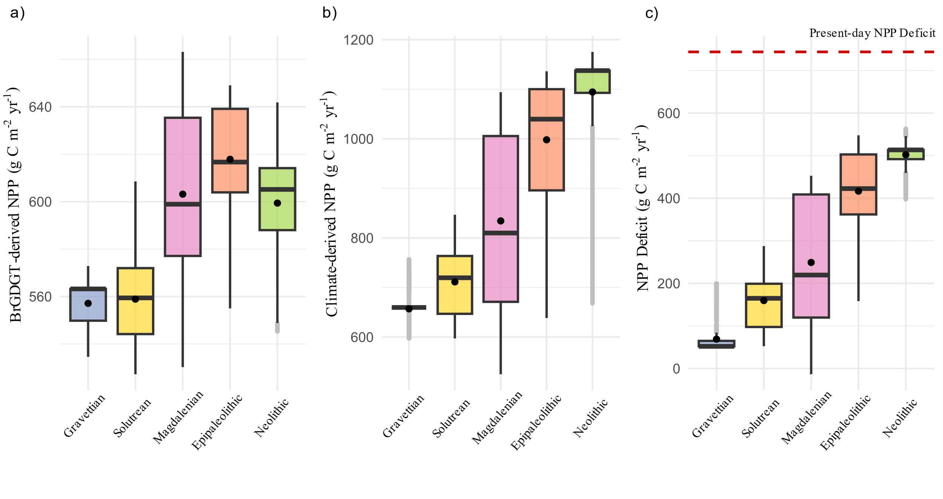
Fig. 6. Net Primary Productivity across cultural phases. Box-and-whisker plots showing (a) brGDGT-derived NPP, (b) climate-derived NPP, and (c) the NPP deficit for each cultural period included in this study.
To evaluate the impact of the NPP deficit (ΔNNP) on primary consumers, herbivore biomass was calculated using (a) the climate-derived NPP (i.e., NPP_{POT}) and (b) the brGDGT-derived NPP (i.e., NPP_{ACT}). In addition, to evaluate the extent to which reconstructed NPP_{ACT} could propagate through the food chain, we quantified biomass fluxes (Supplementary Notes 1 and 2) under two scenarios: (a) using the mammalian community composition documented in the region during the Late Pleistocene, and (b) using the Early Holocene mammalian community structure (Supplementary Note 3).
The NPP deficit (ΔNPP) is estimated to have reduced herbivore biomass, on average, by 55.97% (95% CI = 51.38–60.55) (Supplementary Table 3). Therefore, regardless of its specific drivers, the growing gap between NPP_{POT} and NPP_{ACT} during the Pleistocene-Holocene transition had the potential to markedly affect mammal community biomass.
Across the Late Pleistocene, the composition of the mammal community in the region changed, marked by the disappearance of hyaenas, dholes, and leopards, as well as the end of the intermittent presence of woolly mammoths, steppe bison, and wild asses (Supplementary Note 3; Fig. 7). As a result, large-herbivore biomass declined by 53.7%, while medium-large, medium, and small herbivore biomasses increased by 43.7%, 120.5%, and 128.8%, respectively (Fig. 7; Supplementary Table 4). The effects of this restructuring on human carrying capacity surpassed that associated with NPP fluctuations (Fig. 7). These results suggest that, although the timing of the Pleistocene-Holocene faunal turnover in the region remains uncertain, changes in mammal community composition could outweigh the effects of NPP fluctuations on human carrying capacity.

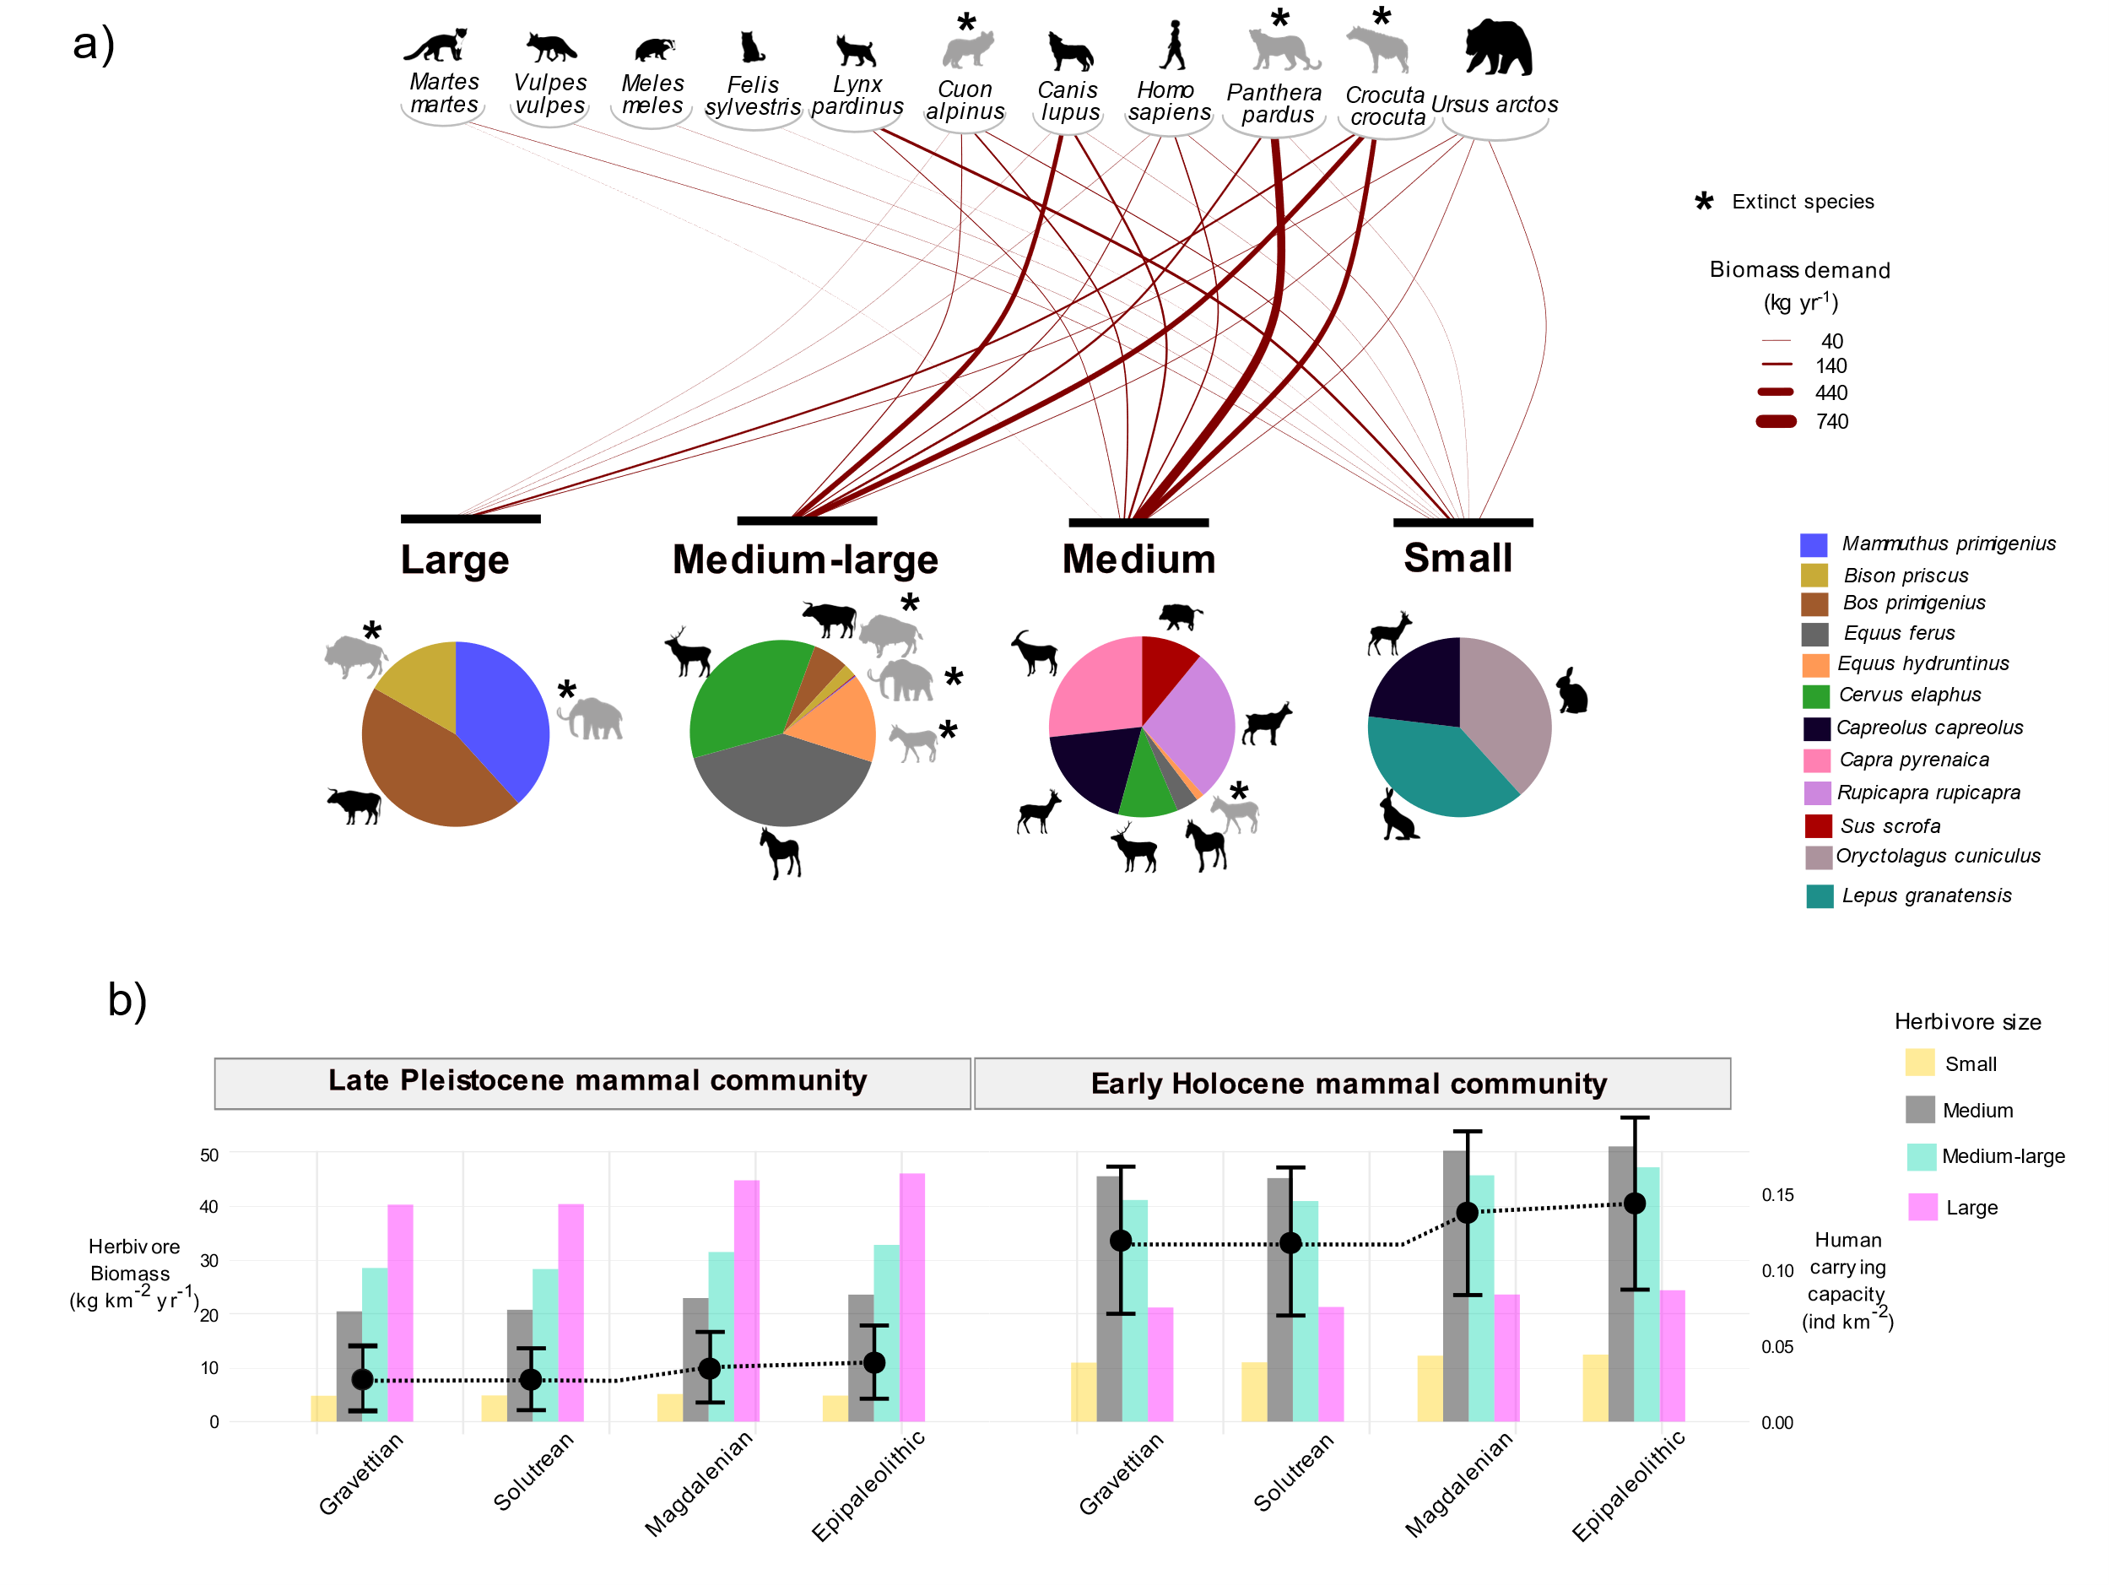
Fig. 7. Top-down and bottom-up effects of NPP fluctuations and megafaunal extinctions on herbivore biomass and human carrying capacity. a) Top: carnivore species and their predatory links on primary-consumer body-size classes (small <10 kg, medium 10–300 kg, medium-large 300–500 kg, large >500 kg). Link width represents demanded biomass based on energetic requirements, dietary meat proportion, and prey preferences (see Supplementary Notes 1 and 2 for details). Bottom: pie charts showing the proportional biomass contribution of each herbivore species to each herbivore body-size class, as estimated from Weibull-derived population structures. b) Biomass of herbivore size classes across cultural periods with a Late Pleistocene and an Early Holocene mammalian community composition; secondary y-axis shows human carrying capacity.

DISCUSSION
Our results indicate that brGDGTs capture substantial variation in NPP across diverse terrestrial ecosystems and under different depositional environments. By linking molecular distributions to productivity drivers, developing a predictive brGDGT–NPP machine learning model, and validating it against independent field measurements, our results indicate that brGDGTs provide a reliable molecular archive for reconstructing NPP in both modern and past terrestrial ecosystems.
BrGDGT distributions respond to changes in both bacterial physiology and community composition^{23,38,39}. Temperature and precipitation are the primary abiotic drivers of NPP, and bacteria can adjust the molecular structure of their membrane lipids in response to climatic conditions^{23,40}. Moreover, bacterial diversity in soils—and thus community composition—represents a key biotic influence on terrestrial primary productivity⁴¹. While the mechanisms linking climate, soils, NPP, and brGDGTs are multiple, our results indicate that brGDGTs capture the main environmental controls on NPP, explaining a comparable proportion of variance to that observed for temperature. Although brGDGTs are well established as proxies in paleoclimate reconstructions, their potential for estimating NPP has remained unexplored. Here we show that brGDGTs record the coupled influences of climate, soil properties and vegetation through their effects on bacterial membrane lipids, thereby linking molecular signatures to primary productivity across terrestrial ecosystems.
In addition to temperature and precipitation, soil clay content, bulk density and pH affect the physical and chemical environment available for plant growth^{42–44}. Clay enhances water and nutrient retention and supports biomass accumulation under non-water-limited conditions^{42,43}, whereas high bulk density can limit oxygen and water supply to roots, disrupting biogeochemical cycling and constraining NPP⁴⁵. Likewise, soil pH is a key regulator of nutrient availability and microbial activity⁴⁶, both of which are critical for NPP^{41,44}. However, soil nitrogen and phosphorus contents showed the weakest correlations with both brGDGTs and NPP. This likely reflects that, although these nutrients are essential for plant productivity⁴⁷, their relative importance varies with ecosystem type, development stage and maturity⁴⁸, and nutrient interactions⁴⁹, potentially masking their effects at the global scale. While these results underscore the need for future studies to examine nutrient effects at finer spatial scales, they also highlight the dominant influence of climatic and edaphic factors in regulating NPP and shaping brGDGT distributions across broad spatial gradients.
Bacteria that produce brGDGTs get their energy from labile organic substrates⁵⁰, and the diversity and composition of bacterial communities in the rhizosphere are influenced by root exudates from plants⁵¹. Higher NPP further increases leaf and root litter deposition, promoting nutrient cycling and increasing the availability of organic matter, which in turn modulates bacterial community composition²⁷. These mechanisms have been proposed to explain recent observations that plant cover can alter brGDGT distributions^{27,39,52}. Our results align with these findings, showing that the fractional abundance of tetramethylated brGDGTs increases under climatic and edaphic conditions associated with higher plant biomass—warmer, wetter environments with soils that are more acidic, less compacted, and richer in clay, phosphorus, and organic matter—whereas penta- and hexamethylated brGDGTs decrease under the same conditions.
Current approaches for estimating NPP in past ecosystems typically rely on paleoclimate reconstructions using temperature and precipitation as main paleoenvironmental proxies^{12,13,53–56}. This reliance introduces three major sources of uncertainty: (a) paleoclimate reconstructions carry inherent and often large margin errors; (b) NPP models add an additional layer of uncertainty; and (c) these uncertainties are further amplified by uneven temporal resolution, as chronological uncertainties commonly hinder precise correlation between paleoclimate records and archaeological assemblages. The approach presented here overcomes these limitations by enabling direct reconstruction of NPP from archaeological and natural archive sediments using brGDGTs, achieving accuracy comparable to modern satellite-based estimates and capturing actual rather than potential NPP.
The Marine Isotope Stage (MIS) 2 (ca. 27–14.6 kyr cal BP) was characterised by cold temperatures, dry conditions, and the predominance of tundra and steppe environments in Europe^{57–61}. Although southern Iberia was less severely affected and has been proposed as a climate refugium during the Last Glacial^{36,62}, regional paleoenvironmental records show that it also experienced cold and arid conditions during stadial phases^{34,63}. Consistently, pollen records from Padul lake indicate predominantly open, low-arboreal landscapes with relatively dry conditions, reflected in the dominance of xerophilous (e.g., Artemisia, Ephedra, Amaranthaceae) over mesophilous (e.g., deciduous Quercus)^{33,64} taxa. Despite these cold and arid conditions, Pleistocene ecosystems around Padul sustained a high diversity of large mammals during the Late Pleistocene, such as mammoths, bison, or hyenas^{65–68}. Under comparable climate conditions, such megafauna diversity is absent in modern ecosystems, a phenomenon known as the ‘productivity paradox’⁶⁹. This paradox has been attributed to efficient nutrient recycling by megafauna, whereby their influence on vegetation structure and carbon and nutrient flows enhanced primary productivity⁷⁰. In addition, it has been proposed that the presence of a richer secondary consumer guild during the Late Pleistocene compared to the Holocene likely exerted top-down control, regulating the effects of herbivory on actual plant biomass^{69,70}. Consistent with this hypothesis, our results show a small between potential and actual NPP during MIS2 in Padul, indicating that ecosystem productivity was close to its climatic potential.
After the Heinrich Event 1, Padul lake experienced rising temperatures and precipitation, consistent with the abrupt climate amelioration and forest expansion observed across Europe^{31,58}. During the Bølling–Allerød interstadial, these climatic changes were accompanied by shifts in land cover, including an increased presence of woody species and expansion of Mediterranean forests^{33,63}. Concurrently, the difference between potential and actual NPP increased. This increase in the NPP deficit (ΔNPP) coincided with rising charcoal concentrations and human population growth during the Magdalenian, a pattern observed across both the Iberian Peninsula⁷¹ and Europe⁷². In southern Iberia, during the Magdalenian and Epipaleolithic, humans diversified their diet by increasing the consumption of smaller prey (e.g., rabbits) and intensifying the exploitation of marine resources^{67,73,74}. These shifts in human subsistence strategies have traditionally been interpreted as reflecting intensified human pressure on ecosystems^{75,76}. However, the association between ΔNPP and human demography does not necessarily imply a direct anthropogenic impact on vegetation.
Although prehistoric hunter-gatherer societies exerted substantial impacts on land cover through burning or deforestation in some regions, particularly since the Last Glacial Maximum^{77–80}, no evidence of forest clearance has been found in south-eastern Iberia during the Late Pleistocene or Early Holocene⁷⁹. In this context, the increase in charcoal concentrations in the Padul record does not necessarily indicate an anthropogenic cause, but could also reflect natural fire regimes that became more common during interglacial periods, when plant biomass was higher⁸¹. Regardless of the agency in the fire and charcoal accumulations, the negative association between charcoal concentrations and NPP_{ACT} (Supplementary Fig. 9) indicates that brGDGT-derived NPP may capture the impact of fire on actual plant biomass and, therefore, serve as a proxy for quantifying the magnitude and ecological impacts of past fires.
Results from this study indicate the extent to which the deficit between potential and actual NPP may have affected herbivore biomass; however, its magnitude depended on the structure and composition of the mammal community. Predatory pressure cascades downward through trophic levels, regulating the abundance of herbivores and plants⁸², while large herbivores often constrain smaller herbivore populations through competition for space and resources^{83,84}. In this connection, results obtained in this study show that the Late Pleistocene mammal turnover triggered cascading effects, leading to trophic release and remarkable increment in the biomass of smaller primary consumers^{84,85}. This would not only have intensified top-down herbivory pressure on vegetation but also increased human carrying capacity by increasing the available biomass of smaller prey. As a result, the increase in biomass of small- and medium-sized herbivores, larger human populations, and changes in fire regimes during the Late Pleistocene–Holocene transition strengthened top-down controls on terrestrial productivity.
Pollen and brGDGTs can have different responses to environmental changes, which could result in a lag in their response, differences in the geographic range of the signal they capture, or variations in the magnitude of the reconstructed signal when used for paleoclimate reconstruction. Therefore, in addition to validating the pollen-based paleoclimate reconstructions with other previous local and regional paleoclimate reconstructions^{34–36} (Supplementary Fig. 4), we assessed whether the reconstructed deficit of NPP is biased by the paleoclimate reconstruction method. Thus, NPP_{POT} was also calculated using temperature and precipitation data from two different general circulation models: the HadCM3B-M2.1³⁷ and the CHELSA-TraCE21k⁸⁶ models (for details, see Methods). The resulting deficit of NPP, despite changing in absolute terms, shows the same temporal trends and proportional increases across the Pleistocene-Holocene transition as those observed when reconstructed from the pollen record (Supplementary Figure 10). This indicates that the observed NPP deficit is robust to uncertainties in current paleoclimate reconstructions.

While this study provides a novel framework for reconstructing past ecosystem productivity, several avenues for future research remain. First, although the brGDGT–NPP model was validated across diverse environments, some variability in NPP is not captured by the model. Further investigation into the mechanistic links between soil bacterial communities and NPP, potentially through the integration of additional covariates related to plant cover or vegetation structure, could enhance predictive performance. Second, the results indicate that brGDGTs are influenced by local environmental and edaphic conditions; therefore, caution is required when applying the model to areas distant from the training dataset. For regions not included in the training data, additional regional calibrations are recommended. On the other hand, the application of our model to the Padul paleolake sedimentary record reflects NPP at the lake catchment scale, which we interpret as a regional proxy; extending this approach to sedimentary archives directly associated with archaeo-paleontological levels would help bridge this spatial gap. Finally, while our study quantifies the impact of NPP fluctuations on trophic resource availability for secondary consumers and their carrying capacity, the resolution of the regional archaeo-paleontological record limits precise chronologies for the Late Pleistocene-Early Holocene fauna turnover. Refining these timelines would enable more accurate reconstructions of past trophic cascades. Notwithstanding these caveats, this study highlights the need to expand climate-based NPP reconstructions to disentangle the relative effects of climate, environmental changes, and human activities on past ecosystem productivity, and provides a validated methodology to achieve this.

METHODS
Global brGDGT Dataset
A recently compiled global dataset of modern brGDGTs samples was used in this study^{22,23}. Only samples analysed with the most recent chromatographic methods that separate 5- and 6-methyl isomers were included. The 7-methyl^{87,88} compound was excluded due to insufficient published data. In this study, we used samples obtained from lacustrine (n=946), riverine sediment and suspended particulate matter (SPM) (n=135), peat (n=427) and soil (n=1293) sediments. Each sample is associated with its geographic coordinates, soil pH, and the relative abundance (%) of each brGDGT compound.
Net Primary Productivity at these locations was obtained from a recently validated machine learning model trained on a global observational dataset at a spatial resolution of 0.05°³⁰. This model incorporated 32 environmental variables, including nine soil variables, 20 climatic variables, and three vegetation variables: Leaf Area Index (LAI), Normalized Difference Vegetation Index (NDVI), and Fraction of Absorbed Photosynthetically Active Radiation (FAPAR). NDVI data were derived from multiple NOAA AVHRR sensors covering 1981–2015, while LAI and FAPAR were obtained from the Global Land Surface Satellite (GLASS) product, spanning 1981–2018 (for details, see ³⁰).
In addition to NPP, climate and environmental variables were extracted from raster layers at the sample coordinates, including mean annual temperature (MAT, ºC) and precipitation (MAP, mm/yr)⁸⁹, potential evapotranspiration (PET, mm/day)⁹⁰, elevation (m.a.s.l.)⁹¹, soil clay content (%), bulk density (kg/m³)⁹² and cation exchange capacity (CEC, cmol(+)/kg)⁹², total soil nitrogen (cg/kg)⁹³, soil phosphorus retention potential (mg/kg)⁹³ and soil organic content (SOC) at 0-5cm and 5-15 cm depth⁹³.
Linking brGDGTs to NPP: mechanisms, prediction, and validation
From the measured brGDGT compounds, the Cyclisation of Branched Tetraethers (CBT’) was computed according to Eq. 1 ¹⁹ and the Methylation of Branched Tetraethers (MBT’_{5ME}) according to Eq. 2¹⁹:
Eq. 1 $CBT'=log10\left(\frac{\left[Ic\right]+\left[IIa'\right]+\left[IIb'\right]+\left[IIc'\right]+\left[IIIa'\right]+\left[IIIb'\right]+\left[IIIc'\right]}{\left[Ia\right]+\left[IIa\right]+\left[IIIa\right]}\right)$
Eq. 2 ${MBT'}_{5ME}=\frac{\left[Ia\right]+\left[Ib\right]+\left[Ic\right]}{\left[Ia\right]+\left[Ib\right]+\left[Ic\right]+\left[IIa\right]+\left[IIb\right]+\left[IIc\right]+\left[IIIa\right]}$
In addition to these indices, we calculated the total relative abundance (%) of tetra-, penta-, and hexamethylated GDGTs. To explore the relationships between NPP, brGDGT distributions, CBT’, MBT’_{5ME}, and the climatic and edaphic factors potentially influencing both brGDGTs and NPP, we applied Spearman’s rank correlation to each pair of variables.
To develop a predictive model of Net Primary Productivity (NPP) from brGDGT distributions, we trained Random Forest regressions using centered log-ratio (CLR)-transformed brGDGT abundances as predictors. Branched GDGTs are typically expressed as percentages, which poses a statistical challenge because compositional data are inherently collinear: each fraction is linearly dependent on the others due to the constant-sum constraint. To address this, paleoenvironmental reconstructions from brGDGTs have traditionally used indices derived from a subset of compounds^{17–20,25,94,95} (but see^{22,96}). To preserve the full information in the data without pre-selecting specific fractions, we applied a centered log-ratio (CLR) transformation to the brGDGT percentages. The CLRs are expressed as:
Eq.3 ${CLR}_{i}=log\left(\frac{l_{i}}{g}\right)$
where l is the value of compound i and g is the geometric mean of all compounds⁹⁷. This pre-processing step enables the use of all brGDGT fractions as initial predictors while avoiding the statistical pitfalls associated with using raw percentages directly^{96,97}.
The Random Forest model was implemented in R using the caret package⁹⁸. Model performance was assessed in three steps. First, using five-fold random cross-validation to evaluate general predictive accuracy. Second, through nested spatial cross-validation with block sizes of 50, 100, 500, and 1000 km, to assess model transferability. For each model, the relationship between predicted NPP and residuals was examined to identify potential biases. Third, because the NPP values used as the dependent variable are model-derived and may carry biases, we further validated the brGDGT-PP models using an independent dataset of 107 field-measured NPP values from sites reported in the literature. These measurements were selected according to the following criteria: (1) NPP measurements were taken from locations proximal to the brGDGT sampling sites, (2) NPP measurements were based on at least one year of continuous field data, and (3) only sites under natural, undisturbed conditions were included (see Data for details). All versions of the brGDGTs-NPP model (i.e., trained on all data, with random cross-validation, and with nested spatial cross-validation at the four block sizes) were applied to this independent dataset. Predicted NPP values for these sites were compared with estimates from the MOD17A3 remote-sensing product^{29,99,100}. Model performance was quantified using the correlation coefficient (r), the coefficient of determination (r²), and the root mean squared error (RMSE).

NPP reconstruction from the Padul paleolake record
The brGDGTs-NPP model was applied to the Padul-15-05 sediment core from Padul paleolake, located at 726 m a.s.l. in southern Spain (37°00′39.77″ N; 3°36′14.06″ W)^{34,36,101,102}. The age model for the studied section of the core is based on 36 AMS radiocarbon dates from the 6.74 m sequence^{101,102}. For this study, we focused on the interval spanning 27 to 5 kyr cal BP, which includes a total of 65 brGDGT samples³⁶. The extraction method for brGDGTs is described in details in ³⁶ .
All compounds were included as a predictor along with sample type, for which lacustrine sediment was selected. However, depositional environment (e.g., soil, lake, peat) is known to influence brGDGT distributions. Although most brGDGTs from the Padul-15-05 core originated in a lacustrine setting^{34,103}, a recent study showed that certain phases had a mixed provenance from both lake and soil sources, particularly during the Holocene¹⁰³. These changes coincide with variations in total organic content, lithology, and facies (Supplementary Fig. 5)³⁶. Therefore, to evaluate the impact of brGDGT source variability on reconstructed actual NPP (NPP_{ACT}), a sensitivity test was conducted by repeating NPP_{ACT} estimations under different brGDGT source origins.
The environmental and climatic conditions around the Padul paleolake were reconstructed from the palynological record obtained from the Padul-15-05³³ core, which shows consistent environmental changes with those observed in a previous palynological record (Padul-III⁶⁴) from the same site. Thus, previous studies have shown that both cores reflect comparable land-cover transformations for this part (i.e., MIS2-MIS1) of the sequence^{33,101,102}. However, because the more recent Padul-15-05 core has a more robust and higher-resolution chronological framework, this was used for the palaeoclimate reconstructions in this study. Based on these data, two metrics were evaluated: (1) the percentage of Mediterranean forest taxa (sum of Quercus, Olea, Phillyrea, and Pistacia), and (2) the Precipitation Index, calculated as Quercus deciduous / (Artemisia + Ephedra + Amaranthaceae + Quercus deciduous)³³. In addition, mean annual temperature and precipitation were reconstructed using weighted average regressions, following procedures described in previous studies^{12,104}. The predictive functions were derived from modern pollen taxa included in the Eurasian Modern Pollen Database v2¹⁰⁵. Prior to the application of the predictive functions to the pollen record, aquatic taxa and rare taxa (<1%) were removed and percentages re-calculated¹⁰⁶. The correlation coefficient (r²) for temperature reconstructions was 0.77, with an RMSE of 4.14. For precipitation, the correlation coefficient was 0.58, with an RMSE of 261.64. The obtained temperatures and precipitations were compared with other paleoclimate reconstructions from this record³⁴ (Supplementary Figure 12) and other regional paleoclimate inferences^{35–37}, showing all of them a close agreement (Supplementary Figure 4) These climate variables were used as inputs in the Miami model⁸ to compute potential Net Primary Productivity (NPP_{POT}):
Eq. 4 ${NPP}_{pot}=min({NPP}_{MAT},{NPP}_{MAP})$
Where:
Eq.5 ${NPP}_{MAT}=\frac{3000}{1+e^{1.315-0.119*MAT}}$
Eq.6 ${NPP}_{MAP}=3000*(1-e^{-0.000664*MAP})$
MAT is the mean annual temperature (ºC) and MAP the mean annual precipitation (mm/yr) reconstructed from the pollen record. Although brGDGTs have been successfully applied to reconstruct past temperatures in the Padul paleolake and are consistent with pollen records³⁶, in this study the NPP_{POT} was estimated from pollen-based paleoclimate reconstructions to ensure independence between the proxies used to derive actual and potential NPP. To account for uncertainties in climate reconstructions, a Monte Carlo simulation was performed as follows: 1) for each sample, reconstructed MAT and MAP values were obtained with their respective 95% confidence intervals; 2) 1,000 Monte Carlo iterations were conducted, and in each iteration, MAT and MAP values were sampled from normal distributions defined by the mean paleoclimate values and standard deviations. The distributions were truncated at the lower and upper 95% CI limits to ensure plausible climate values; 3) for each sampled MAT and MAP value, NPP_{POT} was computed with Eq. 4.
Pollen concentration (grains cm⁻³) and pollen accumulation rates (PAR, grains cm⁻² yr⁻¹) have been shown to be positively correlated with vegetation abundance in present-day terrestrial ecosystems^{107,108}. However, the Pinus genus requires special consideration when analysing PAR data, as its high productivity and efficient wind dispersal often lead to overrepresentation relative to its actual abundance^{108–111}. To address this, we first computed PAR excluding the Pinus genus. Next, to evaluate whether NPP_{ACT} accurately reflects past plant abundance in Padul, we assessed its correlation with PAR as an independent proxy for vegetation abundance. Lastly, the Deficit of NPP (DNPP) was computed as the difference between potential (climate-derived) and actual (brGDGTs-derived) NPP:
$$Eq.7ΔNPP={NPP}_{POT}-{NPP}_{ACT}$$
To assess whether the reconstructed ΔNPP is biased by differential responses of pollen (used for NPP_{POT}) and brGDGTs (used for NPP_{ACT}) to climatic or environmental changes, NPP_{POT} was recalculated using temperature and precipitation outputs from two general circulation models obtained from pastclim¹¹²: the CHELSA-TraCE21k⁸⁶ and the HadCM3B-M2.1 paleoclimate models³⁷. CHELSA-TraCE21k⁸⁶ spans the lasts 21,000 years and provides a 1 km spatial resolution downscaling of the TraCE-21k Earth system model simulation, incorporating detailed topographic and glaciological information⁸⁶. HadCM3B-M2.1 is a coupled general circulation model that spans the last 60,000 years at 0.5° spatial resolution for the Northern Hemisphere³⁷. Prior to analysis, we applied a delta bias correction, which adjusts model outputs based on the difference between present-day observed and simulated values¹¹³. Present-day climate data for Padul were obtained from WorldClim⁸⁹, the same dataset used to define climatic conditions at the brGDGT sampling sites.
In addition to comparing ΔNPP derived from pollen-based palaeoclimate reconstructions and two general circulation models, we also compared the reconstructed ΔNPP with present-day ΔNPP in Padul. For this purpose, brGDGTs from depths of 0.5, 11.4, and 22.2 cm, corresponding to 2012, 1951, and 1827 CE, respectively³⁶, were used to estimate NPP. The resulting mean NPP (464.19 g m⁻² yr⁻¹) is in close agreement with observed NPP (474.98 g m⁻² yr⁻¹)³⁰. This predicted NPP_{ACT}, together with potential NPP derived from present-day climate data⁸⁹ at 10′ spatial resolution, were used to compute present-day ΔNPP.
The reconstructed ΔNPP for the Late Pleistocene-Holocene sequence was compared with regional archaeological records using Summed Probability Distributions. A regional dataset of chronometric determinations, focused on the south-eastern of the Iberian Peninsula, and covering the period of study was compiled from the IDEArq-C14¹¹⁴ database and complemented with additional literature review (Dataset). This resulted in a total of 311 chronometric determinations from 142 archaeological layers, spanning the Gravettian to the Neolithic. Mesolithic and Epipaleolithic layers were merged under the broader term ‘Epipaleolithic’. Radiocarbon dates were calibrated using the IntCal20 curve for terrestrial samples¹¹⁵ and with the Marine20¹¹⁶ curve for marine samples (e.g., shell remains), applying local ΔR values of 94 ± 61¹¹⁷. Following previous studies, dates with large error ranges (coefficient of variation ≥0.05) were excluded^{12,13,118}. To prevent overrepresentation of individual occupational units (i.e., archaeological levels) with many chronometric determinations, dates from the same archaeological level were merged using the combine() function from the rcarbon package¹¹⁹. Summed Probability Distributions were then calculated from these combined dates, with chronological estimates grouped into 300-year bins.
To facilitate broader use of brGDGT-based NPP estimates, we developed an R package with a Shiny web application. The interactive app is publicly available at https://nou42r-marco-vidal0cordasco.shinyapps.io/brgdgt-npp-tool/ and requires no software installation. The platform implements the Random Forest brGDGTs-NPP model, generating NPP predictions along with 95% confidence intervals. The tool also allows estimation of potential NPP using the Miami model when mean annual temperature and precipitation data are available from other (paleo)climate proxies/models corresponding to the same contexts (e.g., stratigraphic layers or sequences).
Human carrying capacity
To evaluate the extent to which brGDGT-derived reconstructions of NPP at Padul lake may have propagated through the food web and influenced herbivore abundance and human demography, we estimated the carrying capacity (CC) of each carnivore and omnivore species present in the region during the Late Pleistocene and Early Holocene. The presence of several megafaunal species in the region was intermittent during the Late Plesitocene⁶⁵ and, therefore, the precise timing of their presence and disappearance remains uncertain (for details, see Supplementary Note 3). Therefore, carrying capacity was calculated under two scenarios: (1) using the mammalian community composition documented in the region during the Late Pleistocene, (2) using the Early Holocene mammalian community structure (Dataset).
There is empirical evidence for a relationship between NPP and herbivore abundance across terrestrial ecosystems: the higher the NPP, the higher the total herbivore biomass^{5,120,121}. Based on this relationship that reflects the bottom-up processes of food chain regulation, the allometric relationship between body mass and population density^{121–124}, and the specific herbivore guild composition, we developed a mathematical model to compute herbivore densities¹², which was validated with 674 extant herbivore density surveys across a wide range of terrestrial ecosystems¹³ . In this study, we applied this modelling framework to brGDGT-derived NPP data from Padul paleolake. Detailed model structure and parameterization are described in Supplementary Note 1.
To compute the carrying capacity (CC) for secondary consumers, including humans, we used the Paleosynecological model^{125,126}. First, daily energy requirement of each secondary consumer was estimated from their mean body weight and the Farlow’s equation¹²⁷ (Supplementary Tables 6 and 7). For humans, Resting Metabolic Rate was estimated with the Kleiber’s equation¹²⁸ and daily energy requirements was obtained by multiplying RMR by a physical activity level of 1.5¹²⁹. These energy requirements were converted into ‘demanded prey biomass’ (DB)¹³⁰ (Supplementary Note 2). To account for prey size preferences of each secondary consumer, prey was categorised into four body size classes: small (1-10 kg), medium (10-100 kg), medium-large (100-500 kg), and large (>500 kg) (Supplementary Table 6). Following previous work^{125,130–132}, the DB of each species was then adjusted by its specific prey preferences according to the percentage each species feeds on each prey size category. Prey size preferences for extant species were obtained from the CarniDIET database¹³³, while those for extinct species were gathered from the literature^{125,130,134} (Supplementary Table 7). For omnivore species, prey preference accounted for both animal and plant components of the diet. Thus, DB is the total biomass needed by a secondary consumer species based on its energy requirements, prey size preferences, and the animal-to-plant composition of its diet. The percentage of the diet composed by animal and plants was obtained from the Phylacine database¹³⁵ (Supplementary Table 7). For humans, CC was computed by using different animal-to-plant diet ratios, ranging from 30% animal / 70% plant to 60% animal / 40% plant¹³⁶.
The prey preference of secondary consumers was determined not by the mean body mass of herbivore species, but by the full distribution of body masses within each herbivore population.^{141,142} The rationale is that while a fully grown, large herbivore may exceed the preferred prey size for a medium-sized carnivore, its smaller juvenile individuals can still fall within the carnivore’s preferred prey size range¹³⁷. To reconstruct the population structure of each herbivore species, we computed survival profiles with Weibull models^{138,139}. This modelling approach estimates the number of individuals in each age class within a stable population (Supplementary Fig. 11). The available biomass for secondary consumers was calculated by multiplying the number of herbivore individuals that do not survive to the next age class, as determined by Weibull models, by their respective body weights. Age-specific body weights for each herbivore species were estimated with Gompertz growth curves¹⁴⁰. Lastly, the maximum sustainable population size (i.e., carrying capacity) of each secondary consumer species was calculated by dividing the available herbivore biomass for that species by its biomass requirements. A full description of the modelling framework and parameterization is provided in Supplementary Note 2.
References
1. Hawkins, B. A. et al. ENERGY, WATER, AND BROAD-SCALE GEOGRAPHIC PATTERNS OF SPECIES RICHNESS. Ecology 84, 3105–3117 (2003).
2. Huston, M. A. Disturbance, productivity, and species diversity: empiricism vs. logic in ecological theory. Ecology 95, 2382–2396 (2014).
3. Twenty-million-year relationship between mammalian diversity and primary productivity. https://www.pnas.org/doi/10.1073/pnas.1602145113.
4. McNaughton, S. J., Oesterheld, M., Frank, D. A. & Williams, K. J. Ecosystem-level patterns of primary productivity and herbivory in terrestrial habitats. Nature 341, 142–144 (1989).
5. Coe, M. J., Cumming, D. H. & Phillipson, J. Biomass and production of large African herbivores in relation to rainfall and primary production. Oecologia 22, 341–354 (1976).
6. Šímová, I. & Storch, D. The enigma of terrestrial primary productivity: measurements, models, scales and the diversity–productivity relationship. Ecography 40, 239–252 (2017).
7. Richardson, K. et al. Earth beyond six of nine planetary boundaries. Science Advances 9, (2023).
8. Lieth, H. Modeling the Primary Productivity of the World. 237–263 (1975) doi:10.1007/978-3-642-80913-2_12.
9. Del Grosso, S. et al. Global potential net primary production predicted from vegetation class, precipitation, and temperature. Ecology 89, 2117–2126 (2008).
10. Weidinger, F. et al. A Parsimonious Downscaling Method for Global Potential Net Primary Production: From 30 arcmin to 30 arcsec Resolution. Journal of Geophysical Research: Biogeosciences 130, e2025JG009019-e2025JG009019 (2025).
11. Prentice, I. C. et al. Principles for satellite monitoring of vegetation carbon uptake. Nature Reviews Earth and Environment 5, 818–832 (2024).
12. Vidal-Cordasco, M., Ocio, D., Hickler, T. & Marín-Arroyo, A. B. Ecosystem productivity affected the spatiotemporal disappearance of Neanderthals in Iberia. Nature Ecology & Evolution 2022 6:11 6, 1644–1657 (2022).
13. Vidal-Cordasco, M., Terlato, G., Ocio, D. & Marín-Arroyo, A. B. Neanderthal coexistence with Homo sapiens in Europe was affected by herbivore carrying capacity. Science Advances 9, (2023).
14. Martínez-Monzón, A. et al. Amphibian body size and species richness as a proxy for primary productivity and climate: The Orce wetlands (Early Pleistocene, Guadix-Baza Basin, SE Spain). Palaeogeography, Palaeoclimatology, Palaeoecology 586, 110752–110752 (2022).
15. Fritz, S. A. et al. Twenty-million-year relationship between mammalian diversity and primary productivity. Proceedings of the National Academy of Sciences 113, 10908–10913 (2016).
16. Diester-Haass, L., Billups, K. & Lear, C. Productivity changes across the mid-Pleistocene climate transition. Earth-Science Reviews 179, 372–391 (2018).
17. Martínez-Sosa, P. et al. A global Bayesian temperature calibration for lacustrine brGDGTs. Geochimica et Cosmochimica Acta 305, 87–105 (2021).
18. Naafs, B. D. A. et al. Introducing global peat-specific temperature and pH calibrations based on brGDGT bacterial lipids. Geochimica et Cosmochimica Acta 208, 285–301 (2017).
19. De Jonge, C. et al. Occurrence and abundance of 6-methyl branched glycerol dialkyl glycerol tetraethers in soils: Implications for palaeoclimate reconstruction. Geochimica et Cosmochimica Acta 141, 97–112 (2014).
20. Zhu, Z., Wu, J., Chu, G. & Liu, J. New global lacustrine brGDGTs temperature calibrations based on machine learning. Quaternary Science Reviews 357, 109319–109319 (2025).
21. De Jonge, C. et al. The impact of soil chemistry, moisture and temperature on branched and isoprenoid GDGTs in soils: A study using six globally distributed elevation transects. Organic Geochemistry 187, 104706–104706 (2024).
22. Tian, L. et al. A novel method to advance the brGDGTs-based paleoclimate reconstruction applicable to different terrestrial environments. Quaternary Science Reviews 328, 108540–108540 (2024).
23. Raberg, J. H., Miller, G. H., Geirsdóttir, Á. & Sepúlveda, J. Near-universal trends in brGDGT lipid distributions in nature. Science Advances 8, 7625–7625 (2022).
24. Dang, X., Yang, H., Naafs, B. D. A., Pancost, R. D. & Xie, S. Evidence of moisture control on the methylation of branched glycerol dialkyl glycerol tetraethers in semi-arid and arid soils. Geochimica et Cosmochimica Acta 189, 24–36 (2016).
25. Wang, H. & Liu, W. Soil temperature and brGDGTs along an elevation gradient on the northeastern Tibetan Plateau: A test of soil brGDGTs as a proxy for paleoelevation. Chemical Geology 566, 120079–120079 (2021).
26. Naafs, B. D. A., Gallego-Sala, A. V., Inglis, G. N. & Pancost, R. D. Refining the global branched glycerol dialkyl glycerol tetraether (brGDGT) soil temperature calibration. Organic Geochemistry 106, 48–56 (2017).
27. Liang, J. et al. Vegetation effects on temperature calibrations of branched glycerol dialkyl glycerol tetraether (brGDGTs) in soils. Organic Geochemistry 127, 1–11 (2019).
28. Halffman, R. et al. Soil chemistry, temperature and bacterial community composition drive brGDGT distributions along a subarctic elevation gradient. Organic Geochemistry 163, 104346–104346 (2022).
29. Running, S. & Zhao, M. MOD17A3HGF MODIS/Terra Net Primary Production Gap-Filled Yearly L4 Global 500 m SIN Grid V006 [Data set]. NASA Land Processes Distributed Active Archive Center https://www.earthdata.nasa.gov/data/catalog/lpcloud-mod17a3hgf-006#toc-copy-citation (2019).
30. Zhou, T. et al. Reducing spatial resolution increased net primary productivity prediction of terrestrial ecosystems: A Random Forest approach. Science of The Total Environment 897, 165134–165134 (2023).
31. Rasmussen, S. O. et al. A stratigraphic framework for abrupt climatic changes during the Last Glacial period based on three synchronized Greenland ice-core records: refining and extending the INTIMATE event stratigraphy. Quaternary Science Reviews 106, 14–28 (2014).
32. Andersen, K. K. et al. High-resolution record of Northern Hemisphere climate extending into the last interglacial period. Nature 431, 147–151 (2004).
33. Camuera, J. et al. Chronological control and centennial-scale climatic subdivisions of the Last Glacial Termination in the western Mediterranean region. Quaternary Science Reviews 255, 106814–106814 (2021).
34. Camuera, J. et al. Past 200 kyr hydroclimate variability in the western Mediterranean and its connection to the African Humid Periods. Scientific Reports 12, 1–13 (2022).
35. Morcillo-Montalbá, L. et al. Rapid Climate Changes in the Westernmost Mediterranean (Alboran Sea) Over the Last 35 kyr: New Insights From Four Lipid Paleothermometers (UK’37, TEXH86, RI-OH’, and LDI). Paleoceanography and Paleoclimatology 36, e2020PA004171 (2021).
36. Rodrigo-Gámiz, M. et al. Paleoclimate reconstruction of the last 36 kyr based on branched glycerol dialkyl glycerol tetraethers in the Padul palaeolake record (Sierra Nevada, southern Iberian Peninsula). Quaternary Science Reviews 281, 107434–107434 (2022).
37. Armstrong, E., Hopcroft, P. O. & Valdes, P. J. A simulated Northern Hemisphere terrestrial climate dataset for the past 60,000 years. Scientific Data 6, 1–16 (2019).
38. De Jonge, C. et al. Lipid biomarker temperature proxy responds to abrupt shift in the bacterial community composition in geothermally heated soils. Organic Geochemistry 137, 103897–103897 (2019).
39. Liang, J. et al. Branched glycerol dialkyl glycerol tetraether (brGDGT) distributions influenced by bacterial community composition in various vegetation soils on the Tibetan Plateau. Palaeogeography, Palaeoclimatology, Palaeoecology 611, 111358–111358 (2023).
40. Hassan, N. et al. Temperature Driven Membrane Lipid Adaptation in Glacial Psychrophilic Bacteria. Frontiers in Microbiology 11, 533104–533104 (2020).
41. Luo, X. et al. Plant species richness enhances aboveground primary productivity via net biodiversity effects and bacterial community interactions. Applied Soil Ecology 209, 106052–106052 (2025).
42. Fensham, R. J., Butler, D. W. & Foley, J. How does clay constrain woody biomass in drylands? Global Ecology and Biogeography 24, 950–958 (2015).
43. Lu, D., Moran, E. & Mausel, P. Linking Amazonian secondary succession forest growth to soil properties. Land Degradation & Development 13, 331–343 (2002).
44. Huston, M. A. & Wolverton, S. The global distribution of net primary production: resolving the paradox. Ecological Monographs 79, 343–377 (2009).
45. Nazari, M. et al. Impacts of Logging-Associated Compaction on Forest Soils: A Meta-Analysis. Frontiers in Forests and Global Change 4, 780074–780074 (2021).
46. Wang, C., Sun, Y., Chen, H. Y. H., Yang, J. & Ruan, H. Meta-analysis shows non-uniform responses of above- and belowground productivity to drought. Science of The Total Environment 782, 146901–146901 (2021).
47. Sun, Y. et al. Phosphorus additions imbalance terrestrial ecosystem C:N:P stoichiometry. Global Change Biology 28, 7353–7365 (2022).
48. Čapek, P. et al. A plant–microbe interaction framework explaining nutrient effects on primary production. Nature Ecology and Evolution 2, 1588–1596 (2018).
49. Weijers, J. W. H., Wiesenberg, G. L. B., Bol, R., Hopmans, E. C. & Pancost, R. D. Carbon isotopic composition of branched tetraether membrane lipids in soils suggest a rapid turnover and a heterotrophic life style of their source organism(s). Biogeosciences 7, 2959–2973 (2010).
50. Hu, L. et al. Root exudate metabolites drive plant-soil feedbacks on growth and defense by shaping the rhizosphere microbiota. Nature Communications 9, 1–13 (2018).
51. Wei, S. et al. Influence of vegetation type on brGDGTs: Results from surface soils beneath sub-alpine forest and grassland under the same climatic conditions. Organic Geochemistry 196, 104831–104831 (2024).
52. Wang, H., An, Z., Lu, H., Zhao, Z. & Liu, W. Calibrating bacterial tetraether distributions towards in situ soil temperature and application to a loess-paleosol sequence. Quaternary Science Reviews 231, 106172–106172 (2020).
53. Vidal-Cordasco, M. & Marín-Arroyo, A. B. Novel dynamics of human-carnivore interactions linked to the arrival of Homo sapiens in Europe. Science Bulletin 71, 421–433 (2026).
54. Beyer, R. M., Krapp, M., Eriksson, A. & Manica, A. Climatic windows for human migration out of Africa in the past 300,000 years. Nature Communications 2021 12:1 12, 1–10 (2021).
55. Leonardi, M., Boschin, F., Boscato, P. & Manica, A. Following the niche: the differential impact of the last glacial maximum on four European ungulates. Communications Biology 5, 1–10 (2022).
56. Timmermann, A. & Friedrich, T. Late Pleistocene climate drivers of early human migration. Nature 538, 92–95 (2016).
57. Šolcová, A. et al. Abrupt vegetation and environmental change since the MIS 2: A unique paleorecord from Slovakia (Central Europe). Quaternary Science Reviews 230, 106170–106170 (2020).
58. Reiss, L. et al. Seasonal climate variations during Marine Isotope Stages 3 and 2 inferred from high-resolution oxygen isotope ratios in horse tooth enamel from Lower Austria. Journal of Quaternary Science 39, 531–546 (2024).
59. Kern, O. A. et al. A near-continuous record of climate and ecosystem variability in Central Europe during the past 130 kyrs (Marine Isotope Stages 5–1) from Füramoos, southern Germany. Quaternary Science Reviews 284, 107505–107505 (2022).
60. Wolf, D. et al. Evidence for strong relations between the upper Tagus loess formation (central Iberia) and the marine atmosphere off the Iberian margin during the last glacial period. Quaternary Research 101, 84–113 (2021).
61. Moreno, A., González-Sampériz, P., Morellón, M., Valero-Garcés, B. L. & Fletcher, W. J. Northern Iberian abrupt climate change dynamics during the last glacial cycle: A view from lacustrine sediments. Quaternary Science Reviews 36, 139–153 (2012).
62. González-Sampériz, P. et al. Steppes, savannahs, forests and phytodiversity reservoirs during the Pleistocene in the Iberian Peninsula. Review of Palaeobotany and Palynology 162, 427–457 (2010).
63. García-Alix, A. et al. Paleohydrological dynamics in the Western Mediterranean during the last glacial cycle. Global and Planetary Change 202, 103527–103527 (2021).
64. Pons, A. & Reille, M. The holocene- and upper pleistocene pollen record from Padul (Granada, Spain): A new study. Palaeogeography, Palaeoclimatology, Palaeoecology 66, 243–263 (1988).
65. Álvarez-Lao, D. J., Kahlke, R. D., García, N. & Mol, D. The Padul mammoth finds — On the southernmost record of Mammuthus primigenius in Europe and its southern spread during the Late Pleistocene. Palaeogeography, Palaeoclimatology, Palaeoecology 278, 57–70 (2009).
66. Monclova Bohórquez, A., Barroso Ruiz, C., Caparrós, M. & Moigne, A. M. Una aproximación a la comprensión de la fauna de macromamíferos de la cueva de Zafarraya: (Alcaucín, Málaga). Menga: Revista de prehistoria de Andalucía, ISSN 2172-6175, Nº. 3, 2012, págs. 83-105 83–105 (2012).
67. Aura Tortosa, J. E. et al. The far south: the Pleistocene–Holocene transition in Nerja Cave (Andalucı́a, Spain). Quaternary International 93–94, 19–30 (2002).
68. Ochando, J. et al. Palynology and chronology of hyaena coprolites from the Piñar karstic Caves Las Ventanas and Carihuela, southern Spain. Palaeogeography, Palaeoclimatology, Palaeoecology 552, 109771–109771 (2020).
69. Zhu, D. et al. The large mean body size of mammalian herbivores explains the productivity paradox during the last glacial maximum. Nature ecology & evolution 2, 640–640 (2018).
70. Hairston, N. G., Smith, F. E. & Slobodkin, L. B. Community Structure, Population Control, and Competition. https://doi.org/10.1086/282146 94, 421–425 (1960).
71. Fernández-López de Pablo, J. et al. Palaeodemographic modelling supports a population bottleneck during the Pleistocene-Holocene transition in Iberia. Nature Communications 10, 1–13 (2019).
72. Schmidt, I. et al. Large scale and regional demographic responses to climatic changes in Europe during the Final Palaeolithic. PLOS ONE 20, e0310942–e0310942 (2025).
73. Évora, M. Osseous industry and exploitation of animal resources in Southern Iberia during the Upper Palaeolithic. Quaternary International 318, 33–45 (2013).
74. Dias, R., Detry, C. & Bicho, N. Changes in the exploitation dynamics of small terrestrial vertebrates and fish during the Pleistocene–Holocene transition in the SW Iberian Peninsula: A review. The Holocene 26, 964–984 (2016).
75. Innes, J. B. & Blackford, J. J. Disturbance and Succession in Early to Mid-Holocene Northern English Forests: Palaeoecological Evidence for Disturbance of Woodland Ecosystems by Mesolithic Hunter-Gatherers. Forests 14, 719–719 (2023).
76. Marín-Arroyo, A. B. Human response to Holocene warming on the Cantabrian Coast (northern Spain): an unexpected outcome. Quaternary Science Reviews 81, 1–11 (2013).
77. Mason, S. L. R. Fire and Mesolithic subsistence — managing oaks for acorns in northwest Europe? Palaeogeography, Palaeoclimatology, Palaeoecology 164, 139–150 (2000).
78. Nikulina, A. et al. On the ecological impact of prehistoric hunter-gatherers in Europe: Early Holocene (Mesolithic) and Last Interglacial (Neanderthal) foragers compared. PLOS ONE 20, e0328218–e0328218 (2025).
79. Anderson, R. S., Jiménez-Moreno, G., Carrión, J. S. & Pérez-Martínez, C. Postglacial history of alpine vegetation, fire, and climate from Laguna de Río Seco, Sierra Nevada, southern Spain. Quaternary Science Reviews 30, 1615–1629 (2011).
80. Kaplan, J. O., Pfeiffer, M., Kolen, J. C. A. & Davis, B. A. S. Large Scale Anthropogenic Reduction of Forest Cover in Last Glacial Maximum Europe. PLOS ONE 11, e0166726 (2016).
81. Morales-Molino, C. & García-Antón, M. Vegetation and fire history since the last glacial maximum in an inland area of the western Mediterranean Basin (Northern Iberian Plateau, NW Spain). Quaternary Research 81, 63–77 (2014).
82. Lacher, T. E. et al. The functional roles of mammals in ecosystems. Journal of Mammalogy 100, 942–964 (2019).
83. Fritz, H., Duncan, P., Gordon, I. J. & Illius, A. W. Megaherbivores influence trophic guilds structure in African ungulate communities. Oecologia 131, 620–625 (2002).
84. DeSantis, L. R. G. et al. Causes and Consequences of Pleistocene Megafaunal Extinctions as Revealed from Rancho La Brea Mammals. Current Biology 29, 2488-2495.e2 (2019).
85. Svenning, J. C. et al. The late-Quaternary megafauna extinctions: Patterns, causes, ecological consequences and implications for ecosystem management in the Anthropocene. Cambridge Prisms: Extinction 2, e5–e5 (2024).
86. Karger, D. N., Nobis, M. P., Normand, S., Graham, C. H. & Zimmermann, N. E. CHELSA-TraCE21k – high-resolution (1&thinsp;km) downscaled transient temperature and precipitation data since the Last Glacial Maximum. Climate of the Past 19, 439–456 (2023).
87. Ding, S. et al. Identification of novel 7-methyl and cyclopentanyl branched glycerol dialkyl glycerol tetraethers in lake sediments. Organic Geochemistry 102, 52–58 (2016).
88. Weber, Y. et al. Identification and carbon isotope composition of a novel branched GDGT isomer in lake sediments: Evidence for lacustrine branched GDGT production. Geochimica et Cosmochimica Acta 154, 118–129 (2015).
89. Fick, S. E. & Hijmans, R. J. WorldClim 2: new 1-km spatial resolution climate surfaces for global land areas. International Journal of Climatology 37, 4302–4315 (2017).
90. Trabucco, A., Spano, D. & Zomer, R. J. Global Aridity Index and Potential Evapotranspiration Database: CIMP_6 Future Projections. EGUGA 11031–11031 (2024) doi:10.5194/EGUSPHERE-EGU24-11031.
91. European Space Agency. Copernicus Global Digital Elevation Model. Distributed by OpenTopography. https://doi.org/10.5069/G9028PQB (2024).
92. Hengl, T. et al. SoilGrids1km — Global Soil Information Based on Automated Mapping. PLOS ONE 9, e105992–e105992 (2014).
93. Poggio, L. et al. SoilGrids 2.0: Producing soil information for the globe with quantified spatial uncertainty. SOIL 7, 217–240 (2021).
94. Sun, M. et al. BrGDGTs-based temperature and hydrological reconstruction from fluvio-lacustrine sediments in the monsoonal North China Plain since 31 kyr BP. Quaternary Science Reviews 277, 107268–107268 (2022).
95. Russell, J. M., Hopmans, E. C., Loomis, S. E., Liang, J. & Sinninghe Damsté, J. S. Distributions of 5- and 6-methyl branched glycerol dialkyl glycerol tetraethers (brGDGTs) in East African lake sediment: Effects of temperature, pH, and new lacustrine paleotemperature calibrations. Organic Geochemistry 117, 56–69 (2018).
96. Lengger, S. K. et al. Differential degradation of intact polar and core glycerol dialkyl glycerol tetraether lipids upon post-depositional oxidation. Organic Geochemistry 65, 83–93 (2013).
97. Aitchison, J. A new approach to null correlations of proportions. Journal of the International Association for Mathematical Geology 13, 175–189 (1981).
98. Kuhn, M. Building Predictive Models in R Using the caret Package. Journal of Statistical Software 28, 1–26 (2008).
99. Zhao, M. & Running, S. W. Drought-Induced Reduction in Global Terrestrial Net Primary Production from 2000 Through 2009. Science 329, 940–943 (2010).
100. Zhao, M., Heinsch, F. A., Nemani, R. R. & Running, S. W. Improvements of the MODIS terrestrial gross and net primary production global data set. Remote Sensing of Environment 95, 164–176 (2005).
101. Camuera, J. et al. Orbital-scale environmental and climatic changes recorded in a new ∼200,000-year-long multiproxy sedimentary record from Padul, southern Iberian Peninsula. Quaternary Science Reviews 198, 91–114 (2018).
102. Camuera, J. et al. Vegetation and climate changes during the last two glacial-interglacial cycles in the western Mediterranean: A new long pollen record from Padul (southern Iberian Peninsula). Quaternary Science Reviews 205, 86–105 (2019).
103. Cromartie, A. et al. Utilizing Probability Estimates from Machine Learning and Pollen to Understand the Depositional Influences on Branched GDGT in Wetlands, Peatlands, and Lakes. https://doi.org/10.5194/EGUSPHERE-2025-526 (2025) doi:10.5194/EGUSPHERE-2025-526.
104. Fernández-García, M., Vidal-Cordasco, M., Jones, J. R. & Marín-Arroyo, A. B. Reassessing palaeoenvironmental conditions during the Middle to Upper Palaeolithic transition in the Cantabrian region (Southwestern Europe). Quaternary Science Reviews 301, 107928–107928 (2023).
105. Davis, B. A. S. et al. The Eurasian Modern Pollen Database (EMPD), version 2. Earth System Science Data 12, 2423–2445 (2020).
106. Chevalier, M. et al. Pollen-based climate reconstruction techniques for late Quaternary studies. Earth-Science Reviews 210, 103384–103384 (2020).
107. Abraham, V. et al. Patterns in recent and Holocene pollen accumulation rates across Europe - The Pollen Monitoring Programme Database as a tool for vegetation reconstruction. Biogeosciences 18, 4511–4534 (2021).
108. Knight, C. A. et al. Methods for robust estimates of tree biomass from pollen accumulation rates: Quantifying paleoecological reconstruction uncertainty. Frontiers in Ecology and Evolution 10, 956143–956143 (2022).
109. Atanassova, J. R. Pollen deposition in moss polsters and pollen traps in the Central Stara Planina Mts (2002-2005). PHYTOLOGIA BALCANICA 13, 223–228 (2007).
110. Quamar, M. F., Mishra, A. K., Mohanty, R. B. & Kar, R. Implications of Pinus L. pollen abundance for reconstructing the Holocene palaeoclimate from the Himalayas, India. Review of Palaeobotany and Palynology 326, 105130–105130 (2024).
111. Poska, A. & Pidek, I. A. Pollen dispersal and deposition characteristics of Abies alba, Fagus sylvatica and Pinus sylvestris, Roztocze region (SE Poland). Vegetation History and Archaeobotany 2009 19:2 19, 91–101 (2009).
112. Leonardi, M., Hallett, E. Y., Beyer, R., Krapp, M. & Manica, A. pastclim 1.2: an R package to easily access and use paleoclimatic reconstructions. Ecography 2023, e06481 (2023).
113. CP - An empirical evaluation of bias correction methods for palaeoclimate simulations. https://cp.copernicus.org/articles/16/1493/2020/.
114. Uriarte González, A. et al. IDEArq-C14: Una Infraestructura de Datos Espaciales para la cronología radiocarbónica de la Prehistoria Reciente ibérica. https://digital.csic.es/handle/10261/199989 (2020).
115. Reimer, P. J. et al. The IntCal20 Northern Hemisphere Radiocarbon Age Calibration Curve (0–55 cal kBP). Radiocarbon 62, 725–757 (2020).
116. Heaton, T. J. et al. Marine20—The Marine Radiocarbon Age Calibration Curve (0–55,000 cal BP). Radiocarbon 62, 779–820 (2020).
117. Gibaja, J. F. et al. The Emergence of Mesolithic Cemeteries in SW Europe: Insights from the El Collado (Oliva, Valencia, Spain) Radiocarbon Record. PLOS ONE 10, e0115505–e0115505 (2015).
118. Clark, G. A., Michael Barton, C. & Straus, L. G. Landscapes, climate change & forager mobility in the Upper Paleolithic of northern Spain. Quaternary International 515, 176–187 (2019).
119. Crema, E. R. & Bevan, A. INFERENCE FROM LARGE SETS OF RADIOCARBON DATES: SOFTWARE AND METHODS. Radiocarbon 63, 23–39 (2021).
120. Santini, L. et al. Global drivers of population density in terrestrial vertebrates. Global Ecology and Biogeography 27, 968–979 (2018).
121. Hatton, I. A. et al. The predator-prey power law: Biomass scaling across terrestrial and aquatic biomes. Science 349, (2015).
122. Damuth, J. Cope’s rule, the island rule and the scaling of mammalian population density. Nature 365, 748–750 (1993).
123. Silva, M., Brimacombe, M. & Downing, J. A. Effects of body mass, climate, geography, and census area on population density of terrestrial mammals. Global Ecology and Biogeography 10, 469–485 (2001).
124. Silva, M., Brown, J. H. & Downing, J. A. Differences in Population Density and Energy Use between Birds and Mammals: A Macroecological Perspective. The Journal of Animal Ecology 66, 327–327 (1997).
125. Rodríguez-Gómez, G. et al. From meat availability to hominin and carnivore biomass: A paleosynecological approach to reconstructing predator-prey biomass ratios in the Pleistocene. Quaternary Science Reviews 328, 108474–108474 (2024).
126. Vidal-Cordasco, M., Gomez, G. R. & Marin-Arroyo, A. B. Inter-band connectivity and climate shaped Neanderthal extinction and Homo sapiens dispersal. bioRxiv 2025.09.23.678019-2025.09.23.678019 (2025) doi:10.1101/2025.09.23.678019.
127. Farlow, J. O. A Consideration of the Trophic Dynamics of a Late Cretaceous Large-Dinosaur Community (Oldman Formation). Ecology 57, 841–857 (1976).
128. Kleiber, M. Metabolic turnover rate: A physiological meaning of the metabolic rate per unit body weight. Journal of Theoretical Biology 53, 199–204 (1975).
129. Prado-Nóvoa, O. et al. Slow it down: evolution of human metabolism over two million years. Historical Biology https://doi.org/10.1080/08912963.2025.2501786;SUBPAGE:STRING:ACCESS (2025) doi:10.1080/08912963.2025.2501786;SUBPAGE:STRING:ACCESS.
130. Rodríguez-Gómez, G., Rodríguez, J., Martín-González, J. ángel, Goikoetxea, I. & Mateos, A. Modeling trophic resource availability for the first human settlers of Europe: The case of Atapuerca TD6. Journal of Human Evolution 64, 645–657 (2013).
131. Rodríguez-Gómez, G., Rodríguez, J., Martín-González, J. A. & Mateos, A. Evaluating the impact of Homo-carnivore competition in European human settlements during the early to middle Pleistocene. Quaternary Research 88, 129–151 (2017).
132. Molino, L. et al. Carrying capacity and meat availability for the Neanderthal groups in the upper valley of the Lozoya River (Madrid, Spain): a key region for the study of their ecosystems in Central Iberia. Archaeological and Anthropological Sciences 2025 17:4 17, 1–22 (2025).
133. Middleton, O., Svensson, H., Scharlemann, J. P. W., Faurby, S. & Sandom, C. CarniDIET 1.0: A database of terrestrial carnivorous mammal diets. Global Ecology and Biogeography 30, 1175–1182 (2021).
134. Rodríguez-Gómez, G. et al. Carrying Capacity, Available Meat and the Fossil Record of the Orce Sites (Baza Basin, Spain). Quaternary 2024, Vol. 7, Page 37 7, 37–37 (2024).
135. Faurby, S. et al. PHYLACINE 1.2: The Phylogenetic Atlas of Mammal Macroecology. Ecology 99, 2626–2626 (2018).
136. Binford, L. R. Constructing Frames of Reference An Analytical Method for Archaeological Theory Building Using Ethnographic and Environmental Data Sets. 113 (University of California Press, Berkeley, 2001).
137. Palmqvist, P., Martinez-Navarro, B. & Arribas, A. Prey selection by terrestrial carnivores in a lower Pleistocene paleocommunity. Paleobiology 22, 514–534 (1996).
138. Martín-González, J. A., Rodríguez-Gómez, G. & Palmqvist, P. Survival profiles from linear models versus Weibull models: Estimating stable and stationary population structures for Pleistocene large mammals. Journal of Archaeological Science: Reports 25, 370–386 (2019).
139. Martín-González, J. A., Mateos, A., Rodríguez-Gómez, G. & Rodríguez, J. A parametrical model to describe a stable and stationary age structure for fossil populations. Quaternary International 413, 69–77 (2016).
140. Zullinger, E. M., Ricklefs, R. E., Redford, K. H. & Mace, G. M. Fitting Sigmoidal Equations to Mammalian Growth Curves. Journal of Mammalogy 65, 607–636 (1984).

Acknowledgements
This research was funded by the Wenner-Gren Foundation (grant number: Gr. 10787; project Shifting the human role in ecosystems: impact biodiversity erosion on the Late Pleistocene and Early Holocene human populations in Iberia). This research was also supported by the European Union under the Marie Skłodowska-Curie Postdoctoral Fellowship Programme (FOOD-WEBS project, No. 101207747, call HORIZON-MSCA-2024-PF-01) and the University of Cambridge, Department of Zoology. The views and opinions expressed are solely those of the authors and do not necessarily reflect those of the University or the European Commission.

Author contributions
M.V.-C. designed the study, compiled the data, developed and ran the models, and performed the analyses. M.R.-G. compiled and analysed the brGDGTs data from the Padul lake record. M.R.-G., A.G.-A., G.J.-M. and J.C. generated the Padul paleolake dataset from the 15-05 core. All authors contributed to evaluating the outcomes. M.V.-C. led the writing with critical input from M.-A., M.R.-G., G.A.-A, J.C, and J.M.-G.

Competing interest declaration
The authors declare no competing interests.

Data availability
All data used in this study are available on GitHub (https://github.com/MarcoVidalCordasco/brGDGT-NPP_Data-Codes ). Once the manuscript is accepted, the data will be hosted on OSF and linked to an ORCID record.
Code availability
All R codes used to perform the analyses reported in this manuscript are available from GitHub (https://github.com/MarcoVidalCordasco/brGDGT-NPP_Data-Codes Once the manuscript is accepted, the codes will be hosted on OSF and linked to an ORCID record.
Corresponding author
Correspondence to Vidal-Cordasco.

