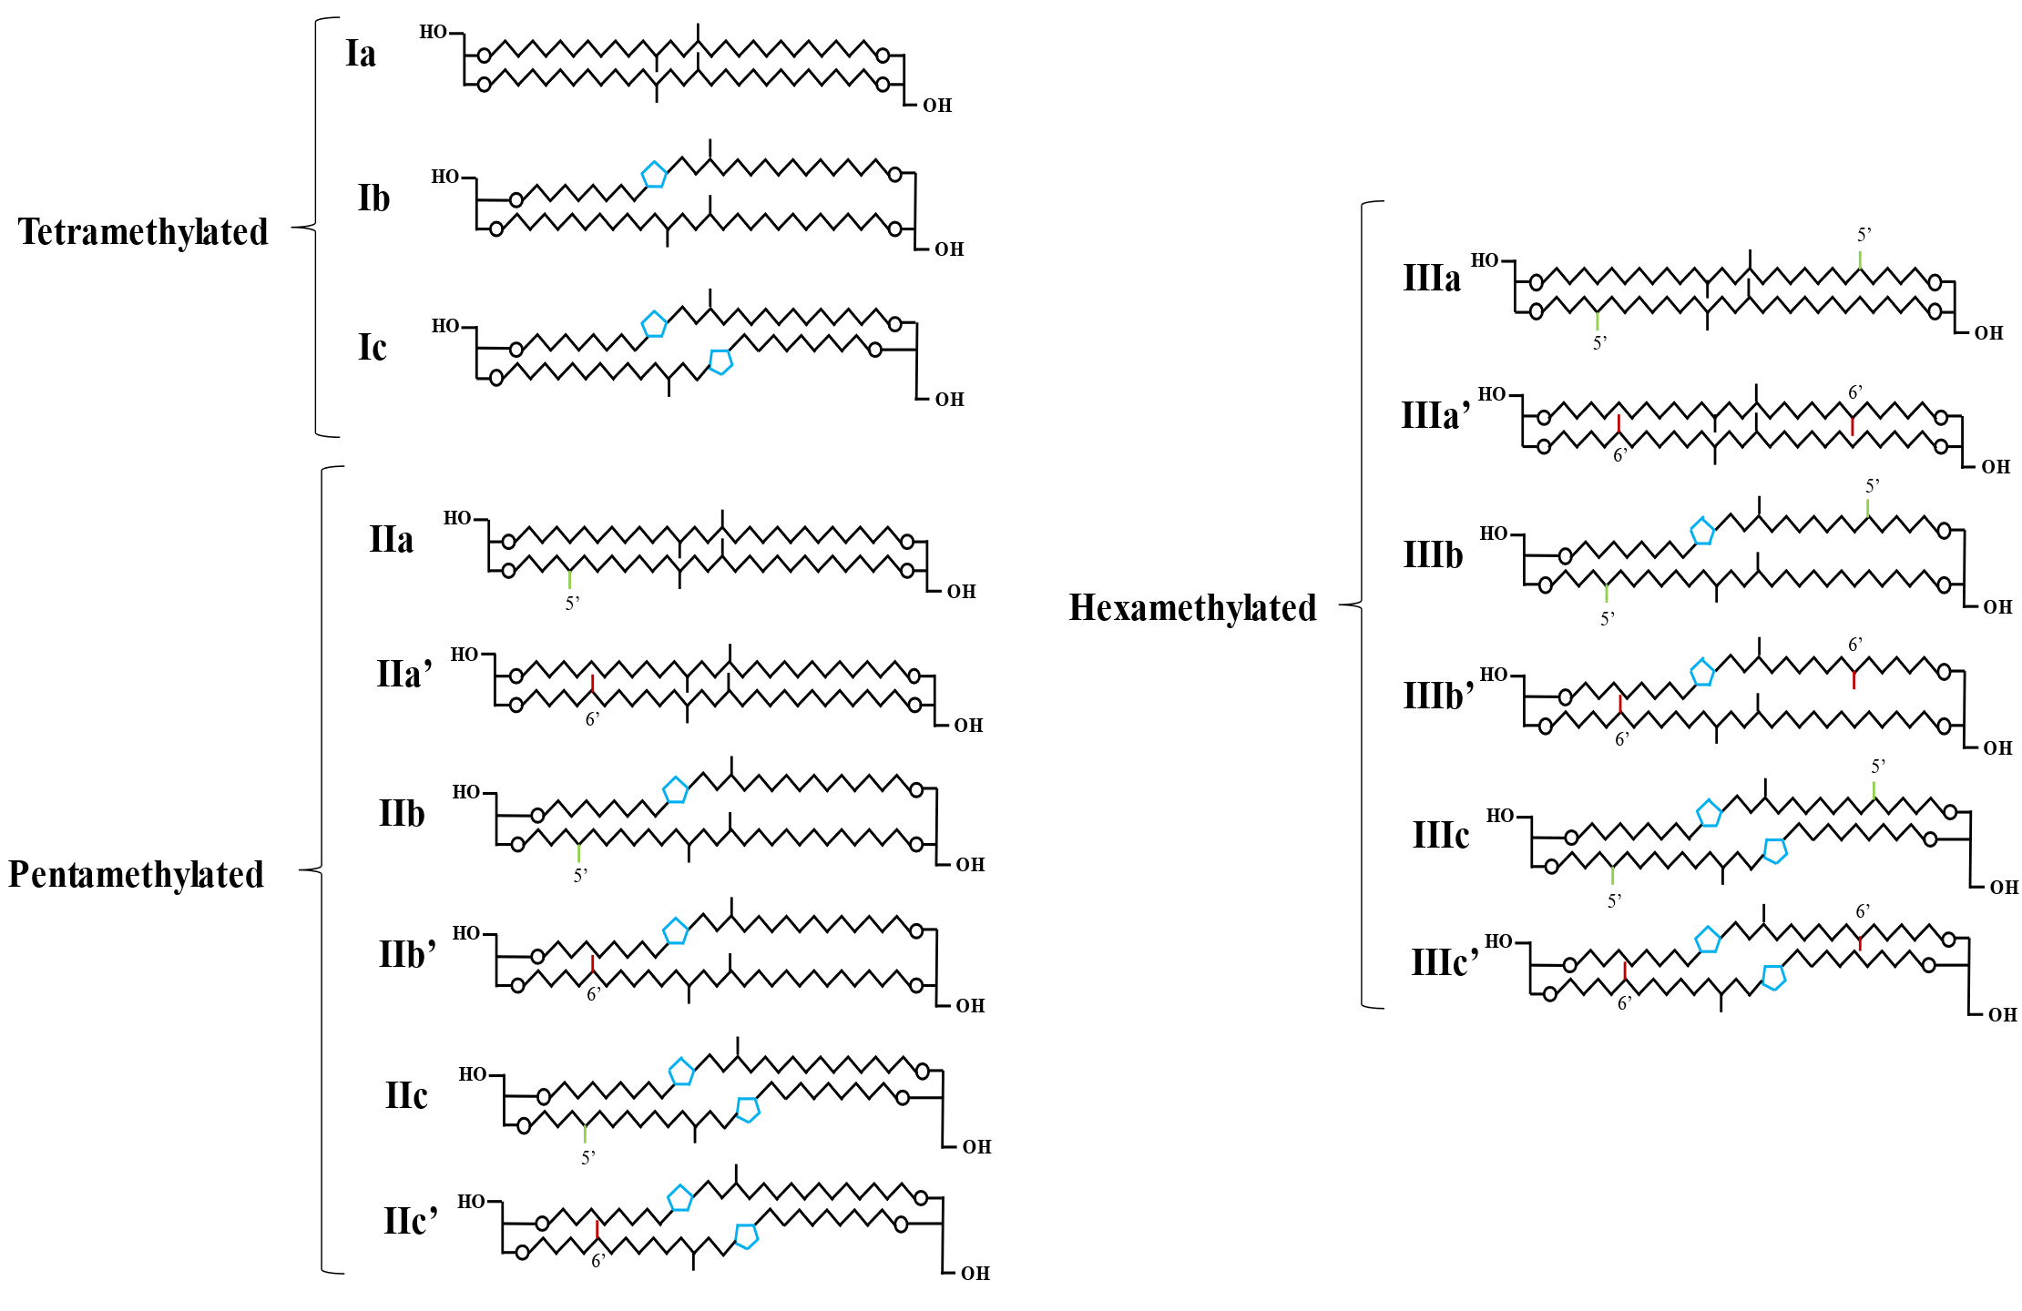
Supplementary Figure 1. Structures of the branched GDGTs used in this study. Letters indicate the number of cyclopentyl rings (in blue): “a” denotes structures without cyclopentyl moieties, “b” denotes structures containing one cyclopentyl moiety, and “c” denotes structures with two cyclopentyl moieties. Structures featuring C6‐methylation are marked in red and indicated with a prime symbol (′), while C5‐methylations are highlighted in green in the corresponding structure.

brGDGT fraction | Linear |  | Quadratic |  | GAM
brGDGT fraction | p-value | r² | p-value | r² | p-value | r²
tetramethylated | 0.00E+00 | 0.517 | 7.30E-03 | 0.518 | 7.30E-03 | 0.533
pentamethylated | 1.40E-238 | 0.386 | 3.80E-37 | 0.429 | 3.80E-37 | 0.453
hexamethylated | 3.20E-230 | 0.375 | 1.50E-25 | 0.405 | 1.50E-25 | 0.409
fIa | 1.00E-300 | 0.46 | 9.00E-10 | 0.469 | 9.00E-10 | 0.483
fIIIa_ | 1.90E-139 | 0.247 | 8.10E-07 | 0.255 | 8.10E-07 | 0.298
fIIa_ | 6.10E-103 | 0.188 | 2.10E-02 | 0.19 | 2.10E-02 | 0.251
fIIIa | 8.90E-106 | 0.193 | 3.60E-23 | 0.227 | 3.60E-23 | 0.244
fIIIb_ | 6.30E-57 | 0.107 | 7.50E-01 | 0.107 | 7.50E-01 | 0.15
fIIb_ | 1.10E-44 | 0.084 | 1.60E-05 | 0.092 | 1.60E-05 | 0.124
fIIb | 4.20E-24 | 0.045 | 7.90E-16 | 0.072 | 7.90E-16 | 0.111
fIIIb | 8.10E-44 | 0.083 | 6.10E-01 | 0.083 | 6.10E-01 | 0.105
fIc | 1.10E-32 | 0.062 | 7.80E-18 | 0.092 | 7.80E-18 | 0.098
fIIa | 3.70E-16 | 0.029 | 5.40E-11 | 0.048 | 5.40E-11 | 0.086
fIb | 1.50E-03 | 0.004 | 7.90E-32 | 0.064 | 7.90E-32 | 0.069
fIIIc_ | 4.20E-15 | 0.027 | 2.40E-01 | 0.028 | 2.40E-01 | 0.055
fIIc_ | 2.30E-14 | 0.026 | 3.70E-02 | 0.028 | 3.70E-02 | 0.052
fIIc | 1.90E-04 | 0.006 | 5.30E-10 | 0.023 | 5.30E-10 | 0.031
fIIIc | 1.40E-04 | 0.006 | 5.30E-01 | 0.007 | 5.30E-01 | 0.02
Supplementary Table 1. Relationship between Net Primary Productivity (NPP) and branched glycerol dialkyl glycerol tetraether (brGDGT) fractions using linear, quadratic, and Generalized Additive Models (GAM), including p-values and coefficients of determination (r²).

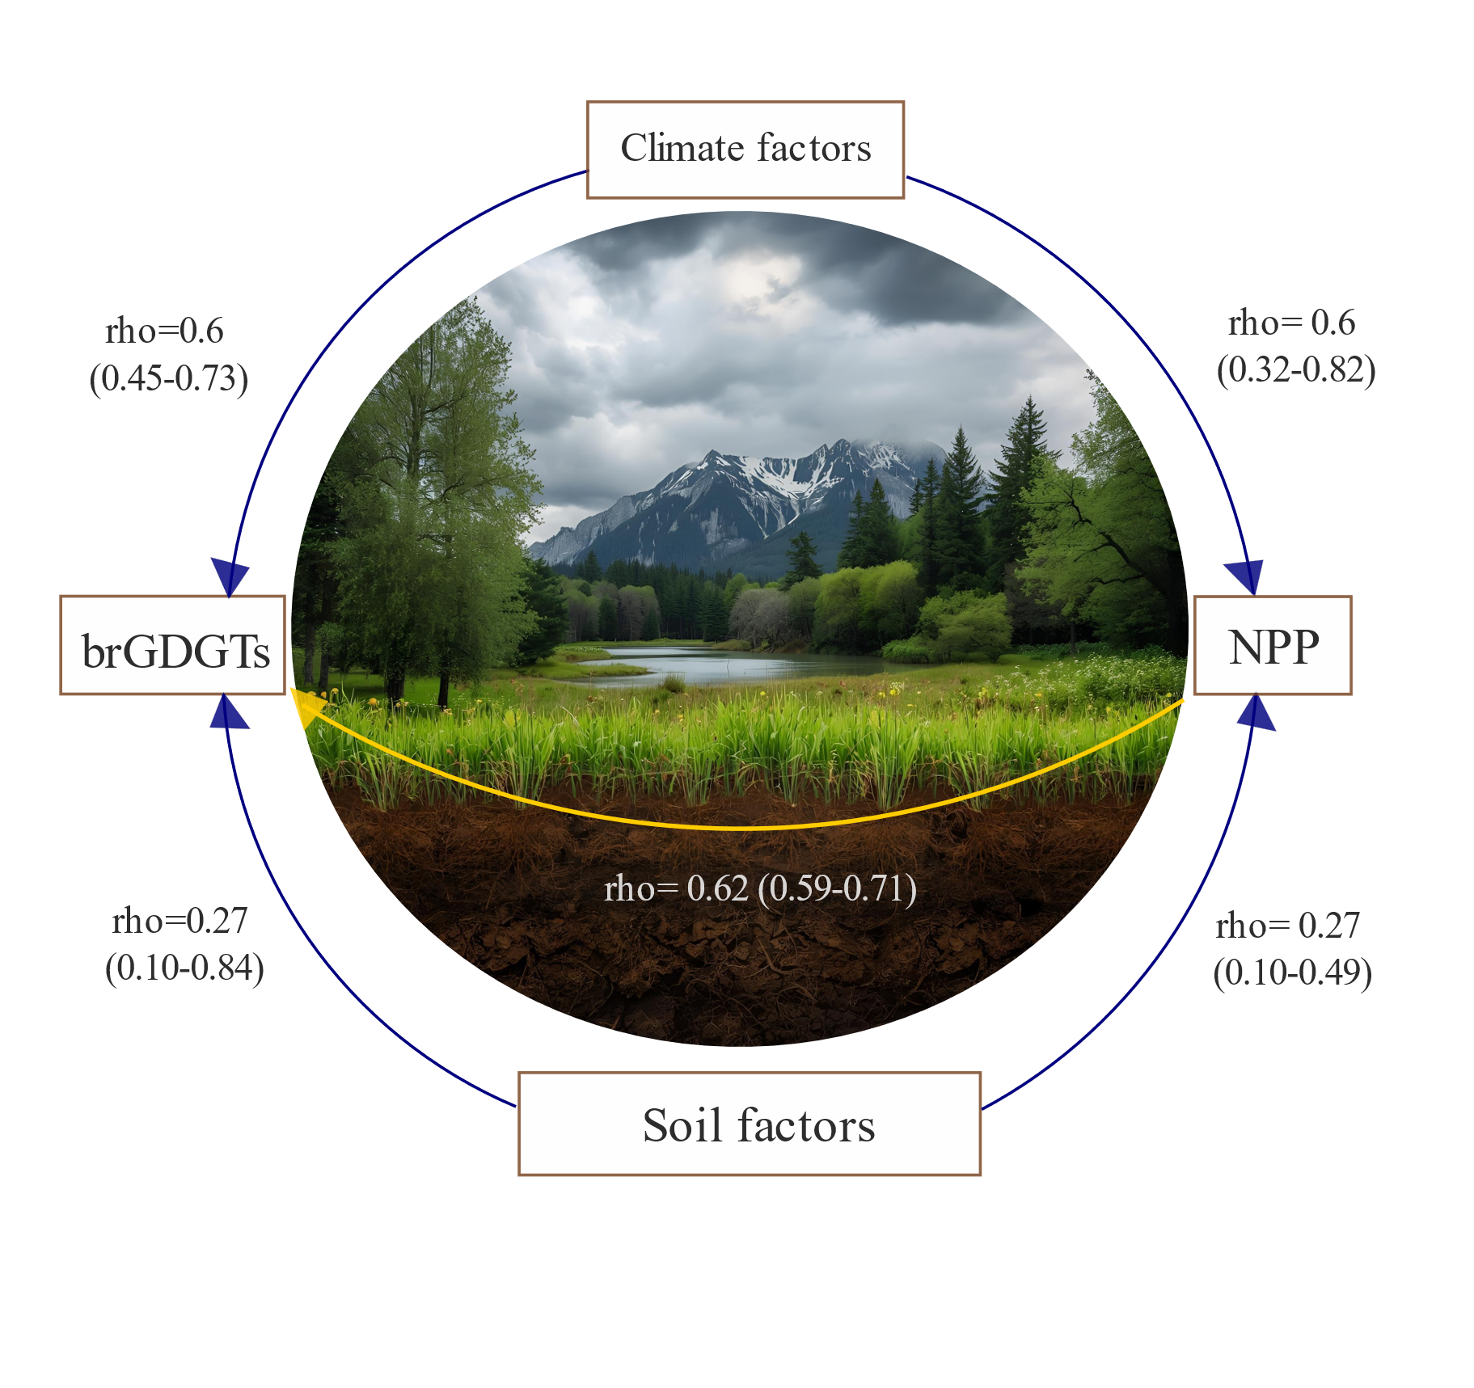
Supplementary Figure 2. Conceptual diagram illustrating the linking pathways through which brGDGTs capture NPP variability mediated by climate and soil factors, including the Spearman rank correlation coefficients stated in the main text (Figure 2). Landscape reconstruction created with Canva.

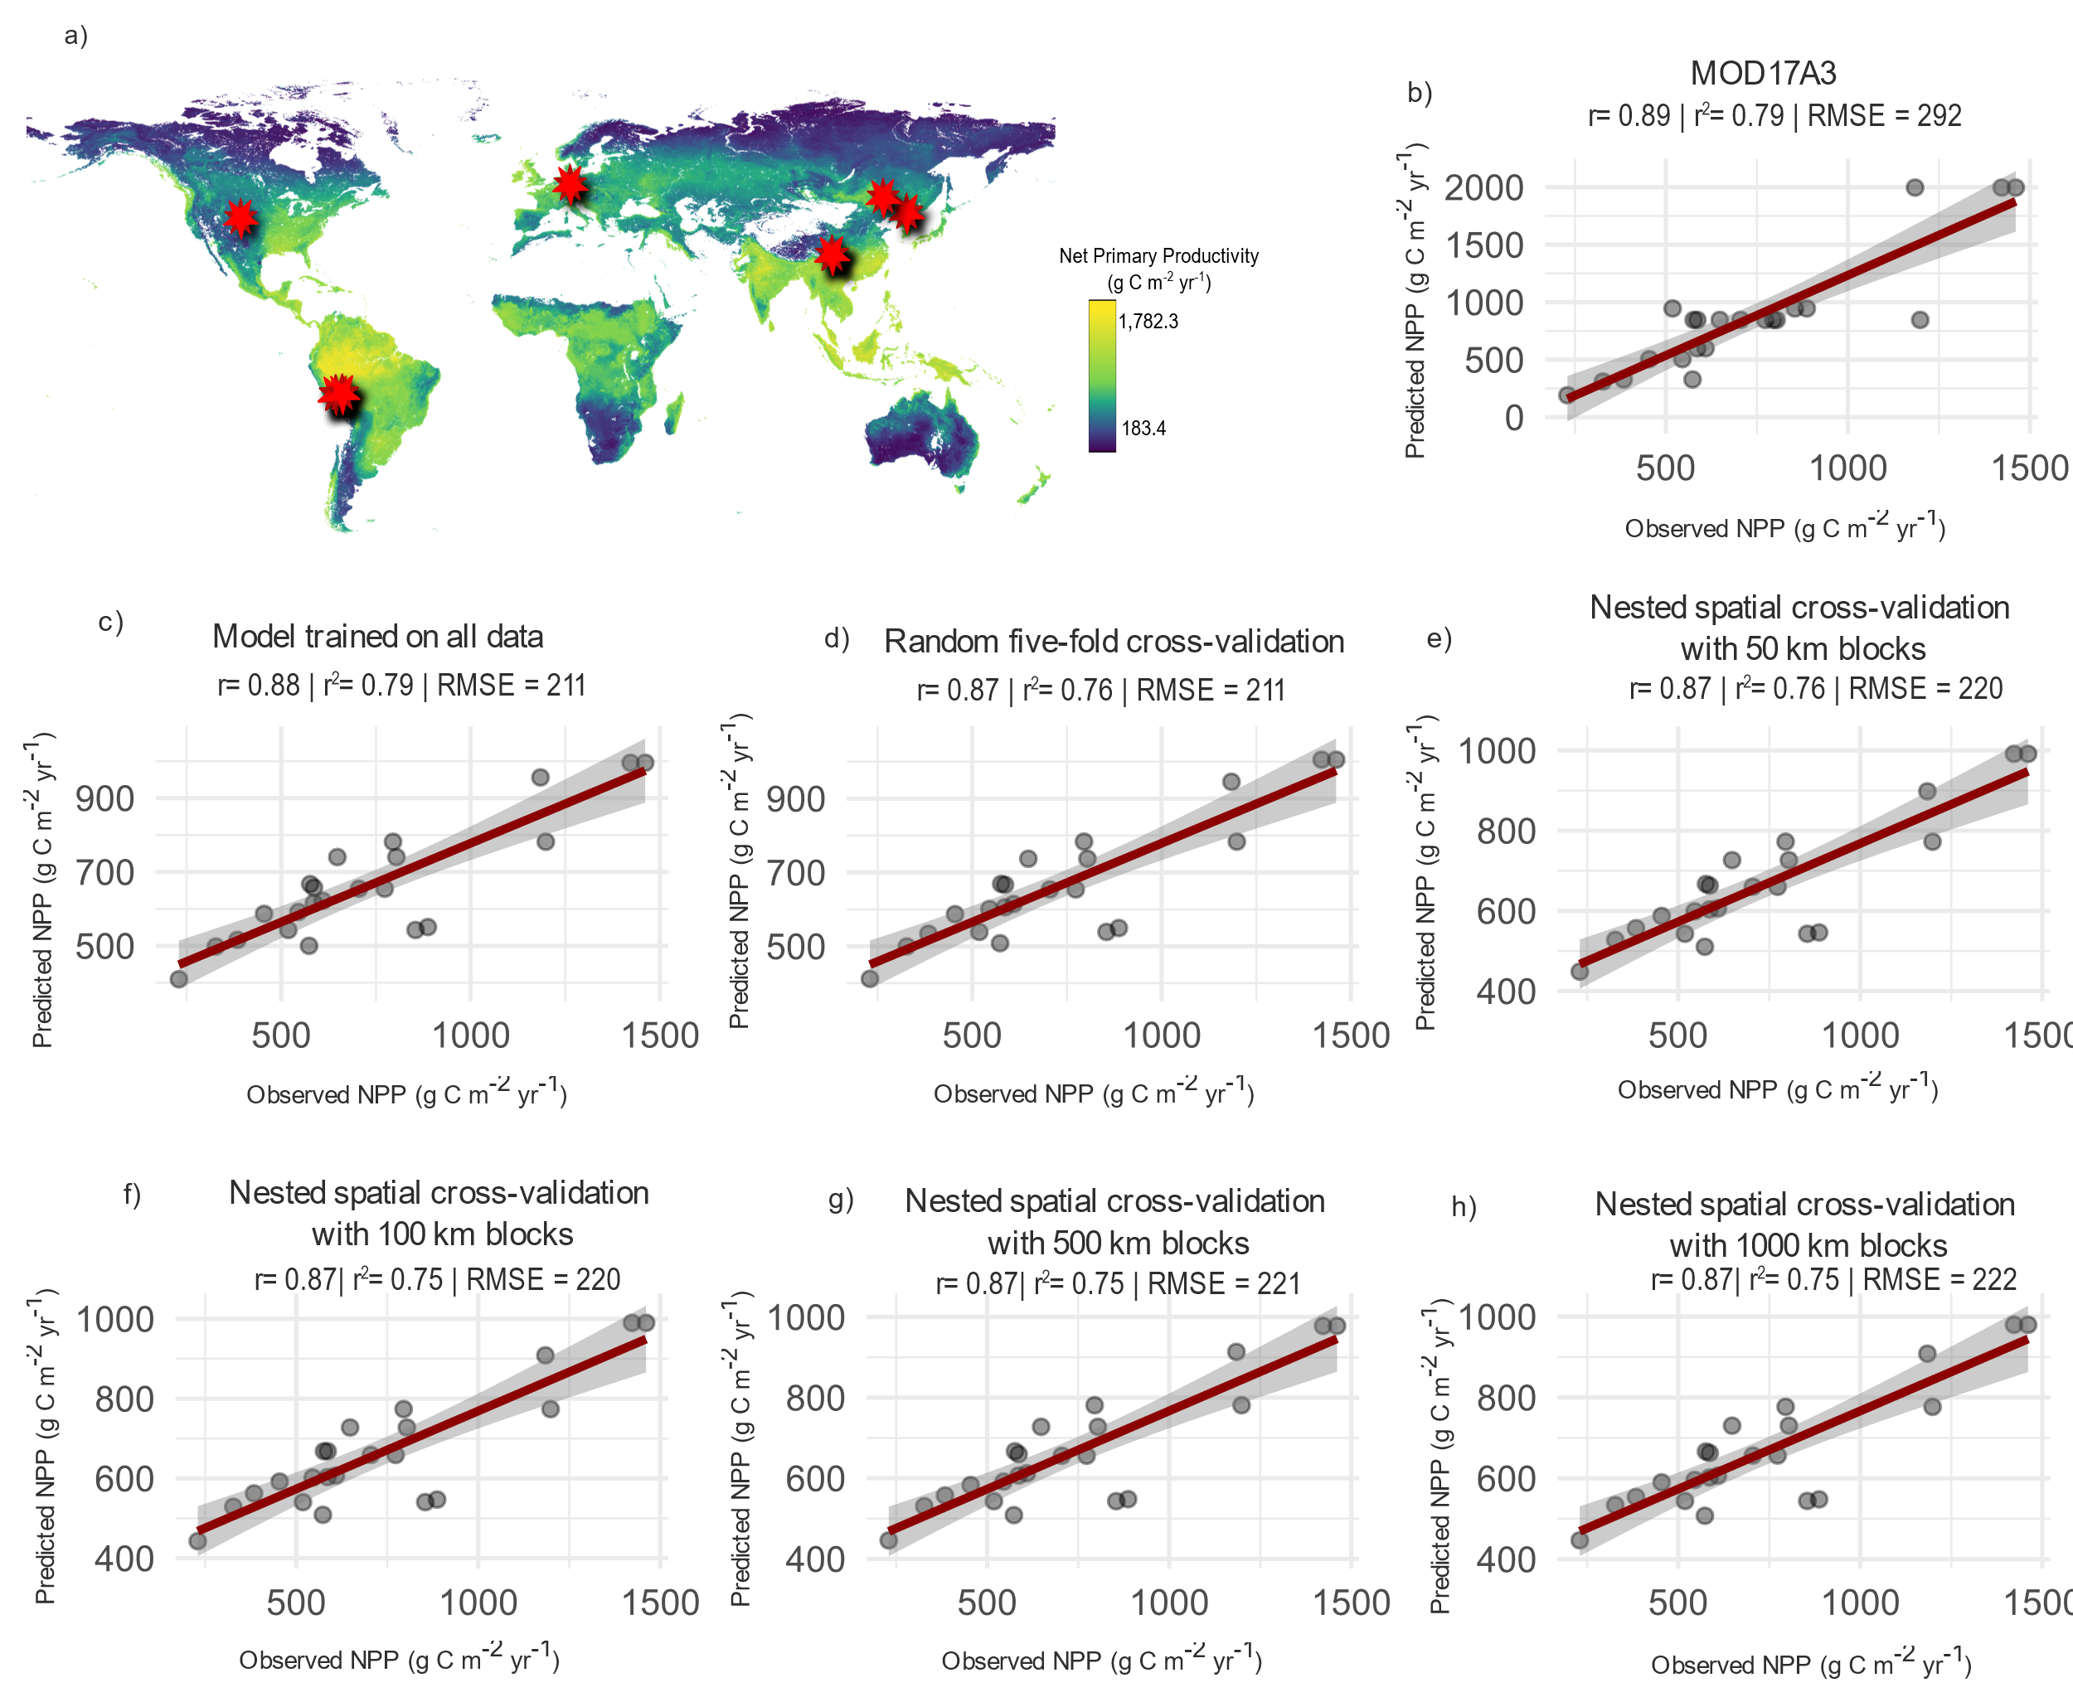
Supplementary Figure 3. Observed vs. predicted NPP when sample type is excluded as predictor. (a) Map of Net Primary Productivity (NPP) used as the dependent variable in the Random Forest models. Red stars indicate sites where both brGDGTs and NPP were measured to evaluate model performance. Correlations between independently measured NPP and predicted NPP are shown for: (b) the remote sensing NPP model (MOD17A3), (c) the brGDGT Random Forest model trained on all data, (d) trained and tested with five-fold random cross-validation, and nested spatial cross-validation with block sizes of (e) 50 km, (f) 100 km, (g) 500 km, and (h) 1000 km.

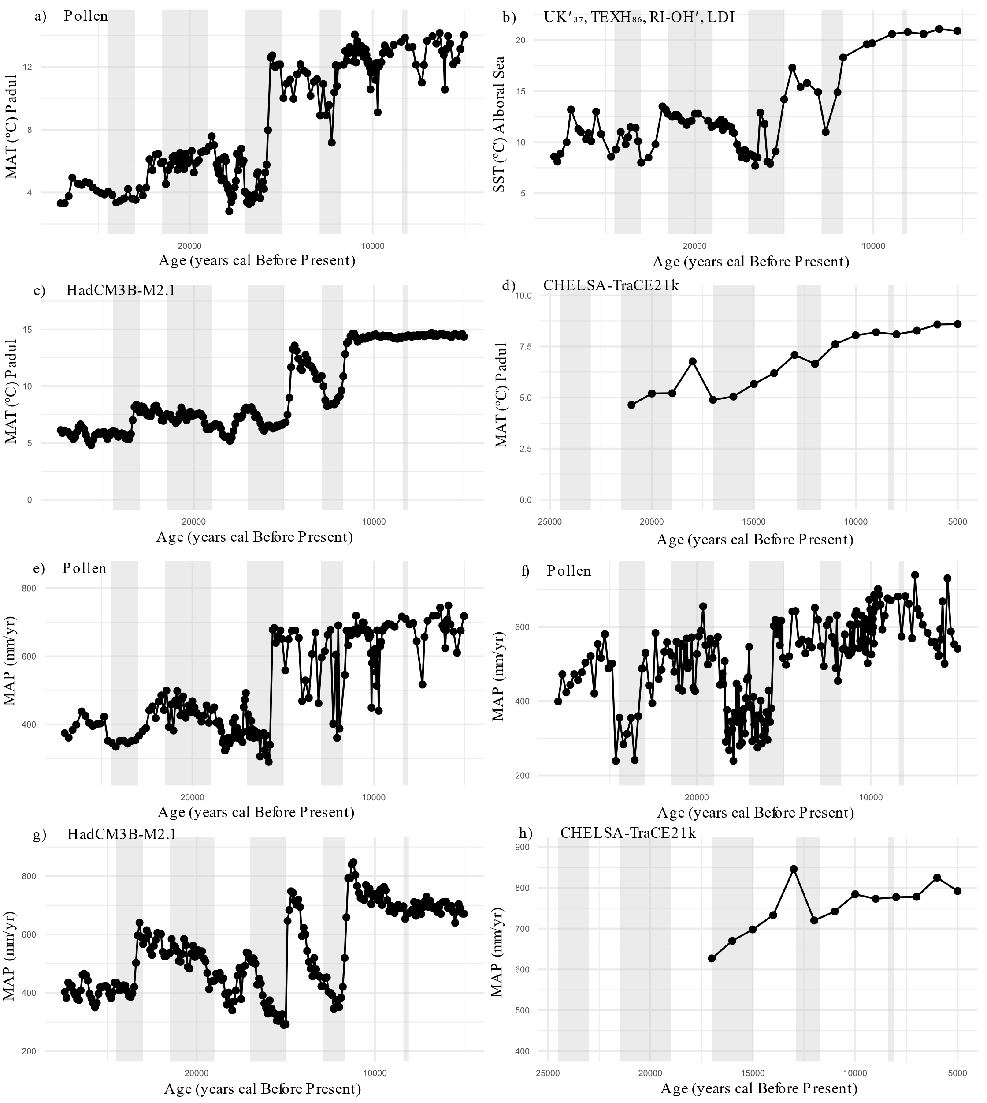
Supplementary Figure 4. Comparison of paleoclimate estimates. (a) Mean annual temperature (MAT) reconstructed in this study from the Padul pollen record; (b) mean sea surface temperature (SST) derived from the average of four organic proxies (UK′₃₇, TEXH₈₆, RI-OH′, and LDI) from core GP04PC in the Alboran Sea Basin¹; (c) mean annual temperature (MAT) for the Padul area obtained from the HadCM3B-M2.1 coupled general circulation model ²; (d) MAT for the Padul area obtained from the CHELSA-TraCE21k paleoclimate model³; (e) mean annual precipitation (MAP) reconstructed in this study from the Padul pollen record; (f) MAP from a previous study based on the Padul pollen record⁴; and (g) MAP simulated by the HadCM3B-M2.1 coupled general circulation model²; (h) MAP obtained from CHELSA-TraCE21k³

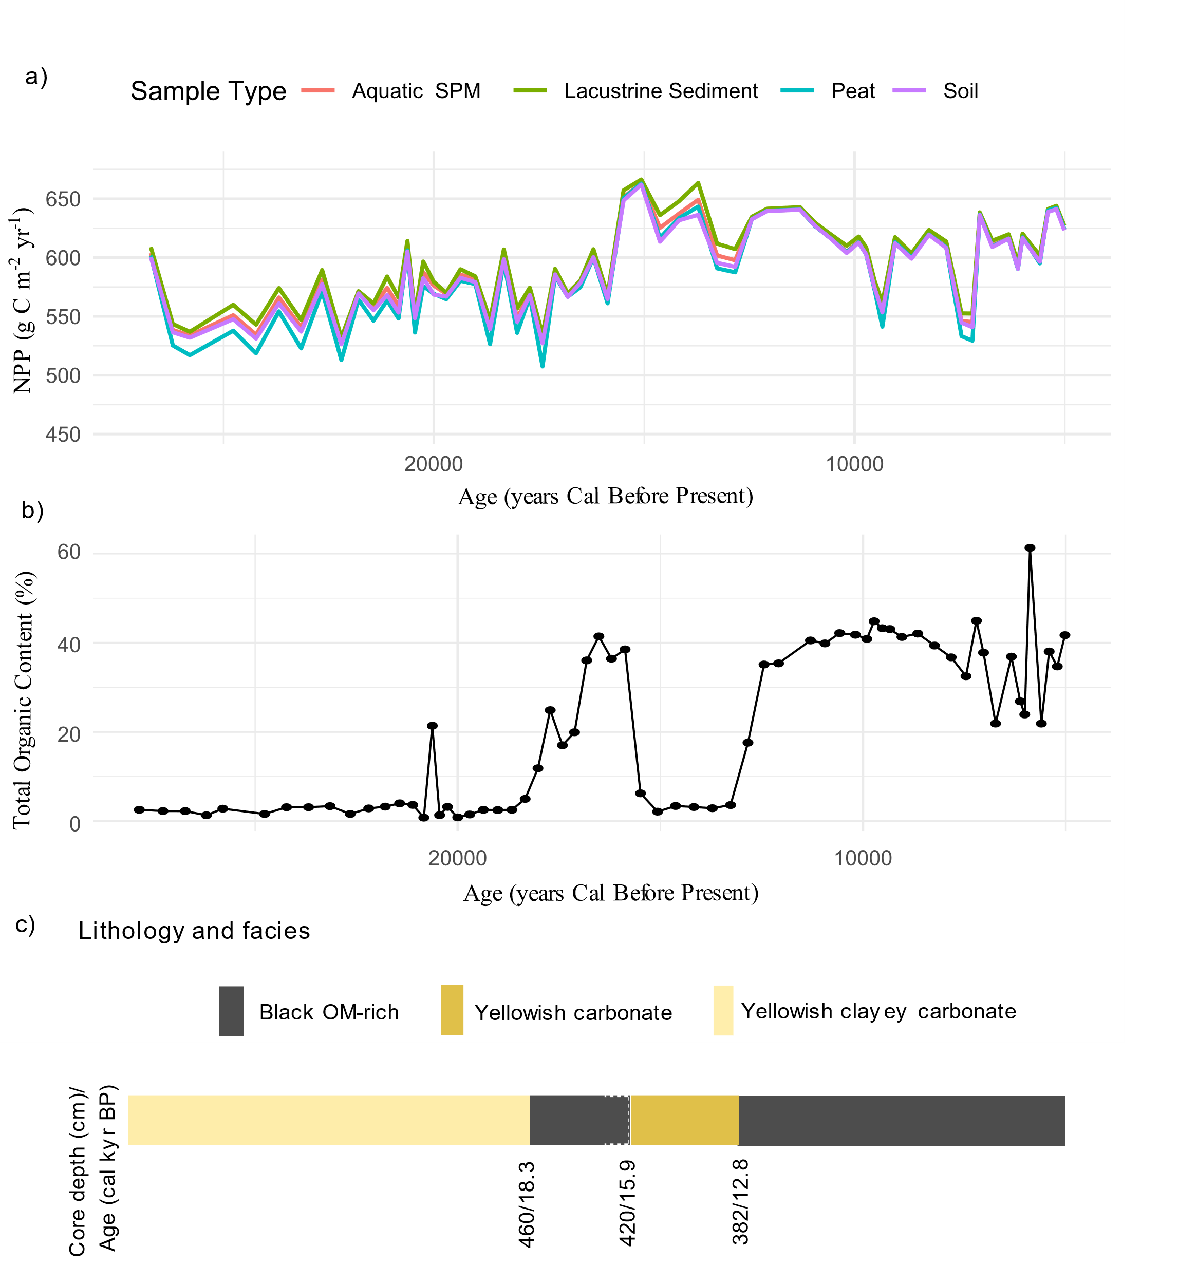
Supplementary Figure 5. (a) Mean net primary productivity (NPP) in Padul reconstructed from brGDGTs using different sample types. (b) Total organic content (%) in the Padul 15-05 Core⁵. (c) Lithology and facies of the Padul core between 27 and 5 kyr cal BP⁵.

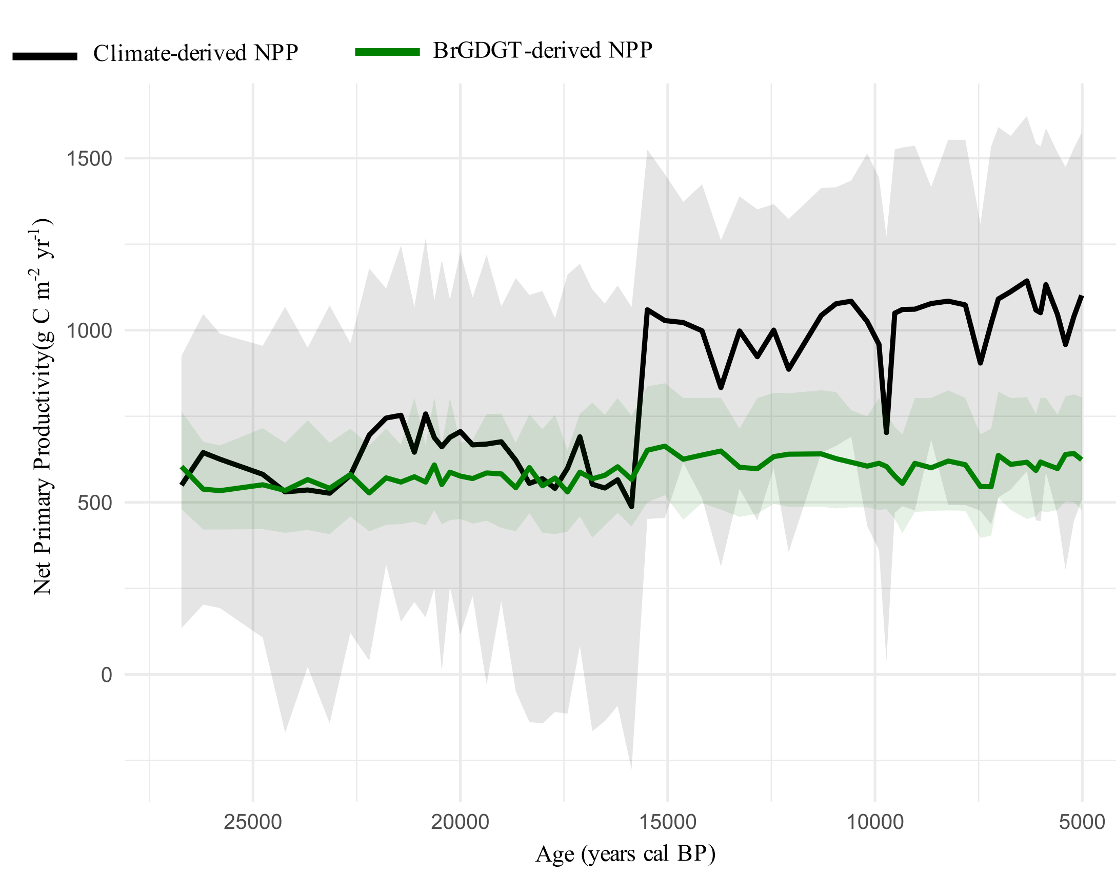
Supplementary Figure 6. Random Forest predictions of NPP in Padul based on brGDGTs (black line) compared with NPP estimates from the paleoclimate record using the Miami model (blue line). Yellow shading indicating the 95% confidence interval. The blue line represents the mean NPP from the Miami model, and the shaded blue area shows the 95% confidence interval obtained by propagating paleoclimate uncertainty effect through 1,000 Monte Carlo simulations.

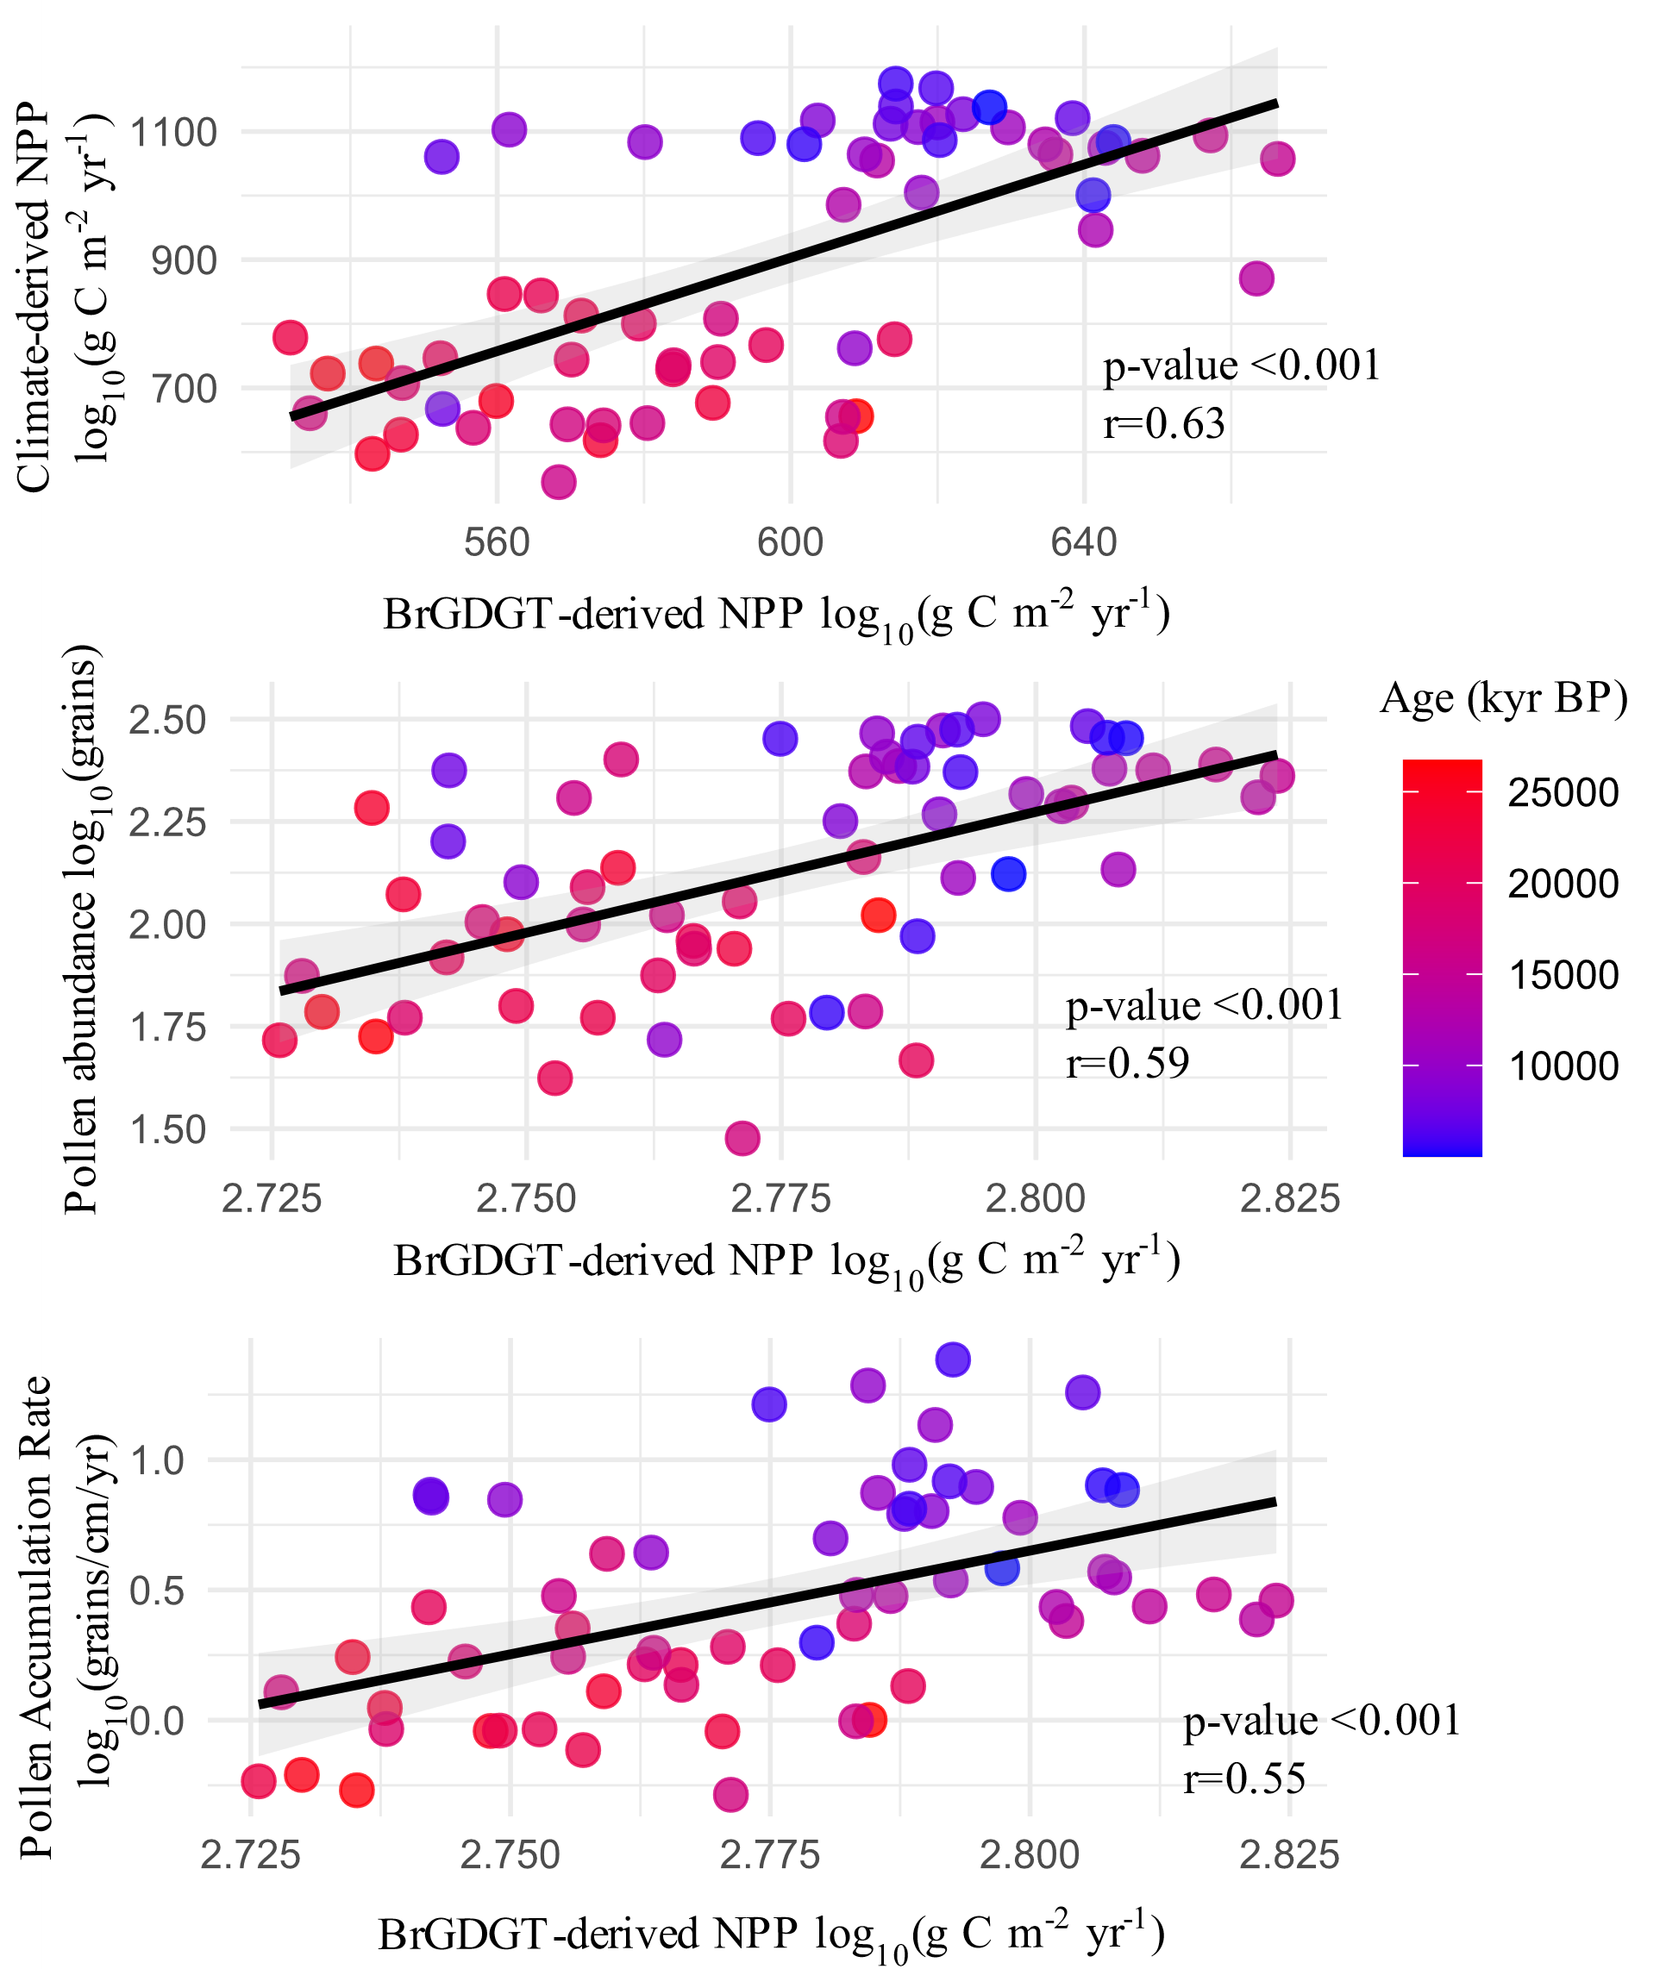
Supplementary Figure 7. Correlation between NPPact and pollen abundance over time in Padul. a) Correlation between actual (brGDGT-derived) and potential (climate-derived) NPP. b) Correlation between actual NPP and pollen concentration. c) Scatter plot showing correlation between pollen accumulation rates and actual NPP. Point colour and size reflects sample chronology in years BP.

Culture | NPP_{ACT} |  | NPP_{POT} |  | Deficit NPP
Culture | Mean | SD | Mean | SD | Mean | SD
Gravettian | 557.12 | 8.80 | 656.92 | 28.25 | 68.96 | 34.44
Solutrean | 558.88 | 16.87 | 711.32 | 65.34 | 159.61 | 62.81
Magdalenian | 603.16 | 34.10 | 834.41 | 169.31 | 249.15 | 149.44
Epipaleolithic | 617.88 | 20.99 | 998.05 | 118.56 | 416.73 | 84.02
Neolithic | 599.40 | 23.93 | 1094.46 | 93.20 | 502.26 | 32.19
Supplementary Table 2. Actual (NPP_{ACT}) and potential (NPP_{POT}) Net Primary Productivity (g C m⁻² yr⁻¹) and Deficit of NPP (g C m⁻² yr⁻¹) across Upper Palaeolithic, Epipaleolithic and Neolithic phases.

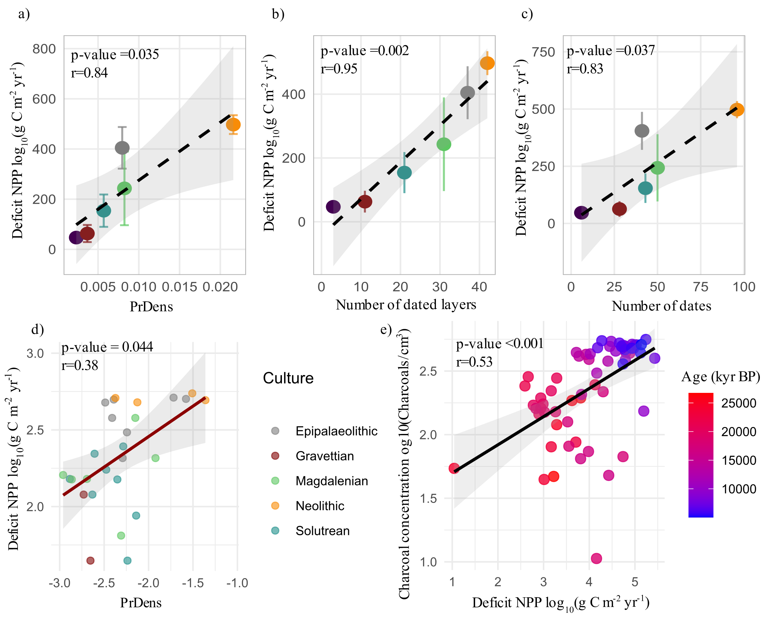
Supplementary Figure 8. Association between human demographic trends, deficit of NPP, and charcoal concentration. Correlation between deficit of NPP and (a) mean Probability Density (PrDens) obtained from summed probability distribution of archaeological levels, (b) number of archaeological dated layers, (c) number of dates, (d) summed probability distributions. (e) Correlation between deficit of NPP and charcoal concentrations. Point colours correspond to chronology.

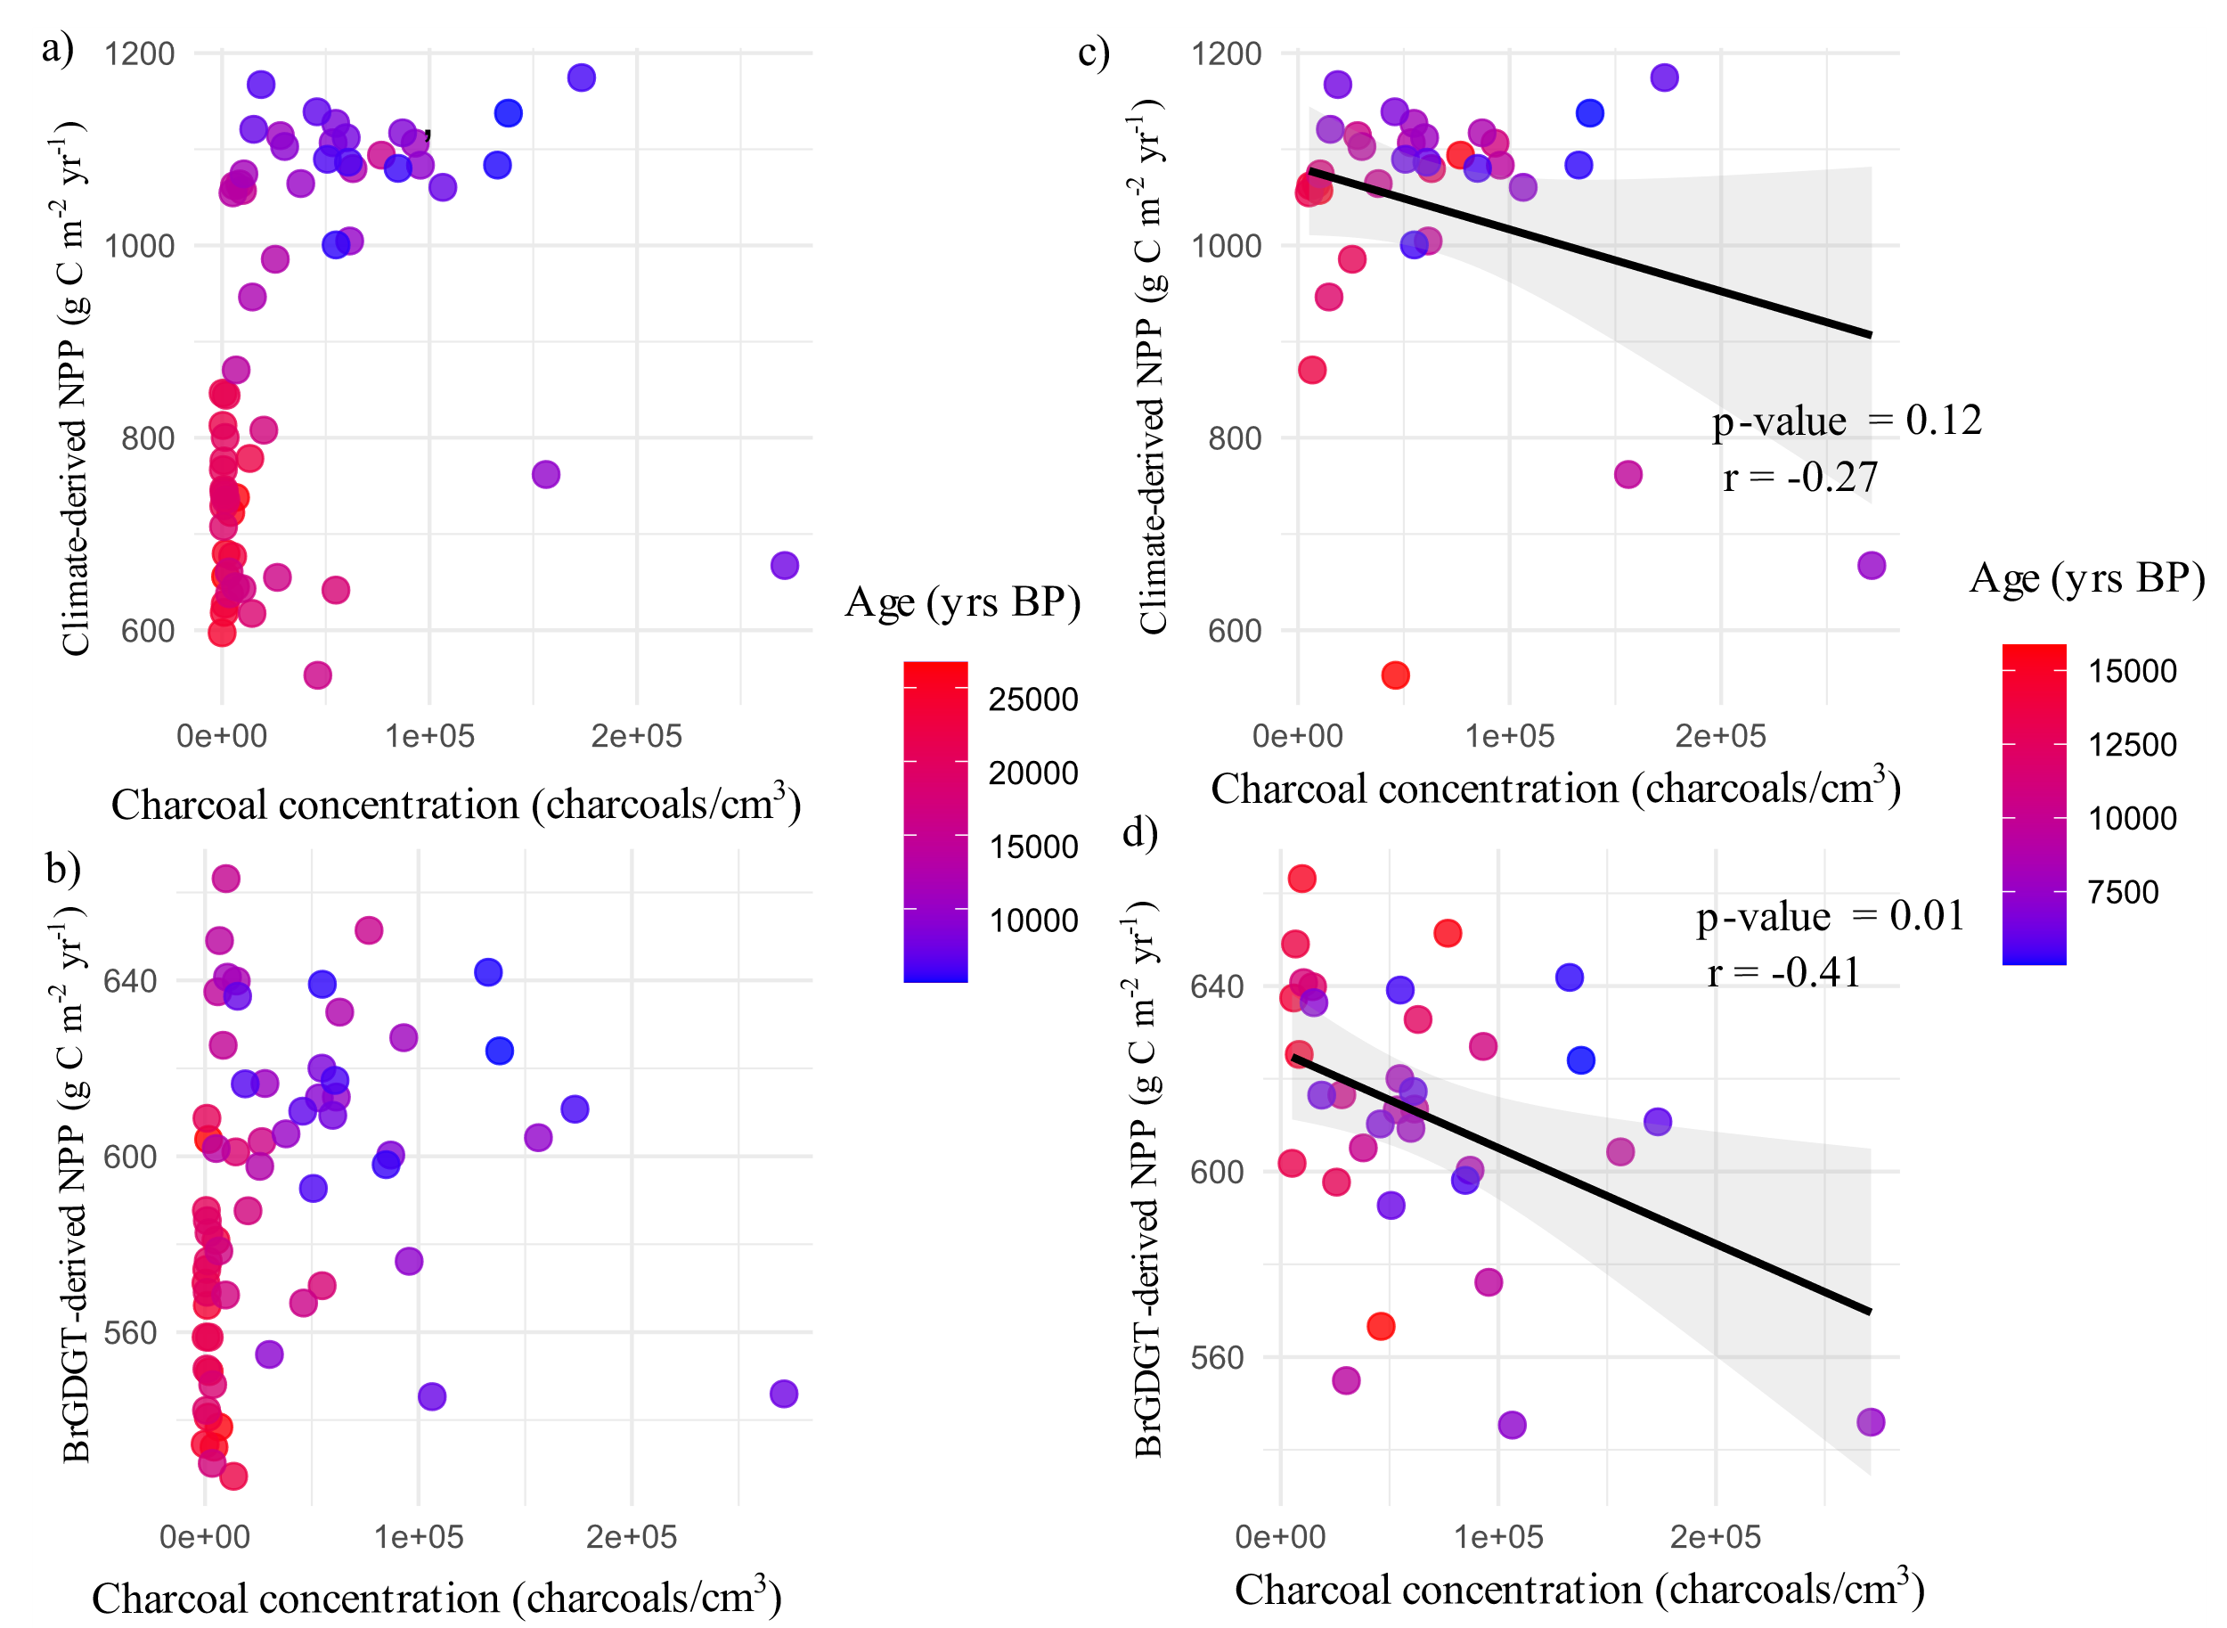
Supplementary Figure 9. Association between charcoal concentration and (a) climate-derived NPP and (b) brGDGT-derived NPP for the entire sequence, and between charcoal concentration and (c) climate-derived NPP and (d) brGDGT-derived NPP since the Magdalenian.

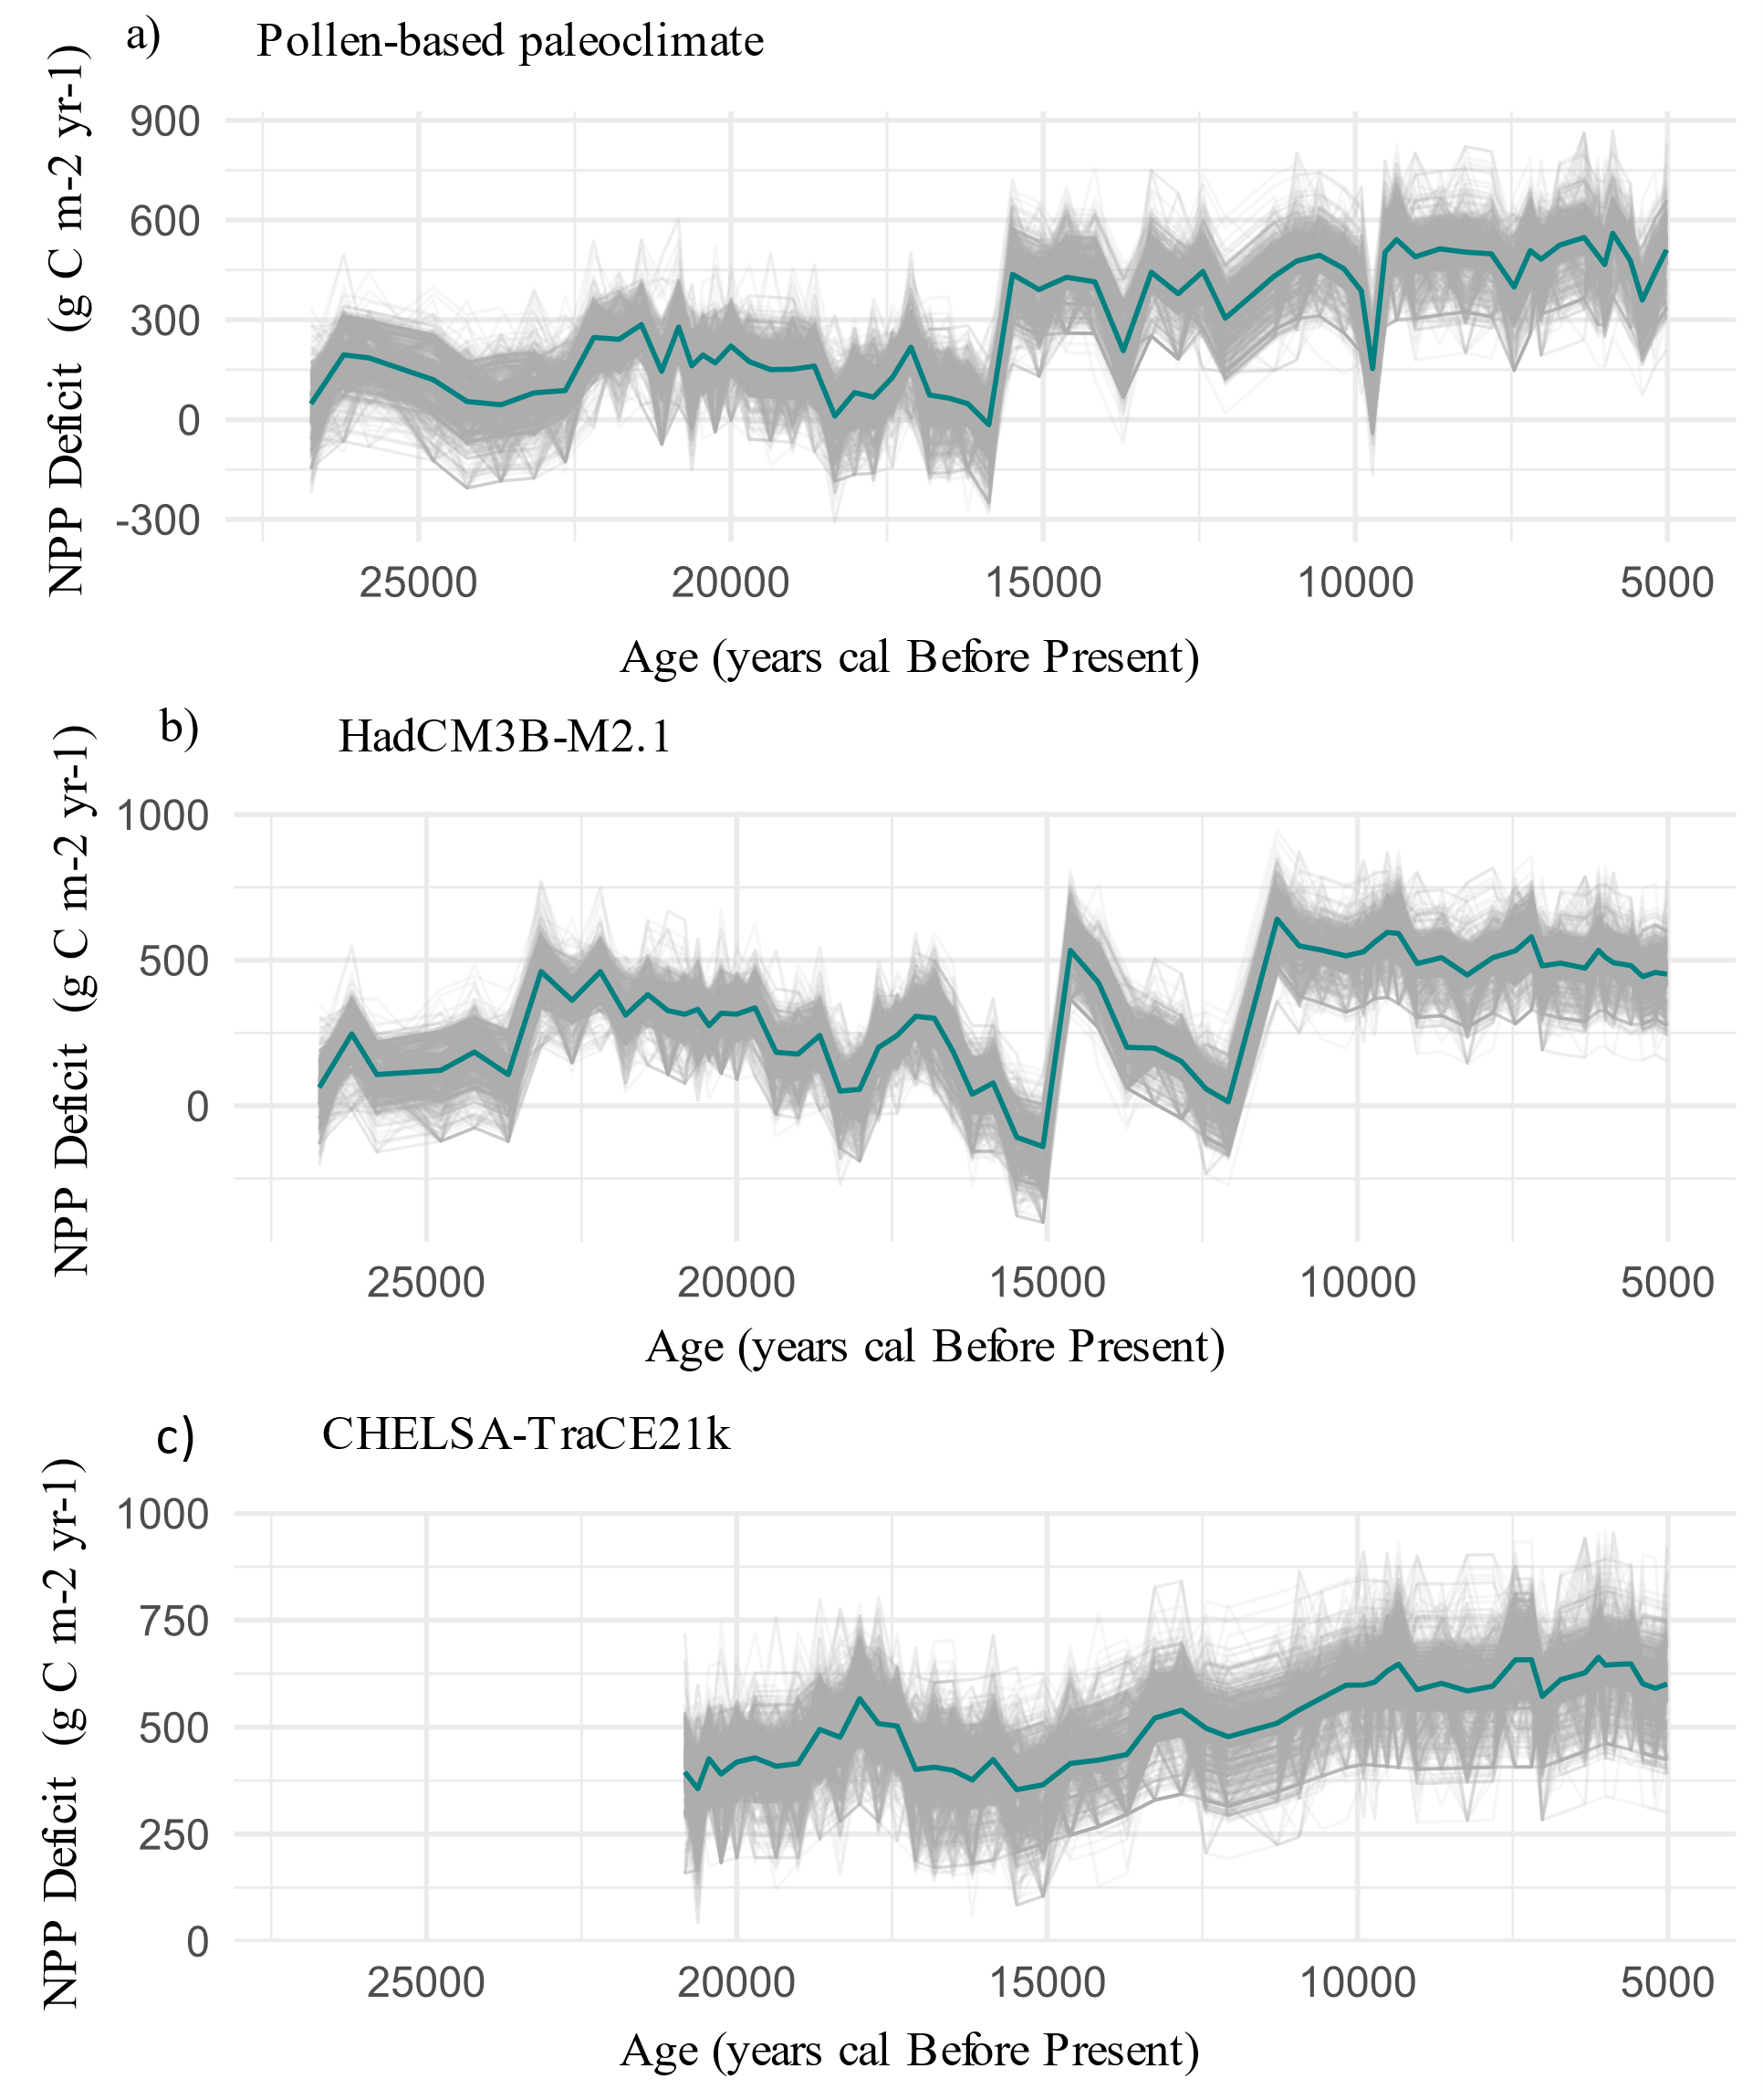
Supplementary Figure 10. Comparison of net primary productivity (NPP) deficits calculated using different paleoclimate models to estimate potential NPP: (a) deficit reconstructed from the Padul pollen record⁶; (b) from HadCM3B-M2.137²; and (c) from the CHELSA-TraCE21k84 model³.

NPP | Fauna | Culture | Small |  | Medium |  | MediumLarge |  | Large
NPP | Fauna | Culture | Mean | SD | Mean | SD | Mean | SD | Mean | SD
brGDGT | P | Gravettian | 4.66 | 8.68 | 20.02 | 24.88 | 27.88 | 44.42 | 39.25 | 79.00
brGDGT | H | Gravettian | 10.66 | 16.53 | 44.14 | 45.33 | 40.08 | 72.65 | 21.08 | 63.25
brGDGT | P | Solutrean | 4.68 | 8.72 | 20.11 | 24.99 | 28.00 | 44.61 | 39.43 | 79.35
brGDGT | H | Solutrean | 10.70 | 16.60 | 44.33 | 45.53 | 40.26 | 72.97 | 21.18 | 63.53
brGDGT | P | Magdalenian | 5.20 | 9.70 | 22.37 | 27.80 | 31.16 | 49.64 | 43.87 | 88.29
brGDGT | H | Magdalenian | 11.91 | 18.47 | 49.33 | 50.66 | 44.80 | 81.20 | 23.56 | 70.69
brGDGT | P | Epipaleolithic | 5.38 | 10.04 | 23.14 | 28.76 | 32.23 | 51.35 | 45.38 | 91.33
brGDGT | H | Epipaleolithic | 12.32 | 19.11 | 51.03 | 52.40 | 46.34 | 83.99 | 24.37 | 73.12
Climate | P | Gravettian | 9.08 | 15.90 | 38.23 | 45.59 | 41.80 | 71.72 | 39.49 | 89.90
Climate | H | Gravettian | 13.36 | 20.78 | 55.54 | 57.07 | 50.66 | 91.69 | 26.34 | 79.03
Climate | P | Solutrean | 10.15 | 17.78 | 42.73 | 50.97 | 46.73 | 80.18 | 44.15 | 100.50
Climate | H | Solutrean | 14.94 | 23.23 | 62.09 | 63.80 | 56.63 | 102.50 | 29.45 | 88.35
Climate | P | Magdalenian | 12.69 | 22.23 | 53.44 | 63.74 | 58.44 | 100.27 | 55.21 | 125.68
Climate | H | Magdalenian | 18.68 | 29.04 | 77.65 | 79.78 | 70.83 | 128.19 | 36.83 | 110.49
Climate | P | Epipaleolithic | 16.31 | 28.57 | 68.68 | 81.92 | 75.11 | 128.87 | 70.96 | 161.53
Climate | H | Epipaleolithic | 24.01 | 37.33 | 99.80 | 102.53 | 91.02 | 164.74 | 47.33 | 142.00
Climate | P | Gravettian | 7.23 | 12.65 | 30.35 | 36.22 | 33.11 | 56.87 | 31.47 | 71.54
Climate | H | Gravettian | 10.66 | 16.53 | 44.14 | 45.33 | 40.08 | 72.65 | 21.08 | 63.25
Supplementary Table 3. Biomass (kg km⁻² yr⁻¹) of herbivores in each body-mass category—small (< 10 kg), medium (10–300 kg), medium-large (300–500 kg), and large (> 500 kg)—for each cultural period based on Net Primary Productivity derived from Padul’s brGDGTs and Net Primary Productivity estimated from climate. Each case (i.e., brGDGTs-derived and climate-derived NPP) was modelled under two scenarios: (1) a representative Late Pleistocene mammalian community composition (P), and (2) a Holocene fauna composition (H) (for details, see Supplementary Note 3).

Paleocommunity | NPP | Culture | Canis lupus | Felis silvestris | Homo sapiens | Lynx pardinus | Martes martes | Meles meles | Ursus arctos | Vulpes vulpes | Crocuta crocuta | Cuon alpinus | Panthera pardus
H | P | Gravettian | 0.04 | 0.23 | 0.11 | 0.03 | 0.16 | 0.13 | 0.12 | 0.12
H | P | Solutrean | 0.05 | 0.26 | 0.13 | 0.04 | 0.18 | 0.14 | 0.13 | 0.13
H | P | Magdalenian | 0.06 | 0.32 | 0.16 | 0.05 | 0.23 | 0.18 | 0.17 | 0.16
H | P | Epipaleolithic | 0.08 | 0.41 | 0.20 | 0.06 | 0.29 | 0.23 | 0.21 | 0.21
H | A | Gravettian | 0.03 | 0.18 | 0.09 | 0.03 | 0.13 | 0.10 | 0.09 | 0.09
H | A | Solutrean | 0.03 | 0.18 | 0.09 | 0.03 | 0.13 | 0.10 | 0.09 | 0.09
H | A | Magdalenian | 0.04 | 0.20 | 0.10 | 0.03 | 0.14 | 0.11 | 0.11 | 0.10
H | A | Epipaleolithic | 0.04 | 0.21 | 0.10 | 0.03 | 0.15 | 0.12 | 0.11 | 0.11
P | P | Gravettian | 0.02 | 0.15 | 0.05 | 0.01 | 0.07 | 0.08 | 0.08 | 0.08 | 0.02 | 0.03 | 0.01
P | P | Solutrean | 0.02 | 0.17 | 0.06 | 0.01 | 0.07 | 0.09 | 0.08 | 0.09 | 0.02 | 0.04 | 0.01
P | P | Magdalenian | 0.03 | 0.21 | 0.08 | 0.02 | 0.09 | 0.11 | 0.11 | 0.11 | 0.02 | 0.05 | 0.01
P | P | Epipaleolithic | 0.04 | 0.27 | 0.10 | 0.02 | 0.12 | 0.15 | 0.14 | 0.14 | 0.03 | 0.06 | 0.02
P | A | Gravettian | 0.02 | 0.12 | 0.04 | 0.01 | 0.05 | 0.06 | 0.06 | 0.06 | 0.01 | 0.03 | 0.01
P | A | Solutrean | 0.02 | 0.12 | 0.04 | 0.01 | 0.05 | 0.07 | 0.06 | 0.06 | 0.01 | 0.03 | 0.01
P | A | Magdalenian | 0.02 | 0.13 | 0.05 | 0.01 | 0.06 | 0.07 | 0.07 | 0.07 | 0.01 | 0.03 | 0.01
P | A | Epipaleolithic | 0.02 | 0.14 | 0.05 | 0.01 | 0.06 | 0.08 | 0.07 | 0.07 | 0.01 | 0.03 | 0.01
Supplementary Table 4. Carrying capacity (individuals km⁻² yr⁻¹) of secondary consumers across cultural periods. Estimates are derived from Net Primary Productivity reconstructed using Padul brGDGTs (A) and pollen-based paleoclimate (P). Calculations incorporate herbivore biomass availability under two mammalian community scenarios—Late Pleistocene (P) and Early Holocene (H)—as well as species-specific prey preferences and energetic requirements (see Supplementary Notes 1 and 2 for details).

Palaeocommunity | NPP | Species | Gravettian | Solutrean | Magdalenian | Epipaleolithic
H | Climate-derived NPP | Equus ferus | 1.57 | 1.66 | 2.08 | 2.68
H | Climate-derived NPP | Bos primigenius | 0.51 | 0.54 | 0.67 | 0.87
H | Climate-derived NPP | Cervus elaphus | 2.15 | 2.28 | 2.85 | 3.68
H | Climate-derived NPP | Capreolus capreolus | 8.07 | 8.57 | 10.72 | 13.82
H | Climate-derived NPP | Capra pyrenaica | 3.71 | 3.94 | 4.93 | 6.35
H | Climate-derived NPP | Rupicapra rupicapra | 6.84 | 7.26 | 9.08 | 11.71
H | Climate-derived NPP | Sus scrofa | 2.62 | 2.78 | 3.47 | 4.48
H | Climate-derived NPP | Oryctolagus | 50.32 | 53.44 | 66.83 | 86.17
H | Climate-derived NPP | Lepus granatensis | 44.63 | 47.40 | 59.27 | 76.43
H | BrGDGT-derived NPP | Equus ferus | 1.21 | 1.20 | 1.34 | 1.39
H | BrGDGT-derived NPP | Bos primigenius | 0.39 | 0.39 | 0.43 | 0.45
H | BrGDGT-derived NPP | Cervus elaphus | 1.66 | 1.65 | 1.84 | 1.90
H | BrGDGT-derived NPP | Capreolus capreolus | 6.23 | 6.20 | 6.90 | 7.15
H | BrGDGT-derived NPP | Capra pyrenaica | 2.86 | 2.85 | 3.17 | 3.29
H | BrGDGT-derived NPP | Rupicapra rupicapra | 5.28 | 5.25 | 5.85 | 6.06
H | BrGDGT-derived NPP | Sus scrofa | 2.02 | 2.01 | 2.24 | 2.32
H | BrGDGT-derived NPP | Oryctolagus | 38.84 | 38.64 | 43.01 | 44.58
H | BrGDGT-derived NPP | Lepus granatensis | 34.45 | 34.27 | 38.15 | 39.54
P | Climate-derived NPP | Mammuthus primigenius | 0.07 | 0.08 | 0.09 | 0.12
P | Climate-derived NPP | Equus hydruntinus | 0.79 | 0.88 | 1.10 | 1.41
P | Climate-derived NPP | Equus ferus | 0.87 | 0.97 | 1.21 | 1.55
P | Climate-derived NPP | Bison priscus | 0.27 | 0.30 | 0.38 | 0.48
P | Climate-derived NPP | Bos primigenius | 0.28 | 0.31 | 0.39 | 0.50
P | Climate-derived NPP | Cervus elaphus | 1.19 | 1.33 | 1.66 | 2.12
P | Climate-derived NPP | Capreolus capreolus | 4.47 | 5.00 | 6.25 | 7.97
P | Climate-derived NPP | Capra pyrenaica | 2.06 | 2.30 | 2.87 | 3.66
P | Climate-derived NPP | Rupicapra rupicapra | 3.79 | 4.24 | 5.30 | 6.75
P | Climate-derived NPP | Sus scrofa | 1.45 | 1.62 | 2.03 | 2.58
P | Climate-derived NPP | Oryctolagus | 27.87 | 31.16 | 38.97 | 49.68
P | Climate-derived NPP | Lepus granatensis | 24.72 | 27.64 | 34.56 | 44.06
P | BrGDGT-derived NPP | Mammuthus primigenius | 0.06 | 0.05 | 0.06 | 0.06
P | BrGDGT-derived NPP | Equus hydruntinus | 0.64 | 0.64 | 0.71 | 0.74
P | BrGDGT-derived NPP | Equus ferus | 0.71 | 0.70 | 0.78 | 0.81
P | BrGDGT-derived NPP | Bison priscus | 0.22 | 0.22 | 0.24 | 0.25
P | BrGDGT-derived NPP | Bos primigenius | 0.23 | 0.23 | 0.25 | 0.26
P | BrGDGT-derived NPP | Cervus elaphus | 0.97 | 0.96 | 1.07 | 1.11
P | BrGDGT-derived NPP | Capreolus capreolus | 3.63 | 3.61 | 4.02 | 4.18
P | BrGDGT-derived NPP | Capra pyrenaica | 1.67 | 1.66 | 1.85 | 1.92
P | BrGDGT-derived NPP | Rupicapra rupicapra | 3.08 | 3.06 | 3.41 | 3.55
P | BrGDGT-derived NPP | Sus scrofa | 1.18 | 1.17 | 1.30 | 1.36
P | BrGDGT-derived NPP | Oryctolagus | 22.65 | 22.53 | 25.08 | 26.08
P | BrGDGT-derived NPP | Lepus granatensis | 20.09 | 19.98 | 22.25 | 23.14
Supplementary Table 5. Herbivore densities estimated with actual, climate-derived, and potential, brGDGTs-derived, Net Primary Productivity (NPP) under two scenarious: with a Late Pleistocene mammal fauna community (P) and with an Holocene community (H).

Species | Extinct | Adult Body Mass (kg) | Neonate Body Mass (kg) | Age at First Birth (d) | Litter Size | Litters Per Year | Longevity (m) | Ref
Mammuthus primigenius | Y | 6000.00 | 101.00 | 11.25 | 1.13 | 0.24 | 65.00 | ^{2–4}
Bison priscus | Y | 950.00 | 39.48 | 2.62 | 1.00 | 0.91 | 25.00 | ^{2–4}
Bos primigenius | N | 900.00 | 37.67 | 2.62 | 1.00 | 0.91 | 25.00 | ^{2–4}
Equus hydruntinus | Y | 227.13 | 28.73 | 3.50 | 1.00 | 0.67 | 38.80 | ^{2–4}
Equus ferus | N | 200.00 | 28.63 | 3.50 | 1.00 | 0.67 | 38.80 | ^{2–4}
Cervus elaphus | N | 131.25 | 82.56 | 2.72 | 1.09 | 0.90 | 26.80 | ^{2–4}
Sus scrofa | N | 101.05 | 0.81 | 0.85 | 4.52 | 1.50 | 21.00 | ^{3–5}
Capra pyrenaica | N | 50.00 | 2.90 | 3.00 | 1.10 | 1.10 | 16.00 | ^{3,4,6,7}
Saiga tatarica | N | 29.00 | 3.50 | 1.32 | 1.50 | 1.10 | 12.00 | ^{3,4}
Rupicapra rupicapra | N | 26.10 | 2.25 | 3.75 | 1.00 | 1.10 | 22.00 | ^{3,4}
Capreolus capreolus | N | 22.50 | 1.21 | 2.00 | 1.79 | 1.10 | 17.00 | ^{3,4}
Oryctolagus coniculus | N | 1.96 | 0.04 | 0.33 | 5.24 | 4.50 | 18.00 | ^{3,4}

Supplementary Table 6. Life history traits of each primary consumer species included in this study and used to compute age-specific body masses with Gompertz growth curves and population structure with Weibull models. The “Extinct” column indicates whether each species became extinct during the Late Pleistocene (Y) or survived into the Holocene (N).

Species | Extinct | Adult Body Mass (kg) | Energy requirements (kcal/day) | % Meat in diet | Prey preference spectrum (%) |  |  |  | Ref
 |  |  |  |  | Small (1-10 kg) | Medium (10-100 kg) | Medium-large (100-500 kg) | Large (>500 kg) | Ref
Ursus arctos | N | 180.52 | 8720.32 | 10.00 | 25.0 | 25.0 | 25.0 | 25.0 | ^{2,3,8}
Panthera pardus | Y | 54.99 | 3808.76 | 100.00 | 2.0 | 80.0 | 18.0 | 0.0 | ^{2,3}
Crocuta crocuta | Y | 62.99 | 4186.88 | 98.50 | 0.0 | 45.2 | 40.1 | 14.7 | ^{2,3}
Canis lupus | N | 32.18 | 2621.96 | 100.00 | 3.0 | 30.0 | 64.0 | 3.0 | ^{2,3}
Meles meles | N | 13 | 1394.16 | 5.00 | 100.0 | 0.0 | 0.0 | 0.0 | ^{2,3,9}
Vulpes vulpes | N | 5.31 | 747.03 | 10.00 | 100.0 | 0.0 | 0.0 | 0.0 | ^{2,3,9}
Felis silvestris | N | 5.5 | 765.56 | 5.00 | 100.0 | 0.0 | 0.0 | 0.0 | ^{2,3,9}
Lynx pardinus | N | 9.4 | 1112.20 | 100.00 | 75.0 | 25.0 | 0.0 | 0.0 | ³
Cuon alpinus | Y | 12.76 | 1376.17 | 90.00 | 22.2 | 44.4 | 27.8 | 5.6 | ³
Martes martes | N | 1.3 | 280.19 | 60.00 | 83.3 | 16.7 | 0.0 | 0.0 | ³
Homo sapiens | N | 59.5 | 2249.45 | [30-60] | 14.0 | 46.0 | 30.0 | 10.0 | ³

Supplementary Table 7. Body size, energy requirements, and prey spectra according to prey weight-size categories for each secondary consumer species. For details, see Supplementary Note 2.

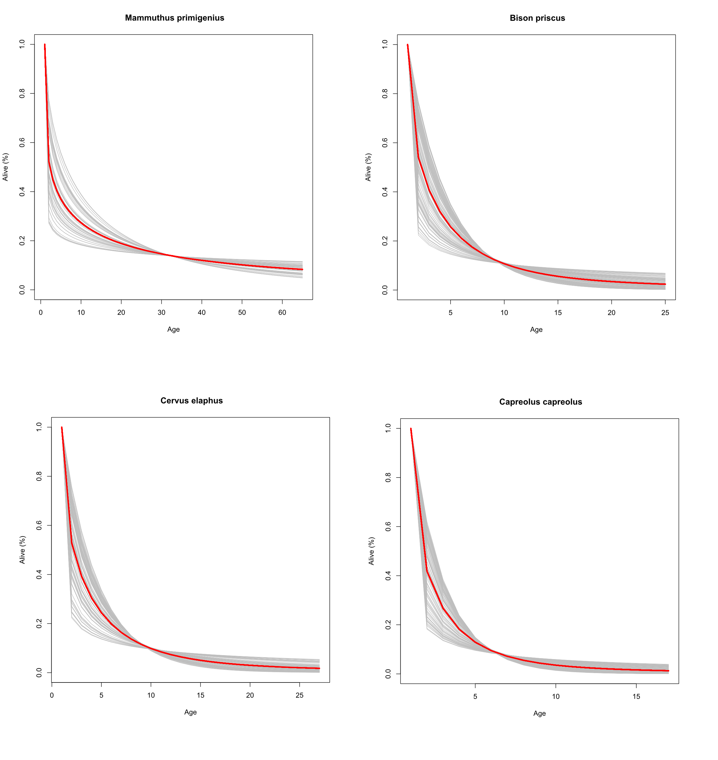Supplementary Figure 11. Example of simulated population structures (n = 100; grey lines) for four species based on fitted Weibull models. Red lines denote the mean structure derived from the simulations.

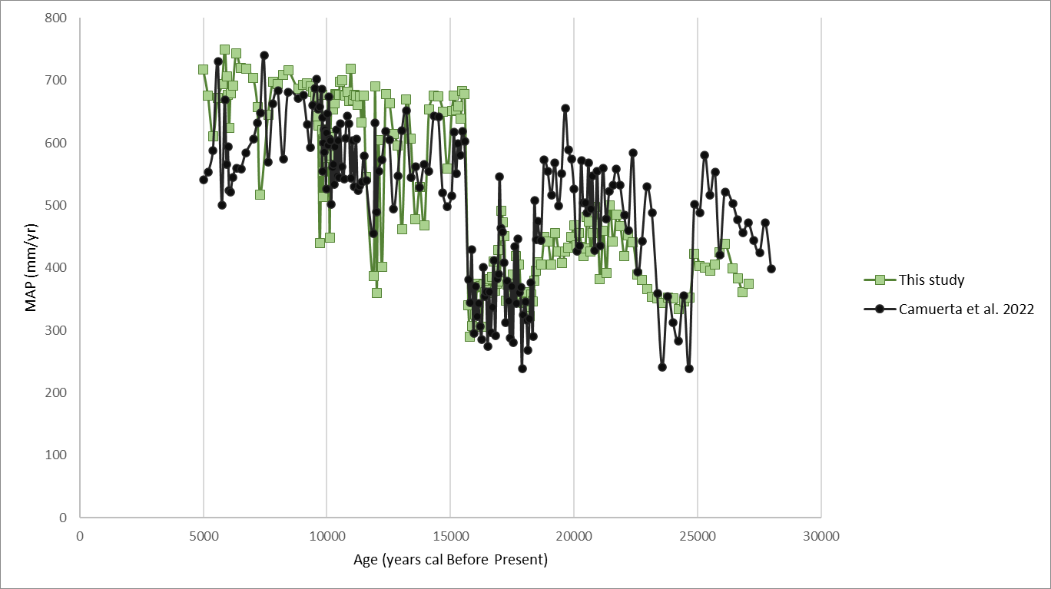
Supplementary Figure 12. Comparison of mean annual precipitation (MAP) estimates from the Padul record obtained in this study (green line) and a previous study (black line).

- Supplementary Note 1.
From Net Primary Productivity to herbivore biomass
In a previous study ¹⁰, we developed a bottom-up modelling framework to estimate herbivore carrying capacity (CC) as a function of: a) Net Primary Productivity (NPP), b) regional herbivore guild structure, and c) known allometric relationships between body mass and population density^{11,12}. Total herbivore biomass in a specific area or region can be obtained by multiplying each species’ population density (D) by its average adult body mass (W), which could be expressed as:
Eq.1
$${THB}_{ }= \sum_{i=1}^{n}{D_{i}*W_{i}}$$
Where n is the number of herbivore species in the community, D the population density of species i expressed as ind/km², and W is the mean body mass of both sexes in kg. Damuth ¹³ showed that population density scales allometrically with body size, with an exponent of -0.75. Despite the relationship between body size and population density may be affected by trophic groups or range sizes¹⁴, recent studies show that the scaling factor of -3/4 fits observations across broad taxonomic levels ¹². Therefore, D in Eq. 1 be expressed as:
Eq.2
$$D_{i}=c W_{i}^{-0.75}$$
Where D is expressed in ind/km², c is the intercept and W is the mean body mass in kg. Thus, substituting Eq. 2 into Eq.1 yields:
Eq.3
$$THB= \sum_{i=1}^{n}{(c W_{i}^{-0.75})*W_{i }}$$
The intercept 𝑐 in Eq. 2 is known to vary across ecosystems or biomes^{11,14}. Rather than assuming a fixed value for 𝑐, in this study we derive it by rearranging the Eq. 3:
Eq.4
$$c=\frac{THB}{\sum_{i=1}^{n}{W_{i}^{0.25}}}$$
Therefore, to compute c, THB must first be estimated. We used the following predictive equation ¹⁰ linking THB to NPP:
Eq.5
$$\log_{10}THB=1.401*\log_{10}{NPP}-0.642$$
Therefore, for each herbivore species and for each NPP value within a given region, population density can be calculated as:
Eq.6
$${CC}_{i}= \left(\frac{THB}{\sum_{i=1}^{n}{W_{i}^{0.25}}} W_{i}^{-0.75}\right)$$
Where CC of species i is expressed as ind/km². Accordingly, THB is allocated across species adjusting for their metabolic requirements, the herbivore guild composition and the NPP. In this study, CC was estimated using: (1) the mean brGDGT-derived NPP calculated for each cultural period in the region around Padul; (2) an herbivore species pool representative of the Late Pleistocene maintained across all cultural periods; (3) an herbivore species pool representative of the Holocene applied to all cultural periods; and (4) a species guild composition shifting from Late Pleistocene to Holocene during the Magdalenian and Epipaleolithic periods (see details in Supplementary Table 1). Body weight for each species was obtained from the Phylacine database ³ (Supplementary Table 1).
The previous equations provide the CC (ind/km²) of each herbivore species; however, estimating the trophic resources available to secondary consumers, and thus their CC, requires converting these densities into biomass. To accomplish this, we first estimated the population structure of each herbivore species. We derived survival profiles using Weibull models ^{15–17} under the assumption of stable and stationary herbivore populations. Accordingly, we applied the following stability function (S):
Eq.7
$$S=\sum_{i=1}^{n}{f_{i}*e^{-{\left(\frac{i-1}{α}\right)}^{β}}}$$
Where n is the total number of age classes of the species, i is the age or time period of the individuals in the cohort, f is the fecundity for each class i, α represents the scale parameter of the Weibull distribution and β the shape parameter of the Weibull distribution. The summation over i from i to n aggregates the survival contributions from all individuals, so in a stable population S should be 1. To ensure S = 1, we need to find appropriate values of α and β. To this aim, we created a loop in R where the code generated a set of random β values for between 0 and 1:
Eq.8
$$β ̴ Uniform (0,1)$$
For each β value, it searched an α value using a numerical root-finding method (with the uniroot function) that identifies α values such that S = 1. This procedure was repeated 100 times, and then we used the average value (Supplementary Fig. 7). Once α is estimated, the proportion of individuals alive at each age class is computed as follows:
Eq. 9
$$P_{i}=e^{-{\left(\frac{i-1}{α}\right)}^{β}}$$
Where P is the probability that an individual survives to age i given the estimated parameters. To compute the total number of individuals by age, we scaled the survival probability to the total population size for the species:
Eq.10
$$N_{i}=\frac{P_{i}}{\sum_{j=i}^{n}{P}}*CC$$
Where N is the number of individuals per km² of age class i, n is the total number of age classes, and CC is the total number of individuals of the species per km², as computed by Eq. 6. Because this equation provides the expected number of individuals in each age class assuming a stable population, we can estimate the primary consumer biomass available to secondary consumers without destabilising the herbivore populations. In other words, for each age class, the available biomass for secondary consumers is the number of individuals that do not survive to the next age multiplied by their respective body mass. Accordingly, the available biomass for each secondary consumer species is calculated as:
Eq. 11
$$B=\left(N_{a}-N_{a-1}\right)*W_{a-1}$$
Where N represents the number of individuals of age a and W its body mass. Age-specific body masses were estimated with Gompertz growth functions¹⁸,parametrised with adult and neonate body weights ^{19–22} (Supplementary Table 1). Reconstruction of population structure with the aforementioned Weibull models requires life-history parameters for each herbivore species, including longevity, age at first reproduction, litter size, and reproductive frequency (litters per year). These data were obtained from the PanTHERIA database ⁴ and the Animal Diversity Web for extant species, and from published literature for extinct taxa (Supplementary Table 1) ².

Supplementary Note 2.
Carrying capacity for secondary consumers

The energy requirement of each secondary consumer species was estimated based on their mean body mass, using Farlow’s equation²³. For humans, Resting Metabolic Rate (RMR) was estimated with Kleiber’s equation²⁴ and then converted to daily energy expenditure by multiplying by a physical activity factor of 1.5²⁵. Energy requirements (kcal per individual) were converted to demanded biomass (DB, kg per individual per year) using a conversion ratio of 1.5 kcal per gram of prey biomass²⁶.
To incorporate predator dietary preferences, prey biomass (as obtained from Eq. 11) was categorised into four body size classes: small (1-10 kg), medium (10-100 kg), medium-large (100-500 kg), and large (>500 kg)^{10,27}. Following previous studies ^{21,26,28}, the biomass demand (DB) of each secondary consumer was weighted by its preference for prey (PP, as percentage) in each herbivore size category (Supplementary Table 2). Therefore, the DB of species i is:
Eq.12
$${DB}_{i}=\sum_{j}{{PP}_{ji} *DB_{i}}$$
Where DB is the annual biomass intake required to meet the energetic needs of secondary consumer i. The term PP refers to the proportion of predation by species i on prey belonging to body-size class j. Values for PP were sourced from the CarniDIET database²⁹ for extant species, and from literature for extinct species (Supplementary Table 2).
For omnivores, PP was adjusted to reflect only their biomass requirement derived from animal matter, thereby incorporating the relative contribution of plant and animal foods to their diet. Consequently, DB accounts for metabolic energy requirements, prey-size preferences, and the percentage of the diet derived from terrestrial animal resources. The percentage of the diet composed by animal and plants was obtained from the Phylacine database³.
Following the Paleosynecological Model (PSEco) framwork²¹, the set of primary consumer biomass accessible to a given predator was not determined by the average adult body mass of herbivore species. Instead, we used the full distribution of body masses within each herbivore population ^{19,20} to define potential prey. The rationale behind this is that a fully grown individuals of a large herbivore species may exceed the preferred prey size range of a medium-sized carnivore; however, younger and smaller individuals of that herbivore species may still fall within the carnivore's preferred prey size spectrum³⁰. Therefore, we estimated the edible biomass (EB) by summing the available herbivore biomass of each size categories (as described in Supplementary Note 1, Eq.11) and applying a wastage factor to reflect the proportion of prey biomass consumable ^{21,26}. The wastage factors used were: 0.8 for small, 0.75 for medium, 0.65 for medium-large, and 0.6 for large-sized herbivores³¹. Therefore:
Eq.13
$${EB}_{jt}= B_{jt}* {wf}_{j}$$
Where EB is the edible biomass of herbivore size class j at time t, B is the total available biomass for the herbivore size class j, and wf is the wastage factor for size class j.
The specific available biomass (Ba) of prey category j for secondary consumer species i is:
Eq.14
$${Ba}_{ij}= {EB}_{jt} * \left(\frac{{DB}_{ij}}{\sum{{DB}_{j}}}\right)$$
Where EB is the edible biomass for the herbivore weight-size category j, and the term$\frac{{DB}_{ij}}{\sum{{DB}_{j}}}$ normalises the biomass demanded by secondary consumer i on prey j, ensuring that the sum Ba across all species predating on j equals the herbivore biomass of prey category j. Lastly, the carrying capacity of the secondary consumer species i is estimated by summing the biomass available to them across all prey size classes and dividing by their individual biomass demand:
Eq.15
$${CC}_{i}=\frac{\sum{{Ba}_{ij}}}{{DB}_{i}}$$

As with primary consumers, carrying capacity (CC) for each secondary consumer species was calculated under three scenarios: (1) using the mammalian community composition documented in the Padul region during the Late Pleistocene, (2) using the Holocene mammalian community structure, and (3) assuming a gradual transition from the Late Pleistocene to Holocene community composition between the Magdalenian and Epipaleolithic.

Supplementary Note 3.
Mammalian community composition
At the Padul Basin, typical cold-adapted faunas from MIS3 and MIS2 have been recovered, including Bison priscus and Mammuthus primigenius. A steppe bison tibia was dated to 34,800 ± 1,360 uncal BP (Ua-24789) ⁷, representing the last directly dated occurrence of this species in Iberia⁸. However, B. priscus likely persisted until the end of the Late Pleistocene in Iberia, as suggested by artistic representations and its bone remains associated with more recent archaeological assemblages in central and northern Iberia⁹. It should also be noted that distinguishing skeletal remains of Bison priscus from those of Bos primigenius is particularly challenging¹⁰. Both species were abundant in Iberia during MIS3 and MIS2 and often co-occur, although B. priscus is relatively uncommon in southern latitudes¹⁰. Consequently, tracing its presence in southwestern Iberia remains difficult.
It has been proposed that B. priscus expanded southward in response to the spread of colder, steppe-like environments reaching southern Iberian during the late MIS3¹⁰. Similarly, the Mammuthus primigenius remains recovered at Padul represent the southernmost known European occurrence of this species⁷. Four direct radiocarbon dates obtained from adult mammoth individuals in Padul yielded ages of 35,790 ± 960 (UGRA 542), 34,800 ± 1,360 (Ua-24789), 33,855 ± 1,215 (Ua-24792), 29,335 ± 990 (Ua-24790), and 25,680 ± 610 (Ua-24791) uncal BP⁷. These dates suggest that woolly mammoths occupied the area over an extended period, likely reflecting intermittent presence linked to climatic fluctuations⁷.
Although all the aforementioned dates fall within MIS3 when calibrated, it is important to emphasise that the last recorded occurrence of a species does not correspond to its extinction. In this context, Optimal Linear Estimations (OLE) can be used to infer extinction timing from the temporal distribution of sightings^{11,12}. Applying this approach to the Padul’s dates yields an estimated local extinction at 21.7 kyr BP. This estimate does not indicate a precise extinction date for woolly mammoths in the area, but rather suggests that the most probable extinction window lies between the last known occurrence (ca. 30 kyr cal BP) and 21.7 kyr cal BP.
In addition to steppe bison and woolly mammoth, the other large mammal species that went extinct during the Late Pleistocene in the region was Equus hydruntinus. Although the European wild ass became extinct in Europe during the Bronze Age¹³, it has been proposed that its geographic range had already undergone a marked contraction following the Last Glacial Maximum, likely driven by rising global temperatures¹⁴. In southern Iberia, remains attributed to E. hydruntinus have been recovered from sites such as Cueva Horá (>30 kyr BP), Boquete de Zafarraya (42–34 kyr BP), Carihuela (70–37 kyr BP)³˒⁴, and Vale Boi (>15 kyr BP), associated with cultures ranging from the Mousterian to the Magdalenian ^{15–17}. Despite persistent difficulties in taxonomic attribution—stemming from challenges in distinguishing this species from E. ferus, and leading to proposals that E. hydruntinus may have survived into the Holocene in Andalucía (see¹⁵for details in southern Iberia)—it is generally accepted that E. hydruntinus became extinct in southern Iberia by the end of the Late Pleistocene^{15–17}.
Given that: (a) steppe bison, mammoth and wild ass are documented in the region during cold phases of the Late Pleistocene, (b) the Padul paleolake core analysed in the study covers one of the subsequent coldest Late Pleistocene episodes (i.e., LGM), and (c) that these species have been suggested to exhibit intermittent presence in the area and an uncertain extinction timing, we computed Carrying Capacity (CC) (see Supplementary Note 1) under two scenarios: one including their presence and another excluding it.
The dhole (Cuon alpinus) was common in Iberian archaeological contexts during MIS3 and MIS2. Its presence is documented at Zafarraya during the Late Pleistocene¹⁸, and its latest occurrence is dated to between 14 and 11 kyr BP at Les Coves de Santa Maira, in Valencia, southwestern Iberia¹⁹. Crocuta crocuta and Panthera pardus are more common in the regional archaeological record, having been recovered from sites such as Las Ventanas ²⁰, Nerja²¹, Cueva de Ardales²² or Zafarraya¹⁸.Although these species are generally assumed to have become extinct in Europe by the end of the Pleistocene, the presence of hyaena coprolites at Carihuela and Las Ventanas dated to the Holocene²³ highlights two key issues: first, the difficulty of accurately determining the timing of these extinctions, even when the species is commonly identified in the archaeo-paleontological record; and second, the fact that the most recent dated fossil seldom corresponds to the actual extinction event²³. For these reasons, we adopted the same approach described above to avoid assumptions about the timing and frequency their presence: carrying capacity (see Supplementary Note 2) was estimated under two scenarios, one assuming their presence and the other assuming their absence.
For details on the specific sites where each species was recovered and the associated references, see Dataset_2

