Climate, vegetation and soil moisture dynamics across the Pleistocene-Holocene transition in Northern Iberia: evidence from the Verdeospesoa mire.
Vidal-Cordasco, M.*^{1,2}; Salik, M.A.³; Pérez-Díaz, S.⁴; Marín-Arroyo, A.B.²; Alsos, I.⁵; Manica, A.¹; Cormier, M.A.³
1. Department of Zoology, University of Cambridge, Cambridge, United Kingdom
2 EvoAdapta I+D+I Group, Doto. Ciencias Históricas, Universidad de Cantabria. Av. Los Castros 44, 39005, Santander, Spain
3. School of Geographical and Earth Sciences, University of Glasgow, Lilybank Gardens, Glasgow, UK
4. Departamento de Geografía, Urbanismo y Ordenacion del Territorio. Universidad de Cantabria, Av. de los Castros, s/n, Santander, Cantabria, 39005, Spain
5. Tromsø Museum, UiT—The Arctic University of Norway, Tromsø, Norway
This study analyses vegetation and hydrological dynamics between 25,000 and 10,000 cal yr BP using a multi-proxy record from the Verdeospesoa peat bog in northern Iberia. We integrate n-alkane distributions, compound-specific δ¹³C and δD analyses, sedimentary ancient DNA, pollen-based paleoclimate reconstructions, and process-based vegetation modelling to reconstruct environmental changes and disentangle its main drivers. During Marine Isotope Stage 2, cold and arid conditions supported open herbaceous landscapes, while reduced evapotranspiration enabled the persistence of local wetlands despite precipitation levels being nearly half those of today. The Bølling–Allerød was characterised by increasing precipitation and forest expansion, whereas the Early Holocene exhibited a marked shift toward terrestrial vascular plant dominance and reduced soil moisture, as indicated by declining aquatic macrophyte indicators and isotopic enrichment. This soil moisture drying trend occurred despite increasing annual precipitation and was driven by higher potential evapotranspiration under warmer conditions. These findings indicate that low evapotranspiration was a key control on soil moisture availability during the driest phases of the Late Glacial, while deglacial warming profoundly altered vegetation structure and local hydrological balance.
Key words: biomarkers, paleoclimate, evapotranspiration, palaeoenvironment, MIS2.
INTRODUCTION
The transition from the Late Pleistocene to the Early Holocene represents one of the most profound ecological transformations of the Late Quaternary, marked by the shift from glacial to interglacial conditions across the Northern Hemisphere (Alley & Clark 1999). This period was characterised by orbitally induced increases in summer insolation (Berger & Loutre 1991), rising temperatures and precipitations, and expansion of forested environments (Carrión et al. 2010; Camuera et al. 2018; Sánchez-Morales et al. 2022). However, deglaciation was not a monotonic process; rather, it was punctuated by millennial-scale climatic oscillations associated with Heinrich events, during which massive iceberg discharges into the North Atlantic released large volumes of freshwater, weakened the Atlantic Meridional Overturning Circulation, and affected climate conditions (Broecker 1994). These episodes temporarily interrupted long-term warming trends (McCabe & Clark 1998), although their timing and consequences varied considerably between regions.
In southern Europe, the Iberian Peninsula occupies a key biogeographic position for investigating Late Quaternary environmental changes. Situated at the intersection of Atlantic and Mediterranean influences, it served as a major glacial refugium for temperate plant taxa during the harshest phases of the Late Pleistocene (Carrión et al. 2003; Magri et al. 2006; Garzón et al. 2007). In this context, the Cantabrian Region in northern Iberia is of particular interest, as its oceanic climate and heterogeneous topography buffered it from the most extreme glacial aridity experienced elsewhere in Iberia (Ludwig et al. 2018; Jones et al. 2021). Paleoecological records from this region document a transition from predominantly open, herbaceous landscapes during the Marine Isotope Stage (MIS) 2 toward expanding temperate forests during the Early Holocene (Pérez-Díaz & López-Sáez 2021; Sánchez-Morales et al. 2022). However, considerable uncertainty remains regarding the magnitude and consequences of these transformations.
Peat bogs represent valuable environmental natural archives that develop under waterlogged conditions, which favour the growth of plants while slowing microbial decomposition of its tissues. This imbalance leads to the progressive accumulation of organic-rich peat composed of a complex mixture of biomolecules derived from plant tissues, microbial biomass, and detritus, reflecting a combination of autochthonous sources (e.g. mosses, sedges) and allochthonous inputs from the surrounding vegetation (Chambers et al. 2012; Regnery et al. 2013). Bog hydrology is primarily controlled by the balance between precipitation, evapotranspiration, and drainage, which together regulate water-table dynamics. Climatic shifts affect this equilibrium by altering precipitation regimes and temperature-driven evaporation rates (Zhu et al. 2025). Such environmental changes leave a direct geochemical signature in the lipid biomarkers recovered from peat matrix, creating a sensitive record of past environmental changes at local scale (Nichols et al. 2006; Urbańczyk et al. 2016).
Among the lipid biomarkers preserved in peat, n-alkanes are especially informative. These long-chain hydrocarbons form the principal constituents of plant epicuticular waxes. These hydrophobic compounds protect leaves from water loss, pathogen attack, and environmental stress, and they can persist over long timescales (Eglinton & Eglinton 2008; Badewien et al. 2015). Sedimentary n-alkane distributions typically exhibit an odd-over-even carbon-number predominance and vary systematically with plant type. Short-chain homologues (C₁₅–C₁₉) are predominantly derived from aquatic algae and microorganisms (Meyers and Benson, 1988), while mid-chain homologues (C₂₃–C₂₅) are associated with aquatic macrophytes and peatland mosses (Ficken et al., 2000; Nichols et al., 2006). Long-chain n-alkanes (C₂₇–C₃₁), in contrast, are produced primarily by terrestrial vascular plants, with the relative abundance of specific chain lengths further differentiating plant functional types: C₂₇ and C₂₉ dominate in woody vegetation, whereas C₃₁ and C₃₃ are more abundant in grasses and herbaceous plants (Meyers and Ishiwatari, 1993; Xie et al., 2002). Consequently, shifts in n-alkane distributions can track changes in vegetation composition and the relative contributions of aquatic versus terrestrial organic matter sources.
Compound-specific stable carbon (δ¹³C) and hydrogen (δD) isotope analyses of n-alkanes provide additional insights into past climatic and ecological conditions. The δ¹³C values of plant-derived n-alkanes primarily reflect carbon assimilation pathways (C₃ vs C₄) and water-use efficiency, but they are also affected by atmospheric CO₂ concentration, moisture availability, and vegetation structure (Breecker et al. 2010; Diefendorf et al. 2010; Liu & An 2020; Warren et al. 2025). The δD values of n-alkanes, in turn, are strongly linked to the isotopic composition of water used by plants during lipid biosynthesis, which is controlled by temperature, precipitation and moisture source (Aichner et al. 2010; Ling et al. 2022; Kjellman et al. 2024). Notably, compound-specific isotopic analyses of n-alkanes with different chain lengths enable the disentanglement of source-specific environmental signals. Short- and mid-chain homologues, typically derived from aquatic and emergent macrophytes, primarily record hydrological conditions within lake or wetland systems(Nichols et al. 2006; Ling et al. 2022). In contrast, long-chain homologues, derived from terrestrial vascular plants, integrate signals from the catchment area and largely reflect the isotopic composition of meteoric water (i.e., precipitation) (Aichner et al. 2010; Ling et al. 2022; Kjellman et al. 2024).
Here, we investigate environmental dynamics across the Pleistocene–Holocene transition (ca. 25,000–10,000 cal yr BP) in the Cantabrian Region using a multi-proxy record from the Verdeospesoa peat bog. Specifically, our objectives are: (i) to reconstruct temporal changes in vegetation composition and hydrological conditions during the Late Pleistocene–Early Holocene transition; and (ii) to evaluate the relative influence of precipitation, temperature, and evapotranspiration on soil-moisture dynamics.
Previous palynological analyses at this site documented remarkable vegetation changes at the end of the Late Pleistocene (Pérez-Díaz & López-Sáez, 2021). Building on these analyses, we expand the paleoenvironmental reconstruction by incorporating n-alkane distributions and compound-specific δ¹³C and δD analyses, sedimentary ancient DNA (sedaDNA) metabarcoding, and pollen-based paleoclimate reconstructions. We further integrate these proxy records with process-based vegetation modelling, which simulates land-cover dynamics as a function of climate, soil properties, and atmospheric CO₂, thereby enabling explicit testing of hypotheses regarding the drivers of vegetation change (Alsos et al. 2024).

MATERIALS AND METHODS
Verdeospesoa record
Verdeospesoa (43°00′18″ N; 2°51′41″ W) is located within Gorbeia Natural Park (Orozko, Basque Country, Spain). Situated at 1015 m.a.s.l., it covers approximately 516 m² and forms part of the Eurosiberian biogeographic belt of northern Iberia, within the Cantabrian Region (Figure 1). Present-day climate conditions at Verdeospesoa are characterised by cool summers, mild winters, and a relatively small annual temperature range, consistent with an oceanic regime under Atlantic influence (Figure 1). The present-day local vegetation in the mire is dominated by hygrophilous species (e.g., Drosera rotundifolia), surrounded by shrublands (e.g., Calluna vulgaris, Erica) and a few patches of acidophilous trees (e.g., Fagus sylvatica, Ilex aquifolium) (Pérez-Díaz & López-Sáez, 2021).
In 2016, a 243 cm sediment core (VP-1) was retrieved using a Russian peat sampler (GYK type; 50 cm length, 5 cm diameter) (Pérez-Díaz & López-Sáez 2017). Magnetic susceptibility, organic matter content determined by loss-on-ignition, and charcoal analysis were conducted, together with the analysis of 45 palynological samples spanning the last ca. 27,000 years (Pérez-Díaz & López-Sáez, 2021). In 2024, a second 225 cm sediment core (VP-2) was retrieved from the same location using the same coring device. The basal interval (225–210 cm) consists of grey clay containing coarse sand and small subangular gravel (2–4 mm) (Supplementary Figure 1). From 210 to 165 cm, the sediment is composed of the same homogeneous grey clay but lacking gravel. Between 165 and 120 cm, a black-brown peat layer is present, whereas the uppermost section (120–0 cm) consists of the same peat, but richer in plant debris (Supplementary Figure 1). This study focuses on the lower section of the core (225–180 cm depth), encompassing the Pleistocene–Holocene transition.

()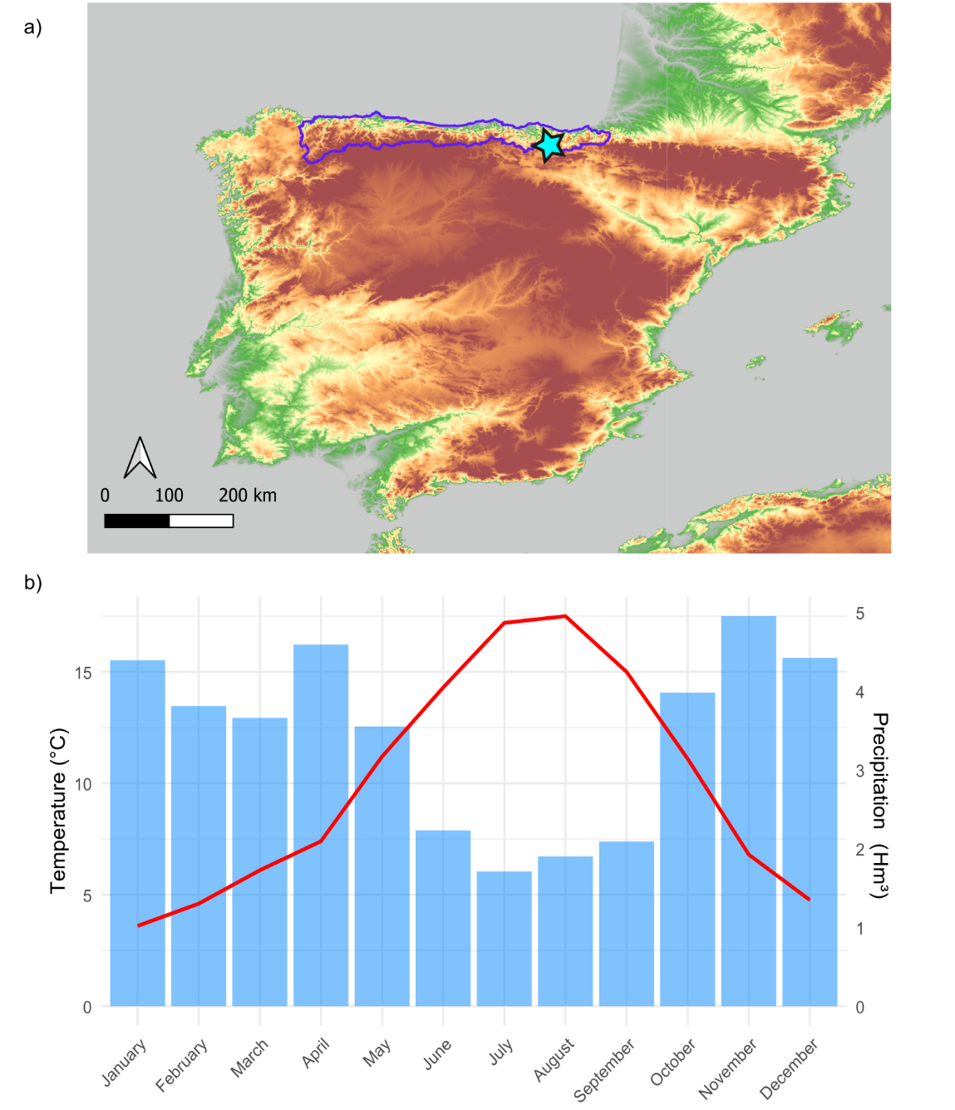
Figure 1. Geographic location and climatic setting of the Verdeospesoa peat bog. (a) Map of the Iberian Peninsula indicating the Cantabrian Region (purple) and the location of the Verdeospesoa peat bog (blue star). (b) Climograph of the study area showing mean monthly precipitation and temperature, derived from AEMET record (https://agroclimap.aemet.es/#).
Radiocarbon dating
Seven bulk sediment samples were radiocarbon dated by Accelerator Mass Spectrometry. All samples were pretreated using acid-base-acid (ABA) protocol to remove contaminants (Table 1). The resulting radiocarbon ages were calibrated using the IntCal20 calibration curve (Reimer et al. 2020) with the OxCal software, and an age–depth model for the 225–180 cm interval was constructed using the Bayesian Bacon age–depth modelling approach (Blaauw & Christen 2011). Model convergence was assessed via Markov Chain Monte Carlo (MCMC) iteration traces and sedimentation rates were calculated as millimetres per year (mm/yr). Posterior age estimates and 95% credible intervals (C.I.) were generated for each depth increment.

N-alkane analyses
Twenty-four samples were extracted from the 225–182 cm core depth interval for n-alkane and hydrogen and carbon isotope analyses using standard methods and processes (Merritt et al. 1994; Toney et al. 2020). Sediment samples were freeze-dried, homogenised, and processed at the Biomarkers for Environmental and Climate Science (BECS) laboratory at the University of Glasgow. Total lipid extracts (TLE) were obtained via an Accelerated Solvent Extractor (Dionex ASE 350) utilising a dichloromethane (DCM) to methanol (MeOH) solvent mixture (9:1, v/v). The resulting TLE was separated into Total Neutral Fractions (TNF) and Total Acid Fractions (TAF) using aminopropyl silica gel column chromatography (LC-NH2 SPE). The neutral fraction was eluted with DCM:isopropanol (1:1, v/v). The TNF was subsequently fractionated via regular silica gel flash column chromatography into four distinct sub-fractions (N1 to N4). The target aliphatic hydrocarbons (n-alkanes) were collected in the N1 fraction using pure n-hexane as the eluent.
Prior to isotopic monitoring, all isolated N1 fractions were dissolved in n-hexane and initially screened on a Gas Chromatograph equipped with a Flame Ionisation Detector (GC-FID). This preliminary step served as a concentration and quality check to verify peak resolution and optimise injection volumes. Compound-specific stable hydrogen isotope compositions of the individual n-alkanes were subsequently determined using Gas Chromatography-Isotope Ratio Mass Spectrometry. The analytical system comprised an Agilent gas chromatograph coupled to an Elementar GC5 combustion/pyrolysis interface operating at 1450°C for the quantitative thermal conversion of organic compounds into pure gas. For δD analyses, organic compounds were quantitatively converted to H₂ via high-temperature pyrolysis at 1450 °C. For δ¹³C analyses, compounds were quantitatively oxidised to CO₂ using a combustion reactor operated at 850 °C. Stable carbon isotope ratios are reported in δ notation relative to the Vienna Pee Dee Belemnite (VPDB) scale, whereas
hydrogen isotopic values are reported in standard delta notation (‰) calibrated relative to the Vienna Standard Mean Ocean Water (V-SMOW) scale. Following previous studies, one sample for n-C₂₉ and n-C₃₁ were excluded as outliers for those specific chain lengths, as they were different from adjacent samples by more than 2 ‰ (Duncan et al. 2025).
The following indexes were used to characterise n-alkanes based on concentration (ug/g) data:
- Average Chain Length (ACL) characterises the chain-length distribution of n-alkanes (Ling et al. 2021). Several studies have reported positive correlations between ACL and temperature (Feakins et al. 2016; Shen et al. 2022) or precipitation(Hoffmann et al. 2013; Wang et al. 2023); however, these relationships are species-dependent and may vary between taxa, with higher values typically observed in grasses and lower values in woody vegetation (Norström et al. 2018):

$$\left(1\right) ACL=\frac{27*C_{27}+29*C_{29}+31*C_{31}+33*C_{33}+35*C_{35}}{C_{27}+C_{29}+C_{31}+C_{33}+C_{35}}$$
- Carbon Preference Index (CPI) describes the predominance of odd-numbered over even-numbered carbon chain lengths in n-alkanes. High CPI values (>2) typically indicate a terrestrial higher-plant source, whereas low CPI values (approaching 1) suggest either a non-terrestrial source (e.g., microbial inputs) or extensive diagenetic/maturation processes that have reduced the original odd-over-even predominance (Luo et al. 2012) (Bush & McInerney 2013):
$$\left(2\right) CPI=0.5*\left(\frac{\sum{C_{25}}-C_{33}(odd)}{\sum{C_{24}}-C_{32}(even)}+\frac{\sum{C_{25}}-C_{33}(odd)}{\sum{C_{26}}-C_{34}(even)}\right)$$
- The Paq ratio distinguishes mid-chain n-alkanes, which are typically produced by aquatic macrophytes, from long-chain n-alkanes, which are mainly derived from emergent and terrestrial plant leaf waxes (Ficken et al. 2000). Consequently, it is widely used to infer sources of organic matter and reconstruct hydrological conditions. Generally, Paq values < 0.1 indicate predominantly terrestrial inputs, values between 0.1 and 0.4 suggest contributions from emergent macrophytes or mixed sources, and values > 0.4 are associated with submerged or floating aquatic macrophytes (Ficken et al. 2000; Huo et al. 2024):
3PaqPaq=C23+C25C23-C31(odd)
- The Terrigenous-to-Aquatic Ratio (TAR) compares the abundance of long‑chain, land‑plant alkanes with short‑chain, algal/aquatic alkanes (Glendell et al. 2018). Therefore, TAR is frequently interpreted as an indicator of source origin and terrestrial plant productivity (Wang et al. 2014):
$$\left(4\right)TAR =\left(\frac{C_{27}+C_{29}+C_{31}}{C_{15}+C_{17}+C_{19}}\right)$$
- The C₃₁/C₂₇ and C₃₁/C₂₉ ratios are frequently used to distinguish herbaceous from woody vegetation inputs (Zhou et al. 2016), although their values may also be affected by additional environmental and depositional factors (Li et al. 2016).
- The Δ_{aq-terr} refers to the offset between the hydrogen stable istopes of short-chain (δD_{aq}) and long-chain (δD_{terr}) n-alkanes, commonly used as a proxy for terrestrial evapotranspiration(Rach et al. 2014; Rach et al. 2017; Strobel et al. 2022; Prochnow et al. 2026). Because leaf and soil water isotope enrichment affects the source water of terrestrial plants (i.e., δD_{terr}) but has a much weaker or negligible effect on the source water of submerged aquatic plants (i.e., δD_{aq}), the magnitude of this offset reflects the strength of evapotranspiration. In the following equation, δD_{aq} commonly refers to δD_{C23}, whereas δD_{terr} refers to either δD_{C31} or δD_{C29} (Rach et al. 2014; Rach et al. 2017; Strobel et al. 2022; Prochnow et al. 2026). In this study, the calculation was performed twice, using both δD_{C31} and δD_{C29}:

5Δaq-terr=1000*δDaq+1000δDterr+1000-1
Sedimentary ancient DNA
Ancient environmental DNA was extracted from eight sediment samples spanning the Pleistocene-Holocene transition and two additional negative control samples. All laboratory procedures were undertaken at the Ancient DNA Laboratory of the Arctic University Museum of Norway in Tromsø using the metabarcoding workflow described by (Julián-Posada et al. 2025). For each sample, eight PCR replicates were performed with both primer sets following the protocol described by (Voldstad et al. 2020). PCR products were pooled and purified prior to library construction. Sequencing libraries were prepared using a modified Illumina TruSeq PCR-free protocol incorporating unique dual indices (Rijal et al. 2021). Library concentrations were determined by quantitative PCR using the Library Quantification Kit for Illumina sequencing platforms. Sequencing was subsequently carried out at the Genomics Support Centre Tromsø (GSCT), The Arctic University of Norway, using an Illumina NextSeq platform with paired-end sequencing (2 × 150 bp). Plant sequence identification was achieved by comparison against four reference databases PhyloAlps (Garcés-Pastor et al. 2022), PhyloNorway (Alsos et al. 2020), ArctBorBryo (Sønstebø et al. 2010), and EMBL rl143(Stoesser et al. 2002). For each taxonomic assignment, we report both the number of reads and the percentage of PCR replicates in which the taxon was detected.
Paleoclimate reconstruction
Mean annual temperature (MAT) and mean annual precipitation (MAP) were reconstructed from the VP-1 core collected at Verdeospesoa for palynological analysis (Pérez-Díaz & López-Sáez, 2021). Climate reconstructions were performed using the Weighted Averaging Partial Least Squares (WA-PLS) method. WA-PLS is a unimodal transfer function that combines weighted averaging with partial least squares regressions to model the relationship between modern pollen composition (i.e., relative abundance of species) and climatic gradients (Zhang et al. 2019; Camuera et al. 2022). Modern pollen assemblages were obtained from the European Modern Pollen Database, which comprises 8,338 samples and 547 taxa (Chevalier et al. 2019), and associated MAT and MAP values were extracted for each site using their geographic coordinates and the WorldClim dataset (Fick & Hijmans 2017) (Supplementary Figure 2). Following previous studies, fossil and modern datasets were harmonised at the genus level to ensure taxonomic consistency and aquatic taxa and rare taxa (<1%) were removed and percentages re-calculated (Chevalier et al. 2020; Vidal-Cordasco et al. 2022). Model performance was assessed using leave-one-out cross-validation. This procedure removes one sample from the training set, fits the model to the remaining data, and predicts the omitted observation. After the cross-validation test, the correlation coefficient (r²) for temperature reconstructions was 0.67, with an RMSE of 4.27. For precipitation, the r² was 0.41, with an RMSE of 307.22.

Land cover simulation
LPJ-GUESS is a process-based vegetation model that simulates land cover dynamics based on climate conditions and soil properties (Smith et al. 2001). Within each patch, age cohorts of Plant Functional Types (PFTs) compete for light, water and space while key processes such as photosynthesis, respiration, phenology, soil carbon and nitrogen cycling, and hydrology are simulated. Each PFT is characterised by specific bioclimatic niche, growth form, leaf phenology, photosynthetic pathway and life history traits. Accordingly, population dynamics of each PFT are determined by competition for light, space and soil resources in each of a number of replicate patches for each simulated grid cell.
In this study, LPJ-GUESS was run in cohort mode to compute Net Primary Productivity (NPP) of each PFT in Verdeospesoa. We used the general wetland PFTs described in previous studies (Wolf et al. 2008; Miller & Smith 2012; Chaudhary et al. 2017; Lagergren et al. 2024) (Supplementary Table 1). For each grid cell, 100 replicate patches with an area of 0.1 ha were simulated. All simulations were initialised with bare ground conditions (no biomass), and the model was spun up for 500 years until the simulated vegetation was in approximate equilibrium. The spin-up phase used monthly climate inputs derived from the first 30 years of the simulated period, which were repeated. Subsequently, the model was run for the interval between 25 and 9 k yrs BP (Supplementary Table 2). Paleoclimate drivers used as input were obtained from three different general circulation models (Armstrong et al. 2019; Beyer et al. 2020; Krapp et al. 2021) retrieved from pastclim (Leonardi et al. 2023) after performing delta bias correction. The model also requires the atmospheric CO₂ concentration (ppm) and the soil classification of each cell to account for how soil texture influences hydrological behaviour and thermal diffusivity. CO₂ data were sourced from (Lüthi et al. 2008), while soil type from (Zobler, 1986).
All data and scripts used to perform all the analyses reported in this manuscript are available from GitHub (https://github.com/MarcoVidalCordasco/n-alkanes_Verdeospesoa).
RESULTS

Chronology

Depth | Lab code | Material | Pre-treatment | Age uncalibrated BP | Age Cal BP
 |  |  |  |  | Mean | 95% CI
121 | ETH-148137 | Bulk | ABA | 2839.1±22.4 | 2941 | 3056-2866
182 | ETH-152077 | Bulk | ABA | 9325±28 | 10530 | 10530-10650
196 | ETH-148138 | Bulk | ABA | 9849.1±85.4 | 11313 | 11313-11689
206 | ETH-155414 | Bulk | ABA | 11184±102 | 13082 | 13300-12845
214 | ETH-152076 | Bulk | ABA | 17263±49 | 20829 | 20956-20634
218 | ETH-158691 | Bulk | ABA | 19500±95-140 | 23518 | 23766-23276
225 | ETH-148139 | Bulk | ABA | 20699.2±162.7 | 24918 | 25325-24334
Table 1. Radiocarbon dates from the Verdeospesoa peat sequence, including sample depth, material, pre-treatment method, uncalibrated C¹⁴ ages, and calibrated age ranges (95% CI) based on the IntCal20 calibration curve using OxCal.

Seven ultrafiltered radiocarbon dates indicate that the interval between 225 and 121 cm depth spans ca. 25,000 to 3,000 cal yr BP (Table 1). This study focuses on the Late Pleistocene-Early Holocene transition; accordingly, an age-depth model was developed for the 225-180 cm interval of the sequence. All radiocarbon dates overlap with the modelled age distribution at the 95% confidence interval, indicating internal consistency. The model estimates a mean 95% confidence range of ±900 years across the sequence, with minimum uncertainty of ±297 years at 182 cm depth and maximum uncertainty of ±1,629 years at 222 cm depth (Figure 2). Mean sedimentation rates increased from 0.04 mm/year (SD = 0.02) in the Pleistocene section of the core (>199 cm depth) to 0.146 mm/year (SD = 0.035) in the Early Holocene, suggesting increased accumulation rate during the transition into the Holocene (i.e., < 200 cm depth) (Figure 2).
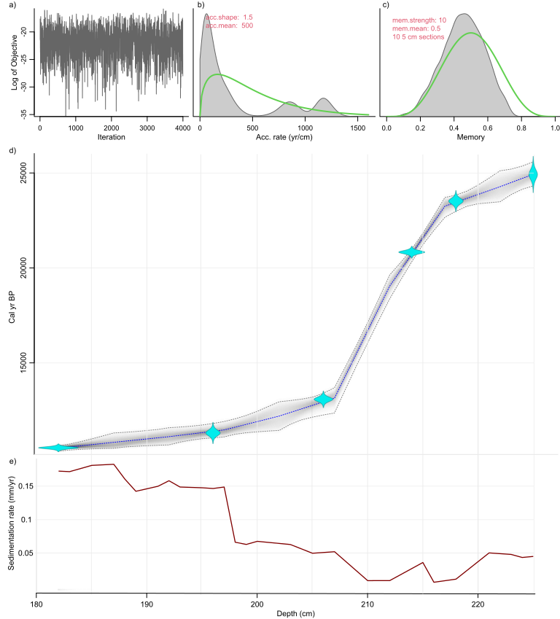
Fig. 2. Age-depth model for the Verdeospesoa peat sequence showing the time interval analysed in this study (25,000-10,000 cal yr BP). (a). Markov chain Monte Carlo iterations (log of objective). (b) Prior (green curve) and posterior (grey histogram) distribution for the accumulation rate. (c) Prior (green curve) and posterior (grey histogram) distribution for the memory. (d) Main age-depth model with calibrated radiocarbon dates and 95% confidence envelope (grey). (e) Temporal evolution of sedimentation rates (mm/yr).

n-Alkane distributions
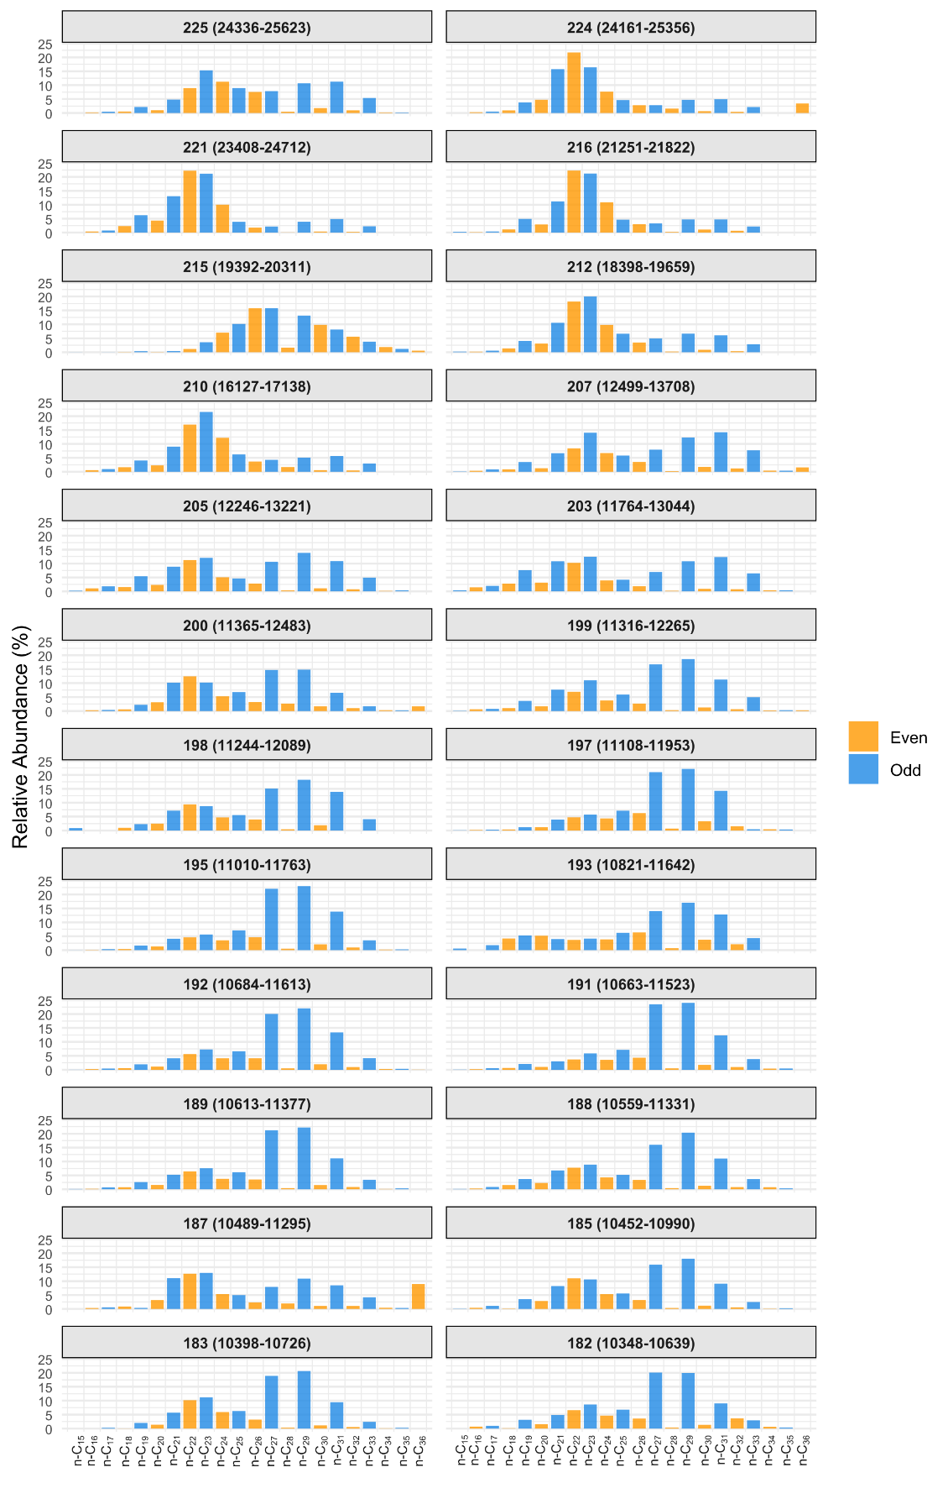
Figure 3. Relative abundance of individual n-alkane homologues by sample depth (cm). The 95% confidence interval age of each sample is shown in parentheses. Odd-numbered homologues are shown in blue and even-numbered homologues in yellow.

The n-alkane distributions span n-C₁₅–n-C₃₆, exhibit a consistent odd-over-even predominance throughout the sequence, and show marked temporal variability in chain-length distributions (Figure 3). At the lower part of sequence (>210 cm depth; >16,730 cal yrs BP), there is a predominance of short-chain n-alkanes (<C₂₅) and low CPI values (mean 2.82; SD 0.81) (Figures 3 and 4). The high P_{AQ} index between 225 and 210 cm depth (24,929-16,730 cal yrs BP) further suggests a greater input from aquatic macrophytes and bryophytes relative to subaerial vascular plants. Between 210 and 205 cm depth (16,730-12,789 cal yrs BP), P_{AQ} values begin a declining trend that continues into the Holocene (Figure 4). In addition to local soil moisture indicators, high Average Chain Length (ACL_{n-C27-n-C33}) and high C₃₁/C₂₇ and C₃₁/C₂₉ ratios suggest a dominant grassy and herbaceous component in the Pleistocene section of the core (i.e., > 199 cm depth) (Figure 4). This is consistent with the pollen record, which indicates a predominance of non-arboreal over arboreal taxa during this interval, followed by increased arboreal pollen and a decline in herbaceous taxa toward the Holocene (Figure 5).

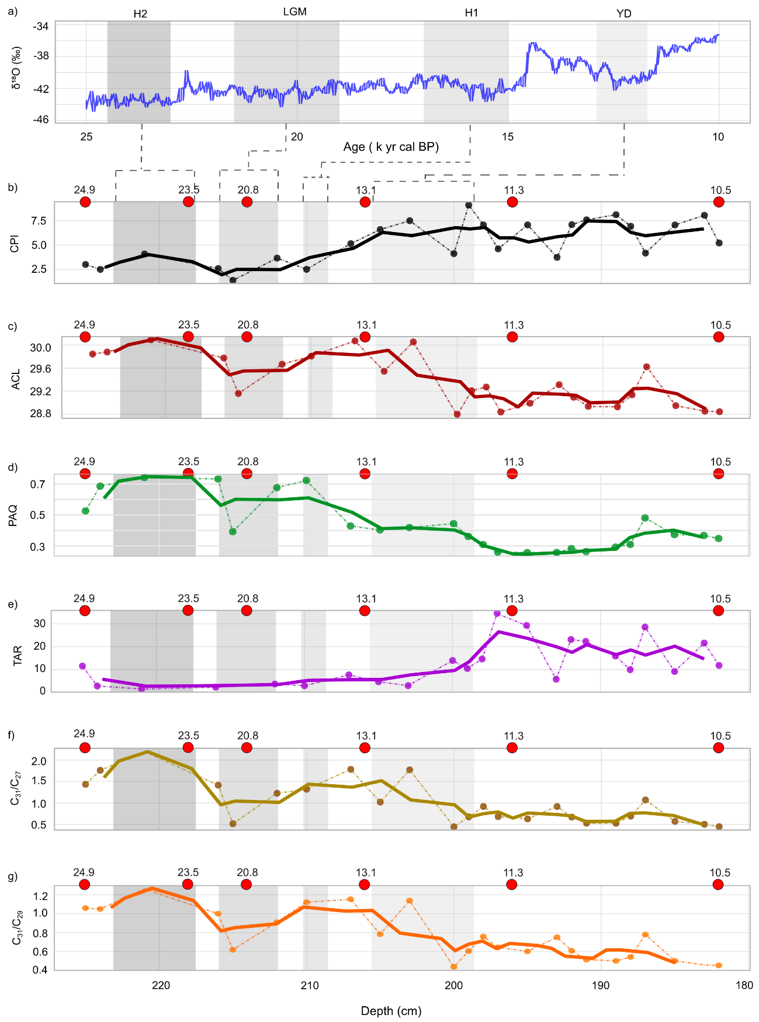Figure 4. Temporal evolution of n-alkane biomarker indices in Verdeospesoa peat bog sediments. a) δ¹⁸O record from the NGRIP ice core (North Greenland Ice Core Project(Rasmussen et al. 2014), (b) Carbon Preference Index (CPI), (c) Average Chain Length (ACL), (d) Paq index, (e) C₃₁/C₂₇ and (f) C₃₁/C₂₉ n-alkane ratios through time. Vertical shaded bands indicate stadial intervals within Marine Isotope Stages 2 and 1, including Heinrich Stadial 2 (HS2), the Last Glacial Maximum (LGM), Heinrich Stadial 1 (HS1), and the Younger Dryas (YD). Red points denote the depth and calibrated chronology (cal k yrs BP) of radiocarbon-dated samples. The bold lines mark the moving average.

In comparison with the Holocene, all n-alkane indexes have a higher variability during the Late Pleistocene (Supplementary Figure 3). With the onset of the Holocene (i.e., <199 cm depth), CPI increases by 68% (Figure 4) in parallel with a threefold increase in sediment accumulation rates (Figure 2). This pattern suggests a shift in input composition and improved preservation conditions (Table 2). After the Younger Dryas, a marked increase in the Terrigenous-to-Aquatic Ratio (TAR) is observed, coinciding with a significant decrease in the Average Chain Length (ACL) of n-alkanes and in the C₃₁/C₂₇ and C₃₁/C₂₉ ratios (Figure 4; Table 2). These changes are consistent with a shift in dominant vegetation from graminoids to an increased contribution of woody vascular plants, in agreement with the pollen record, which shows a rise in tree and shrub abundance relative to sedges and grasses (Figure 5).
 |  | All sequence (n=24) | Pleistocene (n=11) | Holocene (n=13) | Wilcoxon rank test
Depths |  | 225-182 | 225-199 | 198-182 | p-value | W
CPI | mean | 5.38 | 4.35 | 6.4 | 0.014 | 114
 | SD | 2.19 | 2.33 | 1.54
ACL | mean | 29.36 | 29.7 | 29.1 | 0.001 | 19
 | SD | 0.45 | 0.41 | 0.24
PAQ | mean | 0.44 | 0.54 | 0.35 | 0.01 | 28
 | SD | 0.17 | 0.18 | 0.10
TAR | Mean | 15.76 | 12.65 | 18.88 | 0.003 | 121
 | SD | 17.86 | 23.76 | 9.05
C31/C29 | mean | 0.76 | 0.93 | 0.59 | 0.002 | 21
 | SD | 0.26 | 0.26 | 0.12
C31/C27 | mean | 0.98 | 1.30 | 0.68 | 0.010 | 28
 | SD | 0.51 | 0.55 | 0.19
Table 2. Summary statistics (mean and standard deviation, SD) of n-alkane indices for the entire sequence, the Pleistocene interval, and the Holocene interval. Statistical differences between the Pleistocene and Holocene intervals were assessed using the Wilcoxon rank-sum test; p-values and W statistics are reported
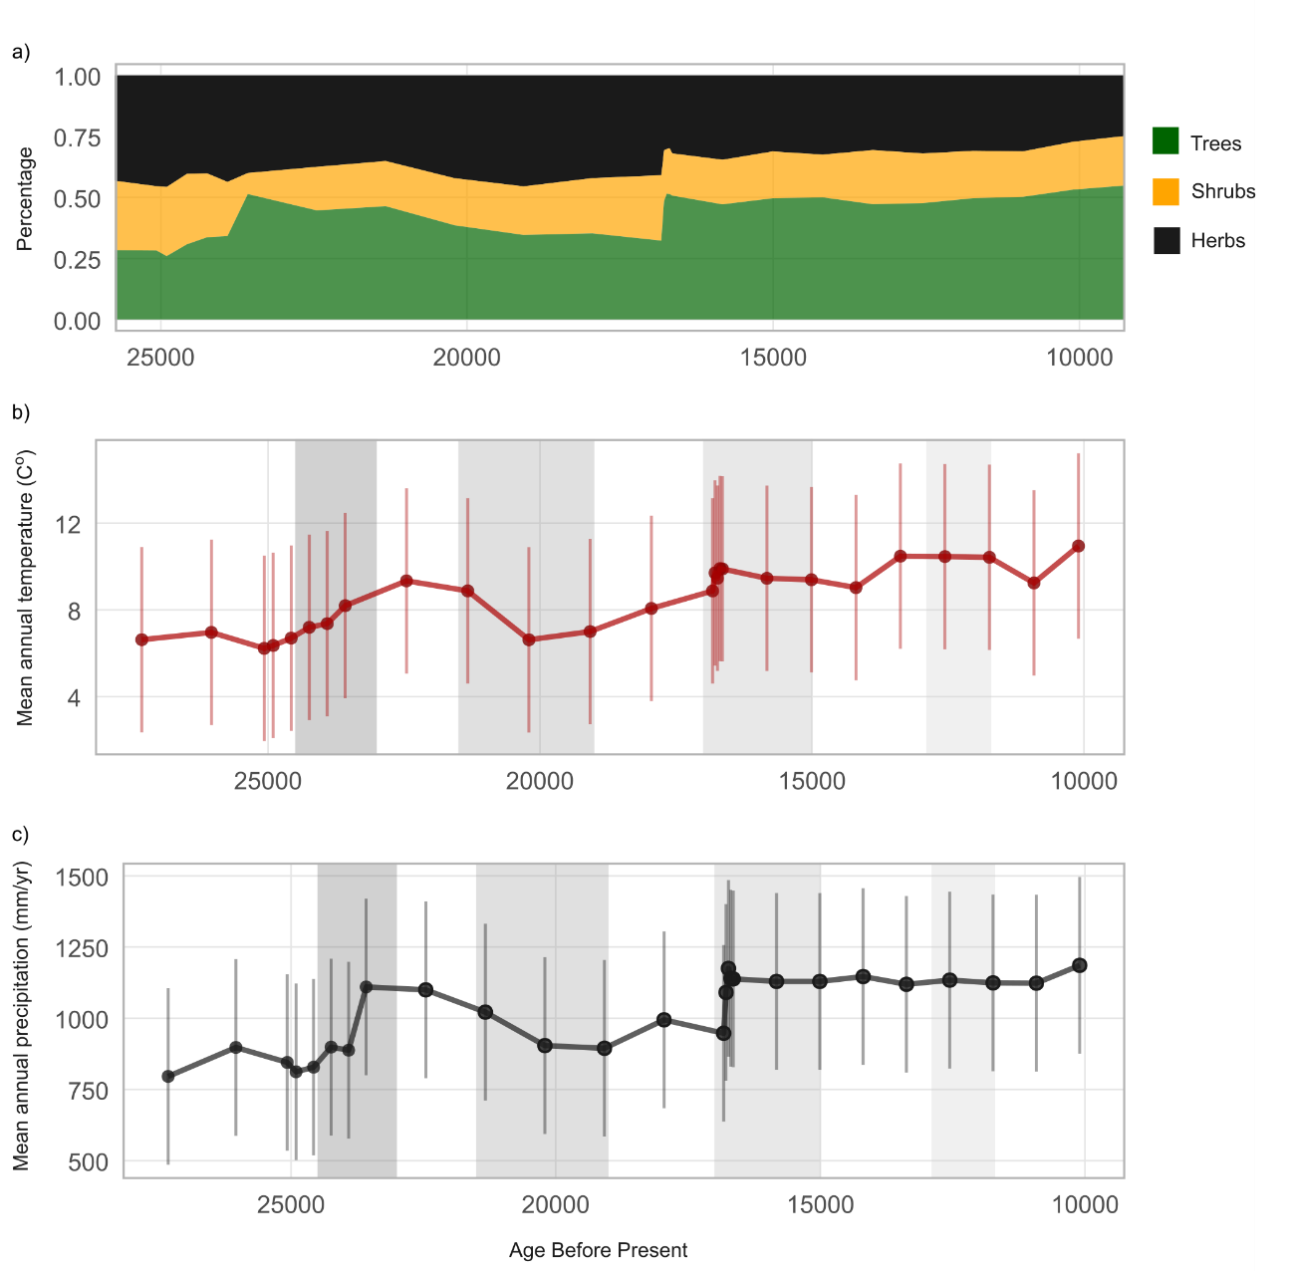
Figure 5. Vegetation and climate evolution at Verdeospesoa inferred from pollen record (Pérez-Díaz & López-Sáez, 2021). (a) Relative abundances (%) of arboreal (trees), shrub, and herbaceous taxa; (b) reconstructed mean annual temperature; and (c) reconstructed mean annual precipitation. Vertical shaded bands indicate stadial intervals.

Stable carbon isotope composition
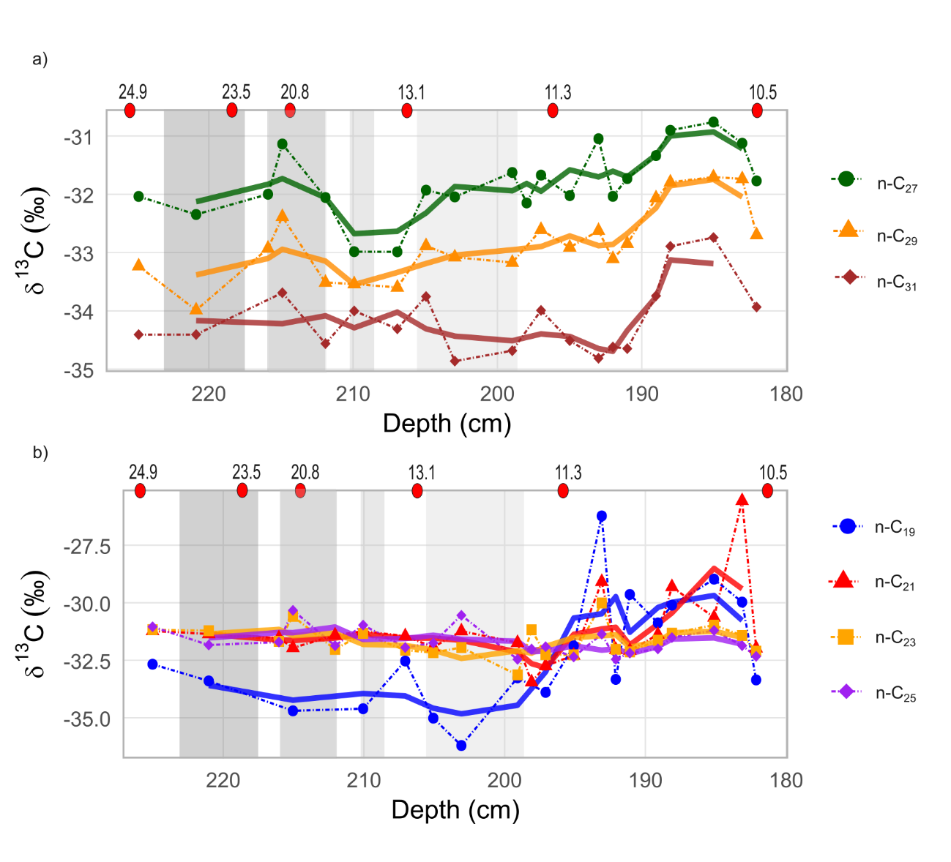
Figure 6. Compound-specific stable carbon isotope ratios of long- and short-chain n-alkanes throughout the sequence. (a) Long-chain n-alkanes; (b) short-chain n-alkanes. Vertical shaded bands indicate stadial intervals. Red points denote the depth and calibrated chronology (cal k yrs BP) of radiocarbon-dated samples. The bold lines mark the moving average.

Compound specific carbon isotope ratios were measured for n-C₁₉ to n-C₃₁. The δ¹³C values of the long-chain n-alkanes (n-C₂₇ to n-C₃₁) decrease with increasing carbon number, whereas the mid-chain homologues (n-C₂₃ to n-C₂₅) are relatively enriched in ¹³C compared to the higher carbon homologues (Figure 5). δ¹³C values of n-C₂₇, n-C₂₉, and n-C₃₁ are positively correlated with one another and, unlike the δ¹³C values of short- and mid-chain n-alkanes, show negative correlations with ACL, C₃₁/C₂₇, and C₃₁/C₂₉ ratios (Supplementary Figure 4). This pattern suggests a common source for these long-chain homologues and indicates that their isotopic variability is affected by changes in terrestrial vegetation composition.
The δ¹³C values of short- and mid-chain n-alkanes (n-C₁₉, n-C₂₁, n-C₂₃, n-C₂₅) show coherent trends across the sequence (Figure 6). Between 225 and 216 cm depth (24,929–21,586 cal BP), all mid-chain n-alkanes exhibit relatively depleted values consistent with a dominant contribution from C₃ vegetation. An increasing decoupling is observed between 215 and 203 cm depth (19,920–12,386 cal BP), whereby δ¹³C values of n-C₁₉ become progressively more negative, while δ¹³C values of n-C₂₁–n-C₂₅ remain relatively stable (Figure 6). Given that n-C₁₉ can derive from algae and microbial sources, this divergence may reflect changes in aquatic and peatland carbon cycling processes, microbial recycling of isotopically light CO₂, or shifts in algal productivity. In contrast, mid-chain n-alkanes are less sensitive to these processes over the same interval. Subsequently, after the Younger Dryas (<200 cm depth), the offset between short- and mid-chain n-alkanes narrows and all experience increasingly positive δ¹³C values (Figure 6), which suggests a broadly similar response to post-glacial environmental change.
The δ¹³C of long-chain n-alkanes (n-C₂₇, n-C₂₉, n-C₃₁) are significantly correlated (Supplementary Figure 5). At 215 cm depth, (ca.19,920 cal yr BP), the δ¹³C values of n-C₂₇, n-C₂₉, and n-C₃₁ became, on average, 0.86‰, 0.54‰, and 0.72‰ more positive, respectively. However, δ¹³C values of mid-chain homologues remain relatively stable (Figure 6). This episode coincides with a drop of 71% in PAQ, of 63.5% in C₃₁/C₂₇ and 38% in C₃₁/C₂₉, suggesting that the δ¹³C positive excursion was affected by a change in the plant community composition. Subsequently, the δ¹³C values of long-chain n-alkanes become increasingly depleted, reaching minimum values in n-C₂₇ (-32.97‰) and n-C₂₉ (-33.51‰) between 210 and 207 cm depth (16,730–13,174 cal yr BP). This depletion likely reflects increased effective moisture conditions for terrestrial C₃ vegetation, leading to enhanced carbon isotope discrimination. In this connection, paleoclimate reconstruction derived from pollen record indicates that mean annual precipitation increased by 22% over the same interval (Figure 5). From 207 cm depth (ca. 13,174 yrs cal BP) onwards, δ¹³C values of n-C₂₇ and n-C₂₉ show a progressive enrichment trend, with a similar increase in n-C₃₁ emerging from 191 cm depth (ca. 11,050 cal yr BP).

Stable hydrogen isotope composition
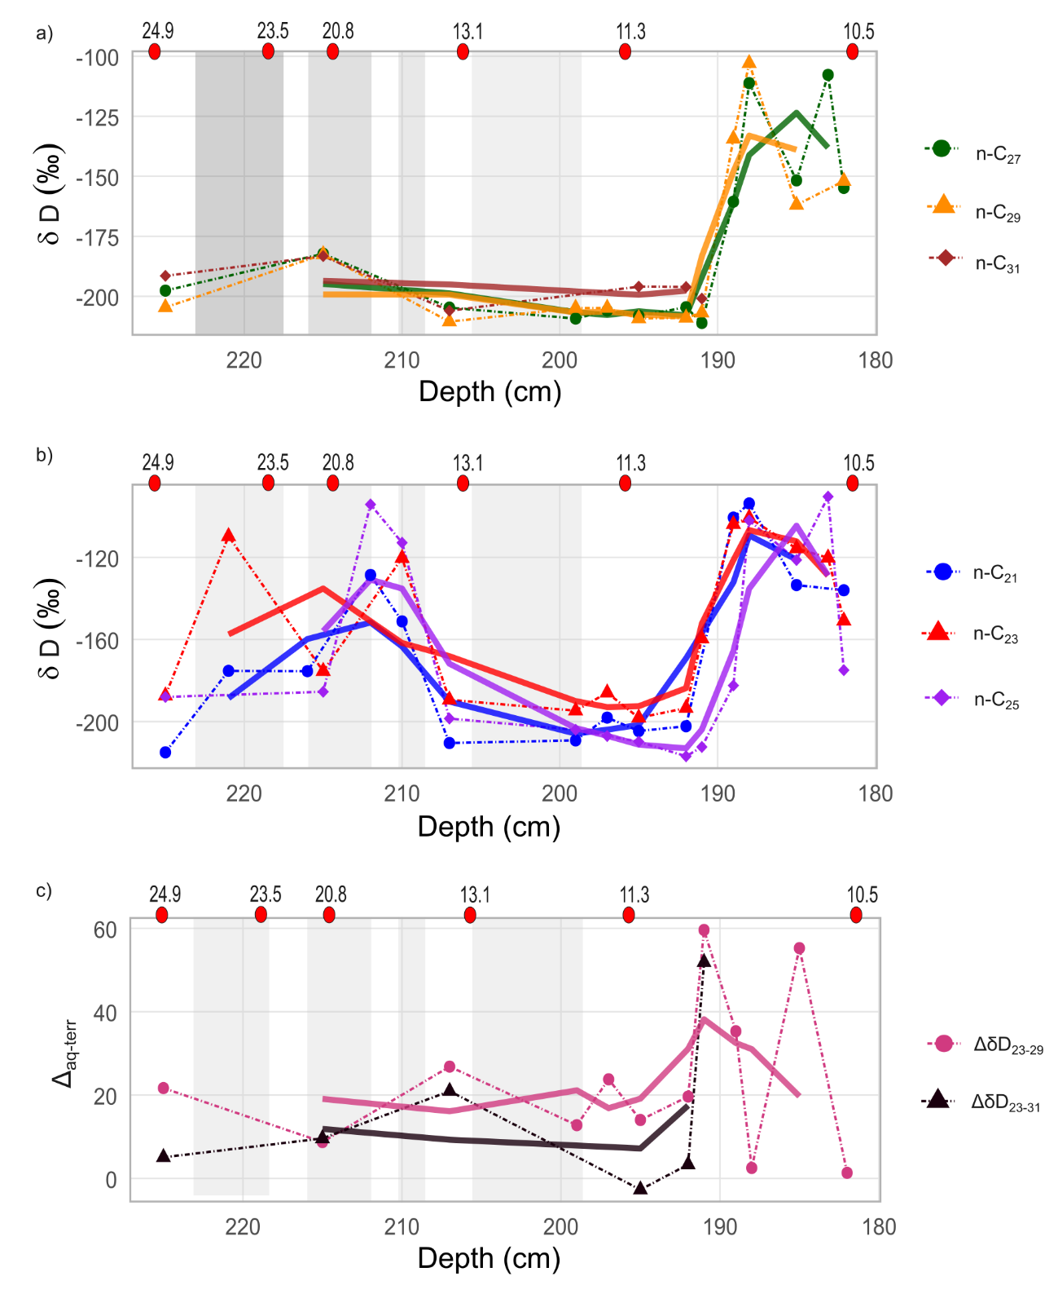
Figure 7. Compound-specific stable hydrogen isotope ratios of long- and short-chain n-alkanes throughout the sequence. (a) Long-chain n-alkanes; (b) short-chain n-alkanes; (c) offset between short- and long-chain n-alkanes. Vertical shaded bands indicate stadial intervals. Red points denote the depth and calibrated chronology (cal k yrs BP) of radiocarbon-dated samples.

Compound-specific δD values of n-alkanes range from −223.4‰ to −86.3‰. Overall, all n-alkanes exhibit broadly similar temporal trends and are significantly correlated with one another, except for the relationships between δD of n-C₃₁ and δD of n-C₂₁ and n-C₂₃ (Supplementary Figure 4). Between 225 and 210 cm depth (24,929–16,730 cal yr BP), two pronounced shifts toward less negative δD values are observed in short- and mid-chain homologues: at 221 cm depth (ca. 22,057 cal yr BP), with a mean enrichment of 58.6‰, and between 212 and 210 cm depth (ca. 19,080–16,730 cal yr BP), with a mean enrichment of 57.3‰ (Figure 7). These shifts are consistent with episodes of reduced precipitation (Figure 5), during which limited water renewal promoted isotopic enrichment of soil waters within the peatland. Because δD measurements of the long-chain homologues were unsuccessful in these samples, the isotopic offset between short- and long-chain n-alkanes (i.e., Δ_{aq-terr}) could not be evaluated. However, pollen-based reconstructions for this interval indicate a mean annual temperature of 7.34 °C (SD 0.98) and a mean annual precipitation of 922 mm/yr (SD 103.32), values that are 4.66 °C and 428 mm/yr lower, respectively, than present-day conditions.
Since the Bølling–Allerød, mean annual temperatures increase by an average of 2.75 °C and precipitation by 216.5 mm/yr, while the most depleted δD values in both long- and mid-chains are observed over this period (207-192 cm depth, ca. 13,174-11,113 cal yrs BP). This pattern points to a shift toward isotopically lighter precipitation or reduced evaporative enrichment of peatland water, reflecting increasing moisture levels. In contrast, the shift toward less negative δD values in all n-alkanes during the Early Holocene (<192 cm depth, <11,113 cal BP) indicates a change in the isotopic composition of source water available to both aquatic and terrestrial plants, likely reflecting a shift in the δD of precipitation driven by (i) warmer temperatures which reduce isotopic fractionation during condensation, (ii) rising sea level which brings moisture sources closer and increases their δD, or (iii) a combination of these processes. Compared with the Pleistocene section of the core, the Holocene interval included in this study shows higher _{Δaq–terr} values and greater variability. Accordingly, Δ_{aq–terr} increases, on average, by 48% when calculated using the offset between δD of n-C₂₃ and n-C₃₁, and by 51% when using the offset between δD of n-C₂₃ and n-C₃₉ (Figure 7).

Ancient sedimentary DNA
A total of 2,007,648 reads, representing 34 unique sequences, were obtained from eight samples (Table 3). After filtration and retaining taxa present in at least three libraries, 16 families, 12 genera, and 10 species were detected.
Wetland taxa dominated the entire sequence. Juncaceae were consistently present, represented by Juncus effusus and Juncus squarrosus, with the latter detected in all PCR replicates across all samples. Cyperaceae were also common but exhibited lower read counts. Within this family, Eriophorum appeared in over 50% of PCR replicates at depths of 212, 205, and 188 cm and in all samples except at 192 cm. The genus Carex occurred in most samples but exhibited low read counts and limited occurrence across PCR replicates (Table 3). The remaining terrestrial herbaceous, shrub, and tree taxa were detected at remarkably lower read counts. Poaceae, Rosaceae, and Pinaceae were present at 218 cm but read counts declined at 212–205 cm. From this moment onward (i.e., ≤198 cm), Asteraceae showed an increasing number of read counts, and the genera Betula and Taxus appeared in the Holocene at 198 cm and 182 cm depth, respectively.
The persistent presence of species typical of acidic, wet and nutrient-poor soils (e.g., Juncus squarrosus), together with a diverse assemblage of terrestrial herbaceous taxa (e.g., Tephroseris, Potentilla, Trifolium, Caltha), is consistent with pollen evidence for open areas within the landscape, suggesting a mosaic of local wetland and open herbaceous communities. Likewise, the gradual, albeit sporadic, appearance of shrub and temperate tree taxa during the Holocene aligns with a trend toward more forested conditions reflected in the pollen record. Nevertheless, low read counts and the limited detection of most species across PCR replicates suggest low DNA preservation.

Type | Family | Genus | Depth | 218 |  | 212 |  | 205 |  | 198 |  | 196 |  | 192 |  | 188 |  | 182
 |  |  | Age (CI) | 21,000-20,223 |  | 19,730-13,748 |  | 13,368-12,565 |  | 12,071-11,262 |  | 11,840-11,045 |  | 11,600-10697 |  | 11,352-10,564 |  | 10,346-10,513
 |  |  | Species | Reads | %PCR | Reads | %PCR | Reads | %PCR | Reads | %PCR | Reads | %PCR | Reads | %PCR | Reads | %PCR | Reads | %PCR
Wetlands/macrophytes | Juncaceae | Juncus | Juncus squarrosus | 370367 | 100 | 49058 | 100 | 158037 | 100 | 153463 | 100 | 149218 | 100 | 691314 | 100 | 99819 | 100 | 21596 | 100
 |  |  | Juncus effusus | 10802 | 37.5 | 425 | 12.5 | 2206 | 62.5 | 1298 | 25 | 418 | 25 | 925 | 12.5 | 6 | 12.5 | 12132 | 100
 | Cyperaceae | Eriophorum | Eriophorum vaginatum | 403 | 12.5 | 682 | 75 | 662 | 75 | 464 | 37.5 |  |  | 952 | 25 | 881 | 87.5 | 123 | 25
 |  | Carex | Carex leporina, Carex chordorrhiza | 246 | 12.5 | 17 | 12.5 | 236 | 37.5 |  |  |  |  |  |  | 370 | 12.5 | 571 | 75
 |  |  | - | 816 | 12.5 | 115 | 3 |  |  | 411 | 25 | 155 | 12.5 |  |  | 160 | 37.5
Terrestrial herbaceus | Asteraceae | - | - |  |  |  |  | 56 | 25 |  |  | 1996 | 12.5 | 5331 | 12.5 | 10253 | 26.78 | 18307 | 35.93
 |  | Tephroseris | Tephroseris integrifolia |  |  | 282 | 25
 | Poaceae | - | - | 53748 | 31.25 |  |  | 429 | 11.1 | 3237 | 12.5 | 8192 | 18 | 39695 | 12.5 | 255 | 12.5
 | Rosaceae | Potentilla | Potentilla erecta | 34658 | 50 | 734 | 12.5 | 512 | 37.5 |  |  | 1227 | 12.5 |  |  | 1326 | 12.5 | 81 | 12.5
 | Fabaceae | Trifolium | Trifolium repens | 12599 | 12.5 | 2305 | 12.5 | 2806 | 50 |  |  | 2374 | 75 |  |  |  |  | 566 | 25
 | Ranunculaeae | Caltha | Caltha palustris |  |  |  |  |  |  | 157 | 12.5 |  |  | 4860 | 25 | 3 | 12.5
 | Solanaeae | - | - |  |  |  |  | 14 | 12.5 | 34137 | 12.5
 | Apiaceae | - | - | 5237 | 12.5 |  |  |  |  | 935 | 12.5
 | Rubicaceae | Galium | - |  |  |  |  |  |  |  |  |  |  |  |  | 1230 | 12.5
 | Campanulaceae |  |  |  |  |  |  |  |  |  |  |  |  |  |  | 506 | 12.5 | 388 | 12.5
Shrubs | Ericaceae | - | - |  |  |  |  | 477 | 12.5 |  |  | 465 | 25 |  |  | 819 | 37.5
 | Adoxacae | Sambucus | Sambucus racemosa |  |  |  |  |  |  |  |  |  |  |  |  | 4 | 12.5
Trees | Pinaceae | Picea | - | 15053 | 12.5
 | Betulaceae | Betula | - |  |  |  |  |  |  | 14499 | 75
 | Taxaceae | Taxus | - |  |  |  |  |  |  |  |  |  |  |  |  |  |  | 3049 | 87.5
Table 4. Taxonomic composition, abundance (read counts and percentage of PCR replicates where the species was identified), and inferred age ranges of plant taxa across sediment depth intervals from sedimentary ancient DNA.

Simulated land cover dynamics
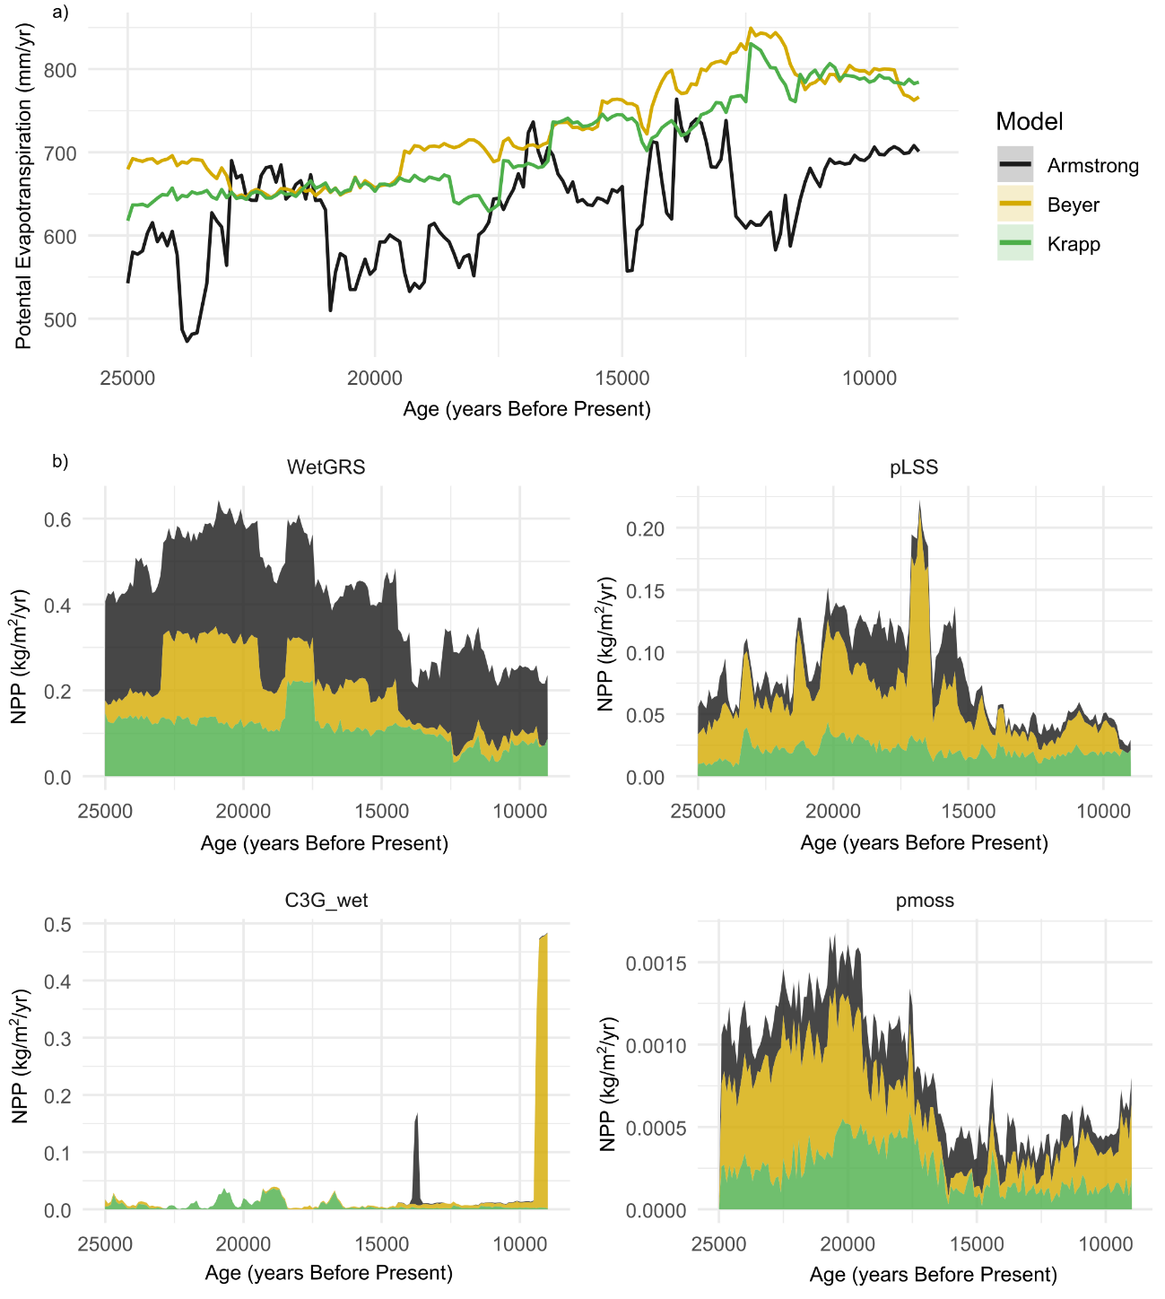
Figure 8. Reconstructed potential evapotranspiration and land cover dynamics at Verdeospesoa according to different paleoclimate models(Armstrong et al. 2019; Beyer et al. 2020; Krapp et al. 2021). (a) Potential evapotranspiration derived from different general circulation models used as inputs for the land cover dynamic simulations. (b) Net primary productivity (NPP) of plant functional types simulated using LPJ-GUESS. For details on each plant functional type, see Supplementary Table 1.

Net Primary Productivity (NPP) across all plant functional types (PFTs) show broadly consistent patterns among the three climate-driven simulations. All paleoclimate models used as drivers in these simulations indicate a substantial increase in potential evapotranspiration after the Last Glacial Maximum (Figure 8). This suggests that, although mean annual precipitation was increasingly higher since the Bølling–Allerød, rising temperatures and enhanced solar radiation amplified evapotranspiration, potentially lowering local soil moisture levels. Accordingly, simulations indicate that flood-tolerant C3 grasses (WetGRS) and peatland low shrub summergreen (pLSS) vegetation are expected to dominate most of the Late Pleistocene sequence, but also to experience a remarkable decline since the Bølling–Allerød (Figure 8). Likewise, NPP from peatland mosses decrease markedly after the Last Glacial Maximum. These trends are consistent with the lipid biomarker and isotopic evidence, indicating that despite the increase in woody vegetation during the Late Pleistocene-Early Holocene transition was driven by rising temperatures and precipitation, increased potential evapotranspiration reduced soil moisture levels, thereby modulating plant functional type distributions and altering plant physiological responses and isotopic fractionation processes.

DISCUSSION
Through the analysis of a peat bog core covering the period ca. 25,000–10,000 years BP and the integration of n-alkane distributions, compound-specific δ¹³C and δD records, sedimentary ancient DNA, pollen data, and land-cover simulations, this study offers new insights into the evolution of vegetation structure and the local- and regional-scale climatic drivers underlying these changes in the Cantabrian Region.
The base of the Verdeospesoa core analysed in this study is dated to 24,929 cal yr BP (95% CI: 25,623–24,336 cal yr BP), suggesting that environmental conditions during the Heinrich Stadial (HS) 2 (ca. 24,500-23,000 cal yr BP) and the Last Glacial Maximum (LGM) (ca. 21,500 and 19,000 yr cal BP) were already conducive to peat bog formation. These cold periods represent the most recent intervals during the Late Glacial when continental ice sheets reached their maximum global extent and volume in Europe (Mix et al. 2001). However, in the Cantabrian Region, glacier expansion peaked earlier, between 48 and 37 kyr cal BP, which has been attributed to relatively drier conditions during MIS2 (Ruiz-Fernández et al. 2016; Serrano et al. 2017). Reconstructed temperatures and precipitations based on mammalian tooth δ¹³C and δ¹⁸O values indicate, for this period, reductions of 5 °C and 450 mm/yr relative to present-day conditions in this area (Lécuyer et al. 2021), which are fully consistent with the pollen-derived temperatures and precipitations provided in this study.
The pollen record recovered from Verdeospesoa indicates, for the MIS2, predominantly open landscapes dominated by herbaceous communities, including grasslands and xerophytic taxa (Pérez-Díaz & López-Sáez, 2021). The CPI values (>2) obtained from the new peat bog core confirm the plant origin of the analysed n-alkanes (Bush & McInerney 2013). Although the n-alkane record has a lower temporal resolution than the pollen record, it is consistent with a predominance of open environments, as indicated by elevated C₃₁/C₂₇ and C₃₁/C₂₉ ratios and high ACL values. In addition, relatively high P_{AQ} and low TAR values point to a contribution from aquatic macrophytes, suggesting that the dominant grassy and herbaceous landscape also included well-developed wetland habitats. This is also supported by sedaDNA data. Although caution is required when interpreting the reconstructed taxonomic richness from sedaDNA—since only three taxa occur in >50% of PCR replicates in this section—these taxa include Juncus, Eriophorum, and Potentilla, all of which are characteristic of wetland and herbaceous terrestrial environments. Taken together, these proxies suggest that, even with low average annual temperatures and precipitations, soil moisture remained high enough to support the continued presence of wetland and hygrophilous herbaceous vegetation (Figure 9).
In the Cantabrian Region, the HS2, LGM, and HS1 are recognised as cold and arid intervals during which sparsely vegetated landscapes predominated (Moreno et al. 2014; Ludwig et al. 2018). Among them, it has been proposed that the HS1 as one of the coldest and most arid periods in Iberia (Moreno et al. 2012). In Lake Enol, this interval is characterised by the lowest sedimentation rates (Moreno et al. 2011), while a speleothem from El Pindal Cave exhibits a hiatus interpreted as evidence of pronounced aridity conditions (Moreno et al. 2010a) (Figure 9). Likewise, stable isotope analyses of planktonic foraminifera recovered from offshore cores in Northern Iberia indicate low sea surface temperatures during this period (Martínez-García et al. 2015; Rofes et al. 2015) (Figure 9). In Verdeospesoa, during the HS2 (i.e., 221 cm depth; ca. 24,057 cal yrs BP), the end of the LGM (i.e., 212 cm depth; 19,080 cal yrs BP) and the beginning of the HS1 (210 cm depth; 16,730 cal yrs BP), δD values of mid- and short-chain n-alkanes become less negative, coinciding with periods of reduced precipitations and temperatures according to the pollen record. In general, less negative δD values are consistent with reduced isotopic depletion of atmospheric moisture as air masses are progressively transported inland and precipitation decreases (Aichner et al. 2010). However, δD values of n-alkanes, particularly in mid-chain homologues, may also be influenced by evapotranspirative enrichment of source water prior to uptake by plants (Ling et al. 2022). In this connection, the evaporative enrichment of shallow pore waters could be affected by a combination of a persistent soil moisture levels that sustain aquatic macrophyte habitats, low precipitations that limit the renewal of surface waters, and prolonged water residence time resulting from low evapotranspiration levels. Therefore, the high P_{AQ} values and low TAR ratio during these episodes, combined with low potential evapotranspiration and the persistent occurrence of wetland and hygrophilous species, indicate that the observed δD variations most likely reflect changes in soil moisture balance under reduced precipitation, with further evaporative enrichment resulting from limited surface-water renewal.
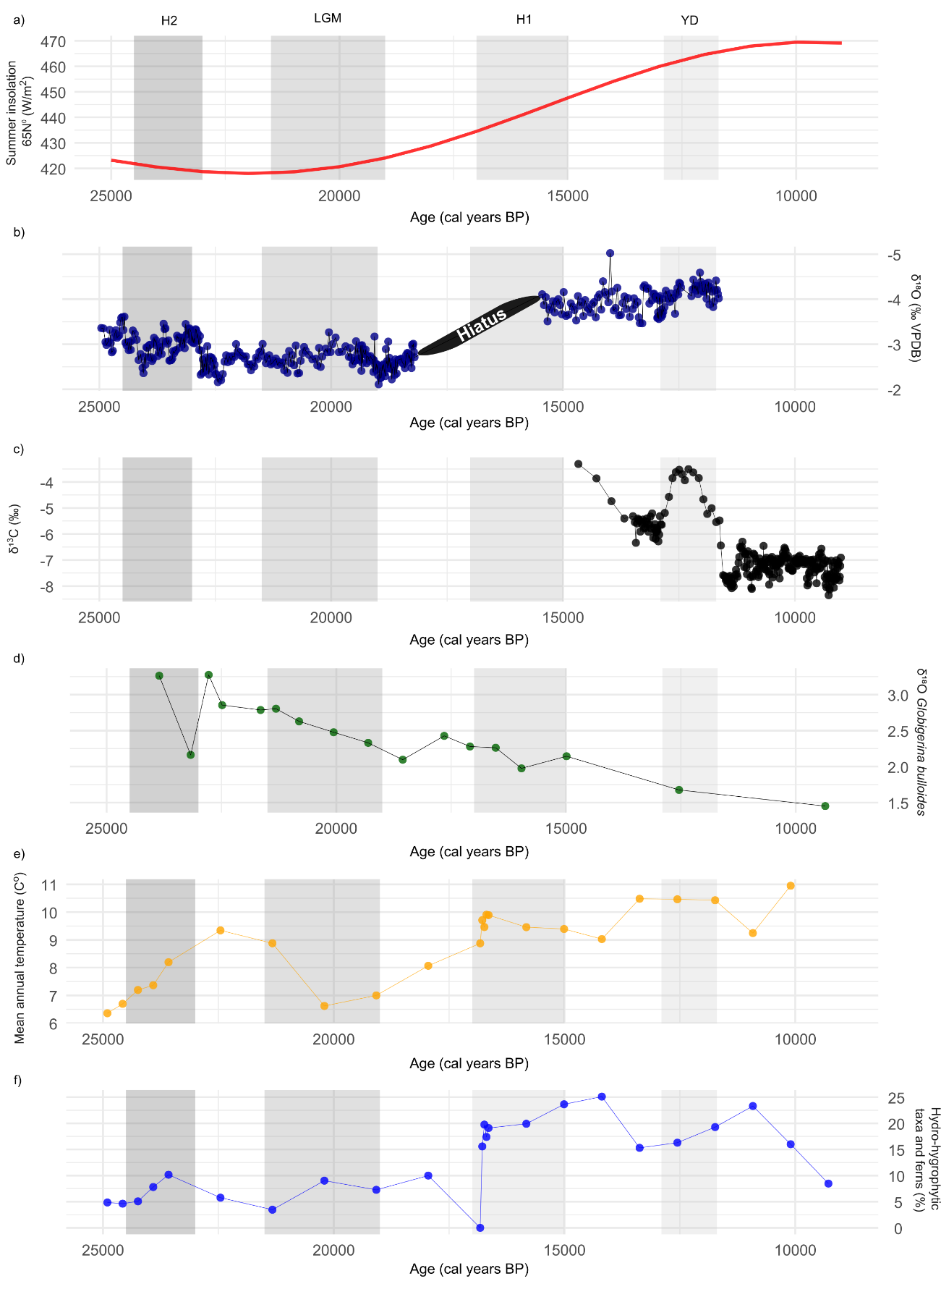
Figure 9. Regional paleoenvironmental conditions. (a) Summer insolation at 65°N (Berger & Loutre 1991); (b) speleothem stable oxygen isotope record from El Pindal Cave (Moreno et al. 2010b); (c) speleothem stable carbon isotope record from El Soplao (Rossi et al. 2018); (d) planktonic foraminiferal stable oxygen isotope record from the Basque Country (Rofes et al. 2015); and (e) mean annual temperature reconstructed from the pollen record of the Verdeospesoa peat bog and (f) percentage of hydro-hygrophytic taxa and ferns (Cyperaceae, Polypodium vulgare type, Pteridium aquilinum) in Verdeospesoa (Pérez-Díaz & López-Sáez, 2021).
Similar mechanisms have been proposed elsewhere on the Iberian Peninsula to explain the hydrological balanced observed in lacustrine systems (Morellón, Valero-Garcés, Vegas-Vilarrúbia, et al. 2009). It has been proposed that, during the coldest intervals of MIS2, reduced summer insolation promoted a positive hydrological balance by decreasing summer evapotranspiration, thereby maintaining relatively high lake levels, even under low precipitation conditions (Morellón, Valero-Garcés, Vegas-Vilarrúbia, et al. 2009). Likewise, the n-alkane distributions, their compound-specific δD signatures, and the paleoclimate reconstructions all suggest that reduced evapotranspiration played a key role in controlling the hydrological status of Verdeospesoa during the coldest and most arid phases of MIS2. These findings imply that, under cold MIS2 climatic conditions, reduced potential evapotranspiration may have helped maintain soil moisture availability despite reduced precipitation.
Variations in the δ¹³C values of long-chain n-alkanes (i.e., > n-C₂₅) are commonly attributed to changes in the relative contributions of C3 and C4 terrestrial plants. The δ¹³C values observed in this study fall within the typical range reported for C3 vegetation (Liu and An, 2020). Under conditions of limited water availability, plants reduce stomatal conductance to minimise transpirational water loss. This reduction decreases the ratio of intercellular to atmospheric CO₂ concentration, leading to lower carbon isotope discrimination and consequently less negative δ¹³C values (Breecker et al. 2010; Diefendorf et al. 2010), although similar isotopic shifts may also arise from changes in vegetation composition (Liu & An 2020) or atmospheric CO₂ concentrations (Warren et al. 2025). The increment in δ¹³C in long-chain n-alkanes at 215 cm depth (ca. 19,920 cal yrs BP) coincides with a remarkable change in ACL, P_{AQ} and C₃₁/C₂₇ and C₃₁/C₂₉ ratios. This suggests that the δ¹³C positive excursion in long-chain n-alkanes was probably due to a plant community composition change rather than a water stress episode affecting terrestrial vascular plants. In this connection, pollen-derived paleoclimate reconstruction indicates an increment of temperatures and precipitations between the HS2 and the LGM.
Between 210 and 207 cm depth (16,730–13,174 cal yr BP), the more negative δ¹³C values of long-chain n-alkanes suggest increased carbon isotope discrimination by terrestrial C₃ vegetation. Concurrently, it is observed a pronounced depletion of δD values across all n-alkanes, which indicates a shift towards isotopically lighter source waters. These transformations are consistent with a substantial increase in precipitations during the Bølling–Allerød. Over this period, the palynological record indicates a marked increase in the proportion of hydro-hygrophytic taxa and ferns in Verdeospesoa (Pérez-Díaz & López-Sáez, 2021) (Figure 9). In addition, mid-chain n-alkane producers maintained relatively stable δ¹³C values despite the marked changes in δD and the δ¹³C depletion in long-chain n-alkanes. This pattern implies a persistent contribution to the mid-chain fraction from a stable assemblage of source organisms with stable biosynthetic fractionation factors (Katrantsiotis et al. 2018). This further suggests that short- and mid-chain n-alkane producers were less sensitive to environmental changes, with soil moisture availability potentially buffering these communities from precipitation fluctuations during the Late Pleistocene.
Between the Bølling–Allerød and the onset of the Holocene, a marked transformation in land cover is observed, characterised by decreases in ACL, PAQ, C₃₁/C₂₉, and C₂₁/C₂₇ ratios and a concomitant increase in TAR. These changes suggest an increased contribution of terrestrial vascular plants relative to aquatic macrophytes. In addition, the staggered enrichment of δ¹³C and δD of all n-alkanes since 11,050 cal yr BP further supports reduced effective soil moisture conditions during the Early Holocene, which is also supported by a reduction in the proportion of hydro-hygrophytic taxa and ferns in Verdeospesoa between 11,000 and 9,000 cal yrs BP (Figure 9) and an increment in the of ca. 50% in the Δ_{aq–terr}. These results indicate that, despite an increase in mean annual precipitation during the Pleistocene-Holocene, soils retained lower moisture levels. This pattern may be explained by the combined effects of: (i) higher potential evapotranspiration driven by increased solar insolation following the end of the Last Glacial period (Figure 9), and (ii) a greater water demand associated with a progressively more forested ecosystem dominated by vascular plants in the surrounding area.
During the Pleistocene-Holocene transition, steppe landscapes in the Eurosiberian region of Iberia were progressively replaced by denser Atlantic forests (Iriarte-Chiapusso et al. 2016; Morellón et al. 2018), which culminated with the highest frequencies of mesophytes during the first millennia of the Holocene. However, the timing and pace of these forest expansions varied considerably across the region (Carrión et al. 2010). Although the onset of the Holocene was generally characterised by increasing mean annual temperatures and precipitations, which promoted forest expansion throughout much of the Iberian Peninsula (Camuera et al. 2019; García-Alix et al. 2021), environmental responses were far from uniform. Evidence from δ¹³C values in a speleothem recovered from El Soplao indicates a potential marked increase in terrestrial soil productivity and land cover following the Younger Dryas (Rossi et al. 2018) (Figure 9). Evidence from Lake Enol indicates a shift toward wetter conditions occurring later, around 9,700 cal yr BP (Moreno et al. 2011). At Lake Estanya, sedimentological and geochemical proxies indicate that the lowest lake levels since the LGM occurred between 11,600 and 9,400 cal yr BP (Morellón, Valero-Garcés, Anselmetti, et al. 2009; Vegas-Vilarrúbia et al. 2013), despite forest expansions at the onset of the Holocene. Similarly, the pollen record from Laguna de la Roya indicates that, despite warmer temperatures characterised the first millennia of the Holocene, climatic conditions remained comparatively dry (Allen et al. 1996). In this context, results obtained from Verdeospesoa suggest that increased mean annual precipitation did not translate into higher soil moisture conditions between 11,000 and 10,000 cal yrs BP. In addition to higher solar insolation and increased potential evapotranspiration driven by orbital forcing (Berger & Loutre 1991), land cover transformations may also have played an important role on soil hydrological conditions. Recent studies have shown that vegetation greening and reforestation can significantly intensify soil drought, as increases in water consumption through enhanced evapotranspiration frequently outweigh gains from increased precipitation (Qu et al. 2026). In this connection, the relevance of soil hydrological status is that soil moisture strongly modulates the impacts of climate change on terrestrial ecosystems (Vereecken et al. 2022). Therefore, future studies should further explore the extent to which shifts in soil hydrological conditions during the Early Holocene may have altered ecosystems vulnerability to climate change.
Despite the multi-proxy approach employed in this study, a few limitations should be acknowledged. First, the age-depth model is based on bulk samples, which can incorporate reworked organic carbon from surrounding soils or underlying sediments. However, the internal consistency of the radiocarbon dates and the absence of age reversals suggest that any bias is minimal. Second, the compound-specific stable isotope data reflect integrated signals from multiple source organisms and are subject to biosynthetic fractionation effects that may vary between species, so future studies should incorporate calibration of fractionation factors for the specific plant taxa present at Verdeospesoa. Third, the sedaDNA data exhibits low taxonomic richness and poor detection of most taxa across PCR replicates, which reflects low DNA preservation. Finally, this study focuses on the Pleistocene–Holocene transition and includes only the first millennium of the Early Holocene; therefore, future work should extend the analysis across the remainder of the Holocene.

CONCLUSIONS
The Verdeospesoa peat bog record indicates that the Pleistocene–Holocene transition in the Cantabrian Region involved a fundamental vegetation reorganisation, shifting from a mosaic of open grasslands and wetland habitats to increasingly forested landscapes. Our results further reveal that soil moisture availability was a critical mediator of ecosystem responses, often decoupled from precipitation trends. During the coldest phases of MIS 2, reduced potential evapotranspiration sustained wetland habitats despite low precipitation, as indicated by evaporatively enriched δD values in mid-chain n-alkanes. Conversely, mean annual temperature and precipitation increased during the Bølling–Allerød, initiating an expansion of forests that reached its maximum extent during the Holocene. Nevertheless, the Early Holocene witnessed reduced effective soil moisture despite higher precipitation, evidenced by enriched δD and δ¹³C values across all n-alkane homologues and declining hydro-hygrophytic taxa. Process-based land cover simulations confirm that rising temperatures and solar insolation amplified evapotranspiration, offsetting precipitation gains and driving the decline of flood-tolerant plant functional types. These findings underscore that environmental responses to the Pleistocene-Holocene climate transition were controlled by a shifting balance between precipitation inputs and evaporative demand, rather than by linear responses to warming. The integration of local-scale lipid biomarker and sedaDNA data, regional pollen signals, and process-based modelling proved essential for disentangling these dynamics.
Acknowledgements
The authors declare that they have no known interest or relationship, financial or otherwise, that is considered a potential source of conflict of interest. This research was funded by the Wenner-Gren Foundation (grant number: Gr. 10787; project ‘Shifting the human role in ecosystems: impact biodiversity erosion on the Late Pleistocene and Early Holocene human populations in Iberia’). This research was also supported by the European Union under the Marie Skłodowska-Curie Postdoctoral Fellowship Programme (FOOD-WEBS project, No. 101207747, call HORIZON-MSCA-2024-PF-01) and the University of Cambridge, Department of Zoology. The views and opinions expressed are solely those of the authors and do not necessarily reflect those of the University or the European Commission.

Author contributions
M.V.-C.: conceptualisation, funding acquisition, fieldwork, formal analysis, investigation, visualisation, writing—original draft, and writing—. M.A.-S.: lipid biomarker measurement, analysis, writing—original draft, and writing—. S.P.-D.: pollen analyses, fieldwork, writing—original draft, and writing—. A.B.M.-A.: writing—original draft, and writing—. I.A.: sedaDNA analyses, writing—original draft, and writing—. A.M.: writing—original draft, and writing—, M.C.: lipid biomarker measurement, analysis, writing—original draft, and writing—.

Aichner, B., Herzschuh, U., Wilkes, H., Vieth, A. & Böhner, J. 2010: δD values of n-alkanes in Tibetan lake sediments and aquatic macrophytes – A surface sediment study and application to a 16 ka record from Lake Koucha. Organic Geochemistry 41, 779–790. https://doi.org/10.1016/j.orggeochem.2010.05.010.
Allen, J. R. M., Huntley, B. & Watts, W. A. 1996: The vegetation and climate of northwest Iberia over the last 14,000 years. Journal of Quaternary Science 11, 125–147. https://doi.org/10.1002/(SICI)1099-1417(199603/04)11:2%3C125::AID-JQS232%3E3.0.CO;2-U.
Alley, R. B. & Clark, P. U. 1999: THE DEGLACIATION OF THE NORTHERN HEMISPHERE: A Global Perspective. Annual Review of Earth and Planetary Sciences 27, 149–182. https://doi.org/10.1146/annurev.earth.27.1.149.
Alsos, I. G., Boussange, V., Rijal, D., Beaulieu, M., Brown, A., Herzschuh, U., Svenning, J.-C. & Pellissier, L. 2024: Using ancient sedimentary DNA to forecast ecosystem trajectories under climate change. Philosophical Transactions of the Royal Society B 379. https://doi.org/10.1098/rstb.2023.0017.
Alsos, I. G., Lavergne, S., Merkel, M. K. F., Boleda, M., Lammers, Y., Alberti, A., Pouchon, C., Denoeud, F., Pitelkova, I., Pușcaș, M., Roquet, C., Hurdu, B.-I., Thuiller, W., Zimmermann, N. E., Hollingsworth, P. M. & Coissac, E. 2020: The Treasure Vault Can be Opened: Large-Scale Genome Skimming Works Well Using Herbarium and Silica Gel Dried Material. Plants 9, 432. https://doi.org/10.3390/plants9040432.
Armstrong, E., Hopcroft, P. O. & Valdes, P. J. 2019: A simulated Northern Hemisphere terrestrial climate dataset for the past 60,000 years. Scientific Data 6, 1–16. https://doi.org/10.1038/S41597-019-0277-1;SUBJMETA=106,1108,2786,413,694,704;KWRD=CLIMATE+AND+EARTH+SYSTEM+MODELLING,PALAEOCLIMATE,PROJECTION+AND+PREDICTION.
Badewien, T., Vogts, A., Dupont, L. & Rullkötter, J. 2015: Influence of Late Pleistocene and Holocene climate on vegetation distributions in southwest Africa elucidated from sedimentary n-alkanes – Differences between 12°S and 20°S. Quaternary Science Reviews 125, 160–171. https://doi.org/10.1016/j.quascirev.2015.08.004.
Berger, A. & Loutre, M. F. 1991: Insolation values for the climate of the last 10 million years. Quaternary Science Reviews 10, 297–317. https://doi.org/10.1016/0277-3791(91)90033-Q.
Beyer, R. M., Krapp, M. & Manica, A. 2020: High-resolution terrestrial climate, bioclimate and vegetation for the last 120,000 years. Scientific Data 7, 1–9. https://doi.org/10.1038/S41597-020-0552-1;SUBJMETA=106,158,2462,413,704;KWRD=PALAEOCLIMATE,PALAEOECOLOGY.
Blaauw, M. & Christen, J. A. 2011: Flexible paleoclimate age-depth models using an autoregressive gamma process. Bayesian Analysis 6, 457–474. https://doi.org/10.1214/11-BA618.
Breecker, D. O., Sharp, Z. D. & McFadden, L. D. 2010: Atmospheric CO2 concentrations during ancient greenhouse climates were similar to those predicted for A.D. 2100. Proceedings of the National Academy of Sciences of the United States of America 107, 576–580. https://doi.org/10.1073/pnas.0902323106.
Broecker, W. S. 1994: Massive iceberg discharges as triggers for global climate change. Nature 372, 421–424. https://doi.org/10.1038/372421a0.
Bush, R. T. & McInerney, F. A. 2013: Leaf wax n-alkane distributions in and across modern plants: Implications for paleoecology and chemotaxonomy. Geochimica et Cosmochimica Acta 117, 161–179. https://doi.org/10.1016/j.gca.2013.04.016.
Camuera, J., Jiménez-Moreno, G., Ramos-Román, M. J., García-Alix, A., Toney, J. L., Anderson, R. S., Jiménez-Espejo, F., Bright, J., Webster, C., Yanes, Y. & Carrión, J. S. 2019: Vegetation and climate changes during the last two glacial-interglacial cycles in the western Mediterranean: A new long pollen record from Padul (southern Iberian Peninsula). Quaternary Science Reviews 205, 86–105. https://doi.org/10.1016/J.QUASCIREV.2018.12.013.
Camuera, J., Jiménez-Moreno, G., Ramos-Román, M. J., García-Alix, A., Toney, J. L., Anderson, R. S., Jiménez-Espejo, F., Kaufman, D., Bright, J., Webster, C., Yanes, Y., Carrión, J. S., Ohkouchi, N., Suga, H., Yamame, M., Yokoyama, Y. & Martínez-Ruiz, F. 2018: Orbital-scale environmental and climatic changes recorded in a new ∼200,000-year-long multiproxy sedimentary record from Padul, southern Iberian Peninsula. Quaternary Science Reviews 198, 91–114. https://doi.org/10.1016/J.QUASCIREV.2018.08.014.
Camuera, J., Ramos-Román, M. J., Jiménez-Moreno, G., García-Alix, A., Ilvonen, L., Ruha, L., Gil-Romera, G., González-Sampériz, P. & Seppä, H. 2022: Past 200 kyr hydroclimate variability in the western Mediterranean and its connection to the African Humid Periods. Scientific Reports 12, 1–13. https://doi.org/10.1038/S41598-022-12047-1;SUBJMETA.
Carrión, J. S., Fernández, S., González-Sampériz, P., Gil-Romera, G., Badal, E., Carrión-Marco, Y., López-Merino, L., López-Sáez, J. A., Fierro, E. & Burjachs, F. 2010: Expected trends and surprises in the Lateglacial and Holocene vegetation history of the Iberian Peninsula and Balearic Islands. Review of Palaeobotany and Palynology 162, 458–475. https://doi.org/10.1016/j.revpalbo.2009.12.007.
Carrión, J. S., Yll, E. I., Walker, M. J., Legaz, A. J., Chaín, C. & López, A. 2003: Glacial refugia of temperate, Mediterranean and Ibero-North African flora in south-eastern Spain: new evidence from cave pollen at two Neanderthal man sites. Global Ecology and Biogeography 12, 119–129. https://doi.org/10.1046/j.1466-822X.2003.00013.x.
Chambers, F. M., Booth, R. K., De Vleeschouwer, F., Lamentowicz, M., Le Roux, G., Mauquoy, D., Nichols, J. E. & van Geel, B. 2012: Development and refinement of proxy-climate indicators from peats. Quaternary International 268, 21–33. https://doi.org/10.1016/j.quaint.2011.04.039.
Chaudhary, N., Miller, P. A. & Smith, B. 2017: Modelling Holocene peatland dynamics with an individual-based dynamic vegetation model. Biogeosciences 14, 2571–2596. https://doi.org/10.5194/bg-14-2571-2017.
Chevalier, M., Davis, B. A. S., Heiri, O., Seppä, H., Chase, B. M., Gajewski, K., Lacourse, T., Telford, R. J., Finsinger, W., Guiot, J., Kühl, N., Maezumi, S. Y., Tipton, J. R., Carter, V. A., Brussel, T., Phelps, L. N., Dawson, A., Zanon, M., Vallé, F., Nolan, C., Mauri, A., de Vernal, A., Izumi, K., Holmström, L., Marsicek, J., Goring, S., Sommer, P. S., Chaput, M. & Kupriyanov, D. 2020: Pollen-based climate reconstruction techniques for late Quaternary studies. Earth-Science Reviews 210, 103384–103384. https://doi.org/10.1016/J.EARSCIREV.2020.103384.
Chevalier, M., Davis, B. A. S., Sommer, P. S., Zanon, M., Carter, V. A., Phelps, L. N., Mauri, A. & Finsinger, W. 2019: Eurasian Modern Pollen Database (former European Modern Pollen Database). https://doi.org/10.1594/PANGAEA.909130.
Diefendorf, A. F., Mueller, K. E., Wing, Scott. L., Koch, P. L. & Freeman, K. H. 2010: Global patterns in leaf 13C discrimination and implications for studies of past and future climate. Proceedings of the National Academy of Sciences 107, 5738–5743. https://doi.org/10.1073/pnas.0910513107.
Duncan, B. J., McKay, R., Levy, R., Prebble, J. G., Naish, T., Seki, O., Kraus, C., Moossen, H., Ventura, G. T., Kulhanek, D. K. & Bendle, J. 2025: Survival strategies of Antarctic vegetation during extensive glacial expansion across the Oligocene/Miocene Transition. EGUsphere 1–24. https://doi.org/10.5194/egusphere-2024-4021.
Eglinton, T. I. & Eglinton, G. 2008: Molecular proxies for paleoclimatology. Earth and Planetary Science Letters 275, 1–16. https://doi.org/10.1016/j.epsl.2008.07.012.
Feakins, S. J., Peters, T., Wu, M. S., Shenkin, A., Salinas, N., Girardin, C. A. J., Bentley, L. P., Blonder, B., Enquist, B. J., Martin, R. E., Asner, G. P. & Malhi, Y. 2016: Production of leaf wax n-alkanes across a tropical forest elevation transect. Organic Geochemistry 100, 89–100. https://doi.org/10.1016/j.orggeochem.2016.07.004.
Fick, S. E. & Hijmans, R. J. 2017: WorldClim 2: new 1-km spatial resolution climate surfaces for global land areas. International Journal of Climatology 37, 4302–4315. https://doi.org/10.1002/JOC.5086.
Ficken, K. J., Li, B., Swain, D. L. & Eglinton, G. 2000: An n-alkane proxy for the sedimentary input of submerged/floating freshwater aquatic macrophytes. Organic Geochemistry 31, 745–745. https://doi.org/10.1016/S0146-6380(00)00081-4.
Garcés-Pastor, S., Coissac, E., Lavergne, S., Schwörer, C., Theurillat, J. P., Heintzman, P. D., Wangensteen, O. S., Tinner, W., Rey, F., Heer, M., Rutzer, A., Walsh, K., Lammers, Y., Brown, A. G., Goslar, T., Rijal, D. P., Karger, D. N., Pellissier, L., Pouchon, C., Roquet, C., Thuiller, W., Zimmermann, N. E., Alberti, A., Wincker, P., Boleda, M., Boyer, F., Hombiat, A., Perrier, C., Douzet, R., Valay, J. G., Aubert, S., Denoeud, F., Bzeznick, B., Gielly, L., Taberlet, P., Rioux, D., Orvain, C., Rome, M., Wüest, R. O., Latzin, S., Spillmann, J., Feichtinger, L., Van Es, J., Garraud, L., Villaret, J. C., Abdulhak, S., Bonnet, V., Huc, S., Fort, N., Legland, T., Sanz, T., Pache, G., Mikolajczak, A., Noble, V., Michaud, H., Offerhaus, B., Dentant, C., Salomez, P., Bonet, R., Delahaye, T., Leccia, M. F., Perfus, M., Eggenberg, S., Möhl, A., Hurdu, B. I., Szatmari, P. M., Pușcaș, M., Smyčka, J., Mráz, P., Šemberová, K., Ronikier, M., Slovák, M., Heiri, O. & Alsos, I. G. 2022: High resolution ancient sedimentary DNA shows that alpine plant diversity is associated with human land use and climate change. Nature Communications 13, 1–16. https://doi.org/10.1038/S41467-022-34010-4;SUBJMETA=106,158,2165,2462,413,670,704;KWRD=BIODIVERSITY,CLIMATE-CHANGE+ECOLOGY,PALAEOCLIMATE,PALAEOECOLOGY.
García-Alix, A., Camuera, J., Ramos-Román, M. J., Toney, J. L., Sachse, D., Schefuß, E., Jiménez-Moreno, G., Jiménez-Espejo, F. J., López-Avilés, A., Anderson, R. S. & Yanes, Y. 2021: Paleohydrological dynamics in the Western Mediterranean during the last glacial cycle. Global and Planetary Change 202, 103527–103527. https://doi.org/10.1016/J.GLOPLACHA.2021.103527.
Garzón, M. B., Dios, R. S. de & Ollero, H. S. 2007: Predictive modelling of tree species distributions on the Iberian Peninsula during the Last Glacial Maximum and Mid-Holocene. Ecography 30, 120–134. https://doi.org/10.1111/j.0906-7590.2007.04813.x.
Glendell, M., Jones, R., Dungait, J. A. J., Meusburger, K., Schwendel, A. C., Barclay, R., Barker, S., Haley, S., Quine, T. A. & Meersmans, J. 2018: Tracing of particulate organic C sources across the terrestrial-aquatic continuum, a case study at the catchment scale (Carminowe Creek, southwest England). Science of The Total Environment 616–617, 1077–1088. https://doi.org/10.1016/j.scitotenv.2017.10.211.
Hoffmann, B., Kahmen, A., Cernusak, L. A., Arndt, S. K. & Sachse, D. 2013: Abundance and distribution of leaf wax n-alkanes in leaves of Acacia and Eucalyptus trees along a strong humidity gradient in northern Australia. Organic Geochemistry 62, 62–67. https://doi.org/10.1016/j.orggeochem.2013.07.003.
Huo, J., Xue, J., Chen, J., Li, Y., Chen, M., Zhao, Z. & Liu, Y. 2024: Late Pleistocene to early Holocene vegetation and environmental changes in the tropical Leizhou Peninsula, South China: New evidence from the n-alkane record. Palaeogeography, Palaeoclimatology, Palaeoecology 655, 112541. https://doi.org/10.1016/j.palaeo.2024.112541.
Iriarte-Chiapusso, M. J., Muñoz Sobrino, C., Gómez-Orellana, L., Hernández-Beloqui, B., García-Moreiras, I., Fernández Rodriguez, C., Heiri, O., Lotter, A. F. & Ramil-Rego, P. 2016: Reviewing the Lateglacial–Holocene transition in NW Iberia: A palaeoecological approach based on the comparison between dissimilar regions. Quaternary International 403, 211–236. https://doi.org/10.1016/j.quaint.2015.09.029.
Jones, J. R., Marín-Arroyo, A. B., Corchón Rodríguez, M. S. & Richards, M. P. 2021: After the Last Glacial Maximum in the refugium of northern Iberia: Environmental shifts, demographic pressure and changing economic strategies at Las Caldas Cave (Asturias, Spain). Quaternary Science Reviews 262, 106931. https://doi.org/10.1016/j.quascirev.2021.106931.
Julián-Posada, I., Gil-Romera, G., Garcés-Pastor, S., Heintzman, P. D., Gómez, D., Fillat, F., Moreno, A., Lara-Recuero, J., Bover, P., Montes, L., Sierra, A., Valero-Garcés, B., Alsos, I. G. & González-Sampériz, P. 2025: Neolithic pastoralism and plant community interactions at high altitudes of the Pyrenees, southern Europe. Communications Earth & Environment 2025 6:1 6, 1–10. https://doi.org/10.1038/s43247-025-02023-8.
Katrantsiotis, C., Kylander, M. E., Smittenberg, R., Yamoah, K. K. A., Hättestrand, M., Avramidis, P., Strandberg, N. A. & Norström, E. 2018: Eastern Mediterranean hydroclimate reconstruction over the last 3600 years based on sedimentary n-alkanes, their carbon and hydrogen isotope composition and XRF data from the Gialova Lagoon, SW Greece. Quaternary Science Reviews 194, 77–93. https://doi.org/10.1016/j.quascirev.2018.07.008.
Kjellman, S. E., Thomas, E. K., Farnsworth, W. R., Cowling, O. C., Allaart, L., Brynjólfsson, S. & Schomacker, A. 2024: Seasonal precipitation variability on Svalbard inferred from Holocene sedimentary leaf wax δ2H. Boreas 53, 430–452. https://doi.org/10.1111/bor.12661.
Krapp, M., Beyer, R. M., Edmundson, S. L., Valdes, P. J. & Manica, A. 2021: A statistics-based reconstruction of high-resolution global terrestrial climate for the last 800,000 years. Scientific Data 2021 8:1 8, 1–18. https://doi.org/10.1038/s41597-021-01009-3.
Lagergren, F., Björk, R. G., Andersson, C., Belušić, D., Björkman, M. P., Kjellström, E., Lind, P., Lindstedt, D., Olenius, T., Pleijel, H., Rosqvist, G. & Miller, P. A. 2024: Kilometre-scale simulations over Fennoscandia reveal a large loss of tundra due to climate warming. Biogeosciences 21, 1093–1116. https://doi.org/10.5194/bg-21-1093-2024.
Lécuyer, C., Hillaire-Marcel, C., Burke, A., Julien, M.-A. & Hélie, J.-F. 2021: Temperature and precipitation regime in LGM human refugia of southwestern Europe inferred from δ13C and δ18O of large mammal remains. Quaternary Science Reviews 255, 106796. https://doi.org/10.1016/j.quascirev.2021.106796.
Leonardi, M., Hallett, E. Y., Beyer, R., Krapp, M. & Manica, A. 2023: pastclim 1.2: an R package to easily access and use paleoclimatic reconstructions. Ecography 2023, e06481. https://doi.org/10.1111/ecog.06481.
Li, Y., Yang, S., Wang, X., Hu, J., Cui, L., Huang, X. & Jiang, W. 2016: Leaf wax n-alkane distributions in Chinese loess since the Last Glacial Maximum and implications for paleoclimate. Quaternary International 399, 190–197. https://doi.org/10.1016/j.quaint.2015.04.029.
Ling, Y., Zheng, M., Sun, Q., Zhang, C., Wang, Y. & Xie, M. 2022: Impact of climatic and environmental factors on δD of n-alkanes in the lake surface sediments of arid Tibet. Quaternary International 637, 44–56. https://doi.org/10.1016/j.quaint.2022.08.014.
Ling, Y., Zheng, M., Wang, S., Sun, Q., Xie, B. & Zhang, C. 2021: The Impact of Climatic and Environmental Factors on n-Alkanes Indices in Southwestern Tibetan Plateau. Acta Geologica Sinica - English Edition 95, 648–658. https://doi.org/10.1111/1755-6724.14376.
Liu, J. & An, Z. 2020: Leaf wax n-alkane carbon isotope values vary among major terrestrial plant groups: Different responses to precipitation amount and temperature, and implications for paleoenvironmental reconstruction. Earth-Science Reviews 202, 103081. https://doi.org/10.1016/j.earscirev.2020.103081.
Ludwig, P., Shao, Y., Kehl, M. & Weniger, G.-C. 2018: The Last Glacial Maximum and Heinrich event I on the Iberian Peninsula: A regional climate modelling study for understanding human settlement patterns. Global and Planetary Change 170, 34–47. https://doi.org/10.1016/j.gloplacha.2018.08.006.
Luo, P., Peng, P., Lü, H., Zheng, Z. & Wang, X. 2012: Latitudinal variations of CPI values of long-chain n-alkanes in surface soils: Evidence for CPI as a proxy of aridity. Science China Earth Sciences 55, 1134–1146. https://doi.org/10.1007/s11430-012-4401-8.
Lüthi, D., Le Floch, M., Bereiter, B., Blunier, T., Barnola, J.-M., Siegenthaler, U., Raynaud, D., Jouzel, J., Fischer, H., Kawamura, K. & Stocker, T. F. 2008: High-resolution carbon dioxide concentration record 650,000–800,000 years before present. Nature 453, 379–382. https://doi.org/10.1038/nature06949.
Magri, D., Vendramin, G. G., Comps, B., Dupanloup, I., Geburek, T., Gömöry, D., Latałowa, M., Litt, T., Paule, L., Roure, J. M., Tantau, I., Van Der Knaap, W. O., Petit, R. J. & De Beaulieu, J.-L. 2006: A new scenario for the Quaternary history of European beech populations: palaeobotanical evidence and genetic consequences. New Phytologist 171, 199–221. https://doi.org/10.1111/j.1469-8137.2006.01740.x.
Martínez-García, B., Rodríguez-Lázaro, J., Pascual, A. & Mendicoa, J. 2015: The “Northern guests” and other palaeoclimatic ostracod proxies in the late Quaternary of the Basque Basin (S Bay of Biscay). Palaeogeography, Palaeoclimatology, Palaeoecology 419, 100–114. https://doi.org/10.1016/j.palaeo.2014.06.032.
McCabe, A. M. & Clark, P. U. 1998: Ice-sheet variability around the North Atlantic Ocean during the last deglaciation. Nature 392, 373–377. https://doi.org/10.1038/32866.
Merritt, D. A., Brand, W. A. & Hayes, J. M. 1994: Isotope-ratio-monitoring gas chromatography-mass spectrometry: methods for isotopic calibration. Organic Geochemistry 21, 573–583. https://doi.org/10.1016/0146-6380(94)90003-5.
Miller, P. A. & Smith, B. 2012: Modelling Tundra Vegetation Response to Recent Arctic Warming. AMBIO 41, 281–291. https://doi.org/10.1007/s13280-012-0306-1.
Mix, A. C., Bard, E. & Schneider, R. 2001: Environmental processes of the ice age: land, oceans, glaciers (EPILOG). Quaternary Science Reviews 20, 627–657. https://doi.org/10.1016/S0277-3791(00)00145-1.
Morellón, M., Aranbarri, J., Moreno, A., González-Sampériz, P. & Valero-Garcés, B. L. 2018: Early Holocene humidity patterns in the Iberian Peninsula reconstructed from lake, pollen and speleothem records. Quaternary Science Reviews 181, 1–18. https://doi.org/10.1016/j.quascirev.2017.11.016.
Morellón, M., Valero-Garcés, B., Anselmetti, F., Ariztegui, D., Schnellmann, M., Moreno, A., Mata, P., Rico, M. & Corella, J. P. 2009: Late Quaternary deposition and facies model for karstic Lake Estanya (North-eastern Spain). Sedimentology 56, 1505–1534. https://doi.org/10.1111/j.1365-3091.2008.01044.x.
Morellón, M., Valero-Garcés, B., Vegas-Vilarrúbia, T., González-Sampériz, P., Romero, Ó., Delgado-Huertas, A., Mata, P., Moreno, A., Rico, M. & Corella, J. P. 2009: Lateglacial and Holocene palaeohydrology in the western Mediterranean region: The Lake Estanya record (NE Spain). Quaternary Science Reviews 28, 2582–2599. https://doi.org/10.1016/j.quascirev.2009.05.014.
Moreno, A., González-Sampériz, P., Morellón, M., Valero-Garcés, B. L. & Fletcher, W. J. 2012: Northern Iberian abrupt climate change dynamics during the last glacial cycle: A view from lacustrine sediments. Quaternary Science Reviews 36, 139–153. https://doi.org/10.1016/j.quascirev.2010.06.031.
Moreno, A., López-Merino, L., Leira, M., Marco-Barba, J., González-Sampériz, P., Valero-Garcés, B. L., López-Sáez, J. A., Santos, L., Mata, P. & Ito, E. 2011: Revealing the last 13,500 years of environmental history from the multiproxy record of a mountain lake (Lago Enol, northern Iberian Peninsula). Journal of Paleolimnology 46, 327–349. https://doi.org/10.1007/s10933-009-9387-7.
Moreno, A., Stoll, H., Jiménez-Sánchez, M., Cacho, I., Valero-Garcés, B., Ito, E. & Edwards, R. L. 2010a: A speleothem record of glacial (25–11.6 kyr BP) rapid climatic changes from northern Iberian Peninsula. Global and Planetary Change 71, 218–231. https://doi.org/10.1016/j.gloplacha.2009.10.002.
Moreno, A., Stoll, H., Jiménez-Sánchez, M., Cacho, I., Valero-Garcés, B., Ito, E. & Edwards, R. L. 2010b: A speleothem record of glacial (25–11.6 kyr BP) rapid climatic changes from northern Iberian Peninsula. Global and Planetary Change 71, 218–231. https://doi.org/10.1016/J.GLOPLACHA.2009.10.002.
Moreno, A., Svensson, A., Brooks, S. J., Connor, S., Engels, S., Fletcher, W., Genty, D., Heiri, O., Labuhn, I., Perşoiu, A., Peyron, O., Sadori, L., Valero-Garcés, B., Wulf, S. & Zanchetta, G. 2014: A compilation of Western European terrestrial records 60–8 ka BP: towards an understanding of latitudinal climatic gradients. Quaternary Science Reviews 106, 167–185. https://doi.org/10.1016/j.quascirev.2014.06.030.
Nichols, J. E., Booth, R. K., Jackson, S. T., Pendall, E. G. & Huang, Y. 2006: Paleohydrologic reconstruction based on n-alkane distributions in ombrotrophic peat. Organic Geochemistry 37, 1505–1513. https://doi.org/10.1016/j.orggeochem.2006.06.020.
Norström, E., Norén, G., Smittenberg, R. H., Massuanganhe, E. A. & Ekblom, A. 2018: Leaf wax δD inferring variable medieval hydroclimate and early initiation of Little Ice Age (LIA) dryness in southern Mozambique. Global and Planetary Change 170, 221–233. https://doi.org/10.1016/j.gloplacha.2018.09.004.
Pérez-Díaz, S. & López-Sáez, J. A. 2017: 33. Verdeospesoa mire (Basque Country, Northern Iberian Peninsula, Spain). Grana 56, 315–317. https://doi.org/10.1080/00173134.2016.1271824.
Pérez-Díaz, S. & López-Sáez, J. A. 2021a: Late Pleistocene environmental dynamics and human occupation in Southwestern Europe. Quaternary International 595, 39–53. https://doi.org/10.1016/J.QUAINT.2021.05.001.
Pérez-Díaz, S. & López-Sáez, J. A. 2021b: Late Pleistocene environmental dynamics and human occupation in Southwestern Europe. Quaternary International 595, 39–53. https://doi.org/10.1016/j.quaint.2021.05.001.
Prochnow, M., Danius, L., Lemma, B., Zech, M., Bazarradnaa, E. & Strobel, P. 2026: Validation of biomarker-based dual and coupled stable isotope approaches for reconstructing lake water evaporation in palaeohydrology. Palaeogeography, Palaeoclimatology, Palaeoecology 698, 113902. https://doi.org/10.1016/j.palaeo.2026.113902.
Qu, Z., Li, X., Peñuelas, J., Chen, D., Miao, C., Shi, F., Deng, Y. & Yang, C. 2026: Global Vegetation Greening Is Exacerbating Soil Dryness. Global Change Biology 32, e70901. https://doi.org/10.1111/gcb.70901.
Rach, O., Brauer, A., Wilkes, H. & Sachse, D. 2014: Delayed hydrological response to Greenland cooling at the onset of the Younger Dryas in western Europe. Nature Geoscience 7, 109–112. https://doi.org/10.1038/ngeo2053.
Rach, O., Kahmen, A., Brauer, A. & Sachse, D. 2017: A dual-biomarker approach for quantification of changes in relative humidity from sedimentary lipid D∕H ratios. Climate of the Past 13, 741–757. https://doi.org/10.5194/cp-13-741-2017.
Rasmussen, S. O., Bigler, M., Blockley, S. P., Blunier, T., Buchardt, S. L., Clausen, H. B., Cvijanovic, I., Dahl-Jensen, D., Johnsen, S. J., Fischer, H., Gkinis, V., Guillevic, M., Hoek, W. Z., Lowe, J. J., Pedro, J. B., Popp, T., Seierstad, I. K., Steffensen, J. P., Svensson, A. M., Vallelonga, P., Vinther, B. M., Walker, M. J. C., Wheatley, J. J. & Winstrup, M. 2014: A stratigraphic framework for abrupt climatic changes during the Last Glacial period based on three synchronized Greenland ice-core records: refining and extending the INTIMATE event stratigraphy. Quaternary Science Reviews 106, 14–28. https://doi.org/10.1016/J.QUASCIREV.2014.09.007.
Regnery, J., Püttmann, W., Koutsodendris, A., Mulch, A. & Pross, J. 2013: Comparison of the paleoclimatic significance of higher land plant biomarker concentrations and pollen data: A case study of lake sediments from the Holsteinian interglacial. Organic Geochemistry 61, 73–84. https://doi.org/10.1016/j.orggeochem.2013.06.006.
Reimer, P. J., Austin, W. E. N., Bard, E., Bayliss, A., Blackwell, P. G., Bronk Ramsey, C., Butzin, M., Cheng, H., Edwards, R. L., Friedrich, M., Grootes, P. M., Guilderson, T. P., Hajdas, I., Heaton, T. J., Hogg, A. G., Hughen, K. A., Kromer, B., Manning, S. W., Muscheler, R., Palmer, J. G., Pearson, C., Van Der Plicht, J., Reimer, R. W., Richards, D. A., Scott, E. M., Southon, J. R., Turney, C. S. M., Wacker, L., Adolphi, F., Büntgen, U., Capano, M., Fahrni, S. M., Fogtmann-Schulz, A., Friedrich, R., Köhler, P., Kudsk, S., Miyake, F., Olsen, J., Reinig, F., Sakamoto, M., Sookdeo, A. & Talamo, S. 2020: The IntCal20 Northern Hemisphere Radiocarbon Age Calibration Curve (0–55 cal kBP). Radiocarbon 62, 725–757. https://doi.org/10.1017/RDC.2020.41.
Rijal, D. P., Heintzman, P. D., Lammers, Y., Yoccoz, N. G., Lorberau, K. E., Pitelkova, I., Goslar, T., Murguzur, F. J. A., Salonen, J. S., Helmens, K. F., Bakke, J., Edwards, M. E., Alm, T., Bråthen, K. A., Brown, A. G. & Alsos, I. G. 2021: Sedimentary ancient DNA shows terrestrial plant richness continuously increased over the Holocene in northern Fennoscandia. Science Advances 7. https://doi.org/10.1126/SCIADV.ABF9557/SUPPL_FILE/SCIADV.ABF9557_SM.PDF.
Rofes, J., Garcia-Ibaibarriaga, N., Aguirre, M., Martínez-García, B., Ortega, L., Zuluaga, M. C., Bailon, S., Alonso-Olazabal, A., Castaños, J. & Murelaga, X. 2015: Combining Small-Vertebrate, Marine and Stable-Isotope Data to Reconstruct Past Environments. Scientific Reports 5, 14219. https://doi.org/10.1038/srep14219.
Rossi, C., Bajo, P., Lozano, R. P. & Hellstrom, J. 2018: Younger Dryas to Early Holocene paleoclimate in Cantabria (N Spain): Constraints from speleothem Mg, annual fluorescence banding and stable isotope records. Quaternary Science Reviews 192, 71–85. https://doi.org/10.1016/j.quascirev.2018.05.025.
Ruiz-Fernández, J., Oliva, M., Cruces, A., Lopes, V., Freitas, M. da C., Andrade, C., García-Hernández, C., López-Sáez, J. A. & Geraldes, M. 2016: Environmental evolution in the Picos de Europa (Cantabrian Mountains, SW Europe) since the Last Glaciation. Quaternary Science Reviews 138, 87–104. https://doi.org/10.1016/j.quascirev.2016.03.002.
Sánchez-Morales, M., Pèlachs, A., García-Codron, J. C., Carracedo, V. & Pérez-Obiol, R. 2022: Landscape dynamics and fire regime since 17,550 cal yr BP in the Cantabrian region (La Molina peat bog, Puente Viesgo, Spain). Quaternary Science Reviews 278, 107373. https://doi.org/10.1016/j.quascirev.2022.107373.
Serrano, E., González-Trueba, J. J., Pellitero, R. & Gómez-Lende, M. 2017: Quaternary glacial history of the Cantabrian Mountains of northern Spain: a new synthesis. In Hughes, P.D. & Woodward, J.C. (eds): Quaternary Glaciation in the Mediterranean Mountains, p. 0. Vol. 433. Geological Society of London.
Shen, Z., Zhang, Z., Chen, J., Chen, L., Pang, X., Chen, R., Liu, J. & Chen, S. 2022: Investigation of Modern n-Alkanes in Daihai Lake Basin, Northern China: Implications for the Interpretation of Paleoclimate Research. Frontiers in Earth Science 10. https://doi.org/10.3389/feart.2022.915500.
Smith, B., Prentice, I. C. & Sykes, M. T. 2001: Representation of vegetation dynamics in the modelling of terrestrial ecosystems: comparing two contrasting approaches within European climate space. Global Ecology and Biogeography 10, 621–637. https://doi.org/10.1046/j.1466-822X.2001.t01-1-00256.x.
Sønstebø, J. H., Gielly, L., Brysting, A. K., Elven, R., Edwards, M., Haile, J., Willerslev, E., Coissac, E., Rioux, D., Sannier, J., Taberlet, P. & Brochmann, C. 2010: Using next-generation sequencing for molecular reconstruction of past Arctic vegetation and climate. Molecular Ecology Resources 10, 1009–1018. https://doi.org/10.1111/j.1755-0998.2010.02855.x.
Stoesser, G., Baker, W., van den Broek, A., Camon, E., Garcia-Pastor, M., Kanz, C., Kulikova, T., Leinonen, R., Lin, Q., Lombard, V., Lopez, R., Redaschi, N., Stoehr, P., Tuli, M. A., Tzouvara, K. & Vaughan, R. 2002: The EMBL Nucleotide Sequence Database. Nucleic Acids Research 30, 21–26. https://doi.org/10.1093/nar/30.1.21.
Strobel, P., Struck, J., Bazarradnaa, E., Zech, M., Zech, R. & Bliedtner, M. 2022: Precipitation and Lake Water Evaporation Recorded by Terrestrial and Aquatic n-Alkane δ2H Isotopes in Lake Khar Nuur, Mongolia. Geochemistry, Geophysics, Geosystems 23, e2021GC010234. https://doi.org/10.1029/2021GC010234.
Toney, J. L., García-Alix, A., Jiménez-Moreno, G., Anderson, R. S., Moossen, H. & Seki, O. 2020: New insights into Holocene hydrology and temperature from lipid biomarkers in western Mediterranean alpine wetlands. Quaternary Science Reviews 240, 106395. https://doi.org/10.1016/j.quascirev.2020.106395.
Urbańczyk, J., Bechtel, A. & Borrego, Á. G. 2016: Organic geochemical evidence of postglacial paleoenvironmental evolution of the Comeya peatland (Asturias, N Spain). International Journal of Coal Geology 168, 46–54. https://doi.org/10.1016/j.coal.2016.10.001.
Vegas-Vilarrúbia, T., González-Sampériz, P., Morellón, M., Gil-Romera, G., Pérez-Sanz, A. & Valero-Garcés, B. 2013: Diatom and vegetation responses to Late Glacial and Early Holocene climate changes at Lake Estanya (Southern Pyrenees, NE Spain). Palaeogeography, Palaeoclimatology, Palaeoecology 392, 335–349. https://doi.org/10.1016/j.palaeo.2013.09.011.
Vereecken, H., Amelung, W., Bauke, S. L., Bogena, H., Brüggemann, N., Montzka, C., Vanderborght, J., Bechtold, M., Blöschl, G., Carminati, A., Javaux, M., Konings, A. G., Kusche, J., Neuweiler, I., Or, D., Steele-Dunne, S., Verhoef, A., Young, M. & Zhang, Y. 2022: Soil hydrology in the Earth system. Nature Reviews Earth & Environment 3, 573–587. https://doi.org/10.1038/s43017-022-00324-6.
Vidal-Cordasco, M., Ocio, D., Hickler, T. & Marín-Arroyo, A. B. 2022: Ecosystem productivity affected the spatiotemporal disappearance of Neanderthals in Iberia. Nature Ecology & Evolution 2022 6:11 6, 1644–1657. https://doi.org/10.1038/s41559-022-01861-5.
Voldstad, L. H., Alsos, I. G., Farnsworth, W. R., Heintzman, P. D., Håkansson, L., Kjellman, S. E., Rouillard, A., Schomacker, A. & Eidesen, P. B. 2020: A complete Holocene lake sediment ancient DNA record reveals long-standing high Arctic plant diversity hotspot in northern Svalbard. Quaternary Science Reviews 234, 106207. https://doi.org/10.1016/j.quascirev.2020.106207.
Wang, M., Li, Q., Toney, J., Henderson, D. & Hou, J. 2023: A re-evaluation of the average chain length of lacustrine sedimentary n-alkanes as a paleoproxy on the Qinghai-Tibet Plateau. Frontiers of Earth Science 17, 905–919. https://doi.org/10.1007/s11707-022-1084-0.
Wang, N., Zong, Y., Brodie, C. R. & Zheng, Z. 2014: An examination of the fidelity of n-alkanes as a palaeoclimate proxy from sediments of Palaeolake Tianyang, South China. Quaternary International 333, 100–109. https://doi.org/10.1016/j.quaint.2014.01.044.
Warren, B., Seki, O., Greene, S. E., Yamoah, K. A., Eley, Y., MacKenzie, A. R. & Bendle, J. 2025: Impact of elevated CO2 on the δ13C of n-alkane biomarkers. Geochimica et Cosmochimica Acta 391, 16–30. https://doi.org/10.1016/j.gca.2024.11.025.
Wolf, A., Callaghan, T. V. & Larson, K. 2008: Future changes in vegetation and ecosystem function of the Barents Region. Climatic Change 87, 51–73. https://doi.org/10.1007/s10584-007-9342-4.
Zhang, W., Fan, B., Li, Y., Xu, Q., Li, B., Ding, G. & Zhang, J. 2019: Pollen record of precipitation changes during the Younger Dryas and Early Holocene in the North China Plain. Quaternary International 532, 116–125. https://doi.org/10.1016/j.quaint.2019.10.017.
Zhou, B., Wali, G., Peterse, F. & Bird, M. I. 2016: Organic carbon isotope and molecular fossil records of vegetation evolution in central Loess Plateau since 450 kyr. Science China Earth Sciences 59, 1206–1215. https://doi.org/10.1007/s11430-016-5276-x.
Zhu, B., Qiu, C., Gasser, T., Ciais, P., Lamboll, R. D., Ballantyne, A., Chang, J., Chaudhary, N., Gallego-Sala, A. V., Guenet, B., Holden, J., Joos, F., Kleinen, T., Kwon, M. J., Melnikova, I., Müller, J., Page, S., Salmon, E., Schleussner, C.-F., Schurgers, G., Shrivastav, G. P., Shurpali, N. J., Tanaka, K., Wårlind, D., Westermann, S., Xi, Y., Zhang, W., Zhang, Y. & Zhu, D. 2025: Warming of northern peatlands increases the global temperature overshoot challenge. One Earth 8, 101353. https://doi.org/10.1016/j.oneear.2025.101353.
Zobler, L. 1986: A world soil file for global climate modeling (NASA TM-87802).

