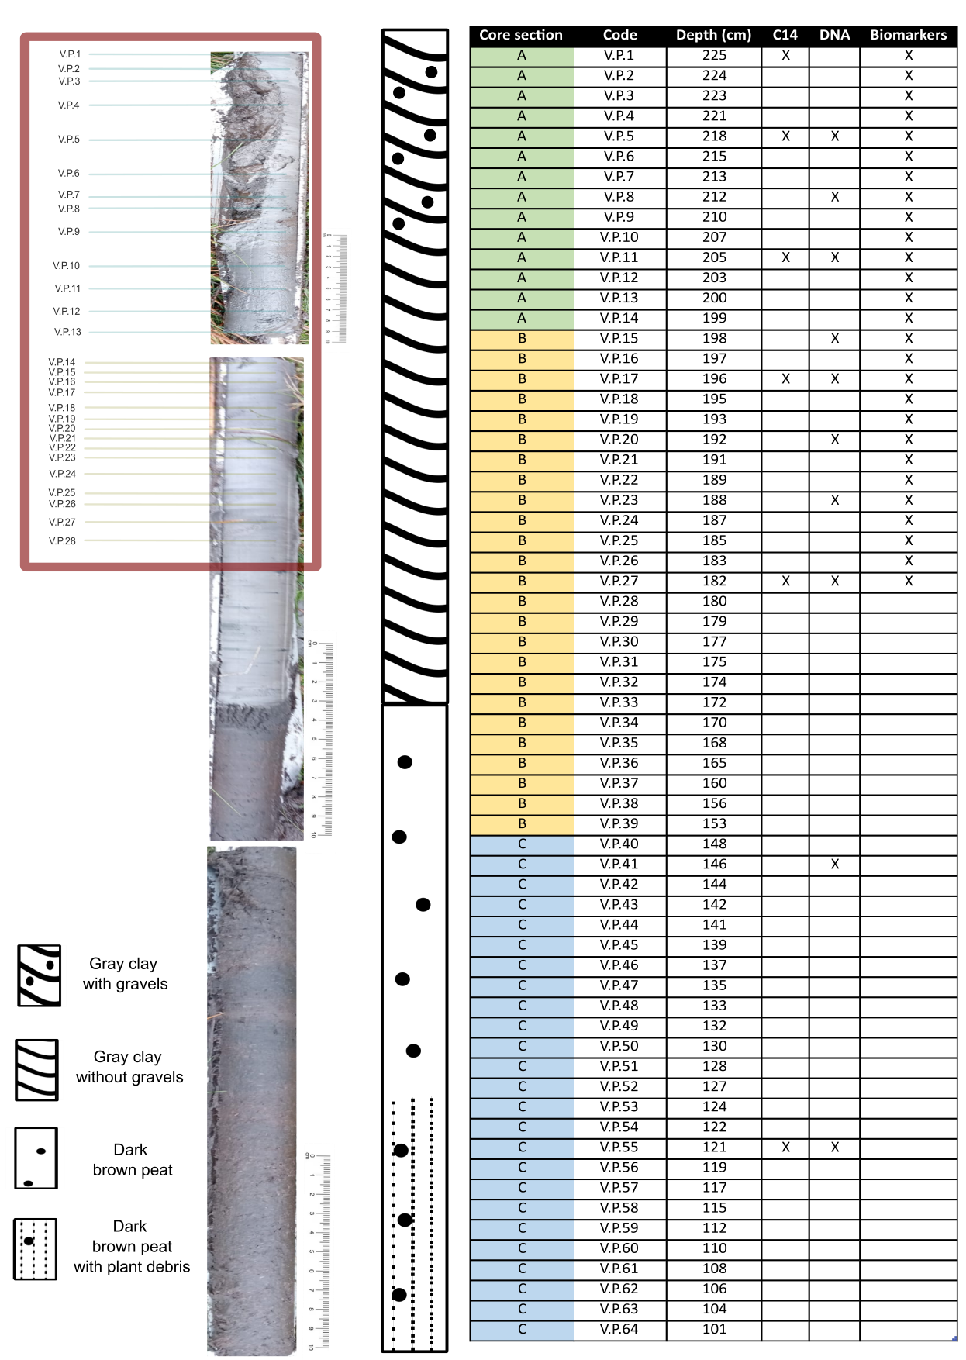
Supplementary Figure 1. Core sections recovered from the Verdeospesoa peat bog, showing their sedimentological characteristics and the sampling depths at which the different analyses were conducted. The red rectangle highlights the section analysed in this study.

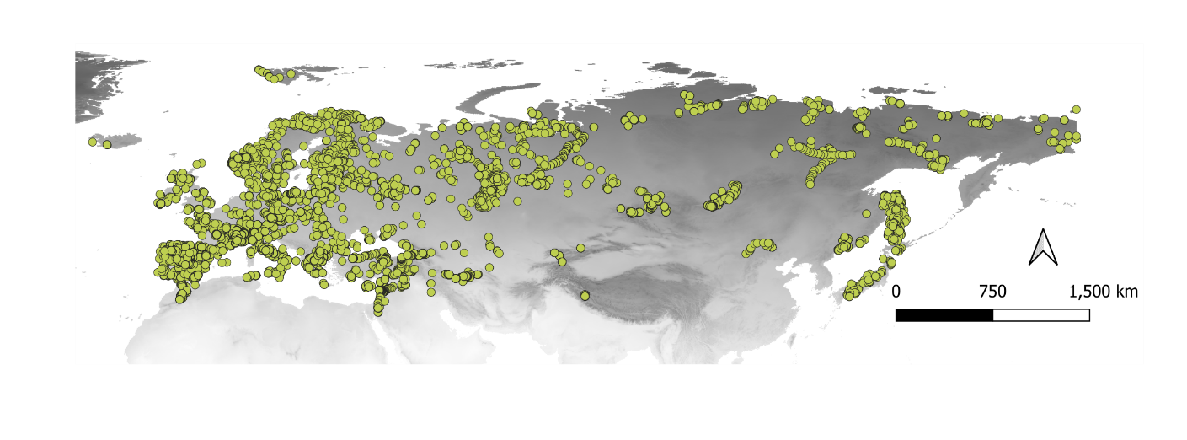
Supplementary Figure 2. Localities of Europe and Asia with extant pollen taxa percentages and its associated climatological conditions from the European Modern Pollen Database

PFT | Long name | Typical represented species
pLSE | Peatland low shrub, evergreen | Vaccinium vitis-idaea, Cassiope spp.
pLSS | Peatland low shrub, summergreen | Vaccinium myrtillus, V. uliginosum, Salix  hastata, S. glauca
pCLM | Peatland cushion forb, lichen and moss tundra | Saxifragaceae, Caryophyllaceae, Papaver  spp., Draba spp., lichens, mosses
WetGRS | Cool, flood-tolerant C3 grass | Carex spp., Eriophorum spp., Juncus spp.,  Typha spp.
pmoss | Peatland moss
C3G_wet | Peatland cool C3 grass
Supplementary Table 1. Plant Functional Types (PFT) in the LPJ-GUESS simulations

Parameter | Value | Parameter | Value
Vegmode | Cohort | Ifdisturb | 1
Nyear | 16000 | Distinterva; | 200
Nyear spinup | 500 | Ifcalccton | 1
Ifdailynpp | 1 | Ifgestab | 1
Ifdailedecomp | 0 | Ifsme | 1
Ifcalcsla | 1 | Ifstochestab | 1
Iffire | 0 | Ifstochmort | 1
Npatch | 100 | Ifcdebt | 0
Npatcharea | 1000 | Textured_soil | 1
esinterval | 5
Supplementary Table 2. Global parameters used in LPJ-GUESS. Vegmode= vegetation mode, nyear= number of simulated years, nyear_spinup= duration of the spin-up phase in years, ifdailynpp= calculate NPP daily (1) or monthly (0), iddailydecomp=calculate soil respiration daily (1) or monthly (0), ifcalcsla= calculate SLA from leaf longevity (1) or not (0), iffire= implement fire (1) or not (0), npatch= number of replicate patches, patcharea= patch area in m2, estinterval= years between establishment events in cohort mode, ifdisturb= generic patch-destroying disturbaces enabled (1) or not (0), destinterval= average return time for generic patch-destroying disturbances in years, ifcalccton= whether to calculate leaf C:N min from leaf longevity (1) or not (0), ifgestab= background establishment enabled (1) or not (0), ifsme = spatial mass effect enabled (1) or not (0), ifstochestab= establishment stochastic (1) or not (0), ifstochmort= mortality stochastic (1) or not (0), ifcdebt= C debt permitted (1) or not (0), testured_soil= if soil class input is used (1) or not (0)

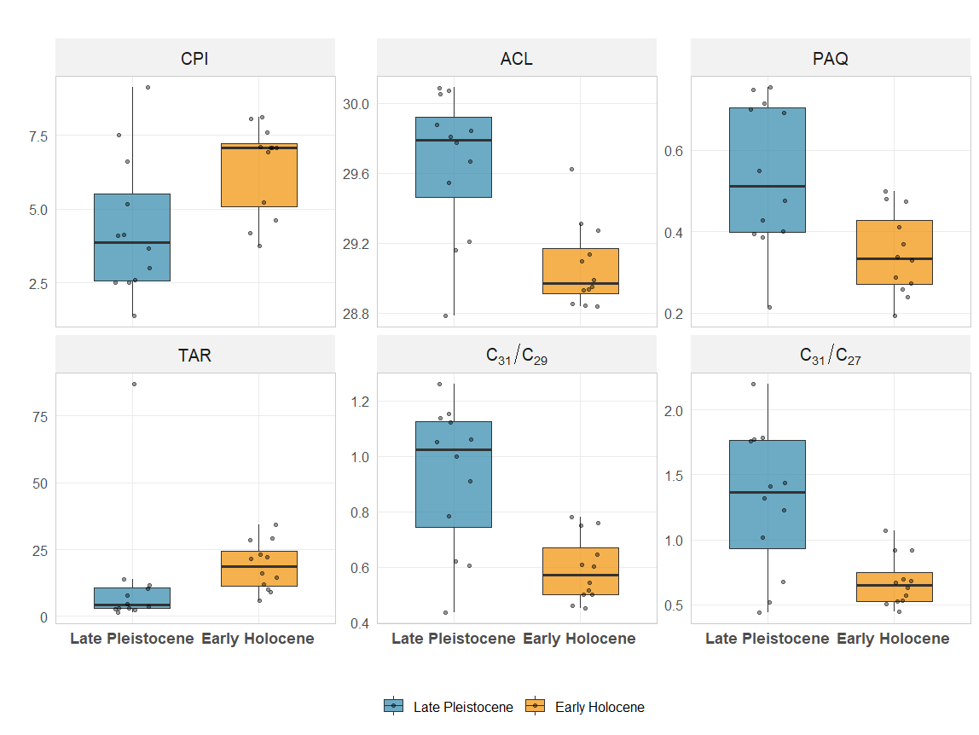
Supplementary Figure 3. Boxplots of n-alkane–derived vegetation and environmental proxies for the Late Pleistocene and Early Holocene. Shown are the Carbon Preference Index (CPI), Average Chain Length (ACL), Paq, Terrigenous-to-Aquatic Ratio (TAR), and the n-alkane chain-length ratios C31/C29 and C31/C27. Boxes represent the interquartile range (IQR), horizontal lines indicate medians, whiskers extend to 1.5 × IQR, and points denote individual samples. Blue and orange colours represent the Late Pleistocene and Early Holocene, respectively.

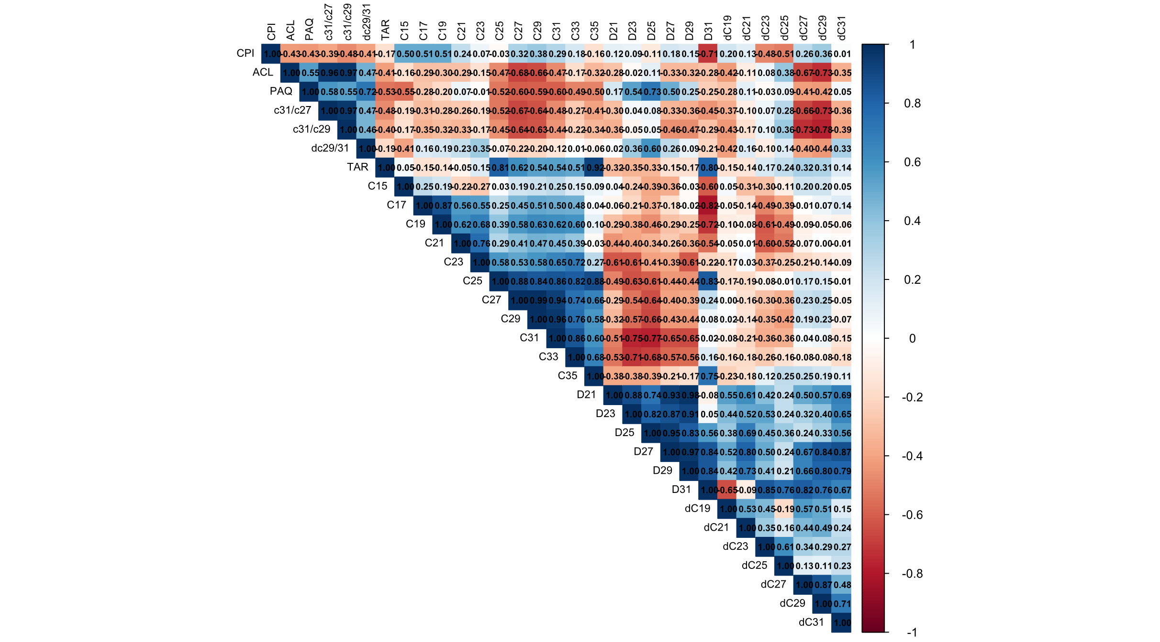
Supplementary Figure 3. Correlation matrix of all n-alkane indices, the abundance of each chain-length compound (Cₙ), and the stable isotope compositions (δ¹³C and δD) of each chain-length compound.

