Redesigning a digital experience
Marco Antonio Hernández Roque A01709802
03 de Noviembre del 2026
Implementation of the Internet of Things
Group 502
Google Maps: Add a stop
Task: plan a walk to Taquería Mamut, then add The Home Depot and Metria Hotel as stops on the way and put them in order.

Current process
Current process: Route preview → ⋮ menu → Edit stops → Choose destination → Search and pick → Drag to reorder → Done
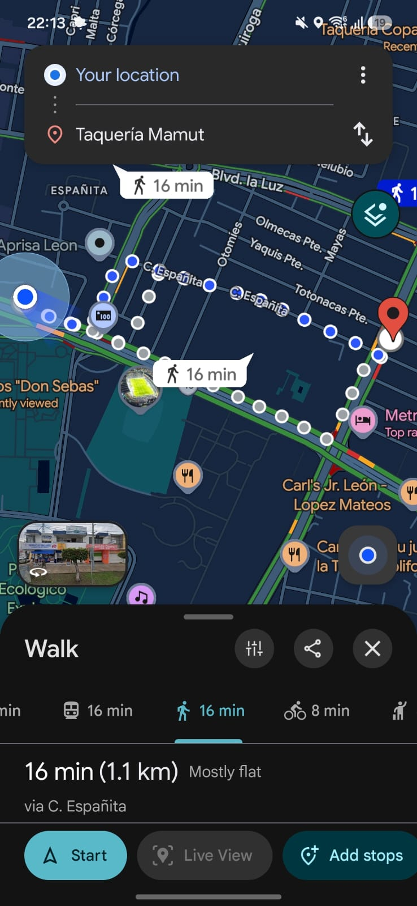  1. Route preview  The walk to Taquería Mamut takes 16 min. “Add stops” is cut off at the right edge of the bottom bar. | 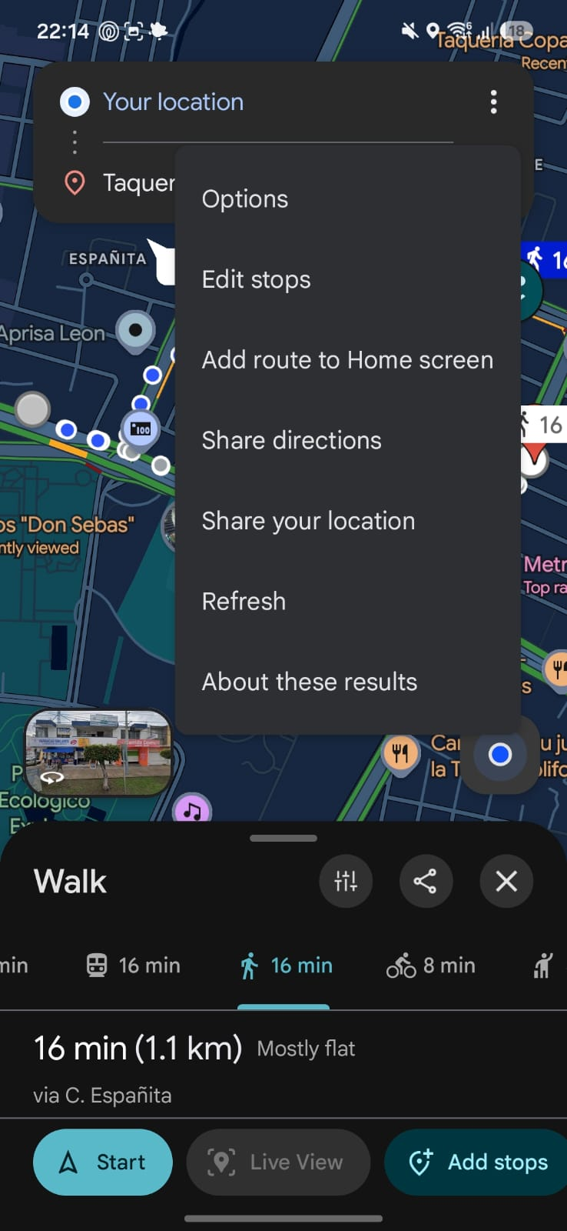  2. Three-dot menu  The option is called “Edit stops” and sits among seven unrelated actions. | 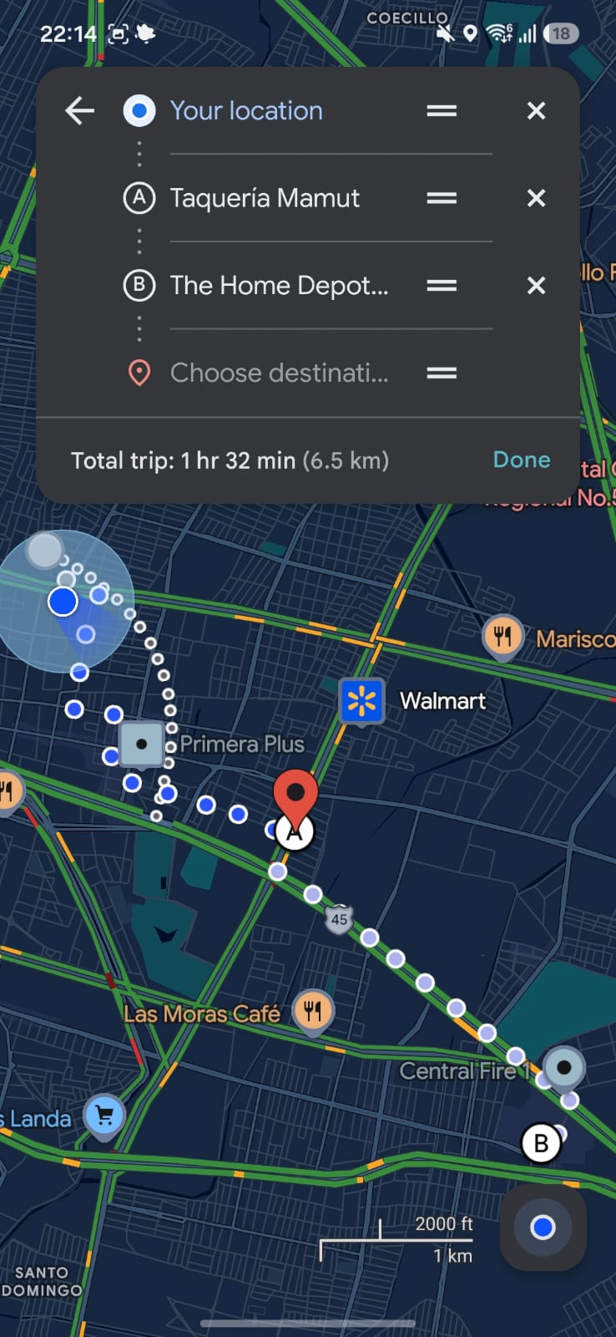  3. Edit stops  The Home Depot is added after the destination, so Taquería Mamut turns into stop A. Total: 1 hr 32 min.
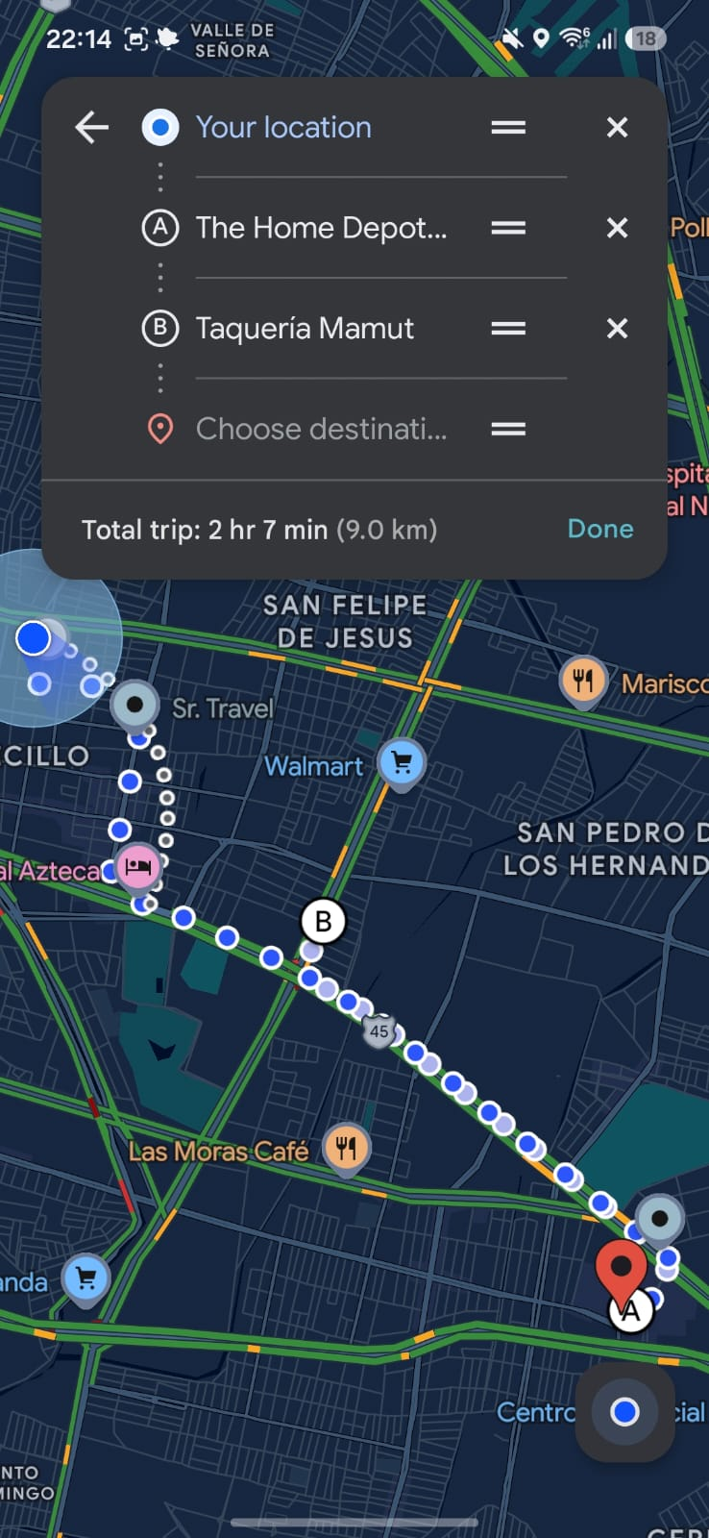  4. Drag to reorder  Swapping the two stops with the ≡ handle makes the trip 2 hr 7 min. There is no warning. | 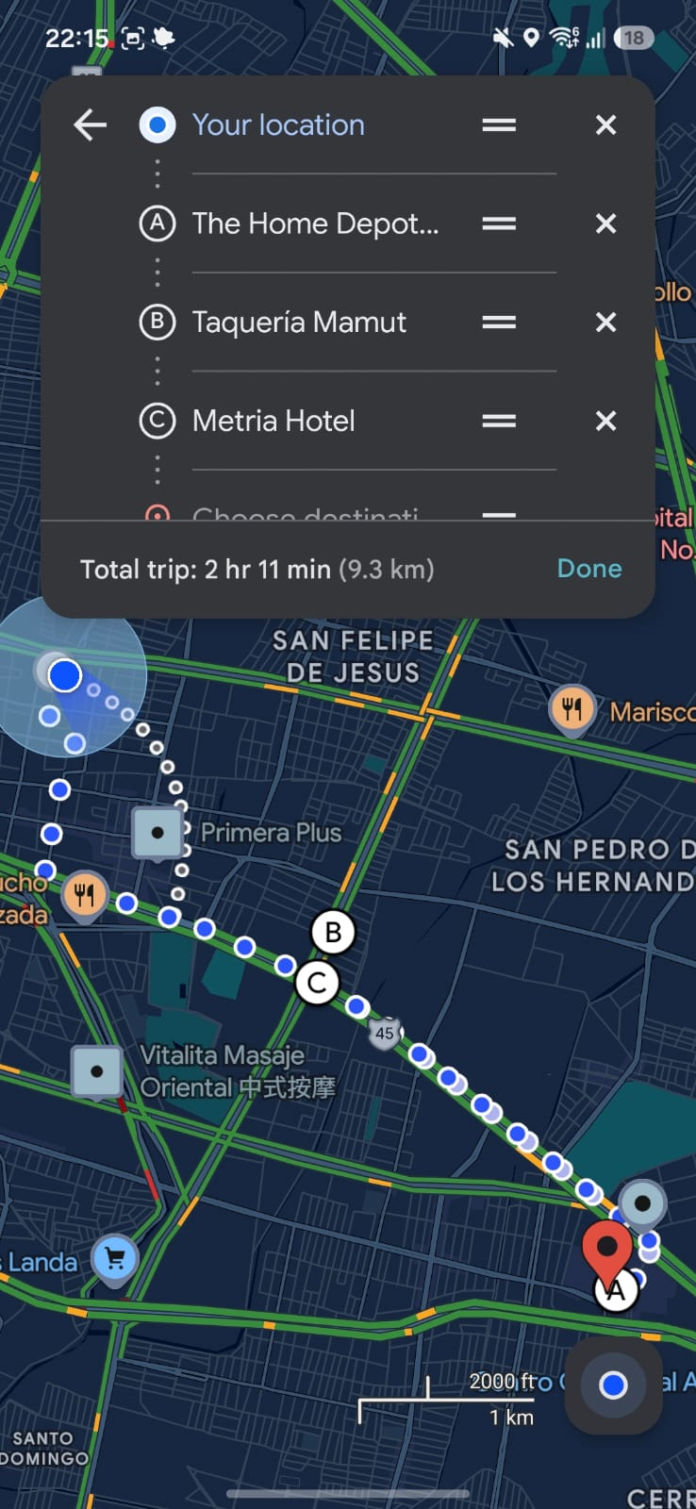  5. Add a third stop  Metria Hotel lands at the end as C, and an empty “Choose destination” field stays below it. | 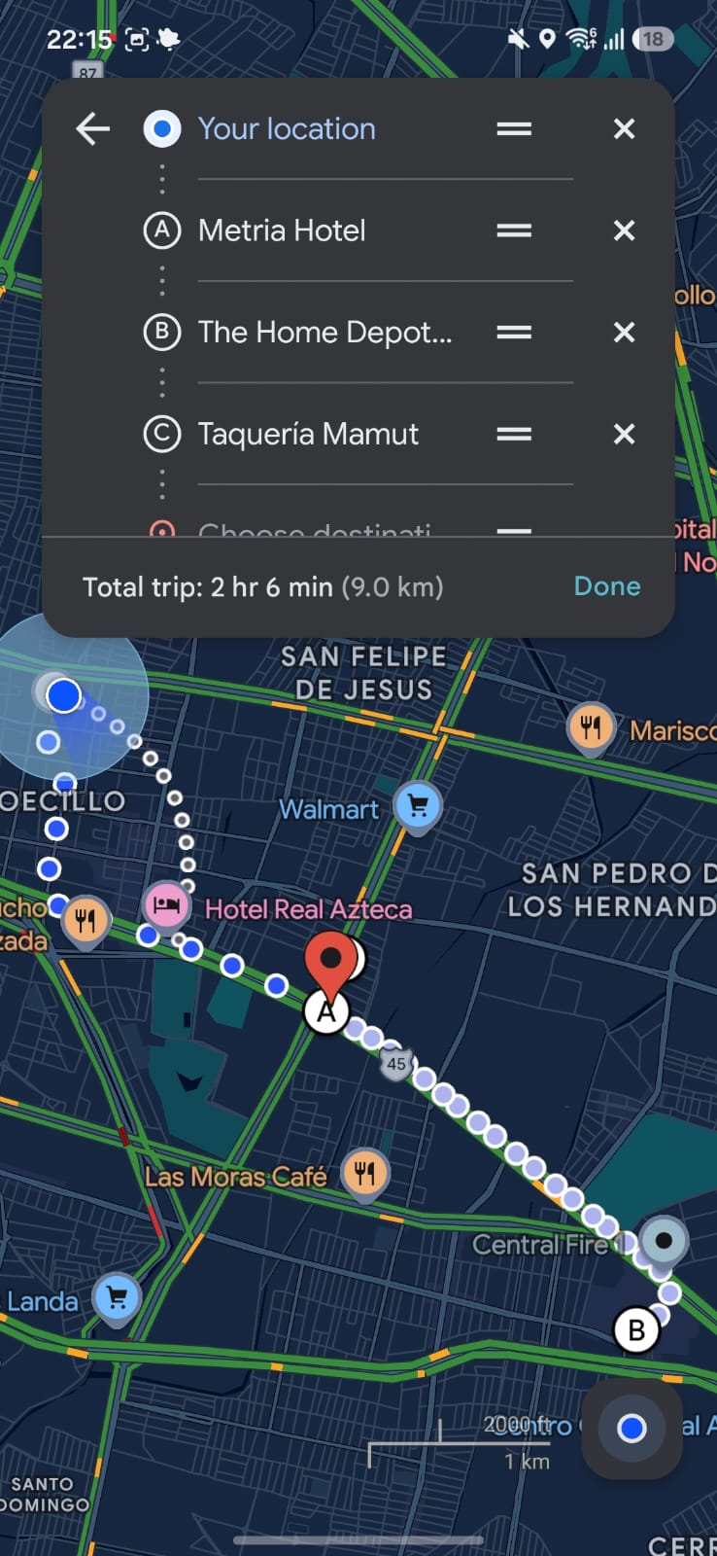  6. Reorder and Done  The final order gives 2 hr 6 min. Edit mode only ends when you tap Done.

UX analysis
Adding a stop takes six screens and five to six actions: open the three-dot menu, tap Edit stops, tap the empty field, search the place, drag it into position and tap Done. The feature exists, but it is hard to find and the result is hard to trust. The “Add stops” button is cut off at the edge of the bottom bar, the menu calls it “Edit stops”, and every new place is added after the destination. The list never says how many minutes each place adds or which order is fastest: swapping two stops changed the trip from 1 hr 32 min to 2 hr 7 min without any warning.
- How many steps? Six screens, five to six actions for one stop.
- Is the navigation clear? Partly. The edit list looks like the route card; only “Done” tells you that you are editing.
- Is the feature easy to find? No. The button is cut off and the menu option is the second of seven.
- Are the buttons easy to identify? Partly. The ≡ handles and ✕ buttons are small and gray, and the empty “Choose destination” field looks required.
- Is the information organized? The list covers the top third of the map and only shows the total time, never the time per stop.
- Confusing moments? The original destination turns into stop A, and the order changes the trip by 35 minutes with no hint.
- What would I change? Put “Add stop” inside the route sheet, show the minutes each place adds, place the stop automatically and use Undo instead of Done.

Design proposal:
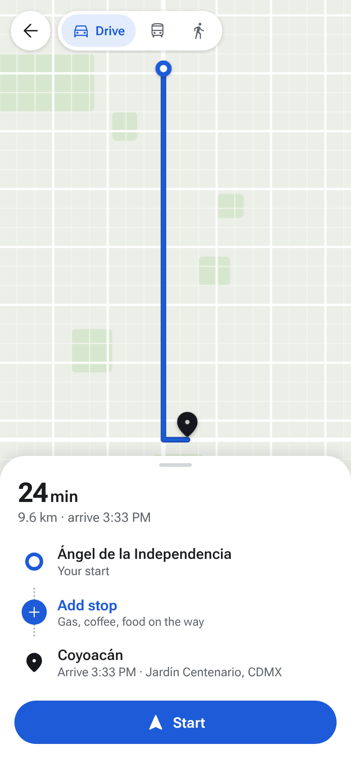  A. Route  “Add stop” is a row inside the route list, within thumb reach. | 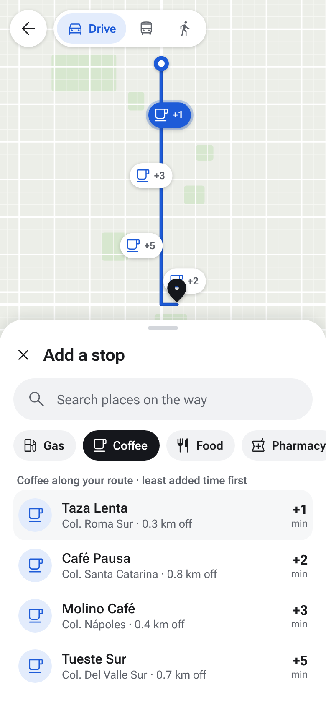  B. Add a stop  Categories along the route. Every place shows the minutes it adds. | 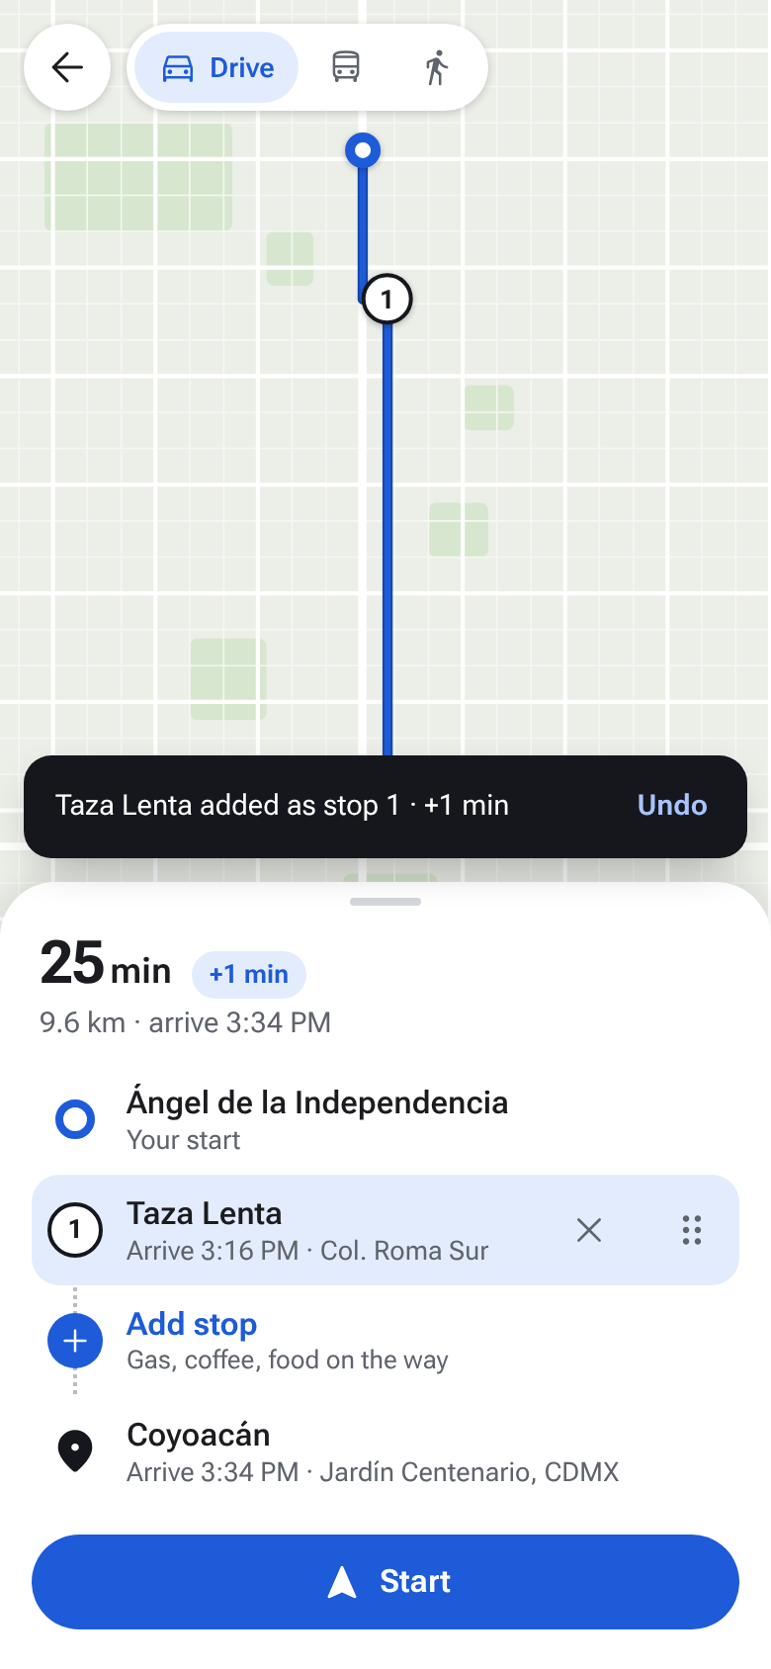  C. Placed  The stop goes where it adds the least time. Undo replaces Done. | 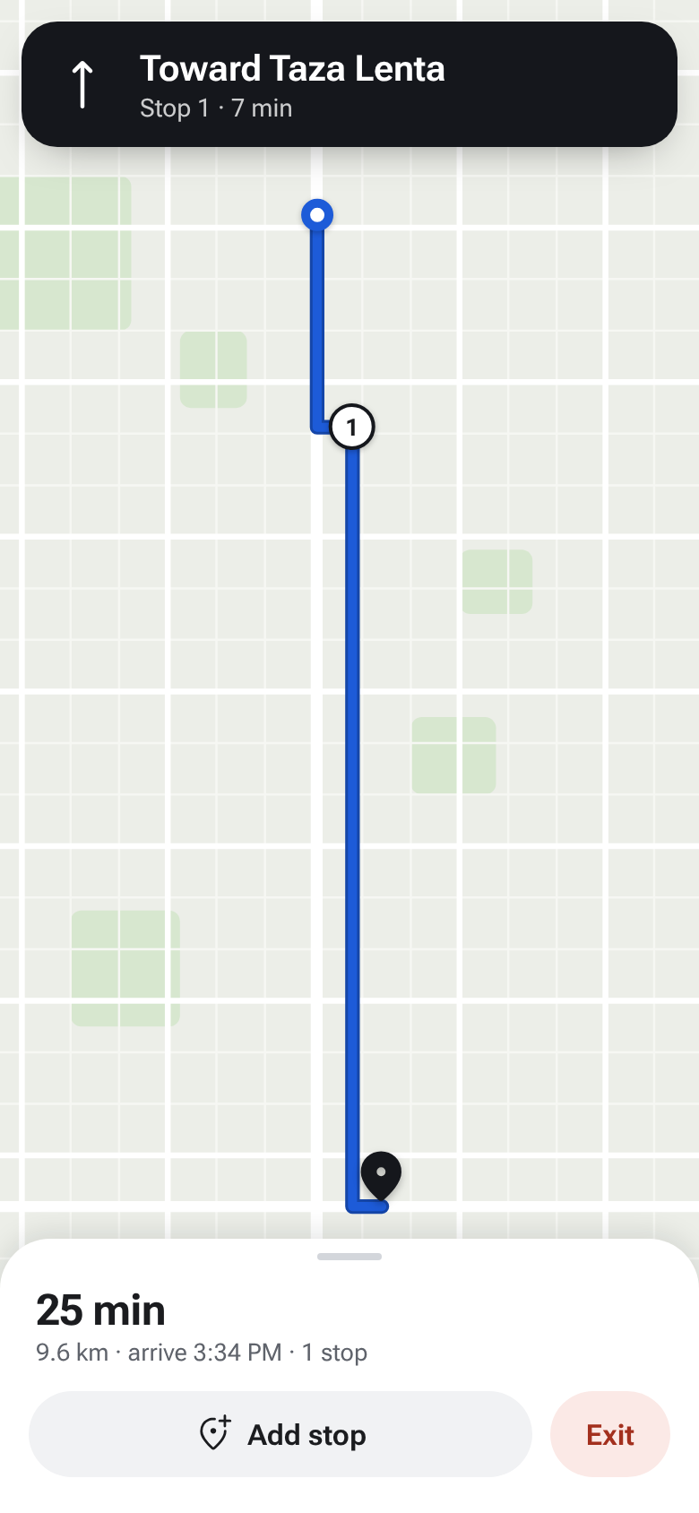  D. During the trip  The same “Add stop” sheet opens while navigating.
This new UX is easier to find and faster to use. It takes just 2 steps: Add stop → Tap a place
Proposed flow: Directions → Add stop → Pick a category or search → Tap a place → Start
Interactive prototype: marcoflesh.github.io/Labs/lab02
 | Current | Proposed
Actions to add one stop | 5 to 6 | 2
Where the option is | Cut-off button, or ⋮ menu → Edit stops | A row inside the route list
Time each place adds | Only the total, after choosing | On every result, before choosing
Where the new stop lands | After the destination | Where it adds the least time
Fixing the order | Drag by hand, no hint of the fastest order | Automatic; dragging is optional
Confirmation | Done | Changes apply live, with Undo

Justification
The current flow has the feature but hides it behind a cut-off button and a generic menu, and it makes the user fix the order by hand. Moving “Add stop” into the route list puts it where the thumb already is, so the feature is visible without exploring. Showing the minutes each place adds turns a blind choice into an informed one, and inserting the stop in the fastest position keeps the original destination at the end and removes the need to drag. Replacing Done with Undo keeps the user in control without an extra confirmation. Categories like Gas, Coffee and Food let the user recognize instead of type, and the same sheet works before and during the trip. The result is 2 steps instead of 5 to 6, with less cognitive load and fewer chances of ending up with a slower route by accident.

