BookTrack
Work Breakdown Structure

Project Planning and Management
- Task 1: Define the project objectives and scope. (Leader)
- Task 2: Assign tasks and responsibilities to all members. (Leader)
- Task 3: Monitor the progress of each member. (Leader)
- Task 4: Coordinate meetings and check project deadlines. (Leader)

User Interface/User Experience Design
- Task 1: Review the approved BookTrack Figma design. (Designer)
- Task 2: Complete the Student wireframes. (Designer)
- Task 3: Complete the Librarian/Staff and Admin wireframes. (Designer)
- Task 4: Check the consistency of buttons, colors, navigation, and layouts. (Designer)

Application Development
- Task 1: Set up the application structure.
  - Sub-task: Prepare the project files and folders.
  - Sub-task: Set up the database connection.
- Task 2: Develop the login system and role-based access.
  - Sub-task: Create access for Student, Librarian/Staff, and Admin.
- Task 3: Develop the book management features.
  - Sub-task: Implement book searching, book details, and shelf locations.
- Task 4: Develop borrowing requests, returns, borrowing history, and overdue tracking. (Programmer)

Quality Assurance and Testing
- Task 1: Prepare the Software Test Plan. (Tester)
- Task 2: Prepare the Test Case Matrix. (Tester)
- Task 3: Test available features and record the actual results. (Tester)
- Task 4: Identify errors and check whether corrections work properly. (Tester)

Technical Documentation
- Task 1: Update the Software Requirements Specification (SRS). (Documenter)
- Task 2: Add the Software Test Plan and Test Case Matrix to the SRS. (Documenter)
- Task 3: Organize the project schedule, requirements, and supporting documents. (Documenter)
- Task 4: Review the final documents for completeness and proper formatting. (Documenter)

BookTrack
Project Schedule

TASK | ASSIGNEE | START DATE | FINISH DATE | DURATION
Phase 1: Project Planning and Management
Task 1: Review project requirements and scope | Leader | Oct. 12, 2026 | Oct. 12, 2026 | 1 day
Task 2: Assign member responsibilities | Leader | Oct. 12, 2026 | Oct. 12, 2026 | 1 day
Task 3: Helps, guide, and review progress and deadlines | Leader | Oct. 12, 2026 | TBL | TBL
Phase 2: UI/UX Design and Requirements Review
Task 1: Review existing Figma wireframes | Designer | Oct. 12, 2026 | TBL | TBL
Task 2: Check Student, Librarian, and Admin page requirements | Programmer | Oct. 12, 2026 | TBL | TBL
Task 3: Review Design changes and requirements | Designer | Oct. 12, 2026 | TBL | TBL
Task 4: Double check wireframe | Designer/Programmer | Oct. 13, 2026 | TBL | TBL
Phase 3: Quality Assurance and Testing Documentation
Task 1: Prepare the Software Test Plan | Tester | Oct. 12, 2026 | Oct. 13, 2026 | 2 days
Task 2: Prepare the Test Case Matrix | Tester | Oct. 12, 2026 | Oct. 13, 2026 | 2 days
Task 3: Present testing documents for instructor checking | Tester | Oct. 14, 2026 | Oct. 14, 2026 | 1 day
Phase 4: Technical Documentation and Final Review
Task 1: Update the SRS and incorporate the test documents | Documenter | Oct. 12, 2026 | Oct. 13, 2026 | 2 days
Task 2: Review and revise documents based on feedback | Documenter | Oct. 12, 2026 | Oct. 14, 2026 | 2 days
Task 3: Final checking and submission preparation | Leader | Oct. 14, 2026 | TBL | TBL

BookTrack
User Flow Diagram

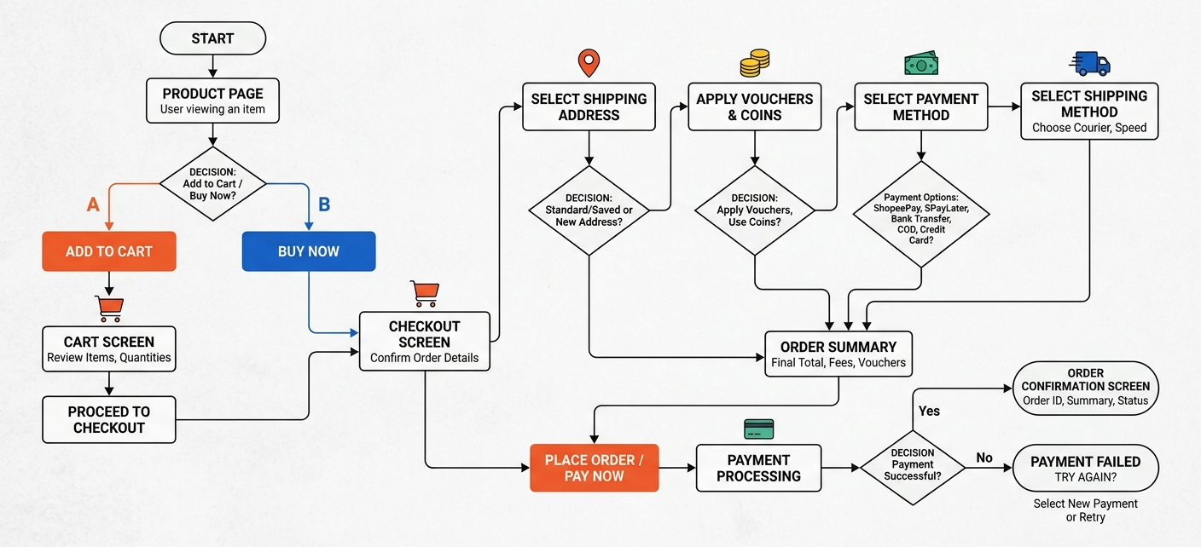
Note: This is just a sample user flow diagram showing the checkout process in Shopee. Your application’s user flow diagram should include all features mentioned in your Software Requirements Specification document.

BookTrack
Wireframe
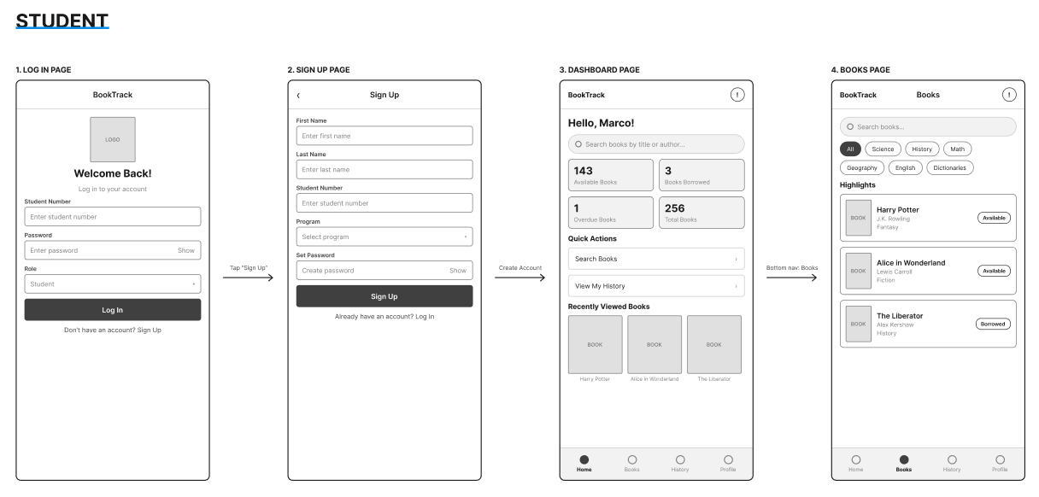

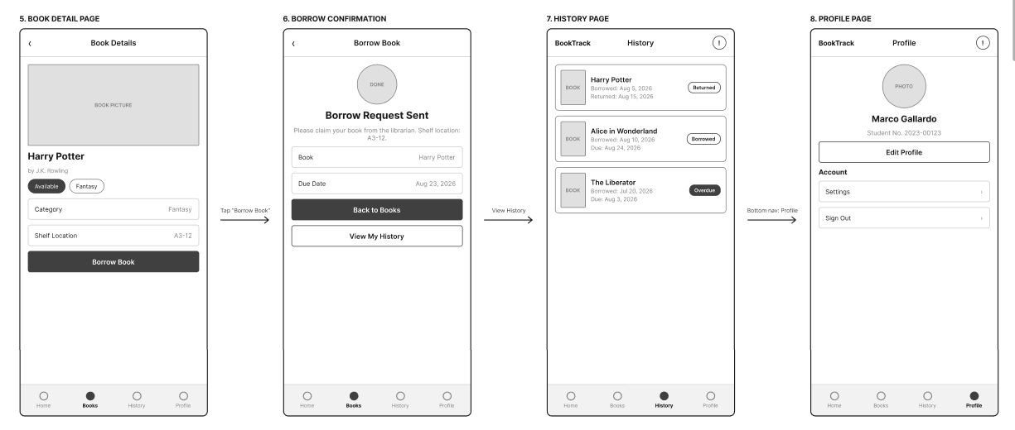

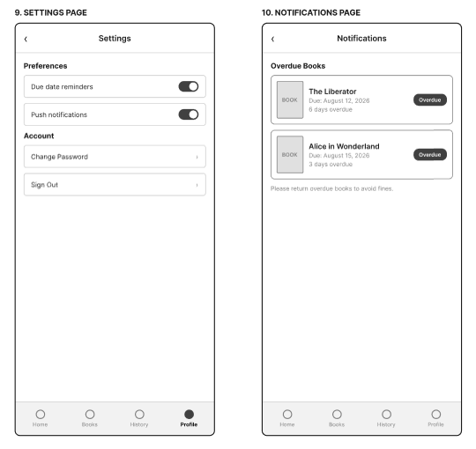
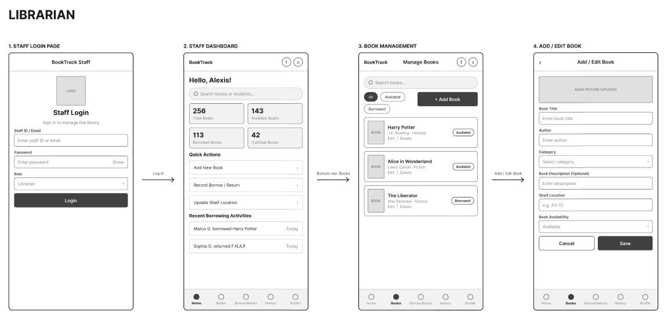

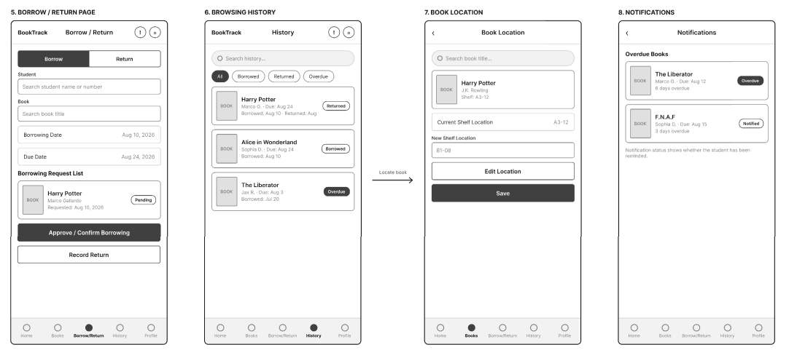
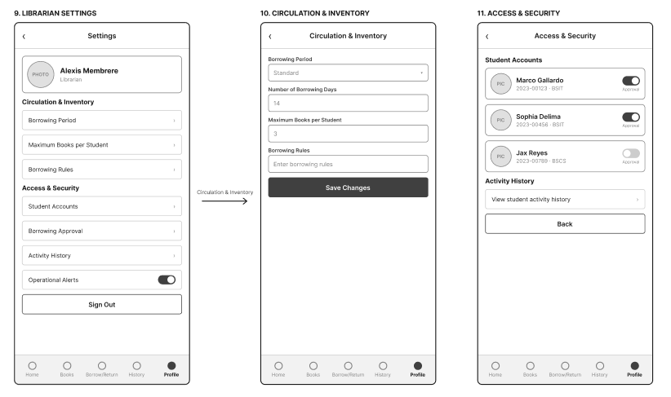

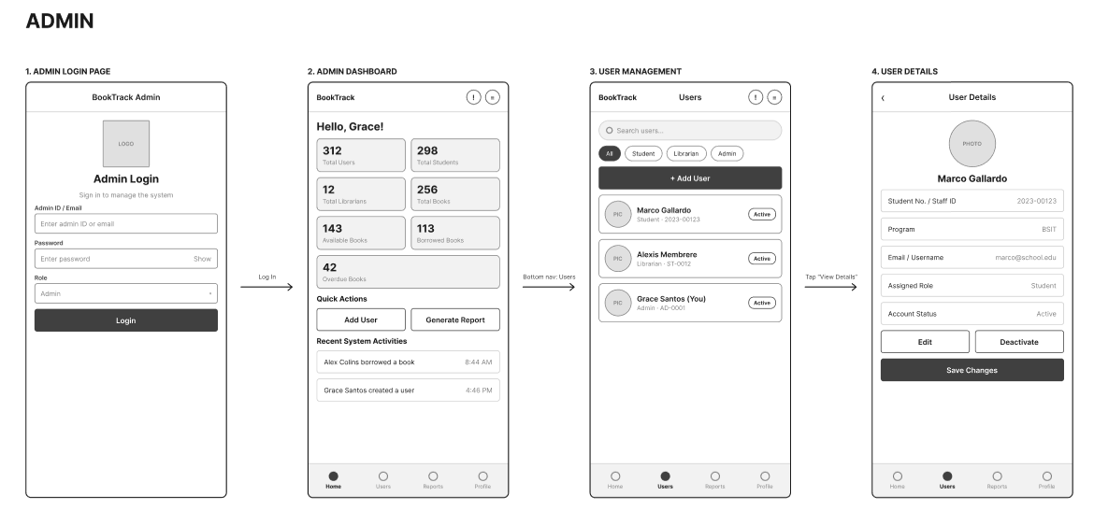

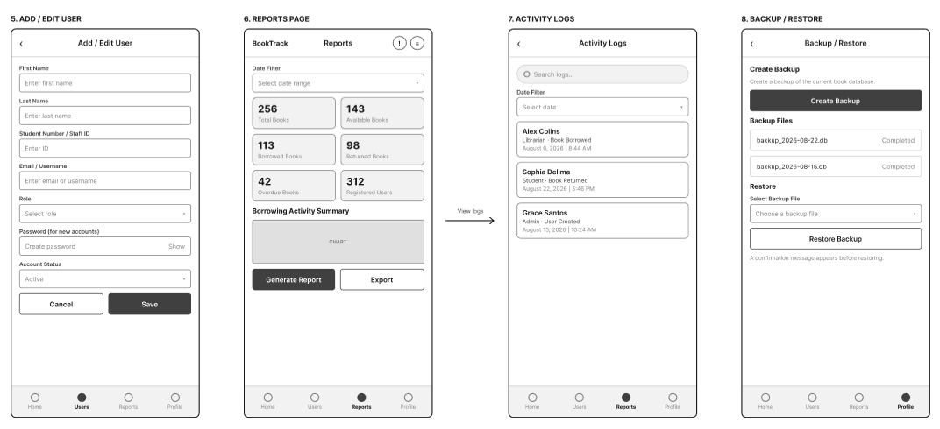
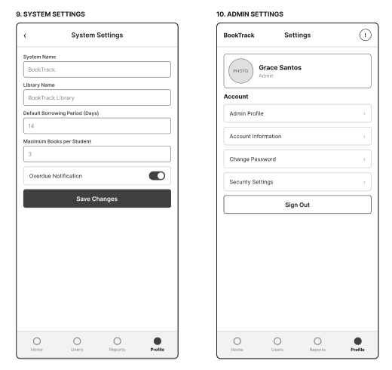

Application Name
Repository Setup

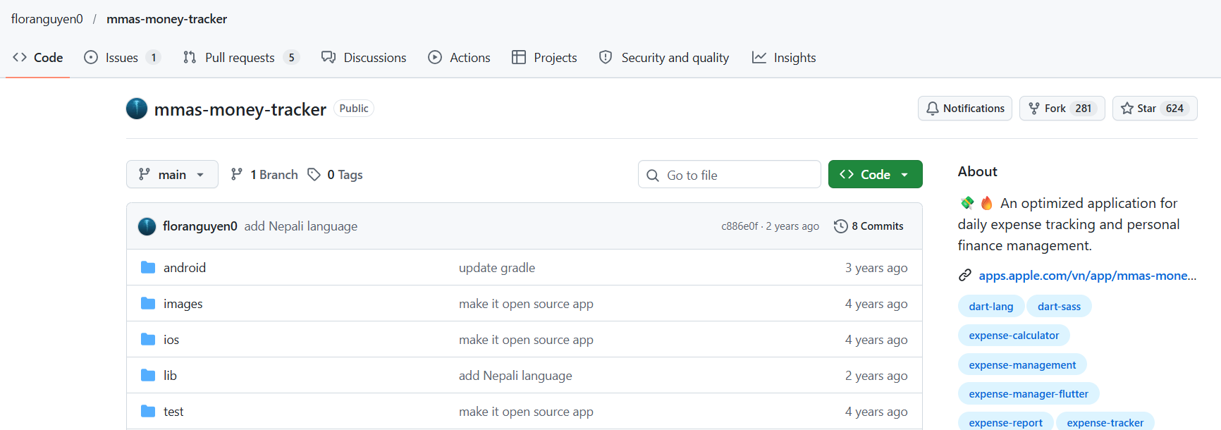
https://github.com/floranguyen0/mmas-money-tracker

Note: This is just a sample github repository. Make sure that your repository matches your approved application name and the link you will be including is accessible.

BookTrack
Test Plan Strategy

Framework: To be finalized by the development team
Target Platform: Android/iOS
QA Tester: Cirelles, Chris Joven
Timeline: Weeks 1–6

1. Objective & Scope
Ensure the BookTrack Library Book Tracking Application operates reliably, follows the approved Figma UI designs, and correctly handles book searching, borrowing requests, book returns, due dates, and overdue records before final release.

In-Scope (What We Test):
- User Authentication: Student, Librarian, and Admin login, account access, and role-based permissions.
- Core App Features & Business Rules: Book searching, book details and availability, shelf location display, borrowing requests, librarian confirmation, return processing, due date recording, borrowing history, and overdue tracking.
- Book and Account Management: Adding, editing, and removing book records; updating shelf locations; managing user accounts and roles; and configuring system settings.
- Screen Navigation & UI Layout Alignment: Verify that page layouts, colors, text, buttons, forms, and navigation match the approved Figma wireframes.
- Reports and Data Management: Check activity logs, reports, and database backup and restore features according to the SRS.

Out-of-Scope (What We Do NOT Test):
- Automated load and stress testing.
- Features not included in the approved SRS or wireframes.
- Testing of external services or systems not integrated into BookTrack.
- Production library data and live user accounts during testing.

2. Testing Approach
- UI/UX Testing: Verify that colors, typography, spacing, buttons, icons, forms, and navigation match the approved Figma designs.
- Functional Testing: Verify login validation, book searching, availability display, borrowing requests, borrowing confirmation, return processing, due dates, shelf locations, and overdue records.
- Integration Testing: Verify that the application correctly transfers and updates information between its interface, backend, and database.
- Access-Control Testing: Verify that Students, Librarians, and Admins can access only the features allowed for their roles.
- Data Integrity Testing: Verify that book availability, borrowing records, return dates, shelf locations, and user information remain accurate after updates.
- Regression Testing: Repeat tests for affected features after defects are fixed to ensure that existing functions continue to work correctly.

3. Testing Environment & Tools
Devices:
- Desktop or laptop computer for testing the web application.
- Mobile phone or mobile browser emulator for checking responsive layouts.
- Supported browsers, such as Google Chrome, Microsoft Edge, Firefox, and Safari, where available.
Tools:
- Defect Tracker: GitHub Issues or an agreed group defect log.
- Visual Target: Figma.
- Test Documentation: BookTrack Test Case Matrix spreadsheet.
- Development Environment: To be confirmed by the development team.
- Database: To be confirmed based on the final technology stack.

BookTrack
Test Case Matrix

https://docs.google.com/spreadsheets/d/1OfLUjQXAO_6xnJhk8WWeGGMIg_7f6886/edit?usp=drive_link&ouid=103096097759045226533&rtpof=true&sd=true

Note: Access the test case matrix by clicking on the link provided above. It is in a spreadsheet format and “Make a Copy” for your own project and rename it to “Application Name- Test Case Matrix”.

BookTrack
Software Requirements Specifications

1. Introduction
Purpose
This Software Requirements Specification (SRS) document details the functional and non-functional requirements for the BookTrack Library Management Application, focusing on student registration, book browsing, borrowing requests, book returns, overdue notifications, and library record management. This document serves as a guide for developers, QA testers, UI/UX designers, and project stakeholders.

Scope
The BookTrack Application is a library management system designed for Students, Librarians, and Administrators. The system allows students to search for books, view book details and shelf locations, request to borrow books, check borrowing history, and receive overdue notifications. Librarians can manage books, approve borrowing requests, record returns, and configure borrowing rules. Administrators can manage user accounts, generate reports, monitor system activities, configure system settings, and perform database backup and restoration.

In-Scope:
- User authentication and role-based access for Students, Librarians, and Admins.
- Student registration and profile management.
- Book catalog browsing, searching, and category filtering.
- Book details, availability status, and shelf location viewing.
- Borrowing requests, approval, and return transactions.
- Borrowing history and overdue notifications.
- Book management and inventory updates.
- Librarian circulation and inventory settings.
- Administrator user management and account status control.
- Reports generation and activity logs.
- System settings and database backup and restoration.

Out-of-Scope:
- Online book purchasing and selling.
- External payment processing.
- Real-time GPS tracking of books or users.
- Third-party library system integration unless added to the approved requirements.

Document References
- BookTrack Updated Wireframe and Page Specifications.
- BookTrack User Flow Diagram, if available.
- BookTrack Software Test Plan.
- BookTrack Test Case Matrix.

2. Overall Description
User Classes and Characteristics
Student: Students can register for an account, browse and search books, view book details, request to borrow books, check their borrowing history, manage permitted profile information, and view overdue notifications.
Librarian: Librarians can manage book records, update book availability and shelf locations, approve borrowing requests, record book returns, review borrowing history, monitor overdue books, and configure circulation rules.
Administrator: Administrators can manage user accounts, monitor library statistics, generate reports, review activity logs, configure system settings, and perform database backup and restoration.

Operating Environment
Operating Systems: The application shall run on the mobile or web platform selected by the development team.
Hardware Specifications: The system shall support compatible smartphones, tablets, laptops, or desktop computers based on the final application platform.
Network Requirements: An internet connection shall be required for authentication, retrieving book records, submitting borrowing requests, updating transactions, and synchronizing data.
Software Environment: The programming framework, backend technology, database management system, and hosting environment shall be confirmed by the development team.
Constraints
Role-Based Access: Users shall only access pages and functions permitted for their assigned roles.
Data Integrity: Book availability, borrowing records, due dates, return dates, shelf locations, and user records must remain accurate.
Borrowing Rules: Borrowing transactions shall follow the configured borrowing period, maximum books per student, and applicable borrowing rules.
Security: Passwords and sensitive account information shall be protected from unauthorized access.
Backup: Database backup and restoration functions shall only be accessible to authorized administrators.

Assumptions and Dependencies
- Users have valid accounts and appropriate permissions.
- Book and user information is stored in the configured database.
- Librarians maintain accurate book records and shelf locations.
- Borrowing rules are configured by authorized personnel.
- The backend and database are operational during normal system use.
- Administrators have the required permissions to perform backup and restoration.

3. System Features and Functional Requirements

FR-01: User Authentication and Role-Based Access
Description: The system shall authenticate Students, Librarians, and Admins using their registered credentials.
Inputs: Student Number, Staff ID or Admin ID/Email, Password, and Role where applicable.
Outputs: Authenticated user session and role-specific dashboard.
System Response:
- Validate required login fields.
- Verify credentials against stored account information.
- Check whether the selected role matches the assigned account role.
- Display an error message when credentials are invalid.
- Navigate users to the appropriate dashboard after successful authentication.
- Prevent unauthorized access to protected pages.
- End the active session when the user signs out.

FR-02: Student Registration
Description: The system shall allow students to create an account by providing the required personal and academic information.
Inputs: First Name, Last Name, Student Number, Program, and Password.
Outputs: Registered student account or an error message.
System Response:
- Display the registration form.
- Validate all required fields.
- Check for duplicate Student Numbers.
- Reject incomplete forms and duplicate accounts.
- Save valid registration information.
- Display a confirmation message after successful registration.

FR-03: Student Dashboard and Navigation
Description: The system shall provide a student dashboard and navigation to the main student pages.
Inputs: Search keywords and navigation selections.
Outputs: Student dashboard and selected page.
System Response:
- Display the dashboard after successful login.
- Provide navigation to Home, Books, History, and Profile.
- Provide access to Notifications through the top navigation.
- Display dashboard content according to the approved wireframe.

FR-04: Book Catalog Search and Categories
Description: The system shall allow users to search for books and browse books by category.
Inputs: Search keywords and selected category.
Outputs: Matching book records and highlighted books.
System Response:
- Display a search bar on the Books page.
- Allow users to search the available book catalog.
- Provide the categories Science, History, Math, Geography, English, and Dictionaries.
- Display books matching the search or selected category.
- Display a message when no matching books are found.
- Show highlighted books according to the approved design.

FR-05: Book Details and Shelf Location
Description: The system shall display the selected book's information, availability, and shelf location.
Inputs: Selected Book ID or book record.
Outputs: Book picture, title, author, availability status, category, and shelf location.
System Response:
- Retrieve the selected book's information.
- Display its picture, title, author, category, and shelf location.
- Indicate whether the book is Available or Not Available.
- Display the Borrow Book button when appropriate.
- Update displayed information when the book record changes.

FR-06: Student Borrowing Request
Description: The system shall allow students to request available books according to the configured borrowing rules.
Inputs: Student account, selected book, and Borrow Book action.
Outputs: Borrowing request record and confirmation or error message.
System Response:
- Check the book's current availability.
- Check the student's borrowing eligibility and borrowing limits.
- Prevent requests for unavailable books.
- Reject requests that violate borrowing rules.
- Save valid borrowing requests.
- Display a confirmation message after successful submission.
- Make requests available for librarian review when approval is required.

FR-07: Student Borrowing History
Description: The system shall allow students to view their own borrowing records.
Inputs: Authenticated Student Account.
Outputs: Cards or a list of borrowing records.
System Response:
- Retrieve records associated with the logged-in student.
- Display relevant book information and borrowing status.
- Show available borrowing, due date, and return information.
- Update the history when transaction information changes.
- Prevent students from viewing another student's private records.

FR-08: Student Profile and Settings
Description: The system shall allow students to view their profiles, edit permitted information, access settings, and sign out.
Inputs: Profile information, permitted edits, settings selections, and Sign Out action.
Outputs: Displayed or updated profile information and signed-out session state.
System Response:
- Display the student's picture, full name, and Student Number.
- Provide an Edit button for permitted information.
- Validate and save profile changes.
- Provide access to available settings.
- End the session when Sign Out is selected.

FR-09: Overdue Book Notifications
Description: The system shall identify overdue borrowing transactions and display relevant notifications.
Inputs: Borrowing records, due dates, return dates, and notification settings.
Outputs: Overdue book list and notification information.
System Response:
- Identify borrowed books whose due dates have passed and that have not been returned.
- Display relevant overdue books on the student's Notifications page.
- Display student name, book title, due date, number of days overdue, and notification status on the librarian's Notifications page.
- Update overdue information when a book is returned.
- Apply configured overdue notification settings.

FR-10: Librarian Dashboard
Description: The system shall provide librarians with an overview of library inventory and borrowing activities.
Inputs: Book records, borrowing transactions, return records, and overdue information.
Outputs: Total Books, Available Books, Borrowed Books, Overdue Books, Quick Actions, and Recent Borrowing Activities.
System Response:
- Display a search bar.
- Calculate and display inventory and borrowing totals.
- Update counts after relevant transactions.
- Display recent borrowing activities.
- Provide access to librarian functions.

FR-11: Book Management
Description: The system shall allow librarians to search, add, edit, and delete or deactivate book records.
Inputs: Book Picture, Book Title, Author, Category, optional Book Description, Shelf Location, Availability Status, and selected action.
Outputs: Updated book catalog and saved book records.
System Response:
- Display book cards or a book list with search functionality.
- Validate required book information.
- Allow librarians to add and edit book records.
- Allow librarians to delete or deactivate records according to approved data management rules.
- Update the catalog after successful changes.
- Display confirmation or error messages.

FR-12: Borrowing Approval and Book Return
Description: The system shall allow librarians to review borrowing requests, approve or confirm borrowing transactions, and record book returns.
Inputs: Student Number, student search, book search, borrowing request, borrowing date, due date, and return action.
Outputs: Updated borrowing transaction, return record, availability status, and confirmation message.
System Response:
- Allow librarians to search for students and books.
- Display the book title, student name, borrowing date, and due date.
- Display requests that require review.
- Check borrowing eligibility before approval.
- Record the transaction after successful approval or confirmation.
- Record the return date when a book is returned.
- Update book availability after the return is recorded.
- Display confirmation or error messages.

FR-13: Librarian Browsing History
Description: The system shall allow librarians to view borrowing transactions and filter records by status.
Inputs: Search keywords and Borrowed, Returned, or Overdue filter.
Outputs: Book Title, Student Name, Borrowing Date, Due Date, Return Date, and Status.
System Response:
- Display borrowing records in cards or a list.
- Allow librarians to search transaction information.
- Filter records by the selected status.
- Display available borrowing and return details.
- Update records when transaction information changes.

FR-14: Book Location Management
Description: The system shall allow librarians to search for books and update shelf locations.
Inputs: Search keywords, selected book, and new shelf location.
Outputs: Updated shelf location and confirmation message.
System Response:
- Provide a search bar.
- Display the book title, author, and current shelf location.
- Allow authorized librarians to edit the shelf location.
- Validate and save the new location.
- Display a confirmation message.

FR-15: Librarian Settings and Circulation Management
Description: The system shall allow librarians to access their profile, configure circulation rules, view student accounts, and access operational alerts.
Inputs: Borrowing Period, Number of Borrowing Days, Maximum Books per Student, Borrowing Rules, and available access settings.
Outputs: Saved circulation settings, student account information, and activity history.
System Response:
- Display the Librarian Profile and available settings.
- Provide Circulation & Inventory, Access & Security, and Operational Alerts.
- Allow authorized librarians to configure borrowing periods and maximum books per student.
- Validate and save circulation settings.
- Display Student Name, Student Number, and Program in the student accounts list.
- Display borrowing approval settings and activity history where permitted.

FR-16: Admin Dashboard
Description: The system shall provide administrators with an overview of users, inventory, borrowing transactions, and system activities.
Inputs: User records, book records, borrowing transactions, and activity logs.
Outputs: Total Users, Total Students, Total Librarians, Total Books, Available Books, Borrowed Books, Overdue Books, Recent System Activities, and Quick Actions.
System Response:
- Calculate and display the required totals.
- Display recent system activities.
- Update dashboard summaries after relevant changes.
- Provide navigation to administrative functions.

FR-17: User Management
Description: The system shall allow administrators to search, filter, view, add, edit, activate, and deactivate user accounts.
Inputs: User Type, First Name, Last Name, Student Number or Staff ID, Email/Username, Program where applicable, Role, Password when creating an account, and Account Status.
Outputs: User account list, user details, and saved account changes.
System Response:
- Display user accounts in a list.
- Provide search and filters for Student, Librarian, and Admin.
- Display the user's picture, full name, identification number, role, and account status.
- Allow administrators to view account details.
- Allow authorized administrators to add and edit accounts.
- Validate required information.
- Allow accounts to be activated or deactivated.
- Save valid changes and display confirmation.
FR-18: Reports Generation
Description: The system shall allow administrators to generate reports on library inventory, borrowing activities, returned books, overdue books, and registered users.
Inputs: Date Filter and Generate Report action.
Outputs: Total Books, Available Books, Borrowed Books, Returned Books, Overdue Books, Total Registered Users, and Borrowing Activity Summary.
System Response:
- Retrieve relevant library and borrowing records.
- Apply the selected date range where applicable.
- Calculate report totals from stored records.
- Display the generated report.
- Provide an Export or Download option if included in the final implementation.

FR-19: Activity Logs
Description: The system shall record and display relevant system activities for administrative monitoring.
Inputs: Search keywords and date filter.
Outputs: User Name, User Role, Activity Performed, Date and Time, and Activity Details.
System Response:
- Display recorded system activities.
- Allow administrators to search and filter logs.
- Display available details for each activity.
- Restrict access to authorized administrators.
- Preserve activity information according to the agreed data retention rules.

FR-20: Database Backup and Restore
Description: The system shall allow authorized administrators to create database backups and restore data from a selected backup file.
Inputs: Create Backup action, backup file selection, Restore Backup action, and confirmation.
Outputs: Backup File Name, Backup Date, Backup Status, and operation confirmation.
System Response:
- Allow administrators to create a backup.
- Record the backup filename, date, and status.
- Allow administrators to select a backup file.
- Request confirmation before restoration.
- Validate the selected backup file where possible.
- Display whether the operation succeeds or fails.
- Restrict backup and restoration functions to authorized users.

FR-21: System Settings
Description: The system shall allow administrators to configure general library and borrowing settings.
Inputs: System Name, Library Name, Default Borrowing Period, Maximum Books per Student, Overdue Notification Setting, and Save Changes action.
Outputs: Updated settings and confirmation message.
System Response:
- Display current system settings.
- Validate values entered by the administrator.
- Save valid changes.
- Apply updated settings to relevant functions.
- Display confirmation or error messages.

FR-22: Admin Profile and Security
Description: The system shall allow administrators to view their profiles, manage account information, change passwords, configure security settings, and sign out.
Inputs: Account information, password-change fields, security settings, and Sign Out action.
Outputs: Updated account information, updated password or security settings, and signed-out session state.
System Response:
- Display the administrator profile and account information.
- Validate password-change information.
- Protect account credentials from unauthorized access.
- Save valid changes.
- End the session when Sign Out is selected.

4. Non-Functional Requirements
Usability
- UI Alignment: Layouts shall follow the approved BookTrack wireframes for Student, Librarian, and Admin interfaces.
- Navigation: Menus and buttons shall allow users to access functions permitted for their roles.
- Form Validation: Required fields shall be identified, and error messages shall explain what needs to be corrected.
- Feedback: The system shall display confirmation messages after successful operations and error messages when operations fail.
- Readability: Book information, availability, borrowing status, due dates, and notifications shall be presented clearly.
- Accessibility: Text and background colors should provide sufficient contrast, and interactive elements should be large enough for comfortable use.

Security
- Data in Transit: Data transmitted between the application and backend shall use HTTPS/TLS in deployed environments.
- Sensitive Data Storage: Passwords shall be stored using a secure password-hashing method. Sensitive session credentials shall not be stored in plain text.
- Session Security: Protected pages shall require authentication, and sessions shall be handled securely.
- Role-Based Authorization: Students, Librarians, and Admins shall only access functions permitted for their assigned roles.
- Input Validation: User inputs shall be validated to reduce invalid data and common application security risks.
- Administrative Protection: User management, system settings, activity logs, and backup/restore functions shall be protected from unauthorized access.

Maintainability
- Architecture: The application should use a modular structure separating authentication, book catalog, borrowing transactions, user management, reports, notifications, and system settings.
- Code Quality: Source code shall use consistent naming, appropriate comments, and reusable functions where applicable.
- Testing: Functional requirements shall be linked to test cases for verification.
- Documentation: Requirements, setup instructions, and test documentation shall be updated when the application changes.
- Version Control: Project source code shall be maintained in the team's GitHub repository.

Performance
- Screen Transition Time: Common page transitions should complete within approximately two seconds under normal test conditions, excluding network or server delays.
- Search Response Time: Book searches and record lookups should return results within an acceptable time under normal conditions.
- Dashboard Updates: Dashboard totals should reflect successful transactions without unnecessary delay.
- Data Processing: Reports and filtered history lists should process available test data without freezing the interface.
- Interface Responsiveness: The interface should remain responsive during searching, filtering, and form submission.

Reliability and Availability
- Data Consistency: Book availability, borrowing records, due dates, return dates, and overdue status shall remain consistent after successful transactions.
- Error Handling: The system shall display appropriate messages when operations fail and avoid saving invalid records.
- Network Failure Handling: The application shall inform users when a network or server problem prevents an operation from completing.
- Backup and Recovery: Backup and restoration operations shall report their results and preserve data integrity.
- Offline Handling: When the backend is unavailable, the application shall inform users and prevent unsupported operations requiring current server data.
- System Availability: The system should be available during the library's intended operating hours, subject to planned maintenance and hosting limitations.

