**Chatham Marconi Summer Stem 2025**

* Two New Courses for 11 to 13 year olds (grades 6 and 7)
* Tuesday, Wednesday, Thursday, August 5, 6, and 7, 2025
* Morning 9:00am to 12:00 noon

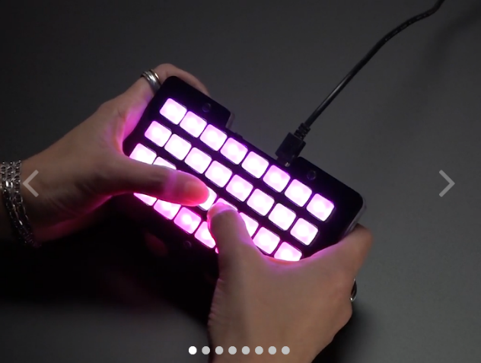

**Example 1: Focus on Fun & Creation, aimed to grab the attention of 10-13 year olds:**

Blast Off with Your Own Sound! 🚀

**The NeoTrellis Synthesizer**

Ever wanted to build your own musical instrument? Now's your chance!

**No experience needed – just bring your imagination!**

Join our 3-day summer course and dive into the awesome world of sound with the Adafruit NeoTrellis M4!

***Imagine***

You'll assemble your own light-up, button-smashing synthesizer in under an hour! Then, the real magic begins.

***Code Your Beats***

Learn to program with CircuitPython and make your buttons play ANYTHING! Drum beats? Electric guitar riffs? Even your own voice? YES!

***Create Your Sound Library***

We'll start with cool tones, and you'll quickly be making your own crazy sound effects.

***Make Some Noise****!*

Turn your creations into wild, personal music and beatboxes.

**No need to be a coding genius!**

We'll show you how to tweak existing programs and unleash your inner sound wizard. Get ready to rock! 🎸🥁🎤

We'll start you off with cool sounds and show you how to customize them.

Don't just listen to music, create it!

Sign up for our 3-day summer sound adventure!

https://youtu.be/57uv1nAAOBk?si=Ae4-gYbtPshycwys&t=256

<https://www.youtube.com/shorts/X-jByVddrAE>