**The Archaeology of Anglo-Norman Rural Settlement in Co. Wexford, Ireland, c.1169-1400**

Many aspects of settlement patterns among mobile populations in the medieval period remain highly elusive. This paper will discuss the use of Geographic Information Systems (or GIS) to obtain data which, in concert with analyses of excavated evidence and historic records, provides new information about the settlement of Ireland by Anglo-Normans in the late twelfth through the fourteenth centuries. The use of new technological methods does not suggest a divorce from previous methods of medieval study. On the contrary, these methods are a tool that can provide further evidence to support or oppose claims made from examination of the historic or archaeological record. GIS is an excellent tool for the researcher. In my study,[1] I use GIS to run a series of statistical tests to determine the topographical preferences for Gaelic-Irish and Anglo-Norman settlements in medieval Wexford, a county in the southeast of Ireland. I also examine the distance between various settlement types in order to understand the relationship between settlements.

GIS is a computer program which allows for the manipulation and analysis of spatial data. I uploaded a map of Ireland to the program which provided me with a base map that was not static but dynamic because it was linked to the Irish National Grid coordinate system. The map of Ireland came from a world terrain base map that I downloaded from NASA’s Shuttle Radar Topography Mission. This World map that I clipped down to Ireland provided the elevation map for the study. Other websites, such as Geo Community’s website, have downloadable data for use in GIS. I downloaded the hydrology map, including rivers, streams, estuaries, and sea side lakes or logons, from Geo Community.

I digitized the soil map in GIS based on Gardiner and Ryan’s (1964) ‘Soil Suitability Map’ for county Wexford. I did this by scanning an image of the soil map and added it as a layer in GIS (which I will discuss in more detail below). I then was able to link the image layer with the georeferenced map of Ireland, then I completed the tedious task of outlining each soil type in the county. This was by no means ideal, however, it was sufficient for the purposes of my study, which sought to isolate general soil patterns.

Breaking County Wexford into these easily downloadable components included adding the sites I wanted to study to this digital map. The coordinates for most of the sites were downloaded directly from the Archaeological Survey of Ireland in the Irish National Grid coordinate system. The website plots the coordinates on a map of Ireland and these coordinates can be exported into GIS. Once I had all my data uploaded, I could chose different ways to manipulate the data.

Each piece of information I uploaded acted as its own layer. I could choose to look at the sites in relation to just the elevation map, or I could look at the sites and the soil map, I could even choose which type of sites to examine, for instance just the churches or just the manorial villages.

In my study, I used GIS to run a series of statistical tests to examine the relationship between sites and the topography as well as the relationship between the sites. Before running the statistics, buffers were created around each of the coordinates. This was done so that the extent of the site, rather than one point in space, could be understood. Buffers of 500m were used around most of the sites. This took into consideration the average diameter of some sites (moated sites and ringforts reached upwards of 100m in diameter) and the possible agricultural land utilized outside the enclosures. The nucleated settlements (boroughs, rural-boroughs, and manorial villages) have buffers of 1km in order to encompass all components of the site. It should be noted here that these buffers may either encompass a far greater area than the site in question ever extended, or they may not reflect the entire extent of the site, but they do offer a general overview of an area.

The goal of the first statistical tests is to isolate factors based on the physical environment which may have influenced the decision making process behind settlement location. The arctool *Zonal statistics as table* generated these first statistic tests. This tool summarizes the values of the raster files (the elevation, slope, soil, and distance maps) that occur within the area of another dataset and creates simplified tables containing statistics such as minimum, maximum, mean, etc. Five tables are generated for each site type that demonstrate the number of sites and their relation to soil types, elevation, slope, distance to the coast, and distance to rivers.

Another important factor that may have influenced the location of settlements is distance to the nearest water source. The *Euclidean distance tool* in GIS calculates the distance between sites and the coast, sites to other water sources, and from site to site. This tool provides the shortest distance between these points. The limitation of the *Euclidean distance tool* is that it calculates distance ‘as the crow flies’ and does not take the terrain into account. It therefore may not represent the shortest actual walking distance between these points, but does offer a general distance useful for comparisons in this paper. The distance layers, calculated with the *Euclidean distance tool,* are then used in the *Zonal statistics as table tool* (described above) and a table is generated for each site type.

It should be noted here that these statistics generated through GIS may not reflect the actual relationship between sites and topography that existed in the medieval period. The soil composition may have changed since the medieval period, nutrient levels could vary, and soil could have eroded. The general elevations may only have varied slightly, but slopes could be more eroded. The distance to the coast is different for some sites due to land reclamation in the west of Wexford where Great Island is located and in the east of Ireland, where Beggerin Island is located.[2] Finally, rivers may have changed course and streams may have dried up over time. Nevertheless, GIS provided the tool that I needed to analyze the settlements of medieval Ireland. By using the *Zonal statistics as table tool*, I was able to analyze the percentage of sites and their relationship to the topography.

The results of the GIS tests showed that the Anglo-Norman sites were located on soil that was the best suitable for the cultivation of crops (Fig. 1). Brown Earths constitute 49% of the soil makeup of County Wexford. Therefore, it is more telling to look at the percentage of sites that occur on the next most productive soil type in County Wexford, the Grey Brown Podzols; which occupy only 3% of the county. Furthermore, the Grey Brown Podzols are more productive for the cultivation of crops than the Brown Podzolics which occupy a higher percentage of the county (10%). The soil chart (Fig. 1) indicates that there seems to be a conscious effort on the part of the Anglo-Normans to place their settlements on the more productive Grey Brown Podzol soils. This particular consideration does not seem to have been in place before the arrival of the Anglo-Normans. The native Gaelic-Irish sites, (highlighted in yellow in Fig. 1), appear on any type of soil with no clear pattern.

Other topographical factors can, thankfully, be summarized quickly. Most sites in the study are situated below 120m above sea level, steep slopes are avoided, only the castles and nucleated settlements are located in high percentages near the coast. And most sites are located within 3km of the nearest water source. This analysis demonstrates that the Anglo-Normans attempted to place their settlements in areas that were the best suited for the cultivation of crops. Some sites, such as the Gaelic-Irish ringforts and the Anglo-Norman mottes share topographical preferences, such as elevations exceeding 200m above sea level (refer to Fig. 2), which supports arguments for the reuse of ringforts as mottes.[3]

Another component of my study used GIS to determine the relationship between the various sites in the study. To conduct this part of the study, I used the *Euclidean distance tool* in GIS, which is the same tool I used to calculate the distance between sites and the coast, and rivers. I was interested here in showing the relationship between sites, and how each site fit into the settlement hierarchy. For the interest of time, I will summarize the results of just one settlement type, the moated site.

Moated sites are individual farmsteads and are classified as a dispersed settlement type. A moated site includes a rectangular earthwork and a surrounding ditch that could be filled with water for added protection. Robin Glassock and Terry Berry have provided a great deal of information on these sites. However, the status of the individuals living at these sites is a matter of some contention. One school of thought argues that these sites represent the manors of minor gentry lords.[4] Others note the lack of moated sites in the historic record as evidence that they were not lordly residences, but instead the farmsteads of well-to-do peasants.[5] I hope to add to the discussion on the status of individuals living at moated sites through my examination of the sites.

When the distribution of moated sites is viewed in relation to nucleated sites, the data is a little difficult to comprehend (Fig. 3), therefore, I examined just one small area to gain an understanding of the relationship between moated sites and nucleated settlements.

This smaller area is Shelmalier, nestled between the rivers Owenduff and Corock (Fig. 4). It includes the manorial villages of Newbawn and Horetown and the rural-borough of Taghmon. The moated sites, indicated in green, appear to be clustered close to the nucleated settlements. Two Newbawn moated sites are so close to the manorial village of Newbawn that they appear within the arbitrary boundary of the manorial village that I set. The other moated sites in the area of Newbawn range in distance from 1.5km-3.7km away from the manorial village. The moated sites of Ballyclemock and Cullenstown, are about 2.6-3 km from the manorial village of Horetown South. These two moated sites are also only about 3.7 km away from the manorial village of Newbawn. Finally, the moated sites around Taghmon also demonstrate this clear association, comprising on average a rough distance of 1km from Taghmon. Moated sites were originally argued to occur 5-8km away from nucleated settlements. My research, however, indicates a far stronger association between moated sites and nucleated settlements. Moated sites are clearly clustered with other moated sites[6] and located within reasonable distances from nucleated settlements and sites which indicate settlement of some kind. The relationship between moated sites and Anglo-Norman nucleated settlements is crucial to an understanding of their function.

This method of analysis certainly has its benefits, however, in order to paint a clear picture of settlement patterns in late medieval Ireland, the digital needs to be examined in conjunction with the tangible. Therefore, I also examined the excavated evidence in order to answer questions about the status of the individuals who lived at moated sites.

I will briefly summarize the findings from the excavation of the moated site of Carrowreagh. In 2000, the northern section of the moated site of Carrowreagh was excavated preceding road development. Inside the moat there is evidence for the existence of a longhouse made of sill-beam foundations and earthen walls. One hearth was found in the northwestern corner of the house, radiocarbon dated to AD 1400-1450, and another hearth was located more centrally, radiocarbon dated to AD 1300-1420.[7]

The majority of artifacts recovered from inside the moat are medieval pottery sherds. These sherds were predominantly Leinster Cooking ware, Fine Wexford type, local copy of Ham Green ware and a few unidentified sherds. The Leinster Cooking ware provides a date between the twelfth to the thirteenth century for the site. [8]

Some of the most interesting features excavated at the site were located outside the moat. A kiln was discovered approximately 2m to the north of the moat. A possible pottery workshop was identified about 9m to the east of the kiln and 9.6m northeast of the moat. The kiln returned a calibrated radiocarbon date of AD 1300-1450.[9] The longhouse, the local pottery wares and the discovery of a kiln and pottery workshop all provide evidence for a lower-status individual occupying this site.

Excavations of moated sites number relatively few. At the time of the study only six moated sites had been excavated and the number has not increased drastically.[10] Of the excavated sites, only one had evidence for a wealthier inhabitant. The evidence however, only included a large hall-like structure, and the inclusion of imported pottery.[11] Therefore, the evidence for lower status individuals inhabiting these sites appears to be the most compelling.

The historic record provides further proof of moated sites as non-lordly residences. A deforestation charter issued by Richard Marshall in 1231-1234, “permitted [Marshall’s] free tenants to ‘clear, enclose and cultivate’ their lands which were within ‘the meters and bounds of the forests of Ross and Taghmon.”[12] The clustering of moated sites found in this area, including the cluster around Taghmon discussed in the case study (Fig. 4), is further proof that these sites were inhabited by free tenants. Finally, although having a lower status, free tenants had the income to afford to construct and live at moated sites.[13]

Lords’ residences are typically located within nucleated settlements, not clustered in groups on the outskirts of towns. Therefore, the spatial analysis of moated sites supports the conclusion that these sites were the residences of well-to-do peasants.

I hope this paper demonstrates the usefulness of GIS to a study on medieval settlements. The statistical analysis tool allowed me to study upwards of 700 sites, a task that would have otherwise been impossible for the time allotted for the project. The difficulties inherent in GIS have been discussed at length and are primarily centered on the fear that GIS lays too great an emphasis on environmental factors, and largely disregards cultural factors.[14] I utilized the archaeological and documentary evidence in conjunction with GIS to address these concerns and learn more about Anglo-Norman settlement in Ireland.

Figures

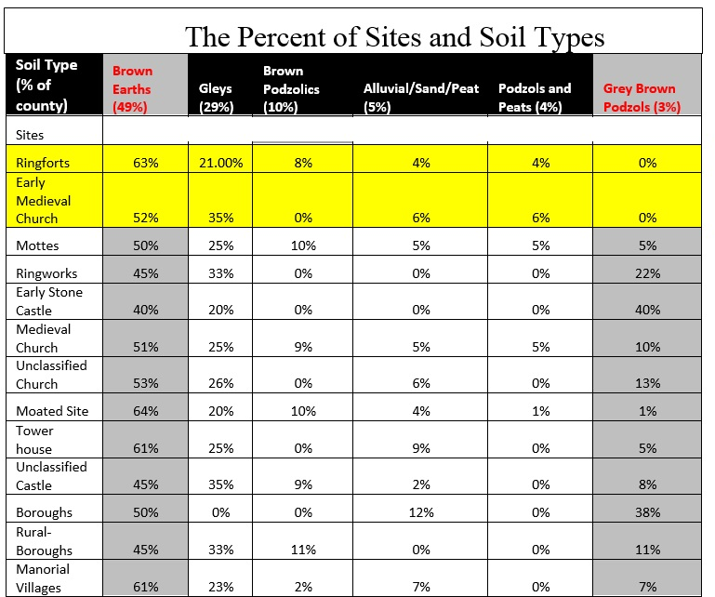

Figure 1. Table illustrating the percentage of sites from the study and their soil types, as well

as the percent of the county that soil type represents, indicated in parenthesis next to the soil type. Gaelic-Irish sites highlighted in yellow (table by author).

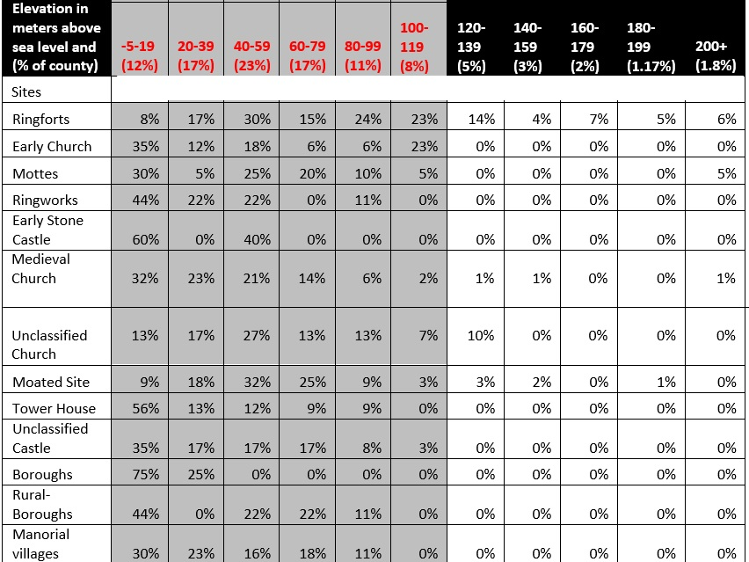

Figure 2. Table illustrating the percentage of sites that occur at certain elevations, and how much of the county is occupied by these altitudes. Most sites are located at elevations under 120m above sea level, highlighted in grey (table by author).

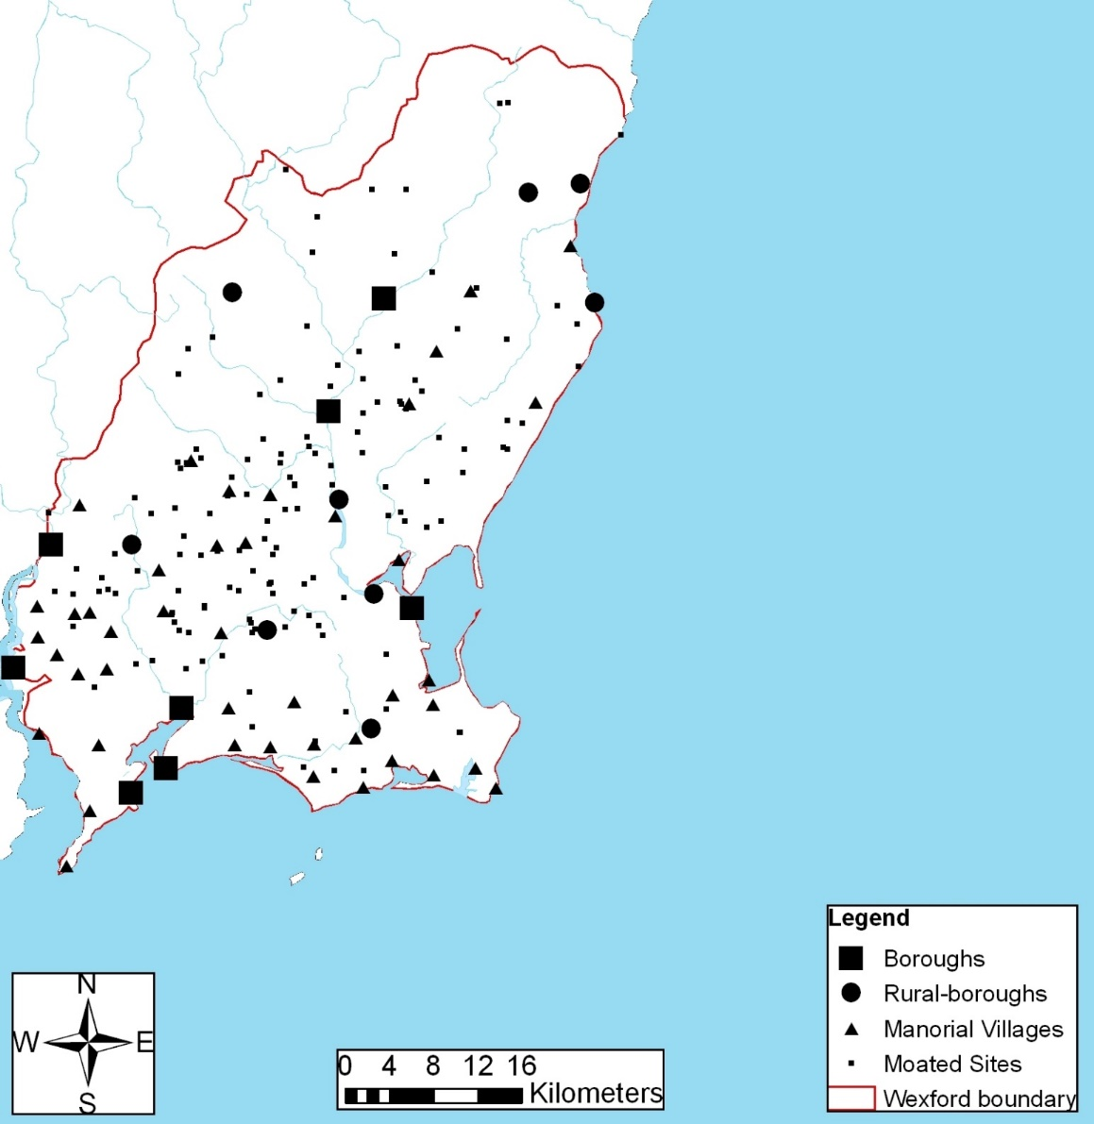

Figure 3. Distribution map of nucleated settlements and moated sites (map compiled by author).

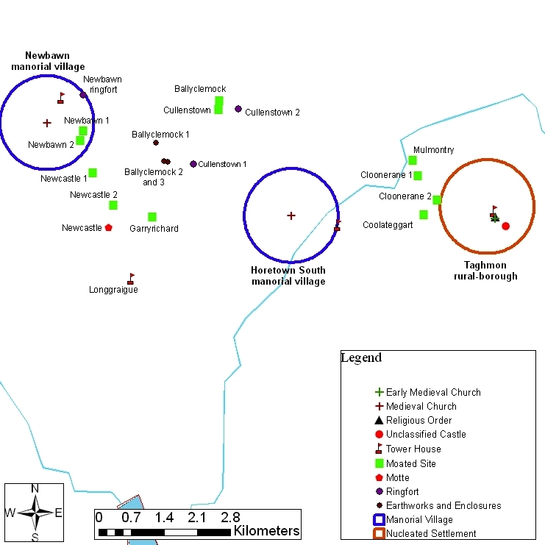

Figure 4. The layout of sites in the case study with labels (map compiled by author).

Notes

1. This paper reflects research completed for my Masters in Medieval Archaeology from the University of York in 2010.
2. Colfer 2002, 9
3. Dikinson and Waterman 1959; Waterman 1959; Waterman 1963; Lynn 1981-1982; Ó Ríordáin 1979; Flannagan 1993
4. Barry 1977, 176; 1987, 84-5; Colfer 2002, 134
5. McNeill 1997, 148-149; O’Conor 1998, 61; O’Conor 2000, 93-94
6. a phenomenon that was recognized by Barry 1977, 110
7. Johnston and Tierney 2009, 10-11
8. Johnston and Tierney 2009, 16
9. Johnston and Tierney 2009, 13.
10. In fact, I can think of only one, and as far as I know it has not been excavated. Magnetic gradiometry and geophysical survey have revealed the presence of a moated site that was used by the Irish lords and had initially been a ringfort. Discovery Programme, “[Roscommon Landscape: Cloonybeirne: O Conor Roe lordship centre](http://www.discoveryprogramme.ie/research/past-projects/medieval-rural-settlement/40-roscommon-landscape-cloonybeirne-o-conor-roe-lordship-centre.html),” http://www.discoveryprogramme.ie/research/past-projects/medieval-rural-settlement/40-roscommon-landscape-cloonybeirne-o-conor-roe-lordship-centre.htmlhttp://www.discoveryprogramme.ie/research/past-projects/medieval-rural-settlement/40-roscommon-landscape-cloonybeirne-o-conor-roe-lordship-centre.html
11. Sweetman 1981, 204; O’Conor 1998, 66
12. Colfer (1987, 81)
13. Barry 1977, 103
14. Gaffney and van Leusen 1995, 374

    Select Bibliography

    Barry (1977) *Medieval moated sites of south-eastern Ireland: counties Carlow, Kilkenny, Tipperary and Wexford.* BAR International Series35. Oxford: British Archaeological Reports.

    Barry (1978) ‘Moated sites in Ireland’ in F A Aberg (ed), *Medieval Moated Sites*, 56-60. The Council for British Archaeology research report no. 17. London: Council for British Archaeology

    Barry, T B (1987) The *archaeology of medieval Ireland*. London: Methuen.

    Barry, T B (2000a) ‘Rural settlement in medieval Ireland’ in T B Barry (ed), *A History of Settlement in Ireland,* 110-123. London: Routledge.

    Barry, T B (2000b) ‘An introduction to dispersed and nucleated medieval rural villages in Ireland’ *Ruralia III*, 6-10.

    Barry, T B (2000c) ‘Excavations at Piperstown deserted medieval village co. Louth, 1987’ *Proceedings of the Royal Irish Academy. Section,* 100c, 113-135.

    Colfer, B (1987) ‘Anglo-Norman Settlement in County Wexford’ in Whelan, K and W Nolan (eds), *Wexford: History and Society*, 65-101. Dublin: Geography Publications.

    Colfer, B (1996) ‘In search of the barricade and ditch at Ballyconnor, Co. Wexford’, in *Archaeology Ireland* 10, 16-19.

    Colfer, B (2002) *Arrogant Trespass: Anglo-Norman Wexford, 1169-1400.* Enniscorthy, County Wexford: Duffry Press.

    Dickinson, C W and D M Waterman (1959) ‘Excavations of a rath with motte at Castleskreen, Co. Down’, *Ulster Journal of Archaeology* 22, 67-82.

    Feagan, G (2009) ‘Discovery and excavation of a medieval moated site at Coolamurry, Co. Wexford’ in C Corlett and M Potterton (eds) *Rural Settlement in medieval Ireland: in light of recent archaeological excavations*, 91-108. Dublin: Wordwell Ltd.

    Flanagan, M T (1989) *Irish society, Anglo-Norman settlers, Angevin kingship: interactions in Ireland in the late twelfth century*. Oxford: Oxford University Press.

    Gaffney, V and P M van Leuson (1995) ‘Postscript—GIS, environmental determinism and archaeology’ in G Lock and Z Stančič (eds) *Archaeology and Geographical Information Systems: A European Perspective,* 367-382. London: Taylor & Francis.

    Gardiner, M J and P Ryan (eds) (1964) *Soils of Co. Wexford*. Dublin: Foras Talúntais.

    Gardiner, M J and P Ryan (1964) ‘Soil Suitability Map’ in M J Gardiner and P Ryan (eds) *Soils of Co. Wexford*. Dublin: Foras Talúntais.

    Glasscock, R E (1968) ‘Kilmagoura, Co. Cork’, *Medieval Archaeology* 12, 196-197.

    Glasscock, R E (1970) ‘Moated sites, and deserted boroughs and villages, two neglected aspects of Anglo-Norman settlement in Ireland’ in N Stephens and R E Glasscock (eds), *Irish Geographical Studies,* 162-177. Belfast: The Queen’s University Belfast.

    Glasscock, R (1971a) ‘The study of deserted medieval settlements in Ireland (to 1968)’ in M Beresford and J G Hurst (eds) *Deserted medieval villages*, 279-291. London: Lutterworth Press.

    ### Glasscock, R (1971b) ‘Gazetter of Deserted towns, rural-boroughs, and nucleated settlements in Ireland’ in M Beresford and J G Hurst (eds) *Deserted medieval villages*, 292-296. London: Lutterworth Press.

    Glasscock, R E (1987) ‘Land and People’ in A Coscrove (ed) *A new history of Ireleand II, medieval Ireland 1169-1534,* 205-271*.* Oxford: Clarendon Press.

    Lynn, C J (1981-1982) ‘The excavation of Rathmullan, a raised rath and motte in County Down’, *Ulster Journal of Archaeology* 44-5, 65-171.

    McNeill, T E (1997) ‘County Down in the later middle ages’ in L Proudfoot (ed*), Down: history and society*, 103-122. Dublin: Geography Publications.

    O’ Conor, K (1998) *The archaeology of medieval rural settlement in Ireland*. Dublin: The Royal Irish Academy.

    O’Conor, K (2000) ‘The ethnicity of Irish moated sites’, in *Ruralia* 3, 92-102.

    Ó Ríordáin, S P and J Hunt (1942) ‘Medieval dwellings at Caherguillamore, co. Limerick’, *Proceedings of the Royal Irish Academy* 12, 37-63.

    Ó Ríordáin, S P (1979) *Antiquities of the Irish countryside*. London: Cork University Press.

    Sweetman, D P (1981) ‘Excavations of a medieval moated site at Rigsdale, county Cork, 1977-1978’, *Proceedings of the Royal Irish Academy* 81c, 193-205.

    Tierney, M (2009) ‘Excavating feudalism? A medieval moated site at Carrowreagh, Co. Wexford’ in C Corlett and M Potterton (eds) *Rural Settlement in medieval Ireland: in light of recent archaeological excavations*, 189-200. Dublin: Wordwell Ltd.

    Tierney, M and P Johnston (2009) ‘Archaeological Excavation Report EO471-Carrowreagh, Co. Wexford, medieval moated site and pottery kiln’, *Eachtra Journal* (4), 1-100.

    Watschong, N (2010) ‘Map of Irish Counties’, http://spirited –ireland.net. Page consulted May 4 2010.

    Watterman, D M (1959) ‘Excavations at Lismahon, co. Down’, in *Medieval Archaeology* 3, 139-176.

    Watterman, D M (1963) ‘Excavations at Duneight, County Down’, *Ulster Journal of Archaeology* 26, 83-87.