Example Report: Simple markov model - beta 1.0

Robert Smith 1,2,3 & Paul Schneider 1,2

1. Dark Peak Analytics
2. University of Sheffield
3. Joint Biosecurity Centre

This is a report generated from a Shiny web application for a time-dependent Markov Model. The purpose of the app is to demonstrate how Shiny can be used create clean, accessible, and intuitive user interfaces for powerful health economic models built in R.

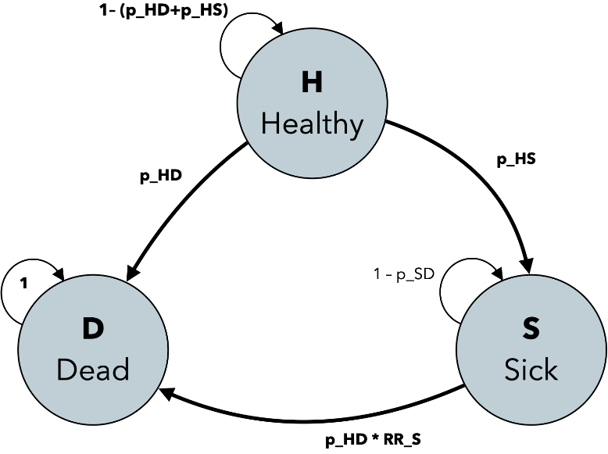The underlying model is a 3-state transition model, with states: '**H**ealthy', '**S**ick' and '**D**ead'. It is used to inform a decision about a new, promising drug, ***Supimab***, which reduces the probability of becoming Sick. All transition probabilities are time-dependent:

Figure 1. Simple Markov Model Structure: p_HD and p_SD is time dependent, and p_HS is obtained by survival analysis from trial data, RR_S is input by the app user as a relative risk with a distribution to incorporate parameter uncertainty.

p(H -> D) = general population's mortality rate, to get p(S -> D), we adjust p(H -> D), using some relative risk. p(H -> S) is extrapolated from fictitious Supimab trial data.

**Having used the app, the user generated this report, which contains the outputs of the model.**

**NOTE**: The source code for the Markov model AND for this shiny app is openly available from our [GitHub repository](https://github.com/bitowaqr/sadm-mk2).