Instructions
In this study you will be asked to make sequences of 2 interconnected decisions.
Each decision involves selecting one of two options, using left (←) or right (→) arrow keys.

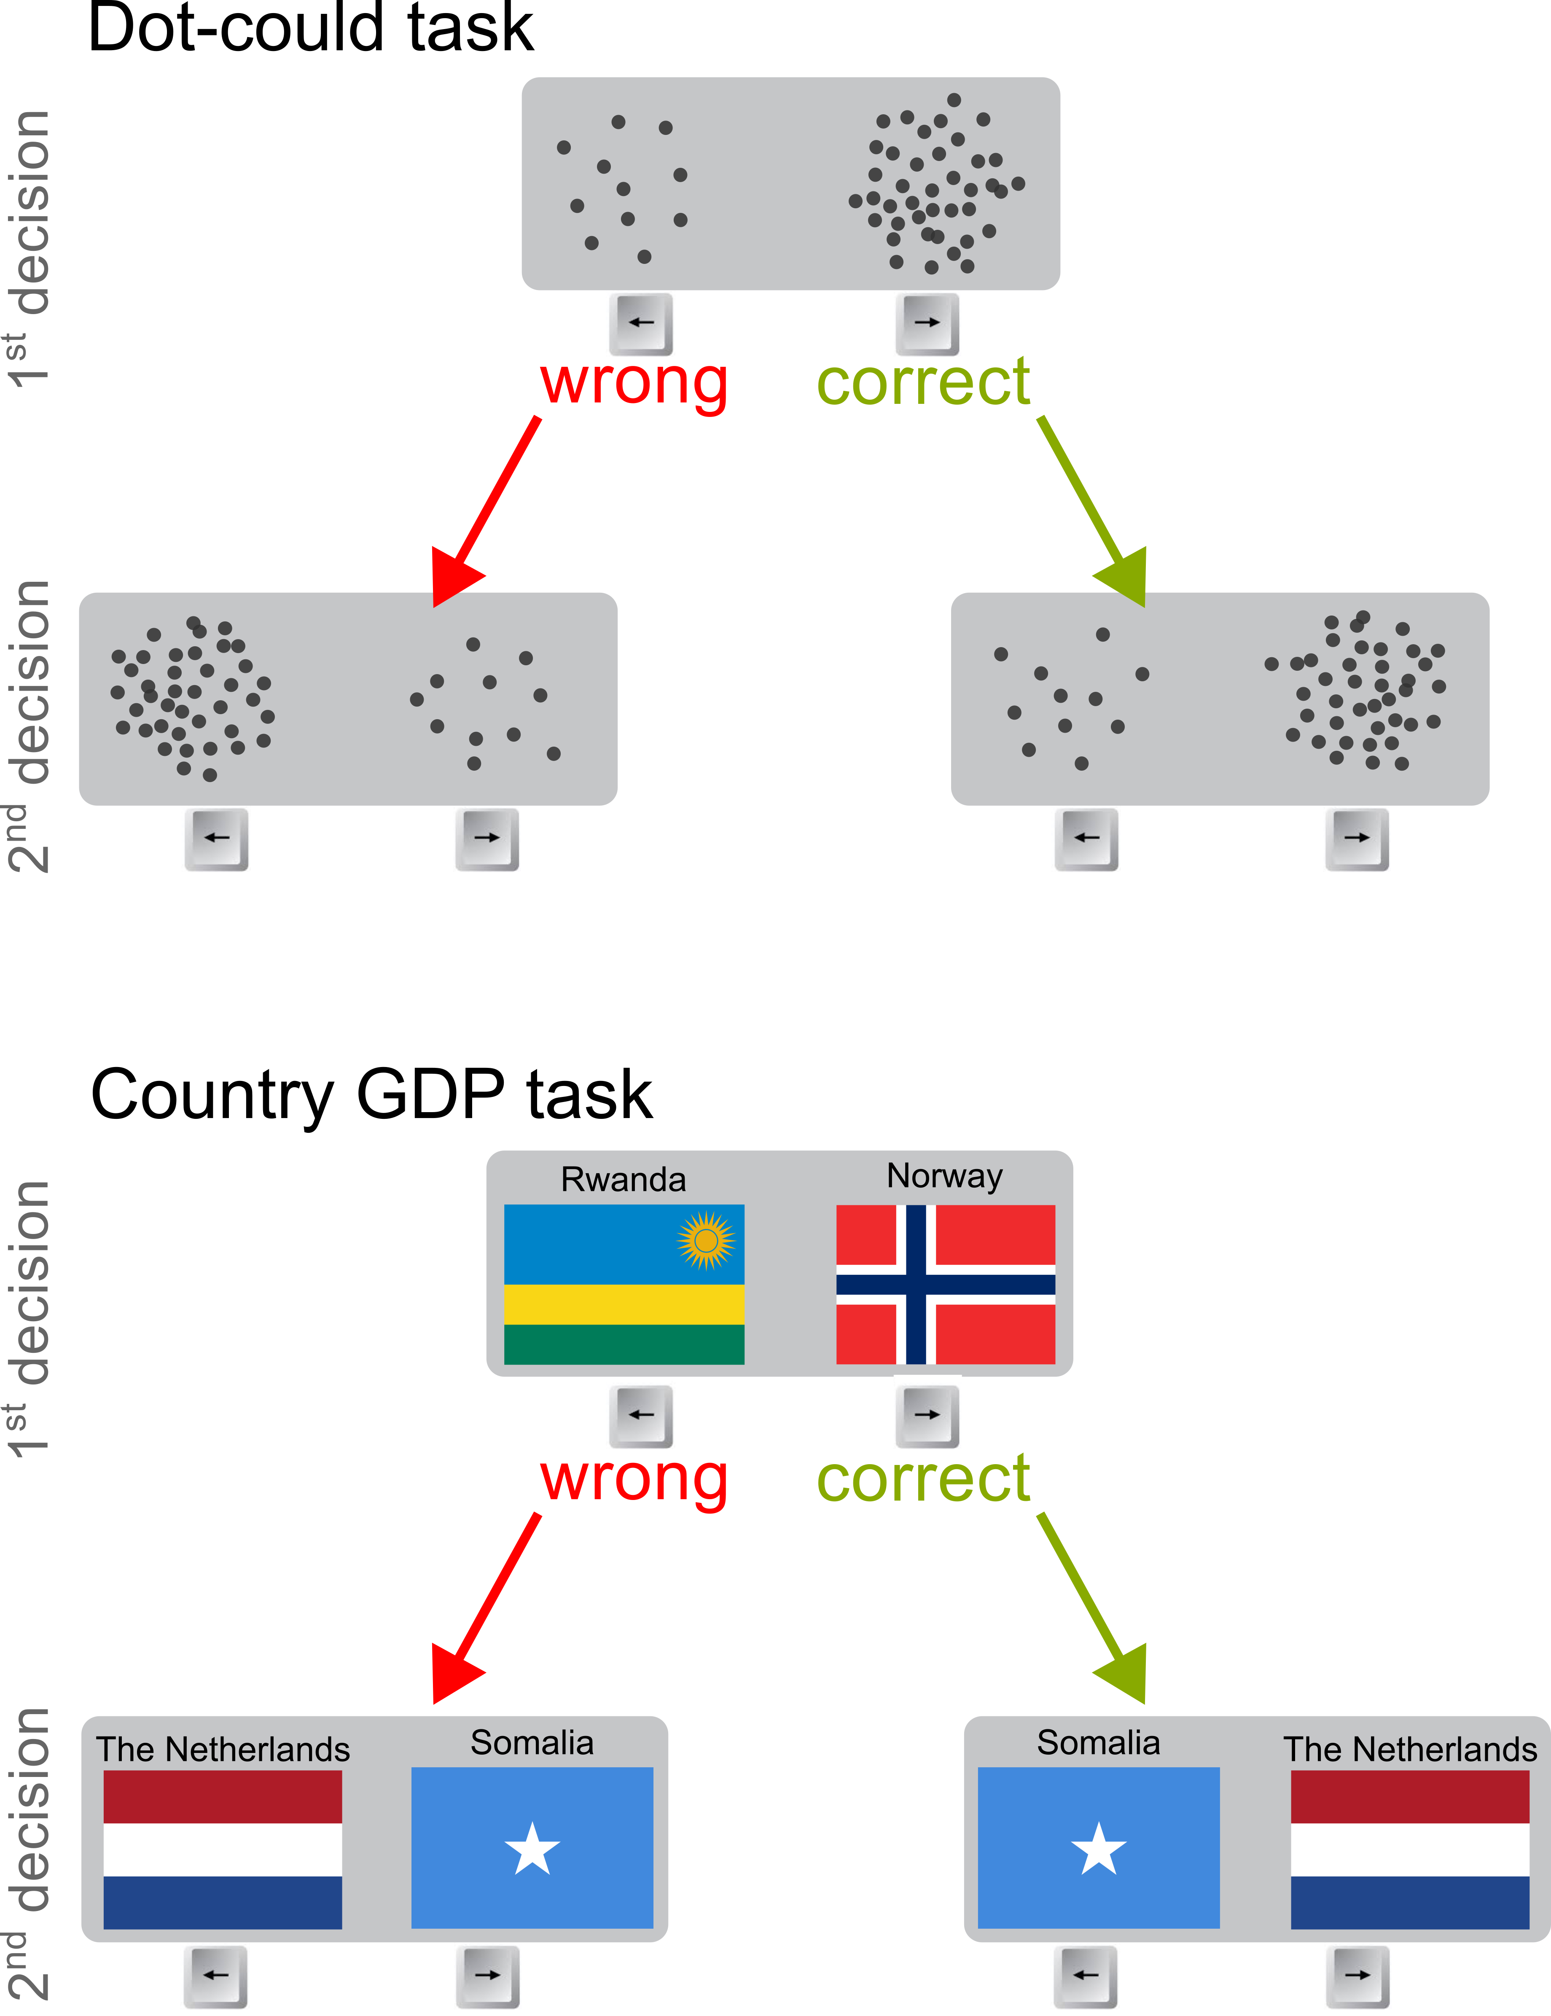
The decisions will be either about which of two dot clouds has more dots (see figure).
In the task, the correctness of the 1st decision will determine which answer (← or →) will be correct in the 2nd decision:
If your 1st decision is correct, the correct answer for the 2nd decision will always be →.
If instead your 1st decision is wrong, the correct answer for the 2nd decision will be ←.

Please note:
- Decisions will be challenging and you may often feel unsure about which answer is correct.
Think about how confident you are that your 1st decision was correct, and use it to guide your 2nd decisions— higher confidence increases the likelihood that → is correct.
- Higher scores increase your chances of winning one of several £50 Amazon vouchers (if you opt-in). Each correct answer boosts your chances, so aim for accuracy!
- There will be numbers (‘1’ or ‘2’) displayed to help you keep track of which decision you are making. There will also be two dots, on the left and right side. Both dots will be grey for the first decision and turn red and green for the second. The green dot will be on the right side will remind you that → is the correct answer if your 1st decision was correct.

