Software Design Document

Project: 图书馆自助借还系统

Authors: 伍开钰21311162 刘洋21311603 岳栩彬21310263

Published on: 2023-07-03

Version: 1.0

Background:

Software design is a process by which the software requirements are translated into a representation of software components, interfaces, and data necessary for the implementation phase. The SDD shows how the software system will be structured to satisfy the requirements. It is the primary reference for code development and, therefore, it must contain all the information required by a programmer to write code. The SDD is performed in two stages. The first is a preliminary design in which the overall system architecture and data architecture is defined. In the second stage—i.e., the detailed design stage—more detailed data structures are defined and algorithms are developed for the defined architecture.

This template is an annotated outline for a software design document adapted from the *IEEE Recommended Practice for Software Design Descriptions*. The *IEEE Recommended Practice for Software Design Descriptions* has been reduced in order to simplify this assignment while still retaining the main components and providing a general idea of a project definition report. For your own information, please refer to IEEE Std 1016[1] for the full *IEEE Recommended Practice for Software Design Descriptions*.

**Table of Contents**

1. Introduction 4

1.1 Purpose 4

1.2 Scope 4

1.3 References 4

1.4 Definitions and Acronyms 5

2. System Overview 6

3. System Architecture 7

3.1 Architectural Design 7

3.2 Decomposition Description 7

3.3 Design Rationale 8

4. Data Design 9

4.1 Data Dictionary 9

4.2 Data Storage 9

5. Component Design 10

6. Human Interface Design 11

6.1 Overview of User Interface 11

6.2 Screen Images 11

6.3 Screen Objects and Actions 11

7. Requirements Matrix 12

8. Appendices 13

# Introduction

## Purpose

本软件设计文档（SDD）的目的是提供图书馆管理系统设计的详细描述。该文档的预期读者包括负责实施系统的开发人员和参与系统开发、测试和维护的利益相关者。本文档将提供软件架构和系统设计、功能和数据结构以及实现细节的全面理解，有助于生成测试用例，并确保系统满足SRS文档中概述的需求。此外，本文档将有助于系统的持续维护。

## Scope

该软件系统为“图书自助借还系统”。本系统将在现有图书管理系统的基础上开发，客户端为自助借还机，分布于图书馆的不同位置，并通过校园局域网连接到一个中央服务器上。通过客户端服务端系统结构完成图书的自助借还功能。

该系统允许在校师生自行完成书籍的借阅、续借和归还操作：

1. 用户将校园卡插入读卡器之后，会开始验证过程，校园卡有效、没有过期且未被挂失时，便可以开启功能操作
2. 用户可以扫描每本书籍的条形码，并设置借阅到期时间即可完成借阅
3. 用户可以从自己的借阅记录中选择书籍进行续借
4. 用户也可以自行扫描书籍选择归还
5. 用户也可以在任何时候取消操作
6. 用户可以查看自己的借阅历史。
7. 借阅期限将至时，系统会向借阅者发送借阅即将到期通知
8. 对超出借阅期限的书籍，系统也会请求扣去借阅者的超期费

通过部署该系统，图书馆可以提高书籍管理效率，减轻工作人员负担，同时方便学校师生完全自助获取图书资源，有效管理借阅情况，减少出现过期等问题。

## References

[1] "IEEE Standard for Information Technology--Systems Design--Software Design Descriptions," https://ieeexplore.ieee.org/document/5167255.

## Definitions and Acronyms

1. 图书自助借还系统：一种用于管理和处理图书馆借阅、归还、续借等业务的软件系统，

可以让用户自行完成借阅、归还和续借操作，不需要借阅员的协助。

1. 自助借还机：自助借还系统中的物理设备，由读卡器、扫描器和键盘/显示器组成，用于读取用户校园卡信息、扫描书籍条形码、显示书籍信息等操作。
2. 客户端子系统：自助借还机上的应用程序，用于处理用户操作并与中央服务器进行数据交互。
3. 服务端子系统：自助借还中央服务器上的应用程序，用于处理并响应客户端子系统向服务器发起的校园卡挂失验证、查询借阅信息、借阅申请等请求。
4. 校园卡：学校为师生提供的一种智能卡，可以用于身份识别、门禁、消费支付等多种场合。
5. 借阅到期时间：用户借阅书籍的截止日期，超过该日期未归还则需要缴纳超期费。
6. 超期费用：用户在借阅到期时间之后未及时归还书籍而需要缴纳的费用。
7. 借阅者：借阅图书的人员，可以是教师或学生。
8. 学工号：学生或教师在学校中的唯一编号，用于身份识别和管理。
9. 有效期：校园卡的有效使用期限，过期后需要重新办理。
10. 人事系统：学校内部管理人员信息、工资、考勤等信息的信息系统。
11. 短信发送系统：用于向借阅者发送到期提醒的短信服务系统。
12. 系统维护人员：负责自助借还机的日常维护和管理的工作人员。

# System Overview

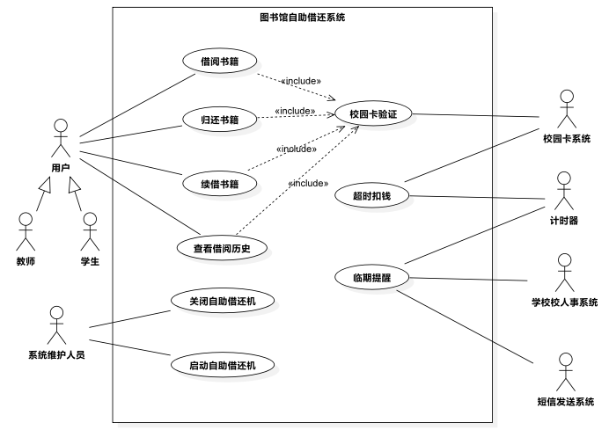

图书自助借还系统的主要功能包括：

1.校园卡认证：系统能够验证用户的校园卡并确定其有效性和挂失状态。

2.借阅功能：用户可以使用自助借还机扫描书籍条形码，系统识别书籍信息并记录借阅情况。用户可以设置借阅到期时间，并完成借阅确认。

3.续借功能：用户可以使用自助借还机查看当前借阅的书籍和借阅到期时间，并进行续借操作。

4.归还功能：用户可以使用自助借还机扫描归还的书籍条形码，系统识别书籍信息，验证并记录归还情况。

5.借阅历史查看：用户可以查看自己的借阅历史记录，包括借阅的书籍和借阅日期。

6.临期提醒和逾期扣费：系统每天自动检查借阅记录，对于借阅临期的用户，系统会通过人事系统获取借阅时间临近的用户的电话号码，并通过短信发送系统向用户发送提示短信；对于借阅逾期的用户，会通过校园卡系统，向该用户的校园卡账户中扣费。

7.系统管理：系统维护人员具有特定权限，可以管理自助借还机的开启和关闭，处理故障情况，并进行系统配置和用户账户管理。

# System Architecture

## Architectural Design

Develop a modular program structure and explain the relationships between the modules to achieve the complete functionality of the system. **This is a high-level overview of how the responsibilities of the system were partitioned and then assigned to subsystems. Identify each high-level subsystem and the roles or responsibilities assigned to it. Describe how these subsystems collaborate with each other in order to achieve the desired functionality.** Don’t go into too much detail about the individual subsystems. The main purpose is to gain a general understanding of how and why the system was decomposed, and how the individual parts work together. **Provide a diagram showing the major subsystems and data repositories and their interconnections.** Describe the diagram if required.

【示例】Speed Detection Subsystem: This subsystem is responsible for detecting the speed of vehicles passing through key locations within the campus. It will consist of multiple speed detectors placed at strategic points in the campus. Each detector will have the ability to capture the vehicle's license plate number and speed, which will be displayed on a nearby speed display board and sent to the backend management system. The data captured by this subsystem will be used to detect vehicles that are exceeding the speed limit.

Vehicle Speed Display Subsystem: This subsystem receives information from the Vehicle Speed Detection Subsystem and displays the detected speed of each vehicle to the driver. This subsystem also includes a mechanism for displaying safe speed limits for the area in which the vehicle is traveling. The display subsystem helps drivers remain aware of their speed while driving on campus.

Backend Management Subsystem: This subsystem is responsible for managing all the data collected by the Speed Detection Subsystem. It can be accessed from both PC and mobile devices, accessible only to authorized personnel from the campus security department. This subsystem will store all the speed detection records sent by the Speed Detection Subsystem. In addition, it will also have features to manage warnings or notifications, generate reports, and maintain a blacklist of vehicles exceeding the speed limit.

要写 -- 这里放置**【子系统划分】**结果：

1. 所运用的子系统组织准则；// 相当于**Design Rationale**

2. 所识别的子系统及各个子系统的职责描述 🡪 参考示例；

3. 子系统之间的并发通信图。

## Decomposition Description

**Provide a decomposition of the subsystems in the architectural design.** Supplement with text as needed. You may choose to give a functional description or an object-oriented (OO) description. For a functional description, put top-level data flow diagram (DFD) and structural decomposition diagrams. For an OO description, put subsystem model, object diagrams, generalization hierarchy diagram(s) (if any), aggregation hierarchy diagram(s) (if any), **interface specifications**, and sequence diagrams here.

要写 -- 这里放置**【子系统设计】**结果：

1. 各个子系统的并发通信图；

2. 所有对象及消息类型的确定依据，如运用的并发任务组织准则等。// 相当于 **Design Rationale**

3. 类/任务的接口设计（不要求每个对象/任务的通信图）-- 因为实体类的操作将在4.1小节给出，这里仅给出实体类以外的其它类/任务的接口。

## Design Rationale

**Discuss the rationale for selecting the architecture** described in 3.1 including **critical issues and trade/offs that were considered**. You may discuss other architectures that were considered, provided that you explain why you didn’t choose them.

可选 -- 除了3.1、3.2小节所给出的设计理由（如子系统组织准则）外，若还有其他重要的体系结构设计选择（如选择顺序性服务设计方案）的理由可放置在这里。

# Data Design

## Data Dictionary

Alphabetically list the system entities or major data along with their types and descriptions. If you provided a functional description in Section 3.2, list all the functions and function parameters. If you provided an OO description, **list the objects and their attributes, methods, and method parameters.**

要写 -- 这里放置**【实体类图（属性+操作）】**！

可选 -- 简要描述各个实体类存储的数据信息（如示例）、以及其中较为复杂的属性、操作。

【示例】

The major data or system entities include:

Vehicle information: This includes vehicle registration number, make and model, owner information, and temporary permits for outside vehicles.

Speed detection records: These records contain the details of each vehicle detected by the speed detector, such as registration number, speed, date, time, and location.

Warning messages: These messages are sent to drivers who violate speed limits. There are different types of warning messages depending on whether the driver is a school staff member or an outside vehicle owner, and the number of times they have violated the speed limit.

Blacklist: This list contains the registration numbers of vehicles that have violated the speed limit more than five times in a quarter. These vehicles will not be allowed inside the campus in the next quarter.



## Data Storage

系统数据(系统数据ID, 教师在借图书上限, 教师单次借阅最长时间, 学生单次借阅最长时间, 单个用户每年同一本书可借阅总时间, 书籍即将到期提醒消息, 校园卡过期提示, 校园卡挂失提示, 书籍条形码无法识别提示, 发送即将到期通知提前天数, 调整时间, 默认借阅到期时间)

自助借还机(自助借还机ID, 位置, 工作状态, 安装时间, 型号, 借还机最后维护时间, *维护人员职工号*)

校园卡(用户编号, 卡号, 单位, 岗位, 已借册数, 有效期)

借阅记录(借阅记录ID, *书籍ID*, *用户编号*, 借阅开始时间, 借阅到期时间, 归还日期, *自助借还机ID*)

系统维护人员(维护人员职工号, 姓名, 密码, 电话)

书籍(书籍ID, 名称, 作者, 书籍状态, 书籍ISBN, 出版社, 价格)

# Component Design

In this section, we take a closer look at what each component does in a more systematic way. If you give a functional description in section 3.2, **provide a summary of your algorithm for each function listed in 3.2 in procedural description language (PDL) or pseudocode.** If you give an OO description, summarize each object member function for all the objects listed in 3.2 in PDL or pseudocode. Describe any local data when necessary.

要写 -- 这里放置类/任务接口的**【详细设计】**，即每个操作的内部算法（伪代码）、每个并发任务的接口规约和行为规约。**NOTE: 各小组内每位组员任选一个类/任务的接口进行详细设计！**不要求写所有的类和任务！

# Human Interface Design

## Overview of User Interface

Describe the functionality of the system from the user’s perspective. **Explain how the user will be able to use your system** to complete all the expected features and the feedback information that will be displayed for the user.

可选 – 这里对用户使用系统的方式进行描述，如用户的授权登录、功能选择输入、以及系统的信息展示等。此部分的内容等同于**用例描述**，但重点关注人类用户。

【示例】The user interface of the campus overspeed monitoring system allows authorized users to access the system through a PC or mobile device. The authorized user is typically a member of the school security department responsible for managing the traffic within the school campus. By accessing the system, the user will be able to view the real-time speed data displayed on the speed detector screens installed at key locations around the campus. The speed detector screen displays the vehicle's license plate number, speed, and an indicator of whether the vehicle is speeding or not. In addition to the real-time speed data, the user can also view detailed records of vehicle speed violations through the backend management system. They can search by vehicle, driver, or road segment to retrieve the necessary information. Once a speeding violation is identified, the user can send an educational message to the driver through SMS. If the driver is a staff member of the school, their department head will also be notified. The system also provides monthly and quarterly statistical reports for each unit in the school to review their performance in terms of traffic safety. Authorized users can adjust the maximum speed limit monthly and quarterly over-speeding limits and add or remove regular administrative users.

## Screen Images

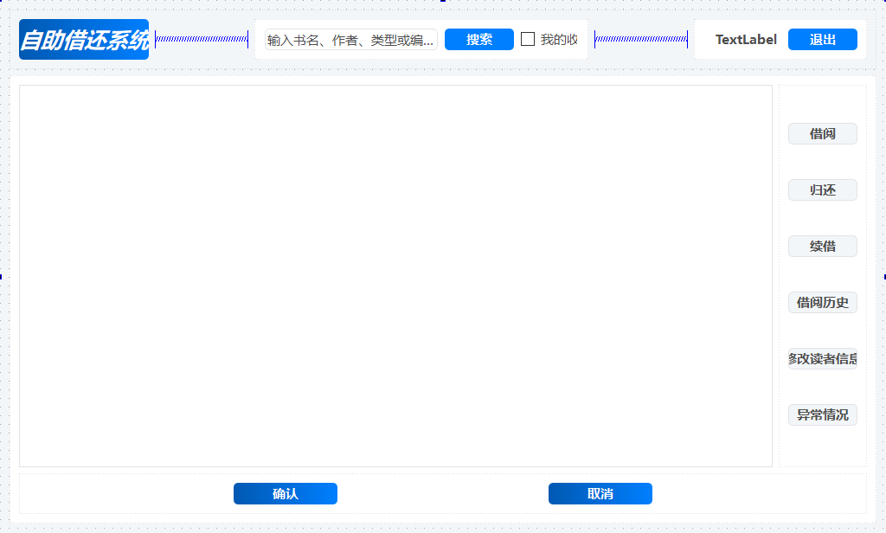

客户端界面：该接口提供授权用户访问软件系统的权限。客户端GUI 提供菜单、按钮（借阅、续借、归还、取消等）、输入框、选择框、搜索框和表单等。在校师生用户可以通过选择借阅、归还、续借和取消来与系统交互。

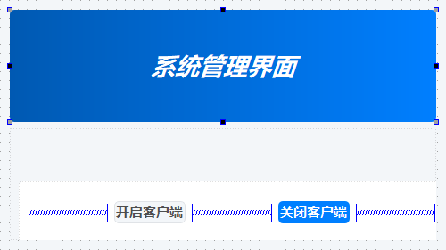

系统管理界面：该接口提供授权系统维护人员访问软件系统的权限。系统管理GUI提供对客户端子系统进行关闭和开启的按钮。系统维护人员可以通过选择关闭或开启按钮来管理客户端子系统。

## Screen Objects and Actions

A discussion of screen objects and actions associated with those objects.

可选 – 对6.2小节的GUI界面中的屏幕对象及其动作进行说明。

# Requirements Matrix

**Provide a cross­reference that traces components and data structures to the requirements** in your software requirements specification (SRS) document.

Use a tabular format to show which system components satisfy each of the functional requirements from the SWRS. Refer to the functional requirements by the numbers/codes that you gave them in the SWRS.

可选 -- 这里提供SRS中需求/用例与SDD中构件和数据之间的交叉引用，实现需求与设计之间的可追踪性。为此，需要给需求/用例、构件、数据进行标识。

# Appendices

市场调研：

市场调研结果显示，用户对图书自助借还系统的认证、借阅、续借、归还、借阅历史查看等功能表示满意。调研还表明，系统的快捷、准确、可视化操作以及提供的临期提醒和逾期扣费功能受到用户青睐。成本效益分析显示，该系统可以提高工作效率，减少人力资源成本。样本输入/输出格式包括校园卡认证、书籍条形码扫描和相关提示信息。市场调研结果为系统实施提供了重要参考。

支援或背景资料：

图书自助借还系统是一种现代化的图书管理解决方案，旨在提供高效、便捷的图书借还服务。该系统利用校园卡认证技术，确保用户身份验证和信息安全。通过条形码扫描技术，系统能够准确记录图书借阅和归还情况。临期提醒和逾期扣费功能帮助图书馆实现自动化管理，提醒用户按时归还图书并促进资源的有效利用。系统管理功能赋予维护人员对设备和系统的管理权限，确保系统的稳定运行和灵活配置。图书自助借还系统使得图书馆更加智能化和用户友好化，提升了用户体验和工作效率。

软件仍要解决的问题：

目前，图书自助借还系统需要解决以下问题：

1）提高条形码扫描的准确性和速度，以确保图书信息的正确识别和记录；

2）改进用户认证过程，确保对用户身份的可靠验证，并处理挂失状态的校园卡；

3）优化系统的稳定性和可靠性，确保自助借还机的正常运行，并减少故障发生的概率；

4）完善临期提醒和逾期扣费机制，以确保及时通知用户借阅到期情况，并按规定扣费；

5）增强用户界面的易用性和用户体验，使操作更加直观和便捷。解决这些问题将进一步提升系统的功能性和可用性，满足用户需求并提供高质量的图书借还服务。

注：以上信息项不属于系统原先需求，而是根据系统功能而延伸出的内容

**1 Introduction**

**1.1 Purpose 已完成**

**1.2 Scope 已完成**

**1.3 References 已完成**

**1.4 Definitions and Acronyms 已完成**

**2 System Overview 已完成**

**3 System Architecture**

**3.1 Architectural Design子系统划分**

**3.2 Decomposition Description 子系统设计**

**3.3 Design Rational 可选 其他体系结构设计选择**

**4 Data Design**

**4.1 Data Dictionary 实体类图(属性+操作)**

**4.2 Data Storage 实体类的存储方式 及 关系数据库映射**

**5 Component Design 类/任务接口详细设计**

**6 Human Interface Design**

**6.1 Overview of User Interface 可选 人类用户为重点的用例描述**

**6.2 Screen Images 已完成**

**6.3 Screen Objects and Actions 可选 GUI屏幕对象以及其动作的说明**

**7 Requirements Matrix 可选 构件和数据的交叉应用**

**8 Appendices 已完成**

1. <http://ieeexplore.ieee.org/browse/standards/collection/ieee>