
FACULTY OF INFORMATION AND COMMUNICATION TECHNOLOGY

(PROG211) OBJECT ORIENTED PROGRAMMING METHODS 1

Title : ASSIGNMENT 1
Issue Date : WEEK 2
Due Date: WEEK 4
Lecturer Name : Mr Julius Laggah
Name of Student : Marcushia Nancila Grace Kati Marcus-Bangura
Class : BSEM1102
Student ID : 905005985
Semester/YEAR : 3/2
Academic Honesty Policy Statement
I, hereby attest that contents of this attachment are my own work. Referenced works, articles, art, programs, papers or parts thereof are acknowledged at the end of this paper. This includes data excerpted from CD-ROMs, the Internet, other private networks, and other people’s disk of the computer system.
Student’s Signature:

LECTURER’S COMMMENTS/GRADE: | for office use only upon receive  Remark  DATE :……………….  TIME : ………………  RECEIVER’S NAME : ……….

ABSTRACT
EduResults is a menu-driven Python prototype designed to demonstrate how a basic Student Digital Examination and Result Management System can support common school record-management tasks. In an educational setting, student information and examination marks must be organised clearly so that authorised users can retrieve records, review performance, and communicate results consistently. This project models a small part of that process through a command-line application that allows a user to register students, record marks for different subjects, search for a student by identification number, display registered students, and generate a report card.
The system is built around three classes: Student, Examination, and ResultManagementSystem. The Student class represents an individual learner and stores details such as the student ID, full name, class, and examination marks. The Examination class supports calculations such as totals and averages, while the ResultManagementSystem class coordinates the registration, searching, mark-recording, and report-card functions. A Python dictionary is used to keep student objects under unique student IDs, making records easy to retrieve and helping the program identify duplicate IDs. The implementation also demonstrates instance methods, a class method, input validation, and interaction between objects.
The project is intended as a learning prototype for the PROG211 Object-Oriented Programming 1 assignment rather than a complete school information system. It stores records in memory while the program is running and does not provide a database, user accounts, or a web interface. The report explains the design, describes how to run the program, documents the supplied tests, and considers how the project reflects Digital Public Goods principles such as open-source availability, accessibility, privacy-respecting design, and modularity. Screenshots of the program running should be inserted in the designated spaces to provide visual evidence of the practical implementation.

TABLE OF CONTENTS

Contents
(PROG211) OBJECT ORIENTED PROGRAMMING METHODS 1 1
1
ABSTRACT 2
TABLE OF CONTENTS 3
1. INTRODUCTION 4
2. OBJECTIVES 4
3. SYSTEM REQUIREMENTS 5
3.1 Hardware Requirements 5
3.2 Software Requirements 5
3.3 Input Requirements 5
3.4 Output Requirements 5
3.5 Operational Requirements 5
3.6 Privacy, Accessibility, and Maintenance Requirements 5
4. SYSTEM DESIGN 6
4.1 Main Classes 6
4.2 Program Flow 6
5. OBJECT-ORIENTED PROGRAMMING CONCEPTS 7
5.1 Classes and Objects 7
5.2 Attributes 7
5.3 Instance Methods 7
5.4 Class Method 7
5.5 Object Interaction 7
6. PROGRAM OPERATION 8
7. DIGITAL PUBLIC GOODS ALIGNMENT 8
SCREENSHOTS OF THE PROGRAM RUNNING 9
Screenshot 1: Program start and main menu 9
Screenshot 2: Registering a student 9
Screenshot 3: Recording examination marks 10
Screenshot 4: Student report card 11
Screenshot 5: Searching or displaying student records 11
Screenshot 6: Searching or displaying All student records 12
Screenshot 7: Changing School Name 13
11. CONCLUSION 14
APPENDIX A – SOURCE CODE 14

1. INTRODUCTION
Education systems depend on accurate and accessible information to support student registration, examination administration, and the communication of academic performance. When student details and marks are recorded inconsistently, it can become difficult to locate a record, verify a result, or present a clear summary of a learner’s performance. Even a small prototype can help demonstrate how a computer program can organise these tasks in a structured and repeatable way.
EduResults, the Student Digital Examination and Result Management System, is a Python console application developed for the PROG211 – Object-Oriented Programming 1 assignment. The project applies the concepts introduced in Lectures 1–3 by modelling learners and examination activities as objects. Users can register a student with a unique identification number, enter marks for subjects, search for a student, display student records, and generate a report card showing subject marks, total marks, average, grade, and overall status according to the rules implemented in the program.
The application separates responsibilities into three classes. Student holds each learner’s personal academic record; Examination performs examination-related calculations; and ResultManagementSystem manages the collection of students and coordinates user actions. A dictionary stores Student objects using their IDs as keys. The program also uses methods to perform operations, including a class method for changing the shared school name. These features make the project a practical demonstration of classes, attributes, objects, methods, data structures, and object interaction.
The assignment also asks students to consider Digital Public Goods (DPG) principles. EduResults is designed to be understandable and modular, can be shared as source code, uses a simple text-based interface, and can be demonstrated with fictional records without sending information to an external service. However, the current version is a prototype: its records are held in memory and are not preserved after the program closes. It should not be treated as a production system for real student data without further development, security controls, persistent storage, and institutional approval.
This report presents the project objectives, system requirements, design, OOP concepts, data structure, operation steps, DPG alignment, testing, limitations, and source code. Dedicated screenshot spaces are included so that images captured while running the actual program can be added as evidence of implementation.

2. OBJECTIVES
- Create and manage student objects with unique student IDs.
- Record and update subject marks within the range 0–100.
- Calculate totals, averages, grades, and overall pass/fail status.
- Search for a student and display one or all registered student records.
- Demonstrate instance methods, a class method, and object interaction.
- Use a dictionary to store multiple Student objects.
- Document how the prototype relates to Digital Public Goods principles.

3. SYSTEM REQUIREMENTS

3.1 Hardware Requirements
A standard desktop or laptop computer capable of running a supported version of Python is sufficient for this console-based project. The application does not require specialised hardware, a dedicated server, or a high-performance graphics card. A keyboard and display are needed to enter commands, interact with the menu, and view student records and report cards. Sufficient free storage should be available for the project folder, source code, assignment report, and screenshots.

3.2 Software Requirements
Python 3.10 or later is recommended for running the application. Visual Studio Code or another Python-compatible editor may be used to inspect and edit the source files. A terminal or command prompt is required to start the program and interact with its menu. The supplied project includes a main program file and a test file. The current implementation uses Python’s built-in features and does not require third-party packages to run.

3.3 Input Requirements
The program accepts student identification numbers, full names, class names, subject names, and examination marks. Student IDs should be unique so that one student’s record is not confused with another’s. Marks must be numeric values within the accepted range of 0 to 100. Users should enter information carefully and follow the prompts displayed by the application. For demonstration and screenshot purposes, fictional student details should be used instead of real sensitive records.

3.4 Output Requirements
The application displays confirmation messages after successful actions and provides feedback when an operation cannot be completed. Depending on the menu option selected, the output can include a student’s details, recorded subject marks, a list of registered students, a search result, or a report card. The report card includes calculated totals, averages, a grade, and an overall pass/fail status based on the program’s implemented grading rules. The grading scale is illustrative and should be checked against the institution’s official policy before any real-world use.

3.5 Operational Requirements
To operate the system, the user extracts the project folder, opens it in an editor or terminal, and runs the main Python file. The user then selects options from the displayed menu and follows the prompts. Since this version stores records in memory, information entered during one session is not automatically saved for the next session. Users should therefore understand that the program is intended for demonstration and learning rather than permanent school record keeping.

3.6 Privacy, Accessibility, and Maintenance Requirements
The system should be demonstrated with fictional data and should not be used to publish confidential student information. Its text-based menu keeps the interface simple and requires no internet connection for normal execution. The code is divided into classes and methods so that individual responsibilities can be reviewed and improved. For a future production version, requirements would include secure user authentication, role-based access, reliable database storage, backups, audit logs, and clear rules governing who may view or change student records.

4. SYSTEM DESIGN

4.1 Main Classes
Class | Responsibility | Examples of methods
Student | Stores one student's details and subject marks. | add_mark(), calculate_average(), get_grade(), display_details(), change_school_name()
Examination | Performs examination calculations. | calculate_total(), calculate_average()
ResultManagementSystem | Registers, searches, and manages Student objects. | add_student(), find_student(), record_mark(), display_report_card()

4.2 Program Flow
The program starts by creating a ResultManagementSystem object and displaying a menu. The user selects an option from 1 to 7. Depending on the selection, the program registers a student, records a mark, displays a report card, searches for a student, lists all students, changes the shared school name, or exits. Input validation checks for empty text, numeric marks, and marks between 0 and 100.

5. OBJECT-ORIENTED PROGRAMMING CONCEPTS

5.1 Classes and Objects
A class defines the structure and behaviour of objects. Student is used to create individual student objects; Examination provides calculation operations; and ResultManagementSystem manages student records. The system creates an Examination object and stores Student objects in its dictionary.

5.2 Attributes
Student attributes include student_id, full_name, class_name, and examinations. The shared class attribute school_name stores the school name for all Student objects.

5.3 Instance Methods
Instance methods operate on an object’s data. Examples include Student.add_mark(), Student.calculate_average(), ResultManagementSystem.add_student(), and ResultManagementSystem.display_report_card().

5.4 Class Method
Student.change_school_name() is decorated with @classmethod. It changes the shared school_name attribute for the Student class and its objects.

5.5 Object Interaction
ResultManagementSystem.record_mark() finds a Student object and calls its add_mark() method. When a report card is requested, the system uses the Student object’s details and grades alongside the Examination object’s total and average calculations.

6. PROGRAM OPERATION
- Extract the EduResults_OOP_Assignment folder from the supplied ZIP file.
- Open the folder in Visual Studio Code.
- Open Terminal → New Terminal.
- Run: python main.py
- Choose menu option 1 to register a student. Example: ER-001, Aminata Kamara, SSS 2A.
- Choose menu option 2 to record subject marks, for example Mathematics 75 and English 65.
- Choose menu option 3 and enter ER-001 to display the report card.
- Use options 4, 5, and 6 to search, list all students, and demonstrate the class method.

7. DIGITAL PUBLIC GOODS ALIGNMENT
- Open source: The source code can be shared in a public GitHub repository with documentation.
- Inclusive and accessible design: A simple text menu and direct prompts make the prototype straightforward to use.
- Privacy-respecting: Demonstration data is fictional; the program does not send data to an external service.
- Modular and reusable: Responsibilities are separated into classes and methods that can be maintained or extended.

SCREENSHOTS OF THE PROGRAM RUNNING
Insert clear screenshots captured from your own computer while running main.py. The spaces below are reserved for the practical evidence requested in the assignment brief. Replace each placeholder with the relevant image and add a short caption.

Screenshot 1: Program start and main menu
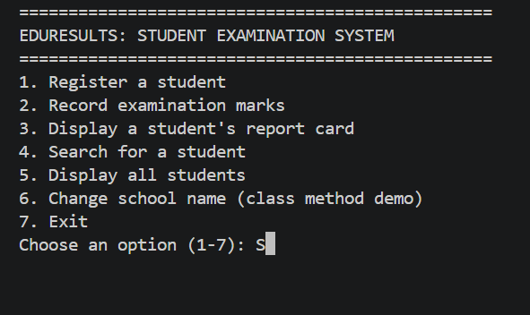

Screenshot 2: Registering a student
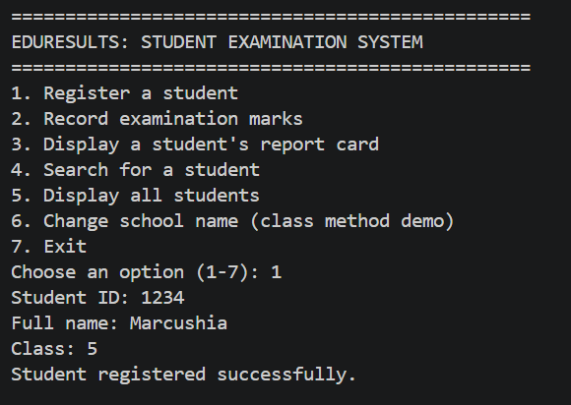

Screenshot 3: Recording examination marks
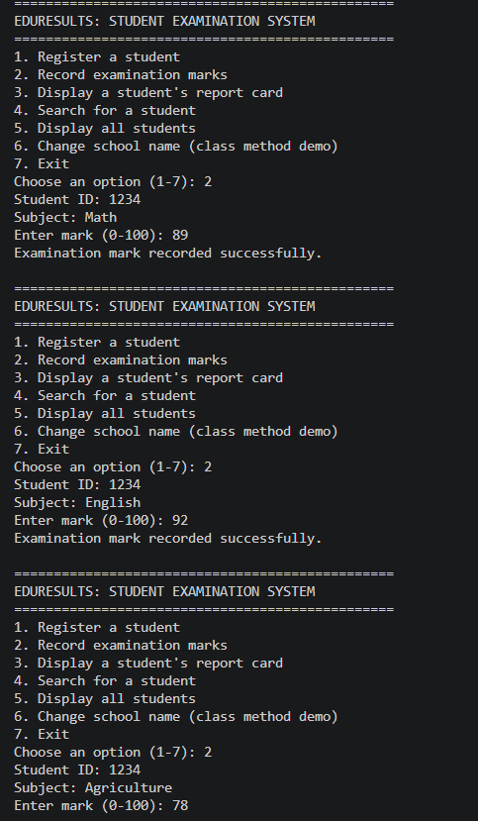

Screenshot 4: Student report card
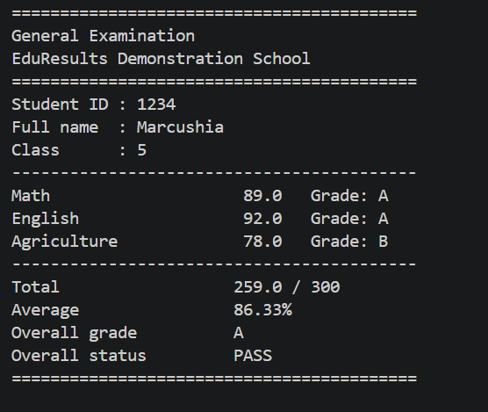

Screenshot 5: Searching or displaying student records
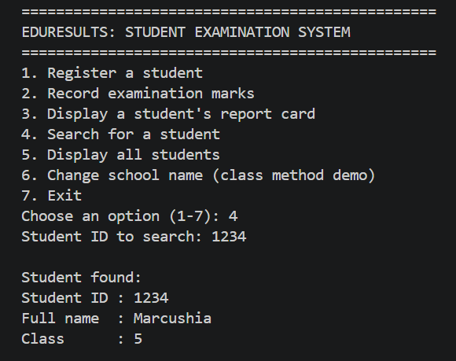

Screenshot 6: Searching or displaying All student records

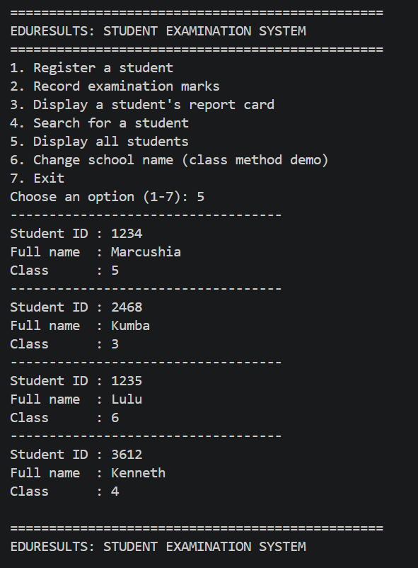

Screenshot 7: Changing School Name
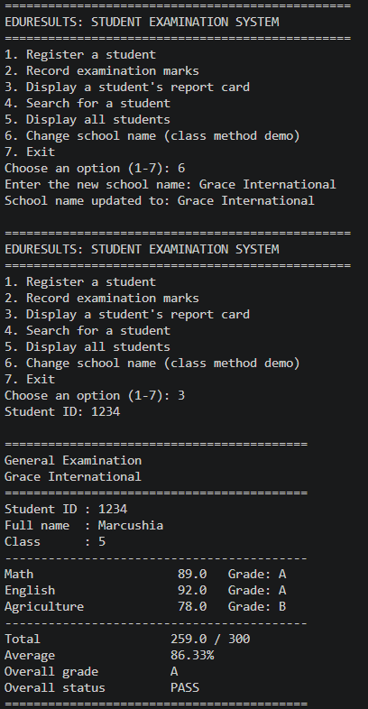

11. CONCLUSION
EduResults demonstrates the core requirements of the OOP1 assignment through classes, objects, instance methods, a class method, object interaction, and a dictionary data structure. It provides basic student registration and examination reporting functionality while illustrating open-source, accessibility, privacy, and modularity considerations. The prototype is suitable for learning and demonstration, with persistence and production security left for future development

APPENDIX A – SOURCE CODE
class Student:
"""Represents one student."""

school_name = "EduResults Demonstration School"

def __init__(self, student_id, full_name, class_name):
self.student_id = student_id.strip().upper()
self.full_name = full_name.strip()
self.class_name = class_name.strip()
self.examinations = {}

def add_mark(self, subject, mark):
"""Add or update a subject mark for this student."""
subject = subject.strip().title()
if not subject:
raise ValueError("Subject cannot be empty.")
if not 0 <= mark <= 100:
raise ValueError("Mark must be between 0 and 100.")
self.examinations[subject] = mark

def calculate_average(self):
"""Return the average of recorded subject marks, or None if no marks."""
if not self.examinations:
return None
return sum(self.examinations.values()) / len(self.examinations)

def get_grade(self, mark):
"""Return a grade using the demonstration grading scale."""
if not 0 <= mark <= 100:
raise ValueError("Mark must be between 0 and 100.")
if mark >= 80:
return "A"
if mark >= 70:
return "B"
if mark >= 60:
return "C"
if mark >= 50:
return "D"
return "F"

def display_details(self):
"""Display the student's basic details."""
print(f"Student ID : {self.student_id}")
print(f"Full name : {self.full_name}")
print(f"Class : {self.class_name}")

@classmethod
def change_school_name(cls, new_name):
"""Change the shared school name for all Student objects."""
if not new_name.strip():
raise ValueError("School name cannot be empty.")
cls.school_name = new_name.strip()

class Examination:
"""Provides examination-related calculations."""

def __init__(self, title="General Examination"):
self.title = title

def calculate_total(self, marks):
"""Calculate the total of a sequence of marks."""
return sum(marks)

def calculate_average(self, marks):
"""Calculate the average of a sequence of marks."""
if not marks:
return None
return sum(marks) / len(marks)

class ResultManagementSystem:
"""Stores and manages Student objects in a dictionary."""

def __init__(self):
# Dictionary data structure: student ID is the key, Student object is the value.
self.students = {}
self.examination = Examination()

def add_student(self, student):
"""Register a Student object. Student IDs must be unique."""
if student.student_id in self.students:
raise ValueError("That student ID is already registered.")
self.students[student.student_id] = student

def find_student(self, student_id):
"""Find a student by ID; return None when not found."""
return self.students.get(student_id.strip().upper())

def display_all_students(self):
"""Display all registered students."""
if not self.students:
print("No students have been registered yet.")
return
for student in self.students.values():
print("-" * 35)
student.display_details()

def record_mark(self, student_id, subject, mark):
"""Record a subject mark for a registered student."""
student = self.find_student(student_id)
if student is None:
raise ValueError("Student ID was not found.")
student.add_mark(subject, mark)

def display_report_card(self, student_id):
"""Display a student's marks, grades, total and average."""
student = self.find_student(student_id)
if student is None:
print("Student ID was not found.")
return

print("\n" + "=" * 42)
print(self.examination.title)
print(Student.school_name)
print("=" * 42)
student.display_details()
print("-" * 42)

if not student.examinations:
print("No examination marks have been recorded.")
return

marks = list(student.examinations.values())
for subject, mark in student.examinations.items():
print(f"{subject:<22} {mark:>5.1f} Grade: {student.get_grade(mark)}")

total = self.examination.calculate_total(marks)
average = self.examination.calculate_average(marks)
overall_grade = student.get_grade(average)
status = "PASS" if average >= 50 else "FAIL"

print("-" * 42)
print(f"{'Total':<22} {total:.1f} / {len(marks) * 100}")
print(f"{'Average':<22} {average:.2f}%")
print(f"{'Overall grade':<22} {overall_grade}")
print(f"{'Overall status':<22} {status}")
print("=" * 42)

def read_non_empty(prompt):
"""Ask until the user enters non-empty text."""
while True:
value = input(prompt).strip()
if value:
return value
print("This field cannot be empty.")

def read_mark():
"""Ask for a valid mark from 0 to 100."""
while True:
try:
mark = float(input("Enter mark (0-100): "))
if 0 <= mark <= 100:
return mark
print("Mark must be between 0 and 100.")
except ValueError:
print("Please enter a valid number, for example 72 or 65.5.")

def show_menu():
print("\n" + "=" * 48)
print("EDURESULTS: STUDENT EXAMINATION SYSTEM")
print("=" * 48)
print("1. Register a student")
print("2. Record examination marks")
print("3. Display a student's report card")
print("4. Search for a student")
print("5. Display all students")
print("6. Change school name (class method demo)")
print("7. Exit")

def main():
system = ResultManagementSystem()
print(f"Welcome to {Student.school_name}")
print("Note: records are stored only while this program is running.")

while True:
show_menu()
choice = input("Choose an option (1-7): ").strip()

try:
if choice == "1":
student_id = read_non_empty("Student ID: ")
full_name = read_non_empty("Full name: ")
class_name = read_non_empty("Class: ")
system.add_student(Student(student_id, full_name, class_name))
print("Student registered successfully.")

elif choice == "2":
student_id = read_non_empty("Student ID: ")
subject = read_non_empty("Subject: ")
mark = read_mark()
system.record_mark(student_id, subject, mark)
print("Examination mark recorded successfully.")

elif choice == "3":
student_id = read_non_empty("Student ID: ")
system.display_report_card(student_id)

elif choice == "4":
student_id = read_non_empty("Student ID to search: ")
student = system.find_student(student_id)
if student:
print("\nStudent found:")
student.display_details()
else:
print("Student ID was not found.")

elif choice == "5":
system.display_all_students()

elif choice == "6":
new_name = read_non_empty("Enter the new school name: ")
Student.change_school_name(new_name)
print(f"School name updated to: {Student.school_name}")

elif choice == "7":
print("Thank you for using EduResults. Goodbye.")
break

else:
print("Please choose a number from 1 to 7.")

except ValueError as error:
print(f"Error: {error}")

if __name__ == "__main__":
main()

