TABLE OF CONTENTS
1. Assignment Answers
1.1 Chosen Domain and Problem Statement
1.2 Aim and Objectives
1.3 System Overview
1.4 Classes, Attributes and Objects
1.5 Object Creation and Interaction
1.6 Python Data Structure
1.7 Methods Used
1.8 Program Algorithm
1.9 Sample Input and Output
1.10 Digital Public Goods (DPG) Alignment
1.11 Testing and Expected Results
1.12 Limitations and Possible Improvements
2. Screenshots of Python Code
3. Screenshot of Program Output
4. Conclusion
5. References

1. ASSIGNMENT ANSWERS

1.1 Chosen Domain and Problem Statement
The selected domain is Health, and the proposed program is called the Patient Record System. Clinics and health centres need an organised way to keep track of basic patient records. When records are managed informally, it can be difficult to find a particular record, identify duplicate entries, or display a list of registered patients. This assignment demonstrates a small Python program that stores and retrieves basic patient records using Object-Oriented Programming (OOP).
The program is an educational prototype, not a complete clinical information system. It uses fictional names and non-sensitive sample details only. It does not collect diagnoses, prescriptions, medical histories, phone numbers, addresses, or other sensitive medical information.

1.2 Aim and Objectives
Aim: To develop a simple, reusable patient-record program that demonstrates the OOP concepts covered in Lectures 1–3.
- Create classes and objects relevant to the health domain.
- Use attributes to represent each patient's basic record.
- Store multiple Patient objects in one Python data structure.
- Provide methods to add, display, and search for records.
- Demonstrate an instance method and a class method.
- Apply privacy-respecting, accessible, open-source, modular, and reusable design principles.

1.3 System Overview
The program contains two classes. The Patient class represents one patient and stores that patient's ID, name, age, and appointment reason. The PatientRecordSystem class manages a collection of Patient objects. It stores them in a dictionary, checks for duplicate IDs, displays all records, and searches for a record by its unique ID.
The program runs from the main() function. It creates one PatientRecordSystem object, creates two fictional Patient objects, adds them to the system, displays all stored records, searches for patient P001, and displays the total number of Patient objects created.

1.4 Classes, Attributes and Objects
Class 1 — Patient: This class is the blueprint for an individual patient record. Its instance attributes are patient_id, name, age, and appointment_reason. Each object can have different values for these attributes. The class attribute total_patients is shared by all Patient objects and counts how many have been created.
Class 2 — PatientRecordSystem: This class is responsible for managing records. Its records instance attribute is a dictionary that stores patient IDs and the corresponding Patient objects. Keeping record-management operations in a separate class makes the program easier to maintain.
Objects created: patient1 is a Patient object with ID P001 and fictional sample details. patient2 is another Patient object with ID P002. The variable system refers to a PatientRecordSystem object. These objects demonstrate how classes are used to create working instances in Python.

1.5 Object Creation and Interaction
The statement Patient("P001", "Amina Kamara", 24, "General check-up") creates the first Patient object. A second statement creates the patient with ID P002. The PatientRecordSystem object receives these objects through add_patient(). It stores each object in its dictionary using the patient's ID as the key. When display_all_patients() is called, the system loops through the stored Patient objects and calls each object's display_record() method. This is object interaction.

1.6 Python Data Structure
The program uses one data structure, a dictionary named records, as required by the brief. The dictionary stores multiple objects using the unique patient ID as the key and the Patient object as the value. For example, the key "P001" points to the patient1 object.
A dictionary is suitable because it allows the program to check whether an ID already exists and retrieve a record using that ID. The add_patient() method prevents duplicate IDs. The display_all_patients() method loops through the dictionary values to display all records, while find_patient() uses get() to return the requested object or None if it does not exist.

1.7 Methods Used
Constructor (__init__): The Patient constructor assigns values to the instance attributes and increases the shared total_patients counter. The PatientRecordSystem constructor creates an empty dictionary for records.
Instance method — display_record(): Displays the basic details of one Patient object. Instance method — add_patient(patient): checks for a duplicate ID and then stores the object. Instance method — display_all_patients(): displays all stored records and handles an empty dictionary. Instance method — find_patient(patient_id): searches for a patient by ID.
Class method — get_total_patients(): This method uses the @classmethod decorator and receives the class as its first argument, cls. It returns the shared total_patients value. This demonstrates the class-method requirement in the assignment brief.

1.8 Program Algorithm
- Start the program.
- Create an empty PatientRecordSystem object and its records dictionary.
- Create two Patient objects using fictional sample data.
- Add each object to the dictionary if its patient ID is not already present.
- Display all patient records stored in the dictionary.
- Search the dictionary for patient ID P001.
- Display the matching record or show “Patient not found.”
- Call the class method to display the number of Patient objects created.
- End the program.

1.9 Sample Input and Output
The program uses two hard-coded fictional records as sample input. No personal information is requested from a user while the program runs.
Sample record 1: P001, Amina Kamara, 24, General check-up
Sample record 2: P002, David Conteh, 31, Dental consultation
Search value: P001
Expected result: The program confirms that both records were added, displays both records, returns the record for P001 in the search, and reports that two Patient objects have been created. A screenshot of the expected output is included in Section 3.

1.10 Digital Public Goods (DPG) Alignment
- Open-source: The Python source file can be shared openly in a GitHub repository. A README should explain the program, how to run it, and how it meets the assignment requirements.
- Inclusive and accessible design: The program uses plain text output, descriptive method names, and a simple structure that beginners can read and understand. It does not require a graphical interface or expensive software.
- Privacy-respecting: The included records are fictional and contain only basic demonstration fields. Real patient details must not be placed in public repositories. A real deployment would require appropriate security, consent, access controls, and compliance with applicable laws.
- Modular and reusable: Patient data and record-management functions are separated into two classes. The classes can be reused in another small application or extended with additional non-sensitive fields.
- Reusable and maintainable code: Methods have clear responsibilities and docstrings describe their purpose. This makes the program easier to test, update, and adapt.

1.11 Testing and Expected Results
Test | Action | Expected result
Add a new patient | Add patient P001 when the dictionary is empty. | The record is stored and a success message appears.
Add another patient | Add patient P002. | The second record is stored without replacing the first.
Display records | Call display_all_patients() after adding both patients. | The program displays both patient records.
Search for an existing ID | Search for P001. | The program returns and displays Amina Kamara's sample record.
Search for an unknown ID | Search for P999. | The method returns None and the program displays Patient not found.
Count objects | Call Patient.get_total_patients(). | The output is 2 for the two Patient objects created.

1.12 Limitations and Possible Improvements
This version is deliberately simple and stores records only while the program is running. When the program closes, the dictionary is lost. It does not have a login screen, database, encryption, role-based permissions, or a graphical interface. It is not suitable for real clinical use.
Possible future improvements include storing data in a secure database, adding user authentication and access permissions, validating age and ID formats, adding a user-friendly interface, providing secure backups, and following all relevant health-data protection requirements. Any public GitHub repository should contain only fictional data.

2. SCREENSHOTS OF PYTHON CODE
The following images show the source code in readable sections. The full source is also supplied as patient_record_system.py so it can be run and checked.
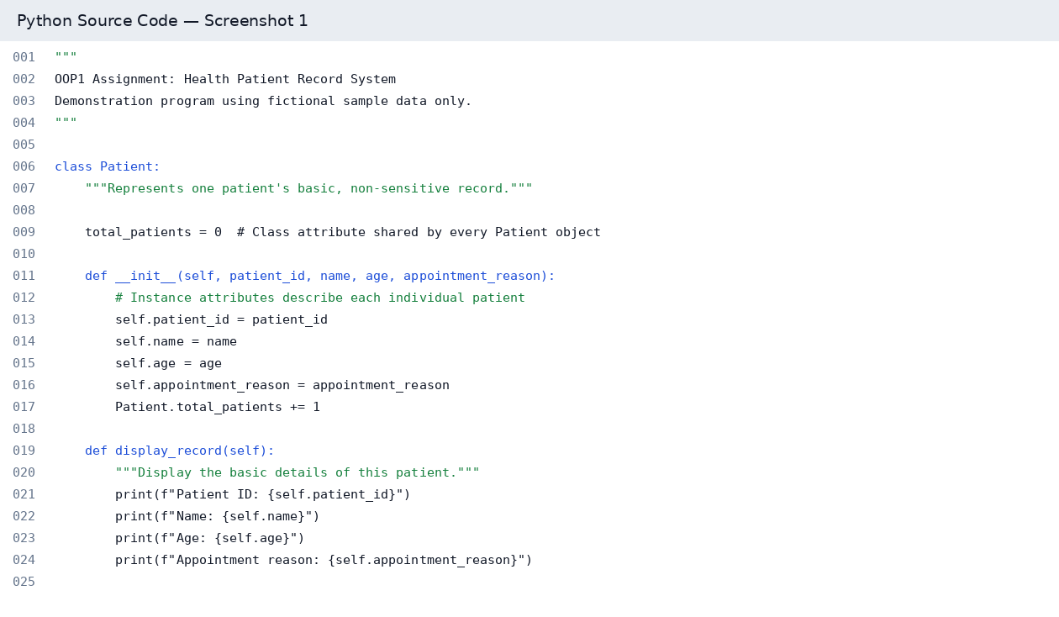

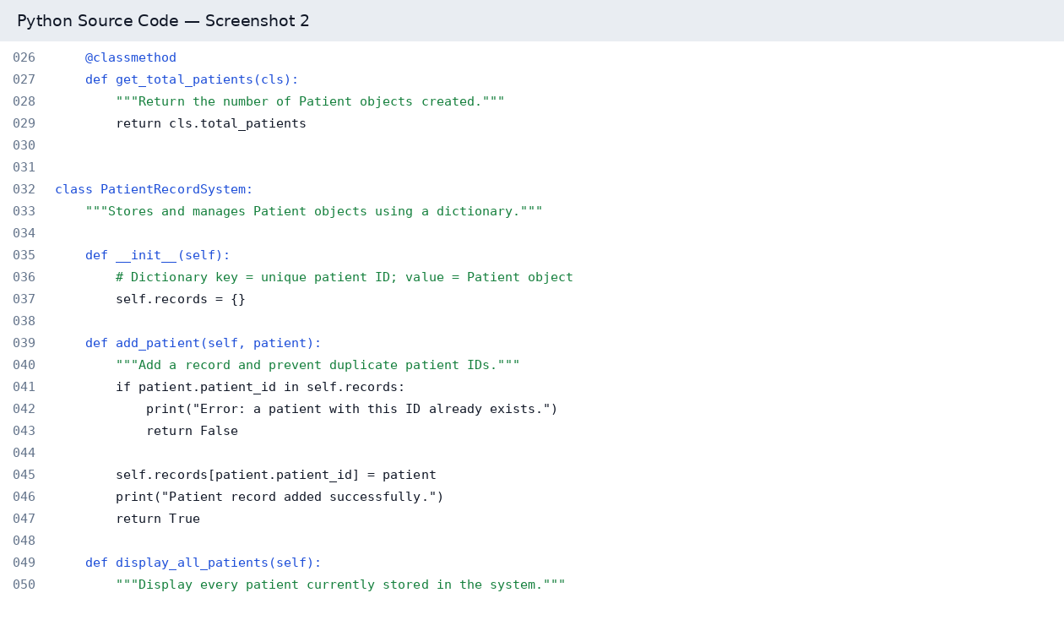

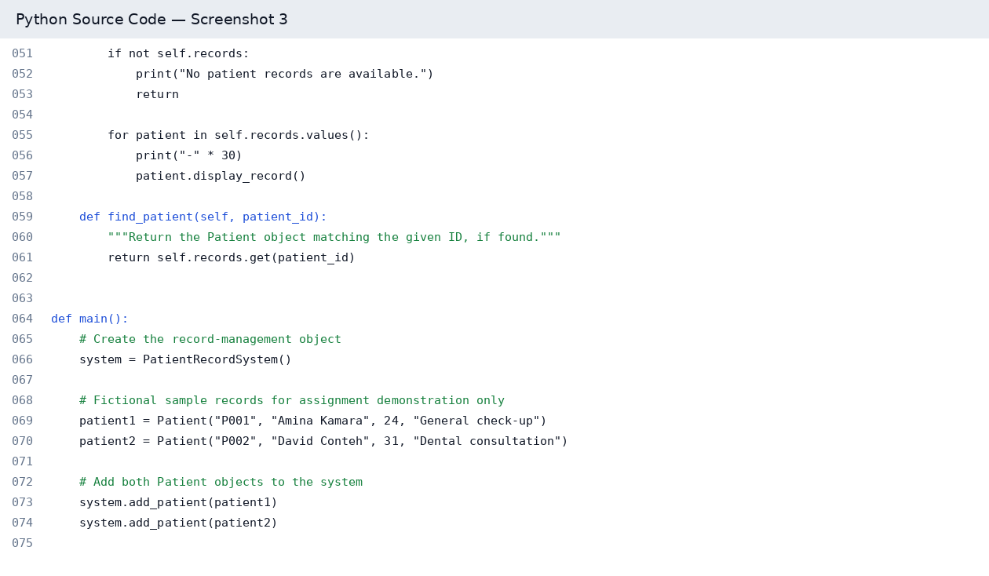

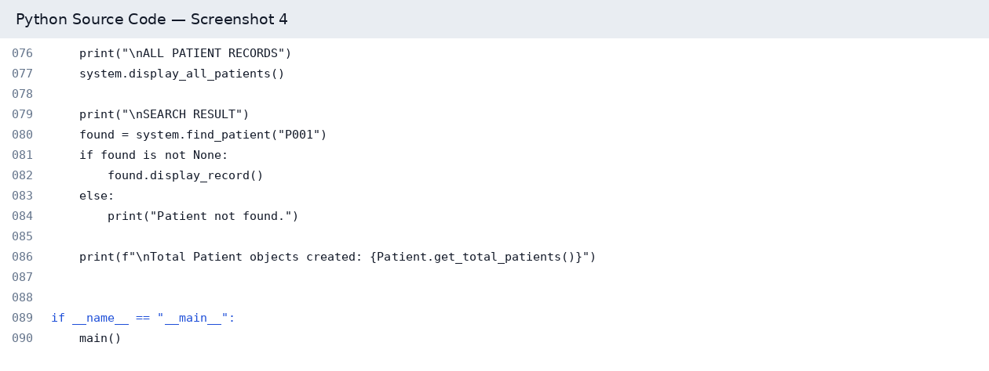

3. SCREENSHOT OF PROGRAM OUTPUT
This is the expected output produced by the supplied program when it is run with the included fictional sample data. If your lecturer specifically requires a screenshot from your own Python editor or terminal, run patient_record_system.py and capture your screen after execution.
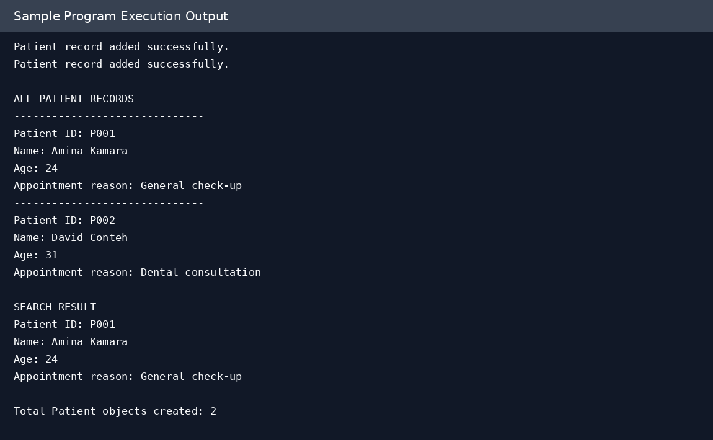

CONCLUSION
The Health Patient Record System demonstrates how Object-Oriented Programming can be applied to a basic health-sector record-management problem. The program uses two classes, attributes, objects, a dictionary, instance methods, and a class method to add, display, and search fictional patient records. The project also considers Digital Public Goods principles through open sharing, accessible text-based interaction, modular structure, reusability, and privacy-conscious use of fictional data. However, this is an educational prototype and should not be used to store real clinical information without appropriate security, access controls, secure storage, and compliance with applicable data-protection requirements.

REFERENCES
Python Software Foundation. (n.d.). *The Python Tutorial: Classes*. Python Documentation. https://docs.python.org/3/tutorial/classes.html
Python Software Foundation. (n.d.). *Built-in Types: Mapping Types — dict*. Python Documentation. https://docs.python.org/3/library/stdtypes.html#mapping-types-dict
Digital Public Goods Alliance. (n.d.). *Digital Public Goods Standard*. https://digitalpublicgoods.net/standard/
Note: These references provide background on Python classes and dictionaries and the Digital Public Goods Standard. Access dates are not included.

