Project 12
<Monopoly>

CIS-17a 45435
Name: Depew, Marcus
Date: 7/26/18

Introduction

Title: Monopoly

The desire is to become the wealthiest player by purchasing property and charging rent. Players start with $1,500 and on “Go”. The players roll dice to determine how many spaces they travel. Then players decide if they want to purchase that property or not. If so they pay it’s cost and if another player lands on that space they charge the player a fee. Each time the players complete a circuit around the board they collect $200. There are Chance and Chest cards which determine a positive or negative outcome for the player. Jail is a square where when a player lands on nothing happens but they may draw a chance card which puts the player in jail until they pay $200 or 8 turns go buy. Free parking is like jail in that it is a free space which can not be bought but rent can not be charged either. When a player is out of money they declare bankruptcy and the remaining players count their money and who ever has more wins. I choose this as my project because I really like monopoly but I am never able to find enough people to play with.

Summary

Project size: about 30 lines
The number of variables: about 20
The number of constructors: 6
The number of arrays: 6

This project includes many concepts that we learned from the chapters in the book 9-12. This project was fun but challenging as I only had about a week so I found myself daydreaming about C++ at work. This game could include many more features as it is only the bare bones of the monopoly game and The player moves around the board and can buy property and pickup chance cards and can read the rulebook. I look forward to adding features, like trading/mortgaging property, jail and more cards. In the future in my free time. This project meets the criteria because it has arrays, pointers, functions, comparing, c-string, loops, reads files has structures, etc..

Description
I had a number of problems initially but I worked though them one at a time. Once problem was the random numbers, Netbeans on my computer did not want to you the getrandom function I was unable to resolve it so I defaulted to srand. I tired to make some sort of ASCII graphic display for the board but it was taking far tolong so I opted for a linear display. I tired to combine some function for the player and computer player but this proved to be too hard and I made separate functions.

Input
The player inputs commands when prompted by the terminal. There are only two options ever presented at once so I used 1 or 2, and Yes and No.

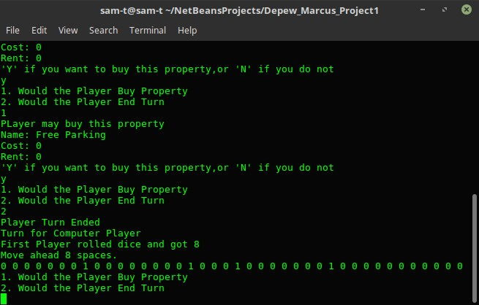

FlowChart Depew_Marcus_Project2/Flowchart.pdf
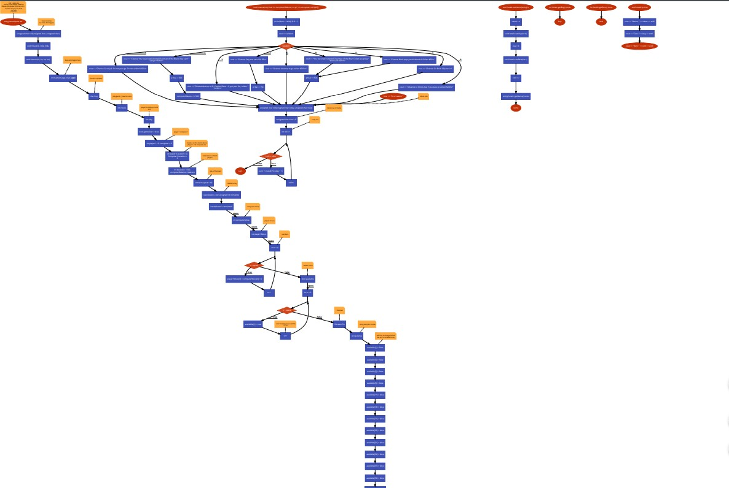

Pseudo code

Declare variables then set the arrays equal to 0 or true;
invoke random number generator.
After declaring the arrays to true or 0 set the exceptions to false.
Prompt the user to either play the game or display the rules.
If the game is not over then player can take his turn.
Player 1 rolls the dice and moves forward.
Display the board. Check if player lands on a computer owned location.
Check to see if there is a winner, if not continue playing.
If the location player landed on is available then prompt the user to either buy the location or to pass.
If the player says yes to buying the location then sets the location equal to false and subtracts the buy amount from player’s bank account.
The player can then choose to see his/her property or end the turn.
If the player chooses to view property then it will display all the locations player 1 owns.
Else wise the player can end the game and it will become the computers turn.
Computer will roll if the game is not over. If the game is over then the computer will not be able to roll.
Then it will check to see if player is in prison, if so then the computer gets to roll twice.
Computer will now roll and move forward the dice amount spaces.
Then determine if the computer or player won, if not then the game continues.
Then checks to see if the computer landed on an owned square.
If the computer can buy the property it will generate a random number either one two or three
If the answer is 2 then the computer will buy the property and the property will no longer be able to be bought.
Once the game is over, where either player becomes bankrupt then it will displays ”Game over”
Variables

Variables | Location | Name
Functions | Above main | win();
Vectors | Line 1203 | P1prop
Bool | Declaring variables | prison=true;
Int | Declaring Variables | play=0;
Structures | In the player.h file | player p;
Objects and classes | In hotel.h file | hotel
Dynamic arrays | Declaring variables | Board
For loops | Line 184 | I<=turn
If-else | Line 231 | p.p1loc==c1prop[i]
Do-while | Line 232 | While game=true;
Switch | Line 321 | (buyans)
Random number | Roll function | dicerool();
Binary files | Line 455 | Ofstream fout
Reading a file | rulebook function | rulebook();
String | Declaring variables | property[];

Main
char buy; int choice; int play; bool gameOver; int player1; compter1; player1Location; Computer1Location; balance; computerBalance; const int space; int computerMove[space];
int player1Move[space]; int buyProperty; int rent[space]
chance
int random
roll
char sum;

Reference
- Starting Out with C++ from Control Structures to Objects-8th Edition
- GitHUb: LehrMark_CSC_CIS_17a_Summer_2018, otherchen/Monopoly, mfahsan/Monopoly,wenjluo26/monopoly, jreing/Monopoly,
- rules of Monopoly – Hasbro: https://www.hasbro.com/common/instruct/monins.pdf
- stackoverflow.com: https://stackoverflow.com/questions/3746484/why-am-i-getting-this-redefinition-of-class-error: https://stackoverflow.com/questions/19665818/generate-random-numbers-using-c11-random-library: https://stackoverflow.com/questions/19122574/to-string-isnt-a-member-of-std/19122592
- Class Powerpoint slides

Code:
/*
* File: main.cpp
* Author: Your Name <Marcus Depew @mdepew1@gmail.com>
*
* Created on July 17, 2018, 7:57 PM
*/
// Libraries
using namespace std;
#include <cstdlib>
#include <ctime>
#include <cstdlib>
#include <fstream>
#include <string>
#include <iostream>
// User Libraries
#include "hotels.h"

// Function Prototypes
unsigned char roll(unsigned char, unsigned char);
void move(int, int&, int&);
void chance(int, int, int, int);

// Execution begins here
int main(int argc, char** argv) {
// Declare variables
char buy;
int choice; // play game || see the rules
int play; // player to roll,buy or end turn
bool gameOver = false;

int player1 = 0, computer = 0; // player 1 computer 1
int player1Location = 0,
Computer1Location =
0; // location on the board where player 1 and computer are
int balance = 1500,
computerBalance = balance; // total balance of both players
const int space = 40; // size of the board

// random array
srand(static_cast<unsigned int>(time(0)));

hotels* board = new hotels[space];

int computerMove[space]; // computer moves
int player1Move[space]; // player moves

// sets Zero
for (int n = 0; n < space; n++) {
player1Move[n] = computerMove[n] = 0;
}
bool available[space]; // Hotels status

for (int n = 0; n < space;
n++) { // sets bored to true available to buy
available[n] = true;
}

ifstream fin; // file input
string temp; // string temp for the file
// Sets the chance,go,income tax, etc to not able to buy
available[1] = false;
available[3] = false;
available[5] = false;
available[8] = false;
available[11] = false;
available[18] = false;
available[21] = false;
available[23] = false;
available[31] = false;
available[34] = false;
available[37] = false;
available[39] = false;

string property[40] = {"Go",
"Mediterranean Avenue",
"Baltic Avenue",
" Income Tax",
"Chance",
"Reading Railroad",
"Oriental Avenue",
"Chance",
"Vermont Avenue",
"Connecticut Avenue",
"Jail",
"St. Charles Place",
"Electric Company",
"States Avenue",
" Virginia Avenue",
"Pennsylvania RailRoad",
"St. James Place",
"Chance",
"Tennessee Avenue",
" New York Avenue",
"Free Parking",
"Kentucky Avenue",
"Chance",
"Indiana Avenue",
"Illinois Avenue",
" B. & O. Railroad",
"Atlantic Avenue",
"Ventnor Avenue",
"Water Works",
"Marvin Gardens",
"Go to Jail",
"Pacific Avenue",
"North Carolina Avenue",
"Chance",
"Pennsylvania Avenue",
"Short Line",
"Chance",
"Park Place",
"Luxury Tax",
"BoardWalk"};
int buyProperty[space] = {0, 60, 0, 60, 0, 200, 100, 0, 100, 120,
0, 140, 150, 140, 160, 200, 180, 0, 180, 200,
0, 220, 0, 220, 240, 200, 260, 260, 150, 280,
0, 300, 300, 0, 320, 200, 0, 350, 0, 400};
int rent[space] = {0, 20, 0, 40, 0, 25, 60, 0, 60, 80,
0, 100, 75, 100, 120, 250, 140, 0, 140, 160,
0, 180, 0, 180, 200, 250, 220, 220, 75, 240,
0, 260, 260, 0, 280, 250, 0, 350, 0, 500};

for (int n = 0; n < space; n++) {
board[n].setName(property[n]);
board[n].setBuy(buyProperty[n]);
board[n].setRent(rent[n]);
}

cout << "MONOPOLY\n";
cout << "You starts off with $1500\n";
do {
do {
cout << "1. Play the game\n2. See rules\n";
cin >> choice;
} while (choice < 1 || choice > 2);
cout << "First Player goes first\n";
switch (choice) {
case 1: {
do {
player1 = roll(6, 2);
cout << "First Player rolled dice and got " << player1 << endl;
cout << "Move ahead " << player1 << " spaces." << endl;
player1Location += player1;
player1Move[player1Location] = 1;
for (int n = 0; n < space; n++) {
cout << player1Move[n] << ' ';
}
cout << endl;
do {
cout << "1. Would the Player Buy Property\n2. Would the Player End "
"Turn\n";
cin >> play;
switch (play) {
case 1: {
if (available[player1Location] == false) {
cout << "This property is unavailable\n";
} else if (available[player1Location] == true) {
cout << "PLayer may buy this property\n";
board[player1Location].print();
do {
cout << "'Y' if you want to buy this property,or 'N' if "
"you do not\n";
cin >> buy;
if (buy != 'Y' && buy != 'y' && buy != 'N' && buy != 'n') {
cout << "Invalid Input\n";
}
} while (buy != 'Y' && buy != 'y' && buy != 'N' &&
buy != 'n');
if (buy == 'Y' && buy == 'y') {
cout << "PLayer purchased " << property[player1Location];
available[player1Location] = false;
}
}
break;
}
case 2: {
cout << "Player Turn Ended\n";
break;
}
default:
cout << "Error Statement";
}
} while (play != 2);
// Computer Play turn
cout << "Turn for Computer Player\n";
computer = roll(6, 2);

// Determine the winner
if (balance <= 0) {
cout << "You lose" << endl;
gameOver = true;
} else if (computerBalance <= 0) {
cout << "You win" << endl;
gameOver = true;
}
} while (gameOver == false);
break;
}
case 2: {
cout << endl;

fin.open("rulesbook.txt"); // Print rulebook
if (fin.is_open()) {
while (getline(fin, temp)) {
cout << temp << endl;
}
}
fin.close();
break;
}
default:
cout << "Error case \n";
}
} while (choice != 1);

delete[] board;
return 0;
}

void chance(int p1bal, int computerBalance, int p1, int computer, int b[40]) {
int random = rand() % 9 + 1;
cout << random;
switch (random) {
case 1: {
cout << "Chance: Go to Jail. Do not pass go. Do not collect $200\n";
break;
}
case 2: {
cout << "Chance: You have been elected Chairman of the Board, Pay each "
"player $500\n";
p1bal -= 500;
computerBalance += 500;
break;
}
case 3: {
cout << "ChanceAdvance to St. Charles Place – If you pass Go, collect "
"$200 \n";
break;
}
case 4: {
cout << "Chance: Pay poor tax of $150\n";
p1bal -= 150;
break;
}
case 5: {
cout << "Chance: Bank pays you dividend of Collect $50\n";
p1bal += 500;
break;
}
case 6: {
cout << "Chance: Advance to go collect $200\n";
break;
}
case 7: {
cout << "Chance: Go Back 3 Spaces.\n";

break;
}
case 8: {
cout << "Advance to Illinois Ave If you pass go collect $200\n";
break;
}
case 9: {
cout << "You have been elected Chairman of the Boar Collect a signing "
"bonus of $500\n";
p1bal += 500;
break;
}

default:
cout << "Error case\n";
}
}

// RDice rolls

unsigned char roll(unsigned char sides, unsigned char nDie) {
// Declare sum the die
unsigned char sum = 0;
// Loop die
for (int roll = 1; roll <= nDie; roll++) {
sum += (rand() % sides + 1);
}
return sum;
}

void hotels::setName(string n) { name = n; }
void hotels::setBuy(int b) { buy = b; }
void hotels::setRent(int r) { rent = r; }
string hotels::getName() const { return name; }
int hotels::getBuy() const { return buy; }
int hotels::getRent() const { return rent; }
void hotels::print() {
cout << "Name: " << name << endl;
cout << "Cost: " << buy << endl;
cout << "Rent: " << rent << endl;
}

