Marcus Rosti

mer3ef

CS 5010

23rd July 2015

Python: Web Scrapper

## Problem description

I love YCombinator's [Hacker News](https://news.ycombinator.com/). It provides a great platform for discussing tech news and has a minimalist interface for fewer distractions. As such, the websites lends itself to scrapping and analysis. The page lists titles with hyperlinks to a website or a discussion forum on the site with users voting on titles to vet the more interesting ones.

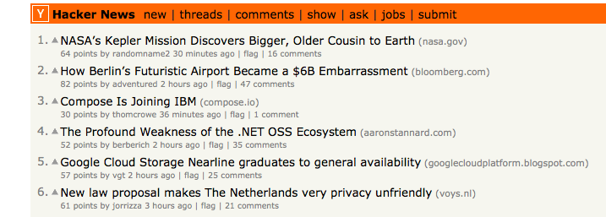It could be a good barometer for tech opinions and trends but we will need to collect the data from it first.

The webpage is written entirely in html. In the above figure, it even looks as if the entire form lies in one large html table. When I looked at the source code, I was right! The title and link lie in a row and the next row after that is contained in a “class=subtext” row. One downside of their setup is that the title row has “class=title” however, so do 30 other elements. The file looks ripe for scrapping

The biggest hurdle in scrapping websites lies in picking the right package. [Beautiful Soup](http://www.crummy.com/software/BeautifulSoup/), a python library, downloads a webpages html and leaves it in a “soup” of data. It automatically parses the data by its html and css tags and allows python to access that data programmatically. Beautiful Soup stores the html in a tree that can be accessed by repeated accessing them as if they were public fields as well as accessing them various find and select functions.

I began parsing the data by looking for unique tags and then

## data analysis

## next steps